Supplementary Materials for

Precipitation consolidation decreases terrestrial water storage

Corey S. Lesk and Justin S. Mankin

Corresponding author: corey.s.lesk@dartmouth.edu

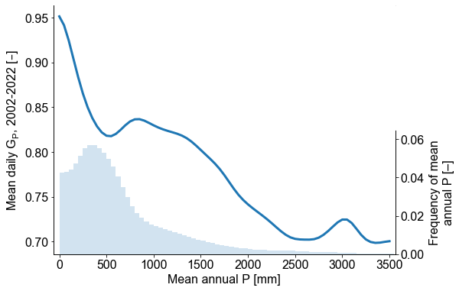
Supplementary Figure 1: Distribution of mean annual precipitation and daily rainfall consolidation across global land area. Climatological G_{P} averaged over 100mm bins of climatological annual precipitation across its global domain (blue curve, left vertical axis). Histogram of climatological annual precipitation in frequency terms (bars, right vertical axis). Data are from the Climate Prediction Center Unified Gauge-Based Daily Analysis.

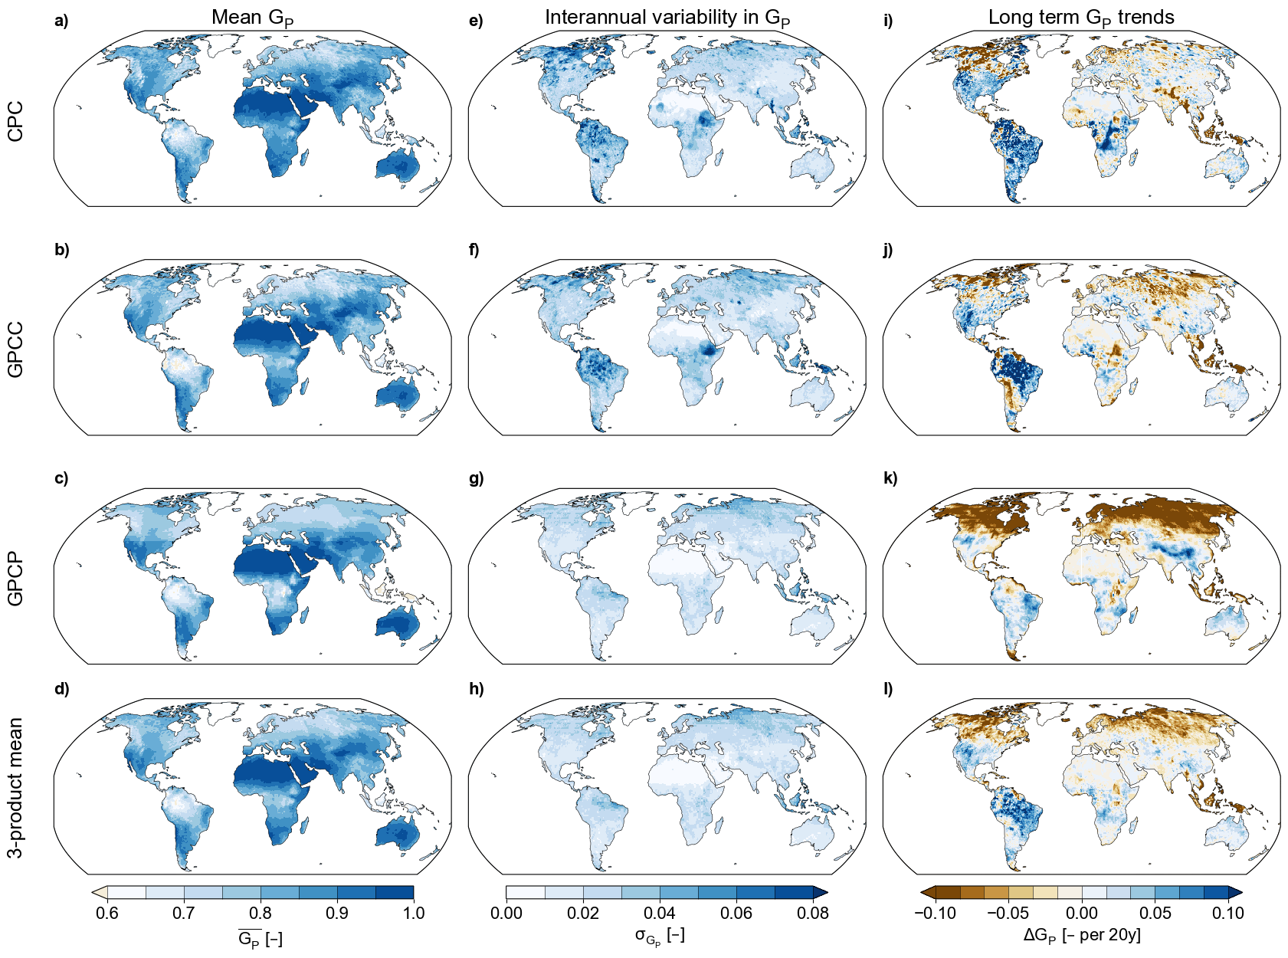

Supplementary Figure 2: Mean, variability, and trends in precipitation consolidation across datasets. a-d) Climatological mean G_{P}, averaged over the complete record length, for individual daily precipitation data products (CPC, GPCC, and GPCP, a-c) and for the three-product mean (d). e-g) Standard deviation of detrended G_{P} anomalies over the complete record length, as a metric of interannual variability in precipitation consolidation. i-l) Long-term linear trends in G_{P}, expressed as changes per 20 years (to harmonize across the varying record lengths of the three data products). Panels d and f are identical to Fig. 1f and g.

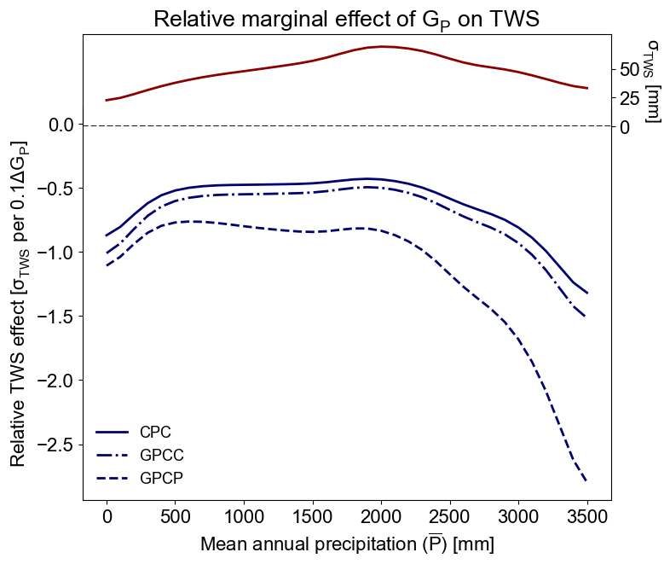
Supplementary Figure 3: Relative effect of precipitation consolidation on terrestrial water storage. Interannual standard deviation of detrended GRACE TWS anomalies, averaged over 100mm bins of climatological annual precipitation across its global domain (red curve, right vertical axis). Marginal effect of precipitation consolidation on TWS, conditional on climatological precipitation (i.e., the effects in Fig. 2b), normalized by TWS standard deviation (blue curves, left vertical axis). This normalization estimates the magnitude of the TWS effect relative to local TWS variability (σ_{TWS}), as opposed to in absolute terms (mm, as in Fig. 2b).

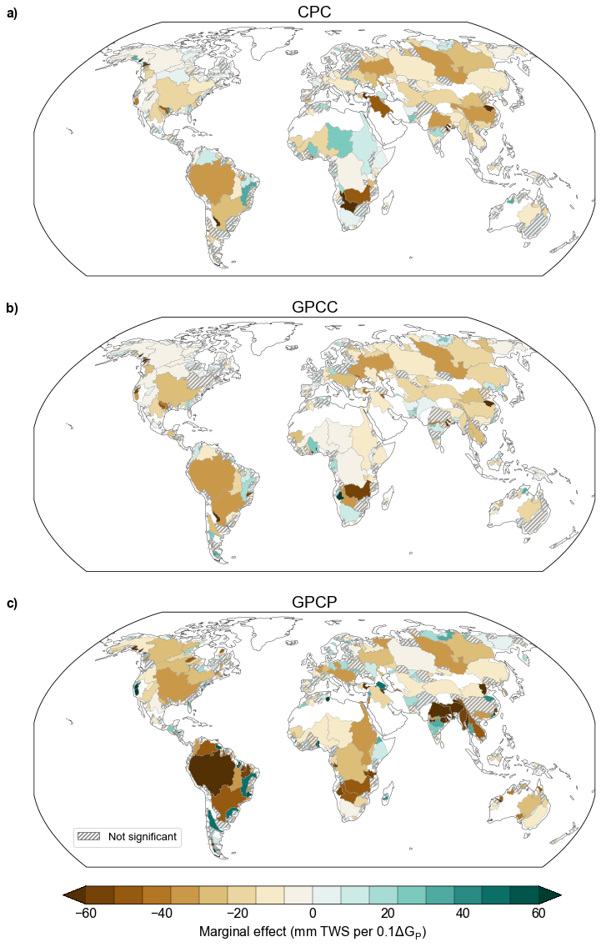
Supplementary Figure 4: Basin-level effects of consolidation on terrestrial water storage across precipitation data products. Same as Fig. 2c, but for individual data products. Main river basin boundaries are from the HydroBASINS dataset. Estimated G_{P} coefficients of TWS are statistically significant (p < 0.05) except in hatched basins.

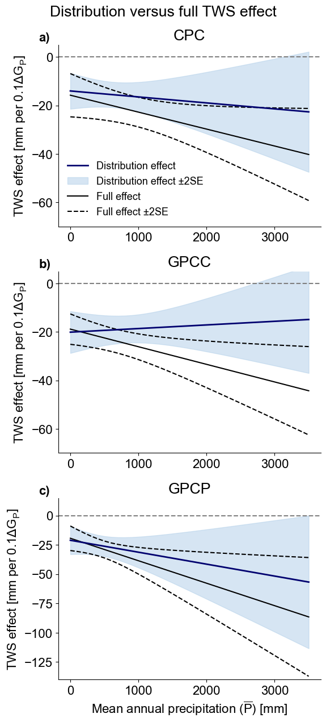
Supplementary Figure 5: Distribution versus full effect of precipitation consolidation on terrestrial water storage across precipitation data products. Same as Fig. 3b, but for individual daily precipitation data products.

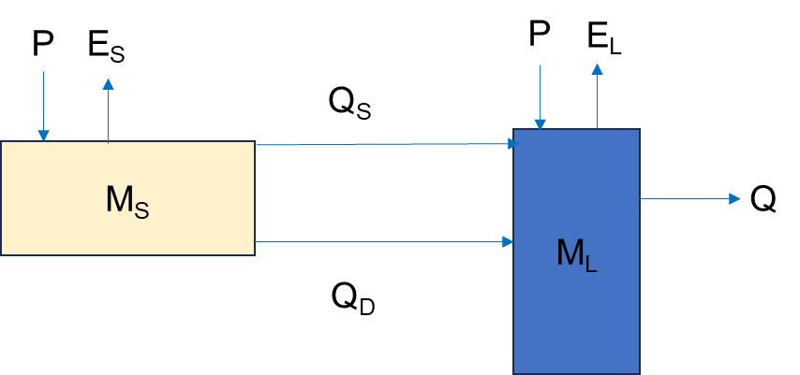

Supplementary Figure 6: Schematic of hydrologic stocks and fluxes in idealized land-surface model. M_{S} and M_{L} denote the soil and surface water stocks, while arrows denote fluxes. P is precipitation; E_{S}, soil evaporation; E_{L} evaporation from the surface water stock; Q_{S}, surface ponding of precipitation (infiltration and saturation excess); Q_{D}, soil drainage; and Q, runoff. In this formulation, Q_{S} is considered a flux internal to the modeled location, while flows out from the surface water stock are classified as runoff (i.e., export).

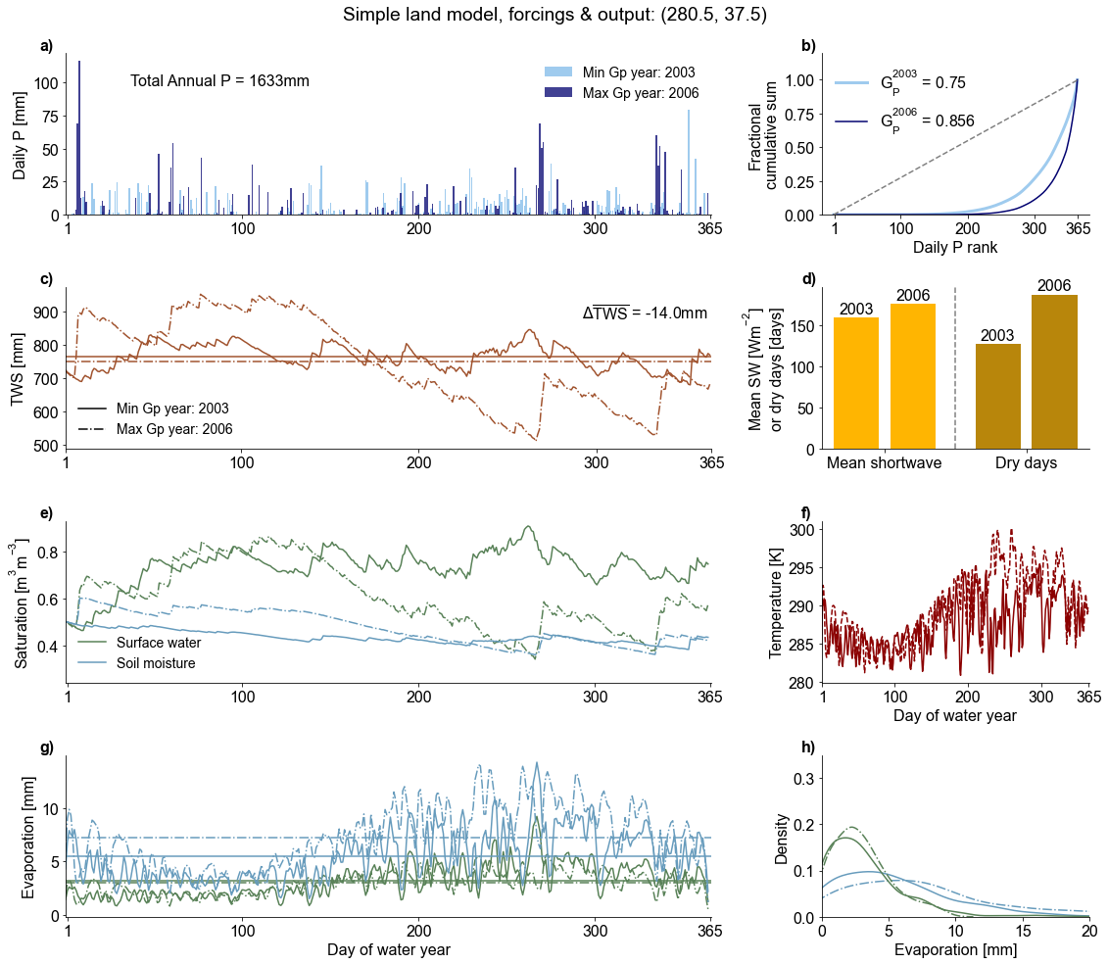
Supplementary Figure 7: Sample simulation from the idealized land-surface model. Output from the Surface Energy and Moisture Balance Model with Hydrology (SEMB-H) run with daily precipitation and shortwave forcings from CPC and GEWEX-SRB for the point 37.5°E, 80.5°N (near Roanoke, Virginia, US). Model output contrasts between the highest and lowest G_{P} years (2006 and 2003). a) Daily precipitation forcing time series for the two years, with daily values scaled such that the two time-series sum to equal annual total precipitation (1633mm). b) Daily precipitation Lorenz curves for the two years, with corresponding G_{P} values annotated. c) Simulated TWS evolution, with horizontal lines denoting annual mean TWS. d) Annual mean shortwave radiation and total dry days for the high and low G_{P} years. e) Daily evolution of the simulated surface water (blue) and soil moisture (green) stocks, in terms of fractional saturation. f) Daily evolution of simulated surface air temperature. g) Evolution of simulated evaporation from surface water and soil moisture stocks). h) Frequency distribution of daily evaporation from surface water and soil moisture stocks. We track the difference in annual mean TWS between the highest and lowest G_{P} years (in this case, -14mm) as equivalent measure to GRACE TWS anomalies used in our panel regression. Solid and dashed lines denote the minimum and maximum G_{P} years in c and e-h.
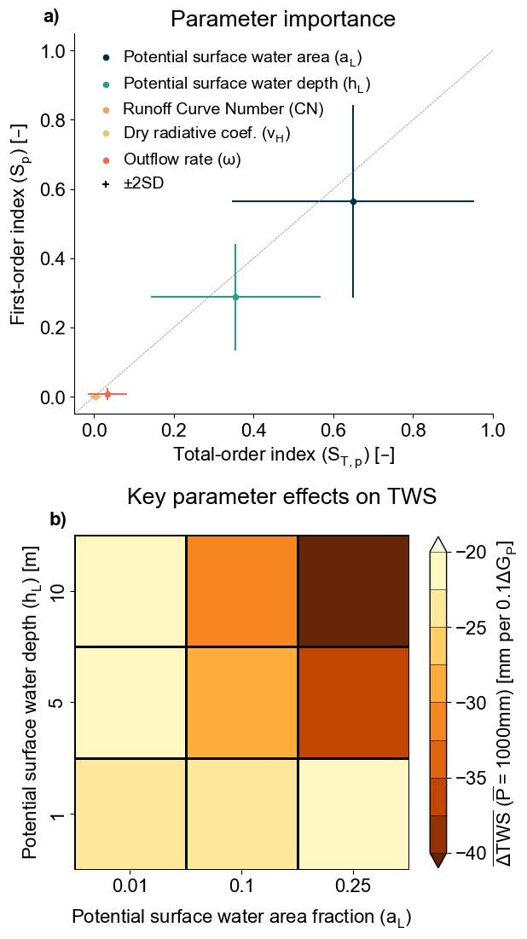
Supplementary Figure 8: Parametric sensitivity of simulated precipitation consolidation effect on TWS. a) Variance-based sensitivity of simulated TWS effect to idealized land-surface model parameter values, estimated using Sobol’ indices. Total- and first-order indices indicate influence of parameter on TWS effect with and without interactive effects among parameters. Error bars show 2 standard errors of the estimate. b) Mean simulated TWS effect at 1000mm of climatological mean precipitation for different joint values of the two most influential model parameters (surface water potential area and depth). Slightly larger total-order versus first-order indices suggest a small interactive influence of surface water depth and area, meaning TWS is more sensitive when either parameter is high but insensitive when either is low.

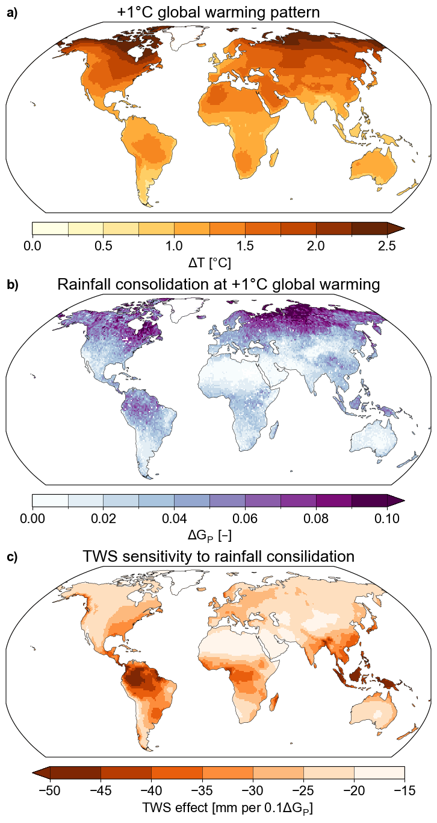
Supplementary Figure 9: Drivers of precipitation consolidation and terrestrial water storage impacts under an additional 1°C of global warming. a) Mean surface air warming pattern at 1°C of global warming, derived from the 26 general circulation and Earth system simulations from the Coupled Model Intercomparison Project, Phase 6 (CMIP6), run under the SSP5-8.5 scenario. b) G_{P} changes for precipitation consolidation under warming from a), projected using a thermodynamic rainfall intensification model. c) TWS sensitivity to precipitation consolidation, conditioned on climatological precipitation, as estimated from the panel regression model (averaged across the three precipitation datasets)
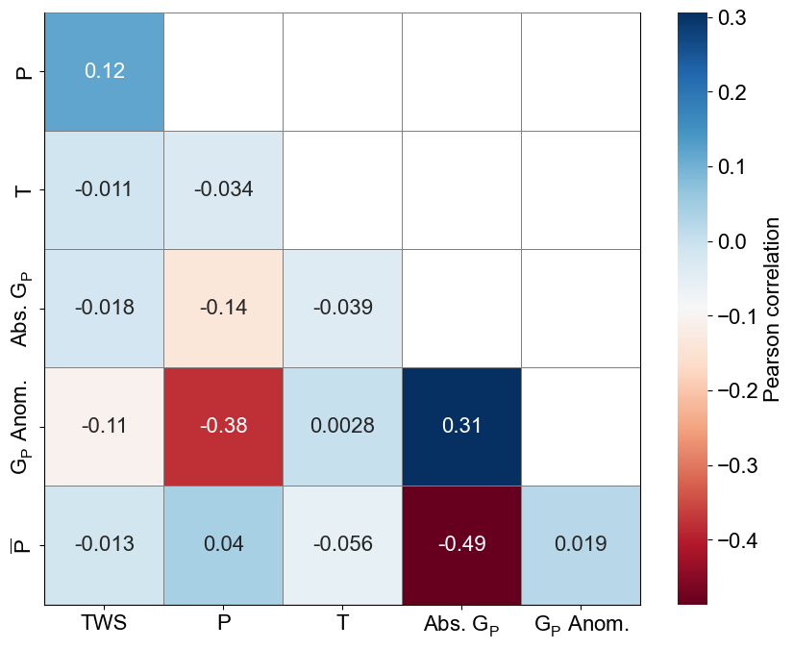

Supplementary Figure 10: Correlation among hydroclimate drivers of terrestrial water storage variability. Pairwise Pearson correlation among the hydroclimate predictors and TWS. All variables except absolute G_{P} and climatological mean precipitation (P̄) are in terms of detrended anomalies, and the correlation is calculated for pooled grid points over space and time.

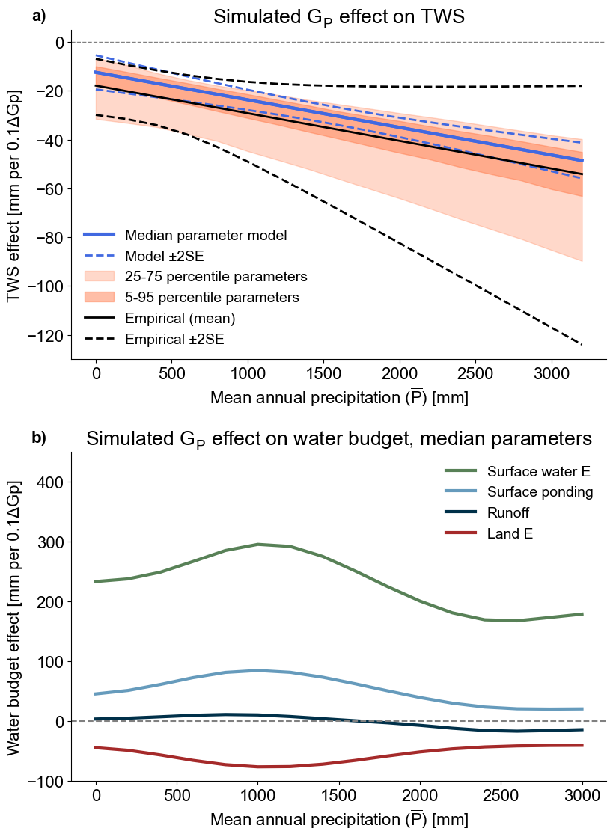

Supplementary Figure Supplementary 11: Idealized land-surface simulation of the consolidation effect on terrestrial water storage with bulk temperature homogenization. Same as Figure 4, but for a model in which evaporation from the surface water stock influences surface air temperatures (i.e., temperatures are instantaneously homogenized across the model).

Supplementary Table 1: Details of and access URLs for datasets used in the study.
Supplementary Table 2: Regression coefficients relating TWS to its hydroclimate drivers.

Supplementary Table 3: Parameters, geometry, and physical constants used in the Simple Energy-Moisture Balance Model with Hydrology, including sensitivity range for key free parameters.
Supplementary Table 4: Models from the Coupled Model Intercomparison Project, Phase 6, used for warming pattern projections.

