Supporting information
A High-Thermal-Insulation and Portable Microreactor for Integrating Widely Used Planar-Type SOFC and Enabling Handheld Power Generation
Bishnu Choudhary ¹, Gia Ginelle Carandang¹, Shinichi Yamagishi ², Saki Tada ², Chie Kawamura ², Yasuko Yanagida¹, Tetsuya Yamada *^{,1}
¹ Laboratory for Future Interdisciplinary Research of Science and Technology, Institute of Integrated research, Institute of Science Tokyo, 4259 Nagatsuta, Midori, Yokohama, Kanagawa 226-8503, Japan
² Materials Research and Development Department, Research and Development laboratory, TAIYO YUDEN CO., LTD., 5607-2, Nakamuroda-machi, Takasaki-shi, Gunma 370-3347, Japan
* Corresponding Author: Dr. Tetsuya Yamada (Email: yamada.t.ap@m.titech.ac.jp)

Fig. S1. Schematic diagram of boundary conditions in a heat exchange simulation.

Table T1. Heat exchange simulation conditions.
Density | 2.520e⁻⁶ $kg/{mm}^{3}$
Young’s module | 66.90 GPa
Poisson’s ratio | 0.29
Yield strength | 94 MPa
Maximum tensile stress | 345.00 MPa
Thermal conductivity | 1.46 $W/m℃$
Coefficient of linier expansion | 1.23e-5 $/℃$
Specific heat | 0.79 kJ$/kg℃$

Table T2. Heat exchange simulation conditions.
Materials
Simple fuel cell | Alumina
Fluid | Hydrogen
Boundary conditions
Simplified fuel cell surface temperature | 800℃
Supply and exhaust port temperature | 20℃
Supply flow velocity | 5m/s
Exhaust port pressure | Atmospheric pressure
Convergence condition
Instantaneous convergence curve slope | 0.0001
Time-averaged convergence rate of change | 0.01
Time-averaged rise curve | 0.01
Variation of analysis value | 1e-5

Fig. S2. Results of heat exchange simulation. (a) One bridge structure with the 0.5 mm distance between the supply port and exhaust port. (b) Ends supported beam structure. The supply and exhaust ports are independent and are part of both ends supported beam. (c) When supply and exhaust ports are independent. Black arrows indicate inlet flow. Red arrows indicate outlet flow.

Fig. S3. Results of exhaust temperature at different fuel supply and exhaust outlets. The distance between supply and exhaust port are change using one bridge structure. End supported beam structure and independent structure are corresponding to Fig. S2(b) and (c).

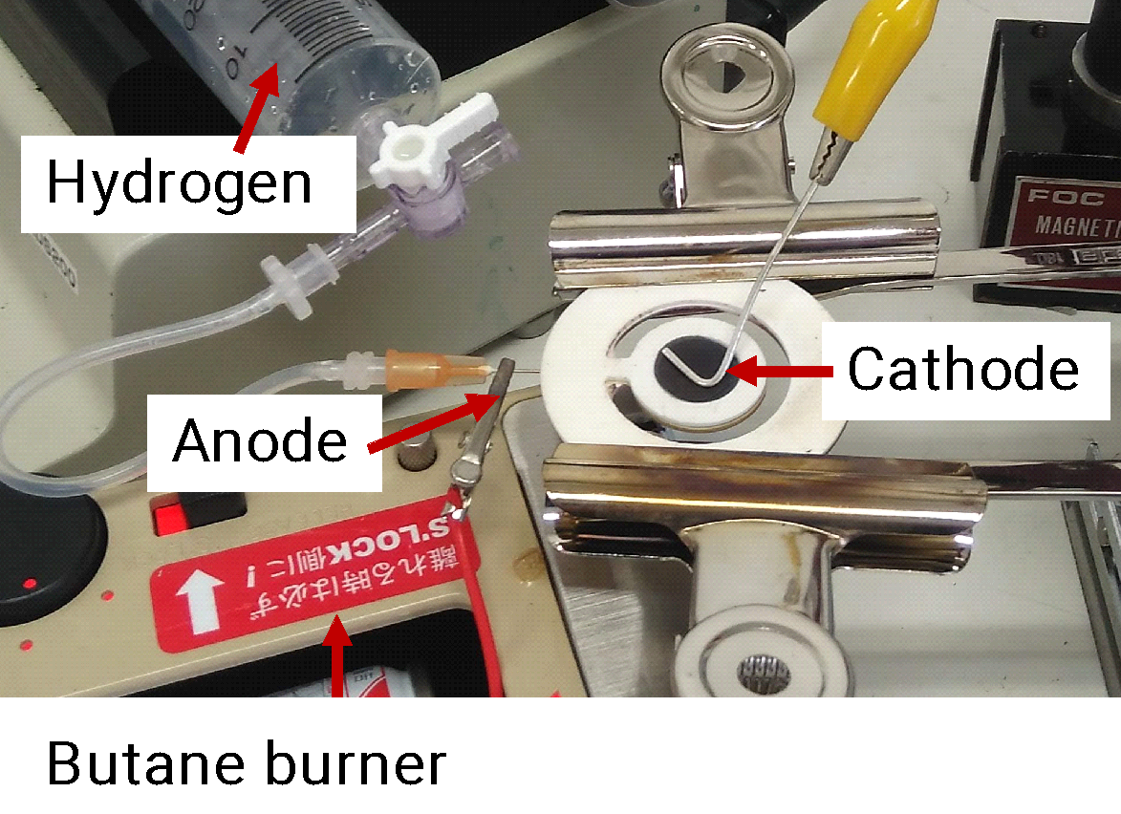
Fig. S4. Experimental setup to measure OCV using glass ceramic reactor.

The simulation is a steady-state model, enabling gravity and energy-based for conjugate conduction, convection, and radiation comprising fluid (air or Krypton gas) and wall materials. The parametric and experimental design of the thermal insulation box was conducted and investigated through the main modes of heat transfer:

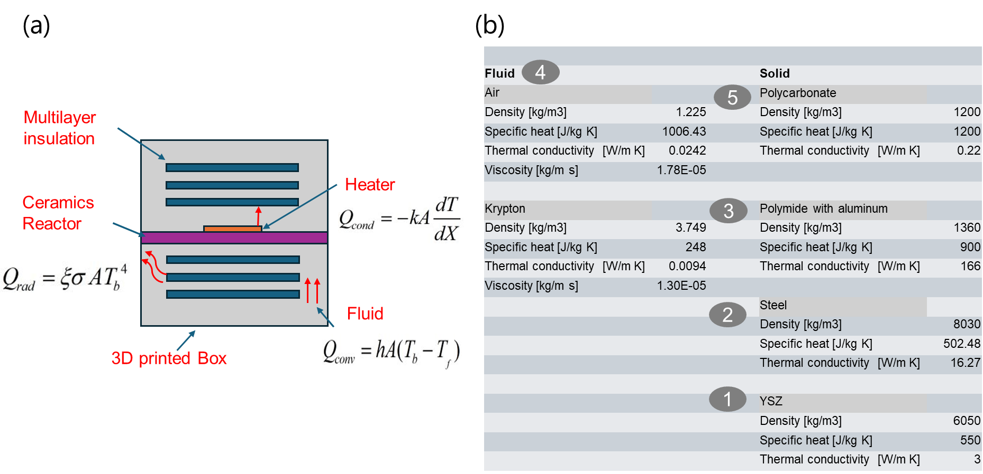
Fig. S5. (a) Schematic of Multilayer insulation (MLI) systems along with heater and ceramic reactor and, (b) database of materials properties for simulation.
YSZ is the ceramic reactor, steel is heater, polyimide was utilized as organic multilayer mirrors, polycarbonate materials were used to print the 3D printed box, and air/krypton gas as fluid was used.
- Conduction: designing heater location and size, ceramics thickness
- Convection: supplying of inside gas (air and Krypton)
- Radiation: multilayer mirror insulations and mirror supports
The heater power was set using heat flux conditions dependent on the heater area. As for the radiation, surface-to-surface radiation was used for assumption and mirror modeling. The solution model uses a SIMPLE scheme, second-order upwind, and default values of solution controls with hybrid initialization. Furthermore, the improvement in the accuracy of the simulation model could be verified through the mesh dependency/sensitivity method along with the comparison of the experimental results.
The proposed SOFC insulation thermal box design [dimension of about 25mm (w) x 30mm (l) x 20mm (h)] comprises (a) upper and bottom cover box lids and inside the box components were (b) multilayer mirrors, (c) mirror supports, (d) 0.3 mm thick YSZ ceramics, and (e) steel heater has been so far established achieving up to 650C (inside box temperature) at set 10W heater power. The thermal insulation testing was conducted using inside and outside box components (a-e), (f) DC power source (g) thermocouple and (h) IR thermal camera.
During experimental box testing, the DC power source attached to the steel heater placed in YSZ ceramics was increased automatically through the ramp feature of the power source recorded along with the inside temperature of the insulation box through the attached thermocouple logger.
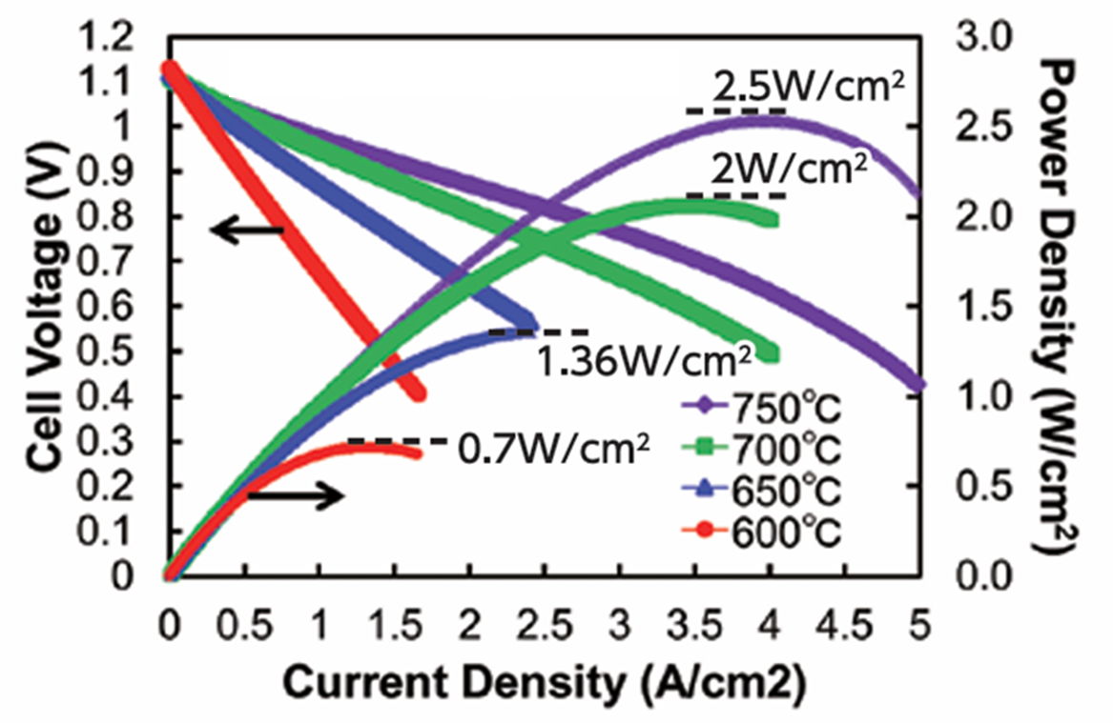
Fig. S6. I-V-P curve of TAIYO YUDEN metal supported SOFC tested in conventional test setup

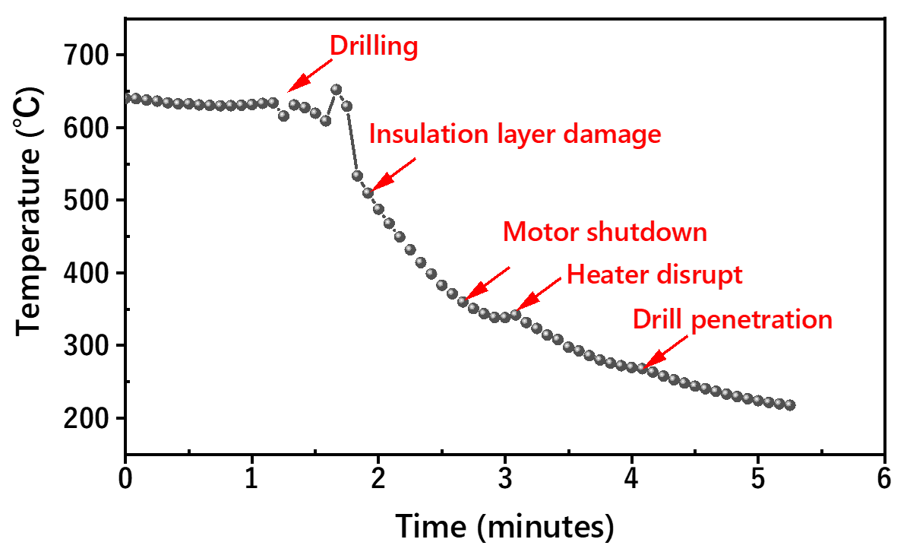
Fig. S7. Temperature profile of the SOFC assembly during the event of drilling

