Appendix

Figure S1. Monthly within-district and across-district mobility flows by Seoul gu, January 2020 – December 2022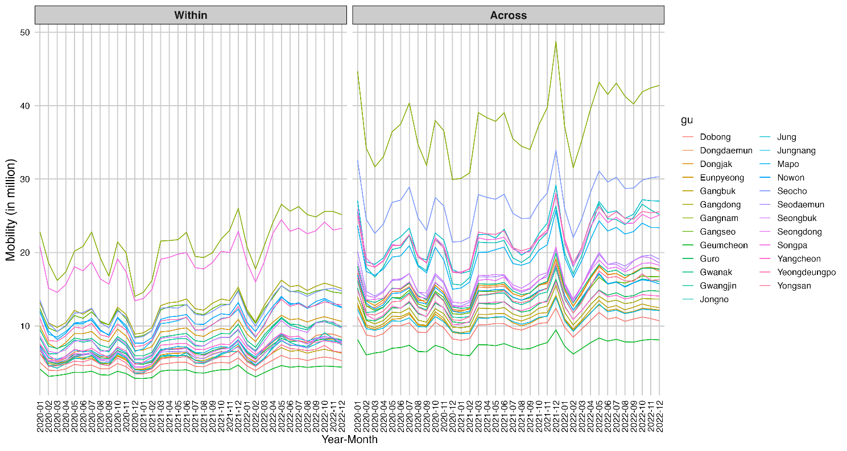
Figure S1 demonstrates descriptive analysis results of monthly mobility patterns “Within” districts (left panel) and “Across” districts (right panel) among 25 districts in Seoul from 2020 to 2022. The "Within" graph (left panel) shows relatively stable but modest mobility levels throughout this period, typically ranging between 5-25 million movements. Gangnam district consistently shows the highest within-district mobility (peaking around 25 million), followed by Songpa, while most other districts maintain lower, more consistent patterns. There are visible seasonal fluctuations across all districts, with a steep decline visible in early and end of 2020 and early 2022, likely related to pandemic restrictions. Beginning in March 2022, after large-scale vaccination, mobility levels plateaued at elevated levels across most districts. On the other hand, the "Across" graph (right panel) displays substantially higher overall mobility between districts compared to within-district movement. Notably, cross-district mobility surged in late 2021—after social-distancing rules were lifted in November amid broad vaccine coverage—rising to roughly two to three times the volume of within-district travel.. Gangnam again leads with the highest between-district mobility (reaching nearly 50 million at its peak), followed by Seocho and several other districts in the 20-30 million range. The across-district mobility also demonstrates more pronounced fluctuations and greater variability between high and low periods, suggesting stronger responses to external factors like pandemic measures or seasonal changes. Comparing the two mobility patterns and scale, within-district mobility remained relatively stable throughout the period, while across-district mobility experienced more dramatic changes and consistently higher volumes. This suggests people were more likely to travel between districts than within them, possibly reflecting commuting patterns where people live in one district but work in another. The highest mobility districts (particularly Gangnam) maintain their leadership position in both graphs, indicating their consistent importance as centers of activity regardless of movement type.

The mobility level (as shown Figure S1) shows how much movement occurred, whereas mobility-weighted density (as shown Table 1) shows how intense or saturated that movement is relative to the network’s capacity (number of all possible edges; origin-destination pairs within / across dongs)—allowing fairer comparisons across places or time periods with different structural characteristics. Therefore, Figure S1 plots raw trip volumes, so across-district travel appears dominant simply because many more journeys cross gu boundaries than stay inside them. Table 1, however, divides those trips by the number of potential origin-destination pairs: there are 425 × 425 = 179,776 possible across-dong links, whereas each gu has far fewer internal links (only the pairs of dongs within that district e.g. 27 dongs × 27 dongs = 729 in Songpa gu ). Once this denominator is applied, the within-gu network shows the higher weighted density, meaning that the smaller web of local streets and bus routes is, on average, more heavily used than the large web of routes (arterial roads, subway and commuter-rail lines, and major bus links) that connect one dong to another across Seoul. In other words, cross-gu mobility moves larger absolute numbers of people, but those flows are spread over hundreds of routes, while neighbourhood trips are funnelled through a tight set of links that become proportionally more saturated. The implication is two-fold: congestion, crowding, and short-range transmission risks are most acute inside districts despite their lower headline volumes, whereas long-range connectivity (and the seeding of infections into new areas) is driven by the larger—but per-link thinner—across-gu flows. Policies therefore need a dual focus: micro-level measures to relieve or manage the densely loaded local network, and targeted interventions on key inter-district corridors that act as gateways for wider spatial spread.
Figure S2. Seoul district reference map and Infomap-derived mobility communities in 2020, 2021, and 2022
- Map of Seoul’s 25 districts with labeled names | - 10 communities in 2020
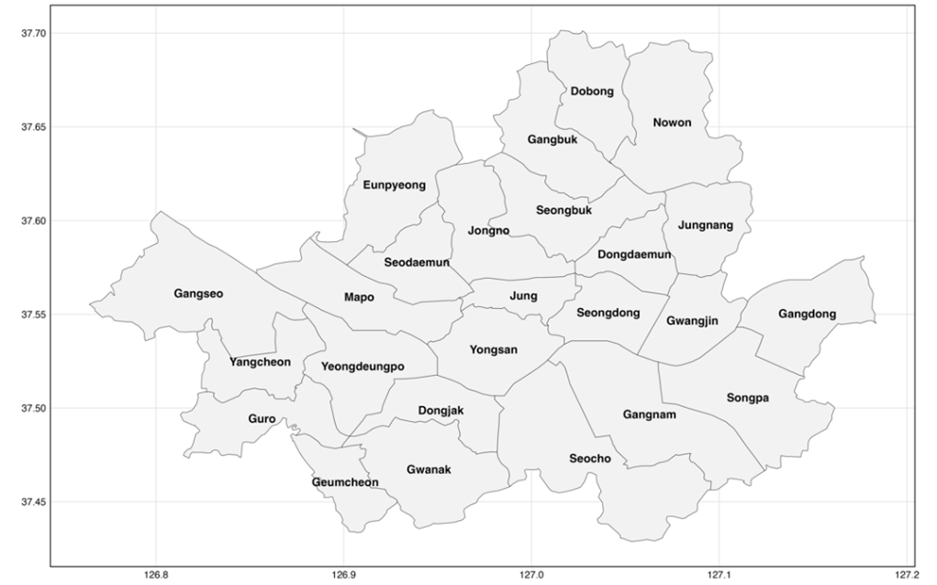 | 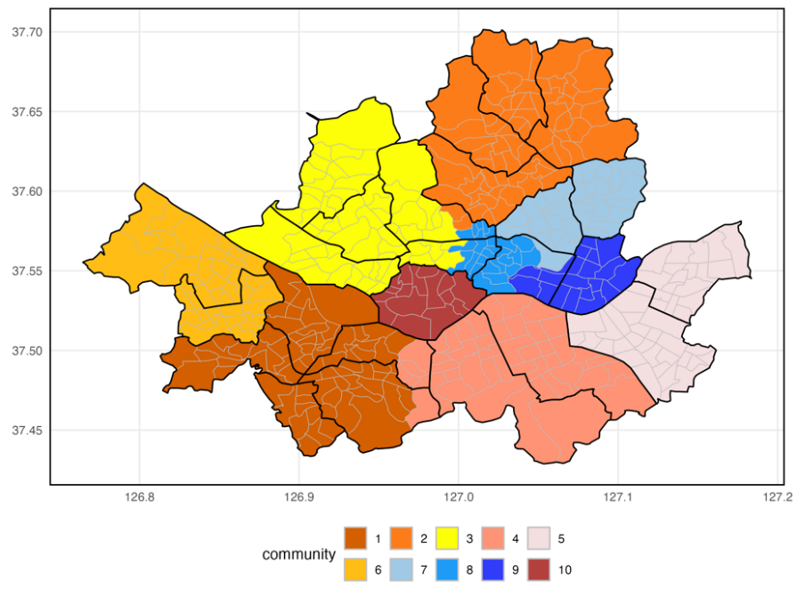
- 11 communities in 2021 | - 12 communities in 2022
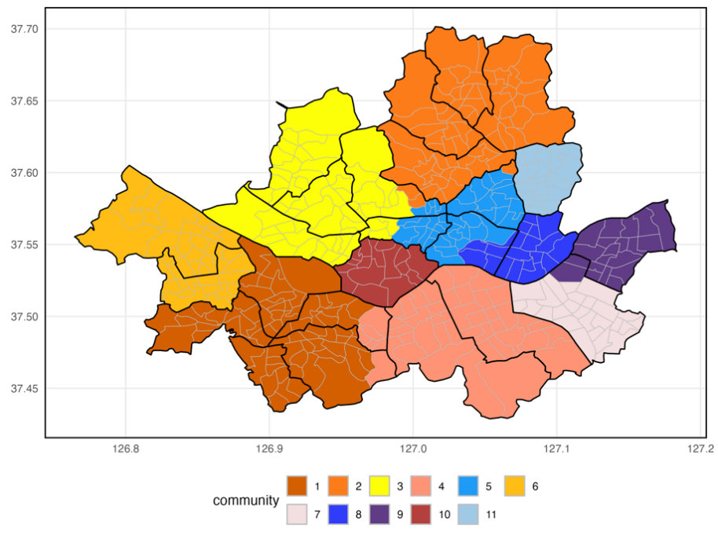 | 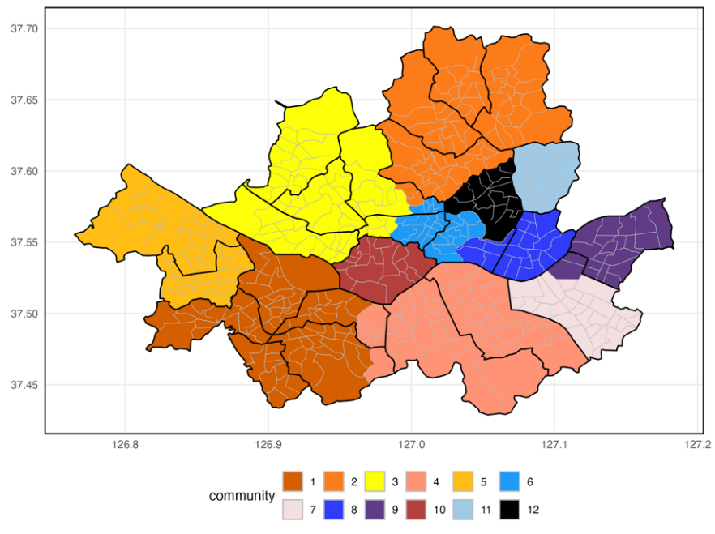
Note: The communities were ordered based on the number of dongs; however, to enhance comparability, the color assignments were slightly adjusted to ensure consistent coloring for corresponding regions.
Over the three years, Seoul’s mobility network remained organized around a handful of stable “macro-blocks” but became progressively more fragmented at the margins. In 2020 the Infomap algorithm grouped the city’s 25 districts into 10 communities: a large south-western block (Guro–Geumcheon–Yeongdeungpo–Guemchun-Gwanak; Gangseo-Yangcheon), an adjoining south-eastern block centered on Gangnam–Seocho, a central block on Yongsan, a cohesive north-western cluster (Mapo–Eunpyeong–Seodaemun-Jongno), and a contiguous band of northern residential districts (Nowon-Dogong-Gangbuk-Seongbuk). By 2021 the number of communities rose to 11. Most of the large 2020 blocks persisted, but two changes stand out: (i) the north-eastern wing (Jungrang, Dongdaemun, Gwangjin) peeled away from the northern belt to form its own cluster. In 2022 the network further divided into 12 communities. The Junggu-Seongdong-Dongdaemun cluster split, with Dongdaemun forming an independent unit—signalling increasingly localised travel patterns even as overall mobility volumes rebounded. Despite this finer segmentation (from 10 to 12) with increasing mobility trends in general, the major north–south dichotomy across the Han River and the overall stability of most community boundaries that transcend administrative boundaries across the three years suggest persistent mobility patterns and stable functional relationships.
Table S1. Demographic, economic, and mobility profiles of the 11 detected mobility communities in Seoul (2020–2022)

Community  (2020-2022) | Number of dongs | Average mobility 2020-2022 (%) | Total population  in 2020¹ | Total number of businesses in 2020² | Total number of National Basic Livelihood Security beneficiaries in 2020  (Per Capita%)³
C-1 | 73 | 15.78 | 1,830,312 | 230,233 | 70,720 (3.86%)
C-2 | 68 | 13.76 | 1,611,090 | 125,945 | 87,742 (5.45%)
C-3 | 61 | 16.52 | 1,291,134 | 142,263 | 50,454 (3.91%)
C-4 | 46 | 16.41 | 1,080,109 | 187,113 | 26,425 (2.45%)
C-5 | 41 | 7.93 | 724,592 | 80,767 | 30,633 (4.23%)
C-6 | 38 | 7.68 | 1,030,862 | 97,434 | 48,678 (4.72%)
C-7 | 25 | 6.56 | 628,791 | 72,046 | 16,707 (2.66%)
C-8 | 20 | 4.68 | 422,540 | 54,314 | 15,927 (3.77%)
C-9 | 20 | 4.83 | 494,166 | 45,971 | 18,088 (3.66%)
C-10 | 16 | 2.96 | 238,405 | 9,929 | 8,833 (3.71%)
C-11 | 16 | 2.89 | 393,862 | 40,320 | 27,462 (6.97%)
Note: The per capita % of National Basic Livelihood Security beneficiaries was calculated by the total number of National Basic Livelihood Security beneficiaries divided by the total population. Mobility (%) represents the proportion of total mobility associated with each community.

Based on Table S1, there are clear patterns in the community-level statistics across Seoul. The largest communities (C-1 through C-4) account for about 62 % of all movements, mirroring their share of businesses (~ 63 %) and population (~ 60 %). They also post the highest average-mobility percentages (15-17 %), indicating the close link between economic activity and movement. On the other hand, communities with ≤ 25 dongs (C-7 to C-11) each generate ≤ 6.6 % of total mobility and hold modest business counts (< 75,000). A notable inverse relationship appears between community size and poverty rates—the smallest community (C-11) has the highest percentage of National Basic Livelihood Security beneficiaries at nearly 7%, while larger communities like C-4 have much lower rates (2.45%). Communities with fewer businesses relative to their population (like C-2) tend to have higher poverty rates (5.45%), suggesting economic opportunity disparities.
Mobility shares plunge to below 8 % in the smaller, largely residential communities (C-5–C-11)—less than half the leading clusters—underscoring that workplace concentration, not population size, is the main driver of community-level movement.

Figure S3. Location of the top and bottom 10 subdistricts (“dongs”) in Seoul ranked by Weighted PageRank
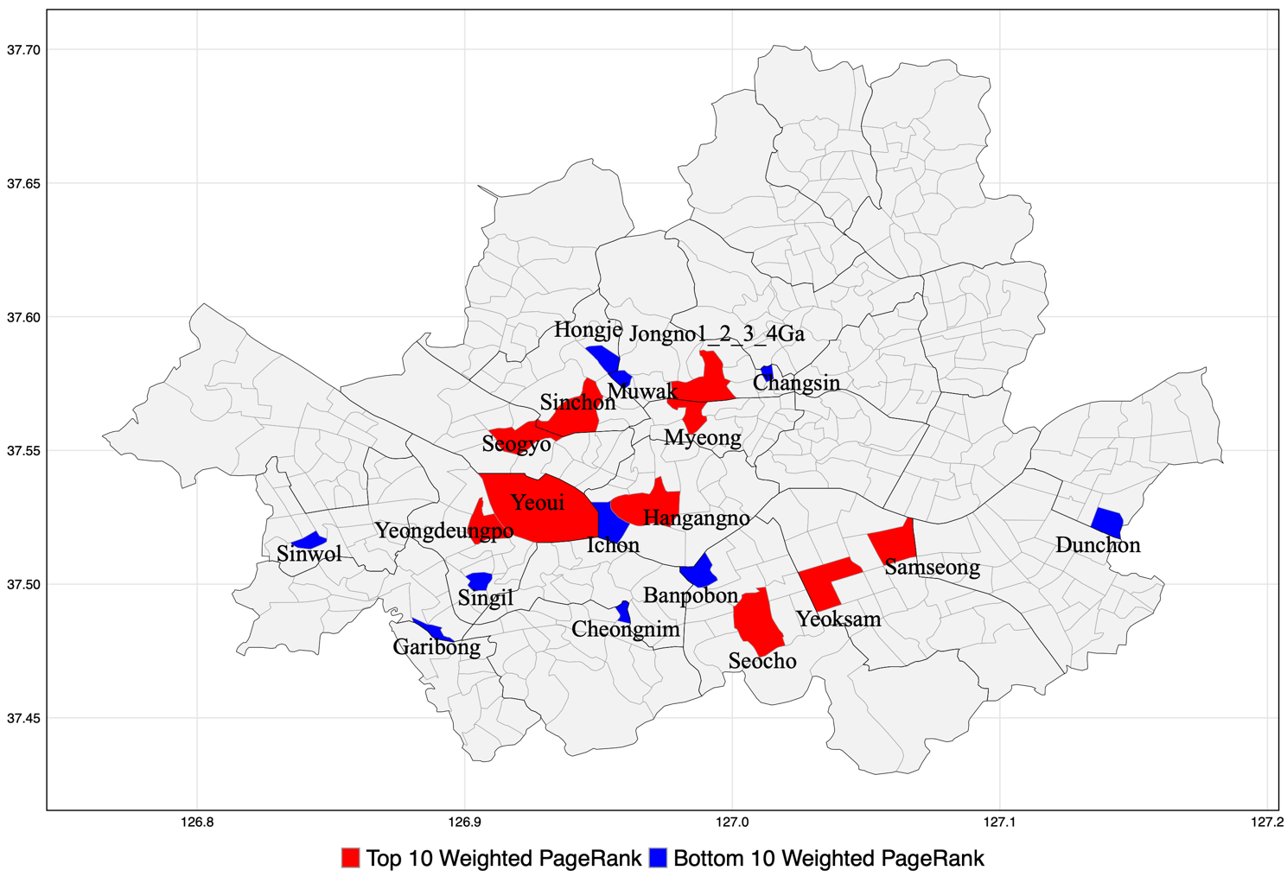

The weighted-PageRank analysis indicates the location of the top and bottom 10 subdistricts (“dongs”) : red-shaded top-10 dongs cluster around the historic downtown (Jongno-Myeong), the Han-river business core (Yeouido), and the Seocho-Yeoksam-Samseong commercial strip, highlighting their role as the city’s most influential transfer nodes. In contrast, the blue bottom-10 dongs, located in western Sinwol and Garibong, south-eastern Dunchon, and a handful of low-density neighbourhoods north of the river, reflect their peripheral, predominantly residential character.

Figure S4. Spatial distribution of COVID-19 incidence and key socioeconomic indicators across Seoul (2020–2022)

A. COVID-19 incidence in 2020 by gu | B. COVID-19 incidence in 2021 by gu | C. COVID-19 incidence in 2022 by gu
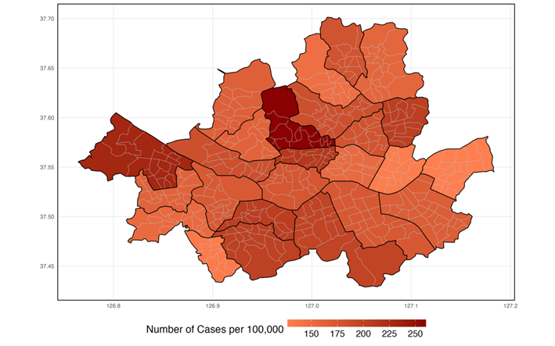 | 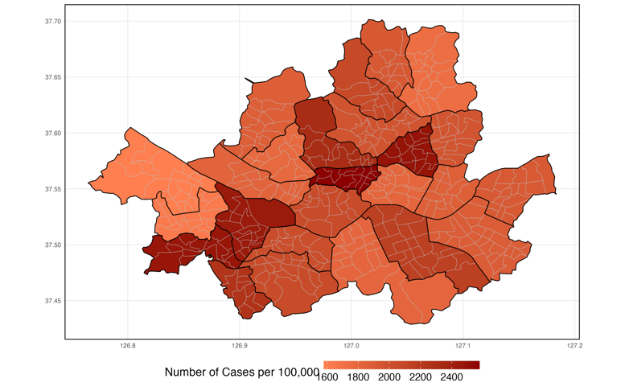 | 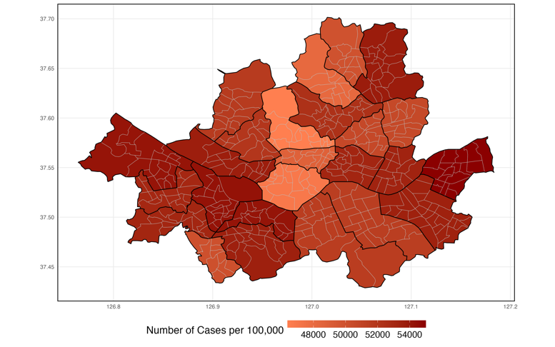
D. Number of population (in thousands) in 2020 by dong | E. National Basic Livelihood Security beneficiaries per capita (%) in 2020 by dong | F. Number of businesses (in thousands) in 2020 by dong
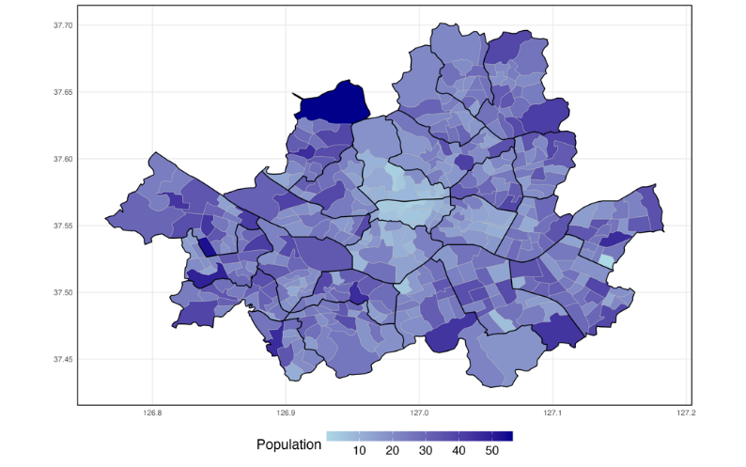 | 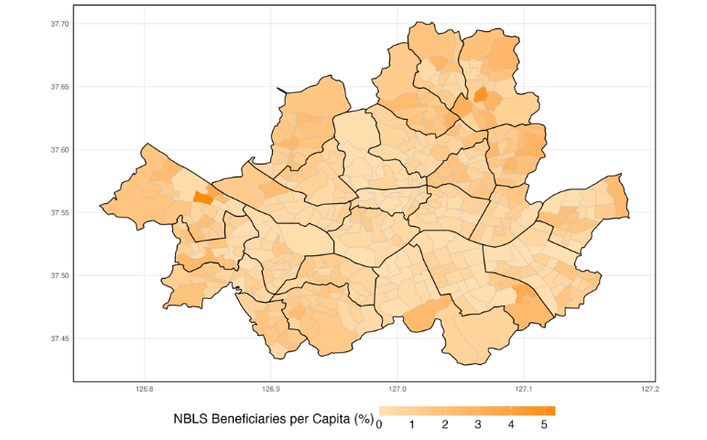 | 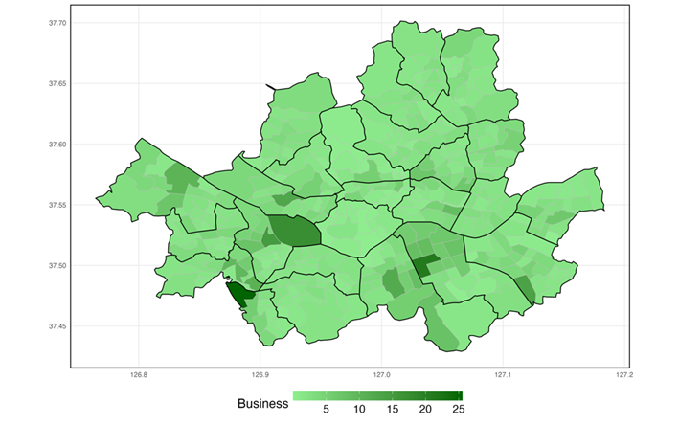
Note: Number of confirmed cases data is only available in gu level, not dong level. Incidence percentage is calculated by the number of confirmed COVID-19 cases⁴ divided by the total population within each gu. The distributions of population, poverty, and business across districts remained generally consistent throughout the period from 2020 to 2022.

Early transmission (2020) was concentrated in the historic-commercial core—Jongno, Jung, Yongsan—and along the Gangnam corridor. These districts sit almost entirely within the four largest mobility communities (C-1–C-4), which capture ~62 % of all trips and host the densest business clusters. Heavy daytime inflow, extensive inter-community links, and low poverty made them “super-receivers,” where crowding in offices, transit, and service venues—not deprivation—amplified spread. By 2021, incidence still peaked in the core but began radiating southwest (Guro, Geumcheon) and northeast (Nowon) along high-betweenness corridors that bridge the large hubs to smaller, more residential communities (C-5, C-6, C-9). These peripheral, industrial gu combine moderate incomes with limited tele-work capacity, sustaining exposure despite partial vaccination.
With Omicron’s arrival in 2022 and >95 % mobility restored, incidence became diffuse, and several outer-ring districts surpassed the city center. Residual susceptibles were clustered in highly residential, lower-mobility communities (C-5–C-11, each < 8 % of total trips) where higher poverty or dense housing favored within-community spread once seeding occurred. The shifting pattern implies phased, cluster-specific control: aggressive testing, ventilation, and commuter screening in early-wave mobility hubs; then mobile clinics, vaccination drives, and social-support measures in outer residential clusters as the epidemic migrates. Network analytics pinpoint high-betweenness “bridge” dongs and commuter corridors—leverage points where targeted restrictions or surveillance yield greater impact than blanket city-wide measures—allowing planners to anticipate rather than merely react to evolving hotspots. By marrying who moves where (network analytics) with who is vulnerable (socio-economic maps), city planners can anticipate—and not merely react to—the shifting geography of COVID-19 and future respiratory epidemics.

References

1 Seoul Metropolitan City_Resident Registration Population (by District) Statistics_20210331 | Public Data Portal. https://www.data.go.kr/data/15046941/fileData.do?recommendDataYn=Y (accessed April 25, 2025).
2 Seoul City Business Status (by Industry Category/Dong) Statistics > Dataset > Public Data | Seoul Open Data Plaza. https://data.seoul.go.kr/dataList/104/S/2/datasetView.do (accessed April 25, 2025).
3 Seoul Metropolitan City_National Basic Livelihood Security Beneficiaries by Gender by District_20221231 | Public Data Portal. https://www.data.go.kr/data/15124215/fileData.do?recommendDataYn=Y (accessed April 25, 2025).
4 Status of confirmed cases and deaths by autonomous district of Seoul City due to COVID-19. https://data.seoul.go.kr (accessed April 25, 2025).

