Supplementary Data
Figure S1: Infusion of sNK cells restored IFN-γ secretion and NK cell-mediated cytotoxic function in the peripheral blood of melanoma tumor-bearing hu-BLT mice
Hu-BLT were implanted with melanoma tumors and injected with NK cells as described in the main file, Figure 1. Following sacrifice, peripheral blood was collected, single cell suspensions were prepared, and were treated with IL-2 (1000 U/ml) and cultured for 7 days, after which the supernatants were harvested and the levels of IFN-γ were determined using specific ELISAs (n=3) (A). Peripheral blood-derived single cell suspensions were treated with IL-2 (1000 U/ml) and were cultured for 7 days, and cytotoxicity assays were performed using a standard 4-hour ⁵¹Cr release assay against OSCSCs, and the LU 30/10⁶ cells were determined using an inverse number of cells required to lyse 30% of OSCSCs x100 (n=2) (B).
Figure S2. Infusion of sNK cells restored IFN-γ secretion in the spleen-derived T cells of melanoma tumor-bearing hu-BLT mice
Hu-BLT were implanted with melanoma tumors and injected with NK cells as described in main file, Figure 1. Following sacrifice, the spleen was collected, single cell suspensions were prepared, and T cells were purified. Spleen-derived T cells were treated with IL-2 (100 U/ml) and were cultured for 7 days, after which the supernatants were harvested and the levels of IFN-γ were determined using specific ELISAs (n=3).

Figure S1 PBMCs
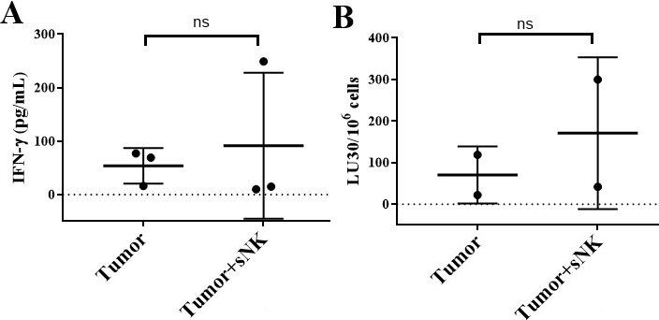
Figure S2 T cells
