The Effect of Plasma-Polymerized Cerium-Doped Hexamethyldisiloxane Film Thickness on Corrosion Protection of L-PBF AlSi10Mg

Mirjam Spuller ¹, Nina Kovač ^{2,3}, Peter Rodič ², Simon Chwatal ¹, Mattia Cabrioli ⁴, Matteo Vanazzi ⁴, Giorgio De Pasquale ⁵, Juergen M. Lackner ¹, Reinhard Kaindl ¹, Wolfgang Waldhauser ¹

¹ Joanneum Research Forschungsgesellschaft mbH, Materials – Institute of Sensors, Photonics and Manufacturing Technologies, Leobner Str. 94a, 8712 Niklasdorf, Austria
² Jožef Stefan Institute, Department of Physical and Organic Chemistry, Jamova c. 39, 1000 Ljubljana, Slovenia
³ Jožef Stefan International Postgraduate School, 1000 Ljubljana, Slovenia
⁴ f3nice, Via Roccoli 252, 23010 Piantedo, Italy
⁵ Politecnico di Torino, Smart Structures and Systems Lab, Corso Duca degli Abruzzi 24, 10129 Torino, Italy

✉ Mirjam Spuller
mirjam.spuller@joanneum.at

Average roughness values of the initial AlSi10Mg substrate
Table S1 Average roughness values determined from optical profilometry (5 line measurements over 4.8 mm each)
Parameter | Average / µm | Deviation / µm
R_{a} | 0.198 | 0.008
R_{q} | 0.259 | 0.004
R_{z} (DIN) | 2.119 | 0.263
R_{z}(ISO) | 2.209 | 0.265
R_{max} | 2.876 | 0.903
R_{p} | 1.703 | 0.776
R_{v} | 1.367 | 0.205
R_{t} | 3.070 | 0.888
R_{sk} | 0.144 | 0.539
R_{ku} | 7.099 | 5.871
R_{Pc} | 74.500 | 8.718
R_{k} | 0.602 | 0.029
R_{pk} | 0.284 | 0.019
R_{vk} | 0.302 | 0.015
M_{r1} | 9.734 | 0.817
M_{r2} | 88.599 | 0.405

FTIR spectra of all samples

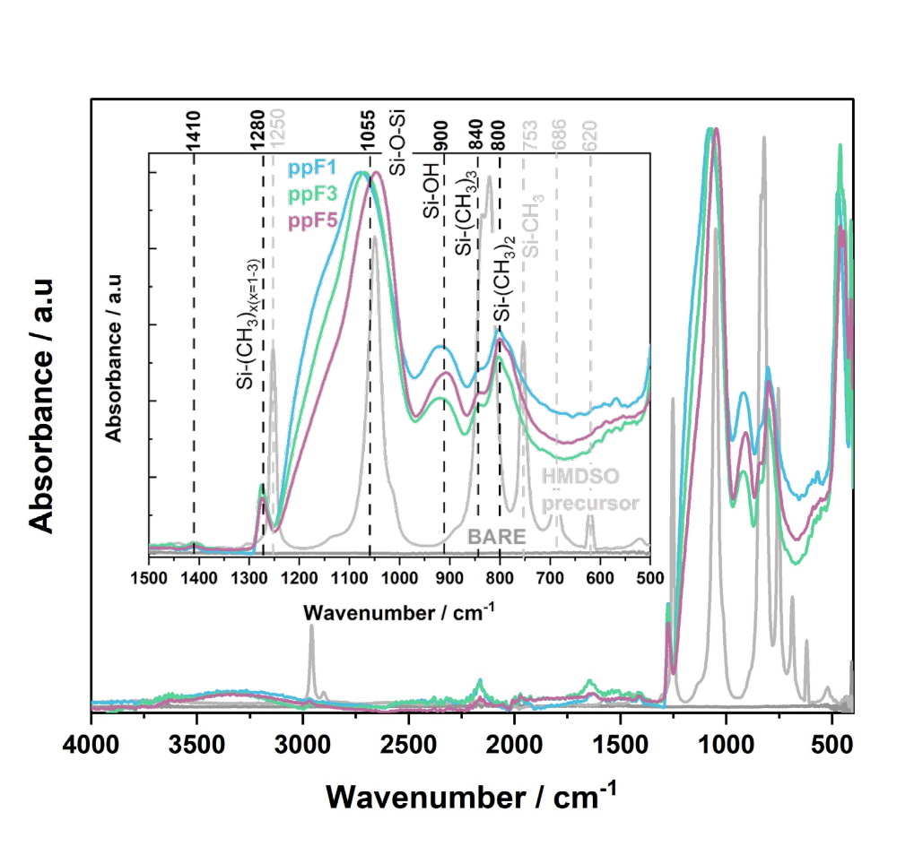
Fig. S1 FTIR spectra of all ppHMDSO films: ppF1 (1 deposition cycle), ppF3 (3 deposition cycles) and ppF5 (5 deposition cycles). The spectra of the AlSi10Mg sample without film (BARE) and the liquid HMDSO precursor are also shown for comparison

Aerosol-assisted APPD setup for film deposition
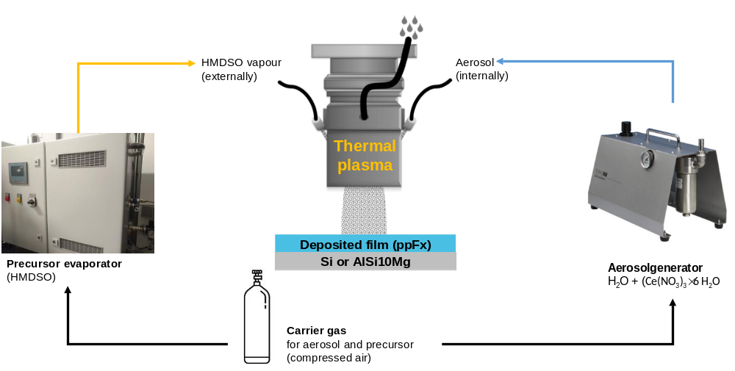
Fig. S2 Schematic representation of the aerosol-assisted APPD setup with the moveable thermal plasma source, the HMDSO evaporator, and the aerosol generator

Corrosion cell for potentiodynamic polarization measurements
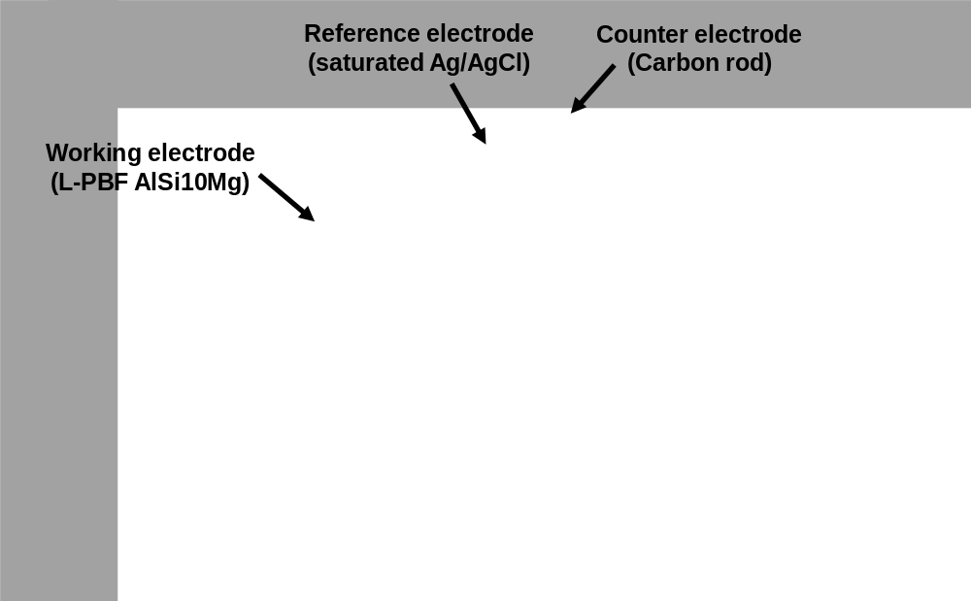
Fig. S3 Press-fit corrosion cell with a three-electrode setup (K0235 Flat Cell Kit, Ametek) used in the study for electrochemical measurements

