Appendix
Appendix 1: JBI Critical Appraisal Checklist for Randomized Controlled Trials


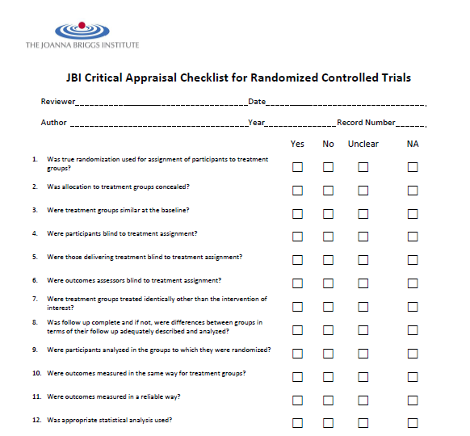

Topic | Virtual Reality for pain management in palliative care or cancer patients
Reference Manager | RefWorks, Covidence
Timeline
Restrictions or Limitations
Key Articles
Databases | PubMed, CINAHL, Embase, Cochrane, Web of Science, Scopus, Compendex
Date Run | Jan 29, 2024
Total Number of Results | 444
Number of Duplicates Removed
Remaining Number of Results

PubMed
Search number | Query | Results
5 | #1 AND #2 AND (#3 OR #4) | 51
4 | neoplasms [mesh] OR neoplasm* [tiab] OR cancer* [tiab] OR tumor* [tiab] OR tumour* [tiab] OR sarcoma* [tiab] OR carcinoma* [tiab] OR oncolog* [tiab] | 5,063,332
3 | "Hospice and Palliative Care Nursing"[Mesh] OR "Palliative Medicine"[Mesh] OR "Palliative Care"[Mesh] OR "Hospice Care"[Mesh] OR "Terminal Care"[Mesh] OR "Hospices"[Mesh] OR palliat* [tiab] OR hospice* [tiab] OR "terminal care" [tiab:~3] OR "end of life care" [tiab:~3] OR "terminal illness" [tiab:~2] OR "terminally ill" [tiab:~2] | 168,838
2 | "pain management" [mesh] OR analgesia [mesh] OR "pain management" [tiab:~3] OR "managing pain" [tiab:~3] OR analgesia* [tiab] | 162,283
1 | "virtual reality" [mesh] OR "virtual reality" [tiab:~3] OR "vr" [tiab] OR "virtual technology" [tiab:~2] | 26,028

Embase
No. | Query | Results
#5 | #1 AND #2 AND (#3 OR #4) | 91
#4 | 'neoplasm'/exp OR neoplasm*:ti,ab,kw OR cancer*:ti,ab,kw OR tumor*:ti,ab,kw OR tumour*:ti,ab,kw OR sarcoma*:ti,ab,kw OR carcinoma*:ti,ab,kw OR oncolog*:ti,ab,kw | 7315012
#3 | 'palliative nursing'/exp OR 'palliative therapy'/exp OR 'hospice care'/exp OR 'terminal care'/exp OR 'hospice nursing'/exp OR 'hospice'/exp OR palliat*:ti,ab,kw OR hospice*:ti,ab,kw OR ((terminal* NEAR/3 (care OR ill OR illness)):ti,ab,kw) OR 'end of life':ti,ab,kw | 291630
#2 | 'analgesia'/exp OR ((pain NEAR/3 manag*):ti,ab,kw) OR analgesia*:ti,ab,kw | 281279
#1 | 'virtual reality'/exp OR ((virtual NEAR/3 (reality OR technology)):ti,ab,kw) OR vr:ti,ab,kw | 43787

CINAHL
# | Query | Limiters/Expanders | Last Run Via | Results
S5 | S1 AND S2 AND (S3 OR S4) | Expanders - Apply related words; Apply equivalent subjects  Search modes - Boolean/Phrase | Interface - EBSCOhost Research Databases  Search Screen - Advanced Search  Database - CINAHL Plus with Full Text | 31
S4 | (MH "Neoplasms+") OR TI (neoplasm* OR cancer* OR tumor* OR tumour* OR sarcoma* OR carcinoma* OR oncolog*) OR AB (neoplasm* OR cancer* OR tumor* OR tumour* OR sarcoma* OR carcinoma* OR oncolog*) | Expanders - Apply related words; Apply equivalent subjects  Search modes - Boolean/Phrase | Interface - EBSCOhost Research Databases  Search Screen - Advanced Search  Database - CINAHL Plus with Full Text | 905,927
S3 | (MH "Palliative Care Nursing") OR (MH "Palliative Care Nurses") OR (MH "Palliative Medicine") OR (MH "Hospice Nurses") OR (MH "Hospice Nursing") OR (MH "Hospices") OR (MH "Terminal Care+") OR (MH "Terminally Ill Patients+") OR TI (palliat* OR hospice* OR (terminal* N3 (care OR ill OR illness)) OR "end of life") OR AB (palliat* OR hospice* OR (terminal* N3 (care OR ill OR illness)) OR "end of life") | Expanders - Apply related words; Apply equivalent subjects  Search modes - Boolean/Phrase | Interface - EBSCOhost Research Databases  Search Screen - Advanced Search  Database - CINAHL Plus with Full Text | 105,483
S2 | (MH "Pain Management") OR (MH "Analgesia+") OR TI ((pain N3 manag*) OR analgesia*) OR AB ((pain N3 manag*) OR analgesia*) | Expanders - Apply related words; Apply equivalent subjects  Search modes - Boolean/Phrase | Interface - EBSCOhost Research Databases  Search Screen - Advanced Search  Database - CINAHL Plus with Full Text | 66,495
S1 | (MH "Virtual Reality+") OR TI ((virtual N3 (reality OR technology)) OR VR) OR AB ((virtual N3 (reality OR technology)) OR VR) | Expanders - Apply related words; Apply equivalent subjects  Search modes - Boolean/Phrase | Interface - EBSCOhost Research Databases  Search Screen - Advanced Search  Database - CINAHL Plus with Full Text | 13,392

Cochrane
Search Name: Virtual reality for pain management in palliative care or cancer patients
Date Run: 13/10/2023 03:15:19
Comment:

ID | Search | Hits
#1 | MeSH descriptor: [Virtual Reality] explode all trees | 1012
#2 | (virtual NEAR/3 (reality OR technology)) OR vr | 9054
#3 | #1 OR #2 | 9057
#4 | MeSH descriptor: [Pain Management] explode all trees | 5120
#5 | MeSH descriptor: [Analgesia] explode all trees | 11846
#6 | (pain NEAR/3 manag*) OR analgesia* | 67825
#7 | #4 OR #5 OR #6 | 69911
#8 | MeSH descriptor: [Palliative Care] explode all trees | 2277
#9 | MeSH descriptor: [Palliative Medicine] explode all trees | 4
#10 | MeSH descriptor: [Hospice and Palliative Care Nursing] explode all trees | 78
#11 | MeSH descriptor: [Hospice Care] explode all trees | 162
#12 | MeSH descriptor: [Terminal Care] explode all trees | 702
#13 | palliat* OR hospice* OR (terminal* NEAR/3 (care OR ill*)) OR "end of life" | 13764
#14 | MeSH descriptor: [Neoplasms] explode all trees | 112875
#15 | neoplasm* OR cancer* OR tumor* OR tumour* OR sarcoma* OR carcinoma* OR oncolog* | 282030
#16 | #8 OR #9 OR #10 OR #11 OR #12 OR #13 OR #14 OR #15 | 295805
#17 | #3 AND #7 AND #16 | 103

Web of Science
TS=((virtual NEAR/3 (reality OR technology) OR "VR")) AND TS=((pain NEAR/3 manag*) OR analgesia*) AND (TS=(palliat* OR hospice* OR (terminal* NEAR/3 (care OR ill OR illness)) OR "end of life") OR TS=(neoplasm* OR cancer* OR tumor* OR tumour* OR sarcoma* OR carcinoma* OR oncolog*))
Searched 10/12/2023
62 results

Scopus
TITLE-ABS-KEY ( ( virtual W/3 reality ) OR ( virtual W/3 technology ) OR vr ) AND TITLE-ABS-KEY ( ( pain W/3 manag* ) OR analgesia* ) AND ( TITLE-ABS-KEY ( palliat* OR hospice* OR ( terminal W/3 ill* ) OR ( terminal W/3 care ) OR "end of life" ) OR TITLE-ABS-KEY ( neoplasm* OR cancer* OR tumor* OR tumour* OR sarcoma* OR carcinoma* OR onolog* ) )
Searched 10/12/2023
94 results

Compendex
( ((((((({VIRTUAL REALITY}) WN CV)) OR (({Virtual reality}) WN CV)) OR (($virtual NEAR/3 $reality) WN KY)) OR (($virtual NEAR/3 $technology) WN KY)) OR (($vr) WN KY))) AND ( ((($pain NEAR/3 $manag) WN KY) OR (($analgesia) WN KY))) AND ( ((($palliat OR $hospice OR $terminal NEAR/3 $ill OR $terminal NEAR/3 $care OR {end of life}) WN KY) OR (($neoplasm OR $cancer OR $tumor OR $tumour OR $sarcoma OR $carcinoma OR $oncolog) WN KY)))
Searched 10/12/2023
12 records

