Cell tracking of adult neural stem cells from the subependymal zone in vitro reveals cell type-specific impact on cell cycle progression by the extracellular matrix molecule tenascin-C
Supplemental data
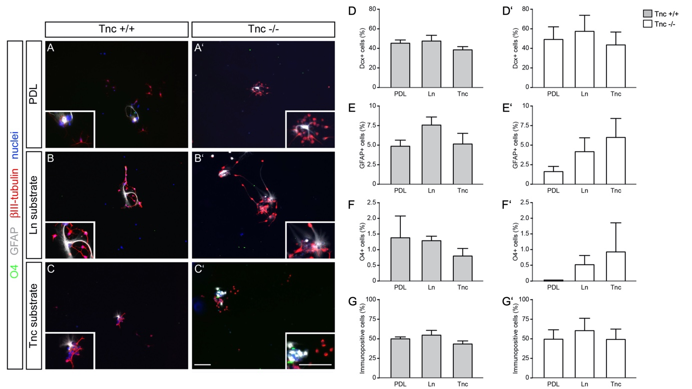
Figure S1. Differentiation assay of wildtype and Tnc-deficient aNSPCs cultures shows no alterations in cell fate. (A) Cells isolated from the lateral ventricular wall of 9 to 11-week old mice were prepared according to a protocol derived from published procedures [1], plated onto different substrates and cultivated for 7 days. Immunofluorescence staining was performed to analyze the proportions of doublecortin- (Dcx+), glial fibrillary acidic protein- (GFAP+) and sulfatide-positive (O4+) cells in cultures of both Tnc^{+/+} and Tnc^{-/-} genotypes. Scale bar: 200 µm. (D-G) Quantification of the cell types after 7 days in vitro indicates only minor effects of extracellular matrix substrates on aNSPC differentiation (N=5; PDL: n=2831, LN1: n=3563, Tnc: n=2027). (D, D’) The percentages of Dcx+ cells in wildtype and Tnc-knockout cultures from the SEZ did not differ between the three substrate conditions. Dcx+ neuroblasts represented the major cell type in these cultures after 7 days of differentiation. (E, E’) Evaluation of the astrocyte fraction in wildtype cultures using GFAP staining disclosed no significant changes. (F, F’) O4+ cells were rare after 7 days of differentiation, but modified neither by Tnc-depletion in the knockout, nor by distinct ECM substrates. (G, G’) Displays the fraction of cells immunopositive for any of the markers, that comprised nearly half of the cells examined. This proportion did not vary between the substrates tested. Data show mean ± s.e.m. Kruskal-Wallis test with Dunn’s multiple comparison were performed for statistical analysis.

Table S1. Cell cycle lengths of the proliferating population within the SEZ cultures in hours in vitro.
Genotype | Substrate | Gene-ration | Median | Mean | Upper quartile | lower quartile | n
Tnc +/+ | PDL | 1st | 9,67 | 12,93 | 18,25 | 5,75 | 171
Tnc +/+ | PDL | 2nd | 21,83 | 23,82 | 27,63 | 17,92 | 157
Tnc +/+ | PDL | 3rd | 17,17 | 19,12 | 19,80 | 15,25 | 81
Tnc +/+ | PDL | 4th | 25,33 | 22,67 | 27,38 | 16,67 | 21
Tnc +/+ | Laminin | 1st | 9,50 | 12,77 | 19,58 | 4,71 | 185
Tnc +/+ | Laminin | 2nd | 20,97 | 22,32 | 25,60 | 16,58 | 176
Tnc +/+ | Laminin | 3rd | 16,75 | 18,25 | 20,67 | 15,08 | 125
Tnc +/+ | Laminin | 4th | 17,00 | 18,13 | 20,08 | 15,25 | 57
Tnc +/+ | Tenascin-C | 1st | 10,83 | 13,82 | 20,33 | 4,38 | 141
Tnc +/+ | Tenascin-C | 2nd | 19,33 | 20,97 | 24,47 | 16,00 | 145
Tnc +/+ | Tenascin-C | 3rd | 16,58 | 17,85 | 19,67 | 15,08 | 67
Tnc +/+ | Tenascin-C | 4th | 16,25 | 18,32 | 22,50 | 15,67 | 7
Tnc -/- | PDL | 1st | 11,33 | 13,63 | 19,30 | 6,07 | 150
Tnc -/- | PDL | 2nd | 18,67 | 20,20 | 24,05 | 14,88 | 117
Tnc -/- | PDL | 3rd | 17,00 | 19,37 | 22,73 | 14,75 | 106
Tnc -/- | PDL | 4th | 18,25 | 19,00 | 21,93 | 14,75 | 54
Tnc -/- | Laminin | 1st | 12,17 | 14,33 | 20,58 | 5,08 | 107
Tnc -/- | Laminin | 2nd | 18,13 | 19,88 | 22,92 | 14,75 | 106
Tnc -/- | Laminin | 3rd | 16,25 | 16,70 | 18,42 | 13,67 | 79
Tnc -/- | Laminin | 4th | 15,00 | 15,45 | 16,55 | 13,63 | 29
Tnc -/- | Tenascin-C | 1st | 10,92 | 13,48 | 18,75 | 5,33 | 93
Tnc -/- | Tenascin-C | 2nd | 17,58 | 19,78 | 22,92 | 14,25 | 103
Tnc -/- | Tenascin-C | 3rd | 16,13 | 17,17 | 19,38 | 13,77 | 96
Tnc -/- | Tenascin-C | 4th | 15,75 | 18,00 | 17,25 | 13,92 | 52

Table S2. Cell cycle lengths of the slow-dividing aNSPC_{late} subpopulation in the SEZ cultures in hours in vitro.
Genotype | Substrate | Gene-ration | Median | Mean | Upper quartile | lower quartile | n
Tnc +/+ | PDL | 1st | 98,92 | 91,12 | 112,67 | 57,97 | 13
Tnc +/+ | PDL | 2nd | 16,80 | 17,33 | 20,00 | 14,54 | 10
Tnc +/+ | PDL | 3rd | 17,17 | 20,73 | 24,80 | 15,92 | 9
Tnc +/+ | PDL | 4th | 18,79 | 18,79 | 20,00 | 17,58 | 2
Tnc +/+ | Laminin | 1st | 73,58 | 80,97 | 100,73 | 68,00 | 18
Tnc +/+ | Laminin | 2nd | 17,50 | 18,55 | 21,32 | 16,00 | 24
Tnc +/+ | Laminin | 3rd | 16,46 | 16,68 | 18,83 | 14,96 | 32
Tnc +/+ | Laminin | 4th | 16,33 | 16,77 | 19,54 | 14,32 | 22
Tnc +/+ | Tenascin-C | 1st | 70,25 | 75,35 | 86,92 | 62,50 | 11
Tnc +/+ | Tenascin-C | 2nd | 19,17 | 19,18 | 21,67 | 15,92 | 27
Tnc +/+ | Tenascin-C | 3rd | 18,83 | 20,03 | 22,40 | 16,35 | 24
Tnc +/+ | Tenascin-C | 4th | 23,25 | 23,25 | 24,00 | 22,50 | 4
Tnc -/- | PDL | 1st | 78,92 | 82,17 | 90,02 | 72,83 | 12
Tnc -/- | PDL | 2nd | 13,92 | 14,41 | 15,50 | 12,46 | 20
Tnc -/- | PDL | 3rd | 15,92 | 17,27 | 18,58 | 14,08 | 37
Tnc -/- | PDL | 4th | 15,96 | 17,67 | 19,77 | 14,40 | 36
Tnc -/- | Laminin | 1st | 70,92 | 80,23 | 95,80 | 61,38 | 9
Tnc -/- | Laminin | 2nd | 14,04 | 14,63 | 17,08 | 12,25 | 14
Tnc -/- | Laminin | 3rd | 15,29 | 15,05 | 17,67 | 12,35 | 26
Tnc -/- | Laminin | 4th | 15,67 | 16,33 | 17,88 | 14,90 | 18
Tnc -/- | Tenascin-C | 1st | 95,75 | 101,25 | 120,58 | 85,38 | 9
Tnc -/- | Tenascin-C | 2nd | 15,17 | 15,35 | 17,18 | 13,67 | 16
Tnc -/- | Tenascin-C | 3rd | 14,67 | 14,88 | 15,75 | 13,50 | 23
Tnc -/- | Tenascin-C | 4th | 15,96 | 15,98 | 17,30 | 14,68 | 22

Table S3. List of primers used for RT-PCR
Primer | Sequence | Annealing Temp. | Accession  No. | Product size (bp)
β-actin forw.  β-actin rev. | TATGCCAACACAGTGCTGTCTGG  AGAAGCACTTGCGGTGCACGATG | 60°C | NM_007393.5 | 247
Ckap2l forw.  Ckap2l rev. | TGCGTTCTGCAAAAATCAAG  TGAGTCCTGGGAGCAGTCTT | 58°C | NM_181589.3 | 218
EGFR forw.  EGFR rev. | ACCCAACTGGGCACTTTTGA  TGTCACCACGTAGTTTCGGG | 58°C | NM_207655.2 | 792
Hes5 forw.  Hes5 rev. | AAGTACCGTGGCGGTGGAGAT  CGCTGGAAGTGGTAAAGCAGCTT | 60°C | NM_010419.4 | 354

Table S4. List of primary antibodies:
Antibody | Producer | Cat. No. | RRID/Reference
Mouse anti-a-tubulin | Sigma | T6199 | AB_477583
Mouse anti-GFAP | Sigma | G3893 | AB_477010
Rabbit anti-Sox2 | Millipore | AB5603 | AB_2286686
Rabbit anti-Notch1 | Cell Signaling | 3608S | AB_2153354
Rabbit anti-cleaved Notch1 | Cell Signaling | 4147S | AB_2153348
Rabbit anti-ERK | Santa Cruz | sc-94 | AB_2140110
Rabbit anti-pERK | Santa Cruz | sc-16982 | AB_2139990
Rabbit anti-EGFR | Santa Cruz | sc-03 | AB_631420
Rabbit anti-Tnc  Rabbit anti-Tnc | Batch KAF14.1  Batch KAF12 |  | Both [2]
Mouse anti-O4 | Millipore | MAB-345 | AB_94872
Mouse anti-bIII tubulin | Sigma | T8660 | AB_477590

Supplemental movie 1 (M1). Adult wild-type neural stem cells cultivated on poly-D-lysine. aNSCs were plated on poly-D-lysine and cultivated for six days. A clone of dividing cells forms a small sphere, indicating that cell adhesion is stronger than cell-substrate attachment (left lower quadrant). A comparable behavior was seen on substrates coated with LN1 or Tnc (not shown).

Supplemental movie 2 (M2). Adult Tnc^{-/-} neural stem cells cultivated on poly-D-lysine. Tnc^{-/-} aNSCs were plated on poly-D-lysine and cultivated for six days. A clone of dividing cells displays three division events, resulting in 8 cells (right lower quadrant). Tnc-deficient cells displayed a better substrate attachment, presumably reflecting the absence of the anti-adhesive ECM compound [2].

Supplemental movie 3 (M3). Adult Tnc^{-/-} neural stem cells cultivated on LN1. Tnc^{-/-} aNSCs were plated on LN1 and cultivated for six days. A clone of dividing cells displays three division events, resulting in 8 cells (right upper quadrant). Tnc-deficient cells on LN1 extended considerable processes in response to LN1. This was not the case with Tnc-secreting wild-type cells.

Supplemental movie 4 (M4). Adult Tnc^{-/-} neural stem cells cultivated on Tnc. Tnc^{-/-} aNSCs were plated on Tnc and cultivated for six days. A clone of dividing cells displays division events (right upper quadrant). Tnc-deficient cells on Tnc extended actively searching filopodia that, however, did not translate into stable processes, different from the situation on LN1. This presumably is a consequence of the anti-adhesive Tnc-rich substrate [2,3].

References
1. Ortega F, Costa MR, Simon-Ebert T, Schroeder T, Gotz M, Berninger B (2011) Using an adherent cell culture of the mouse subependymal zone to study the behavior of adult neural stem cells on a single-cell level. Nat Protoc 6 (12):1847-1859. doi:10.1038/nprot.2011.404
2. Faissner A, Kruse J (1990) J1/tenascin is a repulsive substrate for central nervous system neurons. Neuron 5 (5):627-637
3. May M, Denecke B, Schroeder T, Gotz M, Faissner A (2018) Cell tracking in vitro reveals that the extracellular matrix glycoprotein Tenascin-C modulates cell cycle length and differentiation in neural stem/progenitor cells of the developing mouse spinal cord. Biol Open 7 (7). doi:10.1242/bio.027730

