SUPPLEMENTARY INFORMATION
UV-A based photocatalytic disinfection of secondary effluent from a wastewater treatment plant using Ag-ZnO: Effect of antibiotic presence, catalyst concentration, lamp and persulfate addition
Dinkar Parashar¹; Gopal Achari²; and Mathava Kumar^{3*}
¹Research Scholar, Environmental Engineering Division, Department of Civil Engineering, Indian Institute of Technology Madras, Chennai 600036, Tamil Nadu, India. Email: dinkarparashar98@gmail.com
²Professor, Department of Civil Engineering, University of Calgary, ENF 262, 2500 University Drive NW, Calgary, T2N 1N4, Canada. Email: gachari@ucalgary.ca
³Associate Professor, Environmental Engineering Division, Department of Civil Engineering, Indian Institute of Technology Madras, Chennai 600036, Tamil Nadu, India. Email: mathav@iitm.ac.in; mathavakumar@gmail.com
*Corresponding author: Email: mathav@iitm.ac.in; Tel: (+91) 4422574267.

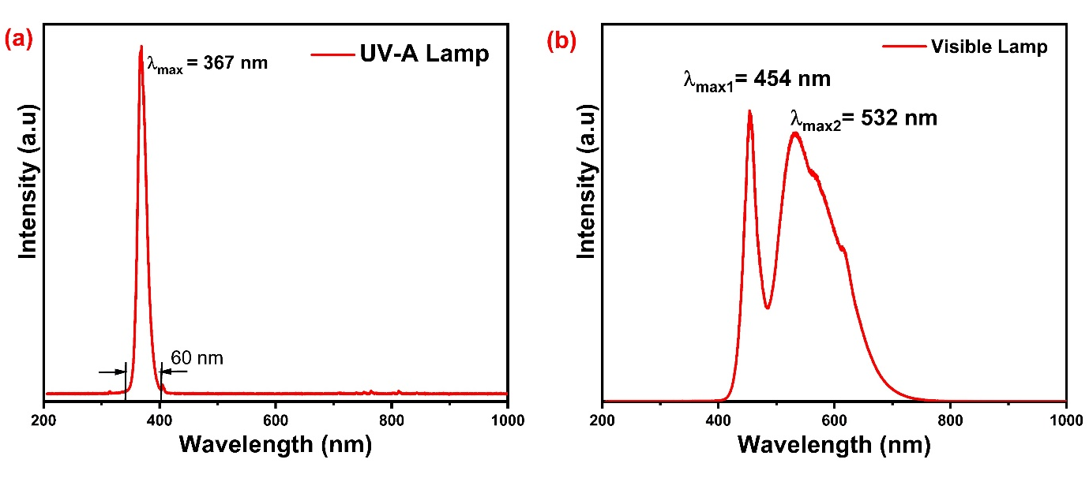
Fig. S1. Wavelength spectrum of monochromatic UV-A (λ_{max} = 367 nm and bandwidth = 60 nm) and (b) polychromatic visible lamps used in the present study
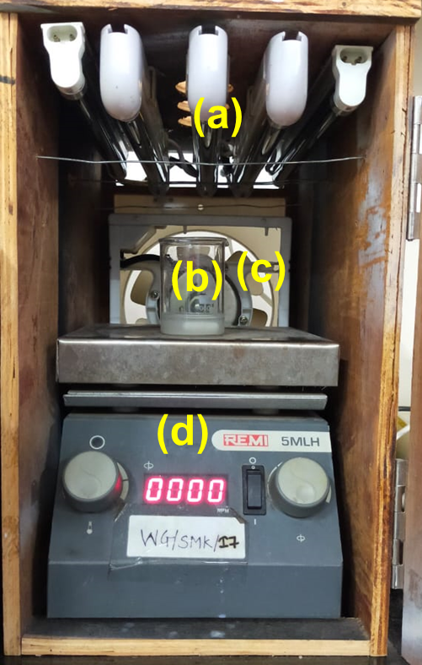
Fig. S2. Photo catalytic reactor having (a) UV-A lamps, (b) Glass beaker (c) Cooling fan at backside and (d) Magnetic Stirrer

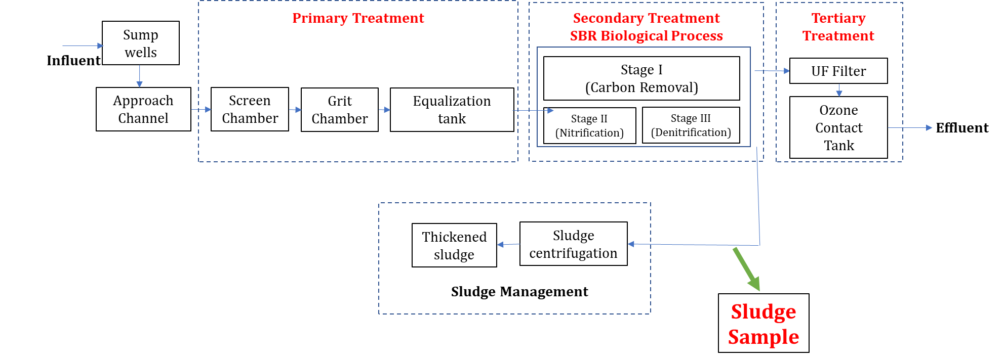
Fig. S3. Schematics of the IIT Madras sewage treatment plant and the sampling location

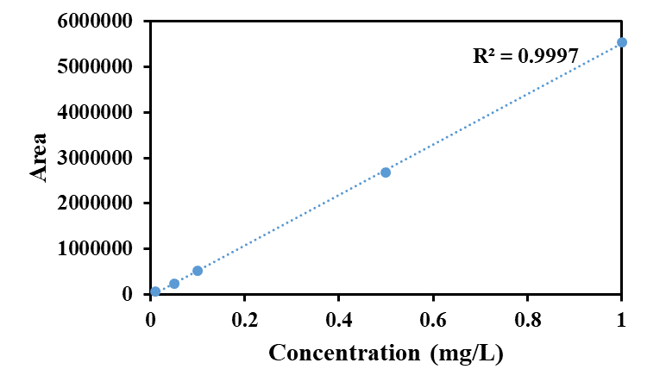
Fig. S4. Calibration plot for antibiotic MNZ in LC-MS instrument
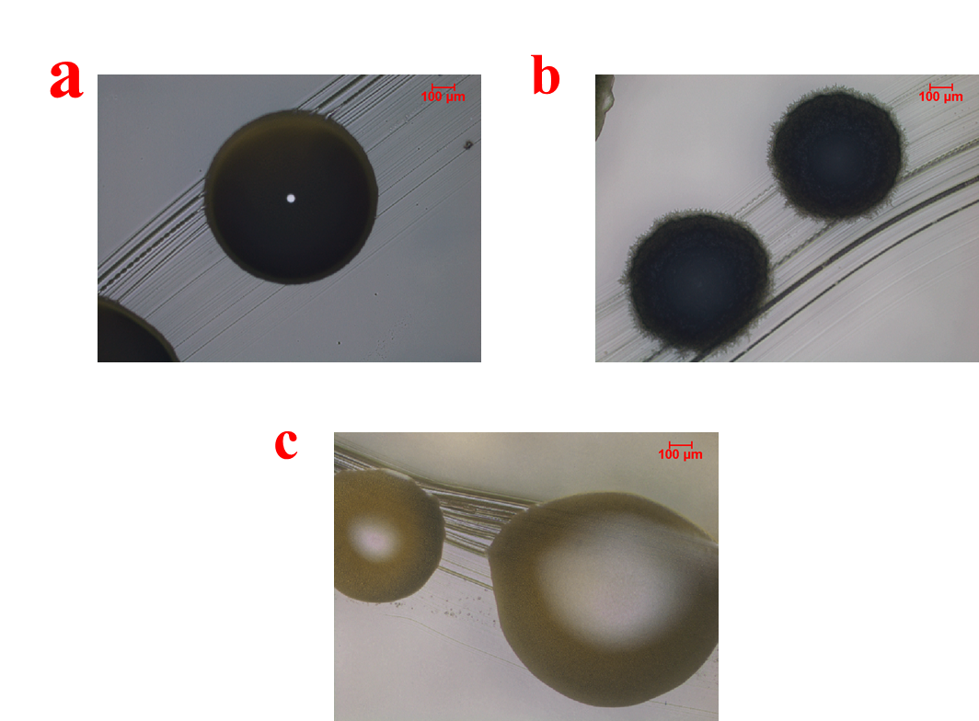
Fig. S5. Microscopic image of the colonies of (a) Stenotrophomonas nematodicola, (b) Frediandcohnia salidurans and (c) Shigella felxneri

