Supplementary Information

Micro- and nano-plastics (MNPs) in urban air: polymer composition, interactions and inhalation risk
Ankush Kaushik¹, Anju Elizbath Peter¹, Manuela van Pinxteren¹, Barbara M. Scholz-Böttcher² and Hartmut Herrmann¹*
¹Atmospheric Chemistry Department (ACD), Leibniz Institute for Tropospheric Research (TROPOS), Permoserstraße 15, Leipzig, 04318, Germany
² Institute for Chemistry and Biology of the Marine Environment (ICBM), Carl von Ossietzky University of Oldenburg, P.O. Box 5634, D-26046 Oldenburg, Germany
*Corresponding Author: Prof. Dr. Hartmut Herrmann (herrmann@tropos.de)
ORCID: https://orcid.org/0000-0001-7044-2101
Supplementary Table 1: List of polymer standards used in the study, including their acronyms, additional characteristics, and suppliers.
Polymer standard | Acronym | Additional  information | Supplier
Polyamide 6 (K891), Alkulon®  K222-D | C-PA6 | Low viscosity | Ter Hell, GmbH, Hamburg,  Germany
Polycarbonate, Markoplon 2558 | C-PC |  | Bayer Material, Science
Polyethylene, Lupolen 4261 AG  UV | C-PE | High density | LyondellBasell
Polyethylene terephthalate,  NEOPET 80 | C-PET |  | Neogroup
Polymethyl methacrylate,  PLEXIGLAS® 7N | C-PMMA |  | Plexiglas®
Polypropylene, HL508FB | C-PP |  | Borealis
Polystyrene, TOTAL C-PS  impact 7240 | C-PS | High-impact C-PS for  extrusion industry | Ter Hell, GmbH, Hamburg,  Germany
Polystyrene, Styrolution C-PS 158N/L | C-PS | Raw material | IINEOS Styrosolution
Deuterated poly(styrene-d8)  P41212-dPS | d₈-PS |  | Polymer Source ^{TM}, Inc.  Canada
Polyurethane | MDI-PUR | MDI-MDI-PUR | GEBA GmbH
Polyvinylchloride, Vinnolit S3268 | C-PVC | Hard C-PVC, raw  material | Vinnolit
All-season truck tire tread | TTT |  | Goodyear Tire & Rubber  Company
All-season car tire tread | CTT |  | Semperit (Continental AG)
Adapted from Goßmann et al.,¹
Supplementary Table 2: Summary of operating conditions for the pyrolysis-GC-MS system, including details of the micro furnace pyrolyzer, gas chromatograph, and mass spectrometer settings.
Micro furnace pyrolyzer (EGA/PY-3030D, FrontierLabs)
Carrier gas | Helium
Temperature | 590°C
Pyrolysis time | 1 min
Transfer line temperature | 320°C
Gas chromatograph (6890 N (Agilent)
Injector | Split/split less
Mode | SIM; Split 1:12.5
Temperature | 300°C
Pre-Column | Trajan P/N 064062; 3 m x 250 µm/363 µm VSPD  Tubing
Column | DB5 (J&W); 30 m x 0.25 mm ID, film thickness  0.25 µm
Flow (constant) | 1.2 mL/min
Temperature program | 35°C (2 min) 310°C (30 min) at 4°C/min  hold 60 min
Transfer line temperature | 280°C
Mass spectrometer (MSD 5973, Agilent)
Ionization energy | 70 eV
Scan rate | 2.91 scans/s
Scan range | m/z 50 - 550
EI-source temperature | 230°C
Quadrupole temperature | 150°C
Adapted from Goßmann et al.,¹

Supplementary Table 3: List of quantified polymers with key pyrolysis markers, associated ions (m/z), masses for Single ion monitoring (SIM) measurements are given in bold, calibration linear equations, coefficients of determination (R²), limits of detection (LOD), and limits of quantification (LOQ) in absolute mass (µg) for the identified polymers.
Polymer | Cluster associated  compounds | Marker Pyrolyzate | Ions (m/z) | Linear Equation | R² | LOD  (µg) | LOQ  (µg)
C-PS | PS, PS-containing copolymers (e.g., ABS, SAN),  PS- or acryl styrene binders, varnish | 2,4,6-triphenyl-1-hexene  (Styrene trimer) | 91,117, 194, 207, 312 [M] | y = 0.7545x + 0.0039 | 0.99 | 0.01 | 0.03
C-PVC* | PVC (hard and plasticized),  chlorinated PE, chlorinated rubber; cluster is interfered by polymers related to soot/black carbon | Naphthalene | 51, 64, 102,128 [M] | y = 0.0602x + 0.0386 | 0.97 | 0.04 | 0.14
C-PET | PET, polybutylene terephthalate | Dimethyl terephthalate | 103,135, 163,194 [M] | y = 0.7474x - 0.0281 | 0.99 | 0.27 | 0.91
C-PMMA | PMMA, polyalkylated methacrylate,  acryl-containing binder | Methyl methacrylate | 69, 85 99, 100 [M] | y = 0.6761x + 0.0464 | 0.98 | 0.02 | 0.08
C-PC | PC, epoxide resin | 2,2-Bis(4’-methoxyphenyl) propane | 77, 133, 149, 241, 256 [M] | y = 7.6117x - 0.1245 | 0.98 | 0.02 | 0.06
C-PE | HDPE, LDPE, PE-containing copolymers and rubbers,  ethylene-vinyl acetate (EVA), EPDM rubber | Avg Alkadienes from C16 to C26 | e.g: C₁₇: 55, 67, 82, 95, 109, 236 [M] | One-point calibration | - | - | -
C-PP | PP, EPDM rubber | 2,4, Dimethyl-1-heptene | 70, 83, 126 [M] | One-point calibration | - | - | -
MDI-PUR | MDI-PUR,  MDI-PUR-based formulations | 4,4’-Methylenbis(N,Ndimethylaniline) | 134, 210, 253, 254 [M] | NA | - | - | -
C-PA6 | PA6 | ɛ-Caprolactam | 55, 84, 85, 113[M] | NA | - | - | -
C-PA6 | PA6 | N-methyl caprolactam | 55, 127[M] | NA | - | - | -
CTT |  | Cyclohexenylbenzene | 104,115, 129, 158 [M] | y = 0.0014x + 0.0016 | 0.99 | 0.12 | 0.39
TTT |  | 2,4-Dimethyl-4-vinylcyclohexene | 68, 93, 121, 136 [M] | y = 0.0092x - 0.0039 | 0.99 | 0.13 | 0.42
d₈-PS (IS) |  | d₈-PS Trimer | 98,126, 208, 222, 336[M] | - | - | - | -
NA: Not Available; IS: Internal Standard
Supplementary Table 4: Concentrations of airborne micro- and nano-plastics (MNPs) measured in the current study, categorized by polymer type and particle size. Polymers include Polymethyl Methacrylate (C-PMMA), Polyvinyl Chloride (C-PVC), Polyethylene Terephthalate (C-PET), Polycarbonate (C-PC), Polystyrene (C-PS), car tire tread (CTT), truck tire tread (TTT), tire wear particles (TWPs), and Polypropylene (C-PP). Particle size classifications are PM₁₀MNPs (plastic particles with aerodynamic diameters ≤10 µm), FMPs (fine microplastics), and CMPs (coarse microplastics). For each polymer and size category, the table presents minimum, maximum, average, and standard deviation (SD) concentrations (in ng/m³). Ratios of FMPs/PM₁₀MNPs and CMPs/PM₁₀MNPs are also included to illustrate the relative distribution of particle sizes within each polymer type.
Polymers | PM Size | Concentration |  |  |  | FMPs/PM₁₀MNPs |  |  |  | CMPs/PM₁₀MNPs
 |  | Min | Max | Avg | SD | Min | Max | Avg | SD | Min | Max | Avg | SD
 |  | ng/m³ |  |  |  | Ratio
C-PMMA | PM₁₀MNPs | 4.9 | 23.4 | 14.3 | 6.1 | 0.3 | 1 | 0.6 | 0.2 | 0 | 0.7 | 0.4 | 0.2
C-PMMA | FMPs | 1.4 | 15.4 | 8.9 | 4.9
C-PMMA | CMPs | 0.4 | 8.4 | 5.4 | 2.7
C-PVC* | PM₁₀MNPs | 36.9 | 108.2 | 74.3 | 27 | 0.2 | 0.9 | 0.6 | 0.3 | 0.1 | 0.8 | 0.4 | 0.3
C-PVC* | FMPs | 10.5 | 102.5 | 42.8 | 26.1
C-PVC* | CMPs | 4.5 | 86.1 | 31.5 | 25.9
C-PET | PM₁₀MNPs | 7.4 | 56.5 | 29.6 | 15.8 | 0.1 | 1 | 0.6 | 0.3 | 0 | 0.9 | 0.4 | 0.3
C-PET | FMPs | 3 | 27.1 | 13.8 | 8.8
C-PET | CMPs | 0.2 | 50.7 | 15.8 | 17
C-PC | PM₁₀MNPs | 1.5 | 1.6 | 1.5 | 0 | 0.9 | 1 | 1 | 0 | 0 | 0.1 | 0 | 0
C-PC | FMPs | 1.4 | 1.6 | 1.4 | 0
C-PC | CMPs | 0 | 0.2 | 0.1 | 0
C-PS | PM₁₀MNPs | 0.5 | 2.4 | 1.1 | 0.5 | 0.1 | 0.7 | 0.3 | 0.2 | 0.3 | 0.9 | 0.7 | 0.2
C-PS | FMPs | 0 | 0.8 | 0.3 | 0.3
C-PS | CMPs | 0.3 | 2.1 | 0.8 | 0.5
CTT | PM₁₀MNPs | 160.1 | 632.4 | 362.4 | 146.6 | 0.2 | 1 | 0.5 | 0.2 | 0 | 0.8 | 0.5 | 0.2
CTT | FMPs | 39 | 336.6 | 185.6 | 73.3
CTT | CMPs | 2.7 | 487.2 | 176.8 | 126.7
TTT | PM₁₀MNPs | 9.9 | 46.8 | 24.2 | 12.2 | 0.2 | 0.9 | 0.6 | 0.2 | 0.1 | 0.8 | 0.4 | 0.2
TTT | FMPs | 2.5 | 25.7 | 14.7 | 7
TTT | CMPs | 1.2 | 32.4 | 9.5 | 9.2
TWPs | PM₁₀MNPs | 0.2 | 0.7 | 0.4 | 0.2 | 0.2 | 1 | 0.5 | 0.2 | 0 | 0.8 | 0.5 | 0.2
TWPs | FMPs | 0 | 0.4 | 0.2 | 0.1
TWPs | CMPs | 0 | 0.5 | 0.2 | 0.1
C-PP | PM₁₀MNPs | 0.9 | 6.1 | 2.5 | 1.6 | 0.1 | 0.9 | 0.3 | 0.2 | 0.1 | 0.9 | 0.7 | 0.2
C-PP | FMPs | 0.1 | 1.5 | 0.7 | 0.4
C-PP | CMPs | 0.2 | 5.6 | 2.1 | 1.9
C-PE | PM₁₀MNPs | 44.2 | 100.7 | 73.3 | 16 | 0.2 | 0.8 | 0.4 | 0.1 | 0.2 | 0.8 | 0.6 | 0.1
C-PE | FMPs | 16.2 | 52.9 | 32.8 | 11.8
C-PE | CMPs | 10.4 | 57.8 | 40.5 | 13.2
∑MNPs | ∑PM₁₀MNPs | 364.3 | 878.1 | 583 | 158.7 | 0.3 | 0.8 | 0.5 | 0.2 | 0.2 | 0.7 | 0.5 | 0.2
∑MNPs | ∑FMPs | 103.5 | 485.9 | 301.1 | 100.9
∑MNPs | ∑CMPs | 88.2 | 620.6 | 281.9 | 136.5
OC | PM₁₀ | 1980.6 | 3943.7 | 2949.2 | 717.4 | 0.6 | 0.8 | 0.7 | 0.1 | 0.0 | 0.4 | 0.3 | 0.1
OC | PM_{2.5} | 1272.4 | 3221.6 | 2113 | 741.5
OC | PM_{10-2.5} | 574.1 | 1279.9 | 832.2 | 191.7
EC | PM₁₀ | 286.5 | 488.2 | 393.2 | 65 | 0.8 | 1.1 | 0.9 | 0.1 | 0.0 | 0.2 | 0.1 | 0.1
EC | PM_{2.5} | 228.6 | 464.2 | 362.6 | 59.7
EC | PM_{10-2.5} | 0 | 100.4 | 31.5 | 42.8
POC | PM₁₀ | 1297.6 | 2627.6 | 2072.9 | 410.2 | 0.0 | 1.1 | 0.6 | 0.2 | 0.0 | 0.5 | 0.3 | 0.2
POC | PM_{2.5} | 838.9 | 1703.4 | 1330.7 | 219
POC | PM_{10-2.5} | 433.5 | 1204.4 | 817.1 | 225.1
SOC | PM₁₀ | 0 | 1787.8 | 876.4 | 498.5 | 0.0 | 1.4 | 0.7 | 0.5 | 0.0 | 1.0 | 0.2 | 0.3
SOC | PM_{2.5} | 0 | 1815.6 | 782.2 | 669.1
SOC | PM_{10-2.5} | 0 | 974.4 | 236.5 | 301.3
POM | PM₁₀ | 3169 | 6309.9 | 4718.8 | 1147.8 | 0.0 | 0.8 | 0.7 | 0.2 | 0.0 | 0.4 | 0.3 | 0.1
POM | PM_{2.5} | 2035.8 | 5154.5 | 3380.7 | 1186.4
POM | PM_{10-2.5} | 918.5 | 2047.8 | 1331.4 | 306.8

Supplementary Table 5: Summary of Micro- and nano-plastic (MNPs) concentrations from different global studies, including study location, sampling type, instrumentation, detected polymers, and reported concentrations.
Location | Type | Sample type | Instrumentation | Analysed polymers | Concentration | Study
Leipzig (Germany) | Urban | PM₁₀, PM_{2.5}, PM_{10-2.5} | Py-GC-MS | C-PMMA, C-PS, C-PP, C-PE, C-PVC*, C-PET, CTT, TTT | PM₁₀MNPs = 0.6±0.2 µg/m³  FMPs= 0.3±0.1 µg/m³  CMPs = 0.3±0.1 µg/m3 | This Study
Kaohsiung  Pingtung  Taichung  Tainan  Taipei  (Taiwan) | Urban | PM_{2.5} | TD/Py-GC-MS | PVC, PE, PP, PS | Kaohsiung = 68.97 ng/m³  Pingtung = 71.03 ng/m³  Taichung = 70.26 ng/m³  Tainan = 71.74 ng/m³  Taipei = 76.86 ng/m³ | ²
Heihe Grand Canyon (China) | Remote | PM_{<100} | LDIR | PET, PS, PP, PE, PVC, PU, Nylon | 126 ng/m³ | ³
Southern New Zealand | Remote | TSP | Py-GC-MS | PET, PS, PP, PE, PVC, PMMA, Nylon | 65 ng/m³ | ⁴
Shanghai (China) | Urban | PM_{2.5} | Py-GC-MS | PS and PVC, PE | 5.6 µg/m³ | ⁵
Kyoto (Japan) | Urban | PM_{11-0.43} | Py-GC-MS | PE, PP, PS, PET, PA66, PA6, PMMA, ABS, SBR | 1.20 µg/m³ | ⁶
Sonblick obsevatory (Austria) | Remote high alpine | PM₁₀ and PM₁ | TD-PTR-MS | PE, PET, PP, PS, PVC, TWP | PM₁₀ = 35 ng/m³  PM₁ = 21 ng/m³ | ⁷
North-South Atlantic Ocean | Open Ocean | PM₁₀ | Py-GC-MS | PE, PP, PI, PS | 0.01 to 51.74 ng/m³ | ⁸
Beijing (China) | Urban | PM₁ | Py-GC-MS | PS | 23-149 pg/m³ | ⁹
Zhengzhou, Taiyuan, Guanzhou (China) | Urban | PM_{2.5} | Py-GC-MS/MS | PE | Zhengzhou= 5.0 pg/m³,  Taiyuan = 10.2 pg/m³,  Guangzhou = 5.2 pg/m³ | ¹⁰
Cartagena (Spain) | Urban | PM₁₀ and PM_{2.5} | Py-GC-MS | PS | PM₁₀ = 2.09 ng/m³  PM_{2.5} = 1.81 ng/m³ | ¹¹
Graz Don Bosco (Austria) | Urban | PM_{2.5} | TD-PTR-MS | PE, PP, PET | PM_{2.5} = 238 ng/m³ | ¹²
North Atlantic Ocean | Open Ocean | >PM₁₀ and PM₅₋₁₀ | Py-GC-MS | C-PP, C-PS, C-PET, C-PMMA, TWP, C-PE, C-MDI-PUR, C-PC, C-PA-6 | >PM₁₀=0.23 to 37.5 ng/m³;  PM₅₋₁₀ = LOQ to 1.82 ng/m³ | ¹³
Gothenburg (Sweden) | Urban and industrial Fjords | PM_{2.8} | Py-GC-MS | C-PP, C-PS, C-PET, C-PMMA, TWP, C-PE, C-MDI-PUR, C-PC, C-PA-6 | Average total of all Fjords = 100.71 ng/m³ | ¹⁴
Tokushima (Japan) | Urban | >PM₁₀, PM_{2.5-10}, PM_{2.5} | Py-GC-MS | PP, PS, SBR | >PM₁₀ = 4.47 ng/m³  PM_{2.5-10} = 1.57 ng/m³  PM_{2.5} = 2.13 ng/m³ | ¹⁵
Cartagena (Spain) | Urban | PM₁₀ | TGA-MS | PS | 36 ng/m³ | ¹⁶
Los Angeles (USA); London (UK); Greater Tokyo (Japan) | Urban | PM₁₀,  PM_{2.5} | Py-GC-MS | Tire Tread | PM₁₀:  London (UK): 0.62 µg/m³  Greater Tokyo (Japan): 0.15 µg/m³  PM_{2.5}:  Los Angeles (USA): 0.006 µg/m³  London (UK): 0.021 µg/m³  Greater Tokyo (Japan): 0.011 µg/m³ | ¹⁷
Seine (France), Chesapeake (USA), Yodo (Japan) | Urban | PM₁₀ | Py-GC-MS | Tire Tread | Seine (France): 0.135 µg/m³; Chesapeake (USA): 0.075 µg/m³;  Yodo (Japan): 0.055 µg/m³ | ¹⁸

Supplementary Table 6: Pearson correlation coefficient (R) matrices among identified polymers (C-PMMA, C-PVC*, C-PET, C-PC, C-PS, CTT, TTT, TWPs, C-PP, C-PE, and ∑MNPs) and carbonaceous species (OC, EC, TC, POC, SOC, POM) in a) PM₁₀MNPs, b) FMPs and c) CMPs, where the red box has R<0.5 and the green box has R>0.5 with p-value <0.05.

- PM₁₀MNPs:
 | C-PMMA | C-PVC* | C-PET | C-PC | C-PS | CTT | TTT | TWPs | C-PP | C-PE | ∑MNPs | OC | EC | TC | POC | SOC | POM
C-PMMA | 1.00
C-PVC* | 0.48 | 1.00
C-PET | 0.38 | 0.34 | 1.00
C-PC | 0.00 | 0.21 | -0.08 | 1.00
C-PS | 0.26 | 0.47 | 0.13 | 0.54 | 1.00
CTT | -0.15 | 0.03 | -0.33 | 0.64 | 0.58 | 1.00
TTT | 0.02 | 0.04 | -0.42 | 0.50 | 0.43 | 0.89 | 1.00
TWPs | -0.14 | 0.03 | -0.34 | 0.63 | 0.57 | 1.00 | 0.90 | 1.00
C-PP | 0.23 | -0.07 | 0.13 | 0.09 | -0.04 | -0.06 | 0.22 | -0.03 | 1.00
C-PE | 0.64 | 0.81 | 0.17 | 0.02 | 0.33 | -0.15 | -0.03 | -0.14 | -0.07 | 1.00
∑MNPs | 0.09 | 0.34 | -0.15 | 0.66 | 0.71 | 0.94 | 0.86 | 0.95 | -0.02 | 0.14 | 1.00
OC | 0.94 | 0.62 | 0.40 | 0.06 | 0.29 | -0.15 | -0.07 | -0.14 | -0.01 | 0.77 | 0.12 | 1.00
EC | 0.72 | 0.66 | 0.42 | 0.12 | 0.42 | 0.07 | 0.07 | 0.07 | 0.06 | 0.76 | 0.33 | 0.81 | 1.00
TC | 0.94 | 0.63 | 0.41 | 0.06 | 0.31 | -0.13 | -0.06 | -0.13 | 0.00 | 0.78 | 0.14 | 1.00 | 0.84 | 1.00
POC | 0.72 | 0.66 | 0.42 | 0.12 | 0.42 | 0.07 | 0.07 | 0.07 | 0.06 | 0.76 | 0.33 | 0.81 | 1.00 | 0.84 | 1.00
SOC | 0.93 | 0.53 | 0.34 | 0.02 | 0.20 | -0.22 | -0.13 | -0.22 | -0.04 | 0.68 | 0.01 | 0.97 | 0.63 | 0.95 | 0.63 | 1.00
POM | 0.94 | 0.62 | 0.40 | 0.06 | 0.29 | -0.15 | -0.07 | -0.14 | -0.01 | 0.77 | 0.12 | 1.00 | 0.81 | 1.00 | 0.81 | 0.97 | 1.00

b) FMPs:
 | C-PMMA | C-PVC* | C-PET | C-PC | C-PS | CTT | TTT | TWPs | C-PP | C-PE | ∑FMPs | OC | EC | TC | POC | SOC | POM
C-PMMA | 1.00
C-PVC* | 0.32 | 1.00
C-PET | 0.78 | 0.14 | 1.00
C-PC | 0.42 | 0.11 | 0.11 | 1.00
C-PS | 0.57 | 0.11 | 0.55 | 0.10 | 1.00
CTT | 0.36 | 0.29 | 0.42 | 0.34 | 0.17 | 1.00
TTT | 0.61 | 0.28 | 0.34 | 0.49 | 0.31 | 0.55 | 1.00
TWPs | 0.40 | 0.30 | 0.42 | 0.37 | 0.19 | 1.00 | 0.61 | 1.00
C-PP | 0.56 | 0.60 | 0.17 | 0.60 | 0.16 | -0.01 | 0.42 | 0.02 | 1.00
C-PE | 0.76 | 0.46 | 0.55 | 0.22 | 0.37 | 0.22 | 0.45 | 0.25 | 0.61 | 1.00
∑FMPs | 0.59 | 0.57 | 0.55 | 0.37 | 0.30 | 0.92 | 0.66 | 0.93 | 0.29 | 0.52 | 1.00
OC | 0.84 | 0.45 | 0.75 | 0.35 | 0.52 | 0.44 | 0.52 | 0.47 | 0.51 | 0.71 | 0.67 | 1.00
EC | 0.53 | 0.39 | 0.44 | 0.59 | 0.22 | 0.77 | 0.68 | 0.79 | 0.34 | 0.26 | 0.80 | 0.72 | 1.00
TC | 0.83 | 0.45 | 0.73 | 0.39 | 0.50 | 0.49 | 0.55 | 0.52 | 0.51 | 0.68 | 0.70 | 1.00 | 0.77 | 1.00
POC | 0.53 | 0.39 | 0.44 | 0.59 | 0.22 | 0.77 | 0.68 | 0.79 | 0.34 | 0.26 | 0.80 | 0.72 | 1.00 | 0.77 | 1.00
SOC | 0.80 | 0.36 | 0.74 | 0.11 | 0.56 | 0.12 | 0.28 | 0.14 | 0.47 | 0.80 | 0.40 | 0.91 | 0.36 | 0.87 | 0.36 | 1.00
POM | 0.84 | 0.45 | 0.75 | 0.35 | 0.52 | 0.44 | 0.52 | 0.47 | 0.51 | 0.71 | 0.67 | 1.00 | 0.72 | 1.00 | 0.72 | 0.91 | 1.00

c) CMPs:
 | C-PMMA | C-PVC* | C-PET | C-PC | C-PS | CTT | TTT | TWPs | C-PP | C-PE | ∑CMPs | OC | EC | TC | POC | SOC | POM
C-PMMA | 1.00
C-PVC* | 0.00 | 1.00
C-PET | 0.25 | -0.05 | 1.00
C-PC | 0.29 | -0.25 | 0.12 | 1.00
C-PS | -0.08 | -0.08 | 0.25 | 0.08 | 1.00
CTT | -0.48 | 0.07 | -0.29 | 0.16 | 0.60 | 1.00
TTT | -0.37 | 0.04 | -0.37 | 0.31 | 0.38 | 0.83 | 1.00
TWPs | -0.48 | 0.07 | -0.30 | 0.17 | 0.59 | 1.00 | 0.85 | 1.00
C-PP | 0.23 | -0.02 | -0.18 | 0.37 | -0.20 | 0.12 | 0.38 | 0.14 | 1.00
C-PE | 0.10 | 0.32 | 0.02 | 0.23 | 0.28 | 0.08 | 0.21 | 0.09 | 0.22 | 1.00
∑CMPs | -0.41 | 0.28 | -0.17 | 0.17 | 0.62 | 0.96 | 0.82 | 0.96 | 0.15 | 0.25 | 1.00
OC | -0.30 | 0.27 | 0.00 | 0.17 | 0.61 | 0.41 | 0.27 | 0.40 | -0.10 | 0.52 | 0.47 | 1.00
EC | 0.60 | -0.39 | -0.08 | 0.04 | -0.24 | -0.59 | -0.33 | -0.58 | 0.08 | 0.37 | -0.59 | -0.30 | 1.00
TC | -0.18 | 0.19 | -0.02 | 0.19 | 0.58 | 0.29 | 0.21 | 0.28 | -0.08 | 0.62 | 0.36 | 0.97 | -0.08 | 1.00
POC | 0.60 | -0.39 | -0.08 | 0.04 | -0.24 | -0.59 | -0.33 | -0.58 | 0.08 | 0.37 | -0.59 | -0.30 | 1.00 | -0.08 | 1.00
SOC | -0.54 | 0.40 | 0.05 | 0.10 | 0.55 | 0.61 | 0.37 | 0.60 | -0.11 | 0.15 | 0.65 | 0.85 | -0.76 | 0.71 | -0.76 | 1.00
POM | -0.30 | 0.27 | 0.00 | 0.17 | 0.61 | 0.41 | 0.27 | 0.40 | -0.10 | 0.52 | 0.47 | 1.00 | -0.30 | 0.97 | -0.30 | 0.85 | 1.00

Supplementary Table 7: Polymer Hazard Index (PHI) values for identified polymers, including hazard categories based on physicochemical and toxicological properties.
Polymer | % Contribution in PM₁₀MNPs (P_{n}) | Hazard Score (S_{n}) | Polymer Hazard Index (PHI) | Hazard Category
C-PMMA | 2.6 | 1021 | 2613 | V
C-PVC* | 13.2 | 10551 | 139323 | V
C-PET | 5.4 | 4 | 22 | III
C-PC | 0.3 | 1177 | 325 | IV
C-PS | 0.2 | 30 | 6 | II
CTT* | 60.6 | 20001 | 1212661 | V
TTT* | 4.0 | 20001 | 80170 | V
C-PP | 0.4 | 1 | 0.4 | I
C-PE | 13.3 | 11 | 146 | IV
*Hazard Score of 1,3-butadiene was considered to calculate the PHI for CTT and TTT. All the Hazard Scores were taken from Lithner et al.,¹⁹
Supplementary Table 8: Estimated Relative Risk (RR) and Attributable Fraction (AF) for cardiopulmonary and lung cancer mortality due to inhalation of airborne MNPs was calculated using^{2,20,21}.
 | Relative Risk (RR) |  | Attributable Fraction (AF)
 | Cardiopulmonary  mortality | Lung cancer  mortality | Cardiopulmonary mortality | Lung cancer mortality
Min | 1.06 | 1.09 | 0.05 (5%) | 0.08 (8%)
Max | 1.10 | 1.15 | 0.09 (9%) | 0.13 (13%)
Avg | 1.08 | 1.12 | 0.07 (7%) | 0.11 (11%)
SD | 0.01 | 0.02 | 0.01 (1%) | 0.01 (1%)

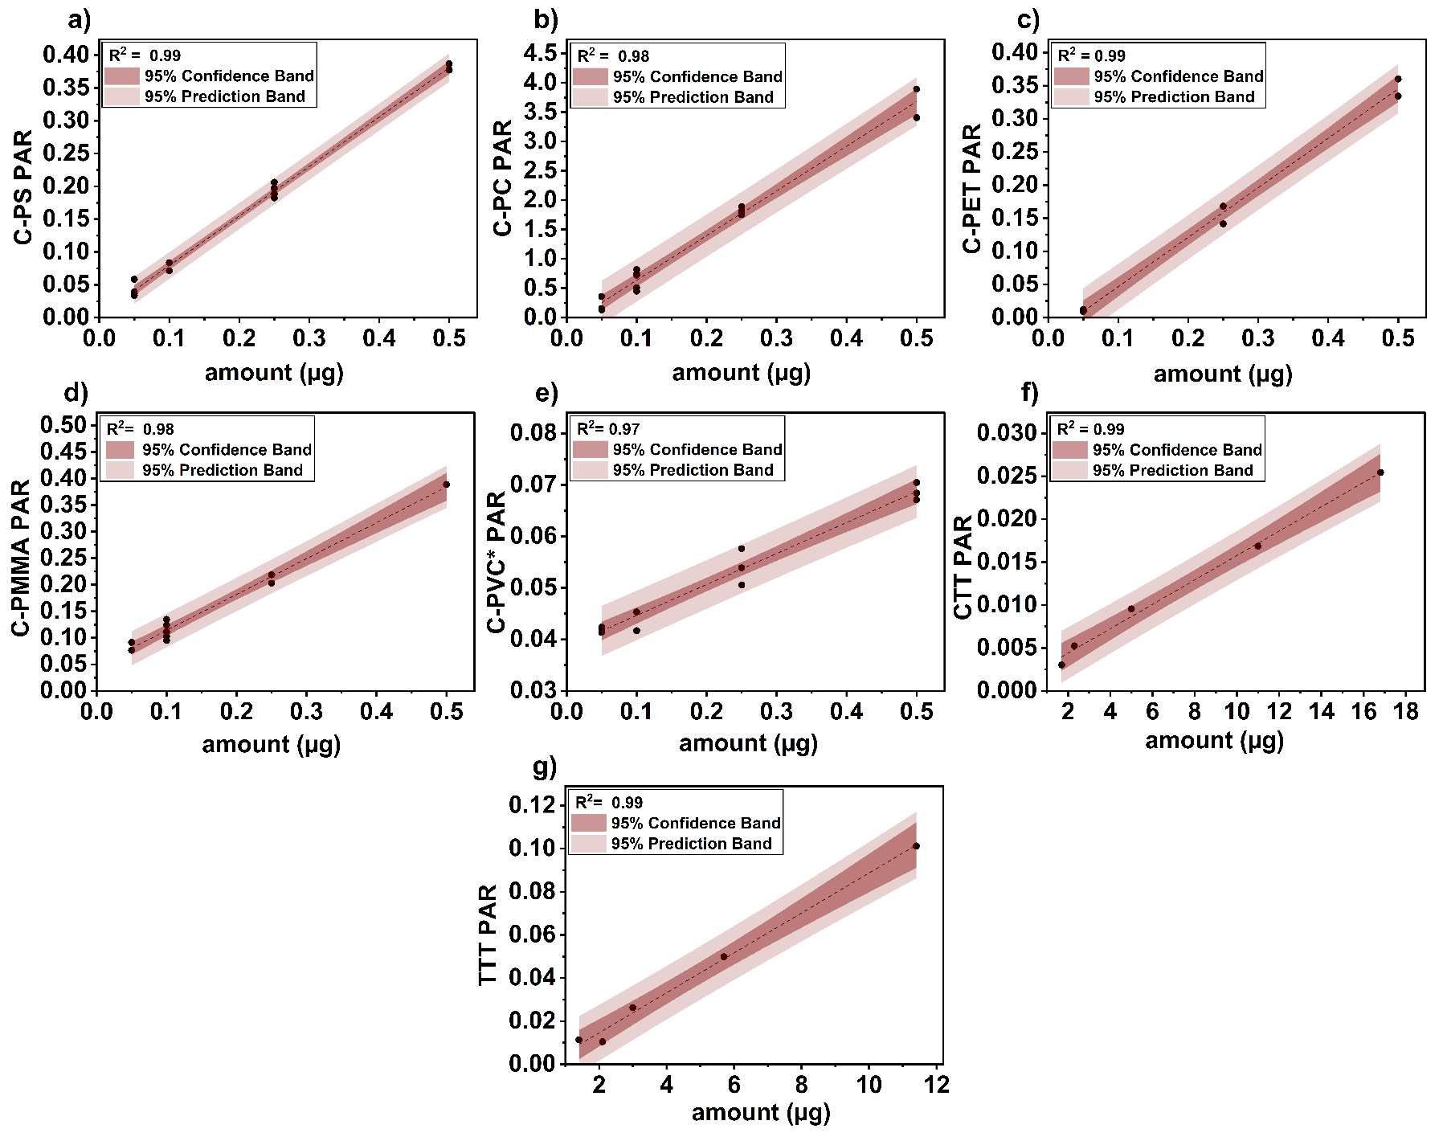
Supplementary Figure 1: Calibration plots for quantification of polymer standards via Py-GC–MS.
Calibration plots for different polymer standards used in the study: (a) Polystyrene (C-PS), (b) Polycarbonate (C-PC), (c) Polyethylene terephthalate (C-PET), (d) Polymethyl methacrylate (C-PMMA), (e) Polyvinyl chloride (C-PVC*), (f) Car tire tread (CTT), and (g) Truck tire tread (TTT). The plots display the linear relationship between polymer amount (µg) and pyrolysis product peak area ratio (PAR) with the internal standard (IS), with 95% confidence and prediction bands. High coefficients of determination (R² > 0.97) indicate strong correlations for all polymers.
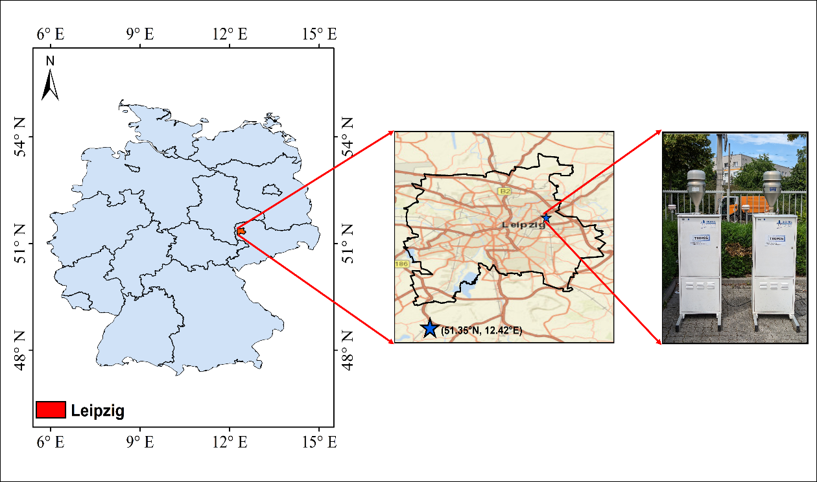
Supplementary Figure 2: Sampling location map for airborne MNPs collection.
This is a geographical map of Leipzig, Germany, showing the urban sampling site at Torgauer Straße with traffic and local emission context.

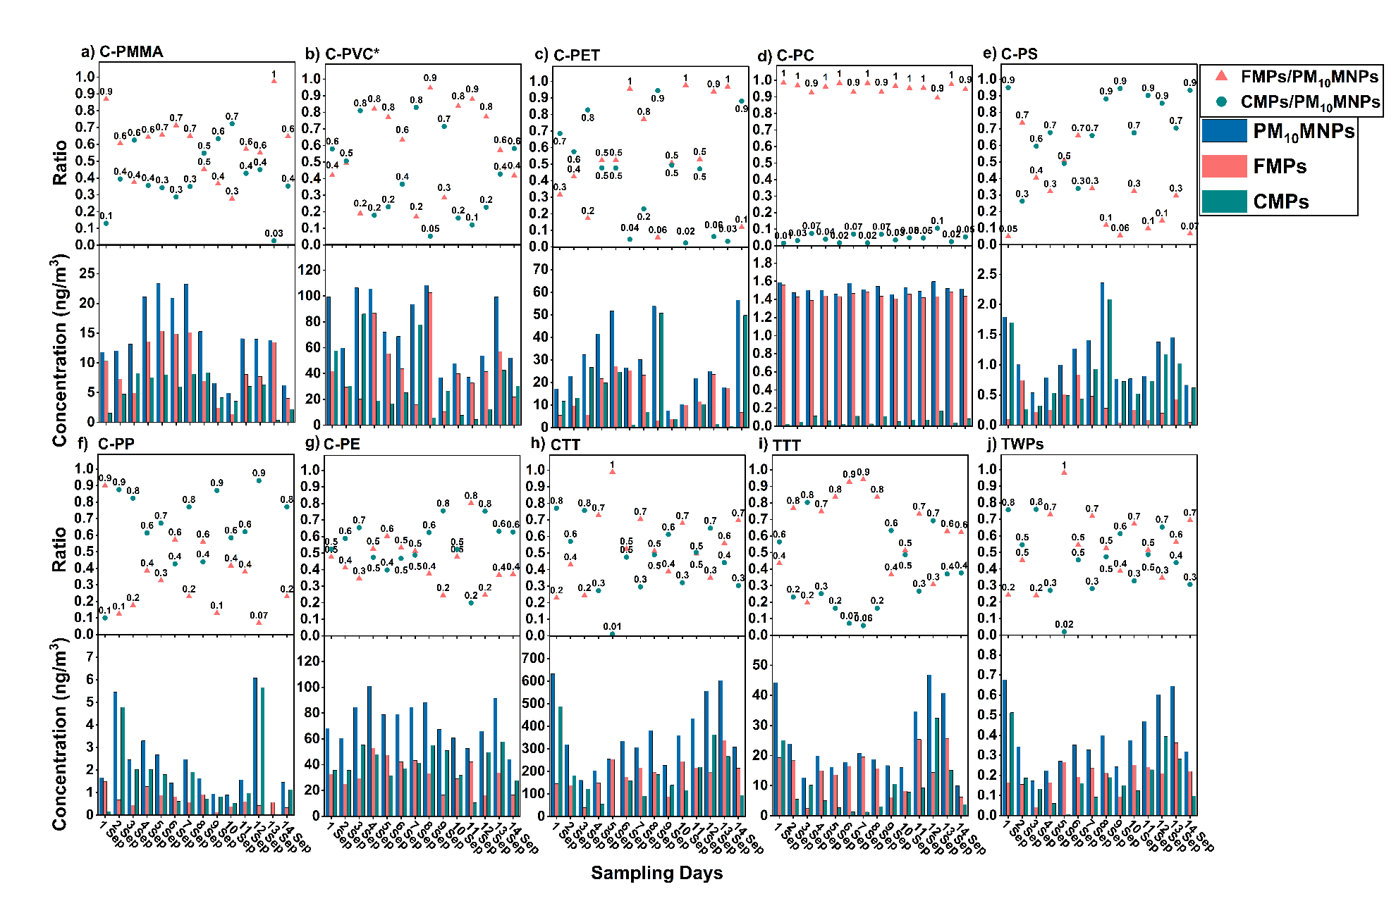
Supplementary Figure 3: Temporal and size-fractional polymer trends of MNPs over the sampling period in airborne samples.
Top panels (a–j) show the FMPs/PM₁₀MNPs and CMPs/PM₁₀MNPs ratios for each polymer. Bottom panels show daily mass concentrations (ng/m³) of polymers in PM₁₀MNPs, FMPs, and CMPs for: (a) Polymethyl methacrylate (C-PMMA), (b) Polyvinyl chloride (C-PVC*), (c) Polyethylene terephthalate (C-PET), (d) Polycarbonate (C-PC), (e) Polystyrene (C-PS), (f) Polypropylene (C-PP), (g) Polyethylene (C-PE), (h) Car tire tread (CTT), (i) Truck tire tread (TTT), and (j) Tire wear particles (TWPs).

References:
1. Goßmann, I., Süßmuth, R. & Scholz-Böttcher, B. M. Plastic in the air?! - Spider webs as spatial and temporal mirror for microplastics including tire wear particles in urban air. Science of The Total Environment 832, 155008 (2022).
2. Wu, C.-H. et al. Evaluation of PM2.5 bound microplastics and plastic additives in several cities in Taiwan: Spatial distribution and human health risk. Science of The Total Environment 959, 178213 (2025).
3. Luo, X. et al. Atmospheric emissions of microplastics entrained with dust from potential source regions. Journal of Hazardous Materials 488, 137509 (2025).
4. Rindelaub, J. D. et al. Aerosol mass concentrations and dry/wet deposition of atmospheric microplastics at a remote coastal location in New Zealand. Environmental Pollution 372, 126034 (2025).
5. Chen, Y. et al. Quantification and Characterization of Fine Plastic Particles as Considerable Components in Atmospheric Fine Particles. Environ. Sci. Technol. acs.est.3c06832 (2024) doi:10.1021/acs.est.3c06832.
6. Morioka, T., Tanaka, S., Kohama-Inoue, A. & Watanabe, A. The quantification of the airborne plastic particles of 0.43–11 μm: Procedure development and application to atmospheric environment. Chemosphere 351, 141131 (2024).
7. Kau, D. et al. Fine micro- and nanoplastics concentrations in particulate matter samples from the high alpine site Sonnblick, Austria. Chemosphere 352, 141410 (2024).
8. Caracci, E. et al. Micro(nano)plastics in the atmosphere of the Atlantic Ocean. Journal of Hazardous Materials 450, 131036 (2023).
9. Sheng, X. et al. Quantitation of Atmospheric Suspended Polystyrene Nanoplastics by Active Sampling Prior to Pyrolysis–Gas Chromatography–Mass Spectrometry. Environ. Sci. Technol. acs.est.3c02299 (2023) doi:10.1021/acs.est.3c02299.
10. Luo, P. et al. A Novel Strategy to Directly Quantify Polyethylene Microplastics in PM _{2.5} Based on Pyrolysis-Gas Chromatography–Tandem Mass Spectrometry. Anal. Chem. 95, 3556–3562 (2023).
11. Costa-Gómez, I. et al. A novel application of thermogravimetry-mass spectrometry for polystyrene quantification in the PM10 and PM2.5 fractions of airborne microplastics. Science of The Total Environment 856, 159041 (2023).
12. Kirchsteiger, B., Materić, D., Happenhofer, F., Holzinger, R. & Kasper-Giebl, A. Fine micro- and nanoplastics particles (PM2.5) in urban air and their relation to polycyclic aromatic hydrocarbons. Atmospheric Environment 301, 119670 (2023).
13. Goßmann, I. et al. Occurrence and backtracking of microplastic mass loads including tire wear particles in northern Atlantic air. Nat Commun 14, 3707 (2023).
14. Goßmann, I. et al. Unraveling the Marine Microplastic Cycle: The First Simultaneous Data Set for Air, Sea Surface Microlayer, and Underlying Water. Environ. Sci. Technol. 57, 16541–16551 (2023).
15. Mizuguchi, H. et al. Direct analysis of airborne microplastics collected on quartz filters by pyrolysis-gas chromatography/mass spectrometry. Journal of Analytical and Applied Pyrolysis 171, 105946 (2023).
16. Peñalver, R. et al. Assessing the level of airborne polystyrene microplastics using thermogravimetry-mass spectrometry: Results for an agricultural area. Science of The Total Environment 787, 147656 (2021).
17. Panko, J., Hitchcock, K., Fuller, G. & Green, D. Evaluation of Tire Wear Contribution to PM2.5 in Urban Environments. Atmosphere 10, 99 (2019).
18. Panko, J. M., Chu, J., Kreider, M. L. & Unice, K. M. Measurement of airborne concentrations of tire and road wear particles in urban and rural areas of France, Japan, and the United States. Atmospheric Environment 72, 192–199 (2013).
19. Lithner, D., Larsson, Å. & Dave, G. Environmental and health hazard ranking and assessment of plastic polymers based on chemical composition. Science of The Total Environment 409, 3309–3324 (2011).
20. Ostro, B. Assessing the environmental burden of disease at national and local levels. (2004).
21. WHO. WHO Global Air Quality Guidelines: Particulate Matter (PM2.5 and PM10), Ozone, Nitrogen Dioxide, Sulfur Dioxide and Carbon Monoxide. (2021).

