Figure S1. Steps performed in the nf-core rare disease pipeline

Figure S2. Variant scoring and prioritization with Genmod

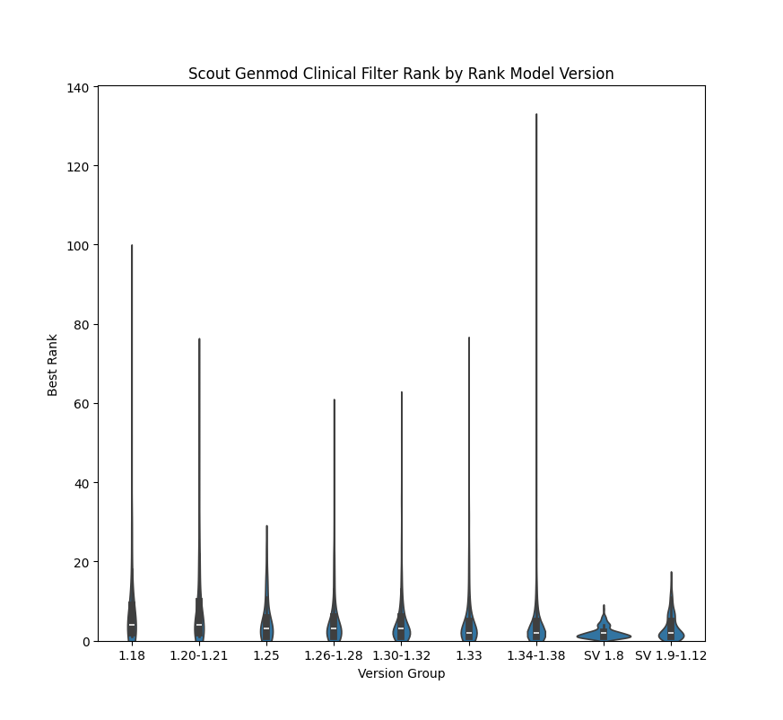
Figure S3: Rank score performance over time. Rank scores of 3,042 previously reported pathogenic variants across nine different versions of Genmod.

