Supplementary Material for

thermal bridging through branches of snow-covered Shrubs cool down permafrost in winter

Florent Domine*, Kevin Fourteau, Ghislain Picard, Georg Lackner, Denis Sarrazin, Mathilde Poirier

*Corresponding author. Email: florent.domine@gmail.com

Details on study site
The locations of the TUNDRA and SALIX sites are shown in Fig. S1. At TUNDRA, the vegetation consists of moss and grasses dominated by Dupontia fisheri, Carex aquatilis and Eriophorum scheuchzeri(1). At SALIX, vegetation at the very spot where snow and soil instruments were deployed (Fig. S2) consists mostly of Salix richardsonii with a very thin moss understory. Basal branches often have a diameter of about 2 cm. Some occasional Salix arctica and S. reticulata were also observed. In other nearby spots with less dense shrubs (Fig. S2), species such as Arctagrostis latifolia and Oxytropis arctica were seen, as well as some bare ground. Photographs of shrubs showing their architecture are shown in Fig. S2. The granulometry of soil samples at both sites and at several depths is shown in Fig. S3.
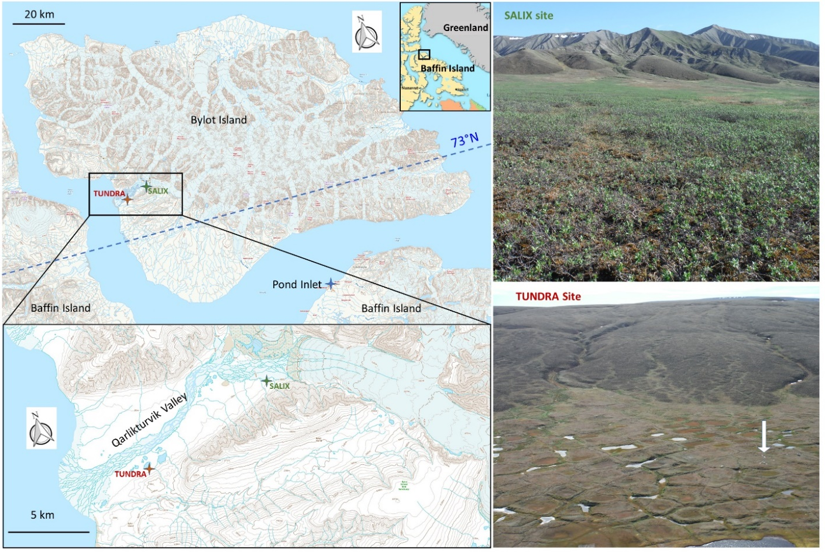
Fig. S1. Map and photographs of study sites. Qarlikturvik valley is on Bylot Island, Canada (73°N, 80°W). Top right: photographs of the SALIX site (73.1816°N, 79.7454°W, 35 m elevation) before instrument installation. Bottom right: aerial photograph of the TUNDRA site (73.1504°N, 80.0046°W, 15 m elevation). Instruments location at the TUNDRA site is indicated by the white arrow.

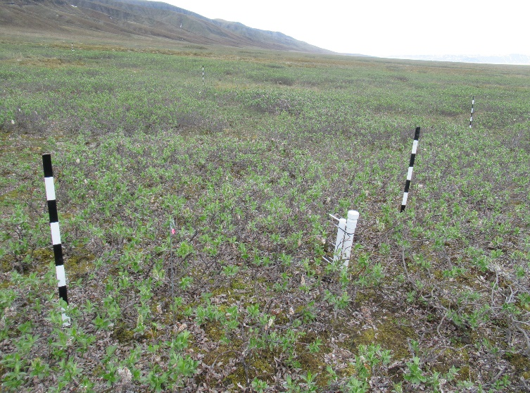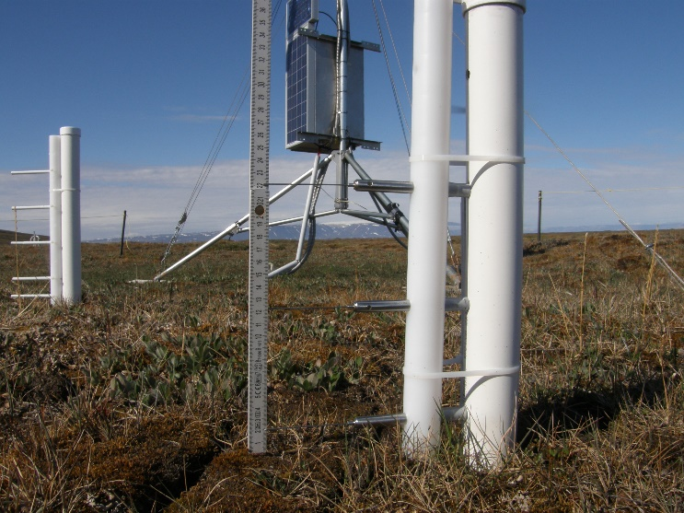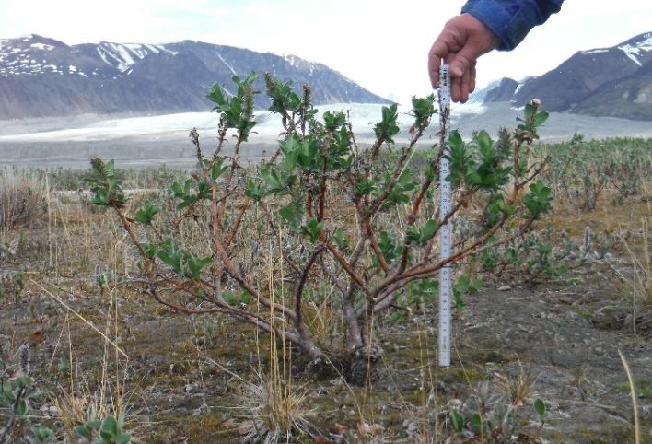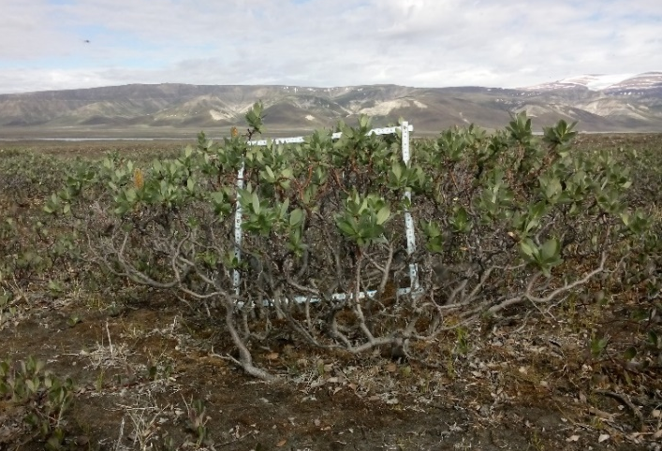
Fig. S2. Photographs of the sites with snow sensors. Top: photographs of the SALIX (left) and TUNDRA (right) sites showing the post supporting the TP08 heated needle probes which measure snow thermal conductivity. Bottom: photographs of shrub structure. Shrub height is approximately 40 cm.

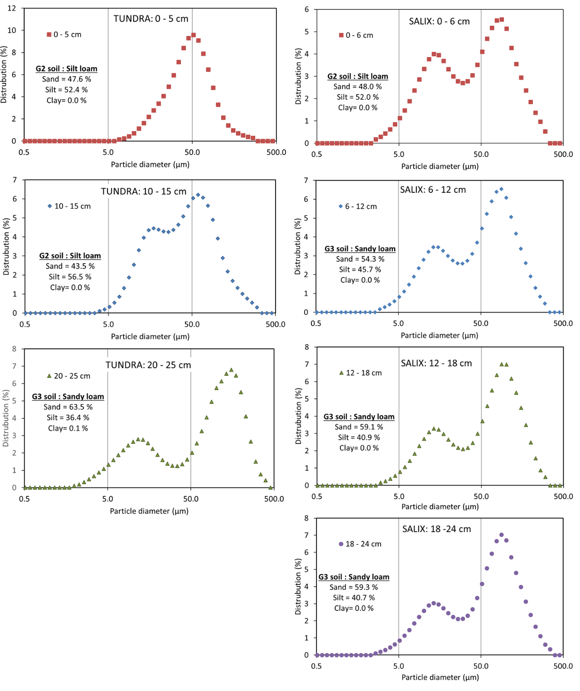
Fig. S3. Granulometric analysis of soil samples. Left: from TUNDRA. Right: from SALIX. Data from several depth ranges are presented. The fractions of sand, silt and clay, based on size distribution, is indicated in each graph. Clay is grains <2 µm, silt is grains between 2 and 50 µm, and sand is grains >50 µm.

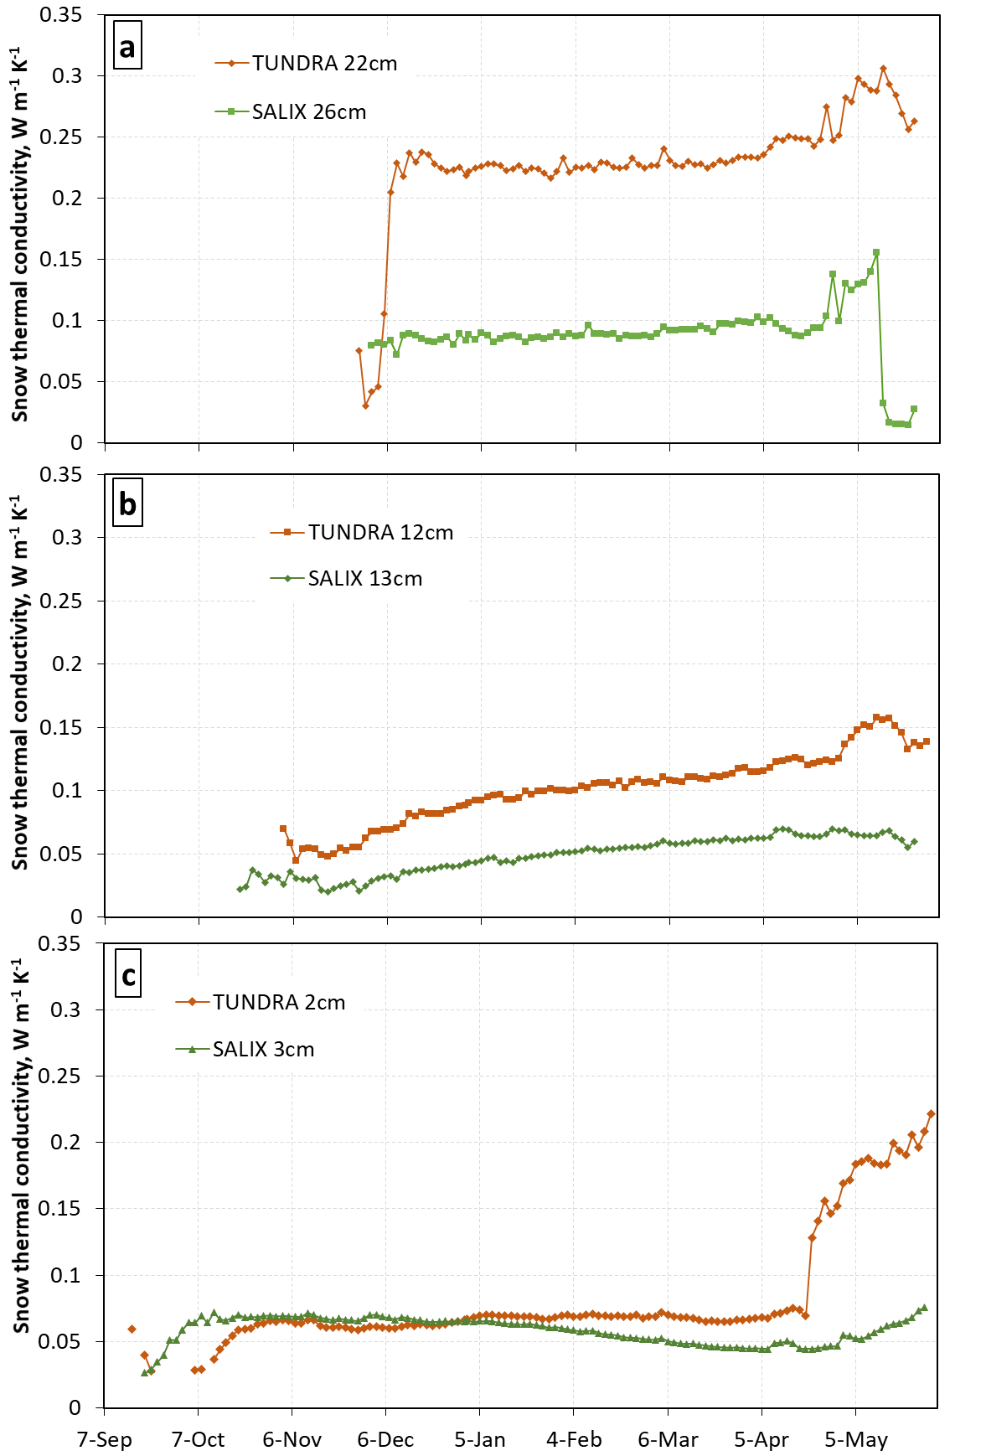
Fig. S4. Snow thermal conductivities at SALIX and TUNDRA for 2108-2019. (a) Upper level, with needle probes at 22 cm (TUNDRA) and 26 cm (SALIX) heights. The conductivity is almost always much higher at TUNDRA. (b) middle level at 12/13 cm. Likewise, the conductivity is always much higher at TUNDRA. (c) lower level 2/3 cm. The conductivity is similar at both sites until mid-January, when it starts decreasing at SALIX.

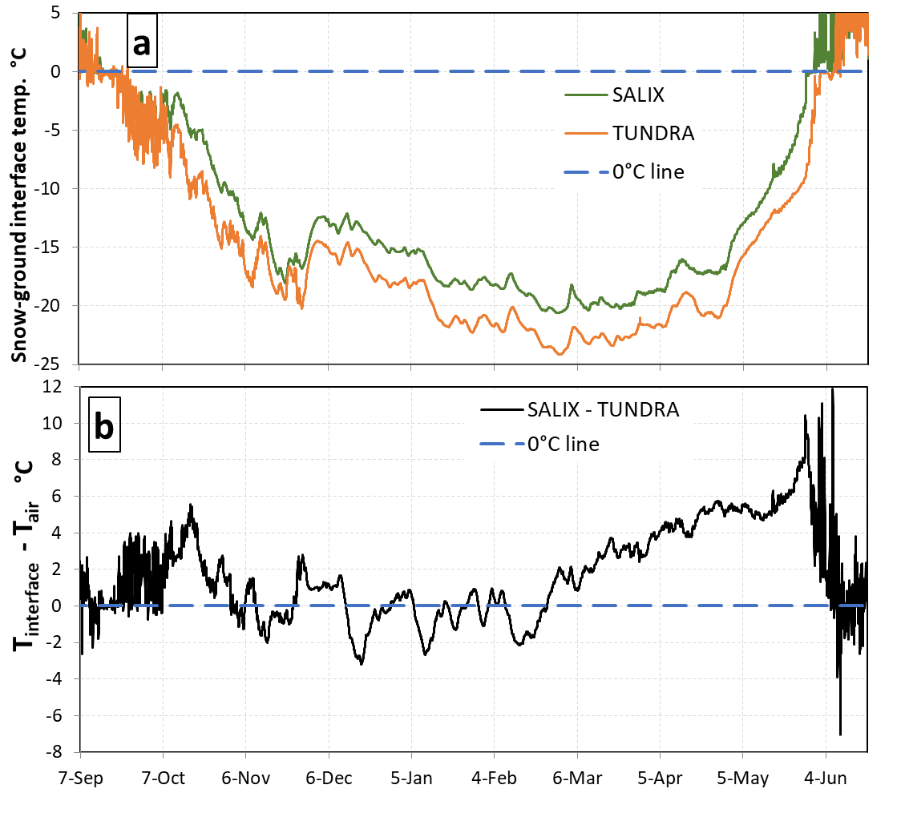

Fig. S5. Temperature data of the snow-ground interface. (a) One-week running mean temperatures at SALIX and TUNDRA. The ground is most of the time warmer at SALIX, but an actual comparison requires correction for differences in air temperature. (b) Temperature difference of the snow-ground interface between SALIX and TUNDRA, corrected for air temperature. This shows that at equal air temperature, from December through March, the ground temperature is most of the time colder at SALIX than at TUNDRA. The dashed horizontal lines are the 0°C lines, added as visual aides.

Soil field measurements
Three soil density profiles were made at or near SALIX. Two of them, dug within 15 m of SALIX, showed values increasing from 1500 to 1850 kg m⁻³ between 5 and 30 cm depth. The third profile, 50 m away, where the shrub density was lower, had values around 1250 kg m⁻³ down to 10 cm depth. These values are fairly similar to those at TUNDRA, where density increased from 1000 kg m⁻³ at 3 cm depth to 1850 kg m⁻³ at 24 cm depth. Regarding soil thermal conductivity, four profiles were measured near SALIX in July 2016 and 2017, yielding values between 0.25 W m⁻¹ K⁻¹ at 2 cm depth to 1.7 W m⁻¹ K⁻¹ at 25 cm depth. The profiles measured where the soil temperature sensors were located ranged from 0.3 at 3 cm depth to 1.2 W m⁻¹ K⁻¹ at 30 cm depth. Around 25 cm depth, values ranged from 0.6 to 1.7 W m⁻¹ K⁻¹. Overall, these profiles are fairly similar to those measured at TUNDRA (2). Granulometric analyses of soil samples were performed and are shown in Fig. S3. Except for the top soil layer where grains around 10 µm are absent at TUNDRA, granulometry is rather similar at both sites. In summary, given variations between nearby spots at each site, there does not appear to be any significant difference in density and thermal conductivity between TUNDRA and SALIX. Except for the top soil layer, granulometry is similar at both sites.

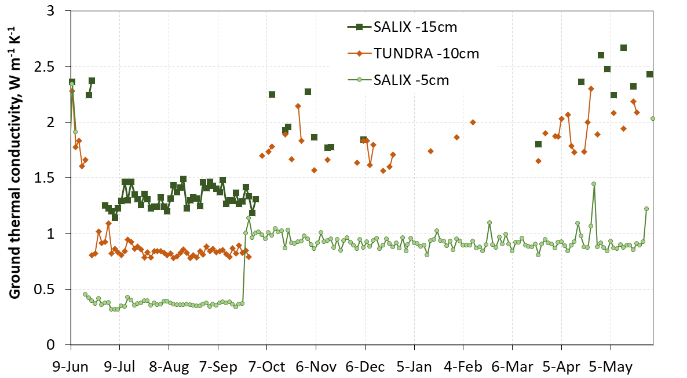
Fig. S6. Ground thermal conductivities at 5 and 15 cm depth at SALIX and at 10 cm depth at TUNDRA. Essentially, these variables only vary with freezing and thawing. For TUNDRA at 10 cm depth and SALIX at 15 cm depth, many values in the frozen state are missing because of insufficient data quality (see Methods), which also results in noisy time series.

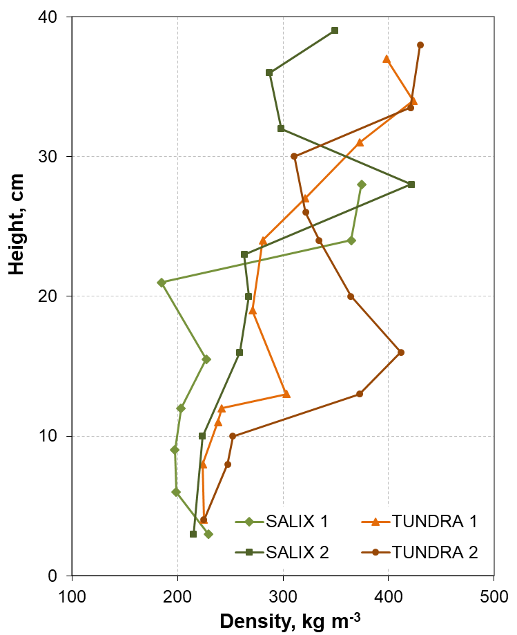
Fig. S7. Snow density profiles measured in pits near the SALIX and TUNDRA sites in mid-May 2019.

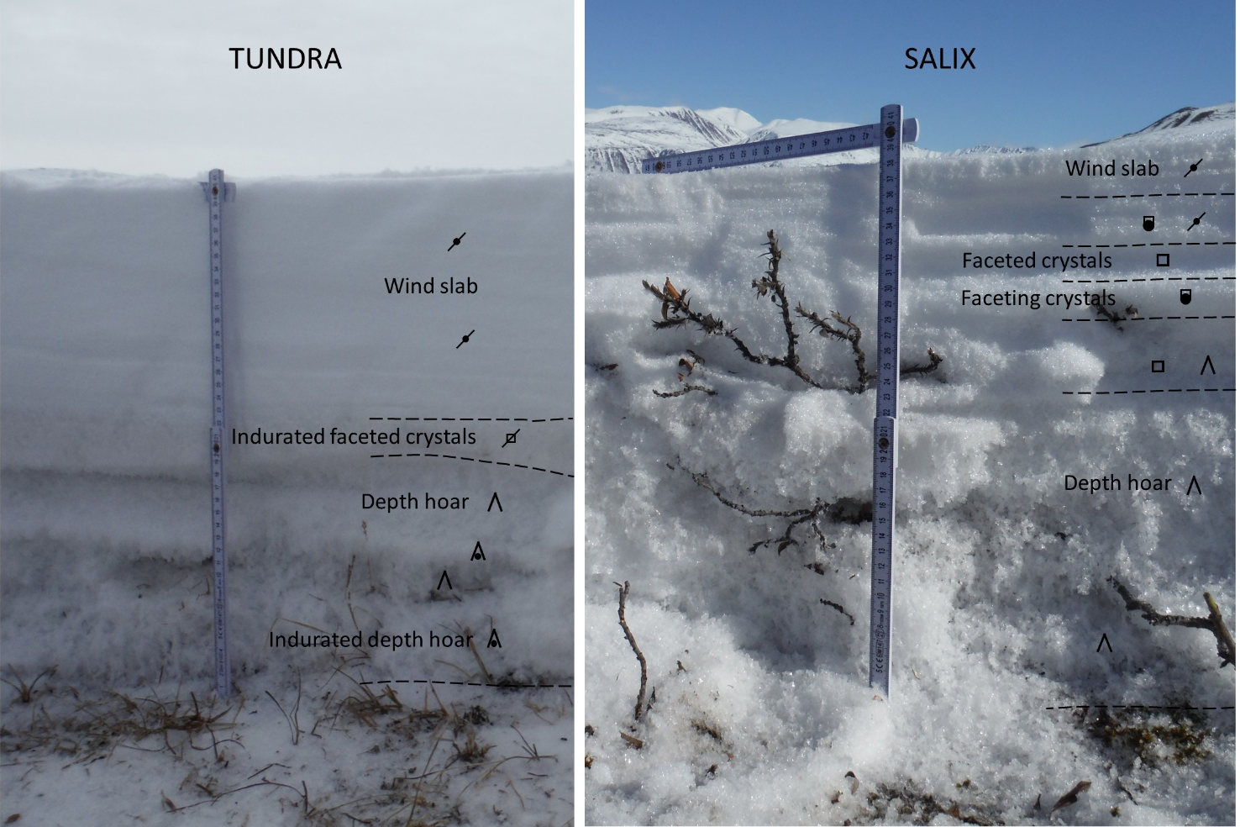
Fig. S8. Photographs of snowpits at TUNDRA and SALIX, taken in May 2015, showing the difference in stratigraphy and in particular the greater depth hoar thickness at SALIX.
Additional data indicating the thermal effects of shrub branches
Fig. S9a shows details of the temperatures of the snow-ground interface and of the air in March and April 2019, when sunlight was significant and generated daily temperature variations. Despite the greater thermal insulance, daily variations are transmitted to the base of the SALIX snowpack, while they are completely damped at TUNDRA. This is all the more surprising given that at TUNDRA, the amplitude of the diurnal air temperature variations is about 3-fold that at SALIX. This cannot be explained by considering just conductive heat fluxes through the snow.
Fig. S9b shows the temperature gradient ∇T in the basal snow layer at SALIX and TUNDRA. The product of ∇T by the thermal conductivity of the basal layer k_{eff} yields the heat flux F through the snow at the snow-ground interface: F=-∇T x k_{eff}. Since k_{eff} has similar values at SALIX and TUNDRA (Fig. S4c) between mid-October and mid-November, and since the temperature gradient is greater at TUNDRA, F is greater at TUNDRA and therefore the snow-ground interface should cool down faster at TUNDRA than at SALIX. Fig. 3c shows that on the contrary SALIX cools down faster between 11 October and 21 November. These considerations lead to the conclusion that conductive heat fluxes through snow only cannot explain observations and that another process comes into play at SALIX.
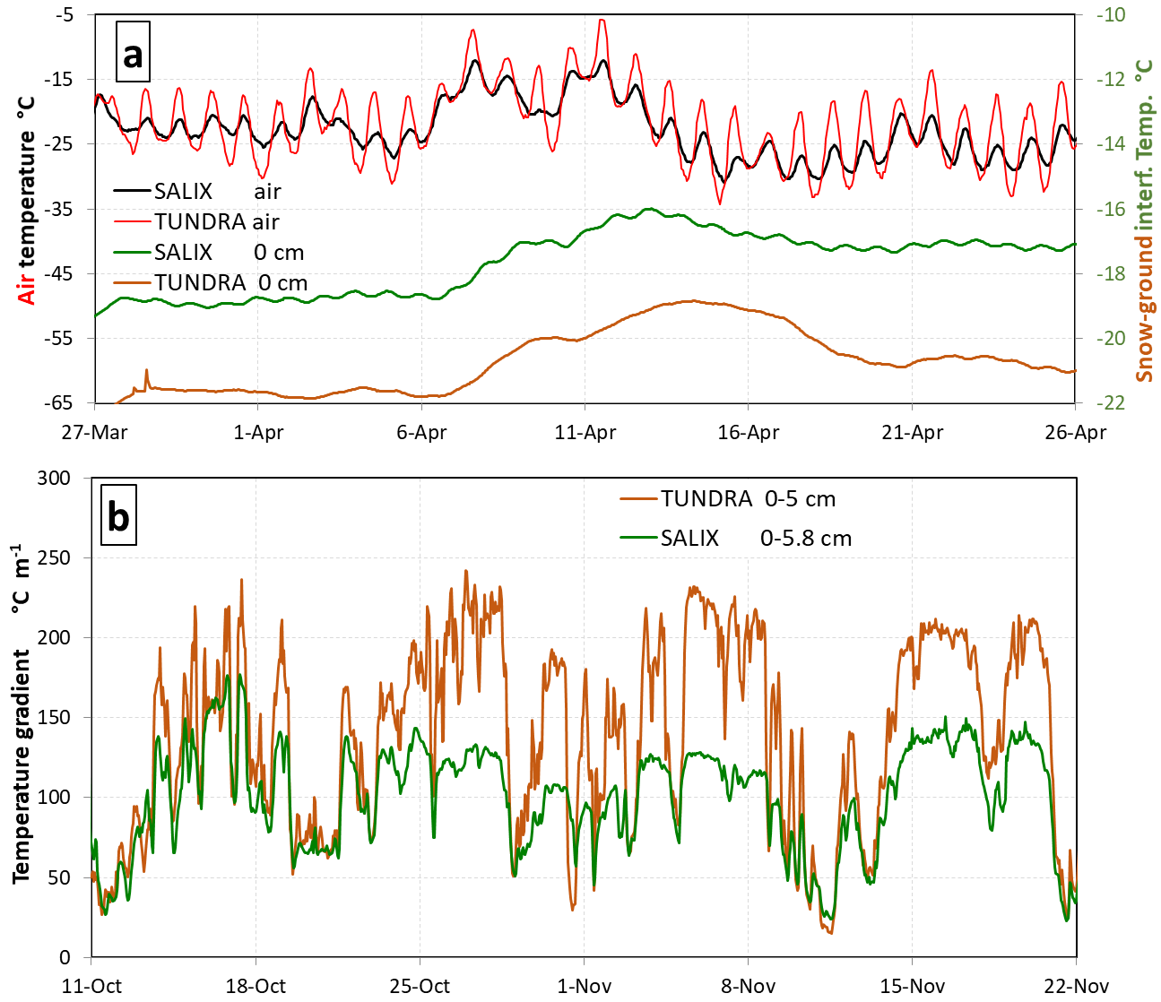
Fig. S9. Comparison of thermal data at TUNDRA and SALIX. (a) Snow-ground interface temperatures and air temperatures at SALIX and TUNDRA for March-April 2019 during a sunlit period; (b) temperature gradient in the basal snow layer at TUNDRA and SALIX between 11 October 2018 and 22 November 2019.

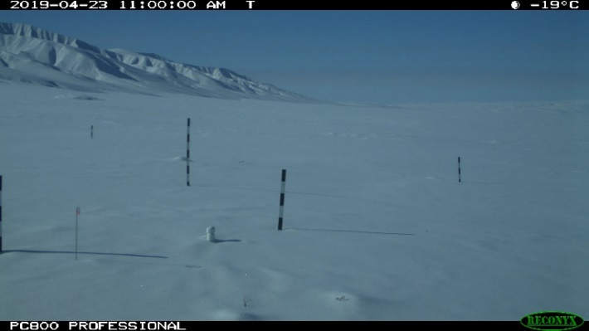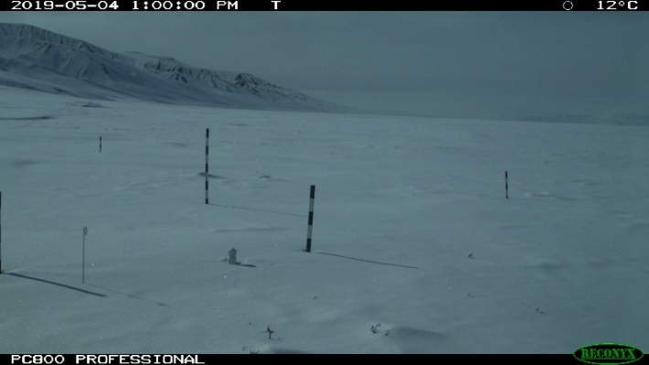

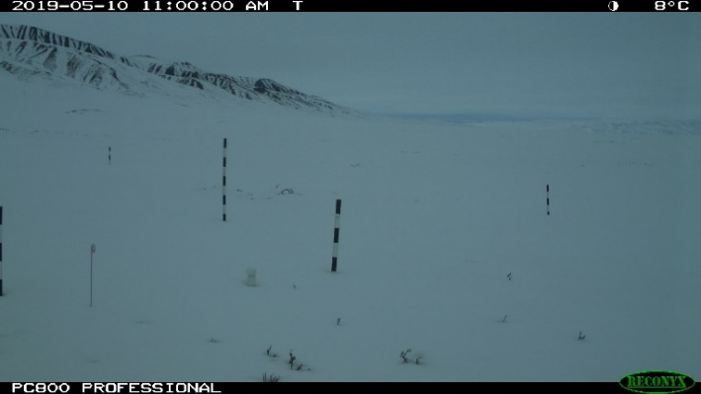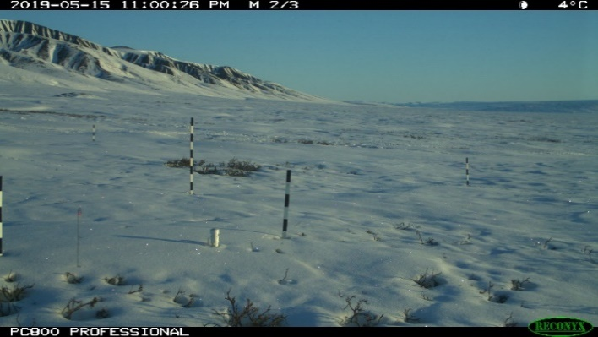

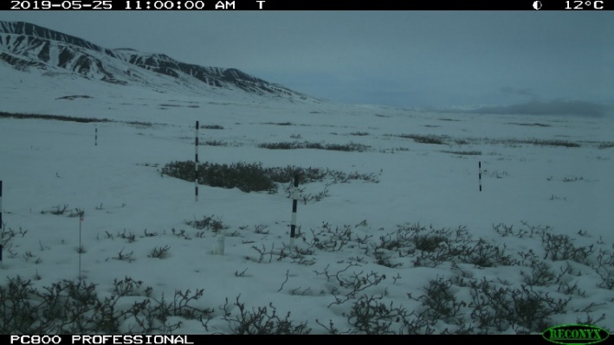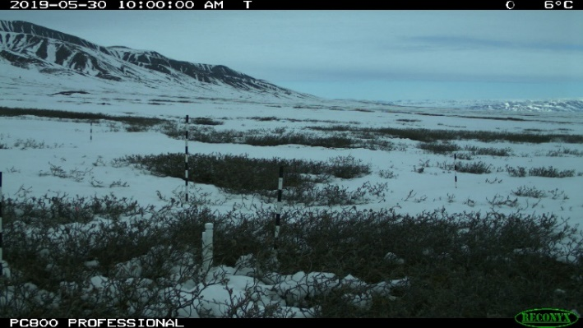
Fig. S10. Time lapse images of the SALIX site. This shows the progression of branch protrusion above the snow. On 23 April, near peak snow height, essentially no branches protrude above the snow. On 4 May, still very few branches are visible. On 10 May, a few branches become visible. On 15 May, a significant number of branches are visible and signs of melting around them are starting to appear. On 25 May, melting is significant around the branches and snow height at the front snow stake has decreased 8 cm relative to 23 April. On 30 May, most of the snow is melted. Meltout at the plastic post was on 3 June. About 4 cm of snow fell on 4 June and final meltout for the visible flat area was on 9 June.

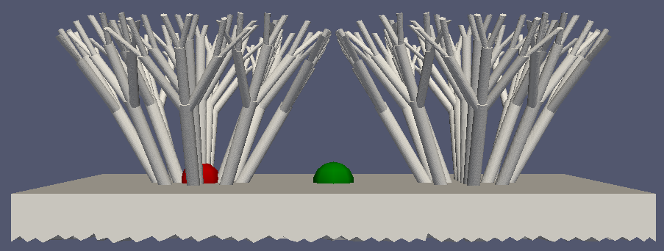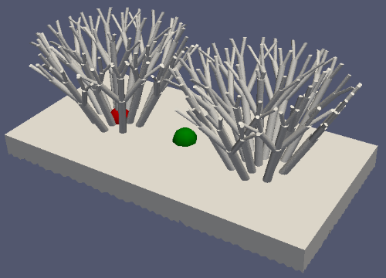
Fig. S11. Schematic of the shrub geometry used in the finite element simulations. Left: side view. Right: top view. Shrubs are 38 cm high and the shrubs centers are 64 cm apart. The green dot corresponds to the spot where the snow-ground interface temperature has been calculated for the green curves in Fig. 5, including the inset of Fig. 5b. The red dot is the spot relevant to the red curve in the inset of Fig. 5b.

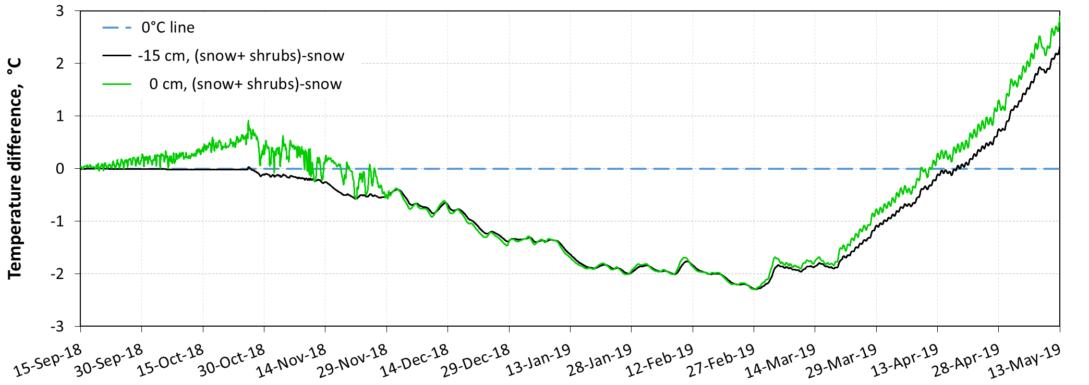
Fig. S12. Finite element simulations of the effect of shrubs on temperature. Simulations are shown for the ground at 15 cm depth and for the snow-ground interface (0 cm depth). This plot shows the temperature simulated with both snow and shrubs minus the temperature simulated with snow only. From December through April, these differences are negative, indicating that shrubs cool the interface and the ground. During about the last 30 days of the plot, the shrubs warm up the interface and the ground.

Table S1. Values of snow and soil physical variables used for MFM simulations. Values change over time because of soil freezing and snow metamorphism so that different values have been used for several time ranges. Mean values of snow thermal conductivities measured over the periods considered are also indicated.
Variable | Measured k_{snow}, TUNDRA | Simulated, TUNDRA | Mult. factorª, k_{snow} | Measured k_{snow}, SALIX | Simulated, SALIX | Mult. factorª, k_{snow}
Simulation start Date |  | 15-sept |  |  | 15-sept
Snow properties
ρ_{snow},^{b} 0-10 cm |  | 220 |  |  | 210
ρ_{snow}, 10-20 cm |  | 325 |  |  | 240
ρ_{snow}, 20-40 cm |  | 350 |  |  | 330
k_{snow},^{c} winter, 0-10 cm | 0.07 | 0.084 | 1.20 | 0.07 | 0.098 | 1.40
k_{snow}, winter, 10-20 cm | 0.07 | 0.084 | 1.20 | 0.04 | 0.056 | 1.40
k_{snow}, winter, 20-40 cm | 0.23 | 0.276 | 1.20 | 0.09 | 0.126 | 1.40
Date ‘’spring’’ period ^{d} |  | 01-Feb |  |  | 01-Janv
k_{snow}, spring, 0-10 cm | 0.07 | 0.084 | 1.20 | 0.05 | 0.085 | 1.70
k_{snow}, spring, 10-20 cm | 0.11 | 0.132 | 1.20 | 0.06 | 0.102 | 1.70
k_{snow}, spring, 20-40 cm | 0.24 | 0.288 | 1.20 | 0.09 | 0.153 | 1.70
Date ‘’melt’’ period ^{e} |  | 01-May |  |  | 01-May
k_{snow}, melt, 0-10 cm | 0.18 | 0.216 | 1.20 | 0.06 | 0.102 | 1.70
k_{snow}, melt, 10-20 cm | 0.14 | 0.168 | 1.20 | 0.07 | 0.119 | 1.70
k_{snow}, melt, 20-40 cm | 0.30 | 0.36 | 1.20 | 0.14 | 0.238 | 1.70
Soil properties
ρ_{soil}, ^{b} summer, 0-10 cm |  | 1320 |  |  | 1320
ρ_{soil}, summer, 10-500 cm |  | 1800 |  |  | 1800
C_{p,soil},^{f} summer, 0-10 cm |  | 600000 |  |  | 600000
C_{p,soil}, summer, 10-500 cm |  | 1667 |  |  | 1667
k_{soil},^{c} summer, 0-10 cm |  | 0.5 |  |  | 0.5
k_{soil}, summer, 10-500 cm |  | 1.2 |  |  | 1.2
Soil Freezing date^{h} |  | 30-oct |  |  | 26-oct
ρ_{soil},^{b} frozen, 0-10 cm |  | 1320 |  |  | 1320
ρ_{soil}, frozen, 10-500 cm |  | 1800 |  |  | 1800
C_{p,soil},^{f} frozen, 0-10 cm |  | 1000 |  |  | 1000
C_{p,soil}, frozen, 10-500 cm |  | 1000 |  |  | 1000
k_{soil},^{c} frozen, 0-10 cm |  | 0.8 |  |  | 0.8
k_{soil}, frozen, 10-500 cm |  | 2 |  |  | 2
Initial soil temperature, 15 September^{i}
Depth, cm |  | Temperature |  |  | Temperature
30 |  | 0 |  |  | 0
5 |  | 0 |  |  | 0
0 |  | 0 |  |  | 0
-5 |  | 0 |  |  | 0
-10 |  | 0.5 |  |  | 0
-30 |  | -0.5 |  |  | 0
-100 |  | -2 |  |  | -4
-200 |  | -6 |  |  | -7
-500 |  | -11 |  |  | -11
ªFactor by which measured thermal conductivity values have been multiplied to account for the artifact caused by the heated needle probe method. For SALIX, the factor has been enhanced to attempt to improve the fit between data and simulations, thus evidencing that a process other than conduction through the snow is taking place.
^{b}Density, kg m⁻³
^{c}Thermal conductivity, W m⁻¹ K⁻¹
^{d}Different time periods are used to account for time-changes in snow thermal conductivity. “spring” is a time period and does not necessarily relate to a season
^{e}Same as ^{c}. “melt” indicates snow metamorphism in spring, when the temperature gradient reverses, and does not necessarily imply that snow actually started melting on May 1st
^{f}Specific heat capacity, J kg⁻¹ K⁻¹
^{g}This very high value is to simulate soil freezing, during which soil temperature does not change. The model does not actually simulate the phase changes of water.
^{h}Date when “frozen”parameter values start being used. This is not the actual observed soil freezing data as this is depth-dependent. The date is chosen to optimize the agreement between simulations and data.
^{i}Based in part on measurements in the active layer at the sites. At depth, values are infered from thermistors in other parts of the valley.

References
1. G. Gauthier et al., The tundra food web of Bylot Island in a changing climate and the role of exchanges between ecosystems. Ecoscience 18, 223-235 (2011).
2. F. Domine, G. Lackner, D. Sarrazin, M. Poirier, M. Belke-Brea, Meteorological, snow and soil data (2013–2019) from a herb tundra permafrost site at Bylot Island, Canadian high Arctic, for driving and testing snow and land surface models. Earth Syst. Sci. Data Discuss. 2021, 1-23 (2021).

