APPENDIX A: SUPPORTING INFORMATION
Cumulative probability plot of cancer risk assessment using MCS
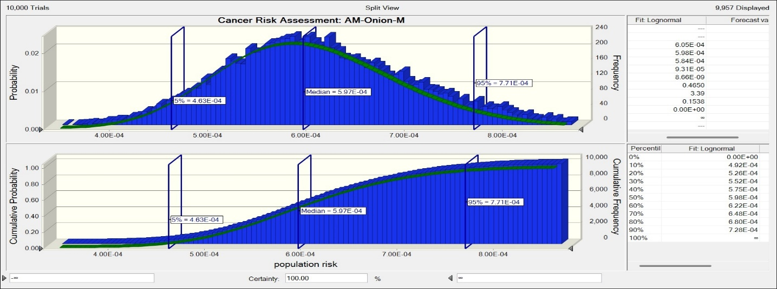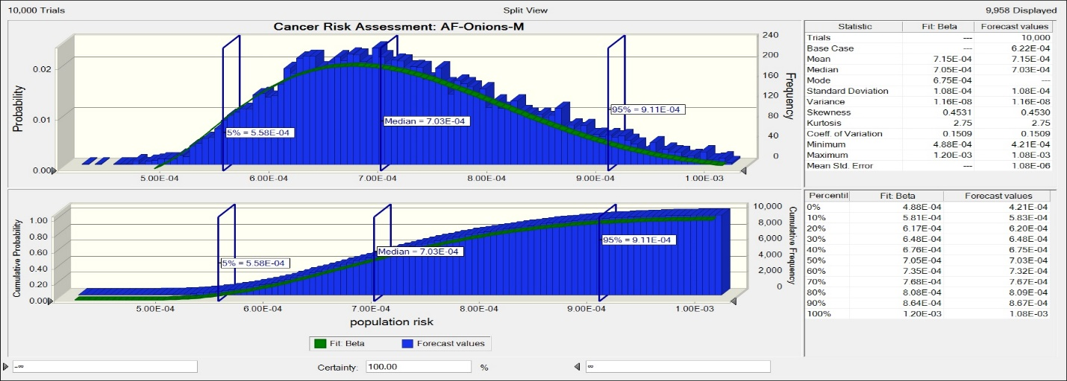
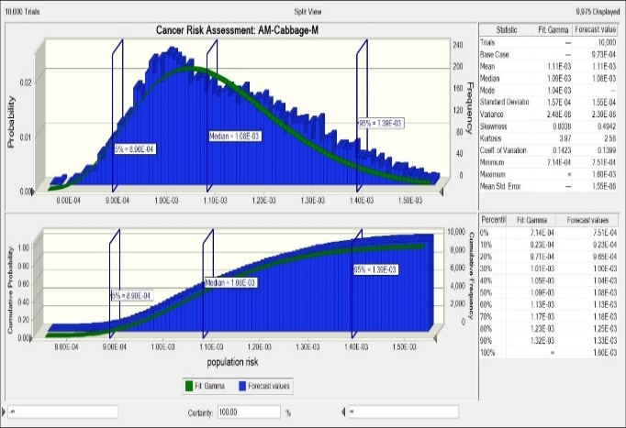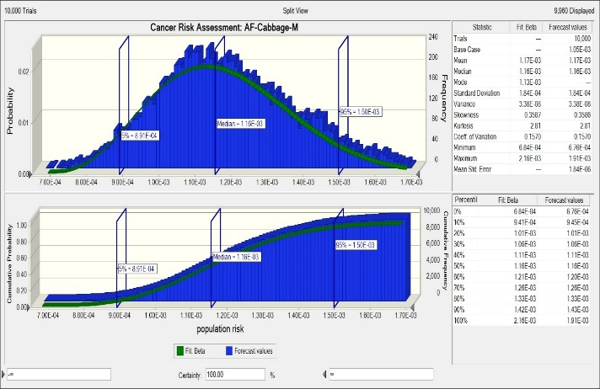
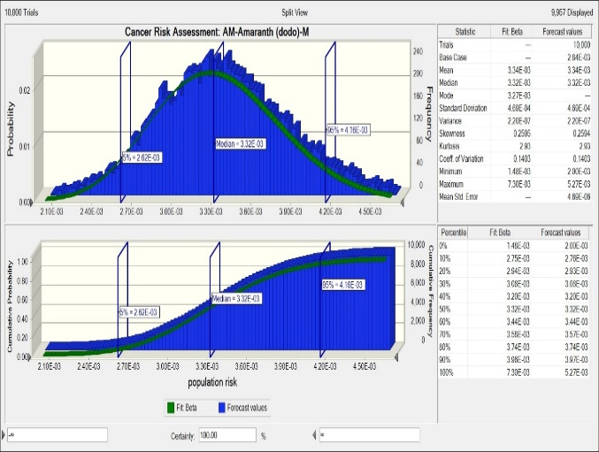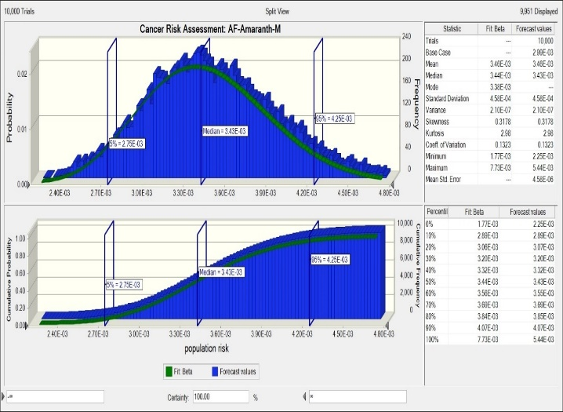
Percentage sensitivity analysis of carcinogenic metals
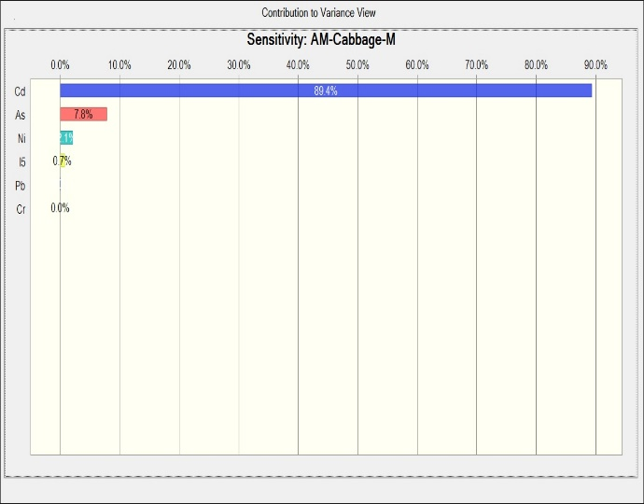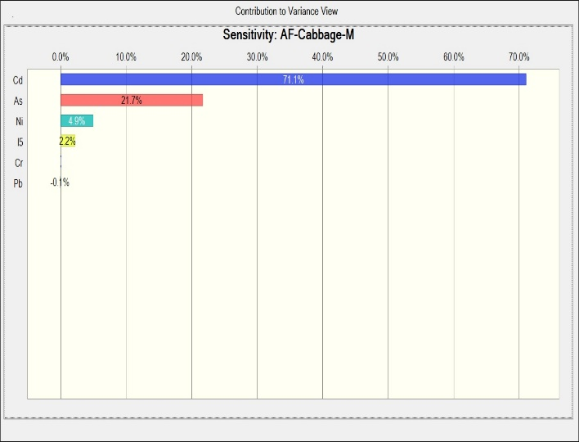
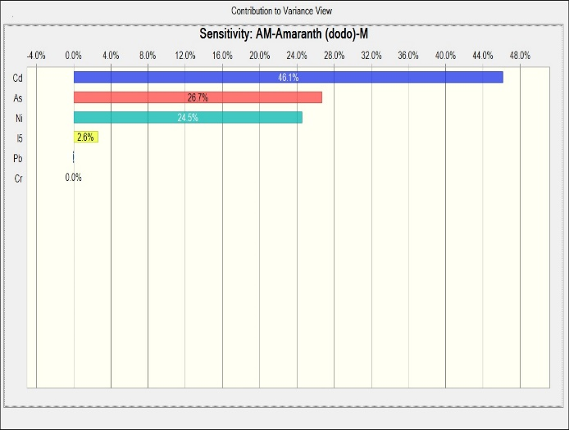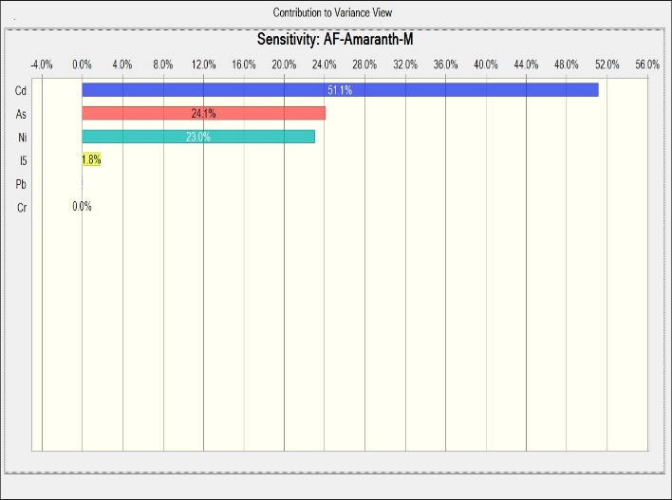
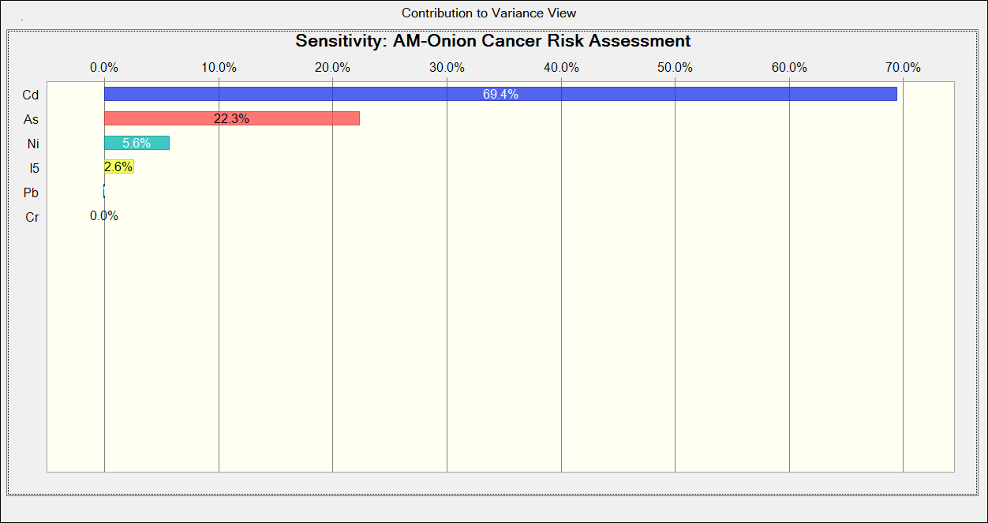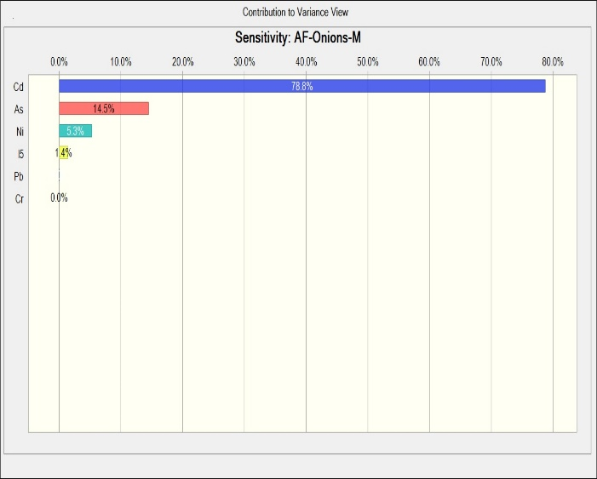
Table S1: Reference oral doses used for health risk assessment
Metals | RfDo (mg/kg/day) | References
As | 0.0003 | Yang et al. (2019)
Cd | 0.00089 | Ahmad et al. (2021)
Cr | 0.0009 | Wong et al. (2022)
Pb | 0.00026*; 0.00016# | Wong et al. (2022)
Hg | 0.00019 | Felix et al. (2022)
Ni | 0.02 | Gu et al. (2016)
Cu | 0.005 | Gu et al. (2016)
Co | 0.0003 | Finley et al. (2012)
Fe | 0.700 | Udom et al. (2022)
Se | 0.005 | Hao et al. (2024)
Mn | 0.140 | Udom et al. (2022)
V | 0.009 | Zhou et al. (2019)
Zn | 0.300 | Kamunda et al. (2016)
*: for young children; #: for older children and adults.

References
Ahmad, W., Alharthy, R. D., Zubair, M., Ahmed, M., Hameed, A., & Rafique, S. (2021). Toxic and heavy metals contamination assessment in soil and water to evaluate human health risk. Scientific Reports, 11(1), 17006. https://doi.org/10.1038/s41598-021-94616-4
Felix, C. S. A., Pereira Junior, J. B., da Silva Junior, J. B., Cruz, A. S., Dantas, K. G. F., & Ferreira, S. L. C. (2022). Determination and human health risk assessment of mercury in fish samples. Talanta, 247, 123557. https://doi.org/10.1016/j.talanta.2022.123557
Finley, B. L., Monnot, A. D., Paustenbach, D. J., & Gaffney, S. H. (2012). Derivation of a chronic oral reference dose for cobalt. Regulatory Toxicology and Pharmacology, 64(3), 491–503. https://doi.org/10.1016/j.yrtph.2012.08.022
Gu, Y.-G., Lin, Q., & Gao, Y.-P. (2016). Metals in exposed-lawn soils from 18 urban parks and its human health implications in southern China’s largest city, Guangzhou. Journal of Cleaner Production, 115, 122–129. https://doi.org/10.1016/j.jclepro.2015.12.031
Hao, L., Han, Y., Zhang, S., Luo, Y., Luo, K., Zhang, L., & Chen, W. (2024). Estimated daily intake and health risk assessment of total and organic selenium in crops across areas with different selenium levels. Journal of Trace Elements in Medicine and Biology, 86, 127525. https://doi.org/10.1016/j.jtemb.2024.127525
Kamunda, C., Mathuthu, M., & Madhuku, M. (2016). Health Risk Assessment of Heavy Metals in Soils from Witwatersrand Gold Mining Basin, South Africa. International Journal of Environmental Research and Public Health, 13(7), 663. https://doi.org/10.3390/ijerph13070663
Udom, G. J., Obilor, O. F., Ise, U. P., Onyeukwu, N. J., Udoh, A. E., Aturamu, A., & Yemitan, O. K. (2022). Heavy Metal Content of a Polyherbal Drug: Any Exposure-associated Public Health Risks? Journal of Health Sciences & Surveillance System, 10(2), 189–196. https://doi.org/10.30476/jhsss.2021.93527.1457
Wong, C., Roberts, S. M., & Saab, I. N. (2022). Review of regulatory reference values and background levels for heavy metals in the human diet. Regulatory Toxicology and Pharmacology, 130, 105122. https://doi.org/10.1016/j.yrtph.2022.105122
Yang, S., Zhao, J., Chang, S. X., Collins, C., Xu, J., & Liu, X. (2019). Status assessment and probabilistic health risk modeling of metals accumulation in agriculture soils across China: A synthesis. Environment International, 128, 165–174. https://doi.org/10.1016/j.envint.2019.04.044
Zhou, Y., Gao, L., Xu, D., & Gao, B. (2019). Geochemical baseline establishment, environmental impact and health risk assessment of vanadium in lake sediments, China. Science of The Total Environment, 660, 1338–1345. https://doi.org/10.1016/j.scitotenv.2019.01.093

