Integrated Experimental and Microstructural Analysis of Basalt Fiber-Reinforced Cemented Soils: Multivariable Strength Prediction and Residual Behavior Assessment

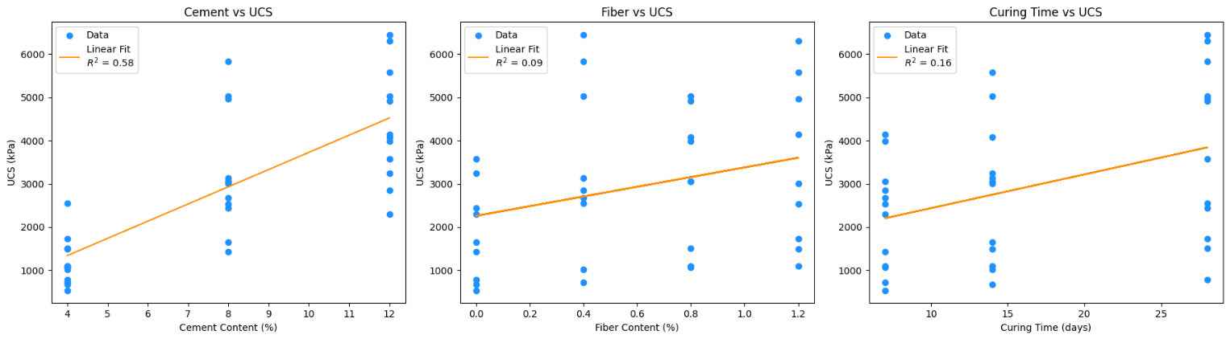
(a) | (b) | (c)
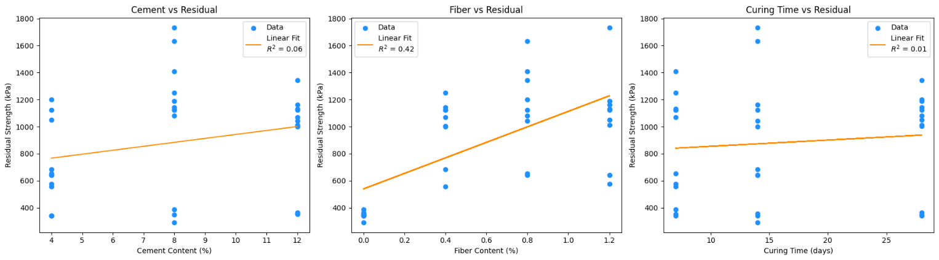
(d) | (e) | (f)
Figure S1: Correlation Between UCS and Residual Strength at Different Curing Periods
(a-c) UCS correlation at 7, 14, and 28 days
(d-f) Residual strength correlation at 7, 14, and 28 days

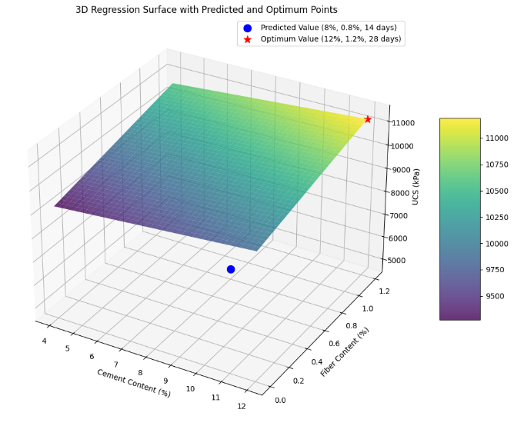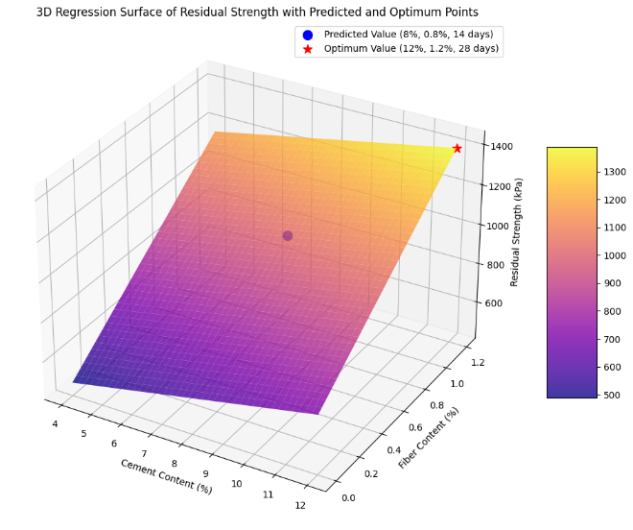
(a) | (b)
Figure S2: Regression Results: Predicted vs Actual Strength
(a)UCS regression model predictions
(b)Residual strength regression model predictions
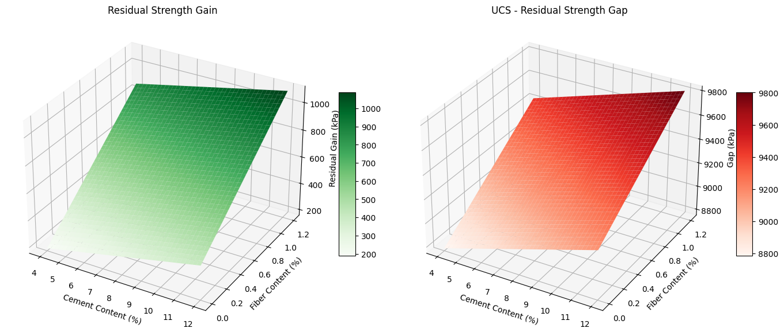
(a) | (b)

Figure S3: Residual Strength Gain vs UCS-Residual Gap
- Residual gain due to fiber content
- Gap between UCS and residual strength values across mixes

Table S1: Calculation Result Between Peak, Residual, RSR, Mean, Standard Deviation, COV, Brittleness Index
 | Mix Type | Peak Strength (kPa) | Residual Strength (kPa) | RSR | Mean Peak (kPa) | Mean Residual (kPa) | Standard Deviation | COV (%) | Brittleness Index
7 | S-4C-0F | 540,816326 | 341,836734 | 0,63207547 | 859,693923 | 531,887755 | 133,395033 | 25,0795459 | 0,36792452
7 | S-4C-0.4F | 724,489795 | 556,122449 | 0,76760563 | 859,693923 | 531,887755 | 133,395033 | 25,0795459 | 0,23239436
7 | S-4C-0.8F | 1071,42857 | 653,061224 | 0,60952381 | 859,693923 | 531,887755 | 133,395033 | 25,0795459 | 0,39047619
7 | S-4C-1.2F | 1102,041 | 576,530612 | 0,52314806 | 859,693923 | 531,887755 | 133,395033 | 25,0795459 | 0,47685193
14 | S-4C-0F | 668,3673 | 341,836734 | 0,51145041 | 1068,87751 | 577,806122 | 158,485243 | 27,4287927 | 0,48854958
14 | S-4C-0.4F | 1015,306 | 683,673469 | 0,67336691 | 1068,87751 | 577,806122 | 158,485243 | 27,4287927 | 0,32663308
14 | S-4C-0.8F | 1096,93877 | 642,857142 | 0,58606512 | 1068,87751 | 577,806122 | 158,485243 | 27,4287927 | 0,41395348
14 | S-4C-1.2F | 1494,898 | 642,857142 | 0,43003411 | 1068,87751 | 577,806122 | 158,485243 | 27,4287927 | 0,56996588
28 | S-4C-0F | 790 | 341,836734 | 0,43270472 | 1646,4795 | 928,571428 | 395,794741 | 42,6240491 | 0,56729527
28 | S-4C-0.4F | 2545,918 | 1122,44898 | 0,44088182 | 1646,4795 | 928,571428 | 395,794741 | 42,6240491 | 0,55911817
28 | S-4C-0.8F | 1515,306 | 1198,97959 | 0,79124585 | 1646,4795 | 928,571428 | 395,794741 | 42,6240491 | 0,20875414
28 | S-4C-1.2F | 1734,694 | 1051,02040 | 0,60588231 | 1646,4795 | 928,571428 | 395,794741 | 42,6240491 | 0,39411769
7 | S-4C-0F | 1428,571 | 387,755102 | 0,27142865 | 2426,02010 | 1042,09183 | 451,607472 | 43,3366289 | 0,72857134
7 | S-8C-0.4F | 2678,57142 | 1250 | 0,46666666 | 2426,02010 | 1042,09183 | 451,607472 | 43,3366289 | 0,53333333
7 | S-8C-0.8F | 3056,122 | 1408,16326 | 0,46076801 | 2426,02010 | 1042,09183 | 451,607472 | 43,3366289 | 0,53923198
7 | S-8C-1.2F | 2540,816 | 1122,44898 | 0,44176712 | 2426,02010 | 1042,09183 | 451,607472 | 43,3366289 | 0,55823287
14 | S-4C-0F | 1647,959 | 290,816326 | 0,17647060 | 2710,45913 | 1195,15306 | 659,702295 | 55,1981429 | 0,82352939
14 | S-8C-0.4F | 3127,551 | 1122,44898 | 0,35889070 | 2710,45913 | 1195,15306 | 659,702295 | 55,1981429 | 0,64110929
14 | S-8C-0.8F | 3061,22449 | 1632,65306 | 0,53333333 | 2710,45913 | 1195,15306 | 659,702295 | 55,1981429 | 0,46666666
14 | S-8C-1.2F | 3005,10204 | 1734,69387 | 0,57724957 | 2710,45913 | 1195,15306 | 659,702295 | 55,19814297 | 0,42275042
28 | S-4C-0F | 2438,776 | 346,938775 | 0,46861915 | 4563,77575 | 940,051020 | 397,836519 | 42,3207369 | 0,85774061
28 | S-8C-0.4F | 5831,633 | 1142,85714 | 0,05949256 | 4563,77575 | 940,051020 | 397,836519 | 42,3207369 | 0,80402450
28 | S-8C-0.8F | 5025,51 | 1081,63265 | 0,21522843 | 4563,77575 | 940,051020 | 397,836519 | 42,3207369 | 0,78477156
28 | S-8C-1.2F | 4959,184 | 1188,77551 | 0,23971191 | 4563,77575 | 940,051020 | 397,836519 | 42,3207369 | 0,76028808
7 | S-12C-0F | 2301,0204 | 352,040816 | 0,15299334 | 3321,42857 | 919,642857 | 379,347971 | 41,2494881 | 0,84700665
7 | S-12C-0.4F | 2857,1428 | 1071,42857 | 0,375 | 3321,42857 | 919,642857 | 379,347971 | 41,2494881 | 0,625
7 | S-12C-0.8F | 3979,5918 | 1122,44898 | 0,28205128 | 3321,42857 | 919,642857 | 379,347971 | 41,2494881 | 0,71794871
7 | S-12C-1.2F | 4147,9591 | 1132,65306 | 0,27306273 | 3321,42857 | 919,642857 | 379,347971 | 41,2494881 | 0,72693726
14 | S-12C-0F | 3244,8979 | 357,142857 | 0,53974904 | 4482,14285 | 890,306122 | 362,149072 | 40,6769158 | 0,88993710
14 | S-12C-0.4F | 5025,5102 | 1000 | 0,94050744 | 4482,14285 | 890,306122 | 362,149072 | 40,6769158 | 0,80101522
14 | S-12C-0.8F | 4076,5306 | 1040,81632 | 0,77258882 | 4482,14285 | 890,306122 | 362,149072 | 40,6769158 | 0,74468085
14 | S-12C-1.2F | 5581,6326 | 1163,26530 | 0,76028808 | 4482,14285 | 890,306122 | 362,149072 | 40,6769158 | 0,79159049
28 | S-12C-0F | 3571,4285 | 362,244898 | 0,82926829 | 5308,67346 | 929,846938 | 409,889525 | 44,0813975 | 0,89857142
28 | S-12C-0.4F | 6443,8775 | 1005,10204 | 0,15597783 | 5308,67346 | 929,846938 | 409,889525 | 44,0813975 | 0,84402216
28 | S-12C-0.8F | 4913,2653 | 1341,83673 | 0,27310488 | 5308,67346 | 929,846938 | 409,889525 | 44,0813975 | 0,72689511
28 | S-12C-1.2F | 6306,1224 | 1010,20408 | 0,16019417 | 5308,67346 | 929,846938 | 409,889525 | 44,0813975 | 0,83980582

Table S2: ANOVA Result

Source | Sum of Squares | DF | F-Value | P-Value
Cement | 60,638,660 | 1 | 103.79 | 1.44 × 10⁻¹¹
Fiber | 9,008,260 | 1 | 15.42 | 0.00043
Curing Time | 16,654,630 | 1 | 28.51 | 7.41 × 10⁻⁶
Residual | 18,696,540 | 32 | — | —
Table S3: Residual ANOVA
Factor | Sum of Squares | DF | F-Value | P-Value
Cement | 1,648,532 | 1 | 56.23 | < 0.001
Fiber | 3,255,894 | 1 | 111.06 | < 0.001
Curing Time | 494,381 | 1 | 16.84 | < 0.001
Residual Error | 936,317 | 32 | — | —

Table S4: Interaction Effects Analysis

Effect | F-value | P-value | Significance
Cement | 109.93 | 2.23 × 10⁻¹¹ | Significant
Fiber | 16.33 | 3.58 × 10⁻⁴ | Significant
Curing Time | 30.19 | 6.42 × 10⁻⁶ | Significant
Cement × Fiber | 2.55 | 0.1208 | Not significant
Cement × Curing Time | 2.20 | 0.1486 | Not significant
Fiber × Curing Time | 0.14 | 0.7120 | Not significant

Table S5: Validation UCS Result

Metric | Value
Mean Absolute Error (MAE) | 502.13 kPa
Root Mean Squared Error (RMSE) | 642.80 kPa
Coefficient of Determination (R²) | 0.85

Table S6: Validation Residual Result
Coefficient of Determination (R²) | Value (kPa)
Mean Absolute Error (MAE) | 111.59
Root Mean Squared Error (RMSE) | 134.24
Coefficient of Determination (R²) | 0.93

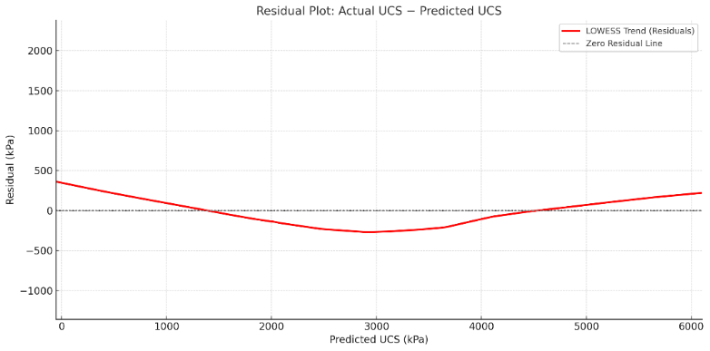 | 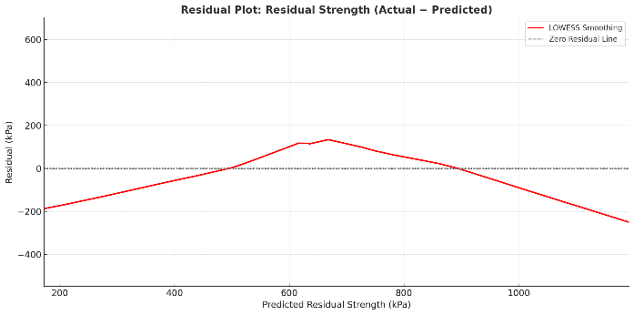
(a) | (b)
Figure S4: Regression Scatter Plots for UCS and Residual Strength Validation
(a) UCS-predicted vs measured
(b) Residual-predicted vs measured

