Appendix A.
Supplementary information about Factor Analysis
Figure X. Scree Plot of Factors.
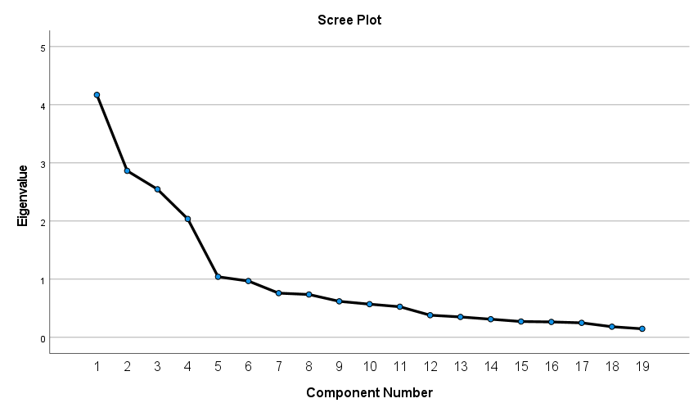
Table 1. Eigenvalues and Variance Explained
Factor | Before Extraction |  | After Extraction
Factor | Eigenvalue | Cumulative Variance % | Eigenvalue | Cumulative Variance %
1 | 4.17 | 21.95 | 4.17 | 21.95
2 | 2.86 | 37.02 | 2.86 | 37.02
3 | 2.55 | 50.42 | 2.55 | 50.42
4 | 2.04 | 61.14 | 2.04 | 61.14
5 | 1.04 | 66.62
6 | .97 | 71.72

The factor correlation matrix revealed low correlations among the factors, which reveals that we have managed to capture distinct factors.
Figure X. Factor Correlation Matrix
Factor | 1 | 2 | 3 | 4
1 | 1 | .20 | .11 | .15
2 | .20 | 1 | .16 | -.06
3 | .11 | .16 | 1 | -.05
4 | .15 | -.06 | -.05 | 1

We used principal axis method when extracting the factors, and promax rotation once we extracted the factors as our variables were correlated. To assess if the correlations between our variables were large enough to conduct a factor analysis, we conducted a Bartlett’s test of sphericity, X² = (171) = 3571.23, p < .000, indicating enough difference among correlations, which warrants a factor analysis. Kaiser-Meyer-Olkin measure was also .78, above the suggested cutoff of .50 (Field, 2018). As we have a sample size that is larger than recommended, we scrutinized the Scree Plot instead of using an Eigenvalue cutoff of 1. An assessment of the inflection points on the scree plot (where the slope/second derivative changes) led to 4 dimensions. These dimensions explained 61.14% of the variance. As we conducted a promax rotation, we focused on the pattern matrix in understanding how the variables load in factors. Note that we suppressed scores below .30. (See Table 1).
To test the theoretical validity of our decision to use election night and past event characteristics to predict future event characteristics, we conducted another factor analysis with election night and future event characteristics. If remembering the past and projecting the future are tightly related, present-past and present-future factors should not differ much, as the pathways between the past and the future converge. If they are different processes, the variables that contribute to the factors should remain relatively stable. The factor loadings for the present-future appeared to be very similar to the factor loadings of the present-past. Factor 1, 3 and 4 consisted of the exact same variables (Factor 3 had Future Agency and Valence instead of Past Agency and Valence as per the analysis). Factor 2 converged in the Personal, National, and Generational importance of the Future and Past events, but while the present-past Factor 2 had temporal distance between the election night and the past event, the present-future factor 2 had international importance of the future event in its place. We believe this slight change is due to the fact that the judgments of temporal distance stem from lived experience, so it is not a factor when projecting into the future.

Appendix B.
Supplementary information about Factor Fit
To assess how well the participants fit the particular category, we calculated the distance between the best fit factor, and the second best fit factor. This distance was .55 for Election Reflection Factor (SD = .44, Min = 0.02, Max = 1.57), .48 for Recent Past Importance Factor (SD = .35, Min = .01, Max = 1.70), 1.04 for Agentic Past Achievement Factor (SD = .60, Min = .07, Max = 2.97), and .65 for Election Glorification Factor (SD = .44, Min = 0, Max = 1.57).
Figure 4.
Factor scores for the best fit factor.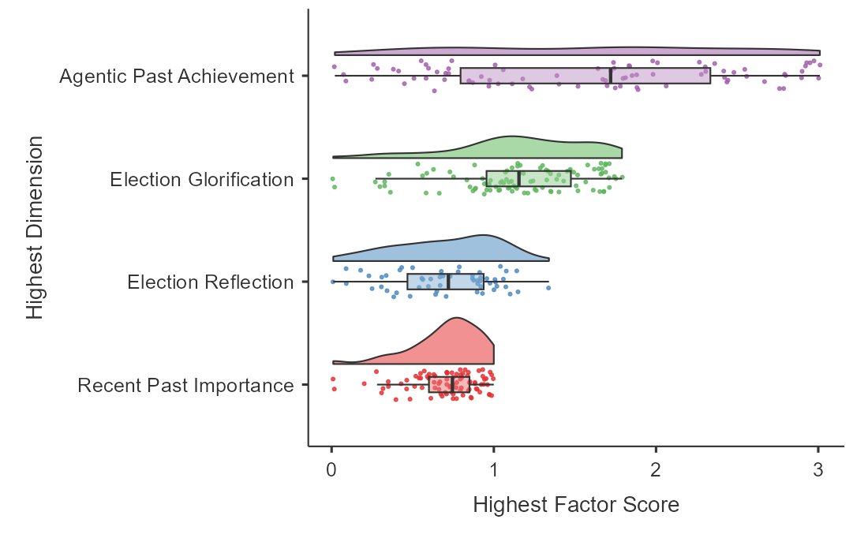
Figure 5.
The distance between the best and the second best fit factor.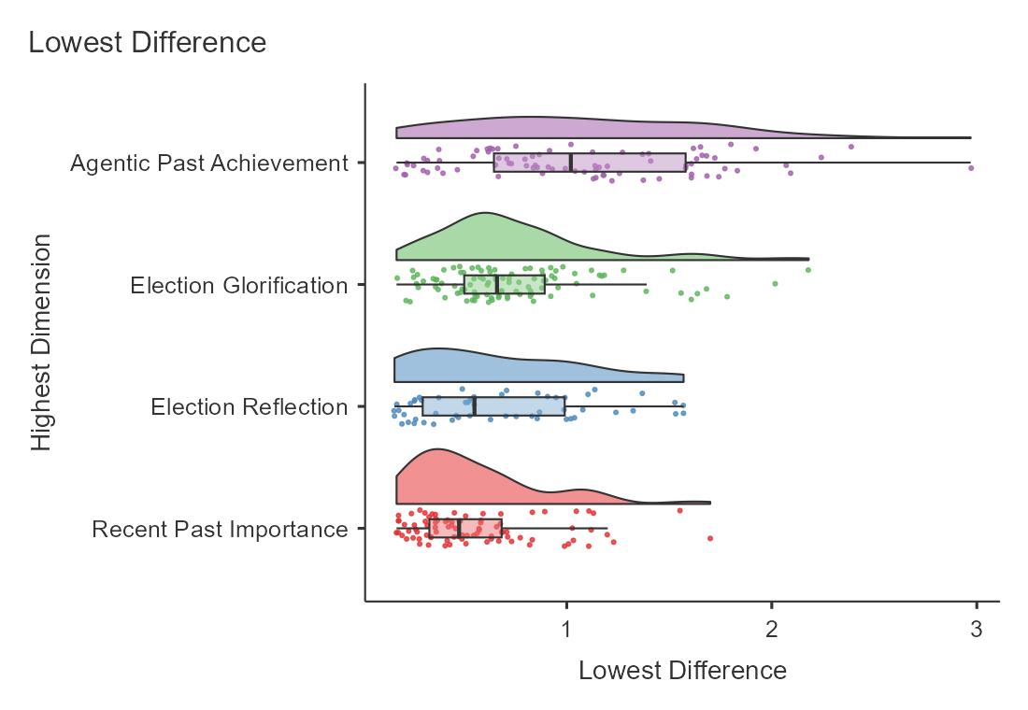
Overall, there are participants that do not have very high factor scores, but Figure 4 does not suggest a problematic distribution that skews towards an unrepresentative factor, or a bimodal distribution that suggests we were missing a factor embedded in another. There were also participants that were a close match to a second factor. Figure 5 suggests a distribution skewed towards a close match for Election Reflection and Recent Past Importance factors. They are both opposition heavy factors, and the main difference between them is party identification. Thus, we believe our classification captures a small difference between two groups that are highly similar.

Appendix C.
Supplementary information about Factor Characteristics

Age differed across factors, F(3, 193.2) = 5.13, p = .002, in Welch’s ANOVA conducted due to significant Levene’s test, p = .02. Participants in Agentic Past Achievement (M = 41.5, CI [38.6, 44.4]) and Election Glorification pathways (M = 42.6, CI [40.1, 45.0]) were older than participants in Recent Past Importance (M = 36.2, CI [33.6, 38.6]), t(185) = 2.83, p = .03, d = .39, t(219) = 3.54, p = .003, d = .47. The post-hoc tests for unequal variances were Games-Howell tests. There were no significant differences among other factors.
Party identification differed across factors, F(3, 280) = 3.01, p = .03. This difference emerge because of differences among two-opposition heavy factors: Election Reflection participants (M = 4.14, CI [3.87, 4.40]) identified with their party more than Recent Past Importance participants (M = 3.68, CI [3.46, 3.90]), t(280) = 2.83, ptukey = .03, d = .48. This highlights a differentiation between the two opposition-heavy factors. There was no significant difference among other factors.
Participants differed on left-right spectrum across factors, F(3, 158) = 88.49, p < .001 in a Welch’s ANOVA as Levene’s test was significant, p < .001. Election glorifying participants (M = 4.32, CI [4.07, 4.57]) rated themselves significantly more rightwing than Election Reflection participants (M = 1.94, CI [1.64, 2.24]), t(120) = 13.38, p < .001, d = 1.9, Recent Past Importance participants (M = 2.07, CI [1.78, 2.36]), t(137) = 13.23, p < .001, d = 1.8, and Agentic Past Achievement participants (M = 3.16, CI [2.88, 3.44]), t(114) = 5.46, p < .001, d = .93. This demonstrates that Erdogan supporters are aligned with his positioning in Turkish politics as a right-wing conservative. Agentic Past Achievement participants were also more rightwing than Recent Past Importance t(135) = 4.68, p < .001, d = .87, and Election Reflection participants, t(135) = 5.1, p < .001, d = .98.
Factors differed on religiosity, F(3, 190) = 33.82, p < .001 in a Welch’s ANOVA as Levene’s test was significant, p = .006. Similar to left/right spectrum, election glorifying participants (M = 3.09, CI [2.95, 3.24]) rated themselves significantly more religious than Election Reflection participants (M = 2.15, CI [1.97, 2.34]), t(138) = 7.83, p < .001, d = 1.2, Recent Past Importance participants (M = 2.28, CI [2.06, 2.36]), t(219) = 9.07, p < .001, d = 1.13, and Agentic Past Achievement participants (M = 2.56, CI [2.40, 2.73]), t(164) = 4.48, p < .001, d = .68. Agentic Past Achievement participants were also more religious than Election Reflection participants, t(152) = 3.00, p = .02, d = .53 and Recent Past Importance participants t(158) = 3.02, p = .02, d = .45.
Patriotism did not differ across factors, F(3, 193) = 2.55, p = .06.
There were differences in how emotional participants from different factors felt after learning the results of the election, Welch’s F(3, 199.23) = 5.23, p = .002. Election Reflection participants (M = 4.18, CI [3.87, 4.50]), felt significantly more emotional than Recent Past Importance participants (M = 3.46, CI [3.20, 3.72]), t(169.18) = 3.83, p = .001, d = . 54. This points to a divergence in the opposition participants, where participants in Recent Past Importance factor were more disengaged emotionally.
Participants differed on how they expected the economic results of the election to affect them in the long run (-2= Very Negative, 0= Neutral, 2= Very Positive), Welch’s F(3, 196.01) = 37.93, p < .001. Election Reflection participants (M = -1.55, CI [-1.9, -1.2]) expected worse economic impact than Recent Past Importance participants (M = -0.44, CI [-.72, -.15]), t(173.16) = -5.09, p < .001, d = .75, Agentic Past Achievement participants (M = -0.29, CI [-.61, .02]), t(152.85) = -5.46, p < .001, d = . 85, and election glorifying participants (M = 0.46, CI [.19, .73]), t(155.83) = -10.69, p < .001, d = 1.35. Election glorifying participants, on the other hand, had faith in the positive economic impact of election, as their expectation was more positive than Recent Past Importance participants, t(195.5) = -4.41, p < .001, d = .60 and Agentic Past Achievement participants, t(155.49) = -3.46, p = .004, d = . 50. Notice only the election glorifying participants has positive value in future economic expectation.
We also assessed how psychological motivations like Need for Cognitive Closure, System Justification, Collective Nostalgia and Collective Anxiety differed across the dimensions. There were no differences in NFC scores across factors, F(3, 197) = 1.44, p = .23.
System Justification differed across factors, F(3, 197) = 71.92, p < .001 in a Welch’s ANOVA as Levene’s test was significant, p < .001. Participants in Election Glorification Factor (M = 3.28, CI [3.17, 3.39]) had significantly higher SJ scores than participants in Election Reflection Factor (M = 2.26, CI [2.12, 2.40]), t(173) = 13.73, p < .001, d = 1.71, Recent Past Importance Factor (M = 2.47, CI [2.35, 2.58]), t(220) =11.01, p < .001, d = 1.36, and Agentic Past Achievement Factor (M = 2.88, CI [2.75, 3.01]), t(146) = 4.04, p < .001, d = .67 in the post hoc comparisons. Participants in Agentic Past Achievement were higher System Justifiers than participants in Election Reflection Factor, t(138) = 6.16, p < .001, d = 1.04 and Recent Past Importance Factor, t(144) = 4.09, p < .001, d = .69. Participants in Recent Past Importance Factor were higher System Justifiers than participants in Election Reflection Factor, t(166) = 2.81, p = .03, d = .35
Collective Angst differed across factors, F(3, 200) = 46.94, p < .001 in a Welch’s ANOVA as Levene’s test was significant, p < .001. Participants in Election Reflection (M = 4.43, CI [4.19, 4.67]) and Recent Past Importance (M = 4.30, CI [4.10, 4.49]) had significantly higher collective angst scores than participants in Agentic Past (M = 3.58, CI [3.36, 3.80]), t(125) = 5.41, p < .001, d = .83, t(129) = 4.57, p < .001, d = .70 in the post hoc comparisons. Participants in Election Reflection, Recent Past Importance and Agentic Past all had higher collective angst scores than Election Glorifers, (M = 3.00, CI [2.82, 3.19]), t(182) = 10.88, p < .001, d = 1.4. t(198) = 9.85, p < .001, d = 1.27, t(174) = 3.23, p = .008, d = .56.
Collective Nostalgia differed across factors, F(3, 198) = 23.23, p < .001 in a Welch’s ANOVA as Levene’s test was significant, p = .001. Participants in Election Glorifiers (M = 3.11, CI [2.94, 3.29]) had lower collective nostalgia scores than Election Reflection (M = 4.16, CI [3.94, 4.39]), Past Event Importance (M = 3.80, CI [3.62, 3.99]), and Agentic Past (M = 3.59, CI [3.38, 3.79]), t(175) = 8.19, p < .001, d = 1.08, t(221) = 5.47, p < .001, d = .72, t(165) = 3.09, p = .01, d = .49. Participants in Agentic past and Recent Past Importance also had lower collective nostalgia scores than Election Reflection, t(149) = 3.73, p = .002, d = .59, t(166) = 2.82, p = .03, d = .37, respectively.

Appendix D.
Supplementary information about Future Agency Differences

Participants came up with equally vivid future events, as there was no difference in vividness across pathways, F(3, 376) = 2.41, p = .07.
We conducted a 3X4 repeated measures ANOVA, where the importance rating of the event (personal, national, generational) was the within subjects variable, and the MTT pathway as the between subjects variable. There were no pathway based differences in future event importance, F(6, 752) = .64, p = .70, so the future projections are equally important across pathways. This is in line with the cues given in the experiment, which directed mental time travel through an event equally important as the recent election. However, the national importance (M = 4.74, CI [4.69, 4.80]) of the future event was higher than personal (M = 4.58, CI [4.50, 4.65]), t(376) = 5.72, ptukey < .001, d = .31, and generational importance (M = 4.59, CI [4.52, 4.66]), t(376) = 5.33, p < .001, d = .28, hinting at a national, not individual or generational mental time travel, F(2, 752) = 21.5, p < .001, partial η²= .05. This is in line with the cues we gave to the participants.

All of the post-hoc tests reported are Games-Howell tests, unless it is reported as Tukey’s.

