Supplementary Material S5: Data from different articles
- Data from Maruyama et al. ¹
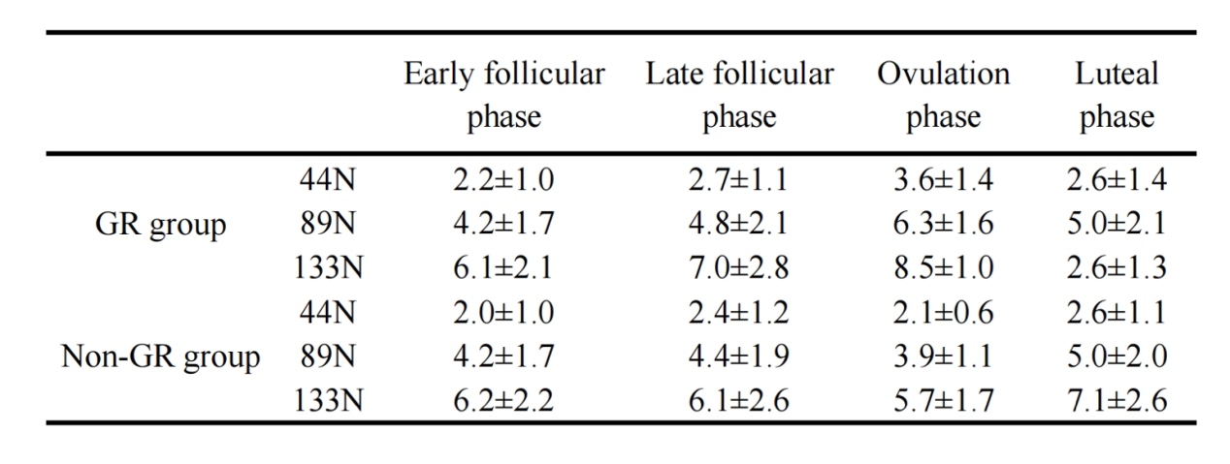

References：
1. Maruyama S, Yamazaki T, Sato Y, et al. Relationship Between Anterior Knee Laxity and General Joint Laxity During the Menstrual Cycle. Orthop J Sports Med. Mar 2021;9(3):2325967121993045. doi:10.1177/2325967121993045

- Data from Maruyama et al. ¹
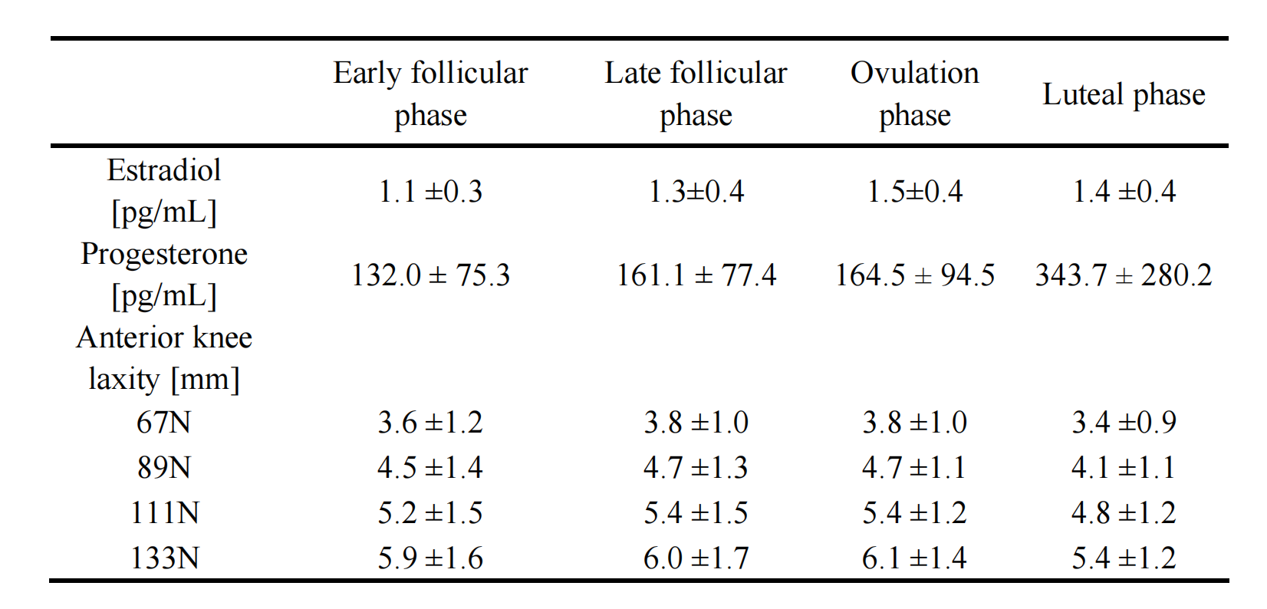

References：
1. Maruyama S, Sekine C, Shagawa M, et al. Menstrual Cycle Changes Joint Laxity in Females-Differences between Eumenorrhea and Oligomenorrhea. J Clin Med. Jun 5 2022;11(11)doi:10.3390/jcm11113222

- Data from Shagawa et al.¹
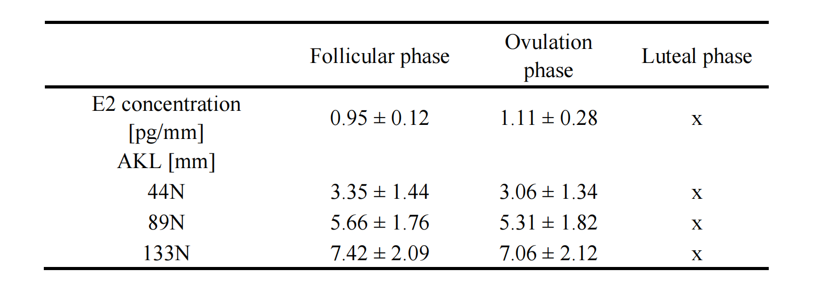

References：
1. Shagawa M, Maruyama S, Sekine C, et al. Comparison of anterior knee laxity, stiffness, genu recurvatum, and general joint laxity in the late follicular phase and the ovulatory phase of the menstrual cycle. BMC Musculoskelet Disord. Oct 18 2021;22(1):886. doi:10.1186/s12891-021-04767-8

- Data from Carcia et al. ¹
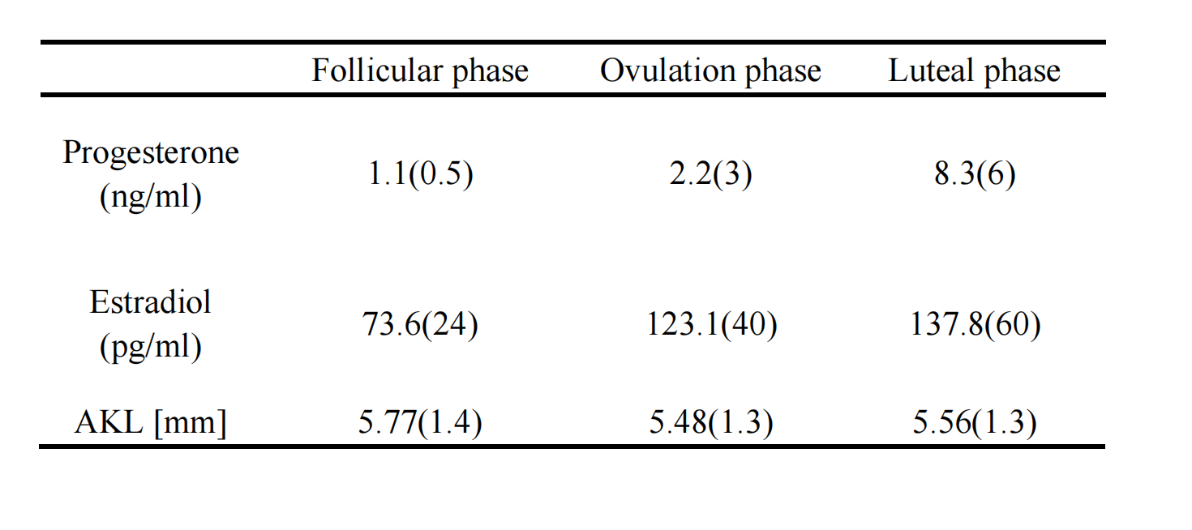

References：
1. Carcia CR, Shultz SJ, Granata KP, Gansneder BM, Perrin DH. Knee ligament behavior following a controlled loading protocol does not differ by menstrual cycle day. Clin Biomech (Bristol, Avon). Dec 2004;19(10):1048-54. doi:10.1016/j.clinbiomech.2004.07.006

- Data from Park et al.¹
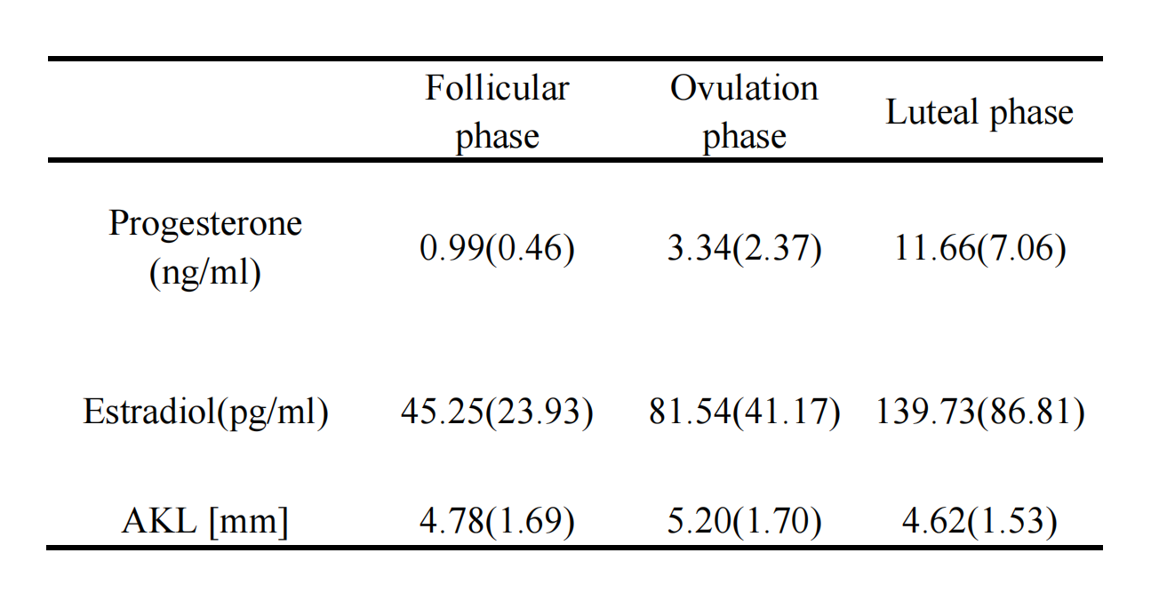

References：
1. Park SK, Stefanyshyn DJ, Ramage B, Hart DA, Ronsky JL. Relationship between knee joint laxity and knee joint mechanics during the menstrual cycle. Br J Sports Med. Mar 2009;43(3):174-9. doi:10.1136/bjsm.2008.049270

- Data from Shafiei et al.¹
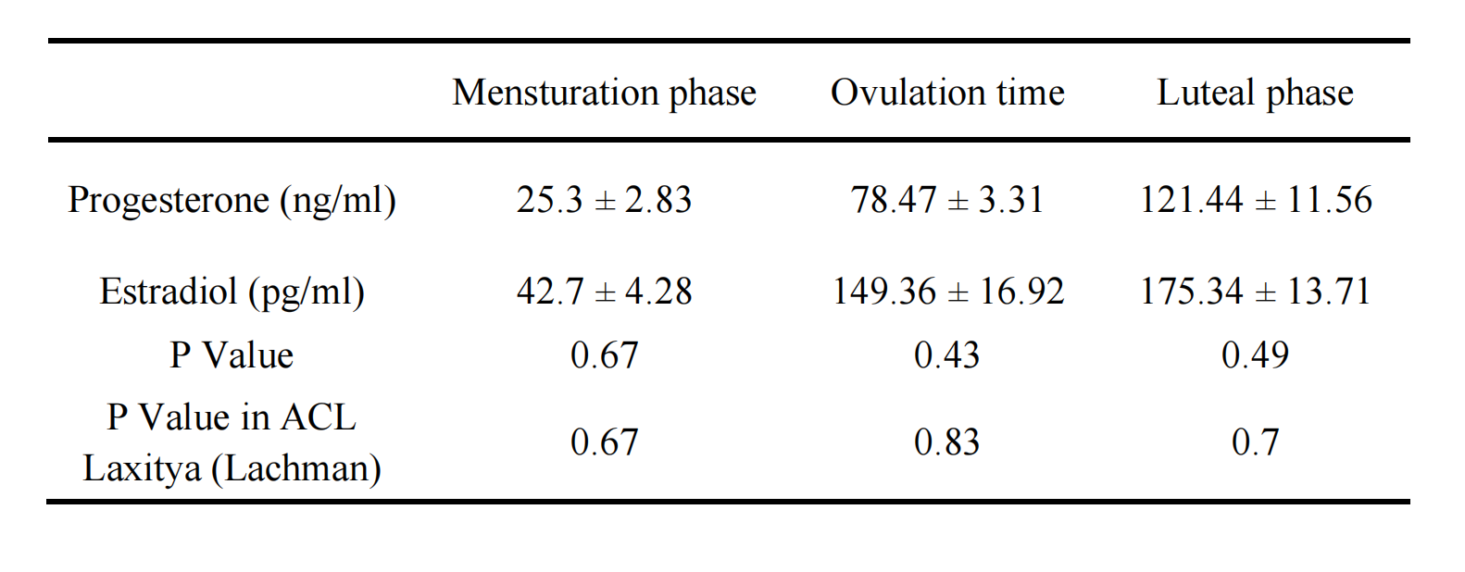

References：
1. Shafiei SE, Peyvandi S, Kariminasab MH, et al. Knee Laxity Variations in the Menstrual Cycle in Female Athletes Referred to the Orthopedic Clinic. Asian J Sports Med. Dec 2016;7(4):e30199. doi:10.5812/asjsm.30199

- Data from Dehghan et al.¹
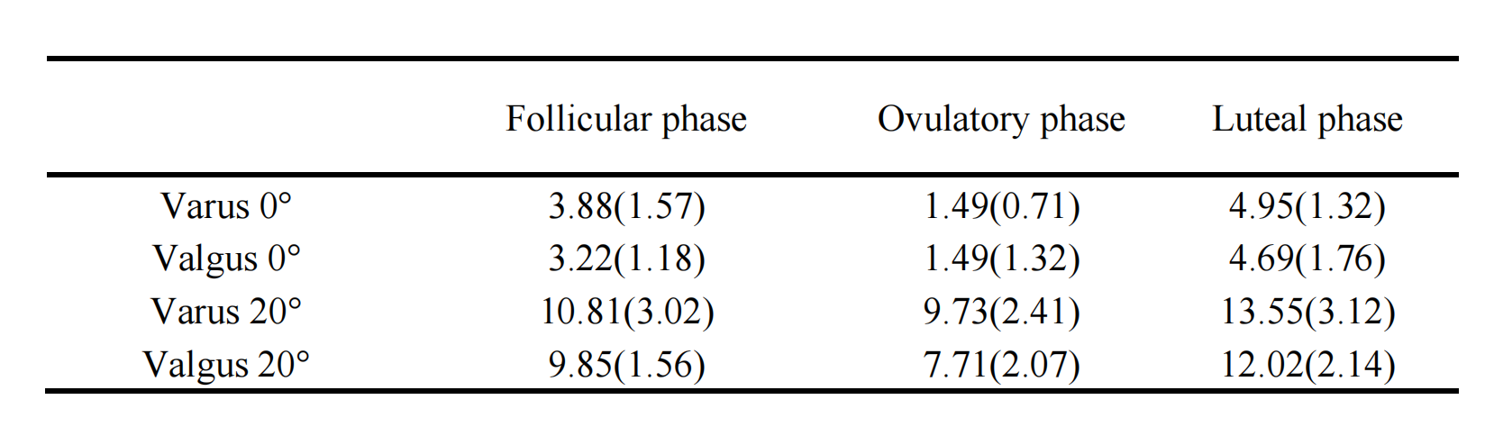

References：
1. Dehghan F, Soori R, Yusof A. Knee Laxities Changes with Sex-steroids throughout the Menstrual Cycle Phases in Athlete and Non-athlete Females. Rev Bras Ortop (Sao Paulo). Feb 2024;59(1):e29-e37. doi:10.1055/s-0043-1771007

- Data from Shultz et al.¹
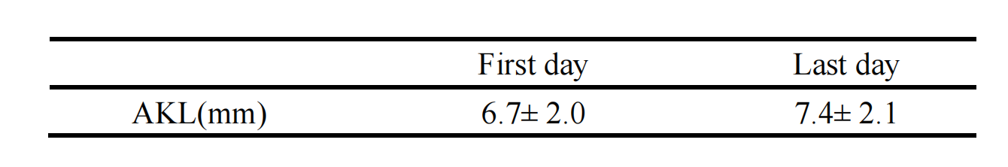

References：
1. Shultz SJ, Schmitz RJ, Nguyen AD, et al. Knee joint laxity and its cyclic variation influence tibiofemoral motion during weight acceptance. Med Sci Sports Exerc. Feb 2011;43(2):287-95. doi:10.1249/MSS.0b013e3181ed118d

