Supplementary material
Table S1. Geographical coordinates, mean annual temperature (MAT, ℃), mean annual precipitation (MAP, mm), and tree species at each experimental site.
Site | Latitude | Longitude | MAT (℃) | MAP (mm)
LS | 47°11′ 3″ | 128°53′ 26″ | -0.31 | 588.12
MERS | 45°16′ 35″ | 127°34′ 44″ | 2.58 | 556.41
LSH | 42° 33′ 13″ | 127° 36′ 57″ | 3.21 | 783.62
CHK | 40° 51′ 25″ | 123° 53′ 82″ | 5.92 | 835.89
Site abbreviations: LS (Liangshui), MERS (Maoershan), LSH (Lushuihe), and CHK (Caohekou).

Table S2. Differences in soil physicochemical properties between two plantation types across four sites.
 | LG |  |  |  | PK
 | LS | MERS | LSH | CHK | LS | MERS | LSH | CHK
pH | 4.80±0.02c | 5.74±0.08a | 5.19±0.03b | 4.86±0.02c | 5.26±0.02ab | 5.60±0.23a | 5.63±0.01a | 5.04±0.01b
TC  (g.kg⁻¹) | 81.90±3.96a | 66.27±1.76b | 46.87±0.03c | 31.80±0.72d | 76.70±0.57a | 45.63±4.79b | 40.70±0.20b | 35.37±0.09b
TN  (g.kg⁻¹) | 9.51±0.70a | 4.47±0.03b | 4.85±0.19b | 2.44±0.27c | 8.93±0.49a | 5.52±0.35b | 4.20±0.18c | 3.36±0.05c
TP  (g.kg⁻¹) | 1.02±0.03c | 1.59±0.02a | 1.33±0.02b | 1.49±0.02a | 1.21±0.04a | 0.98±0.08ab | 1.06±0.02ab | 0.89±0.05b
Clay | 18.70±0.33b | 5.65±0.147d | 21.20±0.61a | 12.7±0.55c | 18.90±0.19b | 23.8±1.62a | 19.7±0.55b | 9.62±0.38c
Silt | 22.42±0.30b | 33.47±0.60a | 24.41±0.48b | 32.62±0.57a | 21.28±0.63b | 25.41±2.32b | 32.39±0.60a | 32.31±0.61a
Sand | 59.18±0.63a | 61.34±0.58a | 59.73±0.87a | 58.480.46a | 59.14±0.29a | 55.14±1.04b | 54.54±0.56b | 61.23±0.94a
Different lowercase letters indicate significant differences (p < 0.05) in soil properties among sites. Plantation type effects (p < 0.05) denote significant differences between the two plantation types. Abbreviations: pH, soil pH; TC, total carbon content; TN, total nitrogen content; TP, total phosphorus content; Clay, clay content; Silt, silt content; Sand, sand content.

Table S3. Results of two-way ANOVA for the effects of site and species on soil physicochemical properties
 | F value |  |  | P value
 | Site | Species | Species×Site | Site | Species | Species×Site
pH | 29.709 | 15.125 | 5.372 | <0.001 | 0.001 | 0.009
TC  (g.kg⁻¹) | 145.562 | 18.985 | 9.437 | <0.001 | <0.001 | <0.001
TN  (g.kg⁻¹) | 116.809 | 0.540 | 3.432 | <0.001 | 0.473 | 0.042
TP  (g.kg⁻¹) | 6.322 | 131.990 | 45.256 | 0.005 | <0.001 | <0.001
Clay | 71.322 | 49.770 | 100.561 | <0.001 | <0.001 | <0.001
Silt | 42.696 | 0.323 | 22.962 | <0.001 | 0.578 | <0.001
Sand | 5.458 | 18.526 | 17.770 | <0.001 | <0.001 | <0.001

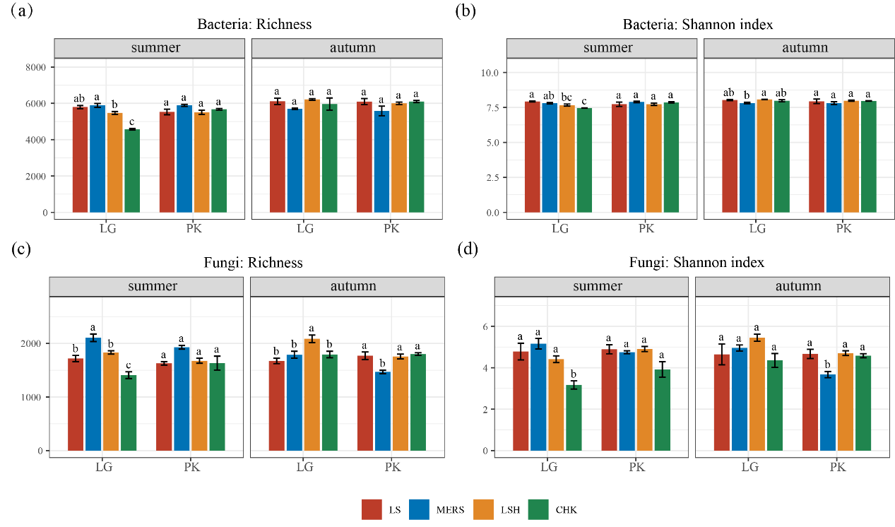
Fig. S1. Divergence in soil microbial diversity between two plantation types across four sites, with (a) bacterial richness, (b) bacterial Shannon index, (c) fungal richness, and (d) fungal Shannon index in the summer and autumn seasons. Column heights represent mean values, error bars indicate standard errors (SE). Different lowercase letters denote significant inter-site differences (p < 0.05) based on post hoc comparisons. Site abbreviations: LS (Liangshui), MERS (Maoershan), LSH (Lushuihe), and CHK (Caohekou). Species abbreviation: LG (Larix gmelinii), PK (Pinus koraiensis).
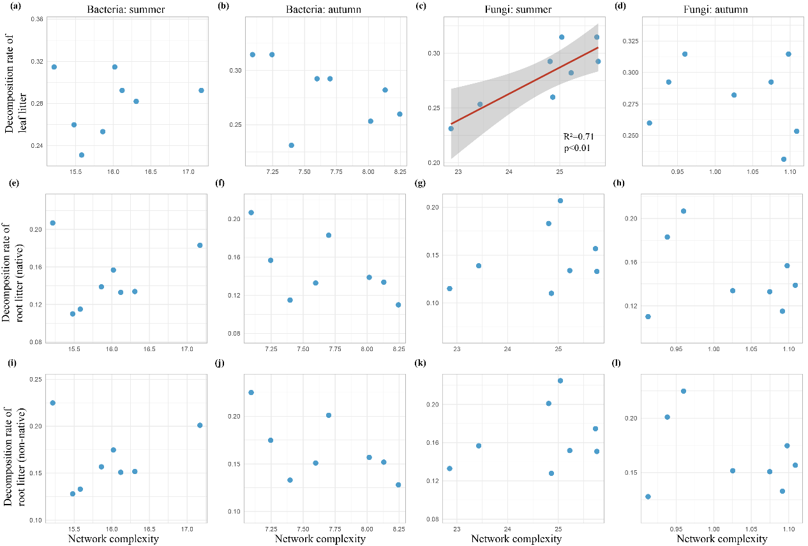
Fig. S2. Relationships between decomposition rates (k) of leaf and first-order root litter and complexity of the soil microbial network complexity in the summer and autumn.

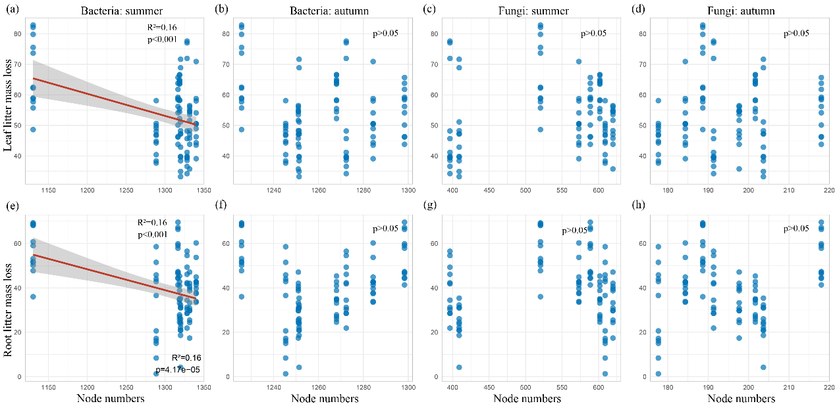
Fig. S3. Relationships between mass loss rates of leaf and first-order root litter and node numbers of the soil microbial network complexity in the summer and autumn.

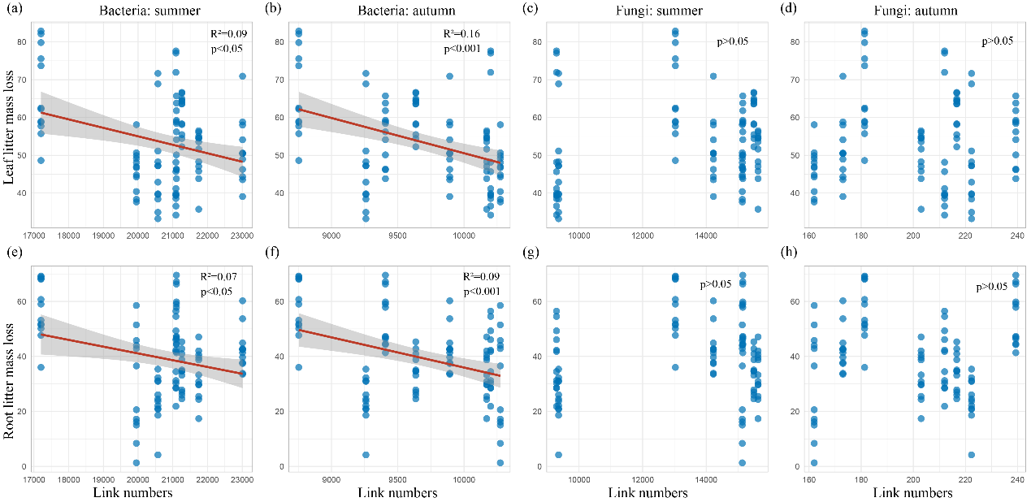
Fig. S4. Relationships between mass loss rates of leaf and first-order root litter and link numbers of the soil microbial network complexity in the summer and autumn.

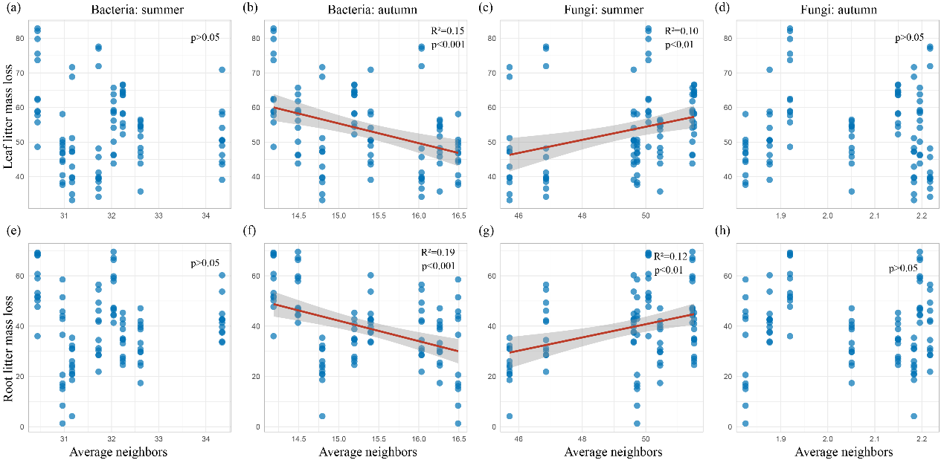
Fig. S5. Relationships between mass loss rates of leaf and first-order root litter and average neighbors of the soil microbial network complexity in the summer and autumn.

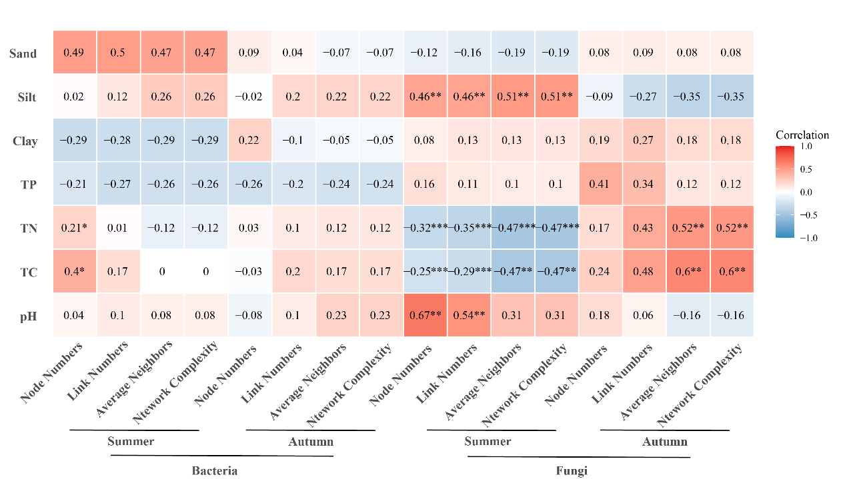
Fig. S6. Spearman's correlation analysis between microbial (bacterial and fungal) subnetwork topological features and soil physicochemical properties in the summer and autumn seasons. Asterisks denote statistical significance levels: * p < 0.05, ​** p < 0.01, ​*** p < 0.001. Abbreviations: pH, soil pH; TC, total carbon content; TN, total nitrogen content; TP, total phosphorus content; Clay, clay content; Silt, silt content; Sand, sand content.

