Appendix –

Training TikTok creators in mental health communication can benefit their audiences on social media

Yuning Liu*
PhD Candidate
The Harvard Kenneth C. Griffin Graduate School of Arts and Sciences
Center for Health Communication, Harvard T.H. Chan School of Public Health
yuning_liu@g.harvard.edu

Matt Motta*
Assistant Professor
Dept. of Health Law, Policy, & Management
Boston University School of Public Health
mmotta@bu.edu

Kenzie Brenna
Creator, @KenzieBrenna
talktokenzie@gmail.com

Shahem McLaurin
Therapist and Creator, @5hahem
shahem@rekaenergy.com

Katharine Speer
Strategist
Center for Health Communication
Harvard T.H. Chan School of Public Health.
hi@katespeer.com

Elissa Scherer
Communication Coordinator
Center for Health Communication
Harvard T.H. Chan School of Public Health.
Escherer@hsph.harvard.edu

Maurice A. Smith
Professor of Bioengineering
Harvard University John A. Paulson School of Engineering and Applied Sciences
Harvard University Center for Brain Science
mas@seas.harvard.edu

Amanda Yarnell
Senior Director
Center for Health Communication
Department of Social and Behavioral Sciences
Harvard T.H. Chan School of Public Health
ayarnell@hsph.harvard.edu

* Are co-first authors

Table A1. Performance of fine-tuned LLMs in classifying comments into study outcomes in the on-platform RCT

 | Epoch of best model | N=0 | N=1 | Precision | Recall | F1 Score | Accuracy
Knowledge construction
Personal reflection | 5 | 2748 | 2739 | 0.95 | 0.95 | 0.95 | 0.95
Express agreement | 5 | 2169 | 2213 | 0.94 | 0.94 | 0.94 | 0.94
Express disagreement | 10 | 328 | 338 | 0.91 | 0.90 | 0.90 | 0.90
Ask clarification questions | 6 | 400 | 413 | 0.93 | 0.93 | 0.93 | 0.93
Reinterpret knowledge | 5 | 2458 | 2559 | 0.95 | 0.95 | 0.95 | 0.95
Apply knowledge to new area | 10 | 1794 | 1822 | 0.95 | 0.95 | 0.95 | 0.95
Text-preprocessing
Emoji only | 1 | 619 | 32 | 0.99 | 0.99 | 0.99 | 0.99
Tagging only | 2 | 741 | 24 | 0.99 | 0.99 | 0.99 | 0.99
* Disclose receiving wb-related prof. Service: Disclose receiving wellbeing-related professional service
Note: The model was fine-tuned by embedding texts using the BERT (bert-base-uncased) architecture.

Table A2. The codebook for the outcomes in the on-platform RCT
Measurement | Definition | Example TikTok video comments
Foundational mental health knowledge construction
Personal reflection | The comment contain statements of the commenter’s personal experience, personal thoughts, or examples | “Omg! I woke last night with the most uncomfortable sensation of not being myself. I was a completely separate observer of this person running in auto”
Advanced mental health knowledge construction
Express agreement | The comment contain statements expressing agreement with the video content | “This is so true - we are living in our own illusion! Now to commit the movie right in front of me…❤️🔮”
Express disagreement | The comment contain statements expressing disagreement with the video content | “ooh I agree with much of what you say except for fact that the reason why people escape to the mind movie is because they'r tryescape real-world prob”
Ask clarification questions | The comment ask for more clarification or information regarding the video content, or express confusion | “I still do not understand the reason for physical illusion or purpose”
Reinterpret knowledge | The commenter uses the information in the video to clarify or challenge their own knowledge or experience. Comments in this category meet two criteria:  1) The comment should provide an interpretation or analysis of the opinions or ideas presented within the content of the video.  2) There must be a discernible link between these ideas or opinions and the knowledge or experience | “THIS ANALOGY 🤧my instinct was to always fight my feelings instead of surrendering, learning to let go and feel the rain - thank u for this!!!”
Apply knowledge to new area | The commenter applies knowledge gained from the video to develop new ideas or opinions in another area. Comments that fall into this category should: 1) provide an interpretation or analysis of the opinions or ideas presented within the content of the video. 2) develop new ideas or opinions based on the interpretation in 1). | (In a video of resisting emotion) “We can get so caught up in trying to “feel right” that it becomes a compulsion. There is no “feeling right” there’s existing. And existing is experiencing emotions, feelings, thoughts. And not judging ourselves for them. Rather embracing that that is what makes us human.”

Table A3. The inter-coder reliability assessment results in the on-platform RCT

 | Percent Agreement | Gwett’s AC
By coding sections
All questions | 0.81 | 0.80
Filtering questions | 0.92 | 0.89
Knowledge construction questions | 0.72 | 0.69
By coding questions
Filtering questions
Tagging only | 0.99 | 0.99
Emoji only | 0.85 | 0.83
Knowledge construction questions
Personal reflection | 0.73 | 0.61
Express agreement | 0.68 | 0.48
Express disagreement | 0.80 | 0.76
Ask clarification questions | 0.82 | 0.78
Reinterpret knowledge | 0.68 | 0.55
Apply knowledge to new area | 0.75 | 0.70

Table A4. Estimated prevalence of mental health knowledge construction in treatment and control groups
 | Foundational  mental health knowledge construction |  |  |  |  | Advanced  mental health knowledge construction
 | Pre period |  | Post period |  |  | Pre period |  | Post period
 | Prev. | 95% CI | Prev. | 95% CI |  | Prev. | 95% CI | Prev. | 95% CI
Toolkits-only VS control
Toolkits-only | 32.86 | (27.21, 38.52) | 35.02 | (29.22, 40.82) |  | 76.93 | (73.69, 80.17) | 77.16 | (73.81, 80.50)
Control | 31.57 | (26.24, 36.91) | 29.58 | (23.86, 35.29) |  | 74.33 | (71.31, 77.34) | 75.42 | (72.08, 78.76)
Sessions+toolkits VS control
Sessions+toolkits | 34.98 | (30.51, 39.45) | 33.71 | (29.28, 38.13) |  | 76.11 | (73.17, 79.05) | 77.21 | (74.31, 80.11)
Control | 32.83 | (27.61, 38.06) | 29.28 | (24.01, 34.54) |  | 74.43 | (71.01, 77.84) | 74.88 | (71.44, 78.32)

Note: The baseline prevalence of advanced mental health knowledge construction is higher than that of foundational knowledge construction, as the advanced category encompasses five stages of the Interactive Analysis Model (IAM): agreement, disagreement, clarification, reinterpretation, and application to new contexts. In contrast, foundational knowledge construction includes only one stage—personal reflection.

Table A5. Estimated prevalence of foundational mental health knowledge construction in toolkits-only and control groups
 | Toolkits-only |  | Control
 | Pre period | Post period | Pre period | Post period
Video featured themes in training toolkits
Yes | 33.45 [26.40, 40.50] | 39.36 [31.87, 46.85] | 34.79 [27.60, 41.98] | 32.11 [23.67, 40.54]
No | 33.45 [27.60, 39.31] | 34.53 [28.51, 40.56] | 31.28 [25.98, 36.58] | 30.22 [24.46, 35.97]
Video comment-to-view ratio
≥0.97% (median) | 32.45 [26.37, 38.52] | 34.79 [28.45, 41.14] | 33.76 [27.89, 39.64] | 30.55 [24.12, 36.98]
<0.97% | 35.46 [28.55, 42.38] | 37.67 [30.60, 44.75] | 31.29 [24.99, 37.59] | 32.91 [25.77, 40.05]
Video like-to-view ratio
≥0.02% (median) | 31.65 [26.28, 37.01] | 34.56 [28.71, 40.41] | 33.73 [28.63, 38.82] | 30.18 [24.56, 35.79]
<0.02% | 36.24 [29.29, 43.19] | 37.64 [30.58, 44.69] | 28.60 [21.80, 35.41] | 31.24 [23.46, 39.03]
Video share-to-view ratio
≥0.18% (median) | 37.17 [30.58, 43.76] | 39.86 [33.11, 46.60] | 31.55 [25.44, 37.66] | 33.05 [26.47, 39.63]
<0.18% | 31.40 [25.45, 37.34] | 32.97 [26.60, 39.34] | 33.64 [28.00, 39.29] | 27.36 [20.80, 33.92]
Creator engagement rate*
≥0.01 (median) | 29.63 [20.94, 38.33] | 31.65 [22.77, 40.53] | 33.63 [25.45, 41.80] | 25.61 [16.23, 34.99]
<0.01 | 35.54 [27.41, 43.67] | 37.89 [29.54, 46.23] | 30.25 [22.56, 37.94] | 29.94 [21.93, 37.95]
Creator follower count
≥500,000 | 40.16 [29.57, 50.75] | 42.15 [31.45, 52.85] | 22.38 [11.60, 33.17] | 20.50 [8.85, 32.15]
<500,000 | 28.86 [23.21, 34.51] | 31.45 [25.34, 37.55] | 35.77 [30.96, 40.57] | 33.60 [28.30, 38.91]
Creator is licensed health professional
Licensed | 31.27 [25.23, 37.31] | 34.15 [27.81, 40.49] | 35.34 [27.91, 42.77] | 33.52 [25.80, 41.24]
Not licensed | 41.93 [28.54, 55.31] | 43.53 [30.01, 57.05] | 28.25 [21.54, 34.97] | 25.57 [17.55, 33.59]
The baseline knowledge construction comments rate presents the estimated prevalence of comments with foundational mental health knowledge construction in the pre-period among the toolkit-only and control groups, respectively.
* Creator engagement level is calculated by: [(comment+like)/view] using data in Mar 2023-May 2023.

Table A6. The summary statistics of the cosine similarity between the original TikTok comment text and the augmented texts through character-level, word-level, and LLM-based text augmentation
 | Overall | Character-level | Word-level | LLM-based
Mean | 0.85 | 0.88 | 0.92 | 0.76
Median | 0.90 | 0.91 | 0.94 | 0.83
SD | 0.16 | 0.10 | 0.08 | 0.20
25th Percentile | 0.81 | 0.84 | 0.89 | 0.70
75th Percentile | 0.95 | 0.95 | 0.97 | 0.90
5th Percentile | 0.50 | 0.67 | 0.72 | 0.29
95th Percentile | 0.99 | 0.99 | 0.99 | 0.95

Note: text was embedded using sentence_transformer with “bert-base-nli-mean-tokens” model.

Table A7. Full model output used to produce Table 3

Manipulation Check: | Help. | Info. | Evid. | Trust. | Interesting. | Engaging | Unclear* | Boring* | Inaccurate*
Treatment (vs. Control) | 0.76* | 0.79* | 0.26+ | 0.19 | 0.28* | 0.34* | 0.43* | 0.43* | 0.09
 | (0.14) | (0.14) | (0.13) | (0.13) | (0.13) | (0.13) | (0.14) | (0.13) | (0.13)
Age 18-22 (vs. 14-17) | -0.37* | -0.14 | -0.35* | -0.16 | -0.39* | -0.33* | -0.24+ | -0.51* | -0.11
 | (0.14) | (0.14) | (0.13) | (0.13) | (0.13) | (0.13) | (0.14) | (0.13) | (0.13)
β₀ | 0.55* | 0.49* | -0.58* | 0.26* | 0.55* | 0.26* | 0.63* | 0.08 | 0.39*
 | (0.12) | (0.12) | (0.12) | (0.11) | (0.11) | (0.11) | (0.12) | (0.11) | (0.11)
N | 1000 | 1000 | 1000 | 1000 | 1000 | 1000 | 1000 | 1000 | 1000

+ p<0.10, * p<0.05

Note. Logistic regression parameter estimates presented with standard errors in parentheses. For consistency, starred items are scored such that a value of 1 indicates that the respondent disagreed with applying that adjective to the video (please refer to Table 1).

We think it is particularly noteworthy that the treatment video did not explicitly reference any of the scenarios featured in our objective competency battery, or mention any of the specific competencies we hoped to test. Viewers became more likely to express both confidence and confidence not because they were presented with specific answers to questions we asked throughout the survey, but (we suspect) because they were encouraged to think about how to provide emotional support in new ways.

Table A8. Outcome & moderator variable measurement

Concept Measured | Analytical Role | Question Wording
Video Informational Content Attitudes | Manipulation Check | Please tell us the extent to which you agree or disagree with each of the following statements.  I found the information presented in the video I just watched to be…  ARRAYED AS MATRIX TABLE. PRESENTED IN RANDOM ORDER.  Helpful ; Informative; Evidence Based; Trustworthy; Interesting; Engaging; Unclear; Boring; Inaccurate  <1> Strongly agree  <2> Agree  <3> Neither agree nor disagree  <4> Disagree  <5> Strongly Disagree  Coding Note: responses are dichotomized such that bolded items take on a value of 1, and 0 otherwise.
Perceived Emotional Support Competencies | Outcome (H1) | QC.2. How prepared do you feel, if at all, to provide emotional support to your friends? [ROTATE RESPONSE OPTIONS]  - Very prepared  - Somewhat prepared  - Not too prepared  - Not prepared at all  QC.3. How prepared do you feel, if at all, to use the “A.S.K” method when having discussions with your friends about their emotional well-being. [ROTATE RESPONSE OPTIONS]  A.S.K. stands for:  Acknowledge the person’s feelings  Support their feelings by validating their emotions and asking what they need  Keep-in-touch and check-in regularly  - Very prepared  - Somewhat prepared  - Not too prepared  - Not prepared at all
Objective Emotional Support Competencies | Outcome (H2) | QB.1. A friend says to you, "My work keeps putting me on the schedule with people who don't know how to keep up. I'm so tired of having to cover for everyone else."  1=I've been really struggling at work too, it's so stressful.  2=Have you talked to your manager about it?  3=That sounds so frustrating, it makes sense you'd be tired of it!  4=Have you thought about trying to keep your work stress at work? It really helps if you can set up better boundaries.  Competency Measured: Active Listening  QB.2. A classmate turns to you and says "I studied so hard for this test, and still didn't pass."  1=I got an A on this one, so I could give you study tips next time?  2=I hear you, that is so discouraging after all the hard work you put in.  3=Have you asked for extra credit? Never hurts to ask.  4=Maybe you'll do better on the next one! It's just one test.  Competency Measured: Validation  QB.3. Your sister tells you, "I can't stand my English teacher. She takes points off for every little mistake, it is starting to feel personal."  1=I have a teacher like that right now, it makes me so mad to get all those points off for nothing.  2=Have you talked to her about it? Maybe there is something easy you could fix on the next one.  3=At least you're still getting high grades. Missing a few points on each essay isn't a big deal.  4=That's so frustrating. It might feel like she's only focused on the small stuff instead of the main message that you put all your effort into.  Competency Measured: Emotional Skill  QB.4. You ask your teammate about their day and they respond, "I'm having the worst day ever, everything keeps going wrong today."  1=That sounds so overwhelming. Do you want to talk about it?  2=Monday's are terrible, I've had the worst day too.  3=No way it's your worst day, you're here with your team! I'm sure we could cheer you up.  4=Did you sleep enough last night? Maybe you're tired and it's making everything worse.  Competency Measured: Emotional Skill  QB.5. Your friend tells you, "I keep losing everything. I hate having to move from my mom's house to my dad's house on the weekends."  1=You could get two sets of things so you always have what you need.  2=Having to move all your stuff between both spaces is really hard and stressful.  3=Have you talked to your parents about it? Maybe they could drop stuff off to you.  4=Same. I lose stuff all the time just living at one house, I totally get it.  Competency Measured: Validation  QB.6. Your friend says, "My girlfriend and I had a big fight last night. She was taking everything I said the wrong way."  1=Relationships are so hard, I never know what to do in those situations.  2=All couples get into fights. It'll all work itself out.  3=Fights like that are hard. You should take some time away so you don't say anything to make it worse by accident.  4=It sounds like you aren't feeling listened to and that she isn't seeing things from your side. Did I get that right?  Competency Measured: Active Listening
Social Media Use | Moderator (RQ2) | About how often, if at all, do you visit or use each of the following social media platforms?  Twitter (X); Facebook; Snapchat; Instagram; TikTok; Linkedin; YouTube  ROTATED RESPONSE ORDER  <1> Not at all  <2> Less than 10 minutes per day  <3> 10-30 minutes per day  <4> 1-2 hours per day  <5> 2-3 hours per day  <6> More than 3 hours per day  Coding note: to prevent sparsity, categories 2-4 and 4-5 are combined into single points on the ordered scale (respectively).

Table A9. Full model output used to produce Figure 3

DV = Perceived Competence | ASK Method | Emotional Support
Treatment (vs. Control) | 0.24+ | 0.34*
 | (0.12) | (0.12)
Age 18-22 (vs. 14-17) | 0.01 | -0.00
 | (0.12) | (0.12)
τ₁ | -3.32* | -3.73*
 | (0.20) | (0.24)
τ₂ | -1.54* | -1.56*
 | (0.12) | (0.12)
τ₃ | 1.16* | 1.09*
 | (0.11) | (0.11)
N | 1000 | 1000

+ p<0.10, * p<0.05

Note. Ordered logistic regression parameter estimates presented with standard errors in parentheses. For brevity each outcome (Q) references the questions listed in Table 1, in the order in which they appear in that table.

Table A10. Full model output used to produce Table 4

DV = Objective Competence | Q1 | Q2 | Q3 | Q4 | Q5 | Q6 | Count
Treatment (vs. Control) | 0.69* | 0.61* | 0.87* | 0.00 | 0.68* | 0.28* | 0.27*
 | (0.13) | (0.13) | (0.15) | (0.14) | (0.13) | (0.13) | (0.04)
Age 18-22 (vs. 14-17) | 0.27* | 0.45* | 0.64* | 0.29* | 0.46* | 0.38* | 0.22*
 | (0.13) | (0.13) | (0.14) | (0.14) | (0.13) | (0.13) | (0.04)
β₀ | -1.08* | -0.94* | -1.68* | 0.63* | -1.08* | -0.54* | 0.68*
 | (0.12) | (0.12) | (0.14) | (0.12) | (0.12) | (0.11) | (0.04)
ln(ɑ) | - | - | - | - | - | - | -2.50*
 |  |  |  |  |  |  | (0.28)
N | 1000 | 1000 | 1000 | 1000 | 1000 | 1000 | 1000

+ p<0.10, * p<0.05

Note. Negative binomial regression parameter estimates presented with standard errors in parentheses.

Table A11. Experimental randomization checks

Outcome: Treatment (vs. Control) Assignment
Racial ID: White (Non-Hispanic) | 0.05
 | (0.21)
Racial ID: Black (Non-Hispanic) | -0.18
 | (0.24)
Racial ID: Hispanic | 0.29
 | (0.24)
Racial ID: Biracial | -0.03
 | (0.26)
Gender ID: Woman | -0.02
 | (0.13)
Gender ID: Non-Binary | -0.22
 | (0.37)
TikTok Use: 1hr or Less (vs. Never) | -0.11
 | (0.15)
TikTok Use: 1-2 hrs (vs. Never) | -0.13
 | (0.21)
TikTok Use: 3+ hrs(vs. Never) | -0.30
 | (0.20)
Sample: Age 18-22 (vs. 14-17) | 0.06
 | (0.13)
Constant | 0.10
 | (0.24)
N | 1000

+ p<0.10, * p<0.05

Note. Logistic regression parameter estimates presented with standard errors in parentheses. Non-significant results demonstrate successful randomization across treatment and control groups.

Table A12. Moderation tests of results presented in Tables A9-A10

 | Perceived Competence |  |  |  |  | Objective Competence
 | General | ASK | General | ASK |  | # Correct | # Correct
 | TikTok | Insta. | TikTok | Insta |  | TikTok | Insta
Treatment (vs. Control) | -0.28 | -0.41+ | -0.28 | -0.41+ |  | 0.25* | 0.25*
 | (0.21) | (0.21) | (0.21) | (0.21) |  | (0.07) | (0.07)
1hr or Less (vs. Never) | -0.44* | -0.64* | -0.44* | -0.64* |  | -0.08 | -0.08
 | (0.21) | (0.21) | (0.21) | (0.21) |  | (0.08) | (0.08)
1-2 hrs (vs. Never) | -0.41 | -0.31 | -0.41 | -0.31 |  | 0.04 | 0.04
 | (0.29) | (0.29) | (0.29) | (0.29) |  | (0.10) | (0.10)
3+ hrs(vs. Never) | -0.64* | -0.64* | -0.64* | -0.64* |  | -0.14 | -0.14
 | (0.27) | (0.27) | (0.27) | (0.27) |  | (0.10) | (0.10)
Treat X <1hr | 0.15 | 0.33 | 0.15 | 0.33 |  | 0.02 | 0.02
 | (0.29) | (0.29) | (0.29) | (0.29) |  | (0.10) | (0.10)
Treat X <1-2hrs | -0.23 | -0.18 | -0.23 | -0.18 |  | -0.08 | -0.08
 | (0.40) | (0.40) | (0.40) | (0.40) |  | (0.14) | (0.14)
Treat X 3+hrs | -0.04 | -0.44 | -0.04 | -0.44 |  | 0.17 | 0.17
 | (0.38) | (0.38) | (0.38) | (0.38) |  | (0.13) | (0.13)
Age 18-22 (vs. 14-17) | -0.03 | -0.04 | -0.03 | -0.04 |  | 0.21* | 0.21*
 | (0.12) | (0.12) | (0.12) | (0.12) |  | (0.04) | (0.04)
Constant | - | - | - | - |  | 0.73* | 0.73*
 |  |  |  |  |  | (0.06) | (0.06)
t1 | -1.51* | -1.52* | -1.51* | -1.52* |  | - | -
 | (0.18) | (0.18) | (0.18) | (0.18)
t2 | 1.22* | 1.18* | 1.22* | 1.18* |  | - | -
 | (0.18) | (0.17) | (0.18) | (0.17)
t3 | 3.01* | 3.37* | 3.01* | 3.37* |  | - | -
 | (0.24) | (0.27) | (0.24) | (0.27)
ln(alpha) | - | - | - | - |  | -2.53* | -2.53*
 |  |  |  |  |  | (0.29) | (0.29)
N | 1000 | 1000 | 1000 | 1000 |  | 1000 | 1000
+ p<0.10, * p<0.05

Note. Ordered logistic (columns 1-4) and negative binomial regression parameter estimates presented with standard errors in parentheses.

Table A13. Demographic composition of the teen & adult samples
​​
Demographic | Adult Sample (18-22), % | Teen Sample (14-17), %
Racial ID: White (Non-Hispanic) | 54 | 55
Racial ID: Black | 13 | 13
Racial ID: Hispanic | 15 | 17
Racial ID: Asian | 7 | 6
Racial ID: Bi/Multi-Racial | 9 | 8
Racial ID: Native American | <1 | 2
Racial ID: Other/Middle Eastern | <1 | <1
Party ID: Democrat | 41 | 33
Party ID: Republican | 18 | 20
Party ID: Independent | 24 | 18
Party ID: Other/Not Sure | 17 | 28
Gender ID: Male | 49 | 51
Gender ID: Female | 44 | 48
Gender ID: Non-Binary | 7 | <1
Age: 18 (14) | 17 | 30
Age: 19 (15) | 22 | 25
Age: 20 (16) | 25 | 30
Age: 21 (17) | 32 | 16
Age: 22 | 4

Note. Weighted sub-sample means presented. ID stands for “Identity.”

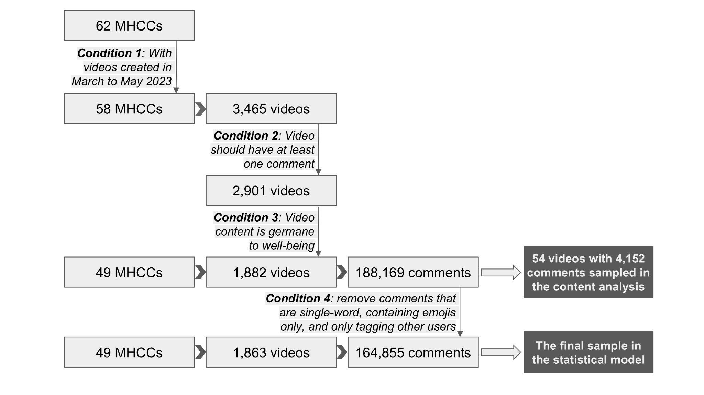

Figure A1. The process of data collection in the on-platform RCT
Note: MHCCs – mental health content creators on TikTok.

Figure A2. Estimated prevalence of foundational mental health knowledge construction in video comments by intervention groups across the study period
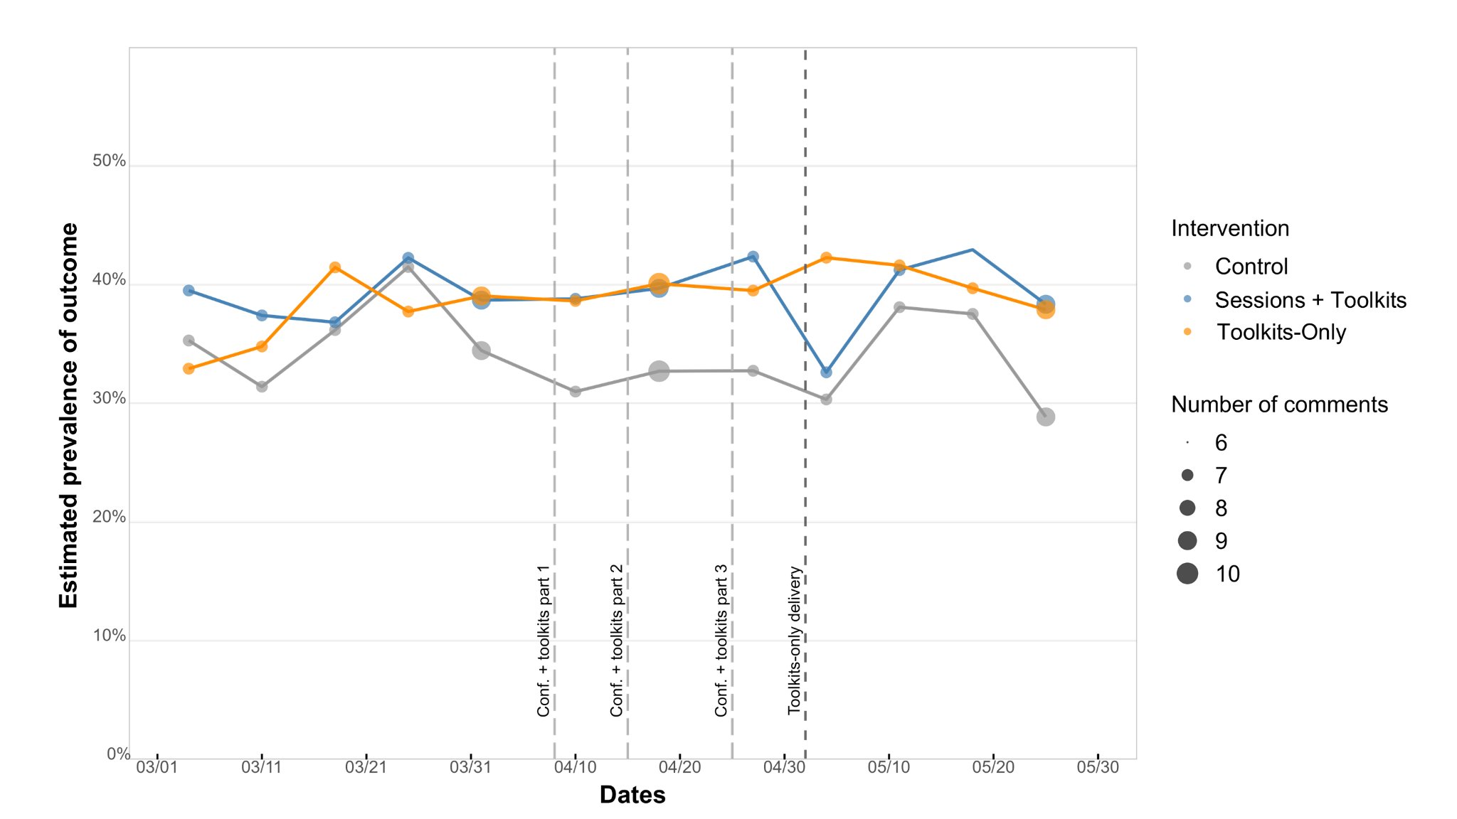
During the pre-intervention period—prior to the first sessions+toolkits treatment on April 8 for the sessions+toolkits and control groups, and prior to the toolkits-only treatment on May 2 for the toolkits-only and control groups—we observe generally parallel trends despite some fluctuations. Following the third sessions+toolkits treatment, the prevalence of foundational mental health knowledge construction in the sessions+toolkits group (blue line) increased before declining, while the control group (grey line) remained relatively flat. In the toolkits-only group (orange line), prevalence increased after the intervention and then gradually declined, whereas the corresponding control group showed no noticeable response following the toolkits-only treatment.

Figure A3. Control & treatment video transcripts

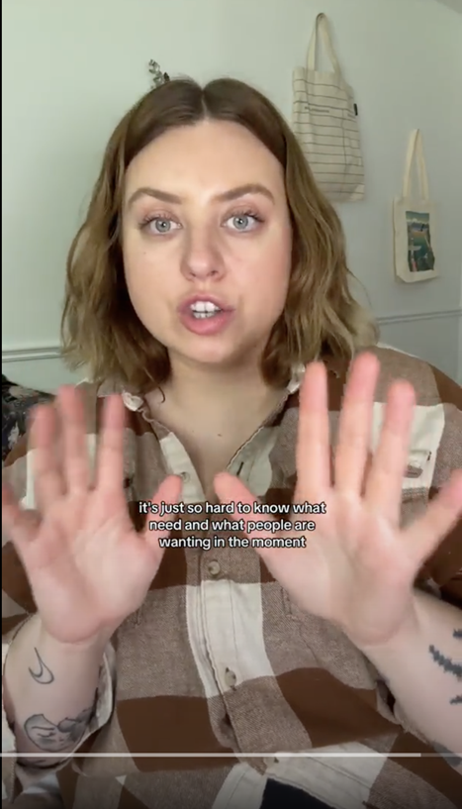
(A) Control video
“I would say that I am okay, I am so-so at emotionally supporting friends, but sometimes it's just so hard to know what [people] need and what people are wanting in the moment.

And there's so much conflicting information online that it makes it hard. Do you give someone space? Do you give someone advice? Is the advice overstepping?

Like it can be difficult in my opinion even as somebody who's been part of the mental health space for quite a while. I also feel like there's so many challenges when it comes to everybody being disconnected because of technology, so it's hard when somebody's going through something and you can only offer them a text or a voice note and then in that case sometimes it feels like, what's the point?

And then I would say the biggest layer, especially for me, is that I'm in a chapter of going through a lot right now and I want to be there for my friends but I am exhausted. And it's like, how do you be there for somebody? How do you emotionally support a friend when you are emotionally so tired and have nothing in your own reservoir?

So those are certain challenges that I personally have and because of them I definitely sometimes shut down and like don't really know how to be there properly or support friends.”

(B) Treatment video

“Okay, emotionally supporting friends does not have to be as intimidating as I have previously felt. When I have a friend who's going through something, what I am going to do?

To start off with, to just simplify things is to validate their experience. Whether I agree or disagree with the circumstance or situation, validation allows a person to feel grounded in their experience.

It also opens up communication and is an emotional regulation tool. I just, I didn't realize all of that about validation. Validation is super cool. And that my role as someone who is supporting somebody else's emotional world is not to problem-solve. I think that was tricky for me in the past. It feels like you have to fix and like you have to come up with a solution.

That is not emotional support. That is problem-solver mode. So, we're not trying to figure out anything right off the bat. What we're trying to do is be there for somebody with the emotions that are coming up for them. I think once you understand that, it makes emotionally supporting someone quite easy.

Then, at the end, asking open-ended questions allows for curiosity and communication to continue. And it is also making you support them from a nonjudgmental space, which is the best.”

Section 1: Prompts applied in LLM-based text augmentation
messages=[
{
"role": "system",
"content": "You are a helpful research assistant that rephrases text. "
},
{
"role": "user",
"content": "The texts you are going to rephrase are user comments on TikTok videos that are related to self-care, well-being, and mental health. \n"
"I will give you a sample, please give me 5 rephrased comments in the format of numbered bullet points.\n"
"Here is the comment:\n"
f"'{[comment_to_aug]}'"

},

