Appendix A: The Withdrawal Assessment Tool-1 (WAT-1)¹
The WAT-1 is a nursing screening tool designed for use after weaning medications begin. The original manuscript recommended assessments every 12 hours; however, frequency of assessments differ across hospital systems. The nursing assessment involves 2 phases, 1) a review of the chart for evidence of loose stools, vomiting/wretching, and elevated temperature, 2) a stimulus and observation period for variables encompassing muscle tone, tremors, sweating, and time to regain a calm state. At the study site, the WAT-1 score evaluations begin after extubation and removal of mechanical ventilation. This generally occurs every 4 hours and is extended as withdrawal symptoms subside.
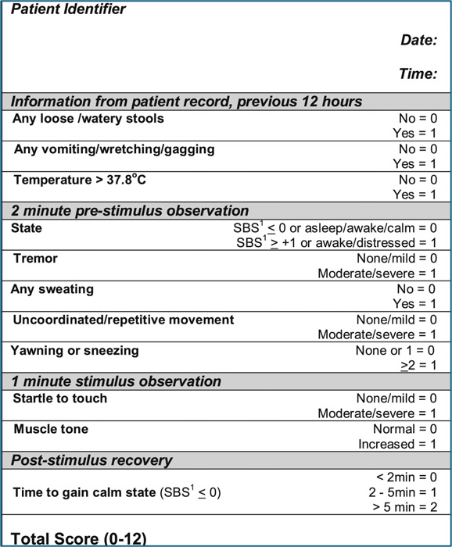
1. Franck, L. S., Harris, S. K., Soetenga, D. J., Amling, J. K. & Curley, M. A. Q. The Withdrawal Assessment Tool–1 (WAT–1): An assessment instrument for monitoring opioid and benzodiazepine withdrawal symptoms in pediatric patients*. Pediatric Critical Care Medicine 9, 573–580 (2008).

