Appendix A (Supplementary Materials)

Soil Responses to Nano-enhanced Bioremediation Techniques: Comparative Analysis of Bio-based Vermicompost, Fe₃O₄ Nanoparticles, and Their Novel Synergistic Effects against Phthalate Contamination

Laleh Ghafghazi ¹. Lobat Taghavi ^{1∗}. Behnam Rasekh ². Hadi Farahani ². Mahyar Safa ³

¹ Department of Natural Resources and Environment, SR.C., Islamic Azad University, P. O. Box 14515-775, Tehran, Iran.
laleh.ghafghazi@gmail.com; laleh.ghafghazi@srbiau.ac.ir
taghavi_lobat@yahoo.com; l.taghavi@srbiau.ac.ir

² Environment & Biotechnology Division, Research Institute of Petroleum Industry (RIPI), P.O. Box: 14665-137 Tehran, Iran.
b.rasekh@gmail.com
hadifarahani@gmail.com

³ Department of Environmental Engineering (Solid Waste), Faculty of Environment, University of Tehran, Iran.
mahyarsafa77@yahoo.com

Contents

Supplementary Figures | Pages | Supplementary Tables | Pages
Fig. S1  Fig. S2  Fig. S3  Fig. S4 | 3  4  5  6 | Table S1  Table S2  Table S3  Table S4  Table S5  Table S6  Table S7  Table S8  Table S9  Table S10 | 7  8  8  9  10  11  12  13  14  15

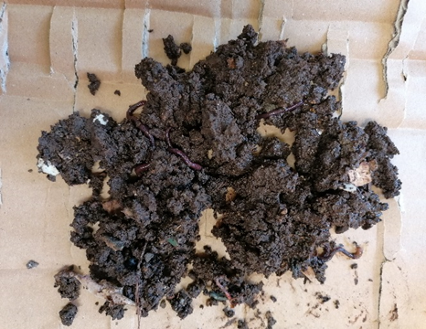  Eisenia Fetida in compost media |  | 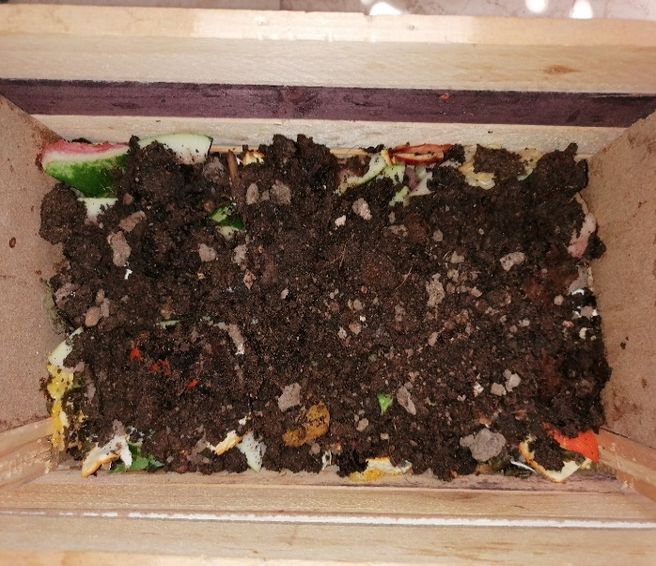 | 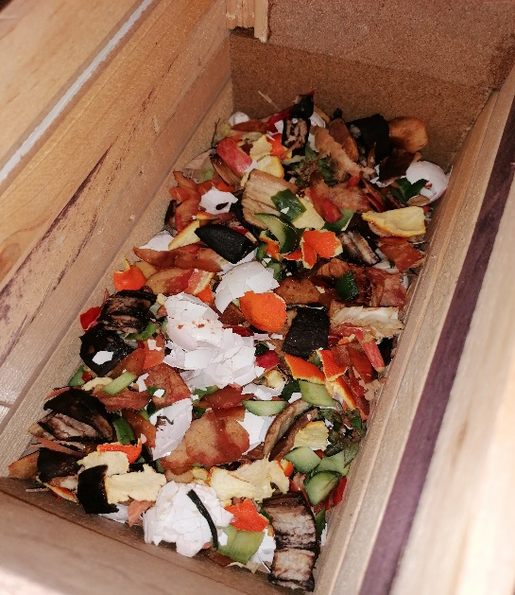
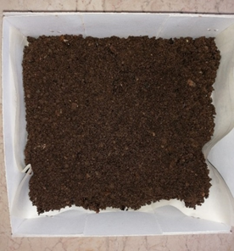  Final Vermicompost | 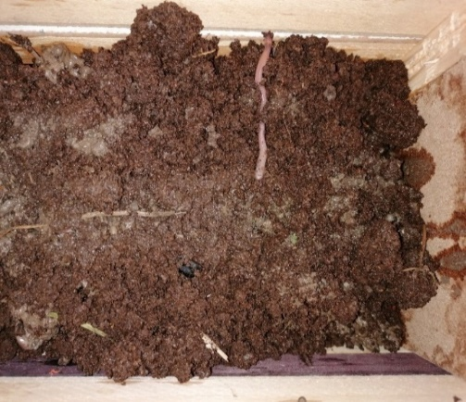 |  | 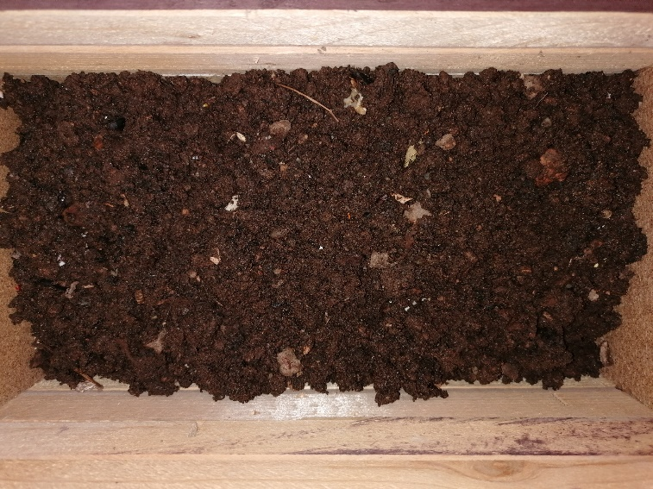
Fig. S1 Vermicompost preparation in a decay-resistant wooden reactor with Eisenia Fetida post-treatment.

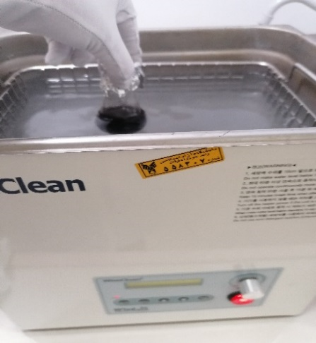 | 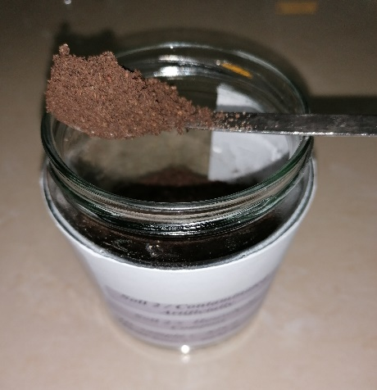 | 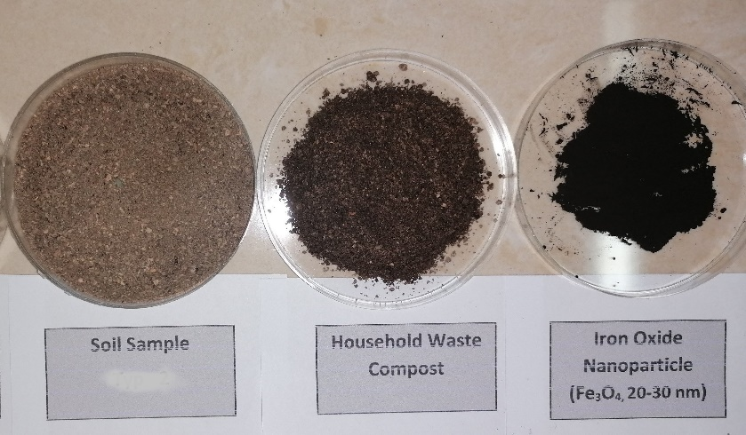
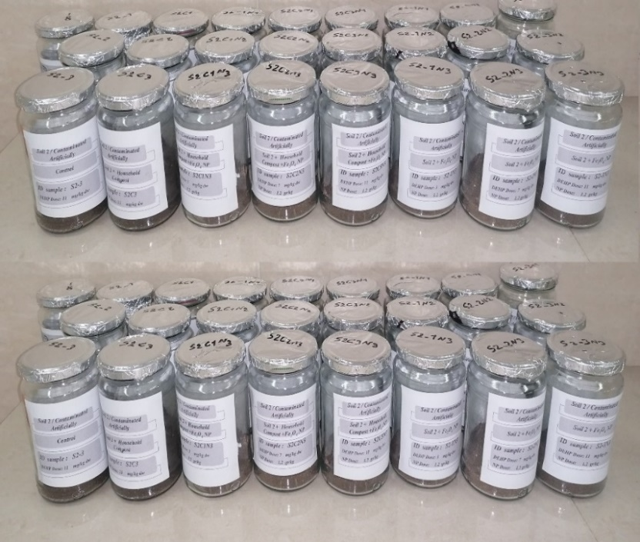 |  | 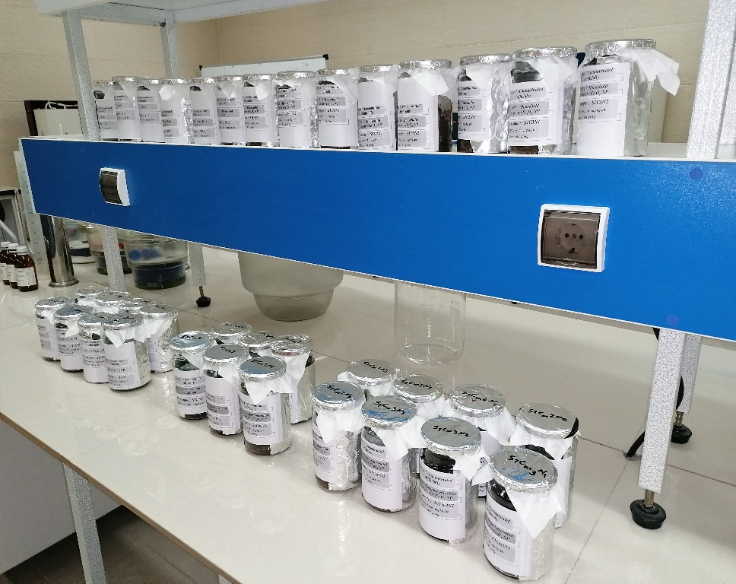
Fig. S2 Prepared group's treatments in the incubation/exposure study.

 | b  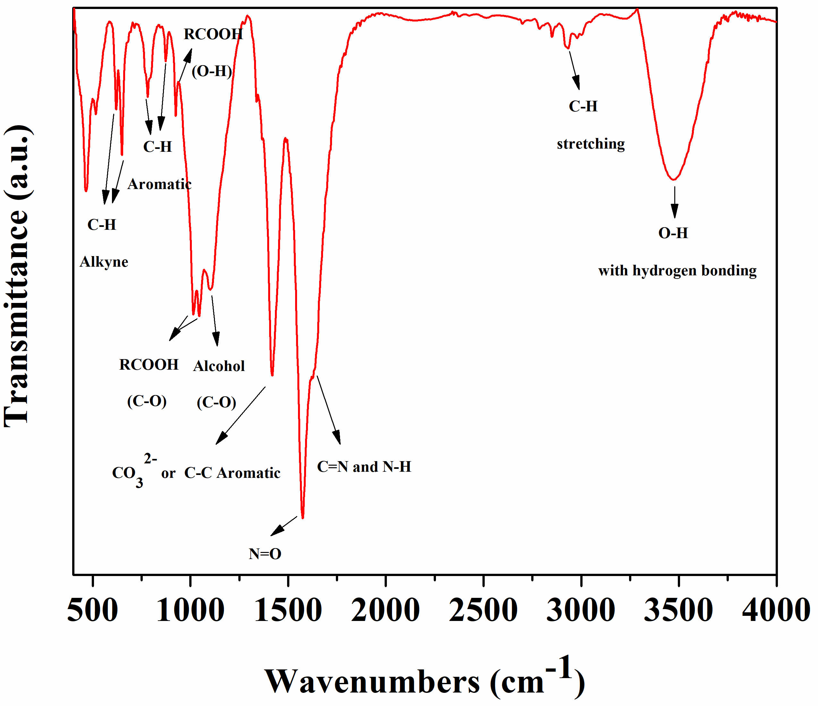
  FT-IR Peaks
  a
  Vibrations |  | ν (cm⁻¹)
   | Fe₂O₃, Fe₃O₄ | 514, 518
   | C-H bending (Alkyne) | 620 ,649
   | C-H bending (Aromatic) | 781, 873
   | RCOOH (O-H) bending | 924
   | RCOOH (C-O) bending | 1015, 1044
   | Alcohol (C-O) | 1101
   | CO₃²⁻ or C-C Aromatic in ring | 1418
   | N=O (Nitroso) | 1574
   | C=N, N-H | 1625
   | C-H stretching | 2935
   | O-H (with hydrogen bonding ( | 3445

Fig. S3 a) Possible bonds in the structure of Vermicompost added by Fe₃O₄ NPs and b) FTIR infra-red spectrum after DEHP absorption.

a | b | 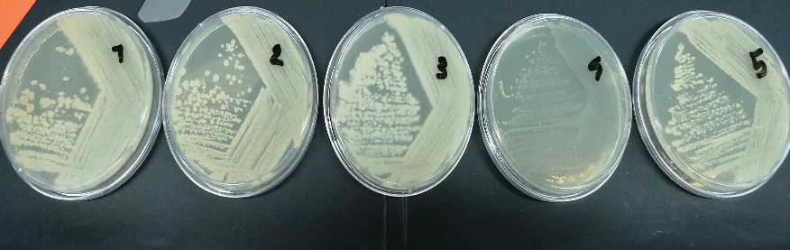  c

Fig. S4 a) Gel electrophoresis image of PCR product and gene fragment amplification, the DNA size marker on the left, and samples L1 to L5 on the right side; b) Gel electrophoresis image of PCR pure product of L1 to L5; c) Related microbial plate samples.

Table S1 Physicochemical and microbial characteristics of selected soil and vermicompost (Mean ± SD, n=3).
Parameter/  Media | Density (Bulk) (Kg.m³) | pH | EC (mS/cm) | OM (%) | TC  (%)  dw | TN  (%) dw | C:N | AP  (%) dw | EK  (%) dw | CEC (meq/100g) | DEHP Background dose(mg.kg⁻¹) | Total Plate Count (CFU/ml)
Agricultural Soil  (0-20 cm depth)  Vermicompost  (85 day process) | 950 ±  0.15  373 ±  0.18 | 6.12 ±0.07 (1:5/H₂O) (24°C)  8.18 ± 0.01  (1:10/H₂O) (25°C) | 1.28 ± 1.30 (1:5/H₂O)  (23°C)  4.08 ± 1.55  (1:10/H₂O) | 4.35  ±  2.15  41.20  ± 0.65 (100g) | 7.14  ±  1.08  38.12 ±  1.06 | 0.94 ± 0.75  3.23 ± 0.07 | 7.59  11.8 | 0.38  ±  1.80  1.32  ±  2.06 | 8.0 ±  0.55  1.10 ±  0.02 | 31  74 | 1.49 ±1.45  0.57 ± 0.15 | 10⁶ × 8.4  ±  7.17  10⁸× 7.9  ±  11.53

Table S2 Numeric independent variables, actual factors and their coded levels (α =1.68).
Factor | Name | Units | Type | Minimum | Maximum | Coded Low | Coded High | Mean | Std. Dev.
A (X1) | Time | days | Numeric | 4.45 | 51.55 | -1 ↔ 14.00 | +1 ↔ 42.00 | 28.00 | 11.87
B (X2) | Fe₃O₄ NPs dose | g.kg⁻¹ (media) | Numeric | 0.6636 | 1.34 | -1 ↔ 0.80 | +1 ↔ 1.20 | 1.0000 | 0.1696
C (X3) | DEHP Concentration | mg.kg⁻¹ (dw.soil) | Numeric | 3.18 | 36.82 | -1 ↔ 10.00 | +1 ↔ 30.00 | 20.00 | 8.48

Table S3 DEHP removal efficiency in treatments of nano and bioremediation comparative experiments (Mean ± SD).
Subset/  DEHP Concentration | Groups | DEHP removal efficiency
Subset/  DEHP Concentration | Groups | Time 1  (7 days, n=24) |  | Time 2  (21 days, n=24) |  | Time 3  (42 days, n=24)
Subset/  DEHP Concentration | Groups | Mean | STDEV | Mean | STDEV | Mean | STDEV
10 mg/kg | S₁ (control) | 12.43 | 0.58 | 12.70 | 0.91 | 14.45 | 0.5
10 mg/kg | S₁V (Soil+ Vermicompost) | 34.8 | 2.13 | 54.79 | 4.99 | 69.34 | 3.15
10 mg/kg | S₁VN (Soil+ Vermicompost+ Fe₃O₄NP) | 43.47 | 1.06 | 66.75 | 3.12 | 94.58 | 2.65
10 mg/kg | S₁N (Soil + Fe₃O₄NP) | 54.28 | 5.30 | 67.09 | 4.77 | 80.90 | 2.20
30 mg/kg | S₂ (control) | 13.34 | 1.11 | 14.15 | 0.13 | 15.10 | 0.48
30 mg/kg | S₂V (Soil+ Vermicompost) | 40.87 | 2.42 | 48.99 | 2.03 | 65.25 | 2.45
30 mg/kg | S₂VN (Soil+ Vermicompost+ Fe₃O₄NP) | 48.22 | 1.80 | 61.50 | 1.41 | 91.16 | 2.60
30 mg/kg | S₂N (Soil+ Fe₃O₄NP) | 33.77 | 4.65 | 52.38 | 2.28 | 75.76 | 0.98

Table S4 Two-way ANOVA comparisons test for DEHP Removal Efficiency analogy.
Table Analyzed | DEHP Removal Efficiency,%
Two-way ANOVA | Ordinary
Alpha | 0.05
Source of Variation | % of total variation | P value | P value summary | Significant?
Row Factor | 0.2583 | 0.0987 | ns | No
Column Factor | 99.60 | <0.0001 | **** | Yes
ANOVA table | SS | DF | MS | F (DFn, DFd) | P value
Row Factor | 18.00 | 1 | 18.00 | F (1, 3) = 5.606 | P=0.0987
Column Factor | 6942 | 3 | 2314 | F (3, 3) = 720.6 | P<0.0001
Residual | 9.633 | 3 | 3.211
Difference between row means
Mean of Time 49 (10 mg/kg) | 64.82
Mean of Time 49 (30 mg/kg) | 61.82
Difference between means | 3.000
SE of difference | 1.267
95% CI of difference | -1.032 to 7.032
Data summary
Number of columns (Column Factor) | 4
Number of rows (Row Factor) | 2
Number of values | 8

Table S5 The results of two-way ANOVA for TN and AP changes (%) in all treatments.
Two-way ANOVA, TN (%) |  | Ordinary
Alpha |  | 0.05
Source of Variation |  | % of total variation | P value |  | summary |  |  | Significant?
Row Factor (Different Times) |  | 13.12 | 0.0031 |  | ** |  |  | Yes
Column Factor (Different Treatment) |  | 76.69 | <0.0001 |  | **** |  |  | Yes
ANOVA table |  | SS | DF |  | MS |  |  | F (DFn, DFd) | P value
Row Factor |  | 24.16 | 2 |  | 12.08 |  |  | F (2, 14) = 9.011 | P=0.0031
Column Factor |  | 141.3 | 7 |  | 20.18 |  |  | F (7, 14) = 15.05 | P<0.0001
Residual |  | 18.77 | 14 |  | 1.341
Number of columns |  | 8
Number of rows (Row Factor) |  | 3
Number of values |  | 24
Two-way ANOVA, AP (%) | Ordinary
Source of Variation (Alpha=0.05) | % of total variation |  |  | P value |  | summary | Significant?
Row Factor | 45 |  |  | 0.0025 |  | ** | Yes
Column Factor | 22 |  |  | 0.3219 |  | ns | No
ANOVA table | SS |  |  | DF |  | MS | F (DFn, DFd) |  |  | P value
Row Factor | 11 |  |  | 2 |  | 5.6 | F (2, 14) = 9.5 |  |  | P=0.0025
Column Factor | 5.3 |  |  | 7 |  | 0.76 | F (7, 14) = 1.3 |  |  | P=0.3219
Residual | 8.3 |  |  | 14 |  | 0.59
Number of columns (Column Factor) | 8
Number of rows (Row Factor) | 3
Number of values | 24

Table S6 The results of two-way ANOVA for EK and SOM changes in all treatments.
Two-way ANOVA, EK (%) | Ordinary
Source of Variation (Alpha=0.05) | % of total variation | P value | summary | Significant?
Row Factor | 15 | 0.0018 | ** | Yes
Column Factor | 74 | <0.0001 | **** | Yes
ANOVA table | SS | DF | MS | F (DFn, DFd) | P value
Row Factor | 12 | 2 | 6.2 | F (2, 14) = 10 | P=0.0018
Column Factor | 59 | 7 | 8.5 | F (7, 14) = 14 | P<0.0001
Residual | 8.5 | 14 | 0.61
Number of columns (Column Factor) | 8
Number of rows (Row Factor) | 3
Number of values | 24
Two-way ANOVA, SOM(%) | Ordinary
Alpha | 0.05
Source of Variation | % of total variation | P value | P value summary | Significant?
Row Factor | 4.847 | 0.0033 | ** | Yes
Column Factor | 91.30 | <0.0001 | **** | Yes
ANOVA table | SS | DF | MS | F (DFn, DFd) | P value
Row Factor | 253.7 | 2 | 126.9 | F (2, 14) = 8.815 | P=0.0033
Column Factor | 4779 | 7 | 682.8 | F (7, 14) = 47.44 | P<0.0001
Residual | 201.5 | 14 | 14.39
Data summary
Number of columns (Column Factor) | 8
Number of rows (Row Factor) | 3
Number of values | 24

Table S7 The results of two-way ANOVA for pH, CEC and EC changes in all treatments.
Two-way ANOVA (pH) (Alpha=0.05) | % of total variation | P value | P value summary | Significant?
Interaction | 1.8 | <0.0001 | **** | Yes
Row Factor | 0.41 | <0.0001 | **** | Yes
Column Factor | 97 | <0.0001 | **** | Yes
ANOVA table | SS | DF | MS | F (DFn, DFd) | P value
Interaction | 1.7 | 21 | 0.081 | F (21, 64) = 7.2 | P<0.0001
Row Factor | 0.38 | 3 | 0.13 | F (3, 64) = 11 | P<0.0001
Column Factor | 90 | 7 | 13 | F (7, 64) = 1139 | P<0.0001
Residual | 0.72 | 64 | 0.011
Number of values | 96
Two-way ANOVA (CEC) (Alpha=0.05) | % of total variation | P value | P value summary | Significant?
Interaction | 6.3 | <0.0001 | **** | Yes
Row Factor | 4.6 | <0.0001 | **** | Yes
Column Factor | 88 | <0.0001 | **** | Yes
ANOVA table | SS | DF | MS | F (DFn, DFd) | P value
Interaction | 908 | 21 | 43 | F (21, 64) = 25 | P<0.0001
Row Factor | 674 | 3 | 225 | F (3, 64) = 129 | P<0.0001
Column Factor | 12824 | 7 | 1832 | F (7, 64) = 1050 | P<0.0001
Residual | 112 | 64 | 1.7
Two-way ANOVA (EC) (Alpha=0.05) | % of total variation | P value | P value summary | Significant?
Interaction | 7.0 | <0.0001 | **** | Yes
Row Factor | 5.0 | <0.0001 | **** | Yes
Column Factor | 88 | <0.0001 | **** | Yes
ANOVA table | SS | DF | MS | F (DFn, DFd) | P value
Interaction | 6804354 | 21 | 324017 | F (21, 64) = 5032 | P<0.0001
Row Factor | 4845108 | 3 | 1615036 | F (3, 64) = 25080 | P<0.0001
Column Factor | 84900247 | 7 | 12128607 | F (7, 64) = 188345 | P<0.0001
Residual | 4121 | 64 | 64

Table S8 The results of Tukey's multiple comparisons test based on the ordinary one-way ANOVA for microbial colony count assay.
Ordinary one-way ANOVA (In groups with spiked soil treatment at 10 mg.kg-1)
Number of comparisons per 1 family | 6 | Alpha |  |  | 0.05
Tukey's multiple comparisons test | Mean Diff. | 95.00% CI of diff. |  |  | Significant? |  | Summary |  | Adjusted P Value
Control (S₁) vs. S₁V | -5.040 | -7.065 to -3.015 |  |  | Yes |  | **** |  | <0.0001 |  | A-B
Control (S₁) vs. S₁VN | -5.108 | -7.133 to -3.082 |  |  | Yes |  | **** |  | <0.0001 |  | A-C
Control (S₁) vs. S₁N | -1.785 | -3.810 to 0.2402 |  |  | No |  | ns |  | 0.0910 |  | A-D
S₁V vs. S₁VN | -0.06750 | -2.093 to 1.958 |  |  | No |  | ns |  | 0.9996 |  | B-C
S₁V vs. S₁N | 3.255 | 1.230 to 5.280 |  |  | Yes |  | ** |  | 0.0022 |  | B-D
S₁VN vs. S₁N | 3.323 | 1.297 to 5.348 |  |  | Yes |  | ** |  | 0.0019 |  | C-D
Ordinary one-way ANOVA (In groups with spiked soil at 100 mg.kg⁻¹)
Number of comparisons per 1 family | 6 |  | Alpha | 0.05
Tukey's multiple comparisons test | Mean Diff. |  | 95.00% CI of diff. | Significant? |  | Summary |  | Adjusted P Value
Control (S₂) vs. S₂V | -4.978 |  | -6.673 to -3.282 | Yes |  | **** |  | <0.0001 |  | A-B
Control (S₂) vs. S₂VN | -4.190 |  | -5.886 to -2.494 | Yes |  | **** |  | <0.0001 |  | A-C
Control (S₂) vs. S₂N | 0.2500 |  | -1.446 to 1.946 | No |  | ns |  | 0.9866 |  | A-D
S₂V vs. S₂VN | 0.7875 |  | -0.9081 to 2.483 | No |  | ns |  | 0.5251 |  | B-C
S₂V vs. S₂N | 5.228 |  | 3.532 to 6.923 | Yes |  | **** |  | <0.0001 |  | B-D
S₂VN vs. S₂N | 4.440 |  | 2.744 to 6.136 | Yes |  | **** |  | <0.0001 |  | C-D

Table S9 RSM model summary statistics and ANOVA/ Fit statistics parameters

Model Summary Statistics
Source | Std. Dev. | Sequential p-value | R² | Adjusted R² | Predicted R² | PRESS
Linear | 0.9914 | 0.2444 | 0.2233 | 0.0776 | -0.2021 | 24.34
2FI | 1.06 | 0.7857 | 0.2822 | -0.0491 | -0.8815 | 38.09
Quadratic | 0.3048 | < 0.0001 | 0.9541 | 0.9128 | 0.7006 | 6.06 | Suggested
Cubic | 0.2143 | 0.0811 | 0.9864 | 0.9569 | -0.1400 | 23.08 | Aliased

ANOVA/Fit Statistics
Std. Dev. | 0.2883 | R² | 0.9507
Mean | 11.09 | Adjusted R² | 0.9220
C.V. % | 2.60 | Predicted R² | 0.7937
 |  | Adeq Precision | 19.4572

Table S10 ANOVA for Reduced Quadratic model (Response: log₁₀ Total Colony Count)
ANOVA for Reduced Quadratic model
Source | Sum of Squares | df | Mean Square | F-value | p-value
Model | 19.25 | 7 | 2.75 | 33.07 | < 0.0001 | significant
A-Time (X₁) | 3.84 | 1 | 3.84 | 46.25 | < 0.0001
B-Fe₃O₄ NPs dose (X₂) | 0.3601 | 1 | 0.3601 | 4.33 | 0.0595
C-DEHP Concentration (X₃) | 0.3149 | 1 | 0.3149 | 3.79 | 0.0754
AB | 1.12 | 1 | 1.12 | 13.53 | 0.0032
A² | 12.71 | 1 | 12.71 | 152.83 | < 0.0001
B² | 0.7866 | 1 | 0.7866 | 9.46 | 0.0096
C² | 1.38 | 1 | 1.38 | 16.62 | 0.0015
Residual | 0.9976 | 12 | 0.0831
Lack of Fit | 0.8257 | 7 | 0.1180 | 3.43 | 0.0967 | not significant
Pure Error | 0.1719 | 5 | 0.0344
Cor Total | 20.24 | 19

∗Corresponding Author taghavi_lobat@yahoo.com; l.taghavi@srbiau.ac.ir (L. Taghavi)

