Assessing the average causal effect of maternal postpartum depression diagnosis on subsequent child development at age five years: A causal analysis using the All Our Families cohort and administrative data in Alberta, Canada

Authors:
Shainur Premji, Centre for Health Economics, University of York, York, United Kingdom.
Nicole Racine, School of Psychology, University of Ottawa and Children’s Hospital of Eastern Ontario Research Institute, Ottawa, Ontario, Canada.
Deborah McNeil, Faculty of Nursing, University of Calgary and Department of Community Health Sciences, Cumming School of Medicine, University of Calgary, Calgary, Alberta, Canada.
Eldon Spackman, Department of Community Health Sciences, Cumming School of Medicine, University of Calgary, Calgary, Alberta, Canada.

Corresponding Author:
Dr Shainur Premji, Centre for Health Economics, University of York, Heslington, York, YO10 5DD, United Kingdom, shainur.premji@york.ac.uk, +44 (0)1904 321467

Journal:
Social Psychiatry and Psychiatric Epidemiology

Supplementary Appendix

A1. Administrative case definition used to identify PPD, developed in partnership with frontline practitioners and content experts

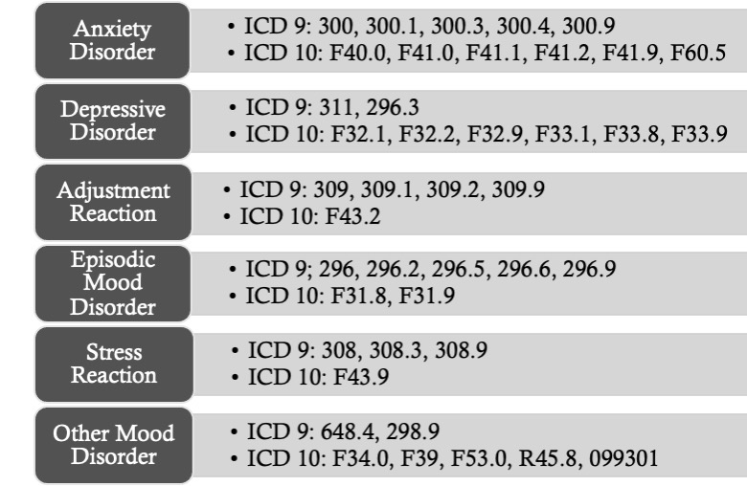

A2. Operational definition of study variables
Variable | Source | Operational definition
During pregnancy (AOF Questionnaire, <25 weeks’ gestation)
Education | AOF | What is the highest level of education you have completed? Recoded to greater than high school (> high school), high school or less (≤ high school)
Ethnicity | AOF | How would you describe your ethnic background? Recoded to White, Other
Household income | AOF | What is your total income, before taxes and deductions, for all household members from all sources in the past 12 months? (reported in increments of $10,000, from less than $10,000 to $150,000 or more). Cutoff $80,000 applied to study.
Marital status | AOF | How would you describe your current marital status? Married, common-law; single, divorced, separated, widowed (Other)
Social support in pregnancy | AOF | Medical Outcomes Study Social Support Scale (MOS SSS) completed by mother, cutoff score 70 applied to indicate adequate or inadequate social support
Time in Canada | AOF | Were you born in Canada? (yes or no); If no, what is the total number of months you have been in Canada? Recoded to born in Canada/ lived here for greater than 5 years (≥5 years); lived in Canada less than 5 years (<5 years)
After birth (AOF Questionnaire, 4 months postpartum)
History of mental health | AOF | Ever experienced feeling sad, blue, depressed or down for most of the time for at least two weeks, or ever experienced other mental disorders such as generalised anxiety disorder, bipolar disorder, schizophrenia, or obsessive-compulsive disorder (yes or no)
Maternal age | AOF | Maternal age at delivery, continuous
Parity | AOF | No previous births (nulliparous); previous birth to a foetus, at least once (multiparous)
AHS administrative data
Birthweight | Vital statistics | Child’s birth weight is less than 2500g (≤2500g, low birthweight) or not (≥2500g)
Child gender | Vital statistics | Child’s gender (male or female)
Gestational age | Vital statistics | Full term (≥37 weeks), Less than full term (<37 weeks)
Large for gestational age | Vital statistics | Indicates whether the birth is large for gestational age (≥90th percentile: yes, or ≤90th percentile: no)
Admission to NICU | Inpatient, physician claims | Admission to NICU within 7 days of birth (yes or no)
LOS in NICU | Inpatient | Date of discharge minus date of admission for NICU inpatient stay
PPD risk score | Public health | Edinburgh Postnatal Depression Scale (EPDS) score, scores ranged from 0 to 30, with higher scores indicating greater risk for PPD
Small for gestational age | Vital statistics | Indicates whether the birth is small for gestational age (<10th percentile: yes, or ≥10th percentile: no).

A3. Sample size calculations
To detect whether we had sufficient sample sizes to detect a meaningful clinically significant difference in child ASQ scores at age five years, we calculated the following estimated sample sizes.

ASQ scores range from 0 to 60, where the higher the score, the greater the functioning. Values that fall below one standard deviation from the mean indicate children may be at risk of delay.¹ For the following ASQ domains, the anticipated effect size = % difference between the mean sample score for the domain and the 1SD cutoff score.

With a desired statistical power of 80%, probability level of 5%, and with 17 predictors in our regression model, we required between 91 and 155 participants in each group to detect a meaningful clinically significant difference in child ASQ scores at age five years.

Our analysis was therefore sufficiently powered to detect a clinically meaningful significant difference, with observed sample sizes ≥ 1696 per ASQ domain.

ASQ Domain | 1SD cutoff | Mean sample score | Diff | % Diff | N required
Communication | 42.80 | 53.73 | 10.93 | 18% | 124
Gross Motor | 41.72 | 53.80 | 12.08 | 20% | 113
Fine Motor | 39.05 | 51.36 | 12.31 | 21% | 109
Problem Solving | 41.29 | 56.86 | 15.57 | 26% | 91
Personal Social | 46.96 | 55.35 | 8.39 | 14% | 155

A4. Propensity and outcome regression models

Propensity model (logistic regression):

- Outcome variable: PPD diagnosis
- Model covariates: PPD risk, ethnicity, time in Canada, history of mental health issues, social support during pregnancy, gestational age, admission to NICU within seven days of birth, birthweight

Outcome model (linear regression):

- Outcome variable: ASQ score
- Model covariates: PPD diagnosis, PPD risk, total annual household income, parity, child sex, maternal age at delivery, marital status, maternal education, ethnicity, gestational age, time in Canada, history of mental health issues, length of stay in NICU, birthweight, gestational age, social support during pregnancy

A5. Multiple Imputation

PPD risk score (14.5% missing data)

Assessing the mechanism of missingness:
 | p-value
Marital status
Married/Common Law | 0.136
Other | 0.136
Education
>High School | 0.126
≤High School | 0.126
Ethnicity
White | 0.264
Other | 0.264
Time in Canada
≥5 years | 0.276
<5 years | 0.276
Annual household income
≥$80,000 | 0.001
<$80,000 | 0.001
Parity
Nulliparous | <0.001
Multiparous | <0.001
History of mental health issues
No | <0.001
Yes | <0.001
Social support in pregnancy
Adequate | 0.307
Inadequate | 0.307
Gestational age
≥37 weeks | 0.476
<37 weeks | 0.476
Child gender
Male | 0.045
Female | 0.045
NICU admission within 7 days of birth
No | 0.694
Yes | 0.694
Birthweight
≥2500 g | <0.001
<2500 g | <0.001
Small for gestational age
No | 0.144
Yes | 0.144
Large for gestational age
No | 0.360
Yes | 0.360

Given missingness in PPD risk score was associated with being multiparous, having a total annual household income of less than $80,000, having a positive history of mental health issues, giving birth to a male child, and giving birth to a child with low birthweight (less than 2500g), we assumed data are missing at random and proceeded to use multiple imputation (MI) methods to estimate the missing values.

MI Approach: Predictive mean matching.

Rationale: Uses realistic estimates that are based on data and does not go outside of observed scores.²

Final MI model covariates: PPD diagnosis, total annual household income, parity, ethnicity, time in Canada, history of mental health issues, length of stay in NICU, social support in pregnancy.

M=20 imputations, to achieve between 99-100% relative efficiency.³

Evaluation of MI process.

Distribution of observed data:

Distribution of observed & imputed data:

Sample characteristics using observed or observed & imputed data
Observed data
N | Mean | SD | Min | Max
2,409 | 4.24 | 3.46 | 0 | 23
Observed and imputed data
N | Mean | SD | Min | Max
2,765 | 4.29 | 3.28 | 0 | 23

Child development scores (39.4% missing data on average per ASQ domain)

Assessing the mechanism of missingness:
 | p-value
Marital status
Married/Common Law | <0.001
Other | <0.001
Education
>High School | <0.001
≤High School | <0.001
Ethnicity
White | <0.001
Other | <0.001
Time in Canada
≥5 years | 0.002
<5 years | 0.002
Annual household income
≥$80,000 | <0.001
<$80,000 | <0.001
Parity
Nulliparous | 0.006
Multiparous | 0.006
History of mental health issues
No | 0.23
Yes | 0.23
Social support in pregnancy
Adequate | 0.006
Inadequate | 0.006
Gestational age
≥37 weeks | 0.129
<37 weeks | 0.129
Child gender
Male | 0.868
Female | 0.868
NICU admission within 7 days of birth
No | 0.222
Yes | 0.222
Birthweight
≥2500 g | 0.409
<2500 g | 0.409
Small for gestational age
No | 0.870
Yes | 0.870
Large for gestational age
No | 0.208
Yes | 0.208

Given missingness in child development scores were associated with lower maternal education levels, not being partnered, being of other ethnicity, having been in Canada for less than five years, a total annual household income of less than $80,000, being multiparous, and having inadequate social support in pregnancy, we assumed data are missing at random and proceeded to use multiple imputation (MI) methods to estimate the missing values.

MI Approach: multiple imputation chained equations (MICE).

Rationale: enables the estimation of missing values using pre-specified multivariate models with conditional distributions.⁴

Final MI model covariates: PPD diagnosis, PPD risk, maternal age at delivery, marital status, total annual household income, parity, ethnicity, time in Canada, maternal education, history of mental health issues, child sex, gestational age, birthweight, length of stay in NICU, social support in pregnancy, small for gestational age, large for gestational age.

M=20 imputations, to achieve between 98-99% relative efficiency.³

Evaluation of MI process.

Distribution of observed data:
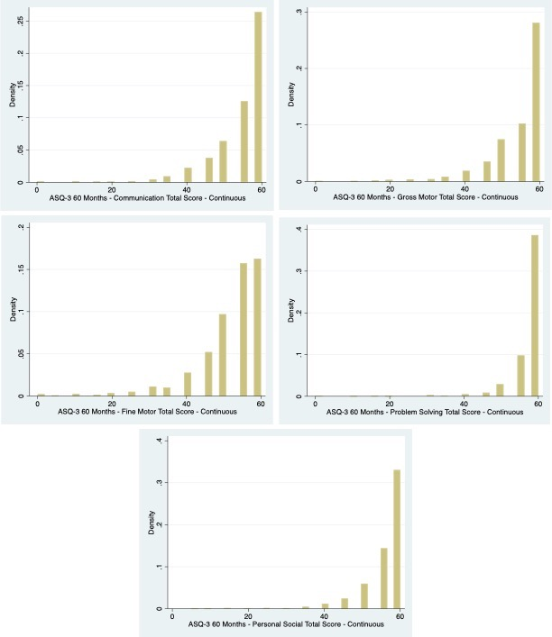

Distribution of observed & imputed data:
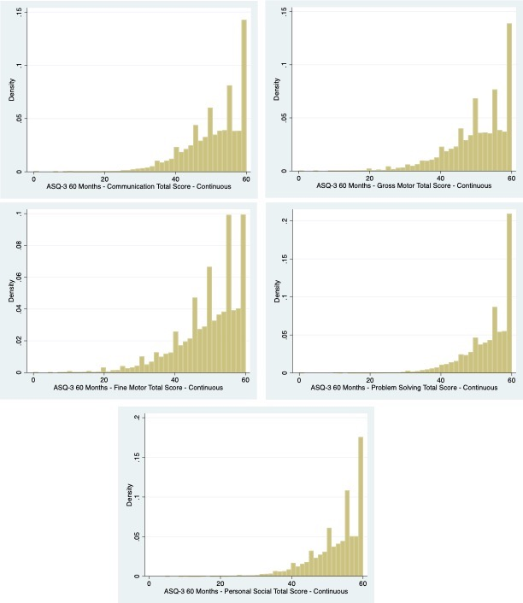

Sample characteristics using observed or observed & imputed data
 |  | Observed data
 | ASQ Domain | N | Mean | SD | Min | Max
 | Communication | 1,696 | 54.54 | 7.95 | 0 | 60
 | Gross Motor | 1,704 | 54.64 | 8.03 | 0 | 60
 | Fine Motor | 1,700 | 51.86 | 9.47 | 0 | 60
 | Problem Solving | 1,709 | 57.68 | 5.42 | 0 | 60
 | Personal Social | 1,717 | 56.05 | 6.43 | 5 | 60
 |  | Observed and imputed data
 | ASQ Domain | N | Mean | SD | Min | Max
 | Communication | 2,615 | 53.73 | 6.63 | 0 | 60
 | Gross Motor | 2,618 | 53.80 | 6.70 | 0 | 60
 | Fine Motor | 2,619 | 51.36 | 7.79 | 0 | 60
 | Problem Solving | 2,618 | 56.86 | 4.60 | 0 | 60
 | Personal Social | 2,618 | 55.35 | 5.44 | 5 | 60

A6. Results of categorical analysis
Association between maternal PPD diagnosis and child risk of delay at age 5 years.

Complete Case Analysis
ASQ Domain | No PPD Diagnosis (n=2473) | PPD Diagnosis (n=343) | p-value
Communication: N (%)
No risk of delay | 1396 (92.2) | 167 (91.8) | 0.832
Risk of delay | 118 (7.8) | 15 (9.2)
Gross Motor: N (%)
No risk of delay | 1412 (92.8) | 163 (89.1) | 0.069
Risk of delay | 109 (7.2) | 20 (10.9)
Fine Motor: N (%)
No risk of delay | 1419 (93.5) | 165 (90.2) | 0.087
Risk of delay | 98 (6.5) | 18 (9.8)
Problem Solving: N (%)
No risk of delay | 1495 (98.0) | 178 (96.7) | 0.248
Risk of delay | 30 (2.0) | 6 (3.3)
Personal Social: N (%)
No risk of delay | 1410 (92.0) | 166 (90.2) | 0.412
Risk of delay | 123 (8.0) | 18 (9.8)

Imputed Analysis
ASQ Domain | No PPD Diagnosis (n=2473) | PPD Diagnosis (n=343) | p-value
Communication: N (%)
No risk of delay | 2190 (94.8) | 288 (94.7) | 0.984
Risk of delay | 121 (5.2) | 16 (5.3)
Gross Motor: N (%)
No risk of delay | 2202 (95.2) | 285 (93.1) | 0.112
Risk of delay | 110 (4.8) | 21 (6.9)
Fine Motor: N (%)
No risk of delay | 2215 (95.8) | 287 (93.8) | 0.117
Risk of delay | 98 (4.2) | 19 (6.2)
Problem Solving: N (%)
No risk of delay | 2282 (98.7) | 300 (98.0) | 0.349
Risk of delay | 30 (1.3) | 6 (2.0)
Personal Social: N (%)
No risk of delay | 2184 (94.5) | 286 (93.5) | 0.477
Risk of delay | 128 (5.5) | 20 (6.5)

References
1. Kids in the monitoring zone: what to do next. Ages & Stages Questionnaires. 2019. https://agesandstages.com/free-resources/articles/kids-in-the-monitoring-zone/
2. Morris TP, White IR, Royston P. Tuning multiple imputation by predictive mean matching and local residual draws. BMC Med Res Methodol. 2014;14(1):75. doi:10.1186/1471-2288-14-75
3. Newgard CD, Haukoos JS. Advanced Statistics: Missing Data in Clinical Research-Part 2: Multiple Imputation. Acad Emerg Med. 2007;14(7):669-678. doi:10.1197/j.aem.2006.11.038
4. Austin PC, Van Buuren S. Logistic regression vs. predictive mean matching for imputing binary covariates. Stat Methods Med Res. 2023;32(11):2172-2183. doi:10.1177/09622802231198795

