SUPPORTING INFORMATION
Additional supporting information can be found online in the Supporting Information section at the end of this article.

Fig. S1 Viral loads and pathological analysis following IBV infection in adult and young chickens.
Fig. S2 Viral loads and pathological analysis following IBV infection in FMT experiment.
Fig. S3 Analysis of gut microbiome origins in recipient chickens following FMT from adult chickens.
Fig. S4 Microbiome composition analysis in adult chickens, young chickens, and FMT-treated young chickens.
Fig. S5 LEfSe analysis between different groups.
Fig. S6 Functional prediction of gut microbiota in adult and young chickens.
Fig. S7 Virome composition analysis in adult chickens, young chickens, and FMT-treated young chickens.
Fig. S8 Analysis of assembled viral contigs in viromic data.
Fig. S9 Prediction of host targets for phage contigs assembled from the virome.
Fig. S10 Microbiome and virome interaction networks in the gut.
Fig. S11 Metabolomic analysis of gut samples from adult chickens, young chickens, and FMT-treated young chickens.
Fig. S12 16S rRNA gene sequencing analysis of gut microbiome in young chickens before and after IBV infection.
Fig. S13 Relative abundance of upregulated bacteria after IBV infection in healthy adult, young or young-FMT chickens.
Fig. S14 Hematoxylin-eosin (H&E) staining tissue section analysis following oral gavage of A. muciniphila.
Fig. S15 Metabolomic analysis of the gut in young chickens administrated of A. muciniphila after IBV infection.
Fig. S16 Relative abundance of GABA in different treatment groups.
Fig. S17 Concentration of IFNs in serum and pathological analysis of trachea and kidneys following oral gavage of with A. muciniphila and IBV infection in young chickens.

Table S1. Genotypes of infectious bronchitis virus (IBV) isolates collected by our research team from 2019 to 2024.

Table S2. Taxonomic classification of 16S rRNA gene amplicons from adult, young, and young-FMT samples.

Table S3. Comparison of predicted microbiota functions between adult and young chicken groups.

Table S4. Species-level taxonomic classification of virome data from adult, young, and young-FMT samples.

Table S5. Predicted host ranges of assembled phage contigs in virome data.

Table S6. Interaction network between microbiota and viruses in adult and young chicken groups.

Table S7. Expression levels and functional annotations of identified metabolites in adult, young, and young-FMT samples.

Table S8. Differentially expressed metabolites between adult and young chicken groups.

Table S9. KEGG pathway analysis of differentially expressed metabolites between adult and young chicken groups.

Table S10. Taxonomic classification of 16S rRNA gene amplicons from young chickens before infection and at 3, 5, and 7 days post-infection (dpi).

Table S11. Differentially expressed metabolites in A. muciniphila-treated and IBV-infected chickens compared to the IBV-infected group.

Fig. S1 Viral loads and pathological analysis following IBV infection in adult and young chickens. A–B Viral loads in the trachea (A) and ileum (B) at days 3, 5, and 7 post-IBV infection (n = 5). C Necropsy images of the trachea and kidneys at 5 dpi. D Hematoxylin-eosin (H&E) staining tissue section analysis of the trachea and kidneys at 5 dpi (Scale bar, 100 μm). E Immunohistochemistry analysis of the trachea and kidneys at 5 dpi (Scale bar, 100 μm). Bar plots in (A)–(B) represent the mean ± SEM, with error bars indicating the SEM (ns indicates not significant). The Student’s t test was used for each comparison.
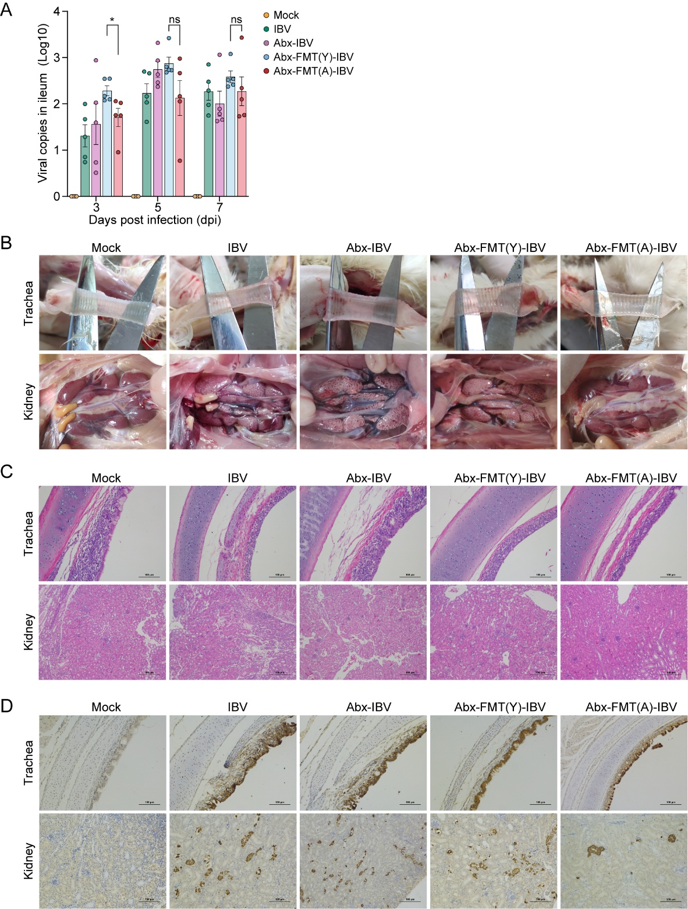
Fig. S2 Viral loads and pathological analysis following IBV infection in FMT experiment. A Viral loads in ileum at days 3, 5, and 7 post-IBV infection (n = 5). B Necropsy images of the trachea and kidneys at 5 dpi. C Hematoxylin-eosin (H&E) staining tissue section analysis of the trachea and kidneys at 5 dpi (Scale bar, 100 μm). D Immunohistochemistry analysis of the trachea and kidneys at 5 dpi (Scale bar, 100 μm). Bar plots in (A) represent the mean ± SEM, with error bars indicating the SEM (* indicates p < 0.05, ns indicates not significant). The Student’s t test was used for each comparison.

Fig. S3 Analysis of gut microbiome origins in recipient chickens following FMT from adult chickens.

Fig. S4 Microbiome composition analysis in adult chickens, young chickens, and FMT-treated young chickens. A–B Comparison of alpha diversity indices: Shannon (A) and Simpson (B) among the groups (n = 20). C–D Gut microbiome composition at the phylum (C) and species (D) levels across different groups of chickens. E–J Gut microbiome composition at the phylum (E), class (F), order (G), family (H), genus (I), and species (J) levels across all samples. Box and point graphs in (B)–(E) indicate the distribution of the data, the top of the box indicates upper quartile, the bottom of the box indicates the lower quartile, the line in the box indicates median, the top line beyond the box indicates maximum, the bottom line beyond the box indicates minimum (* indicate p < 0.05, ns indicates not significant). The Student’s t test was used for each comparison.

Fig. S5 LEfSe analysis between different groups. A–B LEfSe analysis between young-FMT group and young group. C–D LEfSe analysis between adult group and young-FMT group.

Fig. S6 Functional prediction of gut microbiota in adult and young chickens.

Fig. S7 Virome composition analysis in adult chickens, young chickens, and FMT-treated young chickens. A–B Heatmaps showing the relative abundance of viral families at the order (A) and genus (B) levels in the gut virome across different groups.

Fig. S8 Analysis of assembled viral contigs in viromic data. A Distribution of contig lengths and similarities for different viral families assembled from the viromic data. B Phylogenetic tree of assembled Picornaviridae genomes based on whole-genome sequences. C Phylogenetic tree of assembled Coronaviridae genomes based on whole-genome sequences. D Phylogenetic tree of assembled Astroviridae genomes based on whole-genome sequences.

Fig. S9 Prediction of host targets for phage contigs assembled from the virome. A Sankey plot indicate the belonging family and target host genus of each phage contig. B Line plot shows the total confidence score of prediction for each contig. C Bar plot indicate the max score among three prediction method, BLAST, CRISPR, and iPhoP-RF.

Fig. S10 Microbiome and virome interaction networks in the gut. A–B Interaction networks between microbiota and viruses in the gut of adult chickens (A) and young chickens (B).

Fig. S11 Metabolomic analysis of gut samples from adult chickens, young chickens, and FMT-treated young chickens. A Classification of detected metabolites in chicken gut feces. B KEGG functions of detected metabolites. C Venn diagram showing overlapping enriched pathways between differential metabolites and predicted microbiome pathways among adult and young groups. D Correlation analysis of microbiome, virome, and metabolome data using Mantel test. Heatmap of metabolites relative expression level among groups.

Fig. S12 16S rRNA gene sequencing analysis of gut microbiome in young chickens before and after IBV infection. A–D Alpha diversity analysis of the gut microbiome in young chickens before IBV infection and at days 3, 5, and 7 post-infection, using the Chao1 (A), Ace (B), Shannon (C), and Sobs (D) (n = 10). E Heatmap of the relative abundance of gut microbiome at the phylum level in young chickens before IBV infection and at days 3, 5, and 7 post-infection. Box and point graphs in (A)–(D) indicate the distribution of the data, the top of the box indicates upper quartile, the bottom of the box indicates the lower quartile, the line in the box indicates median, the top line beyond the box indicates maximum, the bottom line beyond the box indicates minimum (**, ***, or **** indicate p < 0.01, p < 0.001, and p < 0.0001, respectively; ns indicates not significant). The Student’s t test was used for each comparison.

Fig. S13 Relative abundance of upregulated bacteria after IBV infection in healthy adult, young or young-FMT chickens. A–C Relative abundance of the upregulated bacteria Cloacibacillus porcorum (A), Neglecta timonensis (B), and Akkermansia muciniphila (C) following IBV infection in young chickens, as related to the 16S sequencing data from Figure 2 (n = 20). Box and point graphs in (A)–(C) indicate the distribution of the data.

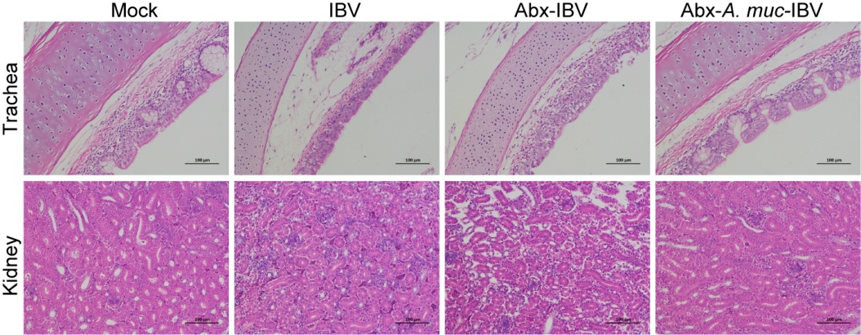
Fig. S14 Hematoxylin-eosin (H&E) staining tissue section analysis following oral gavage of A. muciniphila. H&E analysis of trachea and kidneys at 5 dpi following IBV infection in young chickens following oral gavage of A. muciniphila (Scale bar, 100 μm).

Fig. S15 Metabolomic analysis of the gut in young chickens administrated of A. muciniphila after IBV infection. A Heatmap of differential metabolites between the IBV-infected group administrated of A. muciniphila and the IBV-infected group treated with antibiotics (Abx). B Functional enrichment analysis of differential metabolites between the IBV-infected group administrated of A. muciniphila and the IBV-infected group treated with antibiotics (Abx).

Fig. S16 Relative abundance of GABA in different treatment groups. A Relative abundance of GABA in the IBV-infected group treated with antibiotics (Abx) or the IBV-infected group administrated of A. muciniphila (n = 10). B Relative abundance of GABA in healthy adult or young chickens (n = 20). Point graphs in (A)–(B) indicate the distribution of the data, the black lines indicate mean (***, or **** indicate p < 0.001, and p < 0.0001, respectively). The Student’s t test was used for each comparison.

Fig. S17 Concentration of IFNs in serum and pathological analysis of trachea and kidneys following oral gavage of with A. muciniphila and IBV infection in young chickens. A–B Expression levels of IFN-α (A) and IFN-β (B) in serum samples collected at day 5 post-IBV infection using ELISA kits (n = 5). C Hematoxylin-eosin (H&E) staining tissue section analysis of the trachea and kidneys at 5 dpi (Scale bar, 100 μm). D Immunohistochemistry (IHC) analysis of the trachea and kidneys at 5 dpi (Scale bar, 100 μm). Bar graphs in (A)–(B) represent the mean ± SEM, with error bars indicating the SEM (*, **, ***, or **** indicate p < 0.05, p < 0.01, p < 0.001, and p < 0.0001, respectively; ns indicates not significant). The Student’s t test was used for each comparison.

