SUPPLEMENTARY INFORMATION

List of tables:
Supplement Table 1. Outcome desirability dimensions.
Supplement Table 2. Exemplar WS calculation.
Supplement Table 3. Assessment of outcome desirability.
Supplement Table 4. Operational definitions of Q1-Q3 outcomes.
Supplement Table 5. Outcome validation.

List of Figures:
Supplement Fig. 1. Scoring and weighting of desirability dimensions
Supplement Fig. 2. Ranking of outcomes
Supplement Fig. 3. Simulated DEMYO analysis of a randomized clinical trial.

Supplement Table 1. Outcome desirability dimensions.

Desirability Dimension | Description | Question | Exemplar
Modifiability | This dimension checks the possibility of currently available treatment to change the status (or the trajectory) of the target outcome. | Is the outcome potentially modifiable by treatments? | If blast phase transformation is considered only partially modifiable, this outcome modifiability is judged to be low.
Decisional Value | This dimension highlights how much the outcome is reckoned as a goal for clinical decisions. | Is the outcome an independent decisional criterion for the clinician? | If the decision of which TKI the patient needs to start depends on the estimated possibility to avoid severe thrombocytopenia and major clinically relevant bleedings, the decisional value of the two above outcomes is high.
Reliability | This desirability feature points to the limitations of the outcome assessment methods. | Is outcome assessment by standard methods reliable? | If symptom burden estimation (by standard tools) is a poor marker of patients quality of life due to excessive variability, then this outcome reliability may be considered low.
Meaningfulness^{1,2} | This dimension assesses outcomes value to both physicians and patients. | Is the outcome meaningful to physicians and patients? | If persisting bone marrow fibrosis is not changing prognostic estimations, quality of life, or drug choices, we can judge this outcome meaningfulness is considered low.
Feasibility | This dimension selects outcome assessment methods and turnaround time. | Is monitoring of this outcome feasible? | If circulating immature cell count is available in most hematology centers in a short time, then we can conclude that this outcome feasibility is high.
Cost | The economic dimension casts doubt on the health-care resource consumptions required for monitoring or assessing the outcome. | Does the periodic outcome assessment impose a significant economic burden? | If the allelic burden of driver mutations was very expensive, then the cost dimension of this outcome would be judged to be high.
Acceptability | This dimension accounts for patient point of view in particular when outcome assessment requires invasive tests. | Is periodic outcome assessment acceptable to the patient? | If bone marrow fibrosis at each standard (24 week) time point is considered to be too invasive for patients, this outcome acceptability is judged to be low.
Frequency | This dimension highlights the portion of patients incurring the outcome. | Does the outcome occur too rarely to be included among treatment goals? | If myocardial infarction is considered an extremely rare outcome in the standard time frame of 24 weeks, than this outcome frequency is judged to be very low.

References. 1) Ellis LM, Bernstein DS, Voest EE, et al. American Society of Clinical Oncology perspective: raising the bar for clinical trials by defining clinically meaningful outcomes. J Clin Oncol. 2014;32(12):1277–1280. 2) Weinfurt KP. Clarifying the Meaning of Clinically Meaningful Benefit in Clinical Research. JAMA. 2019;322(24):2381-2382.

Supplement Table 2. Exemplar WS calculation.

Outcome:  “Transformation to blast phase” | Modifiability | Feasibility | Reliability | Meaningfulness | Decisional value | Frequency | Acceptability | Costs | Average
Accomplished | 50% | 83% | 92% | 100% | 92% | 67% | 83% | 58%
Weight | 8 | 8 | 8 | 8 | 3 | 1 | 3 | 1
Score | 4.0 | 6.6 | 7.4 | 8 | 2.7 | 6.7 | 2.5 | 0.58 | 3.7

Legend to Supplement Table 2. Experts voted each pair outcome-desirability dimension by a semi-quantitative Likert scale score ranging from 1 to 7.

Supplement Table 3. Assessment of outcome desirability.

Outcome | Modifiability | Feasibility | Reliability | Meaningfulness | Decisional value | Frequency | Acceptability | Costs
Blast phase | 50% | 83% | 92% | 100% | 92% | 67% | 83% | 58%
Accelerated phase | 46% | 77% | 69% | 85% | 77% | 54% | 77% | 46%
TD anemia | 92% | 83% | 67% | 83% | 67% | 67% | 75% | 42%
Severe non transfusion-dependent anemia | 91% | 73% | 73% | 82% | 64% | 64% | 82% | 36%
Worsening non-severe anemia | 82% | 64% | 64% | 82% | 55% | 55% | 73% | 36%
Stable non-severe anemia | 82% | 73% | 73% | 45% | 18% | 55% | 73% | 36%
Severe thrombocytopenia | 67% | 75% | 83% | 83% | 67% | 58% | 75% | 67%
Stroke | 91% | 82% | 82% | 82% | 55% | 55% | 82% | 36%
Pulmonary embolism | 91% | 82% | 82% | 82% | 55% | 55% | 82% | 36%
Myocardial infarction | 83% | 75% | 75% | 75% | 58% | 50% | 75% | 33%
Deep venous thrombosis | 92% | 75% | 75% | 67% | 50% | 42% | 75% | 33%
Major bleedings | 91% | 73% | 73% | 91% | 64% | 45% | 73% | 35%
Very severe symptom burden | 82% | 73% | 64% | 91% | 55% | 55% | 73% | 36%
Worsening symptoms | 83% | 75% | 50% | 83% | 58% | 58% | 67% | 33%
Severe stable symptoms | 82% | 73% | 64% | 82% | 55% | 55% | 73% | 36%
Severe and symptomatic splenomegaly | 91% | 82% | 73% | 82% | 73% | 55% | 82% | 33%
Severe asymptomatic splenomegaly | 83% | 82% | 64% | 45% | 45% | 45% | 64% | 33%
Moderate worsening splenomegaly | 83% | 75% | 67% | 58% | 33% | 58% | 67% | 36%
Moderate stable splenomegaly | 82% | 73% | 73% | 27% | 9% | 45% | 73% | 36%
Worsening mild splenomegaly | 73% | 64% | 64% | 36% | 18% | 55% | 64% | 27%
Worsening leukocytosis | 83% | 75% | 58% | 25% | 33% | 42% | 67% | 42%
Worsening thrombocytosis | 83% | 75% | 83% | 17% | 17% | 50% | 58% | 33%
Persistent bone marrow fibrosis | 50% | 67% | 42% | 8% | 8% | 33% | 33% | 33%
Worsening bone marrow fibrosis | 50% | 67% | 33% | 42% | 8% | 25% | 33% | 33%
Lack of allelic burden decline (founder mutation) | 75% | 75% | 83% | 33% | 17% | 42% | 67% | 33%
Lack of allelic burden decline (non-founder mutation) | 50% | 67% | 67% | 25% | 17% | 25% | 58% | 33%
Increasing immature circulating cells | 67% | 75% | 58% | 58% | 58% | 58% | 67% | 33%
Transformation to myelodysplastic syndrome | 33% | 75% | 50% | 83% | 58% | 25% | 58% | 42%

Legend to Supplement table 3: the percent rates in the tables show the outcome accomplishment of each relevancy dimension

Supplement Table 4. Operational definitions of Q1-Q3 outcomes.

Outcomes | Operational Definition | References | Agreement
Transformation to blast phase | Circulating or bone marrow blasts 20% or greater | 1-5,12 | na
Transformation to accelerated phase | Circulating or bone marrow blasts 10% or greater | 1-5,12 | 100%
Increasing circulating blast count | Circulating blasts to above 5% confirmed after 4 weeks with no therapy change | 6 | 88%
Transfusion-dependent anemia | The persistent (> 3 mo) need of 2 or more packed red cell units per month | 7 | 90%
Severe anemia | Hemoglobin levels consistently below 8 g/dl in at least two tests and without any external cause | 8 | 90%
Worsening anemia | Progressive and confirmed hemoglobin decline (in less than 12 months) by more than 2 g/dl to below 11 g/dl^{A} | 8 | 82%
Severe thrombocytopenia | Platelet count below 50.000/mmc in at least two tests and without any external cause | 8 | 45%^{B}
Severe splenomegaly | Spleen volume above 1500 mm3, spleen diameter longer than 20 cm, palpatory spleen size more than 10 cm from left costal margin | 9 | 82%^{C}
Symptomatic splenomegaly | Abdominal discomfort (MF-SAF v 2.0 score higher than 5) or early satiety (MF-SAF v 2.0 score higher than 5) associated accompanied by objective evidence of splenomegaly | 10 | 91%
Worsening splenomegaly | Increased spleen palpatory size from left costal margin by more than 5 cm or spleen volume increase by more than 35% | 9 | 82%^{D}
Very severe symptom burden | MF-SAF v 2.0 above 40 or at least 3 dimensions higher than 7 | 11 | 80-91%^{E}
Severe symptom burden | MF-SAF v 2.0 above 30 or at least 2 dimensions higher than 7 | 10 | 75-91%
Worsening symptom burden | MF-SAF v 2.0 increasing by more than 50% (or by > 10 points) ^{F} | 9,13,14 | 73-91%
Severe thrombotic event | Stroke or pulmonary embolism | 15 | na
Major thrombotic events | Myocardial infarction or deep venous thrombosis | 15 | na
Major bleeding events | ISTH definition of major bleeding in non-surgical patients = symptomatic bleeding at critical sites -- intracranial intraspinal, intraocular, retroperitoneal, intra-articular, pericardial, intra-muscle with compartment syndrome -- and/or causing hemoglobin fall by >2 g/dl or need for blood transfusions | 16 | na
Breakthrough adverse genetic features | New detection of high risk mutations or prognostically unfavorable karyotype changes | 17-19 | na

Legend to the table:
na = not assessed A) definition refined by time and threshold benchmarks approved during May 27th meeting: standard IWG-MRT response criteria were mirrored in the definition of worsening anemia and based on CTCAE definition of anemia severity. B) revised and discussed on May 27th virtual meeting to keep consistency with CTCAE and eligibility criteria to pacritinib clinical trials (and exclusion criteria to other clinical trials). C) each of the merged definition received 82% approval. D) 73% of the pannelists also agreed that a 20% increase of spleen volume or a 5 cm worsening of longitudinal spleen diameter at ultrasound were a clinically relevant worsening. E) the final definition merges two approved criteria . F) meaningful MF-SAF v 2.0 change was calculated to be 32% or plus 8 points by Hudgens and coll. However, PGIC-anchored validation of SIMPLIFY trial data by Mesa and coll. Reported higher thresholds. Therefore, more conservative thresholds were adopted.

Supplement Table 5. Outcome validation.

OUTCOME | References reporting correlation with leukemia-free survival or overall survival
Transformation to blast phase | 17, 20-23
Transformation to accelerated phase | 17, 20, 24
Increased circulating blasts | 6, 25-28
Severe anemia | 17, 26, 27, 29-31
Worsening anemia | 17, 32, 33
Severe thrombocytopenia | 17, 32-34
Thrombotic events | 35
Major bleedings | 36
Severe symptom burden | 37, 38
Worsening symptoms | 39
New onset of high risk mutations | 17, 40
Severe splenomegaly | 41-43
Worsening splenomegaly | 43-47
Breakthrough high risk molecular or cytogenetic features | 26, 32, 49-50

Supplement Fig. 1. Scoring and weighting of desirability dimensions.
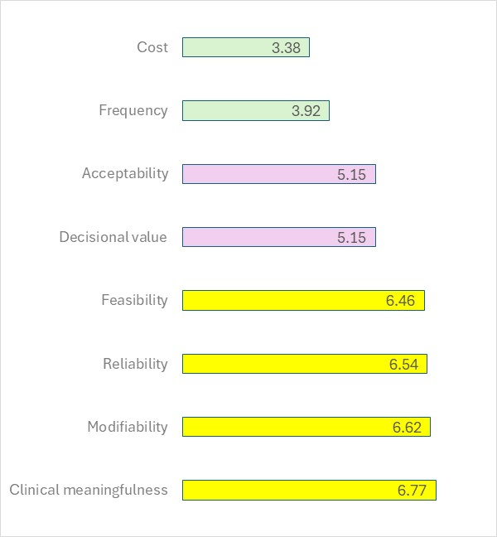
Legend to Supplement Figure 1: X-axis shows the average Likert score assigned to each desirability dimension: the score was based on a semi-quantitative Likert scale ranging from 1 (absolutely poorly relevant) to 7 (absolutely very relevant). Dimension marked by yellow bars were assigned a weight of 8 because the desirability dimensions were 8 ones. Desirability dimension marked by pink bars were assigned a weight of 3. Dimensions marked by green bars were assigned a weight of 1.

Supplement Fig. 2. Ranking of outcomes.

Legend: X-axis shows WS score for each outcome listed on the y-axis. Yellow bars mark outcomes ranked into Q1, blue bars mark Q2 outcomes, pink bars mark Q3 outcomes, and grey bars Q4 outcomes.
Note: WS was calculated for each outcome as shown in Supplementary Table 1. Outcome WS is a weighted mean of each dimension accomplishment. The accomplishment rates of each dimension are provided by Supplementary Table 2 and weights assigned to a dimension by Table 1.
Disclaim: grade 3-4 non-hematologic adverse effects were not specifically addressed, therefore the outcome list was added a disclaimer suggesting that irreversible grade 3-4 treatment-related adverse events were possibly assigned to Q2, and reversible grade 3-4 events to Q3.
.

Supplement Fig. 3. Simulated DEMYO analysis of a randomized clinical trial.

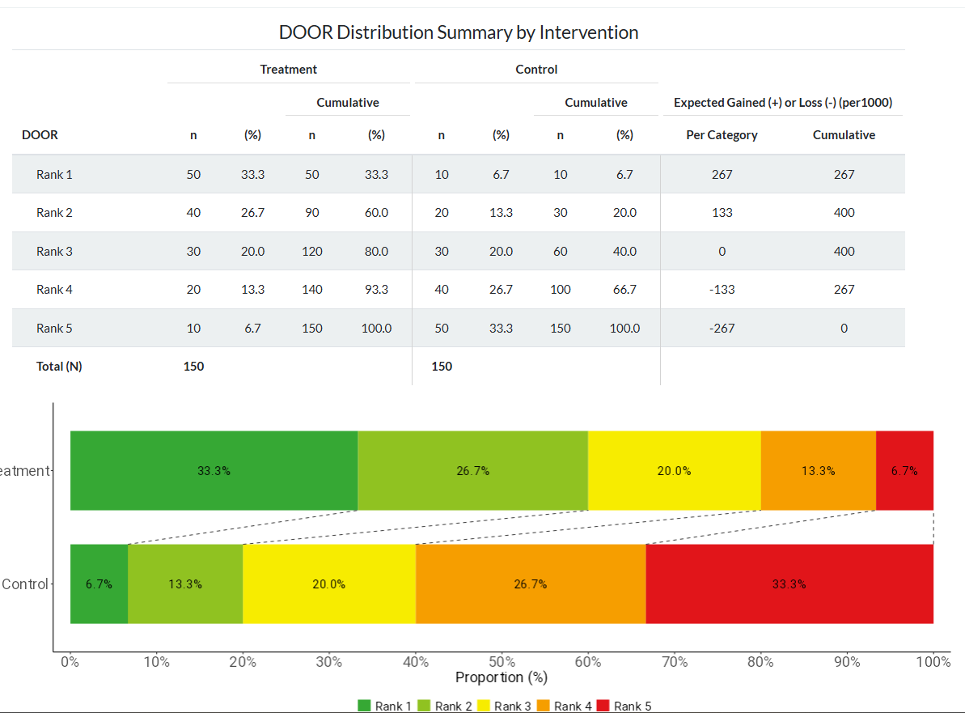
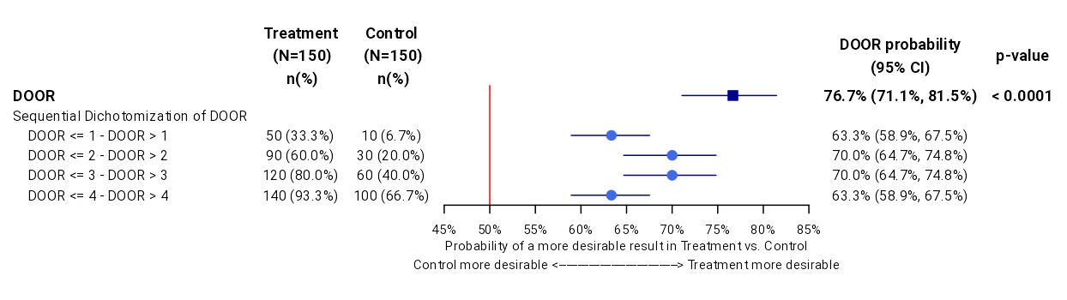

Legend to Figure 3. Treatment versus control comparison is assessed by DOOR probability of achieving better outcomes. In this clinical trial DOOR probability was 76.7% in favor of the treatment arm.

References
- Khoury, J.D., Solary, E., Abla, O. et al. The 5th edition of the World Health Organization classification of haematolymphoid tumours: myeloid and histiocytic/dendritic neoplasms. Leukemia 2022; 36, 1703–19.
- Thiele J, Kvasnicka HM, Orazi A, Gianelli U, Gangat N, Vannucchi AM, et al. The international consensus classification of myeloid neoplasms and acute leukemias: myeloproliferative neoplasms. Am J Hematol 2023;98:166–79.
- Mesa RA, Verstovsek S, Cervantes F, et al. Primary myelofibrosis (PMF), post polycythemia vera myelofibrosis (post-PV MF), post essential thrombocythemia myelofibrosis (post-ET MF), blast phase PMF (PMF-BP): Consensus on terminology by the international working group for myelofibrosis research and treatment (IWG-MRT). Leuk Res 2007;31:737–40.
- Mudireddy M, Gangat N, Hanson CA, Ketterling RP, Pardanani A, Tefferi A. Validation of the WHO-defined 20% circulating blasts threshold for diagnosis of leukemic transformation in primary myelofibrosis. Blood Cancer J. 2018;8(6):57
- Tam CS, Kantarjian H, Cortes J, Lynn A, Pierce S, Zhou L, et al. Dynamic model for predicting death within 12 months in patients with primary or post-polycythemia vera/essential thrombocythemia myelofibrosis. J Clinical Oncol 2009;27:5587–93
- Masarova L, Bose P, Pemmaraju N, , et al. Prognostic value of blasts in peripheral blood in myelofibrosis in the ruxolitinib era. Cancer. 2020;126(19):4322–4331
- Gale RP, Barosi G, Barbui T, et al. What are RBC-transfusion-dependence and -independence? Leukemia Res 2011;35:8-11.
- Common Terminology Criteria for Adverse Events (CTCAE) version 5.0 ttps://ctep.cancer.gov/protocoldevelopment/electronic_applications/docs/CTCAE_v5_Quick_Reference_5x7.pdf (accessed on August 31st)
- Tefferi A,Cervantes F, Mesa R, et al. Revised response criteria for myelofibrosis: International Working Group-Myeloproliferative Neoplasms Research and Treatment (IWG-MRT) and European LeukemiaNet (ELN) consensus report. Blood 2013; 122: 1395–8.
- Mesa RA, Gotlib J, Gupta V, et al. Effect of ruxolitinib therapy on myelofibrosis-related symptoms and other patient-reported outcomes in COMFORT-I: a randomized, double-blind, placebo-controlled trial. J Clin Oncol 2013; 31: 1285-92.
- Marchetti M, Barosi G, Cervantes F, et al. Which patients with myelofibrosis should receive ruxolitinib therapy? ELN-SIE evidence-based recommendations. Leukemia 2017; 31: 882-8.
- Arber DA, Orazi A, Hasserjian RP, et al. International Consensus Classification of Myeloid Neoplasms and Acute Leukemias: integrating morphologic, clinical, and genomic data. Blood 2022; 140: 1200–28.
- Hudgens S, Verstovsek S, Floden L, et al. Meaningful symptomatic change in patients with myelofibrosis from the SIMPLIFY studies. Value Health 2024; 27: 607-13.
- Mesa RA, Hudgens S, Floden L. Symptomatic benefit of momelotinib in patients with myelofibrosis: results from the SIMPLIFY phase III studies. Cancer Med 2023; 12: 10612-24
- Bosco E, Hsueh L, McConeghy KW, Gravenstain S, Saade E. Major adverse cardiovascular event definitions used in observational analysis of administrative databases: a systematic review. BMC Medical Res Methodol 2021;21:241.
- Schulman S, Kearon C. Subcommittee on control of anticoagulation of the Scientific and Standardization Committee of the International Society on Thrombosis and Haemostasis. Definition of major bleeding in clinical investigations of antihemostatic medicinal products in non-surgical patients. J Thromb Haemost 2005; 3: 692-4.
- England JT, McNamara CJ, Kennedy JA, et al. Clinical and molecular correlates of JAK-inhibitor therapy failure in myelofibrosis: long-term data from a molecularly annotated cohort. Leukemia 2022; 36: 1689-92.
- Grinfeld J, Nangalia J, Baxter EJ, et al. Classification and Personalized Prognosis in Myeloproliferative Neoplasms. N Engl J Med 2018; 379: 1416-30
- Kuykendall AT, Talati C, Padron E, et al. Genetically inspired prognostic scoring system (GIPSS) outperforms dynamic international prognostic scoring system (DIPSS) in myelofibrosis patients. Am J Hematol 2019; 94: 87-92.
- Mollard L-M, Chauveau A, Boyer-Perrard F, Douet-Guilbert N, Houot R, Quintin-Roué I, et al.Outcome of Ph-negative myeloproliferative neoplasms transforming to accelerated or leukemic phase. Leukemia Lymphoma 2018; 59: 2812–20.
- Kennedy JA, Atenafu EG, Messner HA, et al. Treatment outcomes following leukemic transformation in Philadelphia-negative myeloproliferative neoplasms. Blood 2013; 121: 2725– 33
- Lancman G, Brunner A, Hoffman R, Mascarenhas J, Hobbs G. Outcomes and predictors of survival in blast phase myeloproliferative neoplasms. Leuk Res 2018; 70: 49–55.
- Chihara D, Kantarjian HM, Newberry KJ, et al. Survival outcome of patients with acute myeloid leukemia transformed from myeloproliferative neoplasms. Blood 2016; 128: 194
- Geyer JT, Margolskee E, Krichevsky SA, Cattaneo D, Boiocchi L, Ronchi P, et al.Disease progression in myeloproliferative neoplasms: comparing patients in accelerated phase with those in chronic phase with increased blasts (<10%) or with other types of disease progression. Haematologica 2020; 105: e221–4
- Masarova L, Bose P, Pemmaraju N, et al. Clinical significance of bone marrow blast percentage in patients with myelofibrosis and the effect of ruxolitinib therapy. Clin Lymphoma Myeloma Leuk 2021; 21: 318-27.
- Vallapureddy RR, Mudireddy M, Penna D, et al. Leukemic transformation among 1306 patients with primary myelofibrosis: risk factors and development of a predictive model. Blood Cancer J 2019; 9: 12.
- Rago A, Latagliata R, Montanaro M, et al. Hemoglobin levels and circulating blasts are two easily evaluable diagnostic parameters highly predictive of leukemic transformation in primary myelofibrosis. Leuk Res 2015; 39: 314-7.
- Shahin OA, Chifotides HT, Bose P, Masarova L, Verstovsek S. Accelerated phase of myeloproliferative neoplasms. Acta Haematol 2021; 144: 484-99.
- Passamonti F, Rumi E, Elena C, Arcaini L, Merli M, Pascutto C, et al. Incidence of leukaemia in patients with primary myelofibrosis and RBC–transfusion-dependence. Br J Haematol 2010; 150: 719–21
- Marcellino BK, Verstovsek S, Mascarenhas J. The myelodepletive phenotype in myelofibrosis: clinical relevance and therapeutic implications. Clin Lymph Myeloma & Leukemia 2020; 20: 415–21
- Gangat N, Caramazza D, Vaidya R, et al. DIPSS plus: A refined Dynamic International Prognostic Scoring System for primary myelofibrosis that incorporates prognostic information from karyotype, platelet count, and transfusion status. J Clinical Oncol 2011; 29 : 392–7.
- Palandri F, Palumbo A, Benevolo G, et al. Incidence of blast phase in myelofibrosis patients according to anemia severity at ruxolitinib start and during therapy. Cancer 2024; 130: 1270-80
- Gangat N, Begna KH, Al-Kali A, et al. Predictors of anemia response to momelotinib therapy in myelofibrosis and impact on survival. Am J Hematol 2023; 98: 282-9
- Huang J, Li C-Y, Mesa RA, Wu W, Hanson CA, Pardanani A, et al. Risk factors for leukemic transformation in patients with primary myelofibrosis. Cancer. 2008;112(12):2726–2732.
- Carobbio A, Vannucchi AM, Rumi E, et al. Survival expectation after thrombosis and overt-myelofibrosis in essential thrombocythemia and prefibrotic myelofibrosis: a multistate model approach. Blood Cancer J 2024; 13: 115.
- Takenaka K, Shimoda K, Uchida N, et al. Clinical features and outcomes of patients with primary myelofibrosis in Japan: report of a 17-year nationwide survey by the Idiopathic Disorders of Hematopoietic Organs Research Committee of Japan. Int J Hematol 2017; 105: 59-69.
- Eppingbroeck AAM, Lechner L, Bakker EC, et al. The personal impact of living with a myeloproliferative neoplasm. Psycho-Oncology 2024; e6338.
- Mazza GL, Mead-Harvey C, Mascarenhas J, et al. Symptom burden and quality of life in patients with high-risk essential thrombocythaemia and polycythaemia vera receiving hydroxyurea or pegylated interferon alfa2a: a post-hoc analysis of the MPN-RC 111 and 112 trials. Lancet Haematol 2022; 9: e38-48.
- Poullet A, Busque L, Sirhan S, et al. Prospective symptom burden analysis in 784 patients with myeloproliferative neoplasms: high burden correlates with inflammatory/genetic biomarkers and reduced survival. Blood 2023; 142 (suppl 1): 917.
- Grinfeld J, Nangalia J, Baxter J, et al. Classification and personalized prognosis in myeloproliferative neoplasms. N Engl J Med 2018; 379: 1416-30.
- Luther M, Henes FO, Zabelina T, et al. Spleen volume and length determined by computed tomography impact outcome after allogeneic stem cell transplantation for myelofibrosis. Bone Marrow Transplant 2023; 58: 755-61
- Song M-K, Chung J-S, Lim S-N, et al. Usefulness of spleen volume measured by computed tomography for predicting clinical outcome in primary myelofibrosis. Int J Hematol 2016; 104: 476-84.
- Gangat N, Begna KH, Al-Kali A, et al. Determinants of survival and retrospective comparisons of 183 clinical trial patients with myelofibrosis treated with momelotinib, ruxolitinib, fedratinib or BMS- 911543 JAK2 inhibitor. Blood Cancer J 2023; 13: 2.
- Palandri F, Palumbo GA, Bonifacio M, et al. Durability of spleen response affects the outcome fo ruxolitinib-treated patients with myelofibrosis: results from a multicentre study of 284 patients. Leuk Res 2018; 74: 86-8
- Verstovsek S, Kantarjian HM, Estrov Z, et al. Long-term outcomes of 107 patients with myelofibrosis receiving JAK1/JAK2 inhibitor ruxolitinib: survival advantage in comparison to matched historical controls. Blood 2012; 120: 1202–9.
- Coltro G, Sant’Antonio E, Palumbo GA, et al. Assessment of the efficacy and tolerability of ruxolitinib for the treatment of myelofibrosis patients in a real life setting: an Italian MYNERVA Project. Cancer Med 2023; 12: 8166–71.
- Vannucchi AM, Kantarjian HM, Kiladjian JJ, et al., A pooled analysis of overall survival in COMFORT-I and COMFORT-II, 2 randomized phase III trials of ruxolitinib for the treatment of myelofibrosis. Haematologica 2015; 100: 1139–45.
- Guglielmelli P, Lasho TL, Rotunno G, , et al.MIPSS70: Mutation-Enhanced International Prognostic Score System for transplantation-age patients with primary myelofibrosis. J Clinical Oncol. 2018;36(4):310–318
- Tefferi A, Nicolosi M, Mudireddy M, et al. Revised cytogenetic risk stratification in primary myelofibrosis: analysis based on 1002 informative patients. Leukemia 2018; 32: 1189–99
- Lundberg P, Karow A, Nienhold R, Looser R, Hao-Shen H, Nissen H, et al. Clonal evolution and clinical correlates of somatic mutations in myeloproliferative neoplasm

