Through the limelight: Analysing the earliest collection of magic lantern glass slides in Portugal

Márcia Vilarigues*¹, Alexandra Rodrigues¹, Ângela Santos¹, Carla Machado¹, Sofia Pires¹, Gilberto Pereira^{2,3}, Vanessa Otero^{1,4}

¹ VICARTE research unit, Department of Conservation and Restoration, NOVA School of Sciences and Technology (NOVA FCT), Caparica, Portugal
² Museu de Ciência da Universidade de Coimbra, Largo Marques de Pombal, Coimbra, Portugal
³ Centro de Física da Universidade de Coimbra, Rua Larga, Coimbra, Portugal
⁴ LAQV-REQUIMTE research unit, Department of Conservation and Restoration, NOVA School of Sciences and Technology (NOVA FCT), Caparica, Portugal

Supplementary Information
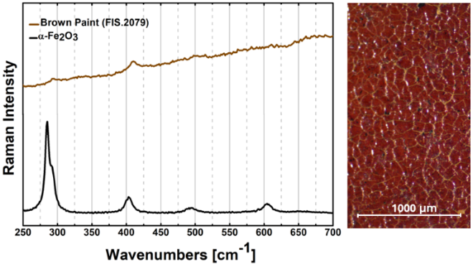

Fig. S1. Raman spectrum of the brown paint of slide FIS.2079 identifying hematite
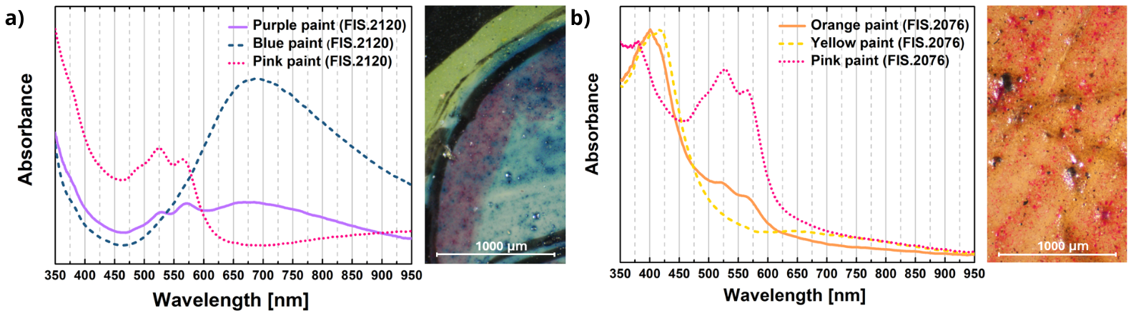

Fig. S2. Representative UV-VIS spectrum of (a) the purple paints and (b) orange paints in the analysed slides
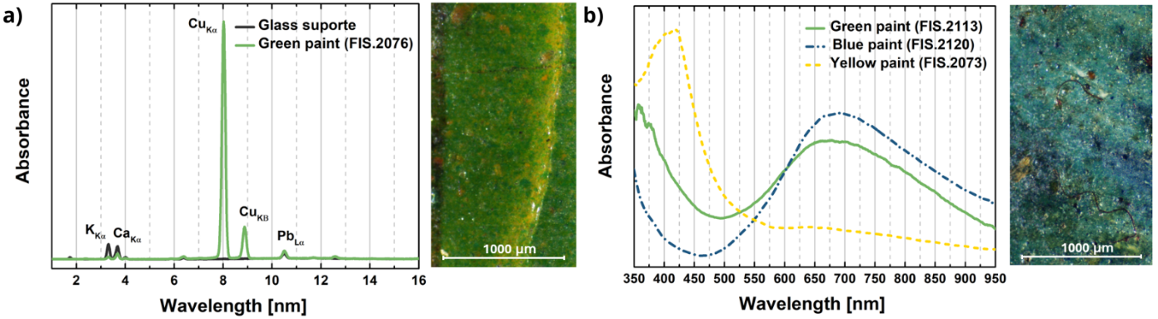
Fig. S3. (a) Representative EDXRF spectrum of the green paints from groups A and D and (b) Representative UV-VIS spectrum of green paints from groups B and C.

