Supplemenatary Table 1: Baseline Characteristics of Caregivers

Characteristic | Value
Age (years), mean (SD) | 37.84 (12.84)
Gender – Female, n (%) | 149 (37.1)
Marital Status – Married, n (%) | 307 (76.4)
Residential Area – Urban, n (%) | 215 (53.5)
Number of Siblings, mean (SD) | 5.21 (2.19)
Educational Status, n (%)
Uneducated | 78 (19.4)
Primary | 58 (14.4)
Secondary | 137 (34.1)
Higher Secondary | 20 (5.0)
Diploma/Bachelor’s and above | 109 (27.1)
Employment Status, n (%)
Unemployed | 150 (37.3)
Employed Full-Time | 139 (34.6)
Employed Part-Time | 103 (25.6)
Retired | 10 (2.5)
Relationship to Patient, n (%)
Spouse | 172 (42.8)
Offspring | 115 (28.6)
Parent | 35 (8.7)
Sibling | 39 (9.7)
Others | 41 (10.2)
Lives with Patient – No, n (%) | 376 (93.5)
Family Type – Joint, n (%) | 196 (48.8)
Overall Health Status, n (%)
Poor | 8 (2.0)
Fair | 57 (14.2)
Good | 192 (47.8)
Excellent | 145 (36.1)
Chronic Health Conditions, n (%)
Hypertension | 316 (78.6)
Diabetes Mellitus | 32 (8.0)
Asthma | 8 (2.0)
Cardiac-related Disease | 10 (2.5)
Hepatitis | 7 (1.7)
Other Chronic Conditions | 29 (7.2)
BMI (kg/m²), mean (SD) | 24.43 (4.42)
Current Smoker, n (%) | 62 (15.4)
Takes Sleeping Pills – No, n (%) | 30 (7.5)
Average Sleep Duration (hours), mean (SD) | 7.56 (2.47)
Physical Activity (hours/day), mean (SD) | 0.76 (0.91)
Past Depression History – No, n (%) | 365 (90.8)
Monthly Income (mean (SD)) | 29,017.48 (39,741.39)
Financial Support to Patient, n (%)
None | 119 (29.6)
Some | 65 (16.2)
Significant | 218 (54.2)
Nature of Relationship (coded), n (%)
0 | 14 (32.6)
1 | 16 (37.2)
3 | 13 (30.2)
Distance to Hospital (km), mean (SD) | 59.11 (67.88)
Hospital Visits per Week, mean (SD) | 1.65 (1.42)
PHQ-9 Score, mean (SD) | 9.25 (6.13)
Depression (PHQ-9 ≥ 5), n (%) | 295 (73.4)
Depression Severity, n (%)
No Depression | 107 (26.6)
Mild | 109 (27.1)
Moderate | 97 (24.1)
Moderately Severe | 66 (16.4)
Severe | 23 (5.7)

Binomial Logistic Regression
Model Fit Measures
 |  |  |  | Overall Model Test
Model | Deviance | AIC | R²_{McF} | χ² | df | p
1 | 481.0 | 511.0 | 0.1314 | 72.77 | 14 | <.001
Note. Models estimated using sample size of N=401

Omnibus Likelihood Ratio Tests
Predictor | χ² | df | p
Education_of_caregiver | 5.9574 | 4 | 0.202
Overall_health_status_of_the_caregiver | 6.5477 | 3 | 0.088
BMI_of_caregiver | 1.8569 | 1 | 0.173
Monthly_income_of_the_caregiver | 22.7654 | 1 | <.001
Duration_of_Physical_activity_in_caregivers | 11.9283 | 1 | <.001
How_often_the_patient_visits_the_hospital_in_a_week | 0.6720 | 1 | 0.412
Number_of_hours_caregiver_spends_caring_for_patient_per_day | 0.6010 | 1 | 0.438
Average_sleep_duration_in_caregivers | 0.7619 | 1 | 0.383
Whether_the_caregiver_lives_with_the_patient | 3.4949 | 1 | 0.062

Model Coefficients - Depression Score - Transform 12
 |  | 95% Confidence Interval
Predictor | Estimate | Lower | Upper | SE | Z | p | Odds ratio
Intercept | 0.34041 | -1.93580 | 2.61663 | 1.16136 | 0.29311 | 0.769 | 1.4055
Education_of_caregiver:
Primary – Uneducated | 0.25152 | -0.51160 | 1.01465 | 0.38936 | 0.64600 | 0.518 | 1.2860
Secondary – Uneducated | 0.67255 | 0.03087 | 1.31422 | 0.32739 | 2.05425 | 0.040 | 1.9592
Higher – Uneducated | 0.04219 | -1.03860 | 1.12298 | 0.55143 | 0.07651 | 0.939 | 1.0431
Diploma/Bachelor's and Above – Uneducated | 0.16185 | -0.53346 | 0.85716 | 0.35476 | 0.45623 | 0.648 | 1.1757
Overall_health_status_of_the_caregiver:
Fair – Poor | -0.61042 | -2.23889 | 1.01806 | 0.83087 | -0.73467 | 0.463 | 0.5431
Good – Poor | -0.16526 | -1.71459 | 1.38407 | 0.79049 | -0.20906 | 0.834 | 0.8477
Excellent – Poor | 0.27145 | -1.29043 | 1.83332 | 0.79689 | 0.34063 | 0.733 | 1.3119
BMI_of_caregiver | -0.03397 | -0.08301 | 0.01506 | 0.02502 | -1.35786 | 0.175 | 0.9666
Monthly_income_of_the_caregiver | 1.089e-5 | 4.534e-6 | 1.725e-5 | 3.245e-6 | 3.35726 | <.001 | 1.0000
Duration_of_Physical_activity_in_caregivers | 0.44761 | 0.18755 | 0.70768 | 0.13269 | 3.37345 | <.001 | 1.5646
How_often_the_patient_visits_the_hospital_in_a_week | 0.07322 | -0.10675 | 0.25320 | 0.09183 | 0.79741 | 0.425 | 1.0760
Number_of_hours_caregiver_spends_caring_for_patient_per_day | 0.01433 | -0.02206 | 0.05071 | 0.01856 | 0.77175 | 0.440 | 1.0144
Average_sleep_duration_in_caregivers | 0.03938 | -0.04958 | 0.12834 | 0.04539 | 0.86765 | 0.386 | 1.0402
Whether_the_caregiver_lives_with_the_patient:
No – Yes | -0.91901 | -1.92663 | 0.08861 | 0.51410 | -1.78760 | 0.074 | 0.3989
Note. Estimates represent the log odds of "Depression Score - Transform 12 = No depression" vs. "Depression Score - Transform 12 = Depression"

Assumption Checks
Collinearity Statistics
 | VIF | Tolerance
Education_of_caregiver | 1.028 | 0.9728
Overall_health_status_of_the_caregiver | 1.029 | 0.9714
BMI_of_caregiver | 1.016 | 0.9845
Monthly_income_of_the_caregiver | 1.031 | 0.9701
Duration_of_Physical_activity_in_caregivers | 1.048 | 0.9542
How_often_the_patient_visits_the_hospital_in_a_week | 1.045 | 0.9568
Number_of_hours_caregiver_spends_caring_for_patient_per_day | 1.083 | 0.9230
Average_sleep_duration_in_caregivers | 1.042 | 0.9594
Whether_the_caregiver_lives_with_the_patient | 1.018 | 0.9828

Reliability Analysis
Scale Reliability Statistics
 | Cronbach's α | McDonald's ω
scale | 0.8214 | 0.8174

Item Reliability Statistics
 | If item dropped
 | Cronbach's α | McDonald's ω
PHQ_1 | 0.8015 | 0.7971
PHQ_2 | 0.7904 | 0.7862
PHQ_3 | 0.7964 | 0.7931
PHQ_4 | 0.7910 | 0.7872
PHQ_6 | 0.8167 | 0.8124
PHQ_5 | 0.8080 | 0.8040
PHQ_7 | 0.7945 | 0.7901
PHQ_8 | 0.7894 | 0.7847
PHQ_9 | 0.8337 | 0.8339

Correlation Heatmap
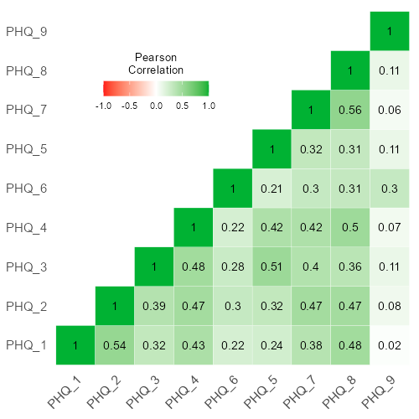

Exploratory Factor Analysis
Factor Loadings
 | Factor
 | 1 | 2 | 3 | Uniqueness
PHQ_1 | 0.7801 |  |  | 0.5199
PHQ_2 | 0.6997 |  |  | 0.4839
PHQ_3 |  | 0.7121 |  | 0.4342
PHQ_4 | 0.4365 | 0.3681 |  | 0.5015
PHQ_5 |  | 0.7240 |  | 0.5292
PHQ_6 |  |  | 0.5830 | 0.5537
PHQ_7 | 0.5834 |  |  | 0.5576
PHQ_8 | 0.7230 |  |  | 0.4609
PHQ_9 |  |  | 0.5214 | 0.7514
Note. 'Principal axis factoring' extraction method was used in combination with a 'promax' rotation

Factor Statistics
Summary
Factor | SS Loadings | % of Variance | Cumulative %
1 | 2.2943 | 25.492 | 25.49
2 | 1.2601 | 14.001 | 39.49
3 | 0.6533 | 7.259 | 46.75

Inter-Factor Correlations
 | 1 | 2 | 3
1 | — | 0.6763 | 0.3599
2 |  | — | 0.3691
3 |  |  | —

Model Fit

Model Fit Measures
 | RMSEA 90% CI |  |  |  | Model Test
RMSEA | Lower | Upper | TLI | BIC | χ² | df | p
0.06388 | 0.03736 | 0.09159 | 0.9398 | -40.24 | 31.72 | 12 | 0.002

Assumption Checks
Bartlett's Test of Sphericity
χ² | df | p
1023 | 36 | <.001

KMO Measure of Sampling Adequacy
 | MSA
Overall | 0.8542
PHQ_1 | 0.8516
PHQ_2 | 0.8711
PHQ_3 | 0.8507
PHQ_4 | 0.8847
PHQ_5 | 0.8470
PHQ_6 | 0.8285
PHQ_7 | 0.8696
PHQ_8 | 0.8537
PHQ_9 | 0.6109

Eigenvalues

Scree Plot
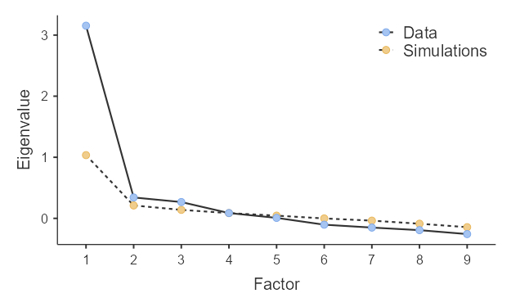

Confirmatory Factor Analysis
Factor Loadings
Factor | Indicator | Estimate | SE | Z | p
Factor 1 | PHQ_1 | 0.7355 | 0.05518 | 13.328 | <.001
Factor 1 | PHQ_2 | 0.7945 | 0.05302 | 14.985 | <.001
Factor 1 | PHQ_4 | 0.7890 | 0.05499 | 14.347 | <.001
Factor 1 | PHQ_7 | 0.7579 | 0.05343 | 14.185 | <.001
Factor 1 | PHQ_8 | 0.8179 | 0.05260 | 15.549 | <.001
Factor 2 | PHQ_3 | 0.9188 | 0.06371 | 14.421 | <.001
Factor 2 | PHQ_5 | 0.7150 | 0.05896 | 12.127 | <.001
Factor 3 | PHQ_6 | 0.8725 | 0.17286 | 5.047 | <.001
Factor 3 | PHQ_9 | 0.1840 | 0.04635 | 3.969 | <.001

Factor Estimates

Factor Covariances
 |  | Estimate | SE | Z | p
Factor 1 | Factor 1 | 1.0000ᵃ
Factor 1 | Factor 2 | 0.7238 | 0.04518 | 16.020 | <.001
Factor 1 | Factor 3 | 0.3937 | 0.08835 | 4.456 | <.001
Factor 2 | Factor 2 | 1.0000ᵃ
Factor 2 | Factor 3 | 0.3477 | 0.09070 | 3.834 | <.001
Factor 3 | Factor 3 | 1.0000ᵃ
ᵃ fixed parameter

Model Fit
Test for Exact Fit
χ² | df | p
63.37 | 24 | <.001

Fit Measures
 |  |  | RMSEA 90% CI
CFI | TLI | RMSEA | Lower | Upper | AIC | BIC
0.9606 | 0.9409 | 0.06388 | 0.04498 | 0.08326 | 9544 | 9664

