Appendix Table 1. ICD-10 codes used as exclusion criteria.
Exclusions | ICD-10 codes
Not between 37 and 41 gestational weeks (ICD-10 codes) (Exclude based on surgery date) | Z3A.0 Less than 10 weeks  Z3A.1 10-19 weeks  Z3A.2 20-29 weeks  Z3A.31- Z3A.36 30-36 weeks  Z3A.42, Z3A.49 42 weeks and greater than 42 weeks
with more than one single fetus | Z37.2-Z37.9
History of abortion | Z87.5
abnormal weight (2500-3999 g) was constructed | P07 (low weight),  P08 (high weight)  P05 (Malnutrition)
Maternal care for other fetal problems | O36
Maternal care for other (suspected) fetal abnormality and damage | O35.8
Maternal care for malpresentation of fetus | O32
Multiple gestation | O30
Placenta Previa and related complications of pregnancy within 90 days | O43.21, O44.0, O44.1, O44.4 (low-lying placenta)
Eclampsia (a seizure disorder in pregnancy) | O15.0
Preterm delivery (prior to thirty-seven weeks gestation) | O60
Maternal care for abnormality of pelvic organs | O34
Obstructed labor due to shoulder dystocia | O66.0
Supervision of high risk pregnancy | O09
Labor and delivery complicated by vasa previa | O69. 4
Abnormalities of forces of labor | O62
Encounter for antenatal screening of mother | Z36
pre-eclampsia | O14
Patients who had any prior pregnancy with a 4th degree perineal laceration in as far back as records are available | O70.3
Other abnormal uterine and vaginal bleeding | N93
Systemic lupus erythematosus (SLE) | M32
History of uterine scar from previous surgery | Z98.891
Herpes viral infection of urogenital system, unspecified | A60. 00
Maternal Medical Conditions | ICD-10 codes
Amniotic fluid complications | O40, O41.0, O41.00X0
Asthma | J45
renal disease | N18
cardiac disease | I51
trauma | T14
Diabetes | E10-E14
Gestational diabetes | O24.319, O24.32, O24.93, O24.911, O24.93, O24.4
Hypertension (including preeclampsia and eclampsia) | O10, I10, I11, I12.9, I13.0, I15.0
Infections | B20, B01, B02, B00/A60, B06, B15-B19, 075. B27.90, B25.9, B97.35, B34.3, A50, B58, O98, O35.1, R75, Z21
Mental health conditions | F039, F1099, V2349, F05, F04, F2089, F3010, F22, F29, F840, F419, F600, F66, F70, F71, F79, O99345
Obesity | O99.21X, O98.4X, E66.9, V85.3X, V85.4X
Substance use (drugs, alcohol and tobacco) | F102, F112, F101, O99330
history of substance abuse | Z86. 4
Thyroid disorders | E040, E042, E0500, E009, E890, E061, E079, O9928

Appendix Figure 1. Selection of the study population.
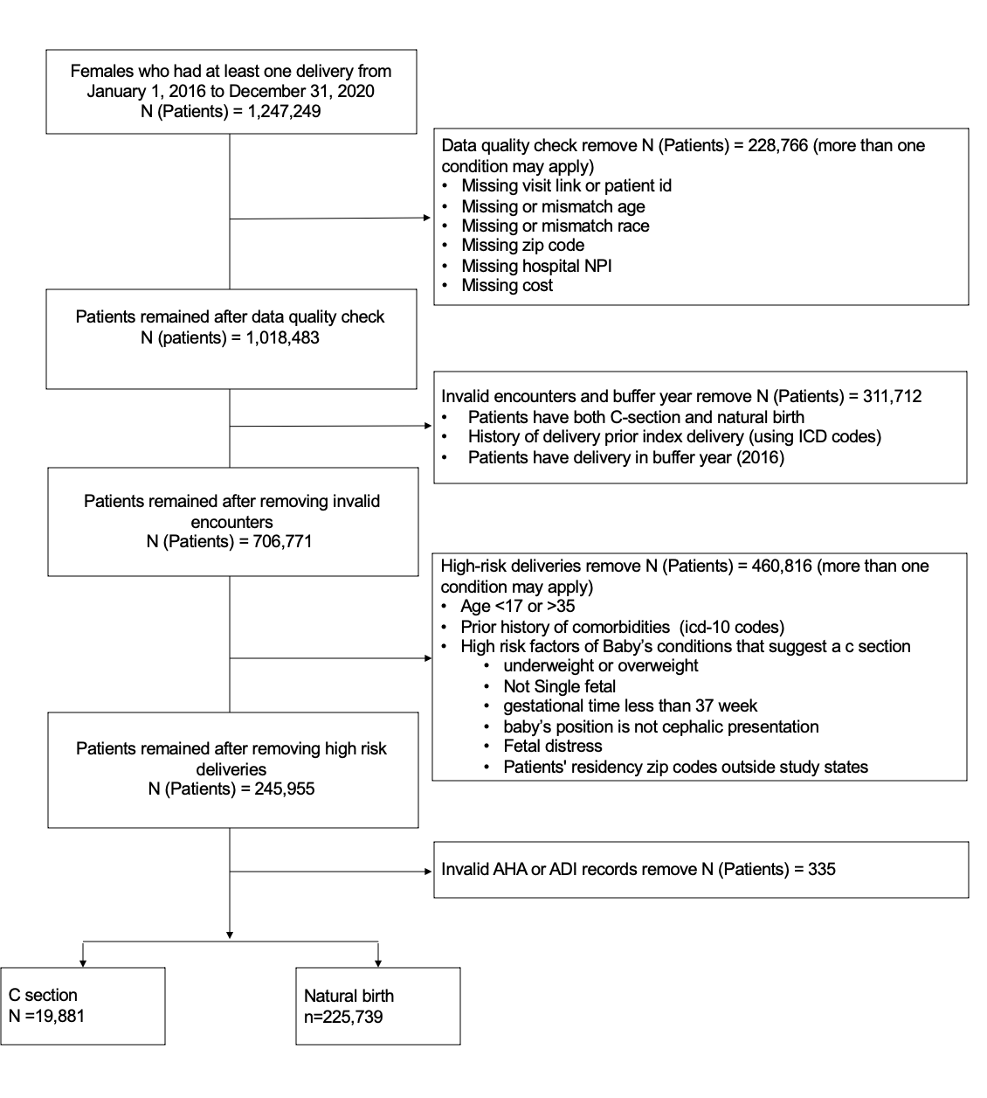

Appendix Table 2. Multivariable generalized estimating equation model assessing individual and hospital characteristics associated with c-section utilization, 2017-2020, Florida.
Characteristic | OR | 95% CI | p-value
Age | 1 | 1.0, 1.00 | 0.1
Race
White | — | —
Asian | 1.07 | 1.01, 1.13 | 0.018
Black | 1.17 | 1.13, 1.21 | <0.001
Hispanic | 1.32 | 1.28, 1.37 | <0.001
Others | 1.14 | 1.08, 1.21 | <0.001
Insurance Type
Medicaid | — | —
Other | 1.09 | 1.04, 1.15 | <0.001
Private Insurance | 1.17 | 1.14, 1.20 | <0.001
Median Household Income Quantile
1 | — | —
2 | 0.99 | 0.96, 1.02 | 0.6
3 | 1 | 0.96, 1.03 | 0.8
4 | 1.01 | 0.96, 1.06 | 0.7
Hospital Beds
< 200 | — | —
200 - 400 | 1.13 | 1.06, 1.21 | <0.001
400 - 600 | 0.87 | 0.80, 0.94 | <0.001
600 - 1000 | 0.85 | 0.78, 0.94 | <0.001
>1000 | 0.83 | 0.76, 0.90 | <0.001
Hospital Type
Government,  Nonfederal | — | —
Investor-owned  (for-profit) | 1.09 | 1.00, 1.18 | 0.038
Nongovernment,  not-for-profit | 0.93 | 0.87, 0.99 | 0.032
Teaching Hospital
No | — | —
Yes | 1.04 | 0.96, 1.12 | 0.4
Appendix Table 3. Multivariable generalized estimating equation model assessing individual and hospital characteristics associated with c-section utilization, 2017-2020, Maryland.
Characteristic | OR | 95% CI | p-value
Age | 0.99 | 0.99, 1.00 | 0.005
Race
White | — | —
Asian | 1.04 | 0.98, 1.11 | 0.2
Black | 1.11 | 1.05, 1.18 | <0.001
Hispanic | 0.79 | 0.74, 0.84 | <0.001
Others | 1.02 | 0.94, 1.11 | 0.6
Insurance Type
Medicaid | — | —
Other | 1.01 | 0.94, 1.08 | 0.8
Private Insurance | 1.11 | 1.06, 1.16 | <0.001
Median Household Income Quantile
1 | — | —
2 | 1.04 | 0.94, 1.15 | 0.4
3 | 0.96 | 0.87, 1.06 | 0.4
4 | 0.89 | 0.81, 0.99 | 0.027
Hospital Beds
< 200 | — | —
200 - 400 | 0.93 | 0.80, 1.09 | 0.4
400 - 600 | 0.63 | 0.50, 0.79 | <0.001
600 - 1000 | 0.58 | 0.34, 0.98 | 0.043
>1000 | 0.67 | 0.41, 1.09 | 0.11
Teaching Hospital
No | — | —
Yes | 1.23 | 0.88, 1.72 | 0.2

Appendix Table 4. Multivariable generalized estimating equation model assessing individual and hospital characteristics associated with c-section utilization, 2017-2020, Wisconsin.
Characteristic | OR | 95% CI | p-value
Age | 0.99 | 0.98, 1.00 | <0.001
Race
White | — | —
Asian | 0.88 | 0.81, 0.95 | 0.002
Black | 1.03 | 0.93, 1.13 | 0.6
Hispanic | 0.85 | 0.78, 0.92 | <0.001
Others | 0.9 | 0.71, 1.13 | 0.3
Insurance Type
Medicaid | — | —
Other | 1.32 | 1.17, 1.49 | <0.001
Private Insurance | 1.19 | 1.13, 1.26 | <0.001
Median Household Income Quantile
1 | — | —
2 | 1.05 | 0.97, 1.14 | 0.2
3 | 1.04 | 0.96, 1.13 | 0.4
4 | 0.96 | 0.87, 1.06 | 0.4
Hospital Beds
< 200 | — | —
200 - 400 | 0.86 | 0.75, 1.00 | 0.049
400 - 600 | 0.83 | 0.45, 1.56 | 0.6
Hospital Type
Investor-owned  (for-profit) | — | —
Nongovernment,  not-for-profit | 1.23 | 0.80, 1.90 | 0.3
Teaching Hospital
No | — | —
Yes | 1.06 | 0.62,1.82 | 0.8

