Figure S1 | Map of Rehri Goth

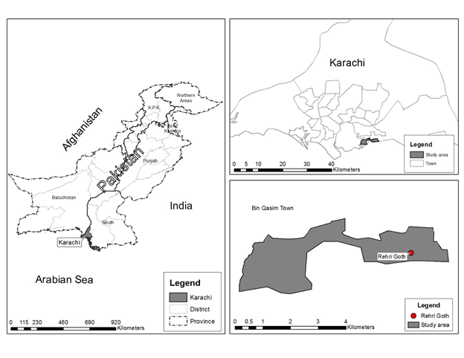

Table S1 | Percent breakdown of under-five deaths (source ANISA study 2012-2013¹⁹) (n=131)

Age at death | N (%)
Day zero | 31 (24)
Day 1-6 | 29 (22)
Day 7-27 | 13 (10)
Day 28-59 | 10 (8)
Month 2-5 | 16 (12)
Month 6-11 | 10 (8)
Month 12-23 | 12 (9)
Month 24-59 | 10 (8)

