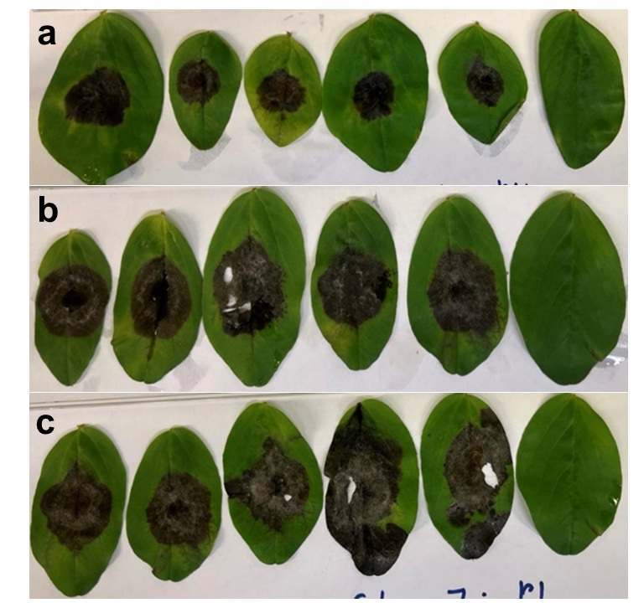
Figure S1. Chocolate spot reaction in (a) ILB 938/2, (b) Mélodie/2, and (c) Kontu caused by B. fabae isolate 19B053-4. The rightmost leaflets show the sterile distilled water control.

Table S1. The SSR markers were used to genotype the 21 Botrytis isolates in this study.
Primer name | Primer sequence (5´-3´) | Reference
NEP1for | CCAACGCAAAATTCCTTTCTATCC | Staats et al. (2007)
NEP1revB | GTTGGCGAAGTTGTGGTCATTGAA | Staats et al. (2007)
NEP2forD | TTGCCTTCTCAAAATCATTACAGC | Staats et al. (2007)
NEP2revD | TCTAGAAAGTAGCCTTCGCAAGAT | Staats et al. (2007)
NEP1(-207)for | CACCTTGTGGGAGATTGTATGGGTGGATATACATC | Staats et al. (2007)
NEP1(+1124)rev | GGTCACCTAATTTTGGCTTTCAGGGTC | Staats et al. (2007)
NEP2 (-200)for | GAACTTTGAATAGTGGGCAGTTGGG | Staats et al. (2007)
NEP2 (+1147)rev | GAGTTTCAGGTATATTCGTTTGGTGGA | Staats et al. (2007)
NEP2forE | GTGACTGTAAAACGACGGCCAGTTCATCATGGTTGCCTTCTCAAGAT | Staats et al. (2007)
NEP2revE | GTGACCAGGAAACAGCTATGACCAAGTAGCAGCTGCAAGATTGTTTG | Staats et al. (2007)
NEP2forF | GTGACTGTAAAACGACGGCCAGTTTCGGTCTTGGCATCTACAGTCAT | Staats et al. (2007)
NEP1revA | GTGACCAGGAAACAGCTATGACCCTTGGCGAGGTTGTTGTTGAAGTT | Staats et al. (2007)
NEP2forE | GTGACTGTAAAACGACGGCCAGTTCATCATGGTTGCCTTCTCAAGAT | Staats et al. (2007)
NEP1revA | GTGACCAGGAAACAGCTATGACCCTTGGCGAGGTTGTTGTTGAAGTT | Staats et al. (2007)
NEP2forF | TTCGGTCTTGGCATCTACAGTCAT | Staats et al. (2007)
NEP2revE | AAGTAGCAGCTGCAAGATTGTTTG | Staats et al. (2007)
NEP2for | TGGTTGCCTTCTCAAAATCA | Mirzaei et al. (2008)
NEP2rev | GCCTTCGCAAGATTGTCTG | Mirzaei et al. (2008)
C₇₂₉₊for | AGCTCGAGAGAGATCTCTGA | Rigotti et al. (2002)
C₇₂₉₋rev | CTGCAATGTTCTGCGTGGAA | Rigotti et al. (2002)

