SUPPLEMENTARY INFORMATION

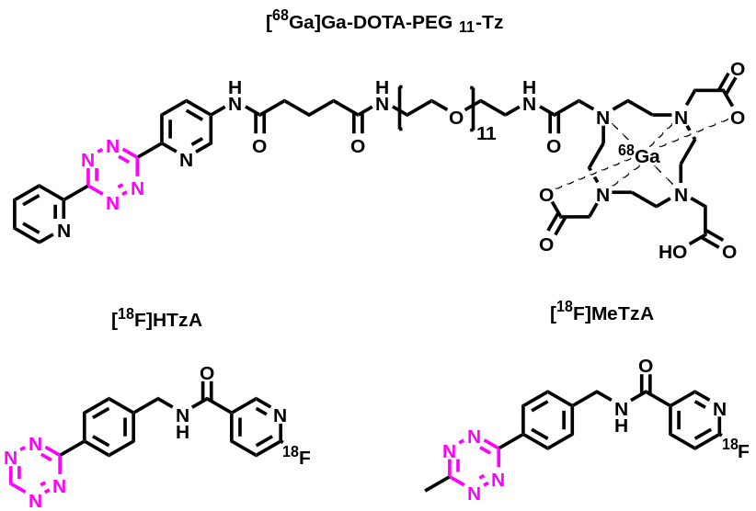

Supplementary Fig. 1: Chemical structures of tetrazines used. A polar gallium-68 radiolabelled tetrazine, [⁶⁸Ga]-DOTA-PEG₁₁-Tz, was used for ex vivo experiments, while two fluorine-18 radiolabelled tetrazines, [¹⁸F]HTzA and [¹⁸F]MeTzA, were evaluated in vivo.

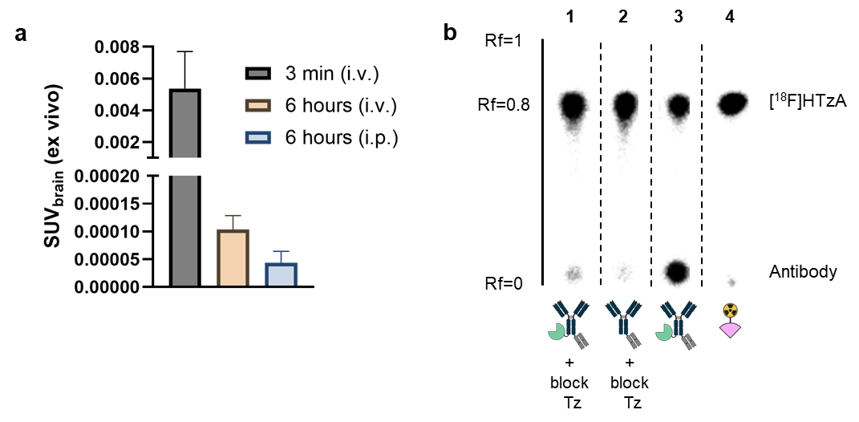
Supplementary Fig. 2: Brain concentrations of [⁶⁸Ga]Ga-DOTA-PEG₁₁-Tz. a A polar tetrazine, radiolabelled with gallium-68 ([⁶⁸Ga]Ga-DOTA-PEG₁₁-Tz), was either intravenously or intraperionally administered to WT mice to ensure that the tetrazine did not enter the brain. The resulting brain concentrations were 100- to 1000-fold lower than those seen with the fluorine-18 labelled brain-penetrant tetrazines used for pretargeting. b Representative radioTLC data. Plasma samples were collected from mice receiving: 1) TCO-Bapi8D3-Fab8D3 and DOTA-PEG₁₁-Tz (blocking tetrazine); 2) Bapi8D3-Fab8D3 and DOTA-PEG₁₁-Tz (blocking tetrazine); 3) Bapi8D3-Fab8D3 without DOTA-PEG₁₁-Tz (no blocking); and 4) PBS as a control. All samples were incubated with [¹⁸F]HTzA for 30 minutes at 37 °C and then applied to NP silica TLC plates. The mobile phase consisted of 8:2 ethyl acetate/n-heptane. Radioactivity distribution was visualised using a Cyclone phosphor imaging system. These data show that pre-injection of DOTA-PEG₁₁-Tz effectively reduced [¹⁸F]HTzA binding to circulating TCO-labelled antibody, whereas in the absence of blocking, [¹⁸F]HTzA successfully underwent click ligation to the antibody in plasma. Mean ± SD of n = 3 per condition (a). (TLC = Thin-Layer Chromatography).
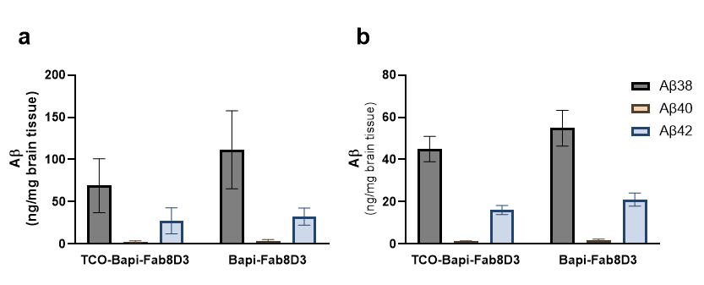
Supplementary Fig. 3: Amyloid-β levels in the brain of mice included in the pretargeted PET study. a Amyloid-β (Aβ) levels in the cerebrum of AppNL-G-F mice that received either TCO-Bapi-Fab8D3 or Bapi-Fab8D3 prior to pretargeted PET with [¹⁸F]HTzA. b Aβ levels in the cerebellum of AppNL-G-F mice that received either TCO-Bapi-Fab8D3 or Bapi-Fab8D3 prior to pretargeted PET with [¹⁸F]HTzA. There were no differences between the two groups of mice for any of the Aβ species. Mean ± SD of n = 3 per condition (a - b). 2-way ANOVA Sidak’s multiple comparison (a-b).

Supplementary Table 1: Mice used in the different studies
Study | Number of AD mice (m/f) | Number of WT | Age (months)
Ex vivo pretargeting | 6 (2/4) | 3 (0/3) | 18-19
Selection of [¹⁸F]Tz | 6 (1/5) | 7 (1/6) | 12-17
Ex vivo [⁶⁸Ga]Tz | n.a. | 9 (5/4) | 4
PET Pretargeting | 6 (3/3) | 3 (2/1) | 16-19

