Synoptic atmospheric conditions drive microclimatic variability in a high-latitude landscapes
Climate Dynamics

Johanna Lehtinen^{a,}*, Juha Aalto^{a,b}, Pekka Niittynen^{a,c} & Miska Luotoª
ª Department of Geosciences and Geography, University of Helsinki, Helsinki, Finland
^{b} Finnish Meteorological Institute, Weather and Climate Change Impact Research, Helsinki, Finland
^{c} Department of Biological and Environmental Science, University of Jyväskylä, Jyväskylä, Finland
*Corresponding author (johanna.lehtinen@helsinki.fi)

SUPPLEMENTARY MATERIAL: FIGURES AND TABLES
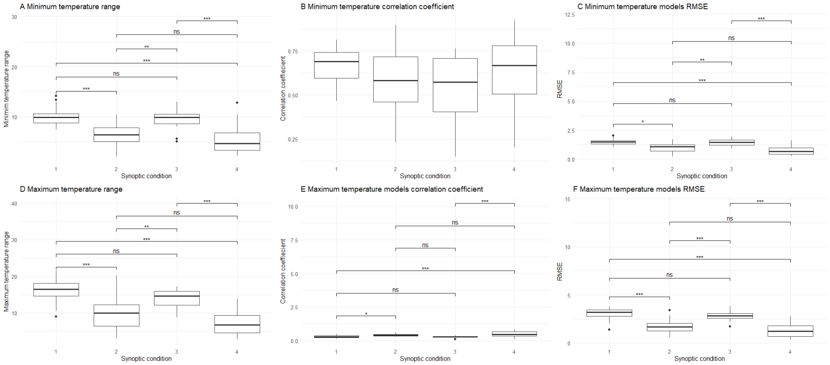
Figure S1. Significance of differences among synoptic conditions for A) observed minimum temperature range, B) minimum temperature models correlation coefficient, C) minimum temperature models RMSE, D) observed maximum temperature range, E) maximum temperature models correlation coefficient, F) maximum temperature models RMSE

Table S1. Observed average temperature range across land cover types during the observational period in different synoptic conditions for minimum and maximum temperatures.
