Supplementary materials
Table S1. Unimodal prediction: Performance estimates in the five predictor groups using three approaches to class imbalance 2
Figures S1-5. Distribution of correctly and incorrectly classified cases in each predictor group based on age at diagnosis using RUSBoost 3
Figure S1. CAPE: Correctly and incorrectly classified cases by the age at diagnosis in RUSBoost 3
Figure S2. General adolescent mental health (Q-14 questionnaire): Correctly and incorrectly classified cases by the age at diagnosis in RUSBoost 4
Figure S3. Schizophrenia polygenic risk scores (SCZ PRS): Correctly and incorrectly classified cases by the age at diagnosis in RUSBoost 4
Figure S4. Childhood and parental mental health diagnoses: Correctly and incorrectly classified cases by the age at diagnosis in RUSBoost 5
Figure S5. Birth-related factors: Correctly and incorrectly classified cases by the age at diagnosis in RUSBoost 5
Table S2. Multimodal prediction with undersampling (RUSBoost) – balanced accuracies that were improved by multimodal prediction are highlighted in bold. 6
Figure S6. Example of how feature values for cases in training set did not match the distribution of values in the test set when using SMOTE 8
Note 1: Dealing with data leakage 9
Figure S7. Age at first diagnosed psychosis 11
Figure S8. Participant age when predictors are being considered based on the predictor cutoff 12
12
Table S3. Complete overview of predictors 13
STROBE Statement—Checklist of items that should be included in reports of cohort studies 18
TRIPOD Checklist: Prediction Model Development 19
References 21

Table S1. Unimodal prediction: Performance estimates in the five predictor groups using three approaches to class imbalance
Feature | Classif-ier | n cases | n controls | n cases train/ test | n controls train/ test | TP | FP | TN | FN | Sensitivity | Specificity | Balanced accuracy
CAPE |  | 47 | 22905 | 38/ 10 | 18324/ 4581 | 6  [5-6] | 932  [877-1003] | 3650  [3578-3705] | 5  [4-6] | 52.23 ± 2.26 [45.56-57.33] | 79.66 ± 0.64 [78.11-80.88] | 65.95 ± 1.09 [62.73-67.91]
Q14 |  | 48 | 23464 | 39/ 10 | 18772/ 4693 | 6  [4-7] | 1019  [953-1074] | 3675  [3620-3741] | 5  [4-6] | 56.24 ± 3.63 [41.11-64.67] | 78.30 ± 0.57 [77.13-79.70] | 67.27 ± 1.76 [60.31-71.16]
SZ PRS | RUS | 242 | 73093 | 194/ 49 | 58475/ 14619 | 31  [28-33] | 6988  [6751-7236] | 7632  [7383-7868] | 19  [16-21] | 62.54 ± 1.88 [57.87-67.36] | 52.20 ± 0.82 [50.50-53.81] | 57.37 ± 0.81 [54.93-59.20]
NPR |  | 378 | 108499 | 303/ 76 | 86800/ 21700 | 24  [22-26] | 2871  [2647-3181] | 18831  [18520-19054] | 53  [51-55] | 31.10 ± 0.97 [28.31-33.35] | 86.77 ± 0.51 [85.34-87.81] | 58.94 ± 0.47 [57.81-60.14]
MBRN |  | 374 | 106562 | 300/ 75 | 85250/ 21313 | 34  [29-37] | 7649  [7111-8168] | 13665  [13145-14202] | 43  [39-47] | 44.04 ± 2.29 [38.19-48.42] | 64.11 ± 1.05 [61.68-66.63] | 54.08 ± 1.05 [51.67-56.26]
CAPE |  | 47 | 22905 | 38/ 10 | 18324/ 4581 | 4  [3-4] | 459  [328-704] | 4124  [3878-4254] | 7  [6-7] | 32.48 ± 4.25 [25.33-40.00] | 90.01 ± 1.99 [84.64-92.85] | 61.24 ± 1.93 [56.25-65.56]
Q14 |  | 48 | 23464 | 39/ 10 | 18772/ 4693 | 5  [2-5] | 685  [331-1054] | 4009  [3640-4363] | 7  [5-8] | 36.45 ± 5.55 [21.11-49.78] | 85.42 ± 3.60 [77.56-92.96] | 60.94 ± 2.17 [55.36-65.61]
SZ PRS | SVM | 242 | 73093 | 194/ 49 | 58475/ 14619 | 21  [18-22] | 4068  [3886-4216] | 10552  [10404-10734] | 29  [28-31] | 41.08 ± 1.81 [36.83-43.79] | 72.18 ± 0.51 [71.16-73.42] | 56.63 ± 0.86 [54.85-58.02]
NPR |  | 378 | 108499 | 303/ 76 | 86800/ 21700 | 24  [21-25] | 2596  [2463-2747] | 19106  [18954-19237] | 54  [51-55] | 30.35 ± 1.28 [27.51-32.81] | 88.04 ± 0.28 [87.34-88.65] | 59.20 ± 0.56 [58.08-60.29]
MBRN |  | 374 | 106562 | 300/ 75 | 85250/ 21313 | 22  [20-23] | 4009  [3783-4355] | 17305  [16958-17530] | 54  [53-55] | 28.38 ± 0.75 [26.48-29.95] | 81.19 ± 0.62 [79.57-82.25] | 54.79 ± 0.35 [53.95-55.42]
CAPE |  | 47 | 22905 | 38/ 10 | 18324/ 4581 | 1  [0-1] | 111  [20-272] | 4472  [4309-4561] | 10  [9-10] | 1.36 ± 1.59 [0.00-6.44] | 97.60 ± 2.29 [94.06-99.56] | 49.48 ± 1.39 [47.14-52.93]
Q14 |  | 48 | 23464 | 39/ 10 | 18772/ 4693 | 2  [1-3] | 569  [526-611] | 4126  [4083-4168] | 9  [8-9] | 14.42 ± 3.11 [8.22-22.89] | 87.90 ± 0.41 [86.99-88.80] | 51.16 ± 1.54 [48.34-55.13]
SZ PRS | SMOTE | 242 | 73093 | 194/ 49 | 58475/ 14619 | 30  [28-31] | 6565  [6495-6629] | 8056  [7990-8125] | 20  [18-21] | 59.73 ± 1.51 [57.04-62.81] | 55.10 ± 0.18 [54.66-55.57] | 57.42 ± 0.75 [56.06-58.93]
NPR |  | 378 | 108499 | 303/ 76 | 86800/ 21700 | 20  [17-22] | 2942  [2316-3630] | 18760  [18071-19384] | 58  [54-59] | 25.01 ± 1.66 [21.94-28.79] | 86.45 ± 1.37 [83.27-89.33] | 55.73 ± 0.59 [54.25-56.79]
MBRN |  | 374 | 106562 | 300/ 75 | 85250/ 21313 | 22  [17-23] | 7253  [5886-7461] | 14061  [13852-15427] | 55  [52-58] | 28.11 ± 1.81 [22.73-30.76] | 65.97 ± 1.85 [64.99-72.40] | 47.04 ± 0.51 [46.09-47.92]
Note. CAPE = Community Assessment of Psychic experiences; Q14 = adolescent general mental health (MoBa 14-year questionnaire); SZ PRS = schizophrenia polygenic risk; NPR = Norwegian Patient Registry (parent and childhood psychiatric diagnoses); MBRN = Norwegian Medical Birth Registry (birth-related factors); Undersampling conducted with RUSBoost,⁷ Oversampling with SMOTE SVM⁸ and Cost-sensitive learning with SVM.⁹

Figures S1-5. Distribution of correctly and incorrectly classified cases in each predictor group based on age at diagnosis using RUSBoost
Abbreviations
- TP: Consistently classified as true positives across 50 repeats
- FP: Consistently classified as false positives across 50 repeats
- Left: Nr. of cases – (nr. of consistent TP + nr. of consistent FP) where, consistent is defined as at least 40 times out of the 50 cross-validation repeats (i.e., 80%)
- X-axis: Age in years when given a psychosis diagnosis (F2*, P72, or P98; some rounding off to be expected)
- Y-axis: Counts
Note. Because of the poor performance of SMOTE, as described in the main manuscript, we did not include it in this comparison.

Figure S1. CAPE: Correctly and incorrectly classified cases by the age at diagnosis in RUSBoost

Figure S2. General adolescent mental health (Q-14 questionnaire): Correctly and incorrectly classified cases by the age at diagnosis in RUSBoost

Figure S3. Schizophrenia polygenic risk scores (SCZ PRS): Correctly and incorrectly classified cases by the age at diagnosis in RUSBoost

Figure S4. Childhood and parental mental health diagnoses: Correctly and incorrectly classified cases by the age at diagnosis in RUSBoost

Figure S5. Birth-related factors: Correctly and incorrectly classified cases by the age at diagnosis in RUSBoost

Table S2. Multimodal prediction with undersampling (RUSBoost) – balanced accuracies that were improved by multimodal prediction are highlighted in bold.
Model | Modality | n cases | n controls | n  cases train / test | n controls train / test | TP | FP | TN | FN | Sensitivity | Specificity | Balanced accuracy
CAPE-SZ PRS | CAPE | 34 | 16940 | 28/ 7 | 13552/ 3388 | 5  [3-5] | 667  [624-725] | 2723  [2664-2764] | 4  [3-4] | 55.11 ± 4.08 [43.81-61.90] | 80.34 ± 0.73 [78.61-81.59] | 67.73 ± 1.96 [62.70-71.64]
 | SZ PRS |  |  |  |  | 3  [2-4] | 1345  [1240-1436] | 2045  [1953-2149] | 5  [4-6] | 35.02 ± 6.19 [24.29-50.00] | 60.34 ± 1.22 [57.64-63.41] | 47.68 ± 2.91 [42.69-54.49]
 | Combined |  |  |  |  | 4  [3-4] | 745  [691-787] | 2645  [2602-2698] | 4  [3-4] | 50.07 ± 3.02 [44.29-56.67] | 78.03 ± 0.62 [76.77-79.62] | 64.05 ± 1.49 [60.99-67.14]
CAPE-MBRN | CAPE | 46 | 22601 | 37/ 10 | 18081/  4521 | 6  [4-6] | 945  [891-1010] | 3577  [3511-3630] | 5  [4-6] | 50.67 ± 3.00 [43.33-57.11] | 79.12 ± 0.62 [77.66-80.30] | 64.90 ± 1.45 [61.46-68.10]
 | MBRN |  |  |  |  | 5  [3-6] | 1600  [1474-1707] | 2922  [2814-3047] | 6  [4-7] | 46.08 ± 6.56 [32.44-61.11] | 64.62 ± 1.28 [62.25-67.41] | 55.35 ± 3.06 [48.85-62.16]
 | Combined |  |  |  |  | 6  [4-6] | 1050  [1001-1089] | 3472  [3432-3520] | 5  [4-6] | 50.96 ± 3.92 [41.11-58.44] | 76.79 ± 0.48 [75.93-77.87] | 63.88 ± 1.93 [59.13-67.42]
CAPE-NPR | CAPE | 47 | 22905 | 38/ 10 | 18324/  4581 | 6  [5-6] | 934  [866-995] | 3648  [3587-3715] | 5  [4-6] | 52.10 ± 3.01 [44.67-60.44] | 79.62 ± 0.71 [78.27-81.10] | 65.86 ± 1.51 [62.25-69.93]
 | NPR |  |  |  |  | 4  [2-4] | 814  [767-851] | 3769  [3731-3815] | 7  [6-8] | 32.06 ± 4.35 [18.89-40.22] | 82.25 ± 0.40 [81.43-83.26] | 57.16 ± 2.05 [51.08-60.93]
 | Combined |  |  |  |  | 6  [5-6] | 987  [936-1041] | 3596  [3540-3645] | 5  [4-5] | 53.19 ± 3.14 [46.67-60.00] | 78.48 ± 0.55 [77.27-79.57] | 65.83 ± 1.59 [63.01-69.63]
CAPE-Q14 | CAPE | 47 | 22675 | 38/ 10 | 18140/  4535 | 6  [5-6] | 924  [871-963] | 3613  [3572-3665] | 5  [4-5] | 51.99 ± 2.79 [46.89-59.33] | 79.64 ± 0.49 [78.77-80.80] | 65.81 ± 1.38 [63.31-69.81]
 | Q14 |  |  |  |  | 6  [5-6] | 998  [949-1066] | 3539  [3470-3587] | 5  [4-5] | 55.08 ± 3.83 [47.33-63.56] | 78.02 ± 0.48 [76.51-79.08] | 66.55 ± 1.88 [62.69-70.72]
 | Combined |  |  |  |  | 6  [5-7] | 937  [880-1006] | 3599  [3530-3656] | 5  [3-5] | 57.42 ± 4.31 [46.22-67.78] | 79.35 ± 0.53 [77.82-80.60] | 68.38 ± 2.16 [62.72-73.83]
CAPE-Q14-NPR | CAPE | 47 | 22675 | 38/ 10 | 18140/  4535 | 6  [5-6] | 928  [883-996] | 3609  [3539-3653] | 5  [4-6] | 51.86 ± 3.16 [45.11-60.22] | 79.56 ± 0.58 [78.03-80.54] | 65.71 ± 1.58 [61.88-70.15]
 | Q14 |  |  |  |  | 6  [5-6] | 994  [946-1041] | 3543  [3495-3590] | 5  [4-5] | 55.45 ± 3.67 [48.67-63.56] | 78.10 ± 0.44 [77.07-79.15] | 66.78 ± 1.75 [63.39-70.52]
 | MBRN |  |  |  |  | 4  [2-4] | 808  [747-848] | 3729  [3687-3789] | 7  [6-8] | 32.33 ± 4.88 [18.67-40.89] | 82.21 ± 0.47 [81.30-83.54] | 57.27 ± 2.28 [50.69-61.26]
 | Combined |  |  |  |  | 6  [5-7] | 926  [880-980] | 3611  [3555-3655] | 5  [4-5] | 58.20 ± 3.51 [49.11-66.00] | 79.61 ± 0.48 [78.39-80.60] | 68.91 ± 1.74 [64.63-72.74]
MBRN- SZ PRS | MBRN | 242 | 72286 | 194/ 49 | 57829/  14458 | 20  [17-22] | 4710  [4410-5039] | 9749  [9419-10048] | 31  [27-33] | 38.64 ± 2.37 [33.47-44.65] | 67.42 ± 1.04 [65.15-69.50] | 53.03 ± 0.98 [50.57-54.90]
 | SZ PRS |  |  |  |  | 31  [28-33] | 6913  [6541-7172] | 7546  [7286-7917] | 19  [17-21] | 62.52 ± 2.27 [56.68-66.51] | 52.19 ± 0.86 [50.39-54.76] | 57.36 ± 0.94 [54.84-59.11]
 | Combined |  |  |  |  | 32  [28-33] | 6848  [6656-6990] | 7611  [7468-7802] | 18  [16-21] | 64.18 ± 1.99 [57.07-67.74] | 52.64 ± 0.59 [51.65-53.96] | 58.41 ± 0.86 [55.43-60.24]
NPR-SZ PRS | NPR | 242 | 73093 | 194/ 49 | 58475/ 14619 | 15  [13-15] | 1832  [1731-1907] | 12788 [12713-12888] | 35  [34-37] | 29.08 ± 1.14 [25.30-31.01] | 87.47 ± 0.27 [86.96-88.16] | 58.28 ± 0.50 [56.69-59.21]
 | SZ PRS |  |  |  |  | 31  [28-32] | 6969  [6665-7202] | 7651  [7417-7955] | 19  [17-21] | 62.46 ± 1.81 [57.81-65.36] | 52.33 ± 0.75 [50.74-54.41] | 57.40 ± 0.72 [55.27-59.07]
 | Combined |  |  |  |  | 30  [28-32] | 6295  [6030-6658] | 8325  [7961-8590] | 20  [17-22] | 61.14 ± 2.00 [56.22-65.26] | 56.94 ± 0.95 [54.45-58.76] | 59.04 ± 0.80 [57.08-60.83]
NPR-MBRN | NPR | 374 | 106562 | 300/ 75 | 85250/ 21313 | 24  [22-26] | 2902  [2704-3220] | 18413  [18093-18609] | 52  [50-54] | 31.25 ± 1.26 [28.36-34.22] | 86.39 ± 0.46 [84.88-87.31] | 58.82 ± 0.57 [57.53-60.20]
 | MBRN |  |  |  |  | 34  [29-38] | 7679  [7250-8274] | 13636  [13039-14063] | 43  [38-46] | 44.22 ± 2.27 [38.75-50.29] | 63.97 ± 0.91 [61.18-65.98] | 54.10 ± 0.96 [52.07-56.80]
 | Combined |  |  |  |  | 30  [28-32] | 4512  [4214-5019] | 16802  [16294-17099] | 47  [44-48] | 38.95 ± 1.31 [36.36-41.73] | 78.83 ± 0.71 [76.45-80.23] | 58.89 ± 0.69 [57.36-60.02]
Q14-SZ PRS | Q14 | 35 | 17334 | 28/ 7 | 13868/ 3467 | 5  [4-5] | 825  [790-860] | 2643  [2607-2677] | 4  [3-4] | 58.23 ± 3.65 [48.57-68.57] | 76.22 ± 0.48 [75.19-77.23] | 67.22 ± 1.80 [62.90-72.39]
 | SZ PRS |  |  |  |  | 4  [2-4] | 1364  [1267-1476] | 2105  [1992-2201] | 5  [3-6] | 39.54 ± 6.74 [17.14-57.14] | 60.68 ± 1.34 [57.46-63.47] | 50.11 ± 3.15 [38.83-58.16]
 | Combined |  |  |  |  | 5  [4-5] | 797  [754-842] | 2671  [2625-2714] | 4  [3-4] | 57.14 ± 4.00 [48.57-65.71] | 77.03 ± 0.58 [75.71-78.26] | 67.09 ± 2.00 [62.62-71.53]
Q14-MBRN | Q14 | 47 | 23149 | 38/ 10 | 18520/ 4630 | 6  [5-6] | 1029  [981-1074] | 3603  [3556-3649] | 5  [4-5] | 56.52 ± 3.98 [46.67-63.78] | 77.79 ± 0.46 [76.80-78.81] | 67.15 ± 1.97 [62.24-70.57]
 | MBRN |  |  |  |  | 5  [3-6] | 1655  [1546-1778] | 2976  [2853-3085] | 6  [5-7] | 44.95 ± 5.47 [30.22-54.67] | 64.26 ± 1.25 [61.61-66.61] | 54.61 ± 2.66 [47.91-59.01]
 | Combined |  |  |  |  | 6  [5-6] | 1006  [956-1052] | 3626  [3579-3674] | 5  [4-5] | 56.88 ± 3.33 [48.67-64.00] | 78.30 ± 0.47 [77.29-79.35] | 67.59 ± 1.67 [63.64-71.32]
Q14-NPR | Q14 | 48 | 23464 | 39/ 10 | 18772/ 4693 | 6  [5-6] | 1017  [959-1063] | 3678  [3630-3735] | 5  [4-5] | 56.00 ± 3.41 [47.56-62.89] | 78.35 ± 0.46 [77.35-79.57] | 67.17 ± 1.62 [63.24-70.53]
 | NPR |  |  |  |  | 4  [3-4] | 835  [801-878] | 3859  [3815-3893] | 7  [6-8] | 33.64 ± 3.85 [23.11-42.00] | 82.22 ± 0.40 [81.29-82.93] | 57.93 ± 1.79 [53.02-61.75]
 | Combined |  |  |  |  | 6  [5-7] | 999  [935-1055] | 3696  [3638-3759] | 5  [4-5] | 55.89 ± 3.63 [49.56-64.89] | 78.74 ± 0.53 [77.52-80.08] | 67.32 ± 1.75 [64.31-71.53]
Note. CAPE = Community Assessment of Psychic experiences; Q14 = adolescent general mental health (MoBa 14-year questionnaire); SZ PRS = schizophrenia polygenic risk; NPR = Norwegian Patient Registry (parent and childhood psychiatric diagnoses); MBRN = Norwegian Medical Birth Registry (birth-related factors); Combined models created using RUSBoost within cross-validation.
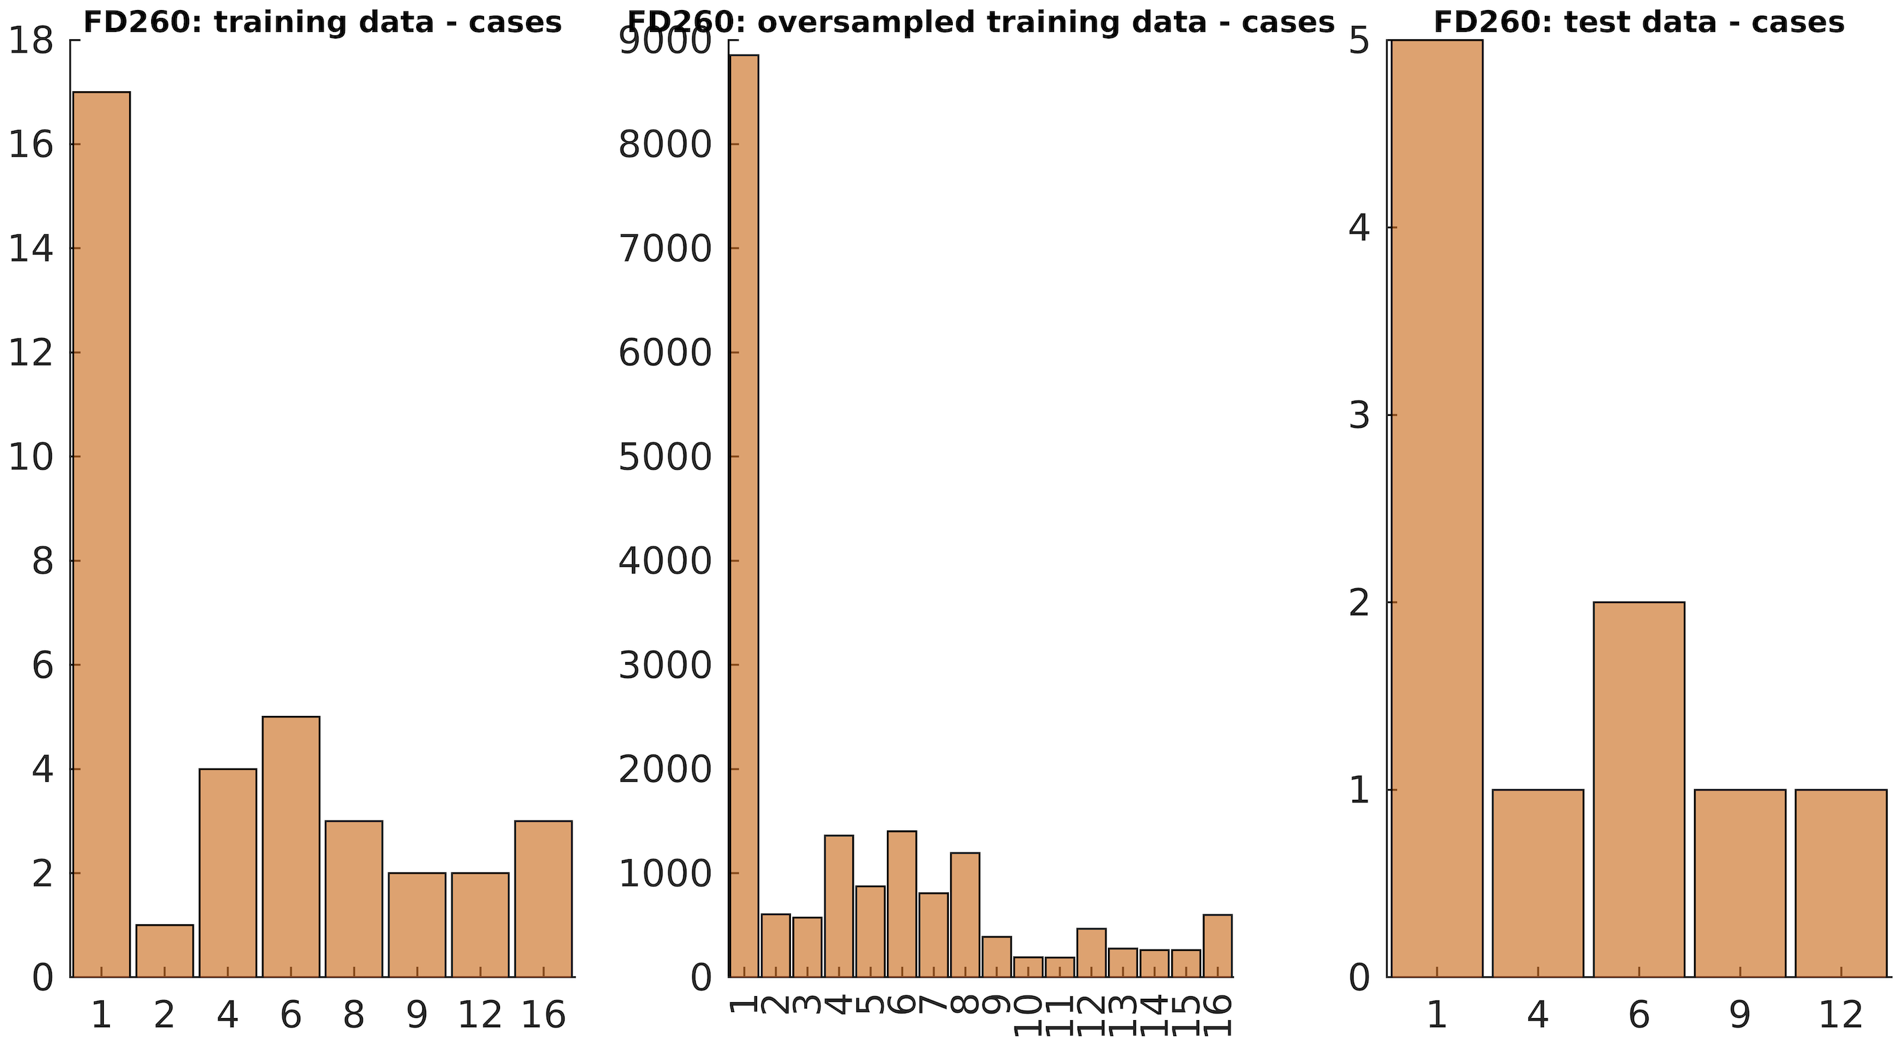

Figure S6. Example of how feature values for cases in training set did not match the distribution of values in the test set when using SMOTE
SMOTE: synthetic minority oversampling; Oversampling works by creating synthetic datapoints for the minority class in the training sample. With ordinal features (such as the general mental health predictor group and the CAPE predictor group), oversampling sometimes led to feature values for the cases in the training set that did not match the distribution of values in the test set. Therefore, the trained model would not generalise to the test set, leading to chance-level performances.

Note 1: Dealing with data leakage
Data leakage arises when incorrect treatment of data during collection, sampling, or pre-processing leads to a false relationship between the independent and outcome variables, leading to inflated performance estimates.¹ We applied several measures to mitigate the effect of data leakage.
Kapoor and Narayanan propose eight types of leakage and present ways to identify and mitigate them. ¹ They also suggest that data leakage might be the reason why more advanced machine learning algorithms seem to outperform simpler (linear association) models, performance that is often not reproduced. In a step-by-step run-through of Kapoor and Narayanan’s taxonomy, we present potential sources of data leakage in our data and our efforts to mitigate these.
1) Lack of a clean separation of training and test datasets. This can lead the training model to learn from the test set, rendering the model to be biased. Examples of this are using no test set,² any pre-processing (such as under or oversampling) before the data is split, or selecting variables from the complete data, which all can lead to leakage of information between training and test sets, and hence overfitting of the training model. To address this, we made sure to create separate datasets before pre-processing our data or building our models. This involved using our cross-validation strategy for handling related individuals where we stratified individuals to either training or test sets based on their family unit. Additionally, we performed all preprocessing, transformation, model building, and testing steps within cross-validation (e.g., regression, standardization, sampling procedures, hyperparameter optimization).
2) Including features in a model that are proxies of the outcome is also a source of leakage.³ In our case, using antipsychotic medication as a predictor of psychosis may lead to leakage of information because many individuals who use antipsychotics are already diagnosed with psychotic disorder. To avoid this, we selected our predictors based on a domain-specific literature search of prior studies on risk factors for psychosis development.
3) The test set is drawn from a distribution that is different from the one of interest.
3.1) For instance, if the test set contains data that was collected before the data in the training set. We made sure to choose features that were measured before any of the participants had developed a psychotic episode. We did this by restricting all predictors to be measured at age 14 or earlier, as per the 14-year self-report questionnaires, and we removed any individuals who had received a psychosis diagnosis before or at the age of 14 (n = 41). This defined cut-off was set and prepared before the data was split into a training and test set.
3.2) Dependence of features between the training and test data may also lead to leakage. A serious example of this is when training and test contain observations from the same individual. In our case, we would have dependence between datasets if the training and test sets contained observations from individuals of the same family. This is why we defined siblingship and used this information to place related individuals together in the same datasets.
3.3) Sampling bias in the test data can also result in data leakage. In our data, selection bias and attrition effects may lead the participants to no longer be representative of the population we are comparing them with (Norwegians born between 1999-2008). Those who continue participating in MoBa tend to have parents who are older and have higher education.^{4,5} They also have fewer severe psychiatric diagnoses than those who were initially included in the study.⁶ If our sample is less likely to have a psychotic disorder than their age-matched peers, this may lead us to underestimate any relationship between our predictors and outcome. To handle this, we chose include all individuals in our models and not exclude those who only had data from the first phases of data collection. We created separate models with those who had data on each separate predictor group. Hence, the sample with birth related factors was substantially bigger than the one using adolescent psychotic disorders.

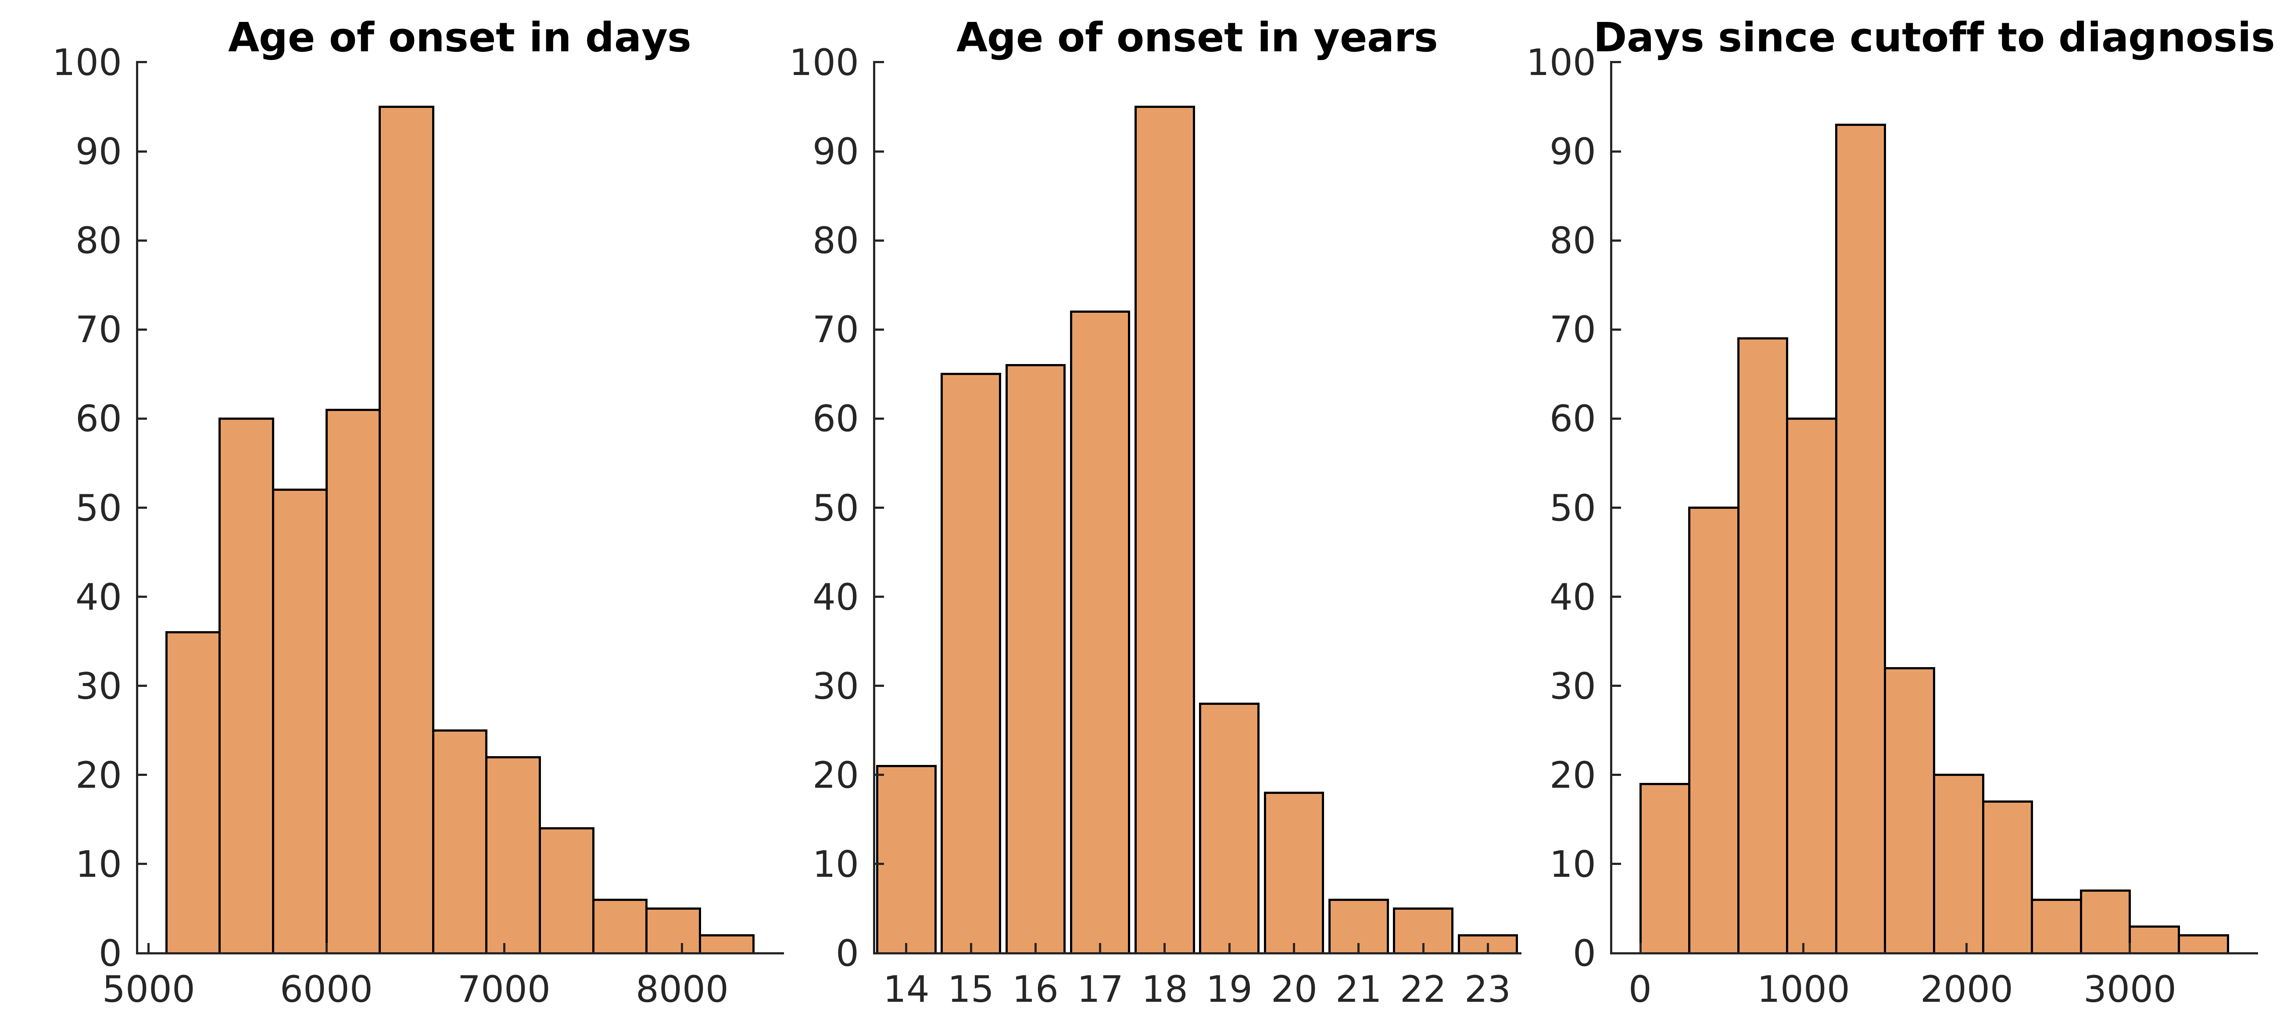
Figure S7. Age at first diagnosed psychosis
Note. Minimum days since cutoff to diagnosis: 183.5 days

Figure S8. Participant age when predictors are being considered based on the predictor cutoff
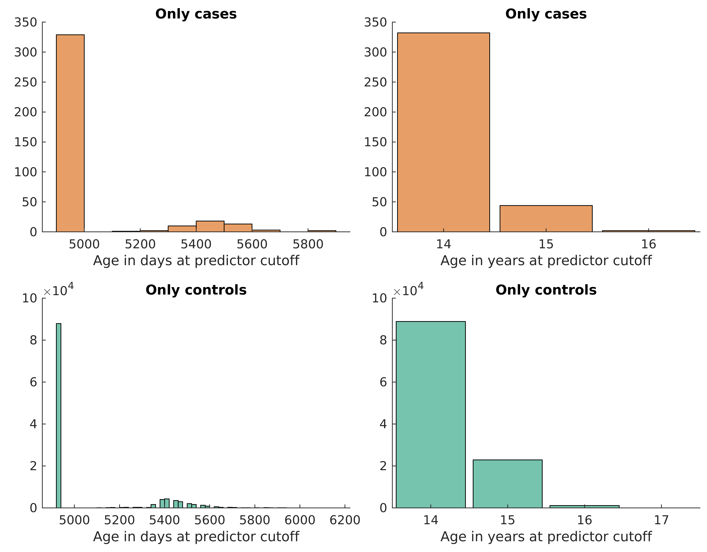

Table S3. Complete overview of predictors
Predictor group | Variable name | Contributing variables | Transformation | Missingness strategy | Additional checks
Psychotic experiences (CAPE-9) | Detailed variable information: https://www.fhi.no/en/ch/studies/moba/for-forskere-artikler/questionnaires-from-moba/#14-year-olds
 | CAPE-9, frequency | UB252:UB268 | Sum score | Keep complete data
 | CAPE-9, distress | UB253:UB269 | Sum score | Keep complete data
 | Interaction term |  | (frequency item) * (distress item)
Adolescent general mental health | Detailed information: https://www.fhi.no/en/ch/studies/moba/for-forskere-artikler/questionnaires-from-moba/#14-year-olds
 | Sex assigned at birth | KJONN (from birth registry)
 | Social competence | UB25:29 | Sum score | Keep complete data
 | Adolescent depression (SMFQ) | UB41:53 | Sum score | Keep complete data
 | Social phobia (miniSPIN) | UB64:66 | Sum score | Keep complete data
 | Bullying | UB67:70 | Sum score | Keep complete data
 | Relationship with parents (SDQII-S) | UB71:74 | Sum score | Keep complete data
 | Parent-child conflict | UB75:78 | Sum score | Keep complete data
 | Sleep problems | UB100:104 | Sum score | Keep complete data
 | Disruptive behavior(RS-DBD) | UB127:134 | Sum score | Keep complete data
 | Youth anxiety (SCARED) | UB166:170 | Sum score | Keep complete data
 | Self-disturbances (EASE) | Version A: UB171:173, Version B: UB323:25 | Sum score | Keep complete data
 | Enjoyment (DES) | UB178:80 | Sum score | Keep complete data
 | Traumatic life events | UB181:219 | Two binarized subscales for each variable: prior trauma/ trauma last year (yes/no) | NA treated as 0
 | Nicotine use: lifetime and daily | Smoking: UB239, e-cigarettes: UB244, nicotine gum: UB245, other nicotine preparations: UB246 | Two binarized variables: lifetime/ daily use (yes/no) | NA treated as 0
 | Lifetime alcohol use | UB247 + UB249 | Binarized variable: lifetime use (yes/no) | We combined responses on the two items to reduce NA, rest of NA values were treated as 0
 | Lifetime cannabis | UB250 | Binarized variable: lifetime use (yes/no) | NA treated as 0
 | Lifetime drug use | UB251 | Binarized variable: lifetime use (yes/no) | NA treated as 0
Schizophrenia polygenic risk scores |  |  |  | Keep complete data
Parent and childhood psychiatric diagnoses
Mother’s diagnoses before the child turned 14 years |  |  | ICD-10 diagnoses (NPR and KUHR): Registries contain no NAs
 | Substance use | Any chapter F1* diagnosis | One combined, binarized score (any diagnosis 1/0)
 | Psychotic disorders | Any chapter F2* diagnosis | One combined, binarized score (any diagnosis 1/0)
 | Bipolar disorder | F31 | One combined, binarized score (any diagnosis 1/0)
 | Depressive episode | F32 | One combined, binarized score (any diagnosis 1/0)
 | Recurrent depressive episode | F33 | One combined, binarized score (any diagnosis 1/0)
 | Stress-related disorders | Any chapter F4* diagnosis | One combined, binarized score (any diagnosis 1/0)
 | Eating disorders | F50 | One combined, binarized score (any diagnosis 1/0)
 | Personality disorders | F60 | One combined, binarized score (any diagnosis 1/0)
 | Developmental disorders | Any chapter F8* diagnosis | One combined, binarized score (any diagnosis 1/0)
 | ADHD | F90 | One combined, binarized score (any diagnosis 1/0)
Father’s diagnoses before the child turned 14 years |  |  | ICD-10 diagnoses (NPR and KUHR): Registries contain no NAs
 | Substance use | Any chapter F1* diagnosis | One combined, binarized score (any diagnosis 1/0)
 | Psychotic disorders | Any chapter F2* diagnosis | One combined, binarized score (any diagnosis 1/0)
 | Bipolar disorder | F31 | One combined, binarized score (any diagnosis 1/0)
 | Depressive episode | F32 | One combined, binarized score (any diagnosis 1/0)
 | Recurrent depressive episode | F33 | One combined, binarized score (any diagnosis 1/0)
 | Stress-related disorders | Any chapter F4* diagnosis | One combined, binarized score (any diagnosis 1/0)
 | Eating disorders | F50 | One combined, binarized score (any diagnosis 1/0)
 | Personality disorders | F60 | One combined, binarized score (any diagnosis 1/0)
 | Developmental disorders | Any chapter F8* diagnosis | One combined, binarized score (any diagnosis 1/0)
 | ADHD | F90 | One combined, binarized score (any diagnosis 1/0)
Child’s diagnoses before the child turned 14 years |  |  | ICD-10 diagnoses (NPR and KUHR): Registries contain no NAs
 | Substance use | Any chapter F1* diagnosis | One combined, binarized score (any diagnosis 1/0)
 | Psychotic disorders | Any chapter F2* diagnosis | One combined, binarized score (any diagnosis 1/0)
 | Bipolar disorder | F31 | One combined, binarized score (any diagnosis 1/0)
 | Depressive episode | F32 | One combined, binarized score (any diagnosis 1/0)
 | Recurrent depressive episode | F33 | One combined, binarized score (any diagnosis 1/0)
 | Stress-related disorders | Any chapter F4* diagnosis | One combined, binarized score (any diagnosis 1/0)
 | Eating disorders | F50 | One combined, binarized score (any diagnosis 1/0)
 | Personality disorders | F60 | One combined, binarized score (any diagnosis 1/0)
 | Developmental disorders | Any chapter F8* diagnosis | One combined, binarized score (any diagnosis 1/0)
 | ADHD | F90 | One combined, binarized score (any diagnosis 1/0)
Birth-related factors
Questionnaires (week 15 and 22 of pregnancy) |  |  | Detailed variable information: https://www.fhi.no/en/ch/studies/moba/for-forskere-artikler/questionnaires-from-moba/#week-15-of-pregnancy
Fever | Fever 1st trimester | AA326:AA328, AA336:AA338 | Combined into binarized variable: fever (1/0) | NA treated as 0
 | Fever 2nd trimester | AA329, AA339 | Combined into binarized variable: fever (1/0) | NA treated as 0
Influenza | Influenza 1st trimester | AA376:AA378 | Combined into binary variable - influenza (1/0 | NA treated as 0
 | Influenza 2nd trimester | AA379:CC535 | Combined into binary variable - influenza (1/0 | NA treated as 0
 | Influenza 3rd trimester | CC536 | Binary variable - influenza (1/0) | NA treated as 0
Pneumonia | Pneumonia 1st trimester | AA386:AA388 | Combined into binary variable - pneumonia (1/0) | NA treated as 0
 | Pneumonia 2nd trimester | AA389, CC544:CC547 | Combined into binary variable - pneumonia (1/0) | NA treated as 0
 | Pneumonia 3rd trimester | CC548 | Binary variable - pneumonia (1/0) | NA treated as 0
Bladder infection | Bladder infection | CC569:CC596 | Combined into binary variable: any bladder infection throughout pregnancy (1/0) | NA treated as 0
Smoking | Active smoking, week 15 | AA1356 | Kept as is | NA treated as 0
 | Passive smoking, week 15 | AA1349 | Kept as is | NA treated as 0
 | Active smoking, week 30 | CC1033 | Kept as is | NA treated as 0
 | Passive smoking, week 30 | CC1137 | Kept as is | NA treated as 0
Alcohol | Alcohol use, 1st trimester | AA1454, CC1157 | Reordered - higher score indicates more drinking | NA in Q1 filled out with values in Q3 and the other way around - sum averaged and rounded up | Check differences in scores between Q1 and Q3
 | Alcohol use, 2nd trimester | CC1158 | Reordered - higher score indicates more drinking | NA treated as 0
 | Alcohol use, 3rd trimester | CC1159 | Reordered - higher score indicates more drinking | NA treated as 0
Drug use | Drug use, month before pregnancy | AA1434, -38, -42, -46, -50 | Binary - yes/ no | NA treated as 0
 | Drug use, week 15 | w15: AA1435, -39, -43, -47, -51 | Binary - yes/ no | NA treated as 0
 | Drug use, week 30 | w30: CC1067:71 | Binary - yes/ no | NA treated as 0
Exposure to harmful substances | Exposure to harmful substances | AA1203:A1271 (18 variables) | Number of days exposed in the past 6 months- truncated into 0 to 180 days | NA treated as 0
MBRN | Detailed variable information: https://www.fhi.no/globalassets/dokumenterfiler/helseregistre/mfr/mbrn-record_v531_english.pdf
 | Gestational duration | SVLEN_DG, SVLEN_UL_DG, SVLEN_SM_DG | Sum score | Variables combined to reduce NAs - Filled in NAs with values on the other variables
 | Hypertension | HYPERTENSJON_KRONISK | Binarize, yes/ no | NA treated as 0
 | Diabetes | DIABETES_MELLITUS | Binarize, 1 = pre-gestational diabetes | NA treated as 0
 | Gestational diabetes | DIABETES_MELLITUS | Binarize, 1 = gestational diabetes | NA treated as 0
 | HELLP syndrome | HELLP | Binarize, yes/ no | NA treated as 0
 | Type of delivery | KSNITT_PLANLAGT; VAGINAL | Binarized, vaginal = 1, caesarean = 0 | Variables combined to reduce NAs - Filled in NAs with values on the other variable
 | Icterus (jaundice) | ICTERUS | Kept as is - binary variable (1/0) | NA treated as 0
 | Weight | VEKT | Extreme values (>400gr) removed | NA values from MBRN were filled in with values from Q1
 | Head circumference | HODE | Extreme values (outside the range of 20-40cm) removed | NA values from MBRN were filled in with values from Q1
 | Parity | PARITET_5 | Kept as is | NA treated as 0
 | Respiratory distress syndrome | RESPIRATORISK_DISTR | Kept as is | NA treated as 0
 | Mother’s age at birth | MORS_ALDER_G | Extreme values (>50 years) removed
 | Father’s age at birth | FARS_ALDER_G | Kept as is
 | Pre-eclampsia | PREEKLTIDL; PREEKL | Binarized, pre-eclampsia and early pre-eclampsia combined | NA treated as 0
 | APGAR 5 | APGAR5 | Kept as is | Use values from APGAR1 or 10 if available, if not, set NA as 9 or 10

STROBE Statement—Checklist of items that should be included in reports of cohort studies

 | Item No | Recommendation | Page No
Title and abstract | 1 | (a) Indicate the study’s design with a commonly used term in the title or the abstract
Title and abstract | 1 | (b) Provide in the abstract an informative and balanced summary of what was done and what was found
Introduction
Background/rationale | 2 | Explain the scientific background and rationale for the investigation being reported
Objectives | 3 | State specific objectives, including any prespecified hypotheses
Methods
Study design | 4 | Present key elements of study design early in the paper
Setting | 5 | Describe the setting, locations, and relevant dates, including periods of recruitment, exposure, follow-up, and data collection
Participants | 6 | (a) Give the eligibility criteria, and the sources and methods of selection of participants. Describe methods of follow-up
Participants | 6 | (b) For matched studies, give matching criteria and number of exposed and unexposed
Variables | 7 | Clearly define all outcomes, exposures, predictors, potential confounders, and effect modifiers. Give diagnostic criteria, if applicable
Data sources/ measurement | 8* | For each variable of interest, give sources of data and details of methods of assessment (measurement). Describe comparability of assessment methods if there is more than one group
Bias | 9 | Describe any efforts to address potential sources of bias
Study size | 10 | Explain how the study size was arrived at
Quantitative variables | 11 | Explain how quantitative variables were handled in the analyses. If applicable, describe which groupings were chosen and why
Statistical methods | 12 | (a) Describe all statistical methods, including those used to control for confounding
Statistical methods | 12 | (b) Describe any methods used to examine subgroups and interactions
Statistical methods | 12 | (c) Explain how missing data were addressed
Statistical methods | 12 | (d) If applicable, explain how loss to follow-up was addressed
Statistical methods | 12 | (e) Describe any sensitivity analyses
Results
Participants | 13* | (a) Report numbers of individuals at each stage of study—eg numbers potentially eligible, examined for eligibility, confirmed eligible, included in the study, completing follow-up, and analysed
Participants | 13* | (b) Give reasons for non-participation at each stage
Participants | 13* | (c) Consider use of a flow diagram
Descriptive data | 14* | (a) Give characteristics of study participants (eg demographic, clinical, social) and information on exposures and potential confounders
Descriptive data | 14* | (b) Indicate number of participants with missing data for each variable of interest
Descriptive data | 14* | (c) Summarise follow-up time (eg, average and total amount)
Outcome data | 15* | Report numbers of outcome events or summary measures over time

Main results | 16 | (a) Give unadjusted estimates and, if applicable, confounder-adjusted estimates and their precision (eg, 95% confidence interval). Make clear which confounders were adjusted for and why they were included
Main results | 16 | (b) Report category boundaries when continuous variables were categorized
Main results | 16 | (c) If relevant, consider translating estimates of relative risk into absolute risk for a meaningful time period
Other analyses | 17 | Report other analyses done—eg analyses of subgroups and interactions, and sensitivity analyses
Discussion
Key results | 18 | Summarise key results with reference to study objectives
Limitations | 19 | Discuss limitations of the study, taking into account sources of potential bias or imprecision. Discuss both direction and magnitude of any potential bias
Interpretation | 20 | Give a cautious overall interpretation of results considering objectives, limitations, multiplicity of analyses, results from similar studies, and other relevant evidence
Generalisability | 21 | Discuss the generalisability (external validity) of the study results
Other information
Funding | 22 | Give the source of funding and the role of the funders for the present study and, if applicable, for the original study on which the present article is based

*Give information separately for exposed and unexposed groups.

Note: An Explanation and Elaboration article discusses each checklist item and gives methodological background and published examples of transparent reporting. The STROBE checklist is best used in conjunction with this article (freely available on the Web sites of PLoS Medicine at http://www.plosmedicine.org/, Annals of Internal Medicine at http://www.annals.org/, and Epidemiology at http://www.epidem.com/). Information on the STROBE Initiative is available at http://www.strobe-statement.org.

TRIPOD Checklist: Prediction Model Development
Section/Topic | Ite | Checklist Item | Page
Title and abstract
Title | 1 | Identify the study as developing and/or validating a multivariable prediction model, the target population, and the outcome to be predicted.
Abstract | 2 | Provide a summary of objectives, study design, setting, participants, sample size, predictors, outcome, statistical analysis, results, and conclusions.
Introduction
Background and objectives | 3a | Explain the medical context (including whether diagnostic or prognostic) and rationale for developing or validating the multivariable prediction model, including references to existing models.
Background and objectives | 3b | Specify the objectives, including whether the study describes the development or validation of the model or both.
Methods
Source of data | 4a | Describe the study design or source of data (e.g., randomized trial, cohort, or registry data), separately for the development and validation data sets, if applicable.
Source of data | 4b | Specify the key study dates, including start of accrual; end of accrual; and, if applicable, end of follow-up.
Participants | 5a | Specify key elements of the study setting (e.g., primary care, secondary care, general population) including number and location of centres.
Participants | 5b | Describe eligibility criteria for participants.
Participants | 5c | Give details of treatments received, if relevant.
Outcome | 6a | Clearly define the outcome that is predicted by the prediction model, including how and when assessed.
Outcome | 6b | Report any actions to blind assessment of the outcome to be predicted.
Predictors | 7a | Clearly define all predictors used in developing or validating the multivariable prediction model, including how and when they were measured.
Predictors | 7b | Report any actions to blind assessment of predictors for the outcome and other predictors.
Sample size | 8 | Explain how the study size was arrived at.
Missing data | 9 | Describe how missing data were handled (e.g., complete-case analysis, single imputation, multiple imputation) with details of any imputation method.
Statistical analysis methods | 10a | Describe how predictors were handled in the analyses.
Statistical analysis methods | 10b | Specify type of model, all model-building procedures (including any predictor selection), and method for internal validation.
Statistical analysis methods | 10d | Specify all measures used to assess model performance and, if relevant, to compare multiple models.
Risk groups | 11 | Provide details on how risk groups were created, if done.
Results
Participants | 13a | Describe the flow of participants through the study, including the number of participants with and without the outcome and, if applicable, a summary of the follow-up time. A diagram may be helpful.
Participants | 13b | Describe the characteristics of the participants (basic demographics, clinical features, available predictors), including the number of participants with missing data for predictors and outcome.
Model development | 14a | Specify the number of participants and outcome events in each analysis.
Model development | 14b | If done, report the unadjusted association between each candidate predictor and outcome.
Model specification | 15a | Present the full prediction model to allow predictions for individuals (i.e., all regression coefficients, and model intercept or baseline survival at a given time point).
Model specification | 15b | Explain how to the use the prediction model.
Model performance | 16 | Report performance measures (with CIs) for the prediction model.
Discussion
Limitations | 18 | Discuss any limitations of the study (such as nonrepresentative sample, few events per predictor, missing data).
Interpretation | 19b | Give an overall interpretation of the results, considering objectives, limitations, and results from similar studies, and other relevant evidence.
Implications | 20 | Discuss the potential clinical use of the model and implications for future research.
Other information
Supplementary information | 21 | Provide information about the availability of supplementary resources, such as study protocol, Web calculator, and data sets.
Funding | 22 | Give the source of funding and the role of the funders for the present study.

References
1. Kapoor S, Narayanan A. Leakage and the reproducibility crisis in machine-learning-based science. Patterns. 2023;4(9):100804. doi:10.1016/j.patter.2023.100804
2. Kuhn M, Johnson K. Applied Predictive Modeling.; 2013. doi:10.1007/978-1-4614-6849-3
3. Kaufman S, Rosset S, Perlich C. Leakage in data mining: Formulation, detection, and avoidance. In: Proceedings of the ACM SIGKDD International Conference on Knowledge Discovery and Data Mining. ; 2011. doi:10.1145/2020408.2020496
4. Nilsen RM, Vollset SE, Gjessing HK, et al. Self-selection and bias in a large prospective pregnancy cohort in Norway. Paediatr Perinat Epidemiol. 2009;23(6). doi:10.1111/j.1365-3016.2009.01062.x
5. Biele G, Gustavson K, Czajkowski NO, et al. Bias from self selection and loss to follow-up in prospective cohort studies. Eur J Epidemiol. 2019;34(10). doi:10.1007/s10654-019-00550-1
6. Birkenæs V, Refsum Bakken N, Frei E, et al. Psychometric Properties and Diagnostic Associations of the Short-Form Community Assessment of Psychic Experiences in a Population-Based Sample of 29 021 Adult Men. Schizophr Bull. Published online September 7, 2023. doi:10.1093/schbul/sbad074
7. Seiffert C, Khoshgoftaar TM, Van Hulse J, Napolitano A. RUSBoost: Improving classification performance when training data is skewed. In: Proceedings - International Conference on Pattern Recognition. ; 2008. doi:10.1109/icpr.2008.4761297
8. Chawla N V, Lazarevic A, Hall LO, Bowyer KW. SMOTEBoost : Improving Prediction. European Conference on Principles of Data Mining and Knowledge Discovery. 2003;2838.
9. Cortes C, Vapnik V. Support-Vector Networks. Mach Learn. 1995;20(3). doi:10.1023/A:1022627411411

