Supplementary Figures
Figure S1: Evaluation of TARDP gene expression analysis in iCMs and TDP-43 nuclear and cytoplasmic staining in iPSC lines. a. qRTPCR analysis of TARDBP mRNA expression in Day 45 iCMs. b. The percentage of the nuclear and c. the ratio of cytoplasmic to nuclear TDP-43 protein immunoreactive signal in healthy and patient iPSCs. 6 randomly selected regions were analyzed for each experiment.

Supplementary Tables
Table S1. Demographic and clinical information of ALS patients, healthy individual and isogenic control to derive the iPSC lines used in the study.
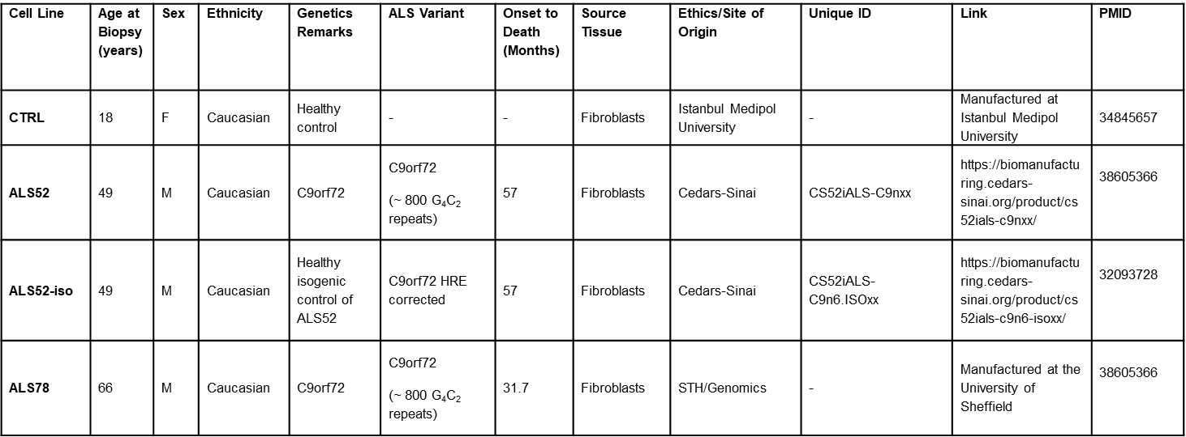

Table S2. List of qRT-PCR primers
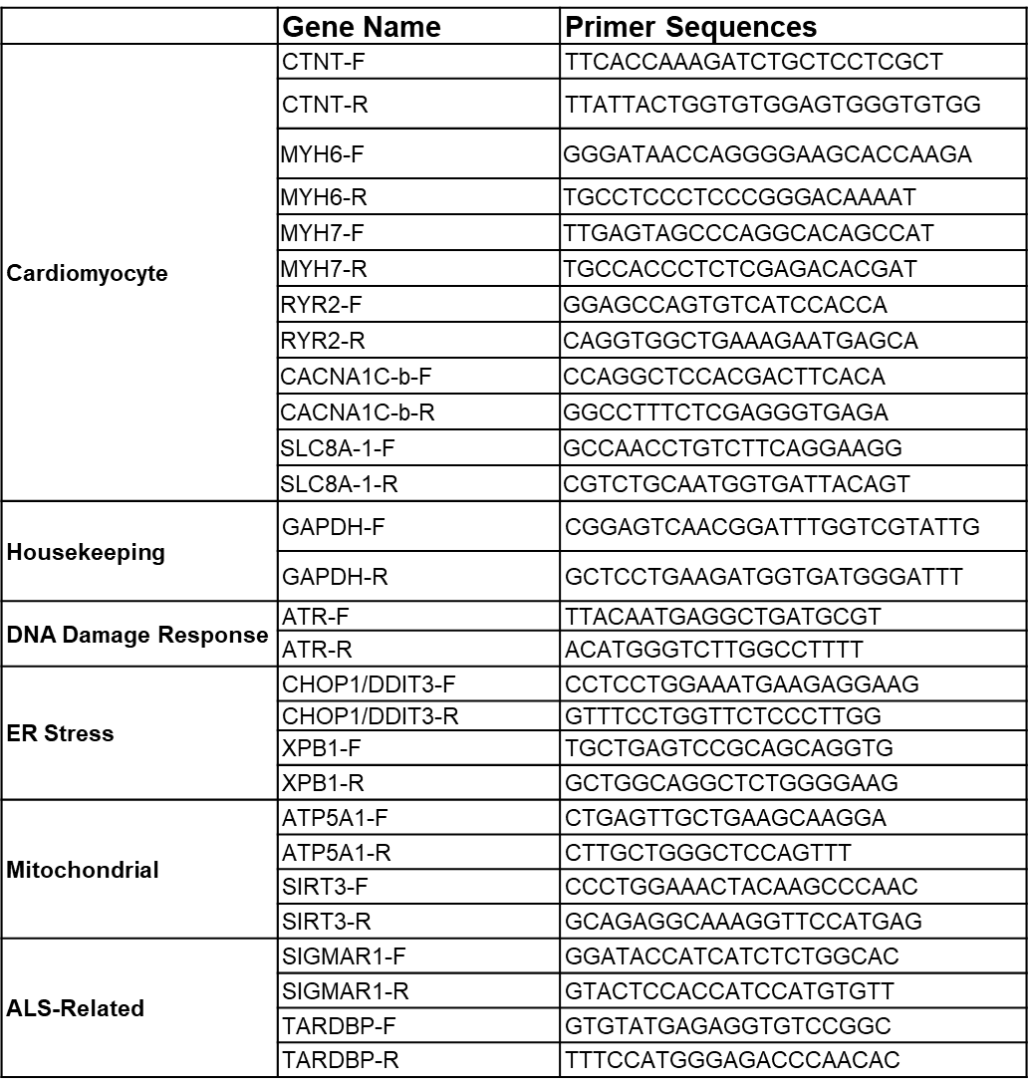

Table S3. List of antibodies
