Elicitation using Jasmonates, Salicylic acid, and Sodium chloride in cell suspension cultures of Justicia gendarussa Burm f.: A route for enhanced and sustainable production of apigenin and apigetrin
Vinaya Chandran¹, Maya Rajan¹, Shahena S¹ & Linu Mathew^{1*}
- School of Biosciences, Mahatma Gandhi University, Kottayam, Kerala, India 686560
*Corresponding author, linumathew@mgu.ac.in, +91 9447505690

Supplementary Data
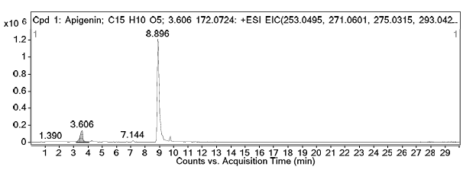
Fig. S1a
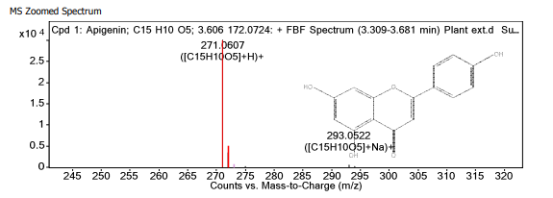
Fig. S1b
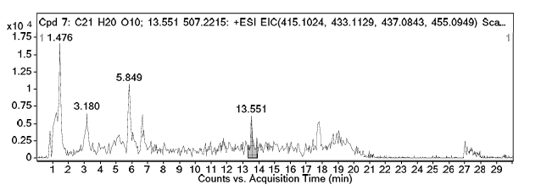
Fig. S1c

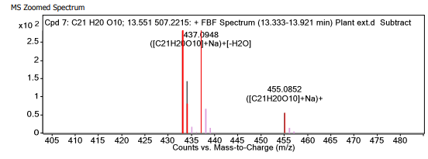
Fig. S1d
Fig. S1: (a) Extracted Ion chromatogram (EIC) of apigenin, (b) MS Zoomed spectrum of apigenin showing major ions, (c) Extracted Ion chromatogram (EIC) of apigetrin, (d) MS Zoomed spectrum of apigetrin showing major ions.

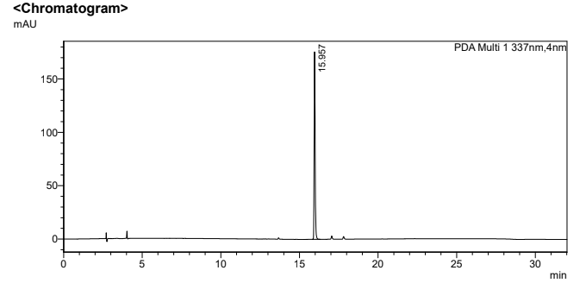
Fig. S2a
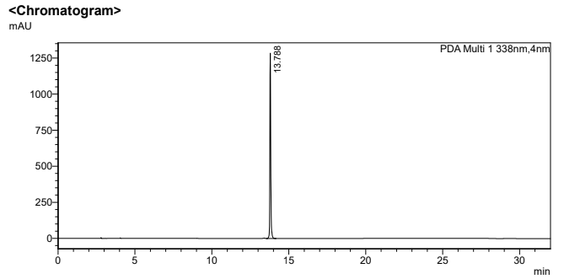

Fig. S2b
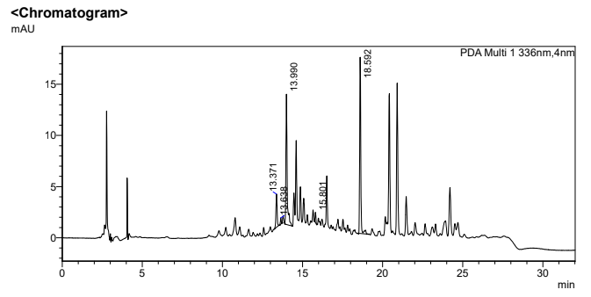
Fig. S2c

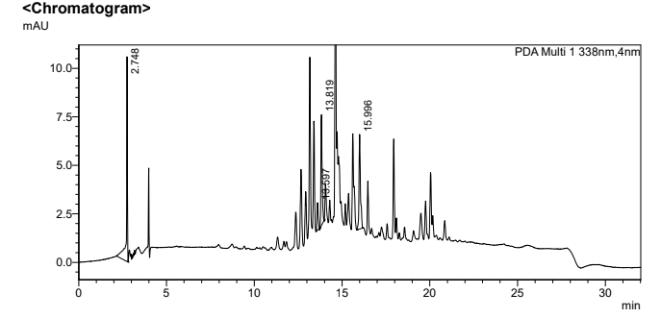

Fig. S2d
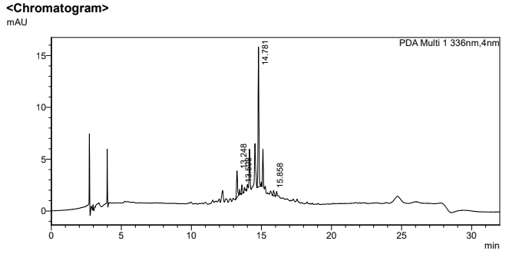
Fig. S2e
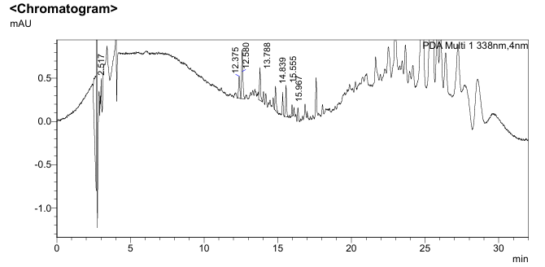

Fig. S2f
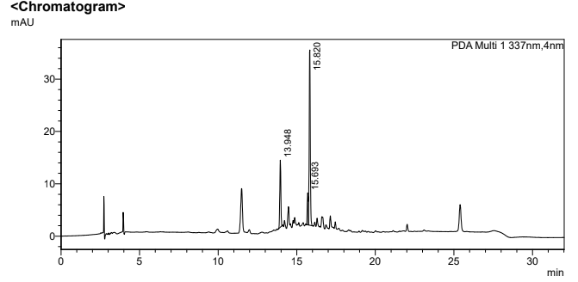
Fig. S2g
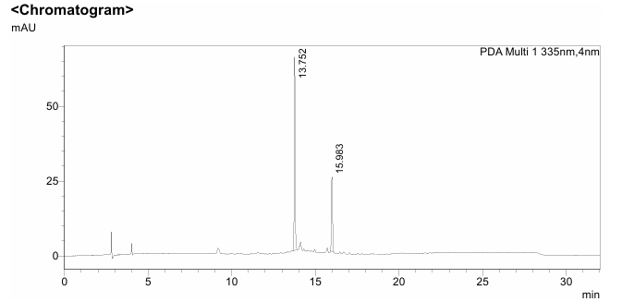
Fig. S2h
Fig. S2: HPLC chromatogram of (a). apigenin standard (b) apigetrin standard (c) leaf (d) stem bark (e) root (f) culture filtrates (g) callus extract on 15th day (h) callus extract on 48th day

Fig. S3a

Fig. S3b
Fig. S3: Calibration curve of (a) apigenin (b) apigetrin using HPLC

