Supplementary Figures
Supplementary Figure 1
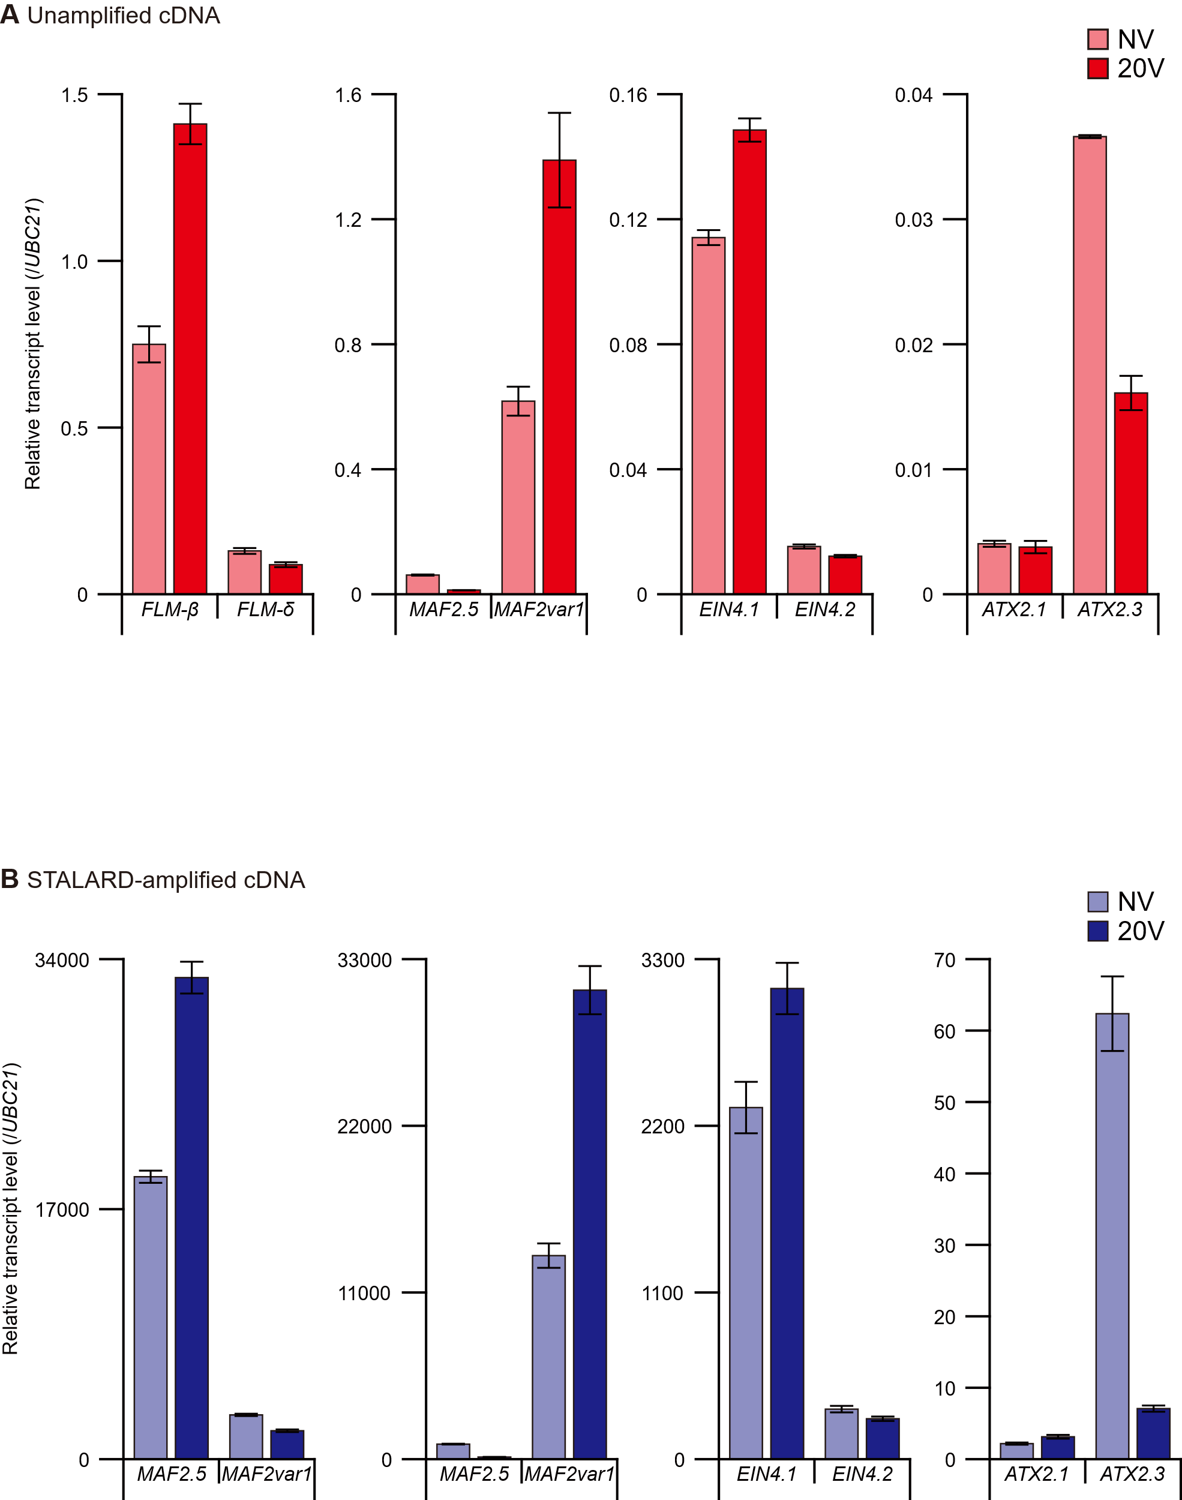
Supplementary Figure 1. Relative transcript levels of alternatively spliced isoforms. A. Relative transcript levels of alternatively spliced isoforms under NV and 20V conditions, measured using first-strand cDNA. Data are presented as mean ± SEM from three biological replicates. B. Relative transcript levels of alternatively spliced isoforms under NV and 20V conditions in STALARD-amplified samples. Data are presented as mean ± SEM from three biological replicates.
Supplementary Figure 2
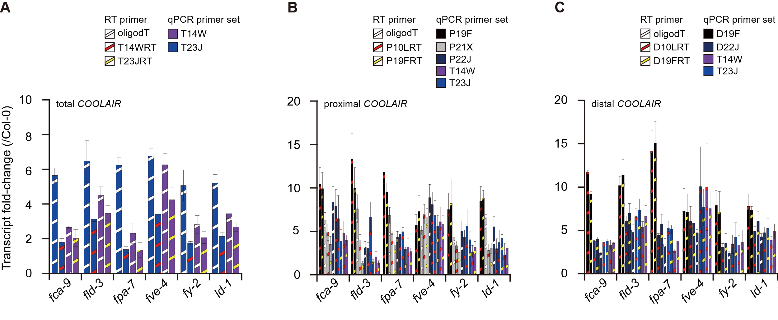
Supplementary Figure 2. Fold changes of COOLAIR transcripts. Fold change in total COOLAIR (A), proximal COOLAIR (B), and distal COOLAIR (C) transcript levels in AP mutants, compared to Col-0, quantified by RT-qPCR using various primer sets. Data are presented as mean ± SEM from three biological replicates.

