Supplementary Material
Supplementary information of microalgae cultivation suspensions images at different concentrations, program codes of proposed models in this work.

Table S1. Images of microalgae cultivation suspensions at different concentrations.
DCW (g/L) | Image_1 | Image_2 | Image_3 | Image_4
0.009 |  |  |  | 
0.049 |  |  |  | 
0.093 |  |  |  | 
0.152 |  |  |  | 
0.203 |  |  |  | 
0.251 |  |  |  | 
0.304 |  |  |  | 
0.352 |  | 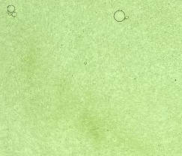 |  | 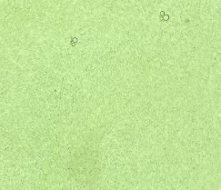
0.397 |  |  | 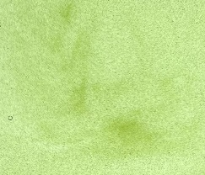 | 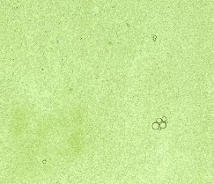
0.506 |  |  |  | 
0.611 |  |  |  | 
0.709 |  |  |  | 
0.813 |  |  |  | 
0.906 |  |  |  | 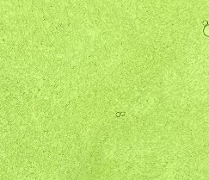
1.004 |  | 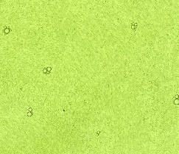 |  | 
1.524 |  |  | 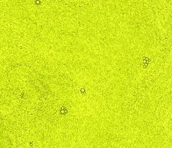
2.123 |  | 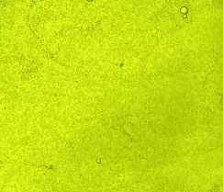
2.674 | 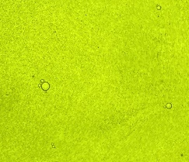 | 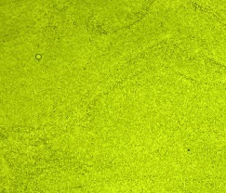 | 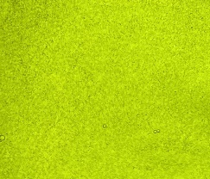 | 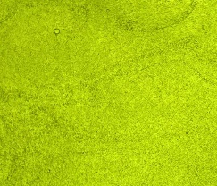
5.114 |  |  | 
7.642 |  |  | 

Appendix S1. Program code for RES

class BasicBlock(nn.Module):
expansion = 1

def __init__(self, in_planes, planes, stride=1, downsample=None):
super(BasicBlock, self).__init__()
self.conv1 = nn.Conv2d(in_planes, planes, kernel_size=3, stride=stride, padding=1, bias=False)
self.bn1 = nn.BatchNorm2d(planes)
self.conv2 = nn.Conv2d(planes, planes, kernel_size=3, stride=1, padding=1, bias=False)
self.bn2 = nn.BatchNorm2d(planes)
self.downsample = downsample

def forward(self, x):
identity = x

out = F.relu(self.bn1(self.conv1(x)))
out = self.bn2(self.conv2(out))

if this.downsample is not None:
identity = self.downsample(x)

out += identity
out = F.relu(out)

return out

class ResNet(nn.Module):
def __init__(self, block, layers, num_classes=1000):
super(ResNet, self).__init__()
self.in_planes = 64

self.conv1 = nn.Conv2d(3, 64, kernel_size=7, stride=2, padding=3, bias=False)
self.bn1 = nn.BatchNorm2d(64)
self.relu = nn.ReLU(inplace=True)
self.maxpool = nn.MaxPool2d(kernel_size=3, stride=2, padding=1)

self.layer1 = self._make_layer(block, 64, layers[0])
self.layer2 = self._make_layer(block, 128, layers[1], stride=2)
self.layer3 = self._make_layer(block, 256, layers[2], stride=2)
self.layer4 = self._make_layer(block, 512, layers[3], stride=2)

self.avgpool = nn.AdaptiveAvgPool2d((1, 1))
self.fc = nn.Linear(512 * block.expansion, num_classes)

def _make_layer(self, block, planes, blocks, stride=1):
downsample = None
if stride != 1 or self.in_planes != planes * block.expansion:
downsample = nn.Sequential(
nn.Conv2d(self.in_planes, planes * block.expansion, kernel_size=1, stride=stride, bias=False),
nn.BatchNorm2d(planes * block.expansion),
)

layers = []
layers.append(block(self.in_planes, planes, stride, downsample))
self.in_planes = planes * block.expansion
for _ in range(1, blocks):
layers.append(block(self.in_planes, planes))

return nn.Sequential(*layers)

def forward(self, x):
x = self.relu(self.bn1(self.conv1(x)))
x = self.maxpool(x)

x = self.layer1(x)
x = self.layer2(x)
x = self.layer3(x)
x = self.layer4(x)

x = self.avgpool(x)
x = torch.flatten(x, 1)
x = self.fc(x)

return x

def ResNet18(num_classes=1000):
return ResNet(BasicBlock, [2, 2, 2, 2], num_classes=num_classes)

Appendix S2. Program code for RES-G

class BasicBlock(nn.Module):
expansion = 1

def __init__(self, in_planes, planes, stride=1, downsample=None):
super(BasicBlock, self).__init__()
self.conv1 = nn.Conv2d(in_planes, planes, kernel_size=3, stride=stride, padding=1, bias=False)
self.bn1 = nn.BatchNorm2d(planes)
self.conv2 = nn.Conv2d(planes, planes, kernel_size=3, stride=1, padding=1, bias=False)
self.bn2 = nn.BatchNorm2d(planes)
self.downsample = downsample

def forward(self, x):
identity = x

out = F.relu(self.bn1(self.conv1(x)))
out = self.bn2(self.conv2(out))

if self.downsample is not None:
identity = self.downsample(x)

out += identity
out = F.relu(out)

return out

class ResNeXtBlock(nn.Module):
expansion = 1

def __init__(self, inplanes, planes, stride=1, downsample=None, groups=32):
super(ResNeXtBlock, self).__init__()
self.conv1 = nn.Conv2d(inplanes, planes * self.expansion, kernel_size=3, stride=stride, padding=1, bias=False, groups=groups)
self.conv2 = nn.Conv2d(planes * self.expansion, planes * self.expansion, kernel_size=3, stride=1, padding=1, bias=False, groups=groups)
self.bn1 = nn.BatchNorm2d(planes * self.expansion)
self.bn2 = nn.BatchNorm2d(planes * self.expansion)
self.relu = nn.ReLU(inplace=True)
self.downsample = downsample
self.stride = stride

def forward(self, x):
identity = x

out = self.conv1(x)
out = self.bn1(out)
out = self.relu(out)

out = self.conv2(out)
out = self.bn2(out)

if self.downsample is not None:
identity = self.downsample(x)

out += identity
out = self.relu(out)

return out

class ResNeXt18(nn.Module):
def __init__(self, block, layers, num_classes=1000, groups=32, width_per_group=64):
super(ResNeXt18, self).__init__()
self.inplanes = 64
self.groups = groups
self.base_width = width_per_group
self.conv1 = nn.Conv2d(3, self.inplanes, kernel_size=7, stride=2, padding=3, bias=False)
self.bn1 = nn.BatchNorm2d(self.inplanes)
self.relu = nn.ReLU(inplace=True)
self.maxpool = nn.MaxPool2d(kernel_size=3, stride=2, padding=1)
self.layer1 = self._make_layer(block, 64, layers[0])
self.layer2 = self._make_layer(block, 128, layers[1], stride=2)
self.layer3 = self._make_layer(block, 256, layers[2], stride=2)
self.layer4 = self._make_layer(block, 512, layers[3], stride=2)
self.avgpool = nn.AdaptiveAvgPool2d((1, 1))
self.fc = nn.Linear(512 * block.expansion, num_classes)

def _make_layer(self, block, planes, blocks, stride=1):
downsample = None
if stride != 1 or self.inplanes != planes * block.expansion:
downsample = nn.Sequential(
nn.Conv2d(self.inplanes, planes * block.expansion, kernel_size=1, stride=stride, bias=False),
nn.BatchNorm2d(planes * block.expansion),
)

layers = []
for _ in range(blocks):
layers.append(block(self.inplanes, planes, stride, downsample, self.groups))
self.inplanes = planes * block.expansion
stride = 1
downsample = None

return nn.Sequential(*layers)

def forward(self, x):
x = self.conv1(x)
x = self.bn1(x)
x = self.relu(x)
x = self.maxpool(x)

x = self.layer1(x)
x = self.layer2(x)
x = self.layer3(x)
x = self.layer4(x)

x = self.avgpool(x)
x = torch.flatten(x, 1)
x = self.fc(x)

return x

def resnext18(num_classes=1000, groups=32, width_per_group=64):
model = ResNeXt18(ResNeXtBlock, [2, 2, 2, 2], num_classes=num_classes, groups=groups, width_per_group=width_per_group)
return model

Appendix S3. Program code for RES-SG

class SeparableConv2d(nn.Module):
def __init__(self, in_channels, out_channels, kernel_size, stride, padding):
super(SeparableConv2d, self).__init__()
self.depthwise = nn.Conv2d(in_channels, in_channels, kernel_size=kernel_size,
stride=stride, padding=padding, groups=in_channels, bias=False)
self.pointwise = nn.Conv2d(in_channels, out_channels, kernel_size=1, bias=False)

def forward(self, x):
x = self.depthwise(x)
x = self.pointwise(x)
return x

class NASNetCell(nn.Module):
def __init__(self, in_channels, out_channels, repeat):
super(NASNetCell, self).__init__()
self.repeat = repeat
self.layers = nn.ModuleList()
for _ in range(self.repeat):
self.layers.append(nn.Sequential(
nn.ReLU(),
SeparableConv2d(in_channels, out_channels, kernel_size=5, stride=1, padding=2),
nn.BatchNorm2d(out_channels),
nn.ReLU(),
SeparableConv2d(out_channels, out_channels, kernel_size=3, stride=1, padding=1),
nn.BatchNorm2d(out_channels)
))

def forward(self, x):
for layer in self.layers:
x = layer(x)
return x

class NASNetLarge(nn.Module):
def __init__(self, num_classes=1000):
super(NASNetLarge, self).__init__()
self.conv0 = nn.Conv2d(3, 96, kernel_size=3, stride=2, padding=0, bias=False)
self.bn0 = nn.BatchNorm2d(96)
self.cell_stem_0 = NASNetCell(96, 168, 5)
self.reduction_cell_0 = NASNetCell(168, 336, 5)
self.cell_stem_1 = NASNetCell(336, 672, 5)
self.reduction_cell_1 = NASNetCell(672, 1344, 5)
self.cell_0 = NASNetCell(1344, 1344, 6)
self.avg_pool = nn.AdaptiveAvgPool2d(1)
self.dropout = nn.Dropout(0.5)
self.fc = nn.Linear(1344, num_classes)

def forward(self, x):
x = self.conv0(x)
x = self.bn0(x)
x = self.cell_stem_0(x)
x = self.reduction_cell_0(x)
x = self.cell_stem_1(x)
x = self.reduction_cell_1(x)
x = self.cell_0(x)
x = self.avg_pool(x)
x = x.view(x.size(0), -1)
x = self.dropout(x)
x = self.fc(x)
return x

def nasnet_large(num_classes=1):
return NASNetLarge(num_classes)

RES-AG：
class BasicBlock(nn.Module):
expansion = 1

def __init__(self, in_planes, planes, stride=1, groups=1):
super(BasicBlock, self).__init__()
self.conv1 = nn.Conv2d(
in_planes, planes, kernel_size=3, stride=stride,
padding=1, bias=False, groups=groups)
self.bn1 = nn.BatchNorm2d(planes)
self.relu = nn.ReLU(inplace=True)
self.conv2 = nn.Conv2d(
planes, planes * self.expansion, kernel_size=3, stride=1,
padding=1, bias=False, groups=groups)
self.bn2 = nn.BatchNorm2d(planes * self.expansion)

self.downsample = None
if stride != 1 or in_planes != planes * self.expansion:
self.downsample = nn.Sequential(
nn.Conv2d(
in_planes, planes * self.expansion,
kernel_size=1, stride=stride, bias=False),
nn.BatchNorm2d(planes * self.expansion),
)

def forward(self, x):
identity = x

out = self.conv1(x)
out = self.bn1(out)
out = self.relu(out)

out = self.conv2(out)
out = self.bn2(out)

if self.downsample is not None:
identity = self.downsample(x)

out += identity
out = self.relu(out)

return out
class ResNet(nn.Module):
def __init__(self, block, layers, num_classes=1000, groups_list=None, channels_list=None):
super(ResNet, self).__init__()
if groups_list is None:
groups_list = [1, 1, 1, 1]
if channels_list is None:
channels_list = [64, 128, 256, 512]

self.in_planes = channels_list[0]
self.conv1 = nn.Conv2d(
3, self.in_planes, kernel_size=7, stride=2, padding=3,
bias=False, groups=groups_list[0])
self.bn1 = nn.BatchNorm2d(self.in_planes)
self.relu = nn.ReLU(inplace=True)
self.maxpool = nn.MaxPool2d(kernel_size=3, stride=2, padding=1)

self.layer1 = self._make_layer(
block, channels_list[0], layers[0], stride=1, groups=groups_list[0])
self.layer2 = self._make_layer(
block, channels_list[1], layers[1], stride=2, groups=groups_list[1])
self.layer3 = self._make_layer(
block, channels_list[2], layers[2], stride=2, groups=groups_list[2])
self.layer4 = self._make_layer(
block, channels_list[3], layers[3], stride=2, groups=groups_list[3])

self.avgpool = nn.AdaptiveAvgPool2d((1, 1))
self.fc = nn.Linear(channels_list[3] * block.expansion, num_classes)

def _make_layer(self, block, planes, blocks, stride=1, groups=1):
layers = []
layers.append(block(self.in_planes, planes, stride, groups))
self.in_planes = planes * block.expansion
for _ in range(1, blocks):
layers.append(block(self.in_planes, planes, groups=groups))
self.in_planes = planes * block.expansion
return nn.Sequential(*layers)

def forward(self, x):
x = self.conv1(x)
x = self.bn1(x)
x = self.relu(x)
x = self.maxpool(x)

x = self.layer1(x)
x = self.layer2(x)
x = self.layer3(x)
x = self.layer4(x)

x = self.avgpool(x)
x = torch.flatten(x, 1)
x = self.fc(x)

return x
layers_options = [
[2, 2, 2, 2],
[1, 2, 3, 4],
]
channels_options = [
[64, 128, 256, 512],
[32, 64, 128, 256],
]
groups_options = [
[1, 1, 1, 1],
[2, 2, 2, 2],
[4, 4, 4, 4],
]
model = RESAGNet( BasicBlock, layers, num_classes=1,groups_list=groups_list, channels_list=channels_list) device = torch.device("cuda" if torch.cuda.is_available() else "cpu") model.to(device)

