Table S1 Summary of repeat content in the Siberian larch genome annotated using RepeatMasker and combined library comprising the RepeatModeler-derived library classified with TEclass, RepBase, MIPS, CPRD and PIER v1.0 libraries
Superfamily | Length, bp | Number | % of genome
Class I: LTR retrotransposon
Other LTR | 1703439143 | 6246018 | 13.80
Gypsy | 192527487 | 878785
Gypsy/PtTalladega | 1663158 | 3646
Gypsy/IFG | 254098 | 990
Gypsy/PtAppalachian | 208844 | 773
Gypsy/PtOuachita | 191626 | 1025
Gypsy/Gymny | 138565 | 476
Gypsy/PtBastrop | 94602 | 594
Gypsy/RLG | 62107 | 1004
Gypsy/PtOzark | 24665 | 234
Gypsy/ALISEI | 21741 | 209
Gypsy/PsAppalachian | 16203 | 108
Gypsy/PtAngelina | 497 | 4
Total Gypsy | 195203593 | 887848 | >2
Copia | 125043599 | 627489
Copia/PtConagree | 115681 | 731
Copia/Silava_Pta | 115133 | 581
Copia/PtPineywoods | 64007 | 401
Copia/PtCumberland | 32521 | 251
Total Copia | 125370941 | 629453 | >1.5
DIR | 7936310 | 51295 | 0.06
ERV | 417289 | 7288
ERV/MER | 27236 | 429
Total ERV | 444525 | 7717 | >1
BEL | 418006 | 7389 | >1
DIRS | 135235 | 2287 | >1
ATGP | 22493 | 272 | >1
RNLTR | 10324 | 197 | >1
RMER | 6732 | 110 | >1
RIRE | 6682 | 100 | >1
Class I: Non-LTR retrotransposon
LINE | 1124712484 | 4237732 | 9.11
LINE/I | 265525048 | 1577725 | 2.15
LINE/L1 | 21091550 | 94925 | 0.17
LINE/RAVLIN_MT | 11341 | 147 | 0.00
Total LINE | 1411340423 | 5910529
Other non-LTR | 22649056 | 133018 | 0.18
Penelope | 15970080 | 79330 | 0.13
Penelope/Poseidon | 39219 | 411 | 0.00
Total Penelope | 16009299 | 79741
SINE | 10566091 | 79177 | >1
LOA | 19191 | 275 | >1
Jockey | 15690 | 120 | >1
TRAS | 14525 | 228 | >1
LIN#_SM | 10491 | 169 | >1
BovB | 9128 | 155 | >1
Outcast | 6887 | 121 | >1
Hero | 6599 | 122 | >1
Other retrotransposon | 390376007 | 1771180 | 3.16
Class II: DNA transposon
Other DNA | 539184594 | 2226370 | 4.37
TIR | 19582568 | 105413 | 0.16
Helitron | 6734298 | 28344
Helitron/Helmet | 4836 | 95
Total Helitron | 6739134 | 28439 | >1
EnSpm | 2142128 | 28885 | 0.02
MuDR | 587040 | 8191
MuDR/Vandal | 29783 | 546
MuDR/Rehavkus | 15474 | 220
MuDR/Arnold | 13638 | 151
MuDR/ATMU | 8652 | 143
MuDR/OSMU | 6609 | 85
Total MuDR | 661196 | 9336 | >1
Mariner | 453859 | 7114
Mariner/SMAR | 8833 | 156
Total Mariner | 462692 | 7270 | >1
REP | 167449 | 1355 | >1
Maverick | 517499 | 5211 | >1
hAT | 1062710 | 15627
hAT/Charlie | 11101 | 194
Total hAT | 1073811 | 15821 | >1
Mite | 32189 | 505 | >1
TcMar | 30674 | 446 | >1
Harbinger | 20160 | 316 | >1
Stowaway | 3957 | 72 | >1
PiggyBac | 1065 | 20 | >1
Tourist | 845 | 16 | >1
Others
Unclassified | 262494312 | 1345055 | 2.13
Simple repeats | 46499317 | 983566 | 0.38
Host | 12847092 | 18499 | 0.10
Low complexity | 11560642 | 211886 | 0.09
Other | 1215941 | 76131 | 0.01
tRNA | 299376 | 4982 | >1
rRNA | 189617 | 1947 | >1
RNA | 1325 | 16 | >1
Caulimovirus | 401990 | 3767 | 0.00
Grand Total | 4790146944 | 20882845 | 38.82

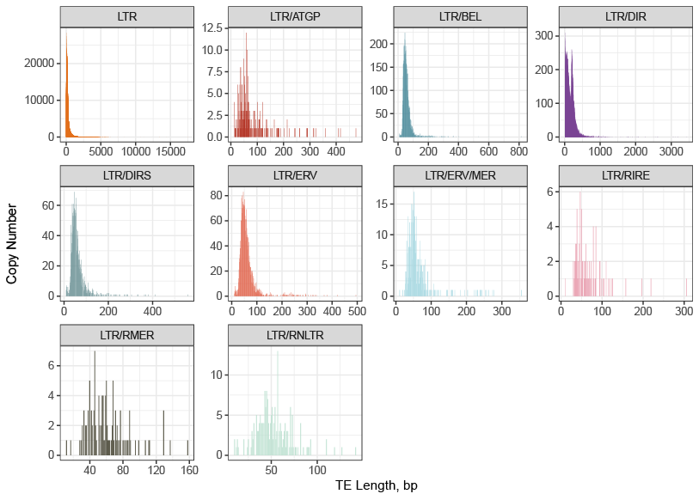
Fig. S1 Length distribution of the main LTR-retrotransposons families in the Siberian larch genome

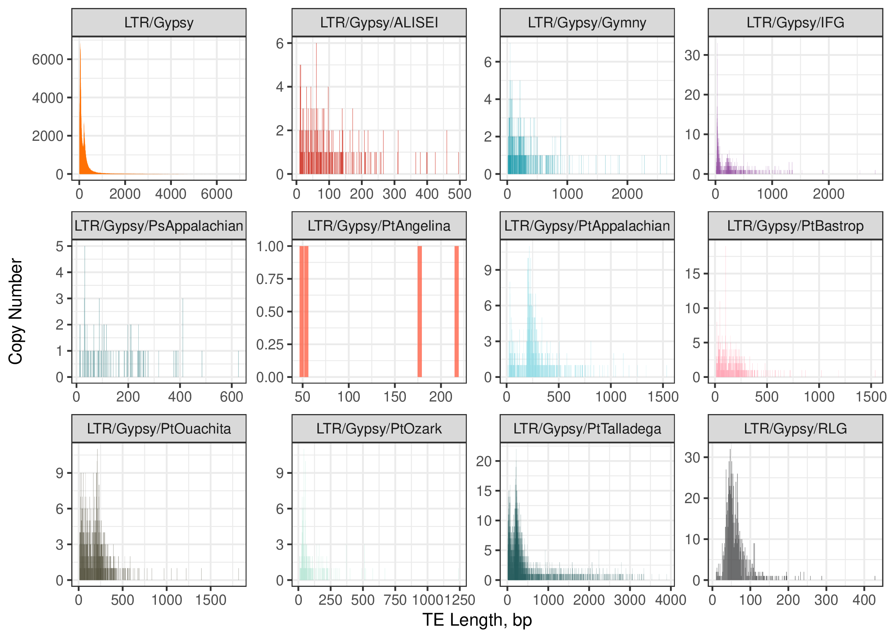
Fig. S2 Length distribution of the Gypsy-retrotransposon superfamilies in the Siberian larch genome
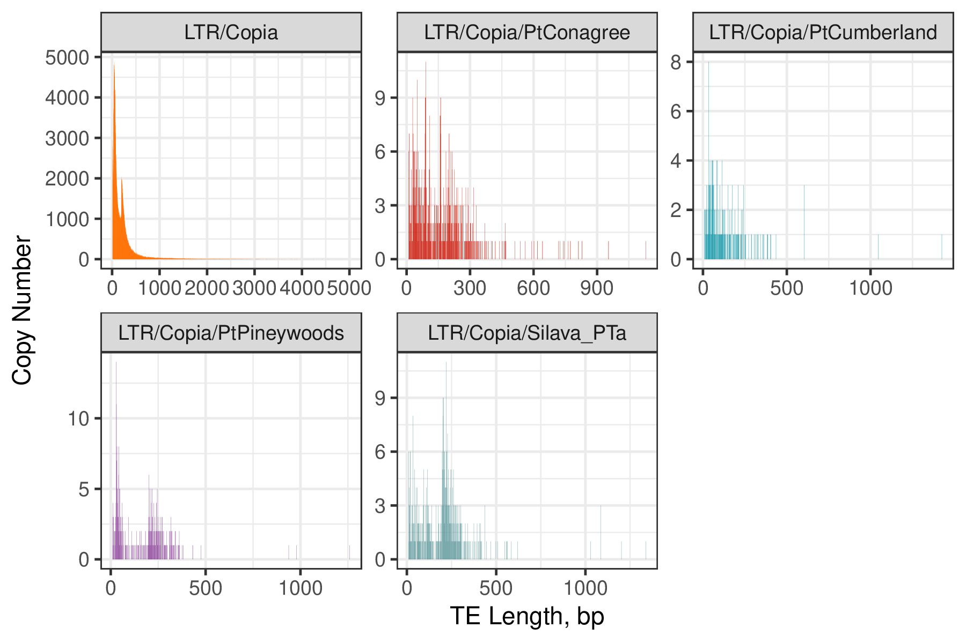
Fig. S3 Length distribution of the Copia-retrotransposon superfamilies in the Siberian larch genome
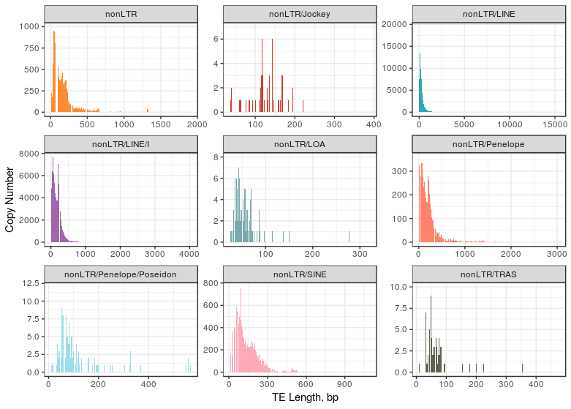
Fig. S4 Length distribution of the main nonLTR-retrotransposon families in the Siberian larch genome
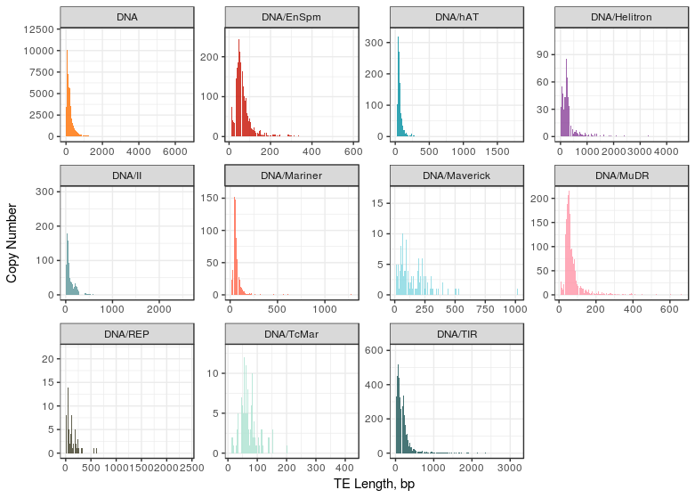
Fig. S5 Length distribution of the main DNA-transposon families in the Siberian larch genome
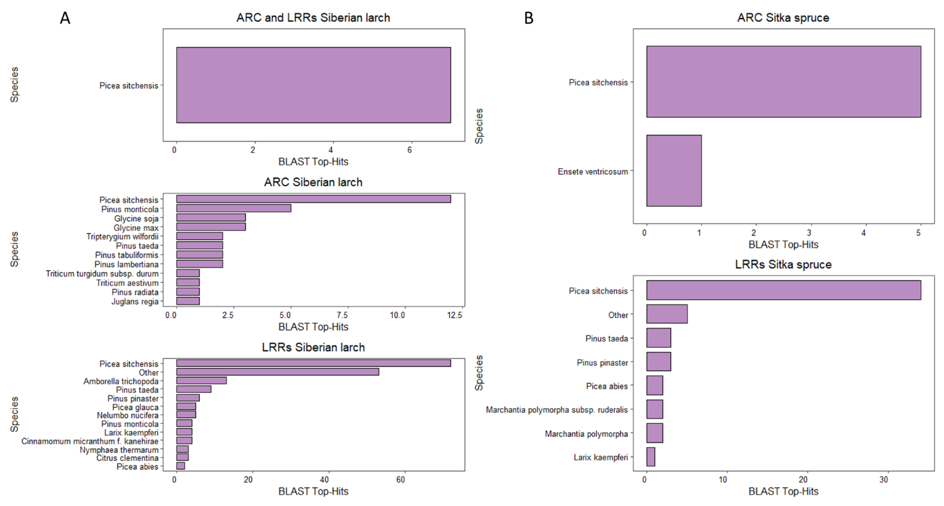
Fig. S6 BLAST top-hits identified for the Siberian larch (A) and Sitka spruce (B) sequences
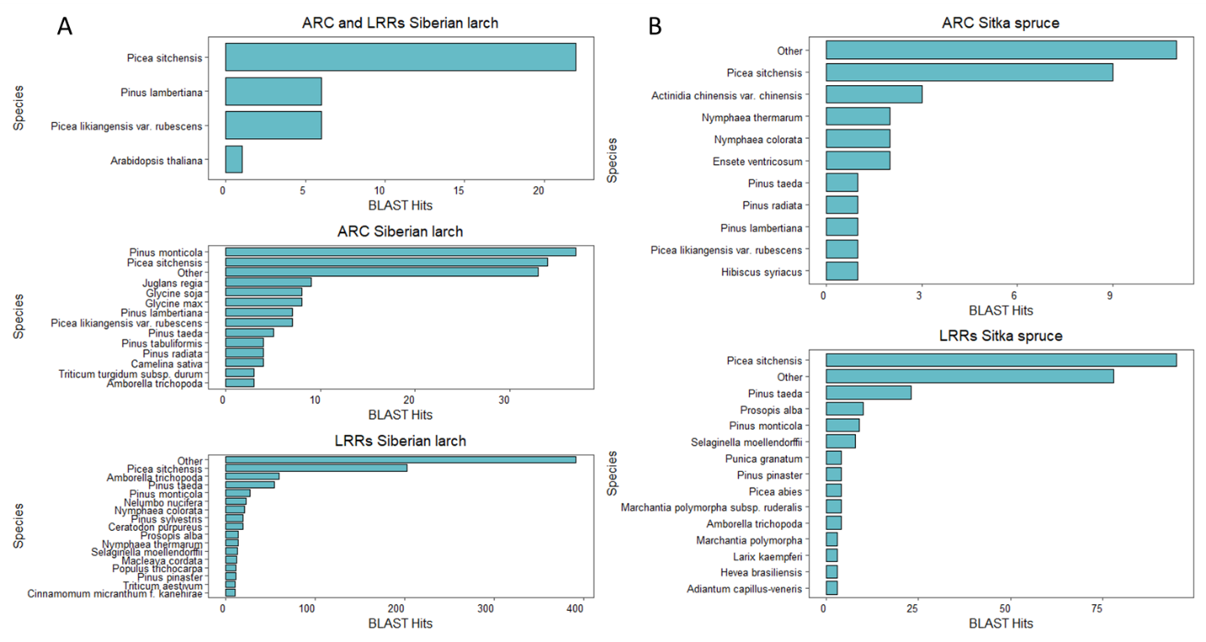
Fig. S7 BLAST hits identified for the Siberian larch (A) and Sitka spruce (B) sequences

