Supplementary Material 2 on
Mapping Malaria Risk in India between 2019-2023: A Tool for the Public to Track Malaria
Avik Kumar Sam¹, Neha Keshri¹, Ipsita Pal Bhowmick², Anup Anvikar³,
Harish C. Phuleria^{1,4,5 *}

- Environmental Science and Engineering Department, Indian Institute of Technology Bombay, Mumbai, India
- Indian Council of Medical Research – Regional Medical Research Centre, Dibrugarh, India
- Indian Council of Medical Research – National Institute of Malaria Research, Delhi, India
- Center in Climate Studies, Indian Institute of Technology Bombay, Mumbai, India
- National Disease Modelling Consortium, Indian Institute of Technology Bombay, Mumbai, India
* Corresponding Author: phuleria@iitb.ac.in

User Guide: How to Use the Malaria Awareness Dashboard
This guide will help you understand and use the Malaria Awareness Dashboard. It’s designed to be simple and useful, especially if you’re using the dashboard for the first time.

Getting Started
When you open the dashboard, here’s what you’ll see and what it means:
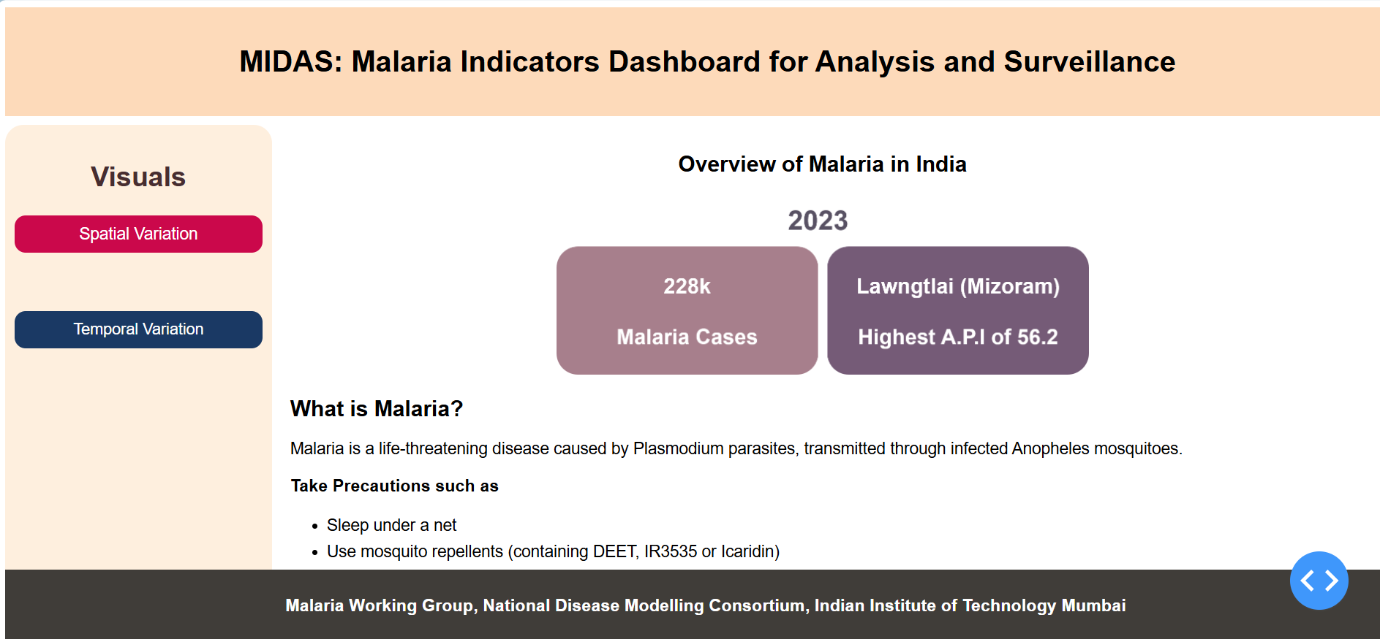
Figure 1 Screenshot of the main page.

Dashboard Title and Subtitle
At the top, you’ll see the title "Dashboard for Malaria Cases". Just below that, it says "Visualizing Spatial and Temporal Data to Raise Awareness." This tells you that the dashboard is meant to help people understand how malaria is spreading across time and space in India.

Summary Highlights (Middle of the Page)
Right in the center of the page, you’ll find two important facts:
- Total Cases: It shows that India had 228,000 malaria cases in 2023.
- Most Affected Area: It also shows the name of the district with the highest number of malaria cases per population (called A.P.I.). In this case, it’s Lawmgtlai in Mizoram with an A.P.I of 56.2.

Left-side Navigation:
On the left side of the screen, you’ll see two buttons:
- Spatial Variation – lets you explore how malaria patterns vary across different regions of India from 2019 to 2023, showing differences by state and district each year.
- Temporal Variation – helps you see how malaria trends have changed over time, from 2019 to 2023, focusing on changes within specific districts year by year.

Footer
At the bottom, there’s a short message: “ANERG - IIT Bombay - Working Towards a Malaria-Free World.” If you will click in this, then it will redirect you to our official lab website.

What to do now?
Start by clicking either Spatial Variation or Temporal Variation on the left to explore more!

Spatial Variation
This page shows where malaria cases are more common across different parts of India.
When you first click on the “Spatial Variation” button, a dropdown appears where you can select a year, like this:
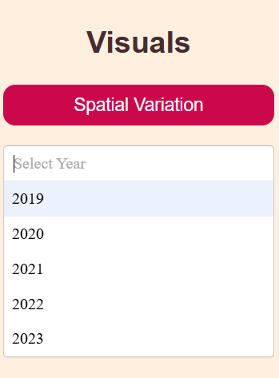
Figure 2 Screenshot of the top left panel (Selection of year)
After selecting a year, a second dropdown will appear to select the region. Currently, the only option is India, so you must select that.
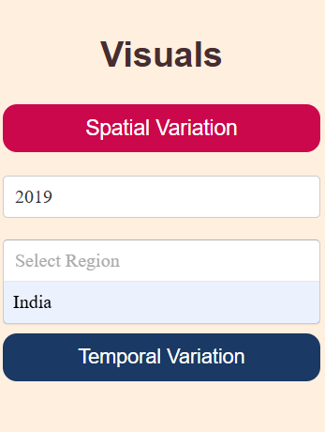
Figure 3 Screenshot of the top left panel (Selection of Region)
Once the region is selected, a list of radio buttons will appear, allowing you to choose from various malaria indicators.
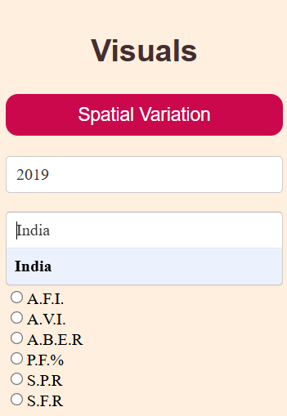
Figure 4 Screenshot of the top left panel (Selection of malaria indicators)
For example, if you select A.P.I. from the list, you’ll see a graph like the one below
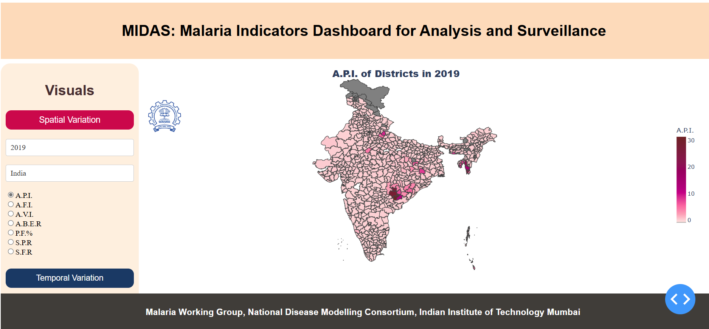
Figure 5 Screenshot of the dashboard output showing the spatial variations in API
You can hover your cursor over the map to get more details about a specific district or state, including the value of the selected indicator. You can also download the map by clicking on this icon (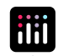) in the top-right corner.
Similar way, you can choose different indicators and different year.

Temporal Variation
This page helps you understand how malaria cases have changed over time, from 2019 to 2023.

After clicking on the “Temporal Variation” button, a dropdown will appear for selecting a state, like this:

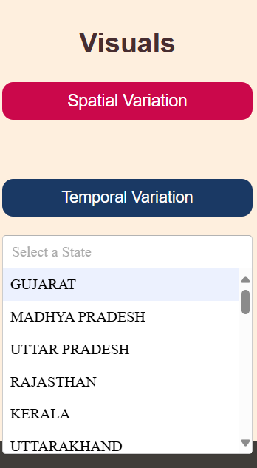
Figure 6 Screenshot of the bottom left panel (Selection of state)

Once a state is selected, another dropdown appears for selecting a district within that state:
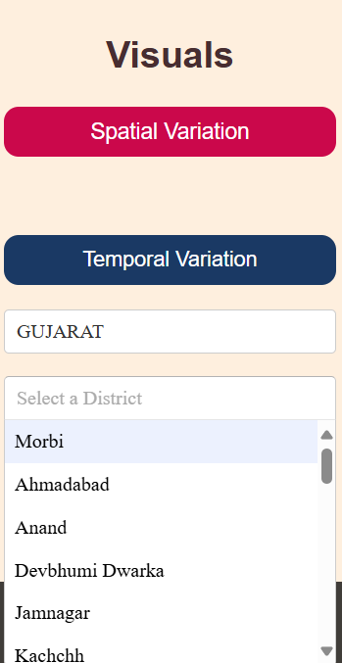
Figure 7 Screenshot of the bottom left panel (Selection of districts)
After selecting the district, a list of radio buttons will appear with different malaria indicators to choose from:
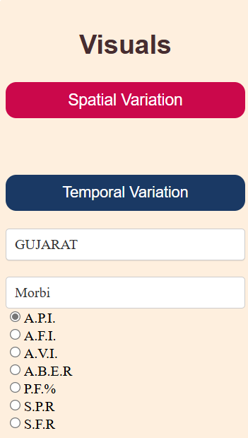
Figure 8 Screenshot of the bottom left panel (Selection of malaria parameters)
Once you choose an indicator — for example, A.P.I. — a line graph will be generated showing three key trends:
- Variation of average A.P.I. in India from 2019 to 2023
- Variation of average A.P.I. in the selected district of the selected state from 2019 to 2023
- Variation of A.P.I. in the selected state (average) from 2019 to 2023
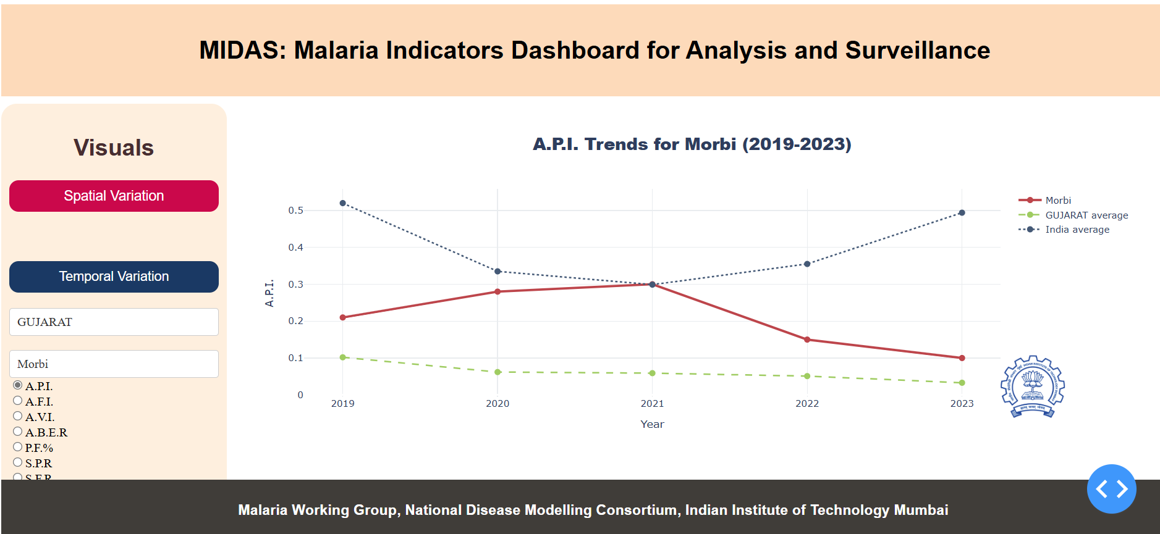
Figure 9 Screenshot of the dashboard showing the temporal trends in API for Morbi, Gujarat.
Just like in the Spatial Variation section, you can download the graph using the same icon in the top-right corner.

