Supplementary Material on

Mapping Malaria Risk in India between 2019-2023: A Tool for the Public to Track Malaria
Avik Kumar Sam¹, Neha Keshri¹, Ipsita Pal Bhowmick², Anup Anvikar³,
Harish C. Phuleria^{1,4,5*}

- Environmental Science and Engineering Department, Indian Institute of Technology Bombay, Mumbai, India
- Indian Council of Medical Research – Regional Medical Research Centre, Dibrugarh, India
- Indian Council of Medical Research – National Institute of Malaria Research, Delhi, India
- Center in Climate Studies, Indian Institute of Technology Bombay, Mumbai, India
- National Disease Modelling Consortium, Indian Institute of Technology Bombay, Mumbai, India

* Corresponding Author: phuleria@iitb.ac.in

Table S1 Year-wise trend in malaria parameters across India. The values are given in thousands.
 |  | Collection |  | Examination
Year | Population | BSC | RDT Col. | BSE | RDT Exam. | Pv_{t} | Pf_{t} | Total
2019 | 1349522 | 134273 | 0 | 134273 | 0 | 182 | 155 | 339
2020 | 1373515 | 73409 | 23902 | 73408 | 23883 | 67 | 118 | 187
2021 | 1385500 | 87961 | 26440 | 87952 | 26440 | 60 | 100 | 162
2022 | 1396755 | 118256 | 34268 | 117786 | 34264 | 75 | 98 | 177
2023 | 1417368 | 126903 | 38046 | 126692 | 38046 | 90 | 135 | 228
BSC: Blood Slides Collected, RDT: Rapid Diagnostic Tests, RDT Col.: RDT Collected, BSE: Blood Slides Examined, RDT Exam.: RDT Examined, Pv_{t}: Cases due to P. Vivax, Pf_{t}: Cases due to P. falciparum.

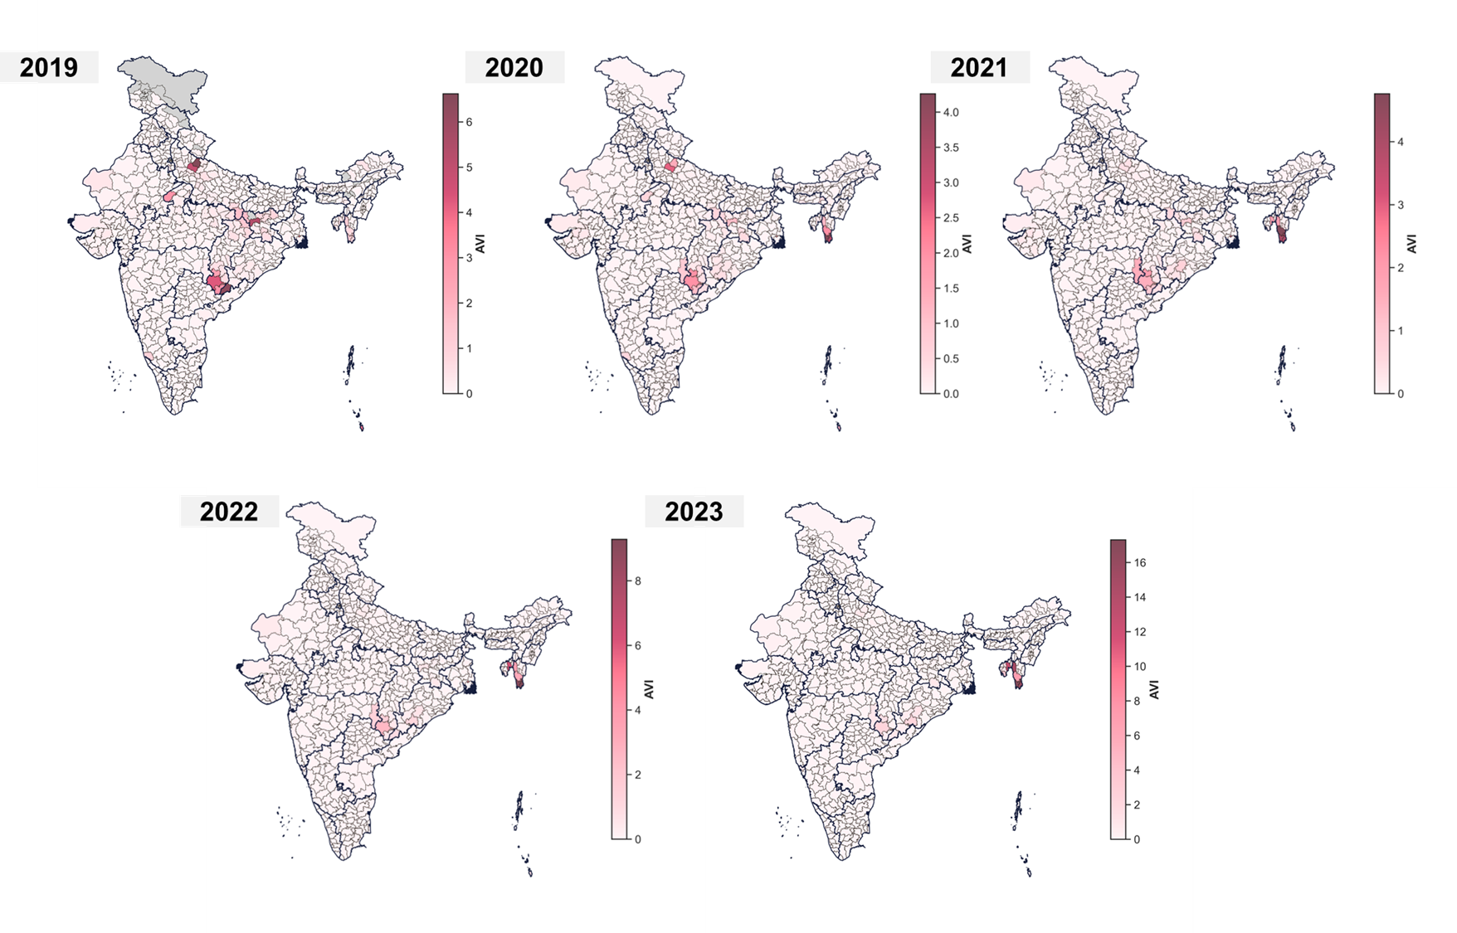
Figure S1 Spatiotemporal distribution in AVI.
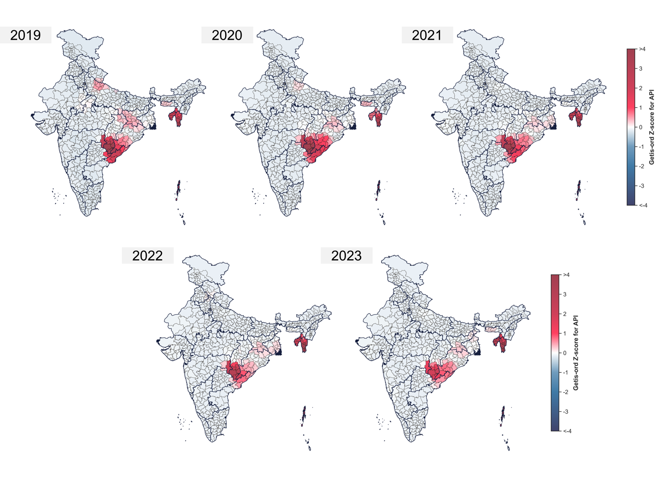
Figure S2 Spatiotemporal distribution of hotspots observed for API.
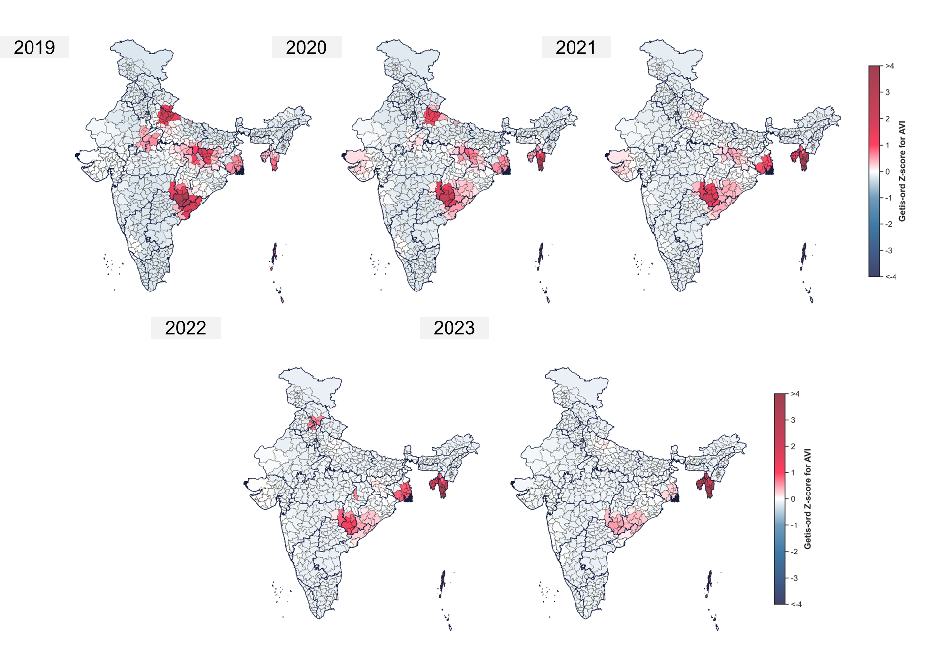
Figure S3 Spatiotemporal distribution of hotspots observed for AVI.
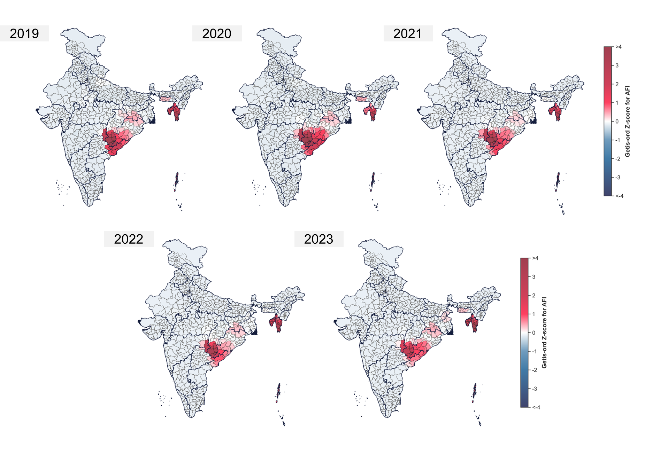
Figure S4 Spatiotemporal distribution of hotspots observed for AFI.
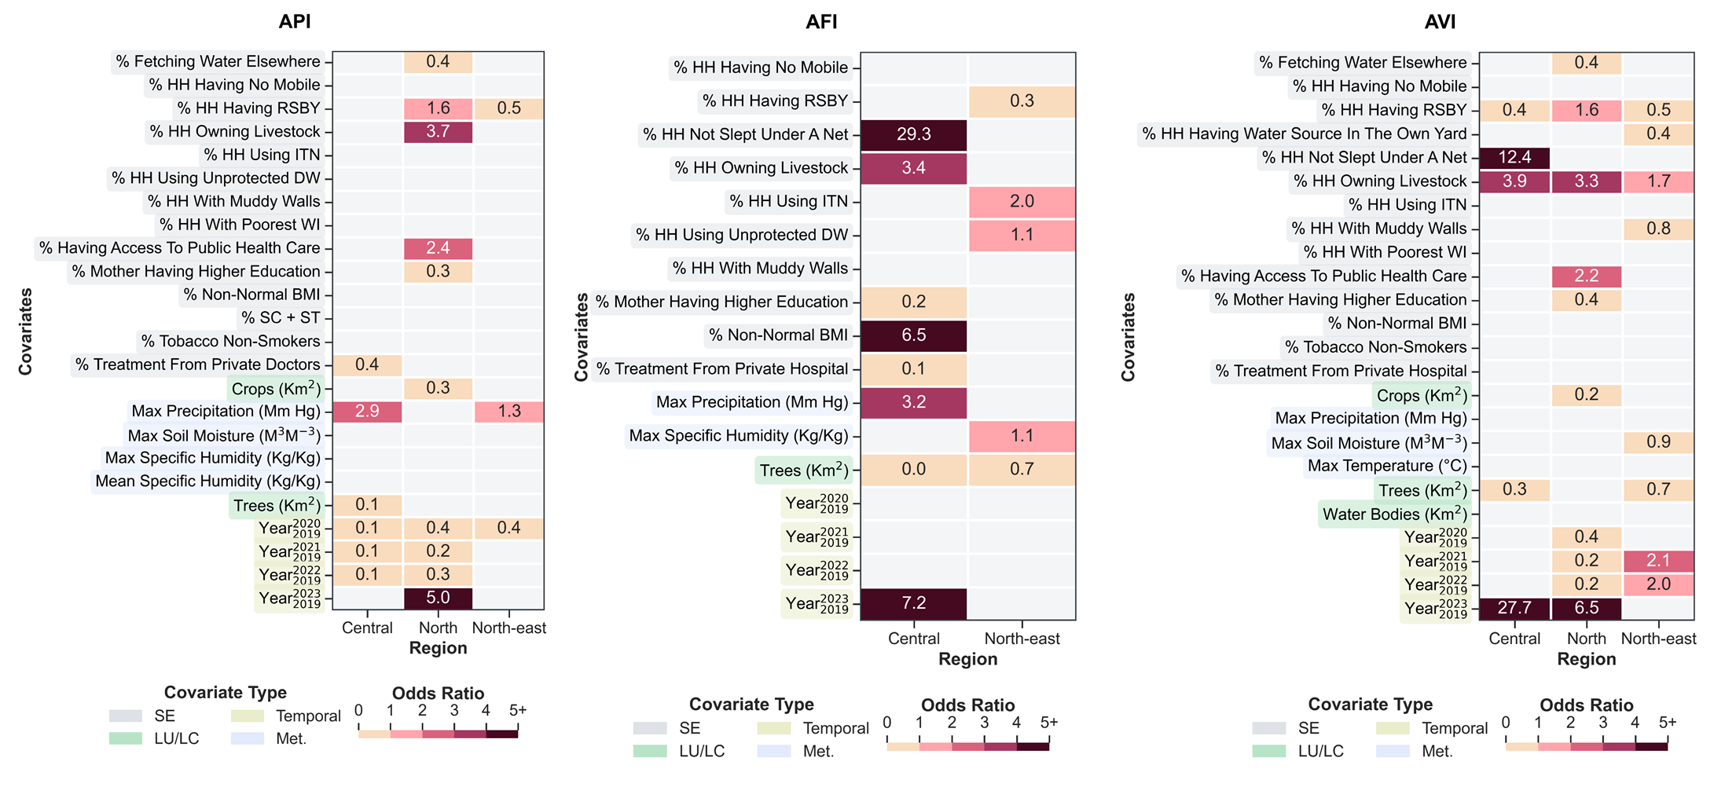
Figure S5 Estimated associations (ORs) for API, AFI and AVI.

