Supplement

Supplementary methods

Outer membrane extraction
Outer membrane extraction for validation of protein expression was performed based on ⁵⁷ with slight modifications. In brief, cultures (50 mL) were incubated overnight. The following day, an amount of cells corresponding to 50 mL of an optical density at 600 nm (OD₆₀₀) equaling 1 were harvested (10 min. 5,000 x g). Pellets were resuspended in 1 mL cold lysis buffer (10 µg/ml DNase I, 100 µg/ml lysozyme, 1 mM MgCl2 in 10 mM HEPES pH 7.5). Mechanical cell disruption was ensured by using a cell homogenizer (Precellys 24 Touch; Bertin Technologies SAS, Montigny-le-Bretonneux, France) for 2x 40 sec with cooling in-between. Cell debris was pelleted (2 min, 10,000 x g) and supernatant transferred into a fresh tube to pellet membranes (30 min, 16,000 x g, 4°C). Pellets were resuspended in 200 µL 0.1 M HEPES pH 7.5. An equal volume of 2% N-lauroyl sarcosine in 10 mM HEPES and samples were incubated (30 min, 300 rpm, 22°C) to solubilize the inner membranes. Afterwards, outer membranes were pelleted (30 min, 16,000 x g, 4°C). Pellets were washed with 0.5 ml 10 mM HEPES pH 7.5 and centrifugation was repeated for 10 min. The pellets were then resuspended in 40 µL 10 mM HEPES pH 7.5, 10 µL sodium dodecyl sulfate–polyacrylamide gel electrophoresis (SDS-PAGE) sample buffer was added, and samples were stored at -20°C until further use.

SDS-PAGE
Samples were prepared by heating at 50°C for 10 min to not disrupt the TAA trimers. Then, the gel (Novex 4-20% Tris-glycine gel; Thermo Fisher Scientific, Waltham, MA, USA) was loaded with 15 µL of each sample and 2.5 µL of the size standard (Pageruler Prestained Protein Ladder; Thermo Fisher Scientific). Electrophoresis was performed for 1 h at 25 mAmp per gel. A colloid comassie brilliant blue stain was used for visualization of protein bands.

Macrocolony formation
Assessing biofilm phenotype was performed by observeing macrocolony formation of long-term agar consisting of LB-Lennox (Carl Roth, Germany) and Span agar (H. Carroux, Germany) A sterile Congo red-Coomassie-Brilliant-Blue G250 solution (50 mg/L Congo red, 25 mg/L Coomassie-Brilliant-Blue G250 solved in 20 mL 87.5% ethanol) was added. Bacterial cultures were inoculated with a single colony grown on LB-agar and incubated overnight at 37 °C shaking (180 rpm). From each culture 5 µL were spotted onto a freshly prepared agar plate. Plates were sealed with PARAFILM® and incubated at 28 °C for five days.

Supplementary tables
Supplementary table 1: List of primers used in this study. The orimer name, sequence and the application are given.
Name | Sequence (5‘ 3‘) | Application
EibD/A_F | TAACGAGGGCAAAAAATGAAATACCTGCTGCCGACC | Amplification of eibD and eibA
EibD/A_R | CACAGGTCAAGCTTATTAAAACTCGAAGTTCACACCAACGT | Amplification of eibD and eibA
EibG_F | TAACGAGGGCAAAAAATGAGTAAAAAGTTTACAATGACACTTC | Amplification of eibG
EibG_R | CACAGGTCAAGCTTATTAAAACTCGAAGTTAACGCCCAT | Amplification of eibG
YadA_F | TAACGAGGGCAAAAAATGATGACTAAAGATTTTAAGATCAGTGTC | Amplification of yadA
YadA_R | GTGGCTCCAAGCGCTCTATTACCACTCGATATTAAATGATGCAT | Amplification of yadA
IBAseq_F | GGTACTATGCTAGCCCCT | Sequencing
IBAseq_R | CGTTTACCGCTACTGCG | Sequencing
EibGmutR | AGCTAAAACACCTGAGCTGATC | Revers primer for domain deletions and exchanges (amplification of eibG-plasmid)
EibG∆NtermF | CTCAGGTGTTTTAGCTGTTCAGGCTAGTGCGGCG | Deletion of N-terminal domain
EibGBBf | GGTCTTTTCCAGCCGTACAG | Exchange up to and including the LHCC domain; eibG template
EibG∆HeadF | CTCAGGTGTTTTAGCTCGTCAGGTTGACCGTGTAAAA | Deletion up to and including the neck domain
EibG∆RHccF | CTCAGGTGTTTTAGCTCGTCAGGTTGACCGTGTAAAA | Deletion up to and including the saddle domain
EibG-EibDNtermR | CGCCGCACTAGCCTGAACTTCGACGCTGAAACCTGTAATTTC | Exchange of N-terminal domain; eibD template
EibG-EibDNtermF | AGCTCAGGTGTTTTAGCTCAGAATGGTACATATTCAGTGTTG | Forward primer for exchange of domains; eibD template
EibG-EibDstalkR | GTACGGCTGGAAAAGACCTGTCAGGGCCGCAGACTG | Exchange up to and including the LHCC domain; eibD template
EibGRHccF | CGTCAGGTTGACCGTGTAAAA | Exchange up to and including the neck domain; eibG template
EibG-EibDneckR | TACACGGTCAACCTGACGAACAGTTGCCGCATCACTGTT | Exchange up to and including the neck domain; eibD template
EibGLPBRf | GTTCAGGCTAGTGCGGCG | Exchange of N-terminal domain; eibG template
EibG∆LPBRf | GAAATATTAAAACAATCGCGTCAGGTTGACCGTGTAAAA | Deletion of LPBR domain
EibGNtermR | CGATTGTTTTAATATTTCAGGATTAATAAT | Deletion of LPBR domain
EibG∆Pass | CTCAGGTGTTTTAGCTCACGAAGAGATGAAGCGTGC | Deletion of the passenger domain
pBAD-EibDf2 | CAGGAGGAATTAACCATGAAATACCTGCTGCCGACCG | Amplification of eibD for cloning into pBAD
pBAD-EibDr2 | GCCAAAACAGCCAAGCTTTTAAAACTCGAAGTTCACACCAACG | Amplification of eibD for cloning into pBAD
pBAD-EibGf | CAGGAGGAATTAACCATGAGTAAAAAGTTTACAATGACACTT | Amplification of eibG for cloning into pBAD
pBAD-EibGr | GCCAAAACAGCCAAGCTTTTAAAACTCGAAGTTAACGCCCAT | Amplification of eibG for cloning into pBAD
pBADRecF | AAGCTTGGCTGTTTTGGCGGA | Amplification of pBAD for cloning eibs
pBADRecR | CATGGTTAATTCCTCCTGTTAGC | Amplification of pBAD for cloning eibs
SpyTag-EibGf | ATGGTGGATGCATATAAACCGACCAAACAGGAGTTACCTCCTATCAAAG | Insertion of SpyTag
SpyTag-EibGr | ATATGCATCCACCATAACAATATGGGCAGCTAAAACACCTGAGCTGATC | Insertion of SpyTag
SpyTag-EibDf | ATGGTGGATGCATATAAACCGACCAAACAGAATGGTACATATTCAGTGTTG | Insertion of SpyTag
SpyTag-EibDr | ATATGCATCCACCATAACAATATGGGCCGCACTCACTCCACCACT | Insertion of SpyTag

Supplementary figures
Supplementary figure 1: Bright field microcopy and quantification of clump formation. (a) Bacteria were cultivated in ZYP medium⁵⁸ containing l-arabinose for induction of EibD or EibG expression respectively and afterwards assed for auto-aggregation by bright field microcopy. The scale bar in the bottom right corner indicates 10 µm. (b+c) Twenty semi-randomly taken pictures were evaluated to obtain their (b) circularity and (c) size using Fiji (ImageJ) and the average was calculated.
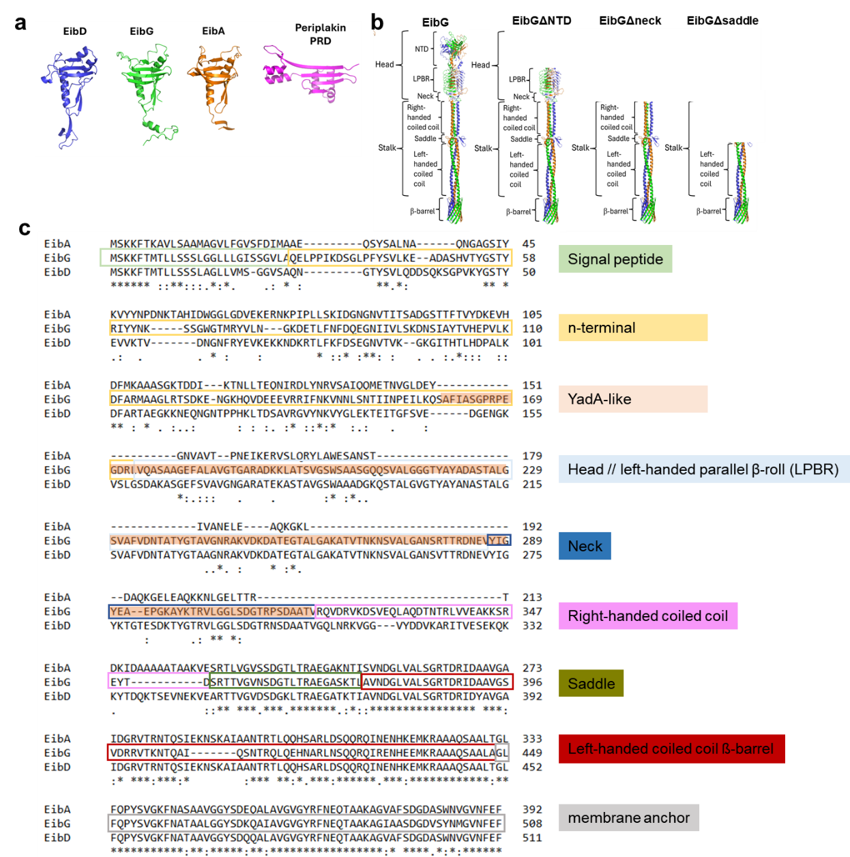
Supplementary figure 2: Annotation of analyzed domains. (a) Structures of the Eib NTDs: A monomer of the NTDs is shown, with EibD in blue, EibG in green and EibA in orange. They share a similar triangular core architecture, but differ in the loops. The figures include the connector to the next domain/region at the C-terminus, which is different for the three proteins: EibA and EibD connect via a beta hairpin, which has a longer loop in EibD, whereas EibG connects through a short α-helix leading into a β-hairpin stacking with the LPBR domain. A DALI search⁵⁹ identified the plectin repeat domain (PRD) of periplakin (PDB ID: 4Q28) as having stuctural similarity with the Eib NTDs (Z score 3.9). This structure is shown in magenta. (b) Structures of the EibG WT and deletion mutants, according to Figure 2 (c) The different structural and functional domains of the Eib proteins are highlighted in the indicated color. Alignment of the different Eib proteins EibA, EibD, and EibG was performed with Clustal Omega Multiple Sequence Alignment (MSA).
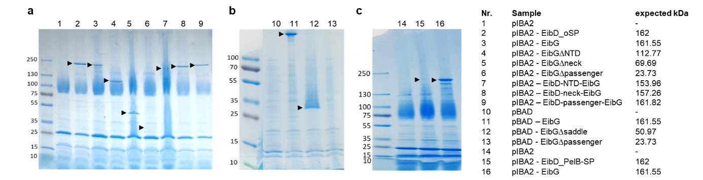
Supplementary figure 3: SDS-PAGE of outer membrane preparations from cells expressing different Eib variants. Strains transformed with indicated plasmids were cultivated in LB (for TOP10 cells with pIBA2 constructs) or in LB-based AIM (for BL21∆ABCF cells with pBAD constructs) overnight and cells corresponding to 10 mL of OD_{600nm}=1 were collected for outer membrane preparation. An SDS-Gel (4-20%) was loaded with 15 µL each. (a+c) SDS-PAGE of all indicated pIBA2 Eib variant constructs. (b) Expression of selected Eib variant was induced by 0.2% l-arabinose in BL21∆ABCF using the pBAD backbone.

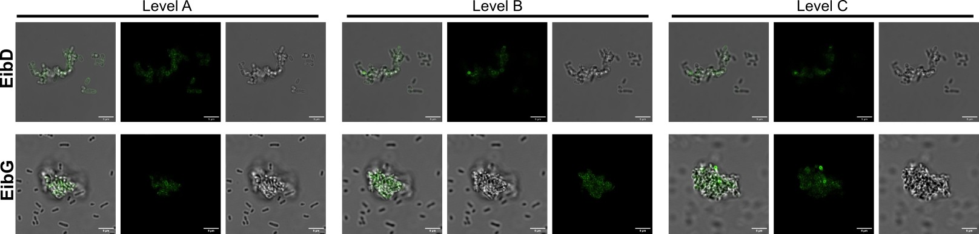
Supplementary figure 4: Z-stack images of clumps formed by cells expressing EibD-SpyTag or EibG-SpyTag. E. coli cells expressing either EibD-SpyTag or EibG-SpyTag were incubated with purified SpyCatcher protein to detect surface-exposed SpyTag. Samples were prepared for confocal microscopy to analyze the spatial distribution of the fluorescent signal. Three representative Z-planes are shown for each condition, illustrating the localization of fluorescence within bacterial clumps. The scale bar in the bottom right corner indicates 5 µm.

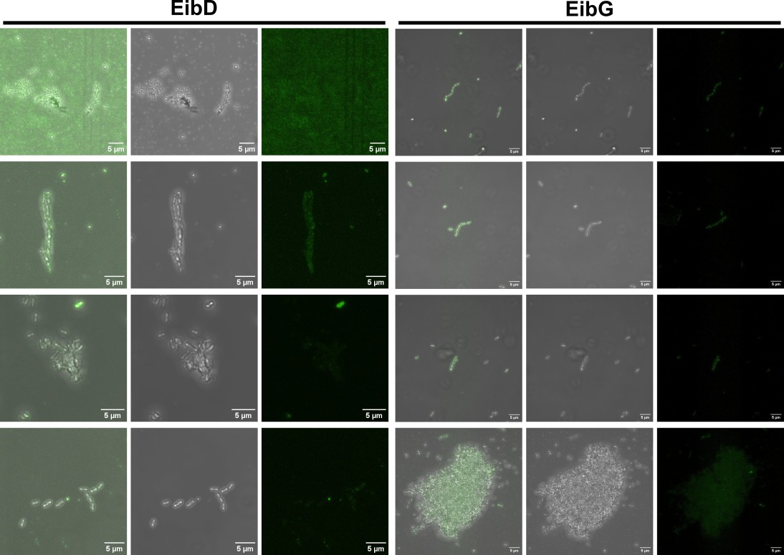
Supplementary figure 5: Cells expressing EibD-SpyTag or EibG-SpyTag stained with SpyCatcher-EQ variant. Regardless of the Eib protein, the staining of individual cells, chains, or clumps with the SpyCatcher-EQ resulted in diffusive non-specific signals. The scale bar in the bottom right corner indicates 5 µm.

Supplementary figure 6: Marcocolony formation on long-term agar plates. Liquid cultures of the indicated stains (ex = exchange between EibD and EibG) were spotted onto long-term agar plates containing Congo red and Coomassie-Brilliant blue for staining of the curli biofilm structures. Plates were sealed with PARAFILM® and incubated at 28 °C for five days.

