Supplementary Material

East meets West in the Western Carpathians: contact zone between Alpine and Carpathian caddisfly lineages evidenced by COI barcodes

Jana Bozáňová^{1,2}, Fedor Čiampor Jr¹, Tomasz Mamos³, Michal Grabowski³, Zuzana Čiamporová-Zat'ovičová^{1,2,*}

¹ ZooLab, Plant Science and Biodiversity Centre, Slovak Academy of Sciences, Bratislava, Slovak Republic
² Department of Ecology, Faculty of Natural Sciences, Comenius University in Bratislava, Bratislava, Slovak Republic
³ Department of Invertebrate Zoology and Hydrobiology, Faculty of Biology & Environmental Protection, University of Łódź, Łódź, Poland
* Corresponding author: zuzana.zatovicova@savba.sk

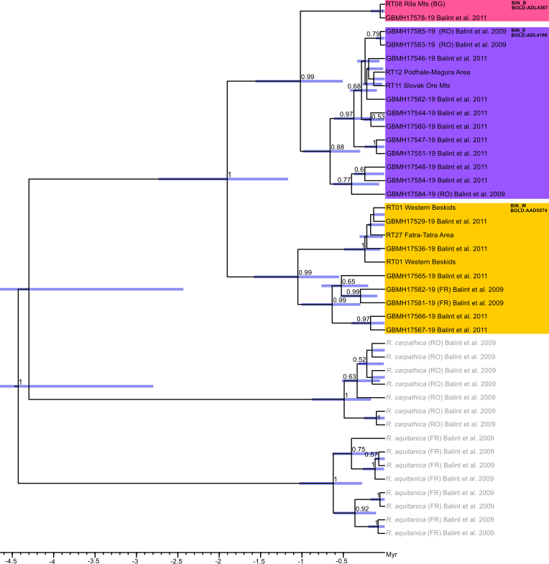Supplementary Figure S1. Bayesian phylogenetic reconstruction of R. tristis based on COI 3′ region. Numbers near nodes are BPP of BEAST v2.6.1. Node bars are 95 % HPD of the divergence time. Sequences from the study area were supplemented with sequences from the study by Bálint et al. (2009; 2011) to support the existence of various BINs identified on the basis of the COI 5' region. The outgroup consisted of European congeneric species: Rhyacophila aquitanica, R. carpathica. Abbreviations: Bulgaria – Rila & Pirin (BG), France – Western Alps (FR), Romania – Carpathians (RO).

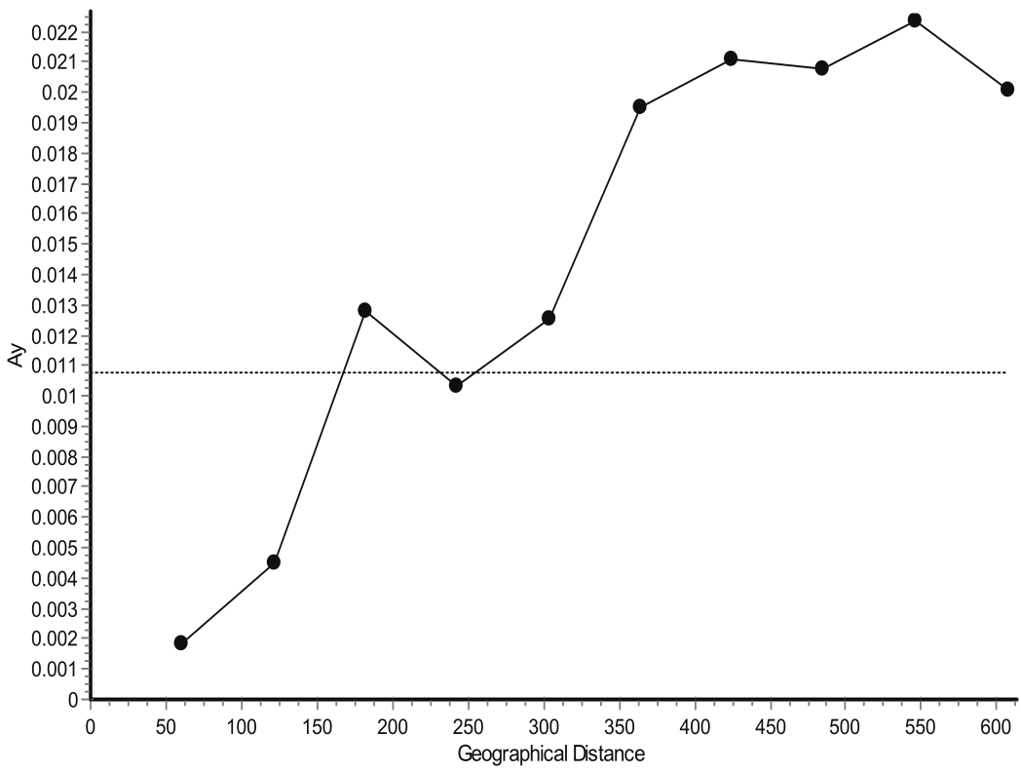
Supplementary Figure S2. Results of the spatial autocorrelation analysis of the R. tristis (P = 0.000). Distance classes (10) are given on the x-axis between 0 and 613 km, and pairwise genetic distances (Ay) are given on the y-axis. The horizontal dotted line indicates the average genetic distance for the observed data set. Values above the horizontal line suggest a correlation between distance class and genetic distance.

Mts System | Geomorphological Unit | Geomorphological Subunit | Code | Locality | Habitat | River basin | GPS Coordinates | Altitude | BIN³
IWC | FTA  Fatra-Tatra Area  (Fatransko-tatranská oblasť) | FTA1  Little Carpathians (Malé Karpaty) | V005 | Doľany | SP | Morava | 48.4245, 17.3210 | 424 m | BIN_W(1)
IWC | FTA  Fatra-Tatra Area  (Fatransko-tatranská oblasť) | FTA1  Little Carpathians (Malé Karpaty) | V071 | Husí stok | SP | Morava | 48.4651, 17.3767 | 273 m | BIN_W(8)
IWC | FTA  Fatra-Tatra Area  (Fatransko-tatranská oblasť) | FTA1  Little Carpathians (Malé Karpaty) | SPV1 | Stupavský p. 1 | ST | Morava | 48.2525, 17.1122 | 292 m | BIN_W(8)
IWC | FTA  Fatra-Tatra Area  (Fatransko-tatranská oblasť) | FTA2  Tatras (Tatry) | T180 | Biela voda | ST | Dunajec a Poprad | 49.2291, 20.0999 | 1065 m | BIN_W(1) /BIN_E(6)
IWC | FTA  Fatra-Tatra Area  (Fatransko-tatranská oblasť) | FTA2  Tatras (Tatry) | TZR1 | Slavkovský p. | ST | Dunajec a Poprad | 49.1315, 20.1988 | 1064 m | BIN_E(7)
IWC | FTA  Fatra-Tatra Area  (Fatransko-tatranská oblasť) | FTA2  Tatras (Tatry) | POP3 | Poprad 3 | ST | Dunajec a Poprad | 49.1169, 20.0808 | 1224 m | BIN_E(1)
IWC | FTA  Fatra-Tatra Area  (Fatransko-tatranská oblasť) | FTA2  Tatras (Tatry) | T37 | Tatranská Javorina | ST | Dunajec a Poprad | 49.1865, 20.1139 | 1339 m | BIN_E(1)
IWC | FTA  Fatra-Tatra Area  (Fatransko-tatranská oblasť) | FTA2  Tatras (Tatry) | T177 | Gáborov p. | ST | Dunajec a Poprad | 49.1839, 19.8149 | 1408 m | BIN_E(2)
IWC | FTA  Fatra-Tatra Area  (Fatransko-tatranská oblasť) | FTA2  Tatras (Tatry) | T36 | Podbanské | ST | Dunajec a Poprad | 49.1926, 20.0143 | 1497 m | BIN_E(1)
IWC | FTA  Fatra-Tatra Area  (Fatransko-tatranská oblasť) | FTA2  Tatras (Tatry) | T023 | Temnosmreč 1 | ST | Dunajec a Poprad | 49.1945, 20.0300 | 1687 m | BIN_E(1)
IWC | FTA  Fatra-Tatra Area  (Fatransko-tatranská oblasť) | FTA2  Tatras (Tatry) | T022 | Temnosmreč 2 | ST | Dunajec a Poprad | 49.1903, 20.0354 | 1713 m | BIN_E(1)
IWC | FTA  Fatra-Tatra Area  (Fatransko-tatranská oblasť) | FTA2  Tatras (Tatry) | POP2 | Poprad 2 | ST | Dunajec a Poprad | 49.0837, 20.1420 | 817 m | BIN_E(1)
IWC | FTA  Fatra-Tatra Area  (Fatransko-tatranská oblasť) | FTA3  Great Fatra (Veľká Fatra) | V033 | Jazierce | SP | Váh | 49.0182, 19.2819 | 589 m | BIN_W(1) /BIN_E(1)
IWC | FTA  Fatra-Tatra Area  (Fatransko-tatranská oblasť) | FTA3  Great Fatra (Veľká Fatra) | MAT1 | Matejkovský p. | ST | Váh | 49.0010, 19.2631 | 728 m | BIN_W(1)
IWC | FTA  Fatra-Tatra Area  (Fatransko-tatranská oblasť) | FTA4  Belianske Tatras (Belianske Tatry) | V036 | Dolina 7 prameňov | SP | Váh | 49.2228, 20.2776 | 1208 m | BIN_E(2)
IWC | FTA  Fatra-Tatra Area  (Fatransko-tatranská oblasť) | FTA5  Strážov Mts (Strážovské vrchy) | NIT1 | Nitra 1 | ST | Váh | 48.6574, 18.6377 | 671 m | BIN_W(4)
IWC | FTA  Fatra-Tatra Area  (Fatransko-tatranská oblasť) | FTA5  Strážov Mts (Strážovské vrchy) | TUR1 | Turiec 1 | ST | Váh | 48.9648, 18.7272 | 575 m | BIN_W(1)
IWC | FTA  Fatra-Tatra Area  (Fatransko-tatranská oblasť) | FTA6  Choč Mts (Chočské vrchy) | V026 | Prosiek 1 | SP | Váh | 49.1621,19.4923 | 705 m | BIN_E(2)
IWC | SCM  Slovak Central Mts  (Slovenské stredohorie) | SCM1  Krupinská planina | KRI1 | Krivánsky | ST | Ipeľ | 48.4970, 19.5040 | 316 m | BIN_E(2)
IWC | SCM  Slovak Central Mts  (Slovenské stredohorie) | SCM2  Poľana Mts (Poľana) | KAM1 | Kamenistý | ST | Hron | 48.6624, 19.6285 | 884 m | BIN_E(1)
IWC | SOM  Slovak Ore Mts  (Slovenské rudohorie) | SOM1  Slovak Karst (Slovenský kras) | V074 | Kunov Teplica | SP | Slaná | 48.6073, 20.3909 | 248 m | BIN_E(1)
IWC | SOM  Slovak Ore Mts  (Slovenské rudohorie) | SOM1  Slovak Karst (Slovenský kras) | V075 | Hučiaca B | SP | Slaná | 48.6252, 20.3899 | 269 m | BIN_E(4)
IWC | SOM  Slovak Ore Mts  (Slovenské rudohorie) | SOM1  Slovak Karst (Slovenský kras) | V088 | Drieňov kúpele | SP | Hornád a Bodva | 48.6245, 20.9520 | 257 m | BIN_E(2)
IWC | SOM  Slovak Ore Mts  (Slovenské rudohorie) | SOM2  Slovak Paradise (Slovenský raj) | V080 | Biele Vody | SP | Hornád a Bodva | 48.8741, 20.4041 | 850 m | BIN_E(1)
IWC | SOM  Slovak Ore Mts  (Slovenské rudohorie) | SOM2  Slovak Paradise (Slovenský raj) | V082 | Pusté pole 2 | SP | Hornád a Bodva | 48.8840, 20.2041 | 953 m | BIN_E(2)
IWC | SOM  Slovak Ore Mts  (Slovenské rudohorie) | SOM2  Slovak Paradise (Slovenský raj) | V084 | Mokrá dolina | SP | Hornád a Bodva | 48.8979, 20.2652 | 883 m | BIN_E(4)
IWC | SOM  Slovak Ore Mts  (Slovenské rudohorie) | SOM2  Slovak Paradise (Slovenský raj) | V078 | bez mena 2 | SP | Hornád a Bodva | 48.8699, 20.2576 | 897 m | BIN_E(3)
IWC | SOM  Slovak Ore Mts  (Slovenské rudohorie) | SOM2  Slovak Paradise (Slovenský raj) | V079 | Dobšinská ľad | SP | Hornád a Bodva | 48.8722, 20.3035 | 875 m | BIN_E(1)
IWC | SOM  Slovak Ore Mts  (Slovenské rudohorie) | SOM2  Slovak Paradise (Slovenský raj) | V081 | Pusté pole 1 | SP | Hornád a Bodva | 48.8839, 20.2038 | 959 m | BIN_E(4)
IWC | SOM  Slovak Ore Mts  (Slovenské rudohorie) | SOM2  Slovak Paradise (Slovenský raj) | V090 | Zejmarská | SP | Hornád a Bodva | 48.8776, 20.3972 | 1028 m | BIN_E(2)
IWC | SOM  Slovak Ore Mts  (Slovenské rudohorie) | SOM2  Slovak Paradise (Slovenský raj) | VER1 | Hnilec 2 | ST | Hornád a Bodva | 48.8848, 20.2365 | 920 m | BIN_E(3)
IWC | SOM  Slovak Ore Mts  (Slovenské rudohorie) | SOM3  Muráň Plateau (Muránska planina) | RAC1 | Racov 1 | SP | Hron | 48.8520, 19.9959 | 659 m | BIN_E(1)
IWC | SOM  Slovak Ore Mts  (Slovenské rudohorie) | SOM4  Volovec Mts (Volovské vrchy) | KOJ1 | Kojšovský p. | ST | Hornád a Bodva | 48.8459, 21.0115 | 408 m | BIN_E(1)
IWC | SOM  Slovak Ore Mts  (Slovenské rudohorie) | SOM4  Volovec Mts (Volovské vrchy) | SMO1 | Smolník 1 | ST | Hornád a Bodva | 48.7090, 20.7007 | 635 m | BIN_E(3)
IWC | MSA  Mátra-Slanec Area  (Severné stredohorie) | MSA1  Slanské Hills (Slanské vrchy) | HLB1 | Hlboký p. | ST | Hornád a Bodva | 48.9922, 21.4759 | 364 m | BIN_E(2)
OWC | SMC  Slovak-Moravian Carpathians  (Slovensko-moravské Karpaty) | SMC1  Javorníky Mts | VAH1 | Váh 1 | ST | Váh | 49.3253, 18.5111 | 582 m | BIN_W(2)
OWC | WB  Western Beskids  (Západné Beskydy) | WB1  Moravian-Silesian Beskids  (Moravsko-sliezske Beskydy) | CZ01 | Lomná | ST | Morava | 49.5477, 18.6504 | 538 m | BIN_W(3)
OWC | WB  Western Beskids  (Západné Beskydy) | WB1  Moravian-Silesian Beskids  (Moravsko-sliezske Beskydy) | CZ02 | Příslopský | ST | Morava | 49.6242, 18.5754 | 497 m | BIN_W(1)
OWC | WB  Western Beskids  (Západné Beskydy) | WB1  Moravian-Silesian Beskids  (Moravsko-sliezske Beskydy) | CZ03 | Satina | ST | Morava | 49.5653, 18.4228 | 772 m | BIN_W(8)
OWC | WB  Western Beskids  (Západné Beskydy) | WB1  Moravian-Silesian Beskids  (Moravsko-sliezske Beskydy) | CZ05 | Kněhyně | ST | Morava | 49.4625, 18.2782 | 570 m | BIN_W(5)
OWC | WB  Western Beskids  (Západné Beskydy) | WB1  Moravian-Silesian Beskids  (Moravsko-sliezske Beskydy) | CZ07 | Bystřička | ST | Morava | 49.3717, 17.7506 | 563 m | BIN_W(4)
OWC | WB  Western Beskids  (Západné Beskydy) | WB2  Silesian Beskids  (Sliezske Beskydy) | PL04 | Żyłica | ST | Wisla | 49.6938, 18.9840 | 609 m | BIN_W(2)
OWC | WB  Western Beskids  (Západné Beskydy) | WB2  Silesian Beskids  (Sliezske Beskydy) | PL05 | Labajów | ST | Wisla | 49.6228, 18.8692 | 523 m | BIN_W(9)
OWC | PMA  Podhale-Magura Area  (Podhôľno-magurská oblasť) | PMA1  Spiš Magura | HNC1 | Hraničná | ST | Dunajec a Poprad | 49.4168, 20.7232 | 386 m | BIN_E(3)
OWC | PMA  Podhale-Magura Area  (Podhôľno-magurská oblasť) | PMA1  Spiš Magura | HRB1 | Hrebeniacky p. | ST | Dunajec a Poprad | 49.3358, 20.8432 | 437 m | BIN_E(2)
OWC | PMA  Podhale-Magura Area  (Podhôľno-magurská oblasť) | PMA1  Spiš Magura | ZAV1 | Závoský p. | ST | Dunajec a Poprad | 49.3866, 20.7533 | 412 m | BIN_E(1)
OWC | PMA  Podhale-Magura Area  (Podhôľno-magurská oblasť) | PMA2  Oravská Magura | BRE1 | Brezovica | ST | Váh | 49.3438, 19.6621 | 687 m | BIN_E(5)
IEC | VM  Vihorlat Mts  (Vihorlatské vrchy) | VM1  Vihorlat Mts (Vihorlatské vrchy) | BAR1 | Barnov 1 | ST | Laborec | 48.9384, 22.1603 | 434 m | BIN_E(4)
IEC | VM  Vihorlat Mts  (Vihorlatské vrchy) | VM1  Vihorlat Mts (Vihorlatské vrchy) | HRA1 | Hrabový p. 1 | ST | Laborec | 48.8780, 22.2975 | 412 m | BIN_E(8)
IEC | VM  Vihorlat Mts  (Vihorlatské vrchy) | VM1  Vihorlat Mts (Vihorlatské vrchy) | JOV1 | Jovsiansky p. | ST | Laborec | 48.8265, 22.1049 | 176 m | BIN_E(2)
IEC | VM  Vihorlat Mts  (Vihorlatské vrchy) | VM1  Vihorlat Mts (Vihorlatské vrchy) | KRV1 | Krivec 1 | ST | Laborec | 48.9073, 22.2037 | 569 m | BIN_E(2)
IEC | VM  Vihorlat Mts  (Vihorlatské vrchy) | VM1  Vihorlat Mts (Vihorlatské vrchy) | LUH | Luhy 1 | ST | Laborec | 48.8598, 22.3424 | 304 m | BIN_E(1)
IEC | VM  Vihorlat Mts  (Vihorlatské vrchy) | VM1  Vihorlat Mts (Vihorlatské vrchy) | MOR1 | Morské oko | ST | Laborec | 48.9182, 22.1965 | 636 m | BIN_E(3)
IEC | VM  Vihorlat Mts  (Vihorlatské vrchy) | VM1  Vihorlat Mts (Vihorlatské vrchy) | SKA1 | Skalný p. | ST | Laborec | 48.8950, 22.2042 | 457 m | BIN_E(2)
OEC | PM  Poloniny Mts (Poloniny) | PM1  Poloniny Mts (Poloniny) | CIR1 | Cirocha 1 | ST | Laborec | 49.0228, 22.2518 | 282 m | BIN_E(3)
OEC | PM  Poloniny Mts (Poloniny) | PM1  Poloniny Mts (Poloniny) | ULI1 | Ulička 1 | ST | Laborec | 49.0008, 22.3884 | 304 m | BIN_E(1)
OEC | PM  Poloniny Mts (Poloniny) | PM1  Poloniny Mts (Poloniny) | PAC1 | Packov | ST | Laborec | 49.0510, 22.5147 | 418 m | BIN_E(1)
 | LB  Low Beskids (Nízke Beskydy) | LB1  Low Beskids (Nízke Beskydy) | HLP1 | Laborec | ST | Laborec | 49.3240, 21.9199 | 458 m | BIN_E(1)
IWC – Inner Western Carpathians, OWC – Outer Western Carpathians, IEC – Inner Eastern Carpathians, OEC – Outer Eastern Carpathians; SP – spring, ST – stream; ³ numbers in parentheses indicate the number of individuals for each locality.
Supplementary Table S1. The list of all sampling sites and their geomorphological affiliation.

R. tristis
 | Source of variation | Df |  | SS |  | Variance components |  | % of variation |  | F value |  | p-value
GU | Among GU | 9 |  | 288.568 |  | 1.99019 |  | 56.53 |  | F_{CT} = 0.565 |  | > 0.00
GU | Among subpopulations within GU | 48 |  | 156.986 |  | 1.00795 |  | 28.63 |  | F_{SC} = 0.659 |  | > 0.00
GU | Within subpopulations | 104 |  | 54.354 |  | 0.52263 |  | 14.84 |  | F_{ST} = 0.852 |  | < 0.00
RB | Among RB | 8 |  | 351.688 |  | 2.46668 |  | 70.03 |  | F_{CT} = 0.700 |  | > 0.00
RB | Among subpopulations within RB | 48 |  | 92.219 |  | 0.53299 |  | 15.13 |  | F_{SC} = 0.505 |  | > 0.00
RB | Within subpopulations | 104 |  | 54.354 |  | 0.52263 |  | 14.84 |  | F_{ST} = 0.852 |  | < 0.00
Df – degree of freedom, SS – sum of squares, GU – geomorphological units, RB – river basins.
Supplementary Table S2. Analysis of molecular variance (AMOVA) calculated from 161 COI mtDNA sequences of R. tristis from studied springs and streams in the W Carpathians. The subpopulation is defined as individuals of one sampling site (see Table S1).

