Supplementary Information for

Origin of the Harappan Ernestites: Fabrication and Raw Materials

M.K. Mahala¹, Jyotiranjan S. Ray¹*, A.K. Kanungo², G.N.S. Sree Bhuvan³, A. Chatterjee^{1,4}, B.G. George⁵, N. Sorcar^{6,7}, Y.S. Rawat⁸, J.S. Kharakwal⁹, and S.V. Rajesh¹⁰

¹Physical Research Laboratory, Navrangpura, Ahmedabad 380009, India
²Indian Institute of Technology Gandhinagar, Palaj, Gandhinagar 382055, India
³Department of Earth Sciences, Pondicherry University, Puducherry 605014, India
⁴Department of Geology, Presidency University, College Street, Kolkata 700073, India
⁵Department of Earth Sciences, Indian Institute of Technology Bombay, Mumbai 400076, India
⁶National Centre for Earth Science Studies, Akkulam, Thiruvananthapuram 695011, India
⁷Korea Polar Research Institute, Incheon 21990, Republic of Korea
⁸Archaeological Survey of India, Dharohar Bhawan, 24 Tilak Marg, New Delhi 110011, India
⁹JRN Rajasthan Vidyapeeth, Sahitya Sansthan, Udaipur 313001, India
¹⁰Department of Archaeology, University of Kerala, Thiruvananthapuram 695581, India

*Correspondence: jsray@prl.res.in

The supplementary information includes:

Supplementary Figures 1-6

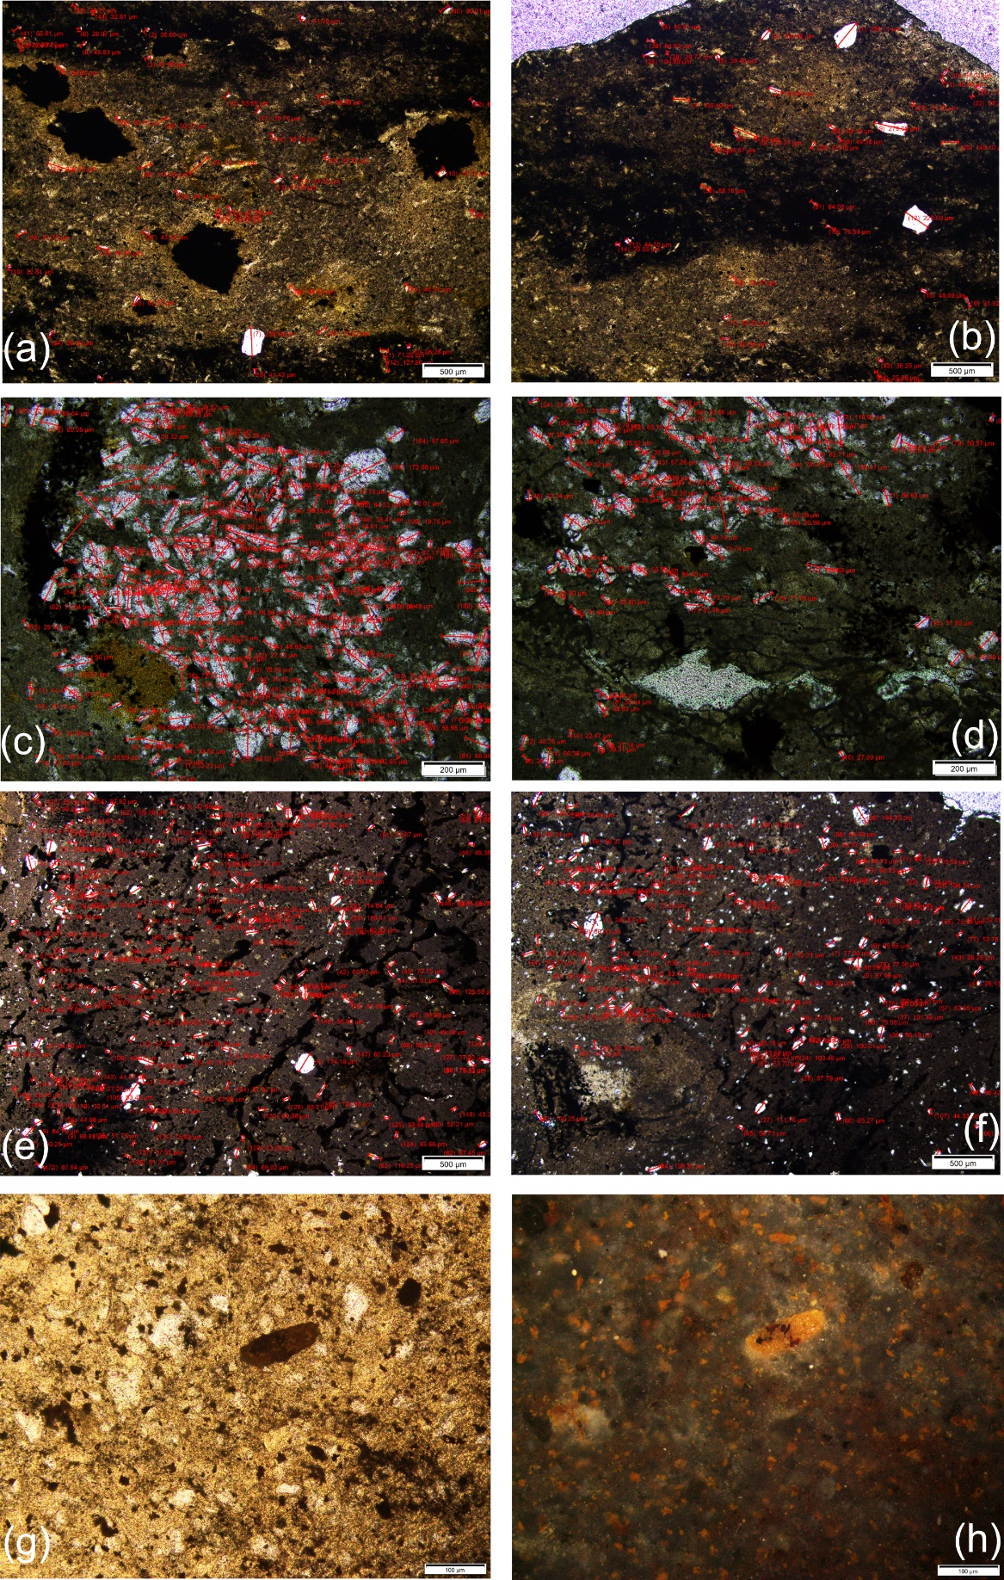
Supplementary Figure 1. Photomicrographs of Ernestites (taken under transmitted or reflected light) showing the distributions of detrital quartz (major) and ilmenite (minor), hematite grains. Quartz grain sizes (diameter) are shown in red. Kanmer Ernestite (plane polarized view) contain detrital ilmenite (sand size ) and quartz (sand to silt size)grains (a, b); Sub-angular to sub-rounded quartz grains (plane polarized view) in Dholavira (c, d); Detrital quartz grains in Bhagatrav are Subangular to subrounded and the opaque phases occur as irregular bands or veins (e, f; plane polarized view); Detrital hematite/titanohematite grains in Dholavira are scattered (g; plane polarized view) and appear reddish under reflected light (h; cross polarized view)

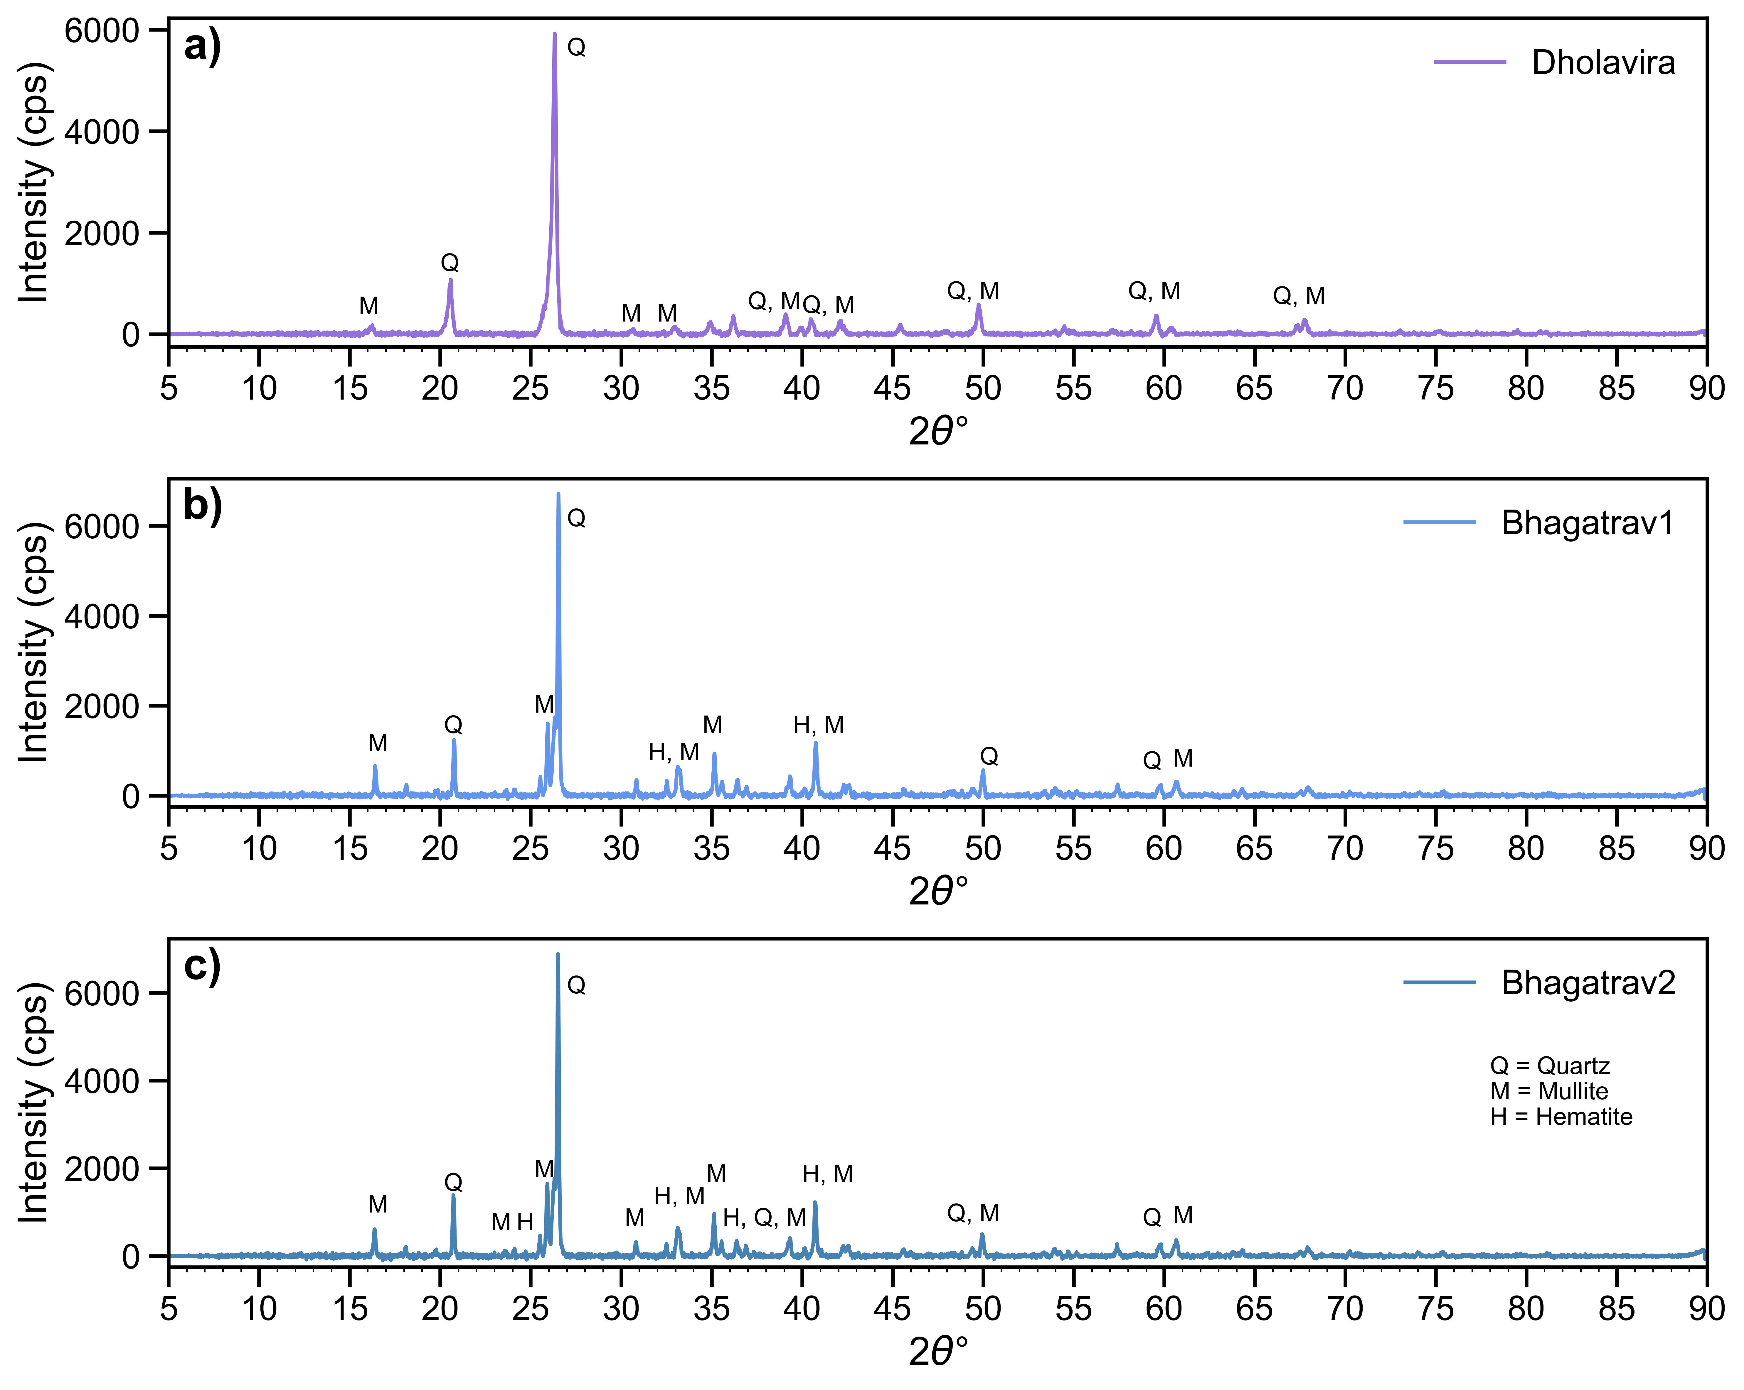Supplementary Figure 2. X-ray diffractograms for Ernestite samples from Dholavira and Bhagatrav. Bhagatrav-1 and Bhagatrav-2 represent two different samples from Bhagatrav. It may be noted that many peaks of mullite, sillimanite, and hematite overlap.

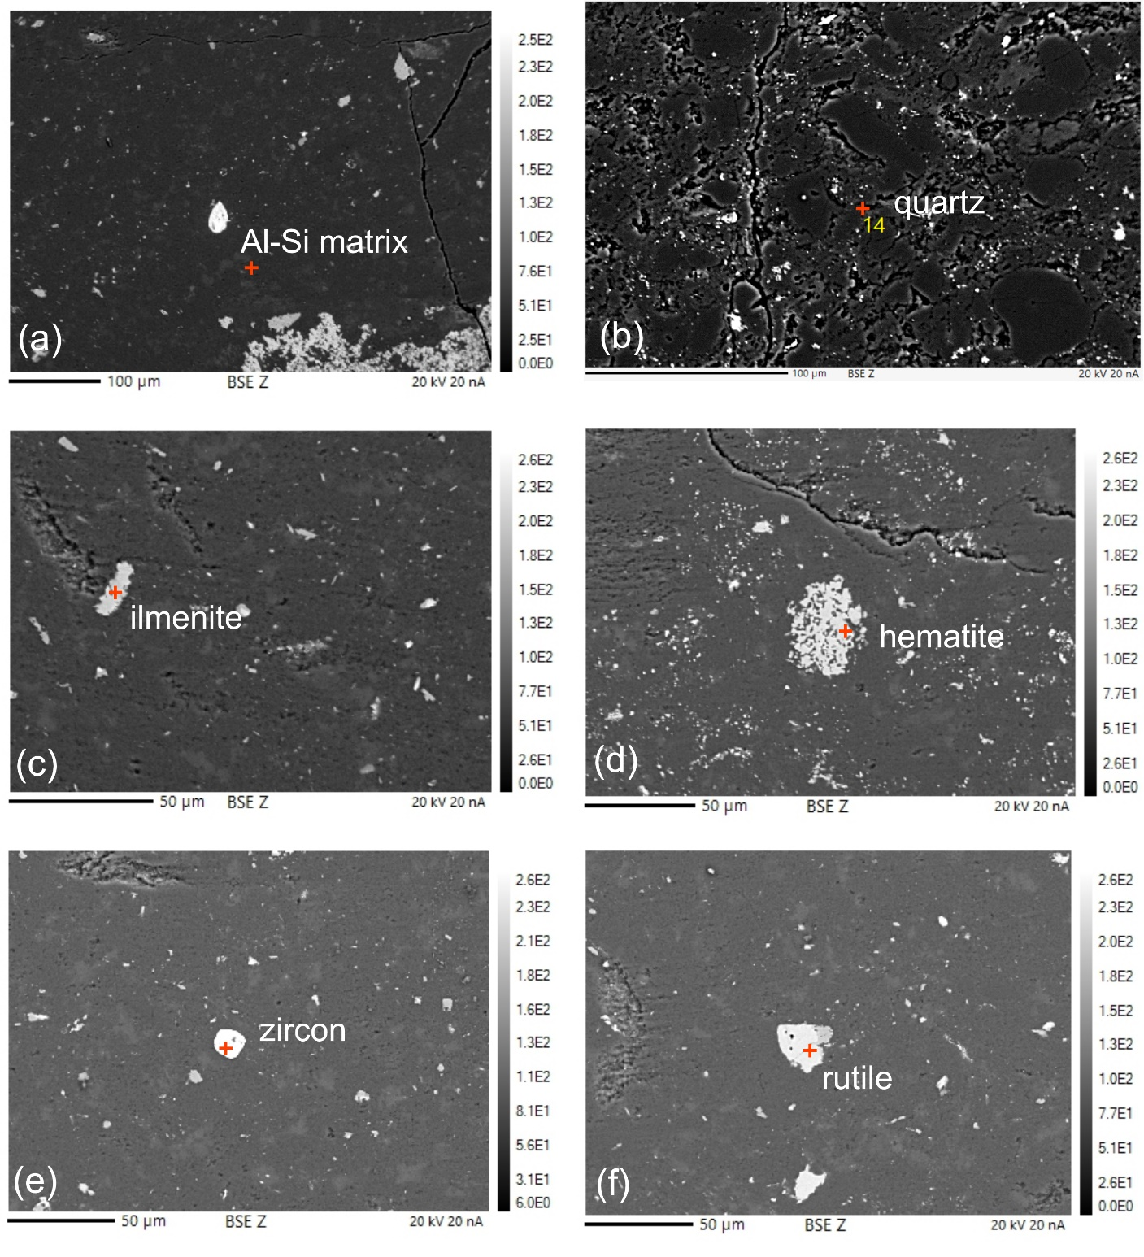
Supplementary Figure 3. Representative backscattered electron images (from EPMA) of various phases identified in the Kanmer Ernestite stone: (a) Aluminosilicate; (b) Quartz; (c) Ilmenite; (d) Hematite; (e) Zircon; (f) Rutile. The in-situ analysis spots are marked.

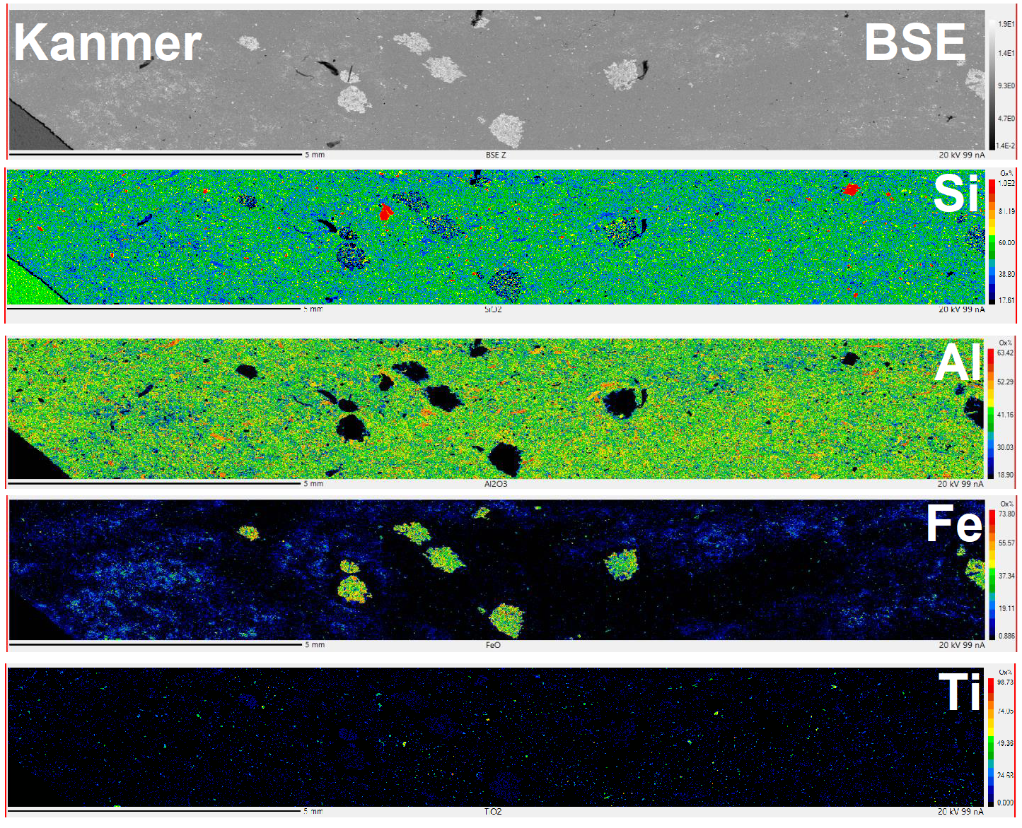

Supplementary Figure 4: Backscattered Electron (BSE) image and elemental (oxide) maps for the Kanmer Ernestite.

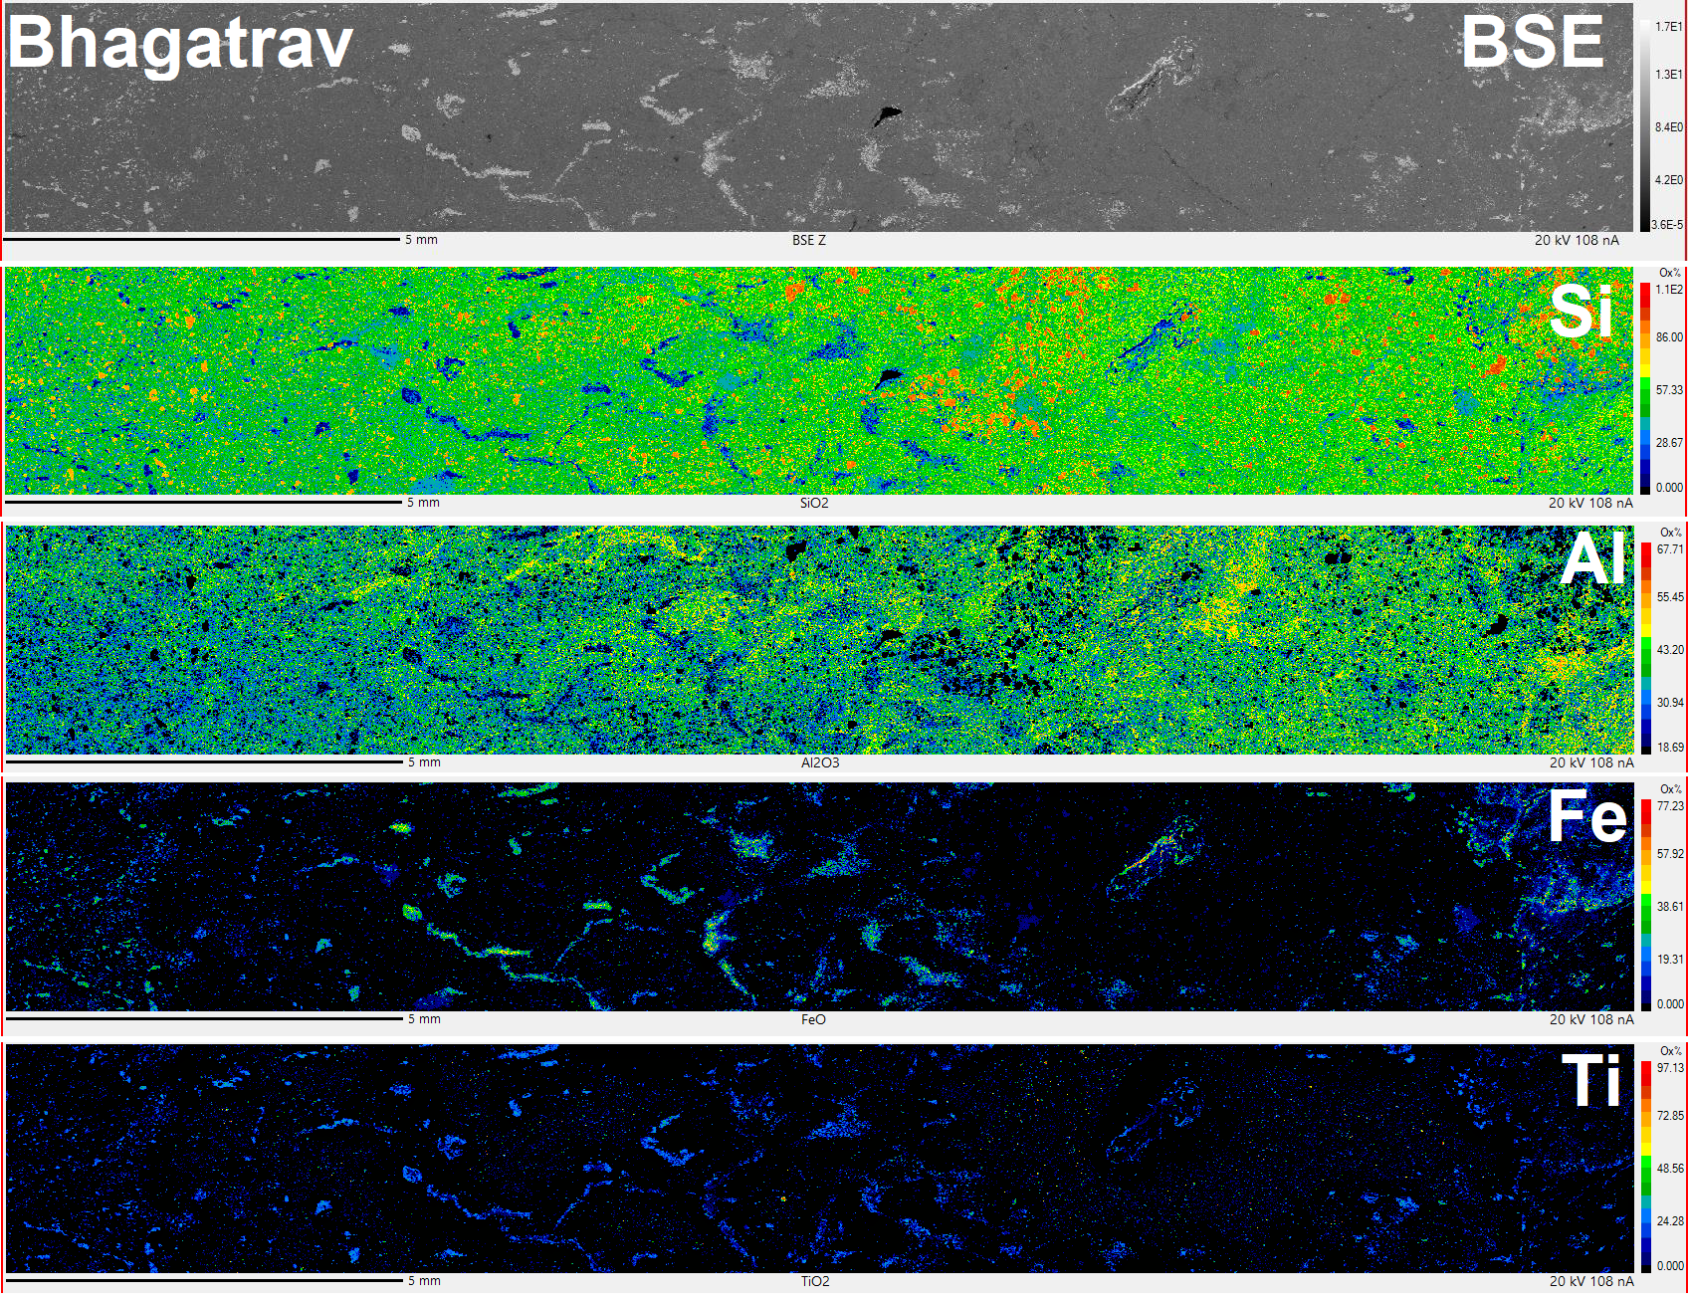

Supplementary Figure 5. Backscattered Electron (BSE) image and elemental (oxide) maps for the Bhagatrav Ernestite.

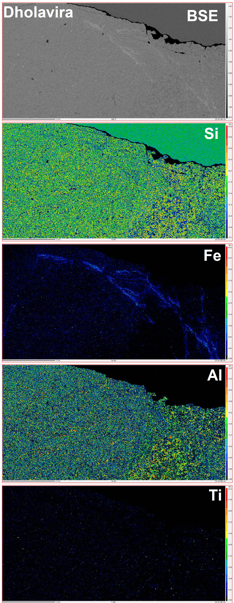
Supplementary Figure 6. Backscattered Electron (BSE) image and elemental (oxide) maps for the Dholavira Ernestite.

