Supplementary Information

Polyethylenimine-impregnated powdered activated carbon for efficient removal of Reactive Yellow 2 from aqueous solutions

Su Bin Kang^{1,*}, Byeong-Chan Min^{2, *}, Kwang-Il Go², Li Yong², Yeoung-Sang Yun¹, Sung Wook Won^{2,†}

¹ School of Chemical Engineering, Jeonbuk National University, 567 Baekje-daero, Jeonju, Jeonbuk, 54896, Republic of Korea
² Department of Marine Environmental Engineering, Gyeongsang National University, 2 Tongyeonghaean-ro, Tongyeong, Gyeongnam 53064, Republic of Korea

†Corresponding author. Tel.: +82 55 772 9136, Fax: +82 55 772 9139, E-mail address: sungukw@gnu.ac.kr (S.W. Won).
*S.B. Kang and B.-C. Min contributed equally to this work.

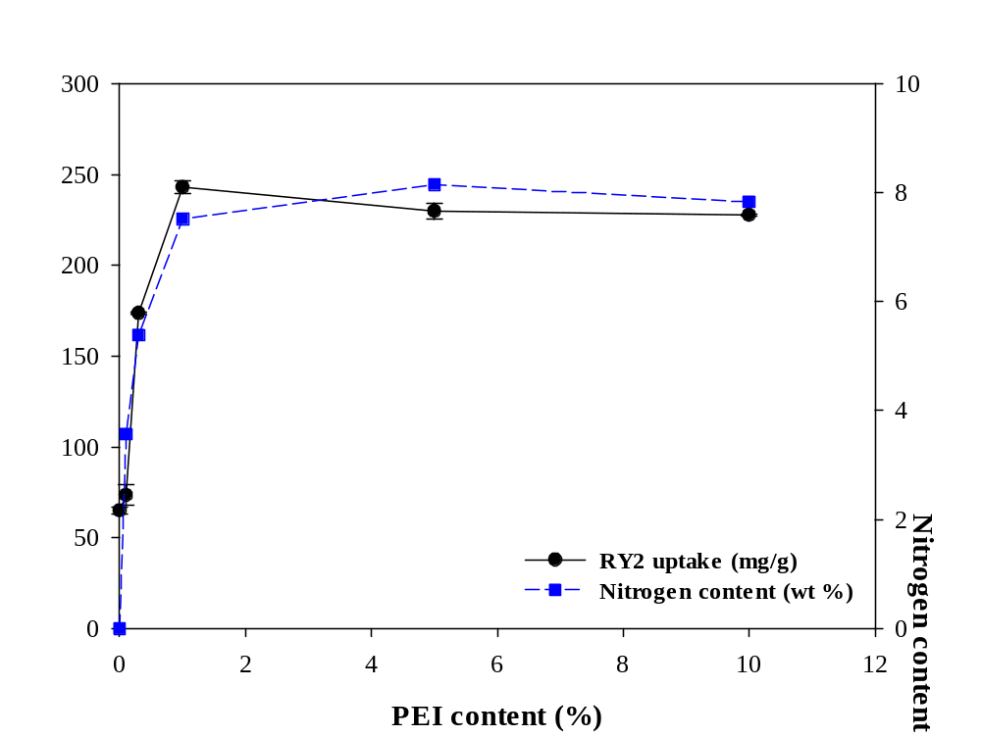
Fig. S1. Effect of PEI content on the RY2 uptake (mg/g) and nitrogen content (wt.%) of PEI/PAC-800 samples.

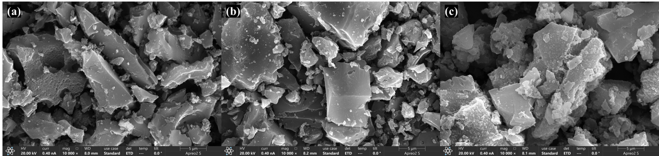
Fig. S2. SEM images (10,000× magnification) of (a) raw PAC, (b) 1% PEI/PAC-800, and (c) RY2-loaded 1% PEI/PAC-800 showing surface morphology.

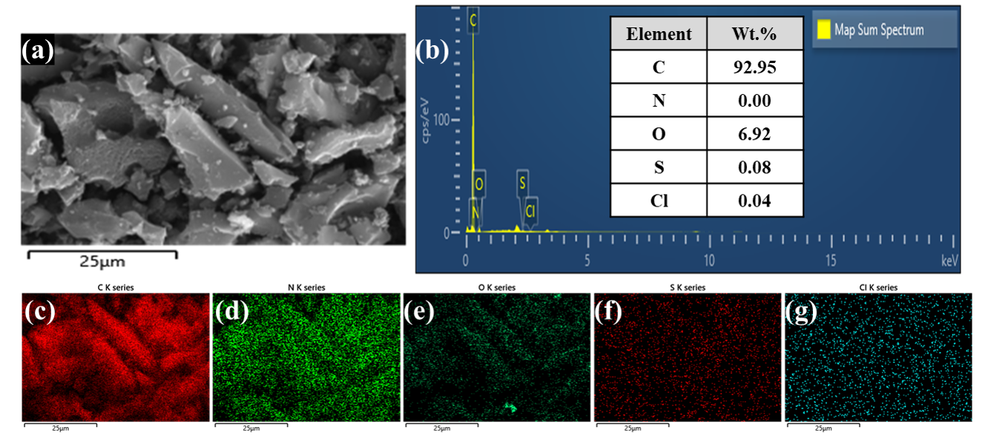
Fig. S3. SEM image and EDS analysis of raw PAC: (a) surface morphology; (b) EDS spectrum and elemental composition; (c–g) elemental mapping of C, N, O, S, and Cl.

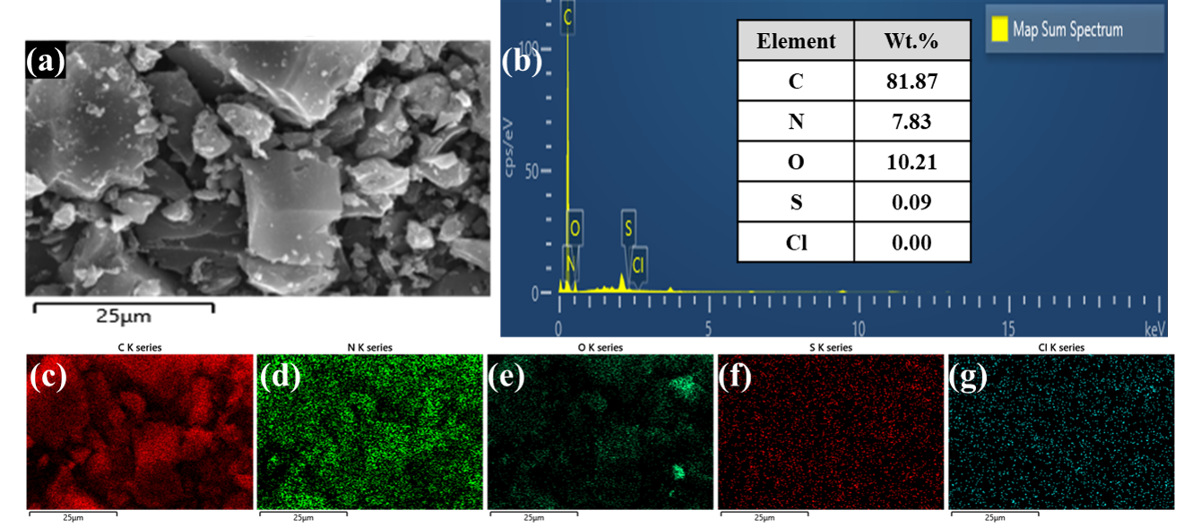
Fig. S4. SEM image and EDS analysis of 1% PEI/PAC-800: (a) surface morphology; (b) EDS spectrum and elemental composition; (c–g) elemental mapping of C, N, O, S, and Cl.

