Physics-Informed Displacement Control for Variable Pattern Printing with V-shaped PDMS Stamps in Roll-to-Roll Microcontact Printing

Jingyang Yan, Huarui Du, Xian Du*

The authors are with the Department of Mechanical and Industrial of Engineering, Institute for Applied Life Sciences, University of Massachusetts, Amherst, MA, 01003, USA.

Supplementary information

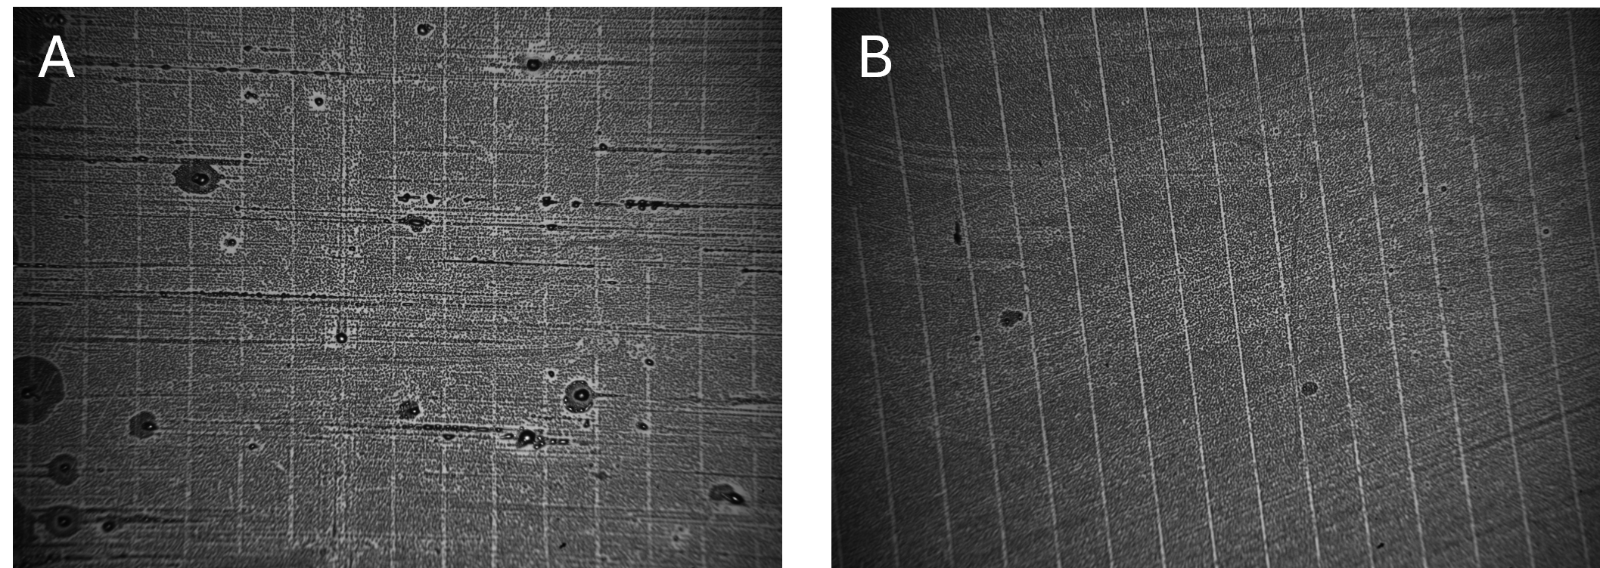
Fig. S1 | Condensation figures of printed patterns using different control strategies. A Patterns printed using force control. The resulting lines exhibit poor continuity and inconsistent quality. B Patterns printed using displacement control. The lines are continuous and well-defined, demonstrating improved printing quality.

S1 Neural Network Modelling
Many manufacturing processes are nonlinear which can be dealt with the nonlinear autoregressive exogenous model (NARX) as described by
$y\left(k\right)=f(y\left(k-1\right),…,y\left(k-n_{y}\right),u\left(k-1\right),…,u(k-n_{u})$, (1)
where k denotes the k^{th} sampling period, $f(∙)$ is an unknown nonlinear function, $u∈R^{m}$ denotes the control input series vector, $y∈R^{n}$ denotes the system output series vector, $n_{u}$ and $n_{y}$ are respectively the exogenously designated time delays of the input and output. The NARX model can be implemented by using a neural network (NN) architecture where feedback connections are enclosed between layers of the network. In this paper, we model the NARX network using a single hidden layer feedforward NN to approximate the function $f(∙)$ by
$y_{NN}\left(k\right)=w_{2}σ\left(w_{1}x\left(k\right)+b_{1}\right)+b_{2}$, (2)
where $y_{NN}\left(k\right)$ refers to the output of the NARX NN or prediction of the dynamic system for the k^{th} period, $w_{1}$ and $w_{2}$ are respectively the weight matrices for the hidden layer and the output layer, $b_{1}$ and $b_{2}$ are respectively the bias vectors for the hidden layer and the output layer, and $σ(∙)$ is the activation function for the hidden layer. The input feature vector is defined as $x\left(k\right)=[y\left(k-1\right),…,y\left(k-n_{y}\right),u\left(k-1\right),…,u(k-n_{u})]$. According to the universal approximation theorem, the NN model can be trained to accurately model the nonlinear mapping $f(∙)$, i.e., $\left\|y_{NN}\left(k\right)-y(k)\right\|<ϵ$ for any $ϵ>0$ where $ϵ$ is an arbitrarily small approximation bound. Therefore, the NN model can be trained by seeking the optimal solution to the following error function,
$J_{train}=\sum_{k}{{\left\|y_{NN}\left(k\right)-y(k)\right\|}^{2}.}$ (3)
This is accomplished by finding a set of weights and biases to minimize the error between the plant outputs and the predicted outputs of the NN.

S2 Neural-Network-Based Model Predictive Control
Model predictive control (MPC) calculates control commands by minimizing a cost function over a finite prediction horizon. The cost function is typically formulated by minimizing not only the squared error between the reference signal and the plant’s output but also the weighted squared change of the control input. Given the NN architectures (refer to Eqs. (2-3)) for the plant dynamics model, the MPC cost function can be formulated by
$J_{MPC}=\sum_{j=1}^{P}{{\left\|y_{r}\left(k+j\right)-y_{NN}(k+j)\right\|}^{2}}+\sum_{j=1}^{M}{λ\left(j\right){\left\|Δu(k+j)\right\|}^{2},}$ (4)
where $P$ is the prediction horizon, $M$ is the control horizon, $y_{r}$ is the reference signal, $y_{NN}(k+j)$ is the predicted output of the system at the $(k+j$)^{th} period based on the available measurements at the k^{th} sampling period, $λ(j)$ is the regulating factor for the control input that maintains the smoothness of the control signal and is typically chosen to be constant or exponential, and $∆u(k+j)=u\left(k+j\right)-u(k+j-1)$ denotes the change in $u.$
In the cost function (4), three parameters are required to be tuned, namely $P$, $M$, and $λ(j)$. The selection of control horizon $P$ and prediction horizon $M$ are correlated with both control performance and time consumption. For optimal performance, the prediction horizon $P$ should be sufficiently large compared with the settling time of the plant to achieve stability. The weighting factors $λ\left(j\right)$ are used to control the balance between the two summations and acts as a damper to the control input. Smaller $λ(j)$ would result in more aggressive control moves. For simplicity, we chose $λ(j)$ to be constant.
The objective of the MPC is to minimize the cost function $J_{MPC}$ in (4) with respect to $[u(k+1), u(k+2),…,u(k+M)]$, denoted by $U$. Since the plant model is a NN structure, a gradient descent method can be used to minimize the cost function iteratively. In each iteration, the intermediate values for $J_{MPC}$ can be denoted by $J_{MPC}(n)$. The control command sequence $U(n)$ can be updated by
$U\left(n+1\right)=U\left(n\right)+ΔU(n)$, (5)
$ΔU\left(n\right)=η(-\frac{∂J_{MPC}(n)}{∂U(n)})$, (6)
where $η>0$ is the update rate for a control command sequence. Since the two summation terms in the cost function are both functions of $U$ modeled by the NN, it is feasible to calculate the Jacobian matrix ($∂J_{MPC}/∂U$) through the backpropagation algorithm, which is the key process of the MPC. After $U$ is optimized through the iterative process, only the first element of $U$ is used as the input to the system.
Table S1 | Computation time (ms) for the proposed method where $M$ and $P$ vary between 1-10 and 1-20, respectively.
P  M | 1 | 2 | 3 | 4 | 5 | 6 | 7 | 8 | 9 | 10 | 11 | 12 | 13 | 14 | 15 | 16 | 17 | 18 | 19 | 20
1 | 0.56 | 1.07 | 1.59 | 2.1 | 2.62 | 3.13 | 3.65 | 4.17 | 4.7 | 5.2 | 5.71 | 6.23 | 6.75 | 7.26 | 7.78 | 8.3 | 8.8 | 9.3 | 9.84 | 10.35
2 |  | 1.3 | 1.9 | 2.47 | 3.05 | 3.63 | 4.22 | 4.8 | 5.4 | 6 | 6.55 | 7.14 | 7.72 | 8.32 | 8.9 | 9.48 | 10.05 | 10.65 | 11.23 | 11.8
3 |  |  | 2 | 2.61 | 3.22 | 3.83 | 4.44 | 5.05 | 5.68 | 6.28 | 6.9 | 7.5 | 8.1 | 8.72 | 9.34 | 9.93 | 10.55 | 11.2 | 11.81 | 12.4
4 |  |  |  | 2.74 | 3.4 | 4.02 | 4.65 | 5.31 | 5.94 | 6.58 | 7.21 | 7.85 | 8.48 | 9.12 | 9.8 | 10.39 | 11.04 | 11.7 | 12.32 | 12.93
5 |  |  |  |  | 3.53 | 4.2 | 4.88 | 5.55 | 6.2 | 6.86 | 7.55 | 8.21 | 8.86 | 9.54 | 10.2 | 10.85 | 11.51 | 12.18 | 12.84 | 13.53
6 |  |  |  |  |  | 4.38 | 5.05 | 5.75 | 6.45 | 7.15 | 7.85 | 8.52 | 9.22 | 9.93 | 10.63 | 11.29 | 12 | 12.69 | 13.4 | 14.1
7 |  |  |  |  |  |  | 5.25 | 6 | 6.7 | 7.41 | 8.13 | 8.85 | 9.6 | 10.29 | 11.03 | 11.72 | 12.5 | 13.2 | 13.9 | 14.65
8 |  |  |  |  |  |  |  | 6.18 | 6.93 | 7.68 | 8.44 | 9.2 | 9.92 | 10.68 | 11.45 | 12.19 | 12.93 | 13.7 | 14.43 | 15.2
9 |  |  |  |  |  |  |  |  | 7.18 | 7.95 | 8.73 | 9.49 | 10.28 | 11.04 | 11.84 | 12.61 | 13.43 | 14.2 | 15.03 | 15.75
10 |  |  |  |  |  |  |  |  |  | 8.22 | 9.04 | 9.83 | 10.65 | 11.44 | 12.25 | 13.1 | 13.9 | 14.7 | 15.53 | 16.3

Table S2 | Prediction RMSE (µm) for the proposed method where $M$ and $P$ vary between 1-10 and 1-20, respectively.
P  M | 1 | 2 | 3 | 4 | 5 | 6 | 7 | 8 | 9 | 10 | 11 | 12 | 13 | 14 | 15 | 16 | 17 | 18 | 19 | 20
1 | - | - | - | - | - | - | - | - | - | - | - | - | - | - | - | - | - | - | - | -
2 |  | 2.01 | 2.01 | 2.00 | 1.99 | 2.15 | 2.08 | 2.07 | 2.13 | 2.15 | 3.47 | 3.56 | 3.28 | 4.21 | 3.31 | 3.92 | 3.76 | 3.66 | 2.97 | 3.78
3 |  |  | 2.00 | 2.00 | 1.99 | 1.99 | 2.04 | 2.08 | 2.07 | 2.35 | 2.33 | 1.45 | 1.37 | 2.87 | 1.97 | 4.44 | 5.33 | 5.85 | 6.44 | 5.61
4 |  |  |  | 1.99 | 2.00 | 1.99 | 1.99 | 2.02 | 2.06 | 2.07 | 0.88 | 1.50 | 1.01 | 1.78 | 1.22 | 3.39 | 4.31 | 4.04 | 4.94 | 4.79
5 |  |  |  |  | 1.99 | 1.99 | 1.99 | 2.02 | 2.07 | 2.08 | 1.02 | 1.42 | 2.28 | 1.56 | 1.05 | 2.28 | 2.65 | 3.10 | 3.46 | 3.97
6 |  |  |  |  |  | 2.00 | 1.99 | 2.02 | 2.14 | 2.15 | 0.86 | 0.94 | 1.04 | 0.95 | 1.04 | 0.90 | 1.16 | 1.95 | 2.30 | 3.20
7 |  |  |  |  |  |  | 1.99 | 2.02 | 2.13 | 2.22 | 1.04 | 0.88 | 0.96 | 0.99 | 1.50 | 1.79 | 1.30 | 1.50 | 1.85 | 2.63
8 |  |  |  |  |  |  |  | 2.02 | 2.12 | 1.25 | 0.92 | 0.87 | 0.87 | 1.04 | 1.56 | 0.89 | 0.98 | 0.88 | 1.02 | 1.19
9 |  |  |  |  |  |  |  |  | 2.12 | 1.04 | 0.89 | 0.89 | 0.98 | 0.85 | 1.49 | 0.86 | 1.53 | 1.31 | 1.66 | 1.01
10 |  |  |  |  |  |  |  |  |  | 1.14 | 0.90 | 0.92 | 0.91 | 0.89 | 0.87 | 0.86 | 0.87 | 1.78 | 1.66 | 0.96

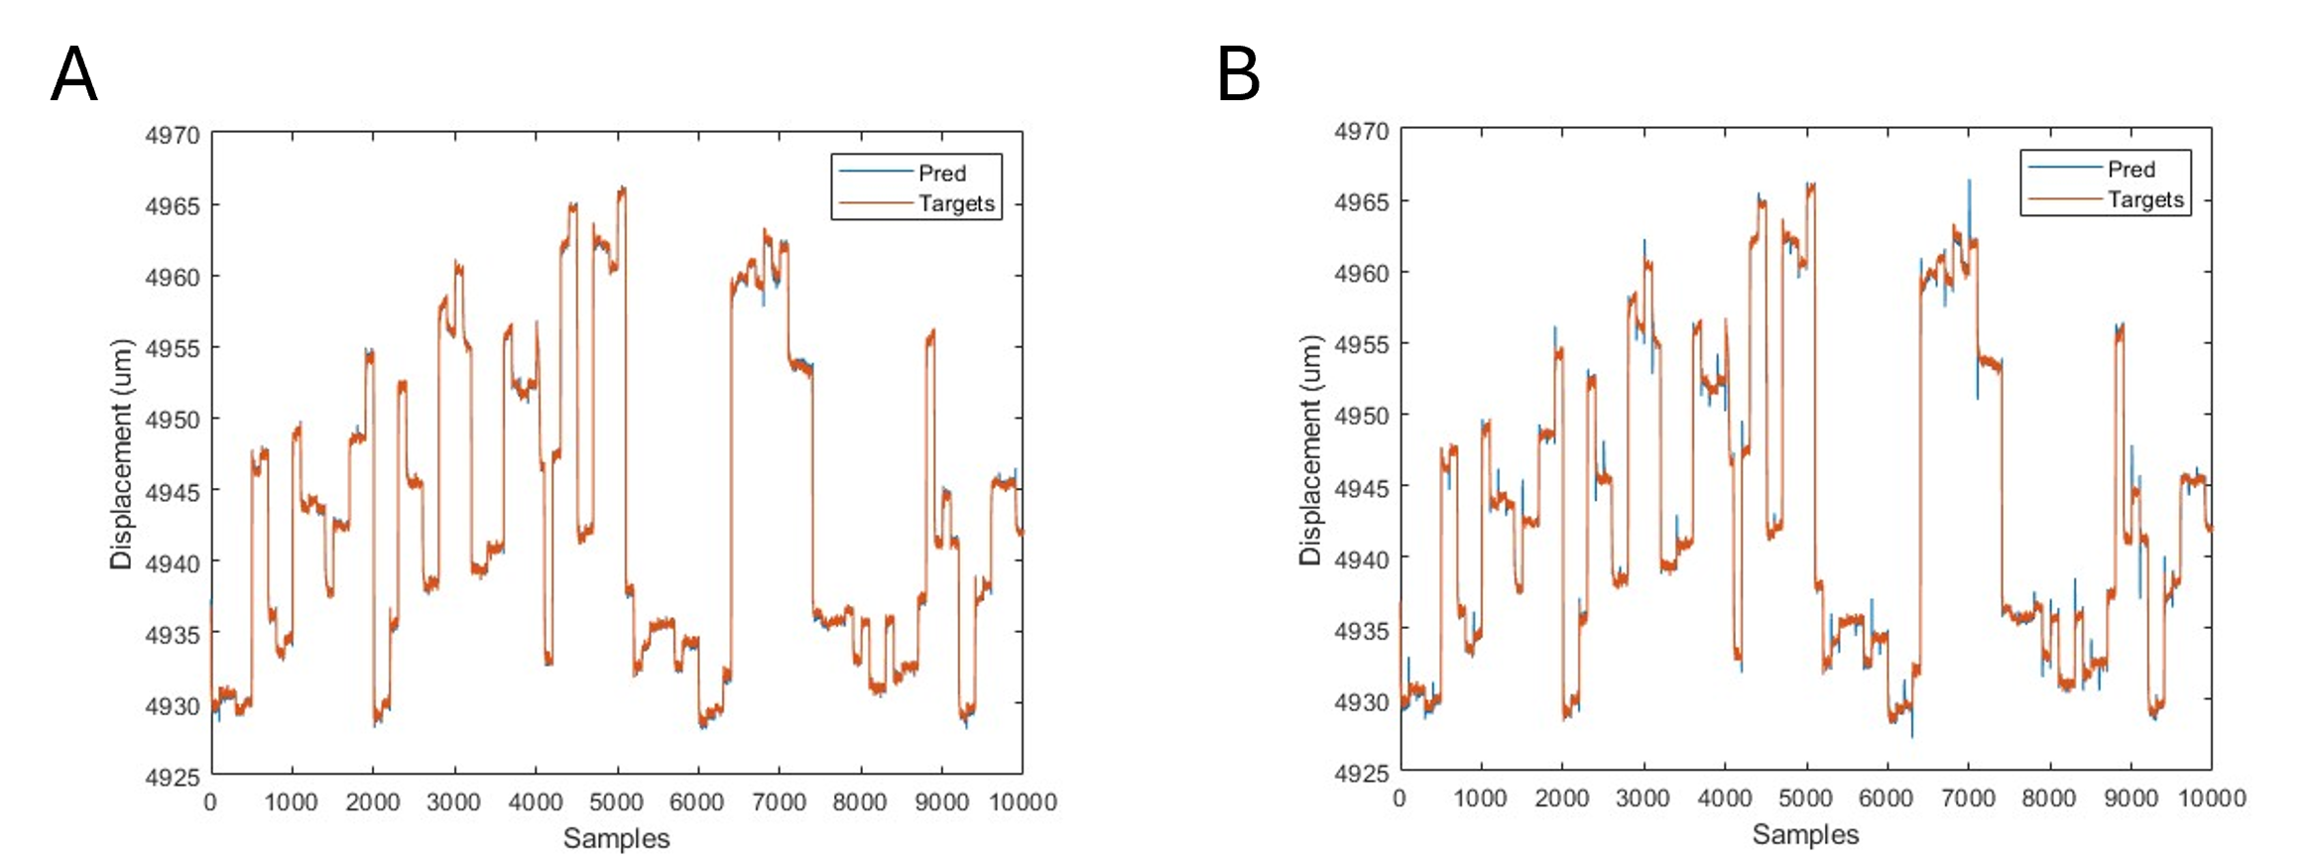
Fig. S3 | Training results of different neural network architectures. A Trained by feedforward neural networks with 7 hidden units, the RMSE error is 0.88 µm. B Trained by LSTM network with 8 hidden units with RMSE of 1.23 µm.
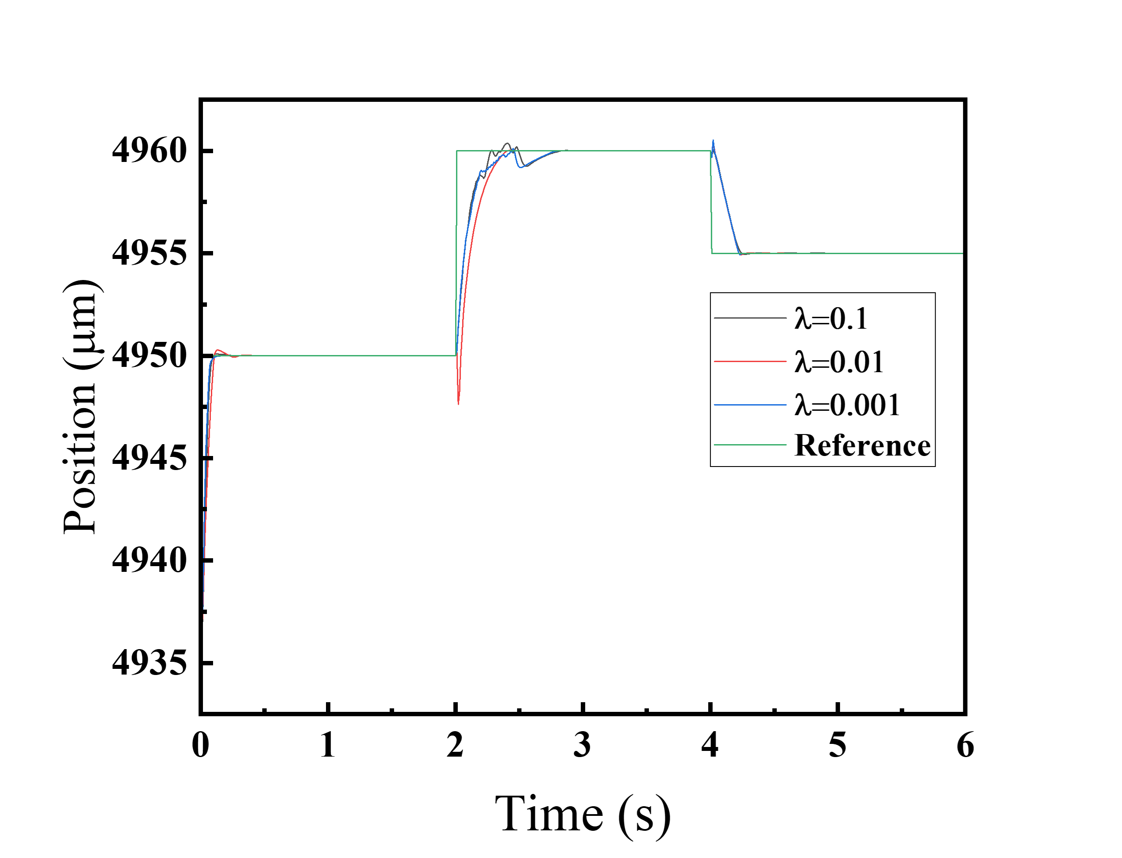
Fig. S2 | Effects of varying the weighting factor λ.

S3 Experimental setup of the R2R microcontact printing system
This system comprises three subsystems as shown in Fig. S4: the web handling system, the printing module, and the printing quality monitoring system. Each subsystem is described in detail in the following sections.
The web handling system comprises two idler rollers and two motorized rollers. A ring-type rotation encoder with a readhead (LM10, RLS) is mounted on the left idler roller to measure the linear speed of the moving web. This measured speed serves as the feedback signal for controlling the web's linear velocity. The right idler roller is a tension measurement roller (RMGZ9, FMS) used to monitor web tension, providing feedback to maintain consistent tension control. The motorized unwind roller utilizes feedback from the speed encoder to maintain a constant linear web speed, while the motorized rewind roller operates in torque mode, maintaining constant tension based on signals from the tension roller.
The printing module consists of one impression roller and one print roller. Before printing, a stamp is securely wrapped around the print roller. During the printing process, the inked stamp actuated by a positioning stage transfers patterns onto the flexible web substrate by compression. The positioning stage comprises two parallel plate flexures, each connected to the print roller shaft via air bushings. The two ends of the impression roller are clamped onto two load cells (MAGPOWR TS25FC, MAXCESS) for monitoring contact forces. The print roller is driven by two voice coil actuators (NCC08-34-350-2X, H2W TECHNOLOGIES) through the flexure mechanism, powered by linear current amplifiers (LCA-5/15, H2W TECHNOLOGIES). All sensors and amplifiers interface with a real-time controller (CompactRIO-9049, National Instruments) operating at a sampling rate of 10 ms.
The printing quality monitoring system consists of two sub-systems: a droplet size control unit and a high-resolution image acquisition system (IAS). The schematic diagram is shown in Fig. S5. The droplet size control unit is designed to generate CFs with precisely controlled droplet dimensions. It includes a boiler equipped with a heating element and temperature sensor for generating warm, saturated vapor. Dry nitrogen gas is humidified in the boiler and directed toward the substrate via a nozzle made of plastic tubing. The humidified nitrogen flow is regulated by a mass flow controller connected to the controller, maintaining droplet sizes around micrometer-scale for clear CF formation. The IAS captures CF images in real time and includes a high-speed CMOS area-scan camera(Aca4112, Basler), a motion stage, an illumination source, a coaxial in-line illuminator, and a 10× objective lens. The IAS is connected to the controller via USB and captures images at a resolution of 1000 × 1000 pixels. Due to limited GPU capabilities of the real- time controller, the captured images are transferred to a high-performance PC via USB for efficient processing.
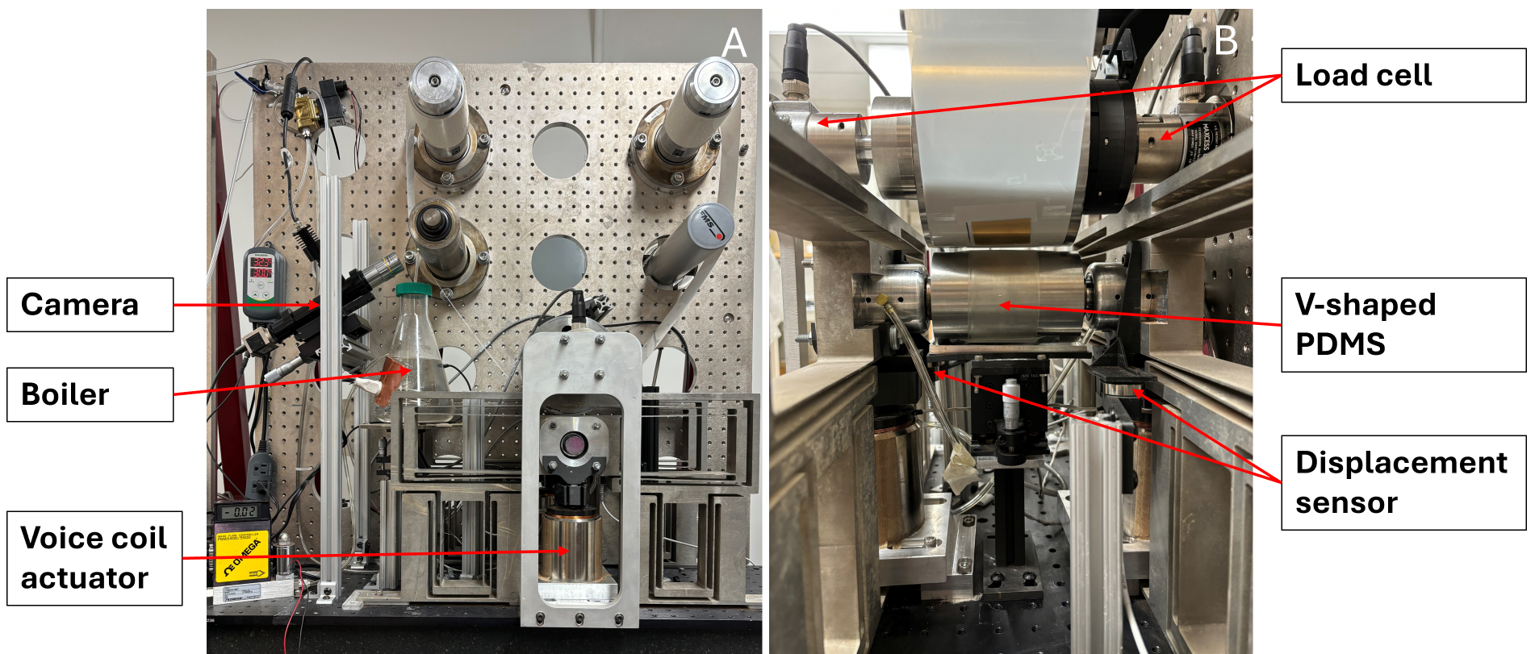
Fig. S4 | Experimental setup of the R2R microcontact printing system. A The front view of the R2R microcontact printing system. B The detailed view of the printing module. Two displacement sensors are installed to measure the displacement of the V-shaped PDMS. Two load cells are used to measure the applied load on the V-shaped PDMS.

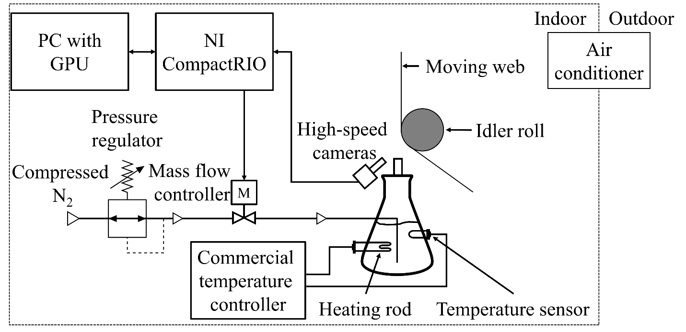
Fig. S5 | Schematic diagram of the in-situ printing quality monitoring system

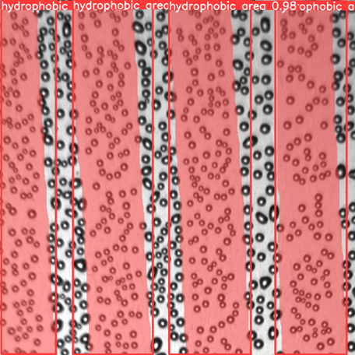
Fig. S6 | Example of segmented condensation figure. The segmentation algorithm identifies printed regions in the condensation figure based on droplet distribution. Droplets appear smaller and denser on the printed areas, which are highlighted with a red mask.

S4 Experimental setup of the single roller system
Accurate data collection from the entire R2R system can be both time-consuming and inefficient, often requiring extensive resources and complex setups. To address these challenges and streamline the process, we designed a single roller system as indicated in Fig. S7(b) that effectively emulates the R2R system in a more controlled and manageable environment. This emulation allows for precise manipulation and measurement of variables, facilitating a more thorough understanding of the system's mechanics. Our design employs several sophisticated components to ensure accurate and reliable data collection. In our setup, the FMS RMGZ 922 Force Measuring Roller measured the pressure while the PDMS print pattern was securely attached to the roller. A glass plate positioned beneath the print pattern and connected to a moving arm created friction with the pattern, emulating the continuous motion of the R2R system. To ensure that the force applied during the printing process is evenly distributed, we incorporate a rail system that supports the glass plate. This rail system maintains the stability and alignment of the glass plate, preventing any unwanted deviations that could affect the accuracy of the data collected. Additionally, a high-resolution camera is strategically positioned underneath the glass plate to capture detailed images of the print pattern as shown in Fig. S6. These images are crucial for analyzing the contact area and understanding how it changes under various forces.
In Fig. S7(a), the schematic represents the interaction between the roller and the V-shaped PDMS layer as the glass plate is moved by a mechanical arm. As the glass plate moves, various sections of the V-shaped PDMS begin to deform, and this deformation can be observed through the change in contact area. A camera placed beneath the glass plate captures these changes in real-time, allowing us to study how the PDMS behaves under different forces. The roller applies pressure while moving, and by adjusting the force applied, we can record variations in the contact area of the PDMS. This setup is essential for analyzing the material properties of PDMS and how it responds to mechanical forces in a controlled environment, providing valuable data for further investigation into its deformation characteristics. Figure S8 illustrates the deformation pattern of the PDMS surface under mechanical contact as viewed from below the glass plate. The distinct contact areas appear as smoother bands across the surface, representing regions where the roller applies sufficient pressure to bring the PDMS into full contact with the glass substrate. These smooth regions highlight the areas of effective material deformation and pressure transfer. In contrast, rougher regions, where the surface texture of the PDMS remains visible, indicate zones with minimal or no contact between the PDMS and the glass plate.
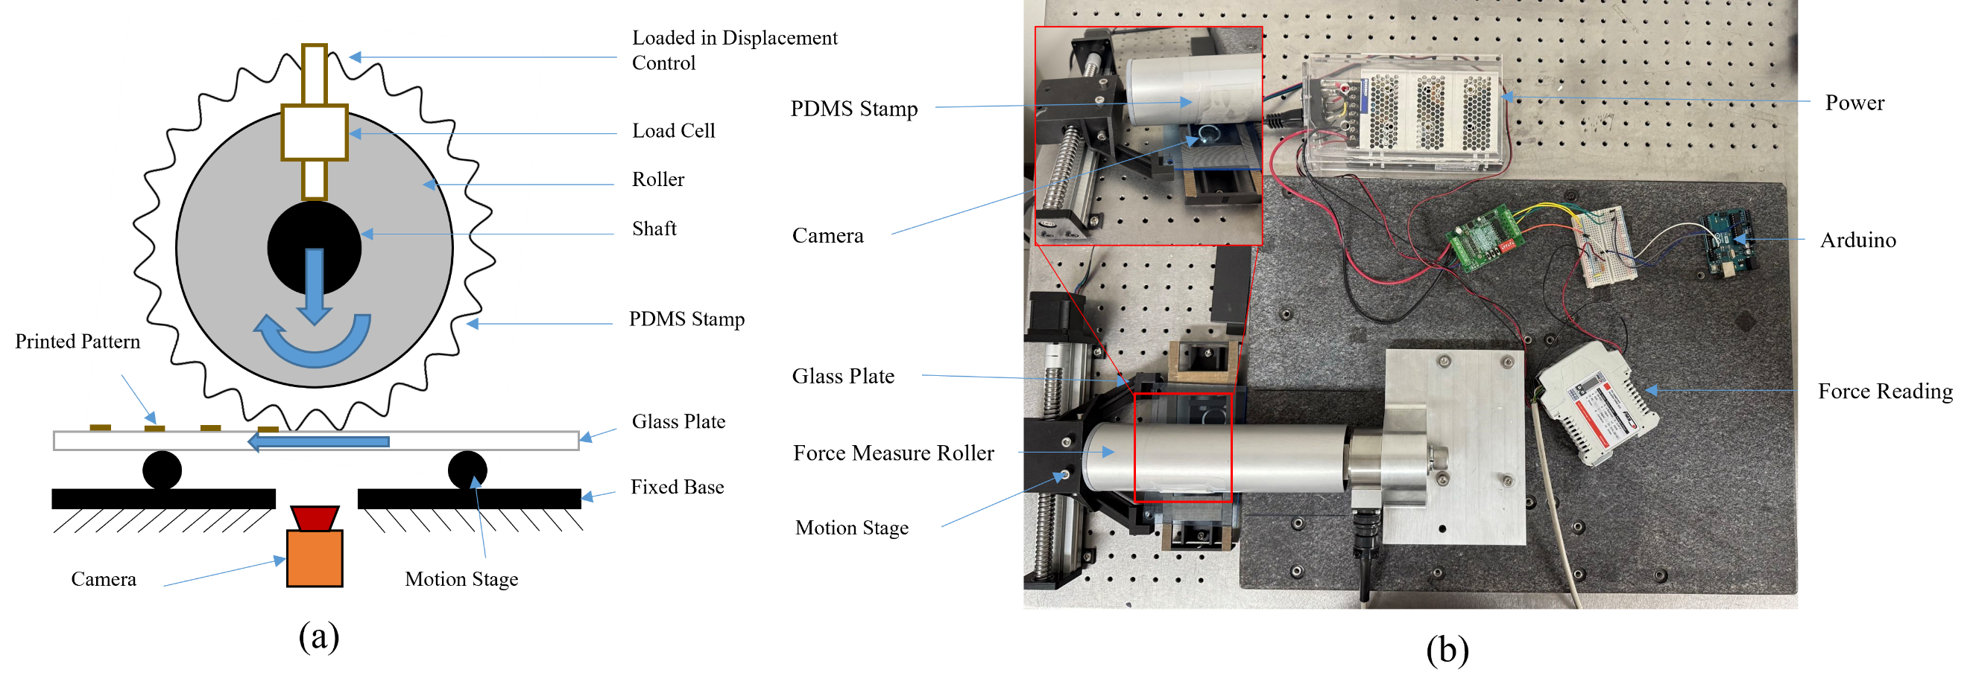
Fig. S7 | Experimental setup of the single roller system. (a) Schematic of the experimental setup (b) Real experimental setup

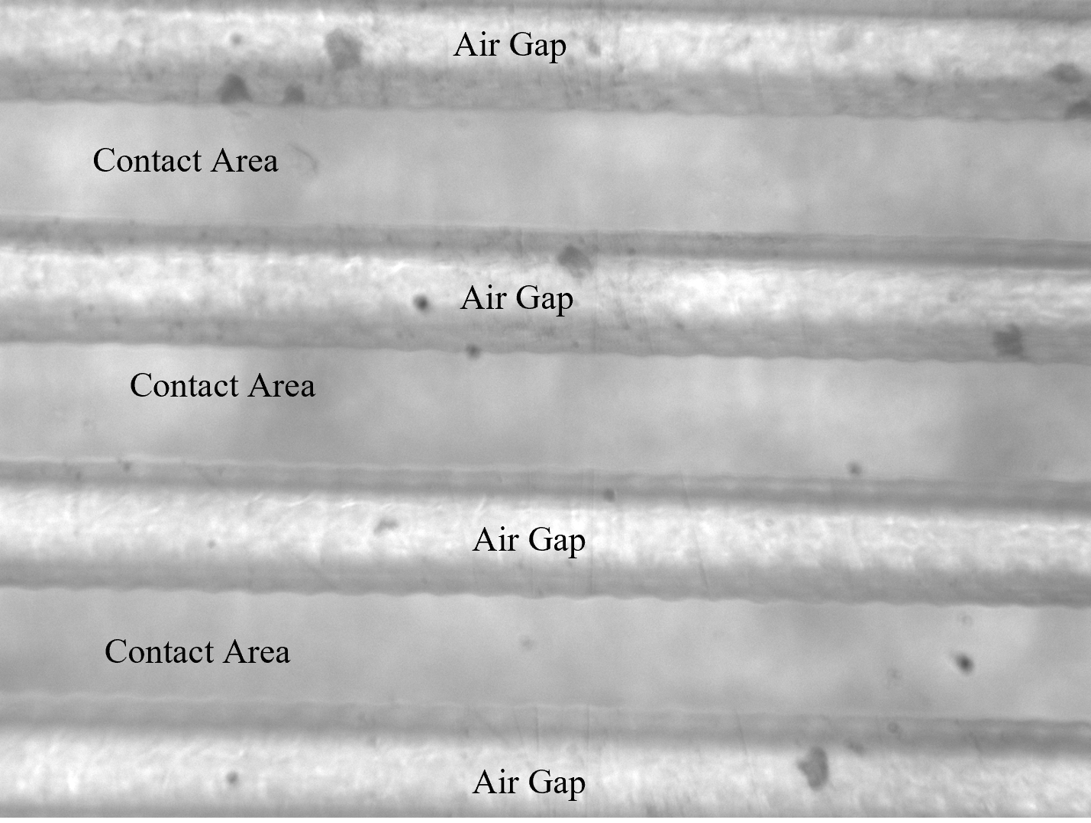
Fig. S8 | Observed deformation of V-shaped PDMS.

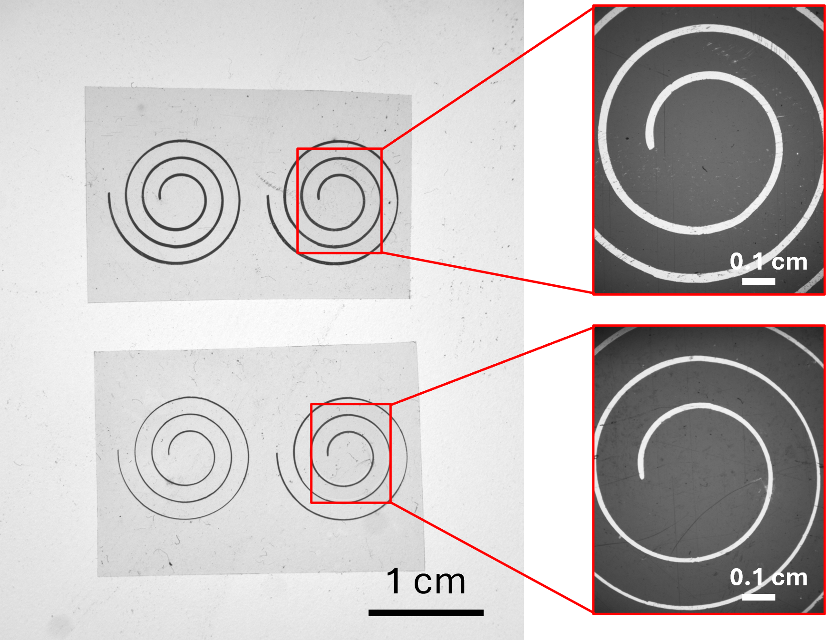
Fig. S9 | Printed spiral antenna.

