Feasibility study and direct extraction of endogenous free metallic cations by medical device combining hemodialysis and colloidal chelating polymer.
Marco Natuzzi,^{1,2} Coralie Grange,^{1,2} Thomas Gréa,^{2,5} Thomas Brichart,¹ Axel Aigle,¹ Denise Bechet,¹ Benoit Hautefeuille,² Eloise Thomas,³ Jean-Yves Ayoub,⁴ Jeanne-Marie Bonnet,⁴ Vanessa Louzier,⁴ Bernard Allaouchiche,⁴ Aymeric Couturier,⁵ Alexandra Montembault,⁶ Paula Nunes de Oliveira,⁶ Laurent David,⁶ François Lux*,^{1,2,7} Olivier Tillement.^{1,2}
¹ MexBrain - 305 rue des fours 69270 Fontaines-Saint-Martin.
² Institut Lumière-Matière, UMR 5306, Université Lyon1-CNRS, Université de Lyon, Villeurbanne Cedex, France; Institut Universitaire de France, Paris, France.
³ LAGEPP, CNRS UMR 5007, Univ Claude Bernard Lyon 1, Université de Lyon, 69622 Villeurbanne, France.
⁴ APCSe Agressions Pulmonaires et Circulatoires dans le Sepsis, Université de Lyon, VetAgro Sup - Campus Vétérinaire de Lyon, 1 Avenue Bourgelat, 69280, Marcy-l'Étoile, France.
⁵ Service de Néphrologie et Dialyse, Assistance Publique-Hôpitaux de Paris (APHP), Hôpital Universitaire Ambroise Paré, Boulogne Billancourt, France.
⁶ IMP, CNRS UMR 5223, Univ Claude Bernard Lyon 1, Univ Lyon, 15 bd Latarjet, 69622 Villeurbanne, France.
⁷ Institut Universitaire de France (IUF), 75231 Paris, France.
* Correspondence and requests for materials should be addressed to Dr François Lux (email: francois.lux@univ-lyon1.fr)

Characterization of Chitosan@DOTAGA.

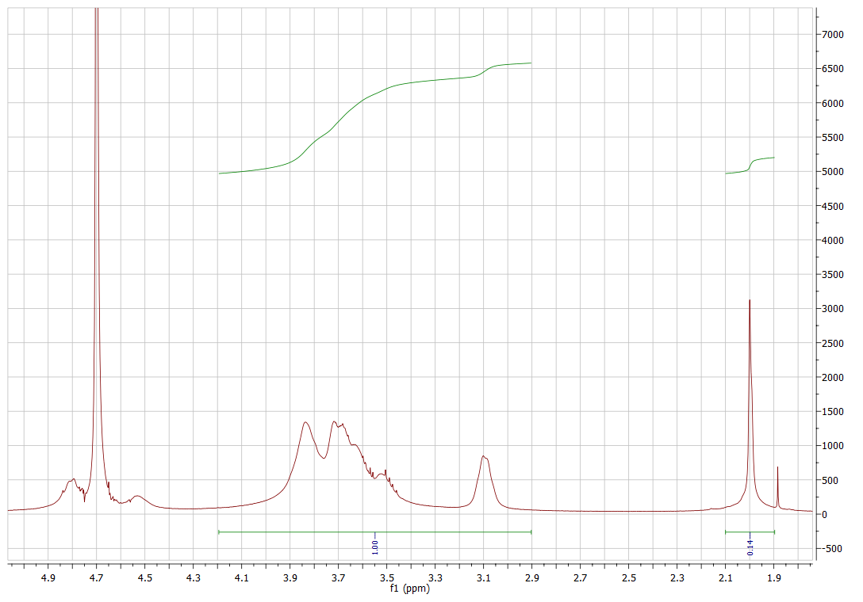
Figure S1. RMN spectrum of acetylated chitosan in D₂O.

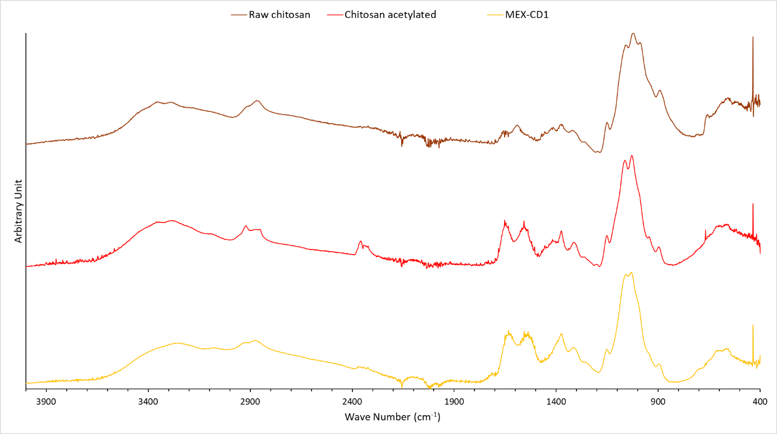Figure S2. IR spectrum of chitosan, acetylated chitosan and Chitosan@DOTAGA

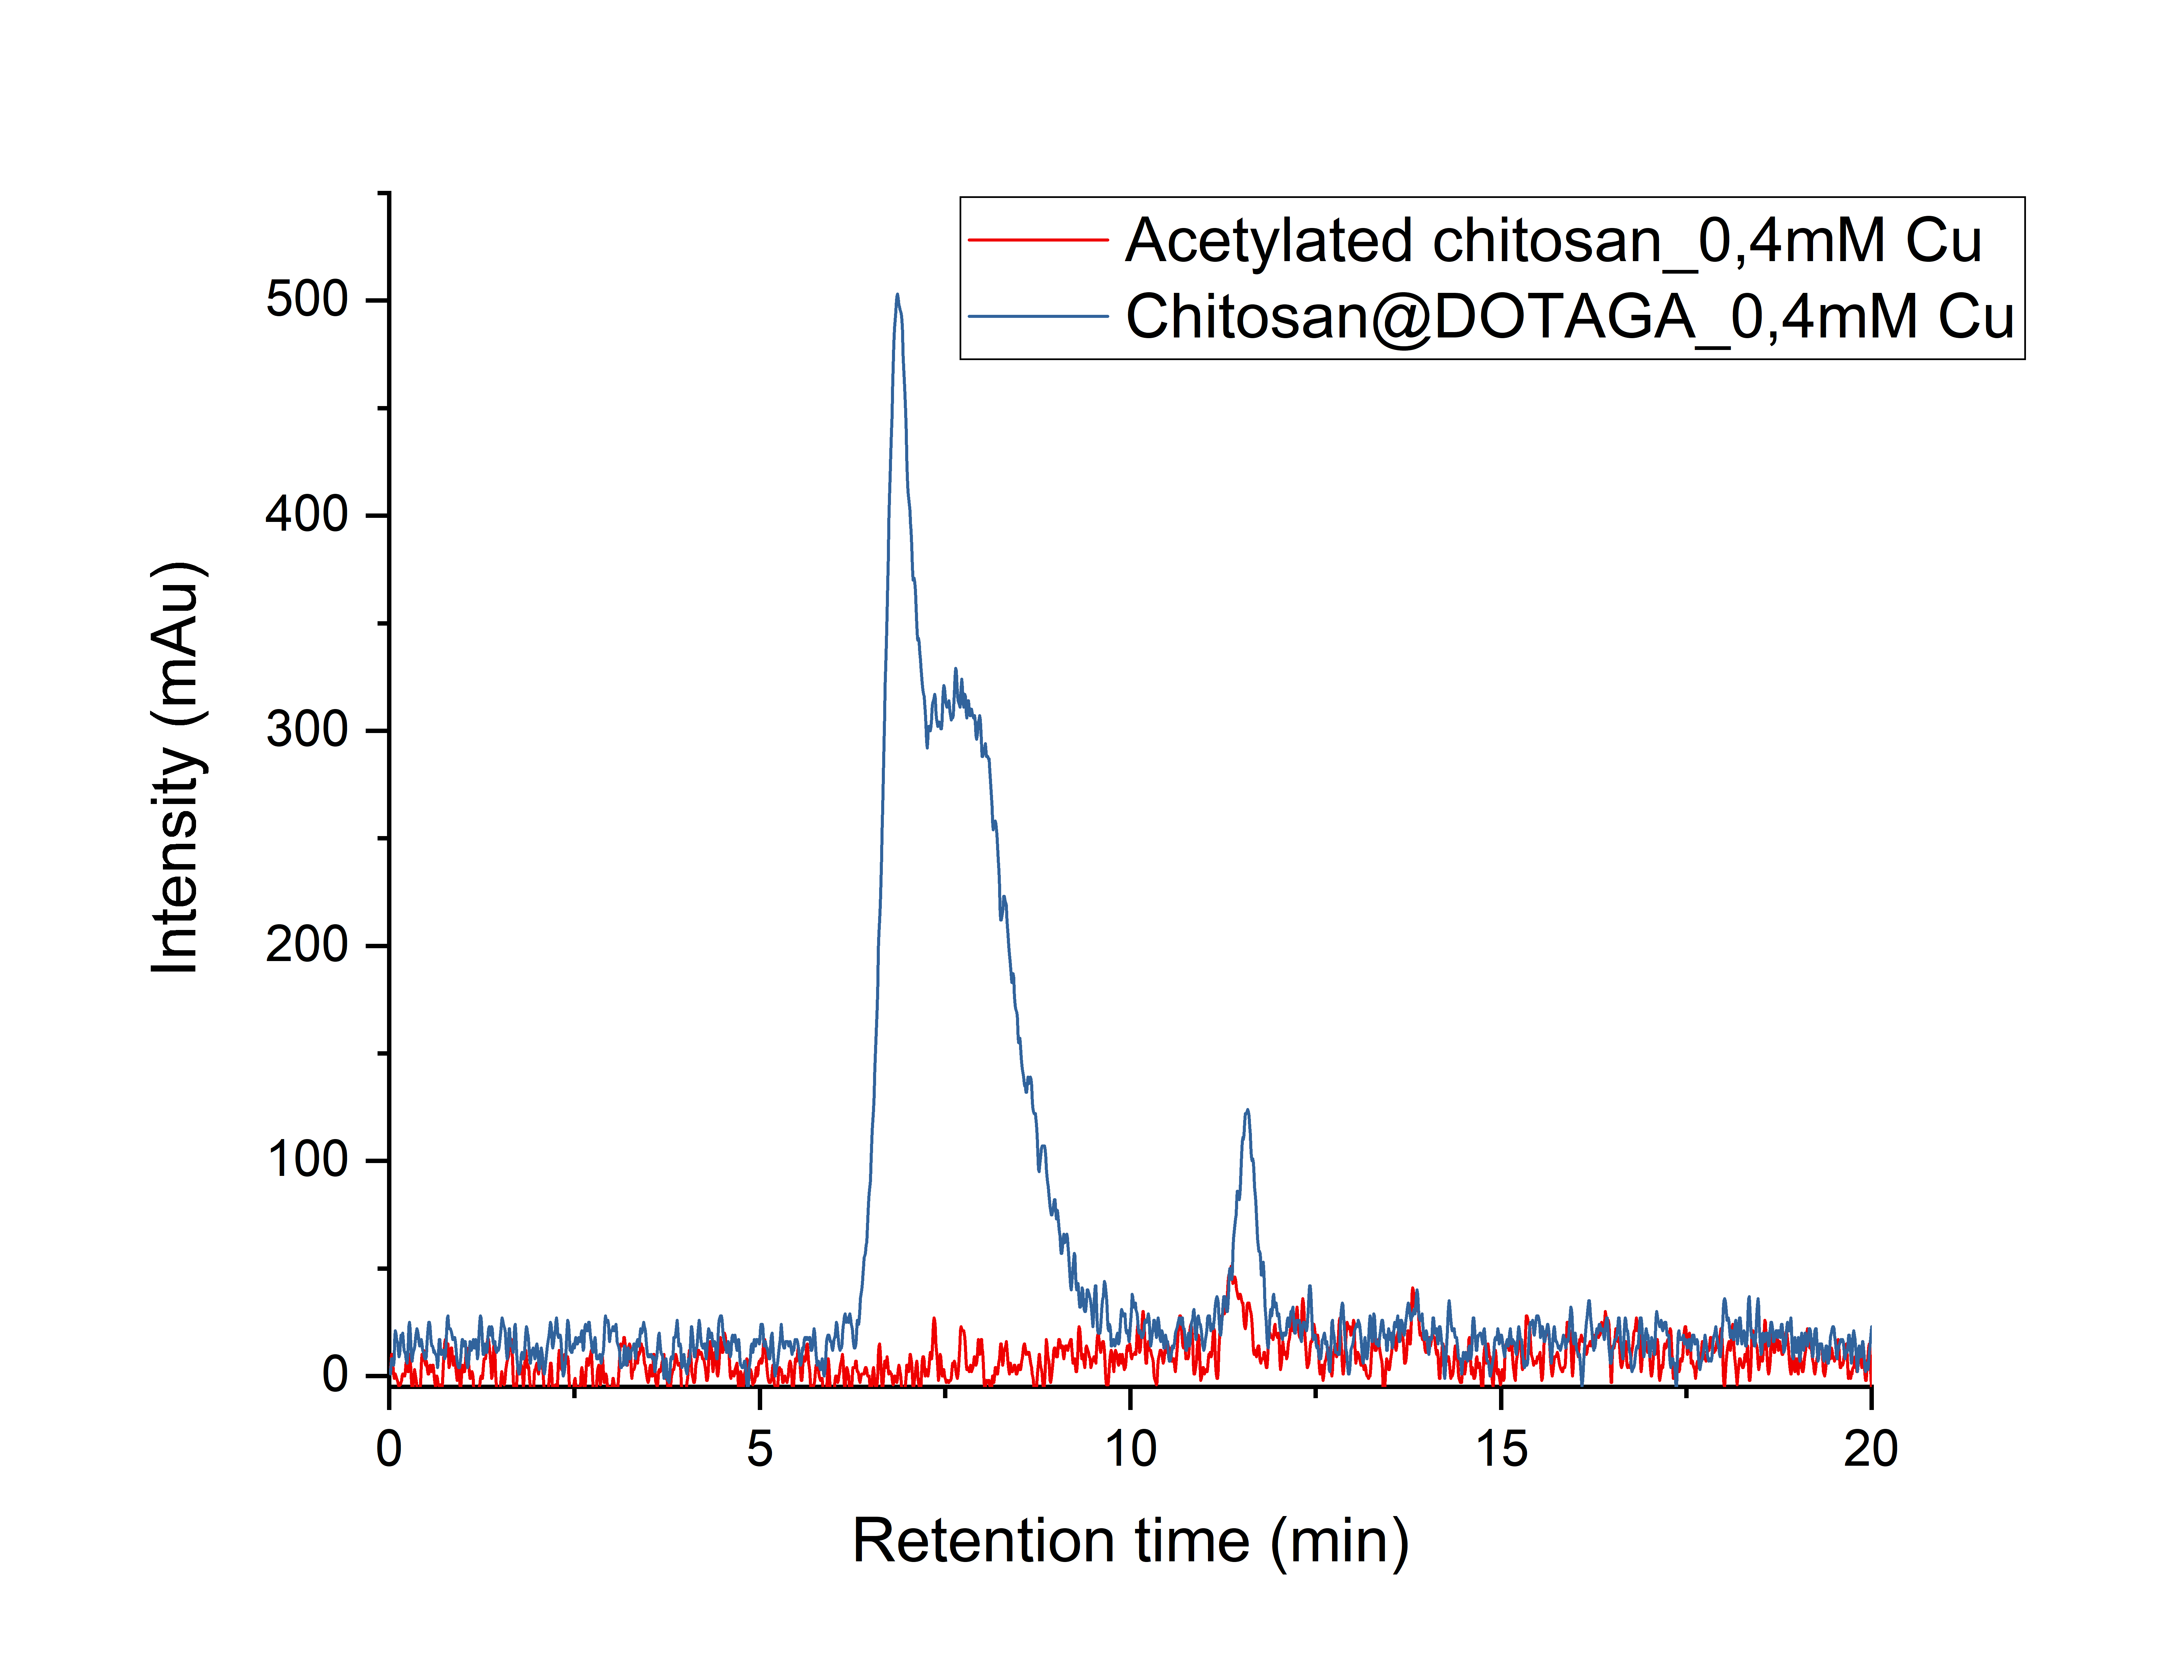Figure S3. HPLC-UV of chitosan and Chitosan@DOTAGA at 1g/L after addition of Cu 0,4mM. λ_{Abs}=295nm
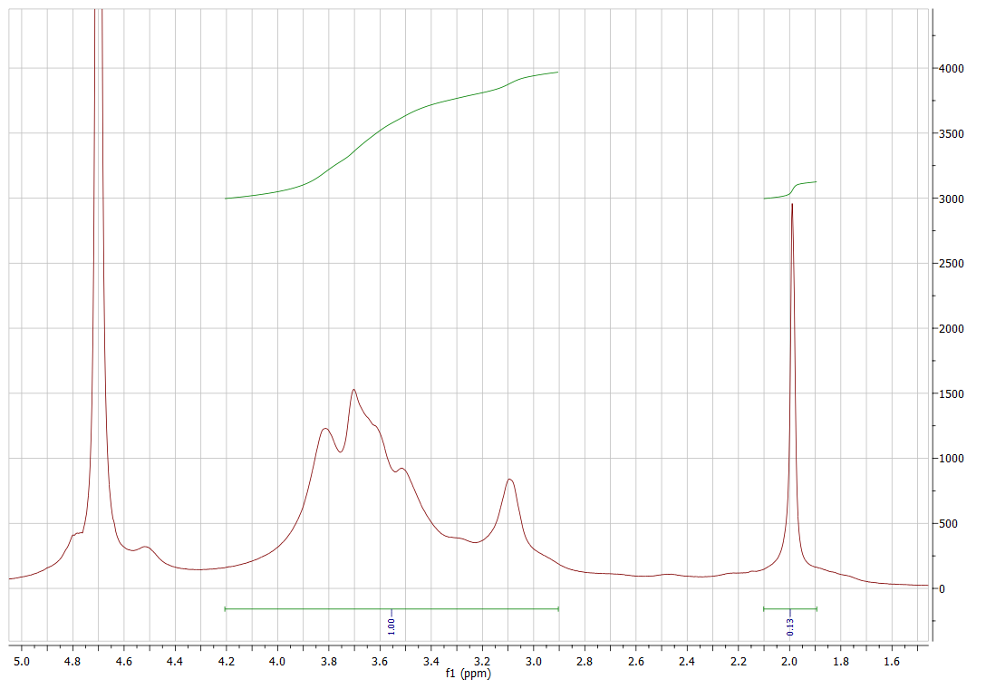Figure S4. RMN spectrum of Chitosan@DOTAGA in D₂O.

In vivo proof of concept on healthy sheep.

Scanning Electron Microscopy (SEM) was performed with a FEI Quanta 250 FEG instrument. Membranes were deposited on conductive adhesive tabs fixed on flat steel holders before or after dialysis of blood by hemosol or hemosol combined to Chitosan@DOTAGA. Then, samples were coated under vacuum by cathodic sputtering with copper (10 nm) and observed by SEM under an accelerating voltage of 5 kV

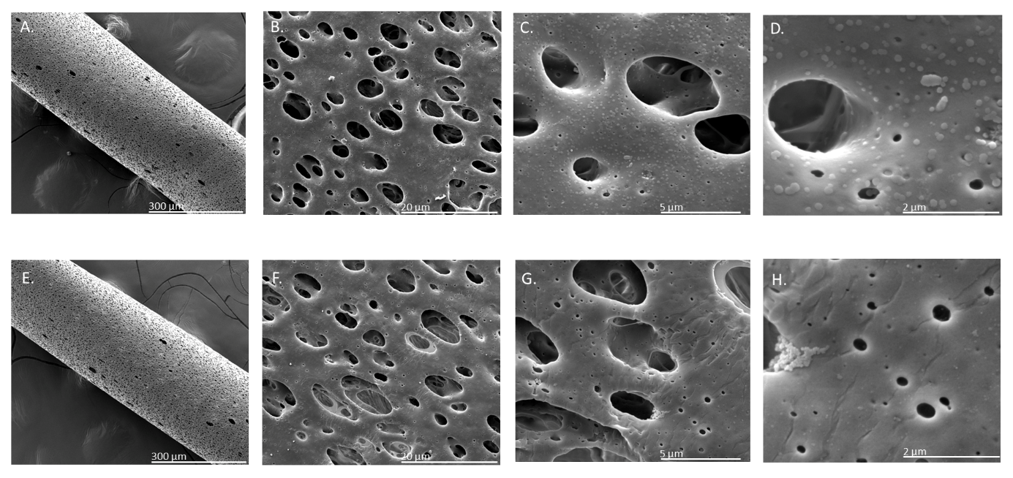
Figure S5. SEM images of Theralite HCO membrane (Baxter) after dialysis of blood by hemosol (A., B., C., D.) or hemosol combined to Chitosan@DOTAGA (E., F., G., H.).

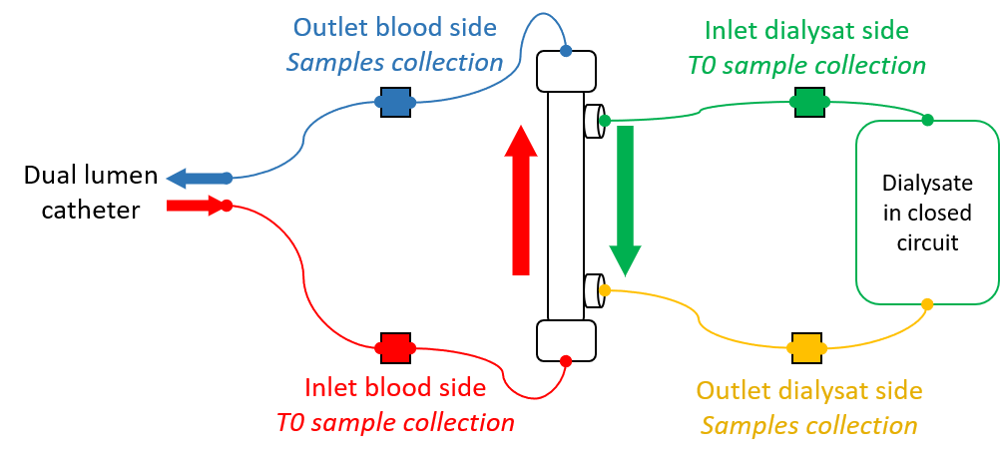
Figure S6. Schematic representation of the recirculation hemodialysis protocol with sampling sites.

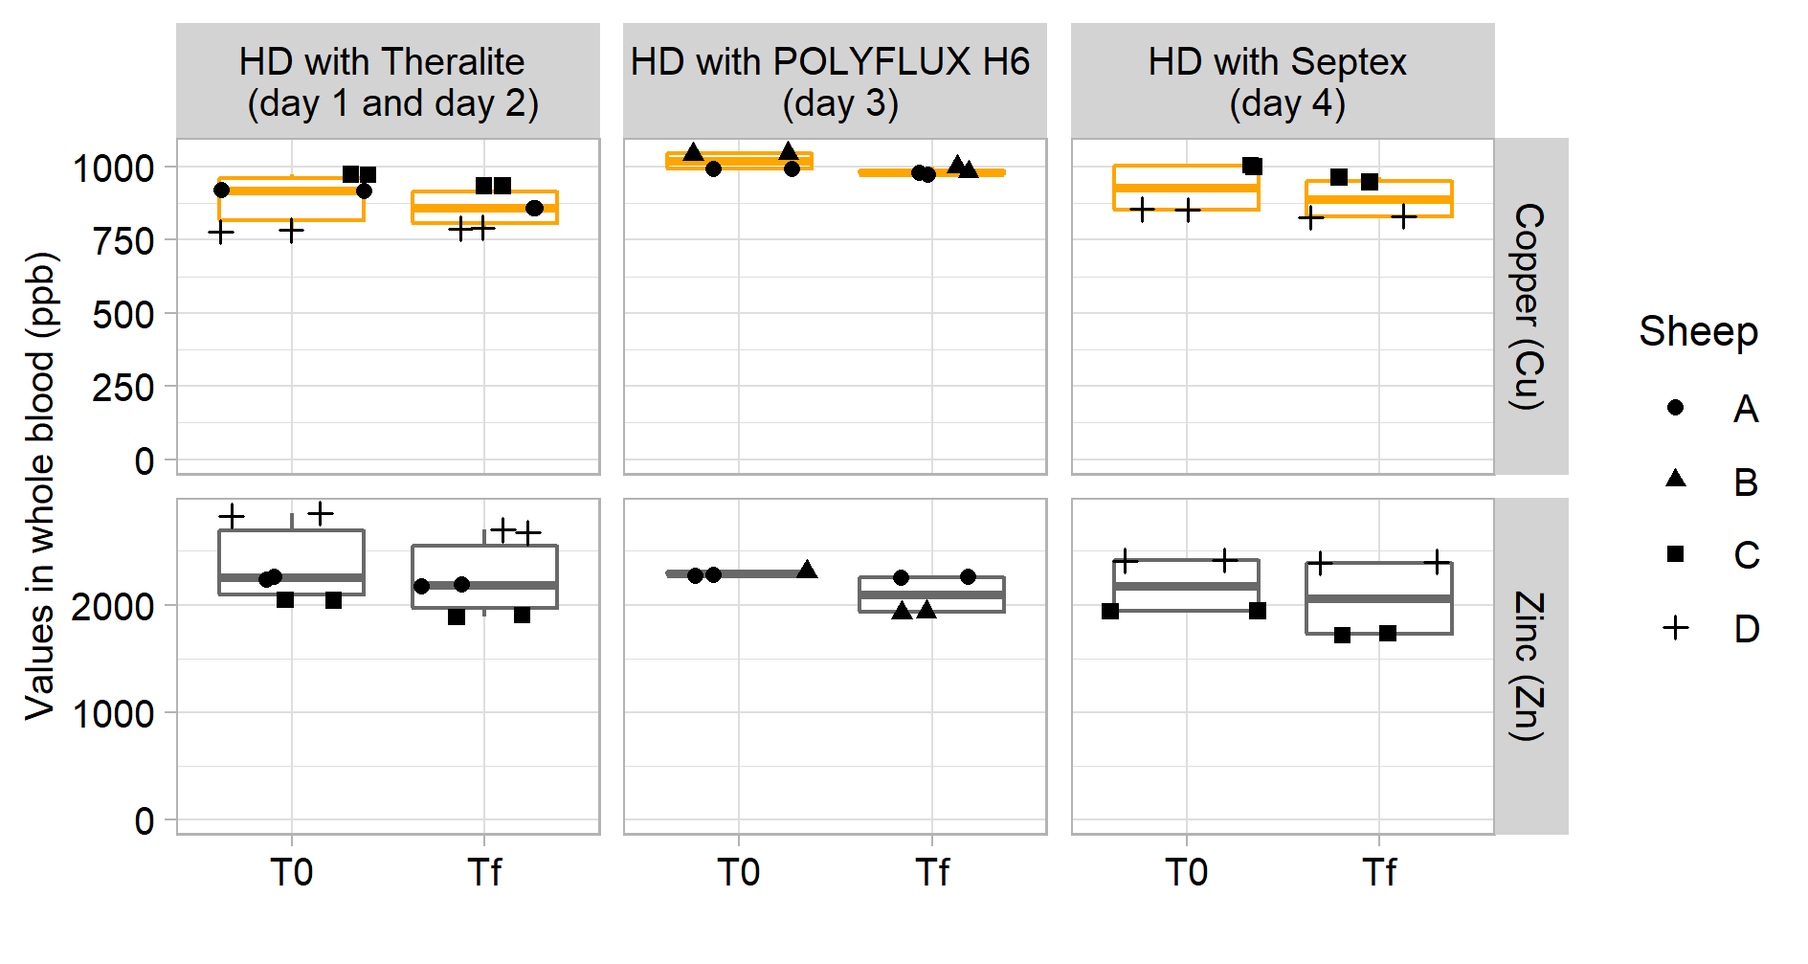
Figure S7. Evolution of copper and zinc levels in whole blood before and after dialysis combined with Chitosan@DOTAGA with three different types of dialyser membranes.

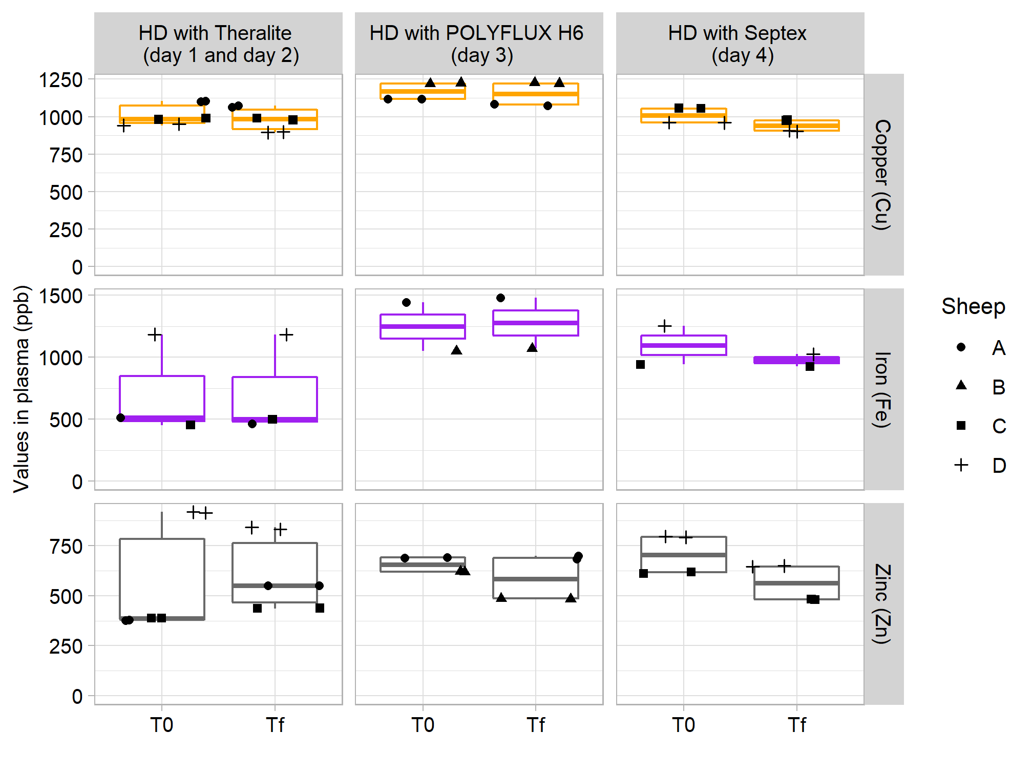
Figure S8. Evolution of copper, iron and zinc levels in plasma before and after dialysis combined with Chitosan@DOTAGA with three different types of dialyser membranes.

