Trial protocol
1 Study design
This study was designed and conducted as a randomized, controlled, single-blind trial. After baseline investigation and physical examination, we randomly assigned the participants to the intervention group (52% sodium-limited formula salt and CM-DASH) and control group (traditional salt and CM-DASH diet) by using a random number table. From the day of their admission onwards, all participants were subjected to salt restriction (less than 5 g/day) and food intake according to the CM-DASH diet. The 8-week diet intervention was divided into three stages: DASH diet adaptation at home (weeks 1–2), centralized feeding in the hospital (weeks 3–4), and dietary behavior intervention at home (weeks 5–8).Participants attended follow-ups in the hospital once a week to collect information on salt intake, office BP, drug use, and the incidence of adverse events. For safety considerations, the participants measured their BP by themselves at home every day. In addition, general inspection, blood samples, 24-hour urine samples, and casual urine samples were measured at baseline, in the fourth week, and at the end of the intervention.
2 Technology line

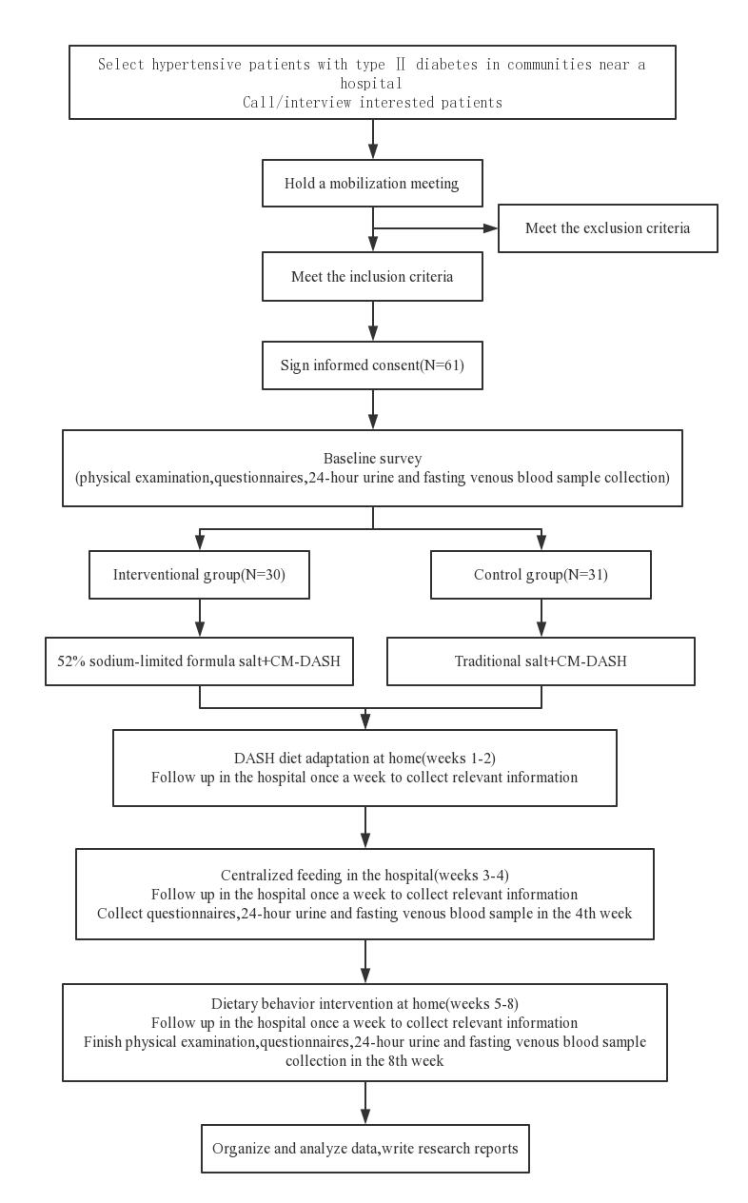
Figure 1. Technology roadmap
3 Participants
3.1 Sample size
This study is a quantitative clinical trial of advantages and disadvantages. According to our pre-trial data and the following formula, 46 samples are required. Considering about 10% of the patients lost to follow-up, no less than 51 patients are included. (δ=16.84，α=0.05, β=0.1，$μ_{1}−μ_{2}$=$11.4$mmHg)$$n=2δ^{2}∗f(α,β)∕( u_{1}−u_{2})^{2}$$
3.2 Inclusion and exclusion criteria
Inclusion criteria:
- age between 35 and 75 years,
- no plan to move out of their community in the following 3 months, residence near the indicated hospital for regular follow-up visits,
- and ability to strictly follow the salt reduction and dietary recommendations during the trial,
- the participants and the family members with whom they were living were required to agree to the terms of the study and sign an informed consent form.
Exclusion criteria:
- serious complications of hypertension or diabetes,
- hypercortisolism or hyperaldosteronism,
- acute disease, such as upper respiratory infection, fever, or diarrhea,
- using potassium-retaining diuretics,
- pregnant,
- not suitable to take the test product,
- the participants or their family members have abnormal kidney or liver function.
4 Intervention
4.1 Salt
The intervention group was given 52% sodium-limited formula salt (Gu Da Chu, developed by Shanghai Institute of Ecological Health Sciences: solid compound condiment; standard of execution, Q/BAAM0009S; food production license number, SC10334042205441; main ingredients, potassium chloride [KCl] [31%], sodium chloride [NaCl] [52%], carbohydrates [9.2%], protein [4.4%]).
The control group was given traditional salt (Jing Xin, developed by Chongqing Salt Industry Group Co., Ltd: purified salt; product standard, NY/T1040; sodium chloride content, >99%).
All participants were subjected to salt restriction (less than 5 g/day). The patients were given a week’s supply of salt (according to the number of family members) and a regular salt shaker (a flat teaspoon is ~ 1 g).
4.2 CM-DASH diet
We modified the DASH dietary requirements of the participants according to the DASH dietary energy estimate sheet and sample recipes, the dietary pagoda for Chinese residents, and the dietary habits of Chinese people. Food selections were recommended as follows: staple foods, coarse grain–fine grain ratio of 1:1; lean meat and white meat; vegetables and fruits with low sugar; low-fat/nonfat milk; low-fat nuts; low sodium and high potassium foods; plant oils; and less than 5 g of salt. The nutritional contents of breakfast, lunch and dinner are shown in the table below.
Table 1 Breakfast nutrition list
Food | Weight | Energy | Protein | Fat | Carbohydrate | Na | Dietary fiber | Cholesterol
Food | (g) | (kcal） | (g) | (g) | (g) | (mg) | (g) | (mg)
Whole-wheat bread | 100 | 272.5 | 9 | 1.8 | 50.6 | 603 | 5.6 | 1
Low-fat milk | 250 | 112 | 8.5 | 3.3 | 12.5 | 167.5 | 0 | 12.5
Egg | 50 | 63 | 5.9 | 3.9 | 1.2 | 57.9 | 0 | 264
Total | 400 | 447.5 | 23.4 | 9 | 64.3 | 828.4 | 5.6 | 277.5

Table 2 Lunch nutrition list
Food | Weight | Energy | Protein | Fat | Carbohydrate | Na | Dietary fiber | Cholesterol
 | (g) | (kcal） | (g) | (g) | (g) | (mg) | (g) | (mg)
Rise | 45 | 156 | 3.3 | 0.4 | 35 | 1.7 | 0.3 | 0
Corn grits | 10 | 34.5 | 0.8 | 0.3 | 7.6 | 0.2 | 0.4 | 0
Azuki bean | 10 | 30.9 | 2 | 0.1 | 6.3 | 0.2 | 0.8 | 0
Chicken breast | 40 | 53.3 | 7.7 | 2 | 1 | 13.7 | 0 | 32.8
Lean | 40 | 57 | 8.1 | 2.5 | 0.6 | 23 | 0 | 32.4
Celery | 50 | 6.9 | 0.4 | 0.1 | 1.5 | 53.3 | 0.4 | 0
Tofu | 50 | 75 | 7.9 | 3.9 | 2.5 | 117 | 0.4 | 0
Green bean | 100 | 27.3 | 1.9 | 0.4 | 5.5 | 8.3 | 1.5 | 0
Carrot | 100 | 42 | 1.4 | 0.2 | 9.9 | 24.3 | 1.3 | 0
Plant oil | 15 | 135 | 0 | 15 | 0 | 0 | 0 | 0
52% sodium-limited formula salt | 2.5 | 1.4 | 0.1 | 0 | 0.2 | 512.7 | 0 | 0
Total | 462.5 | 619.3 | 33.6 | 24.9 | 70.1 | 754.4 | 5.1 | 65.2

Table 2 Dinner nutrition list
Food | Weight | Energy | Protein | Fat | Carbohydrate | Na | Dietary fiber | Cholesterol
 | (g) | (kcal） | (g) | (g) | (g) | (mg) | (g) | (mg)
Rise | 45 | 156 | 3.3 | 0.4 | 35 | 1.7 | 0.3 | 0
Corn grits | 10 | 34.5 | 0.8 | 0.3 | 7.6 | 0.2 | 0.4 | 0
Azuki bean | 10 | 30.9 | 2 | 0.1 | 6.3 | 0.2 | 0.8 | 0
Chicken breast | 40 | 53.3 | 7.7 | 2 | 1 | 13.7 | 0 | 32.8
Lean | 40 | 57 | 8.1 | 2.5 | 0.6 | 23 | 0 | 32.4
Carrot | 50 | 21 | 0.7 | 0.1 | 5 | 12.2 | 0.7 | 0
Green pepper | 50 | 11 | 0.4 | 0.2 | 2.6 | 3.5 | 0 | 0
Cauliflower | 100 | 20 | 1.7 | 0.1 | 3.8 | 25.9 | 1 | 0
Vigna sinensis | 100 | 28 | 2.8 | 0.3 | 5.7 | 2.1 | 2.2 | 0
Plant oil | 15 | 135 | 0 | 15 | 0 | 0 | 0 | 0
52% sodium-limited formula salt | 2.5 | 1.4 | 0.1 | 0 | 0.2 | 512.7 | 0 | 0
Total | 462.5 | 548.1 | 27.6 | 21 | 67.8 | 595.2 | 5.4 | 65.2

