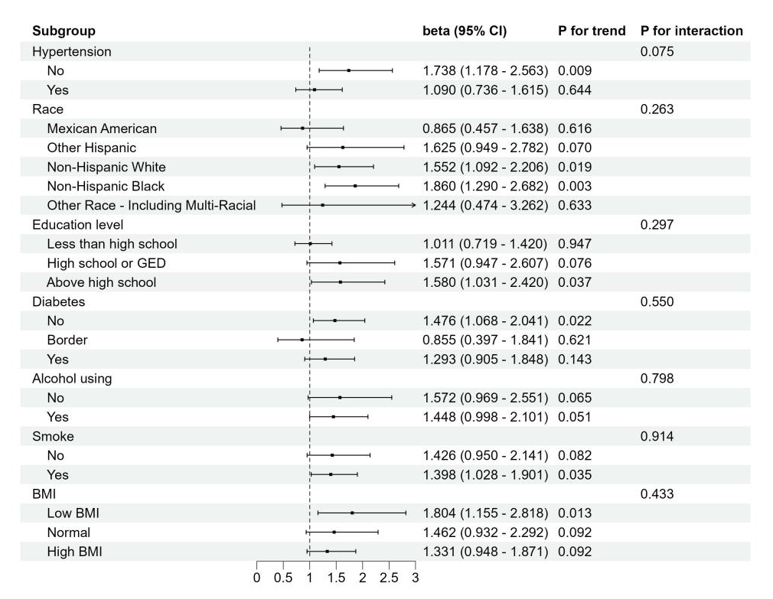
Suppl. Fig 1. Subgroup analysis of the association between ALP and AAC in middle-aged females.

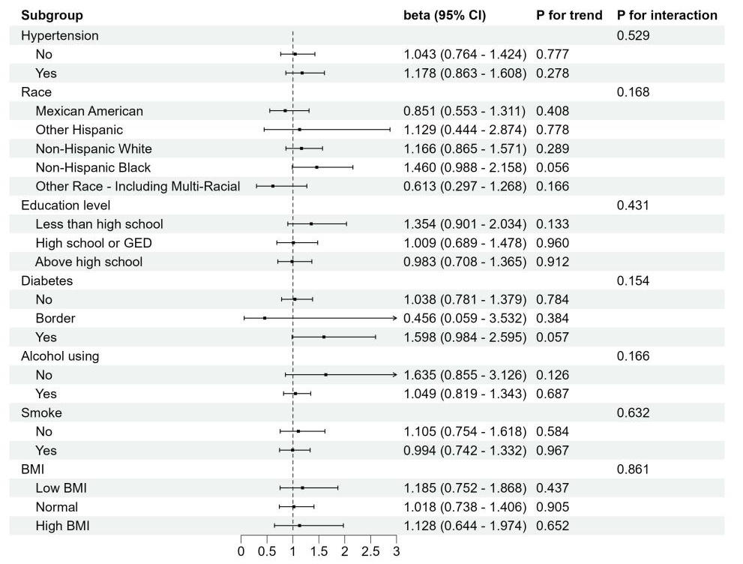
Suppl. Fig 2. Subgroup analysis of the association between ALP and AAC in middle-aged males.

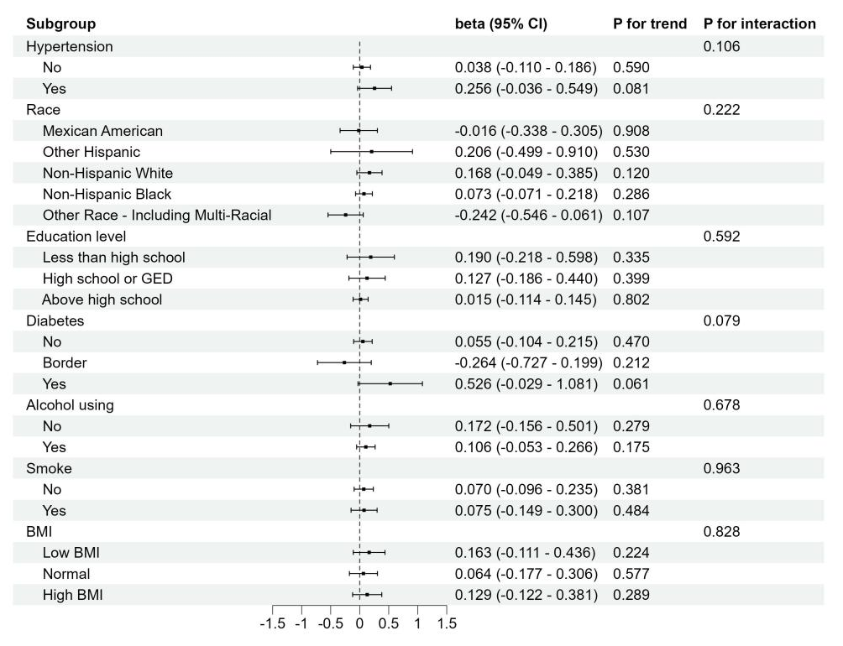
Suppl. Fig 3. Subgroup analysis of the association between ALP and AAC scores in middle-aged males.

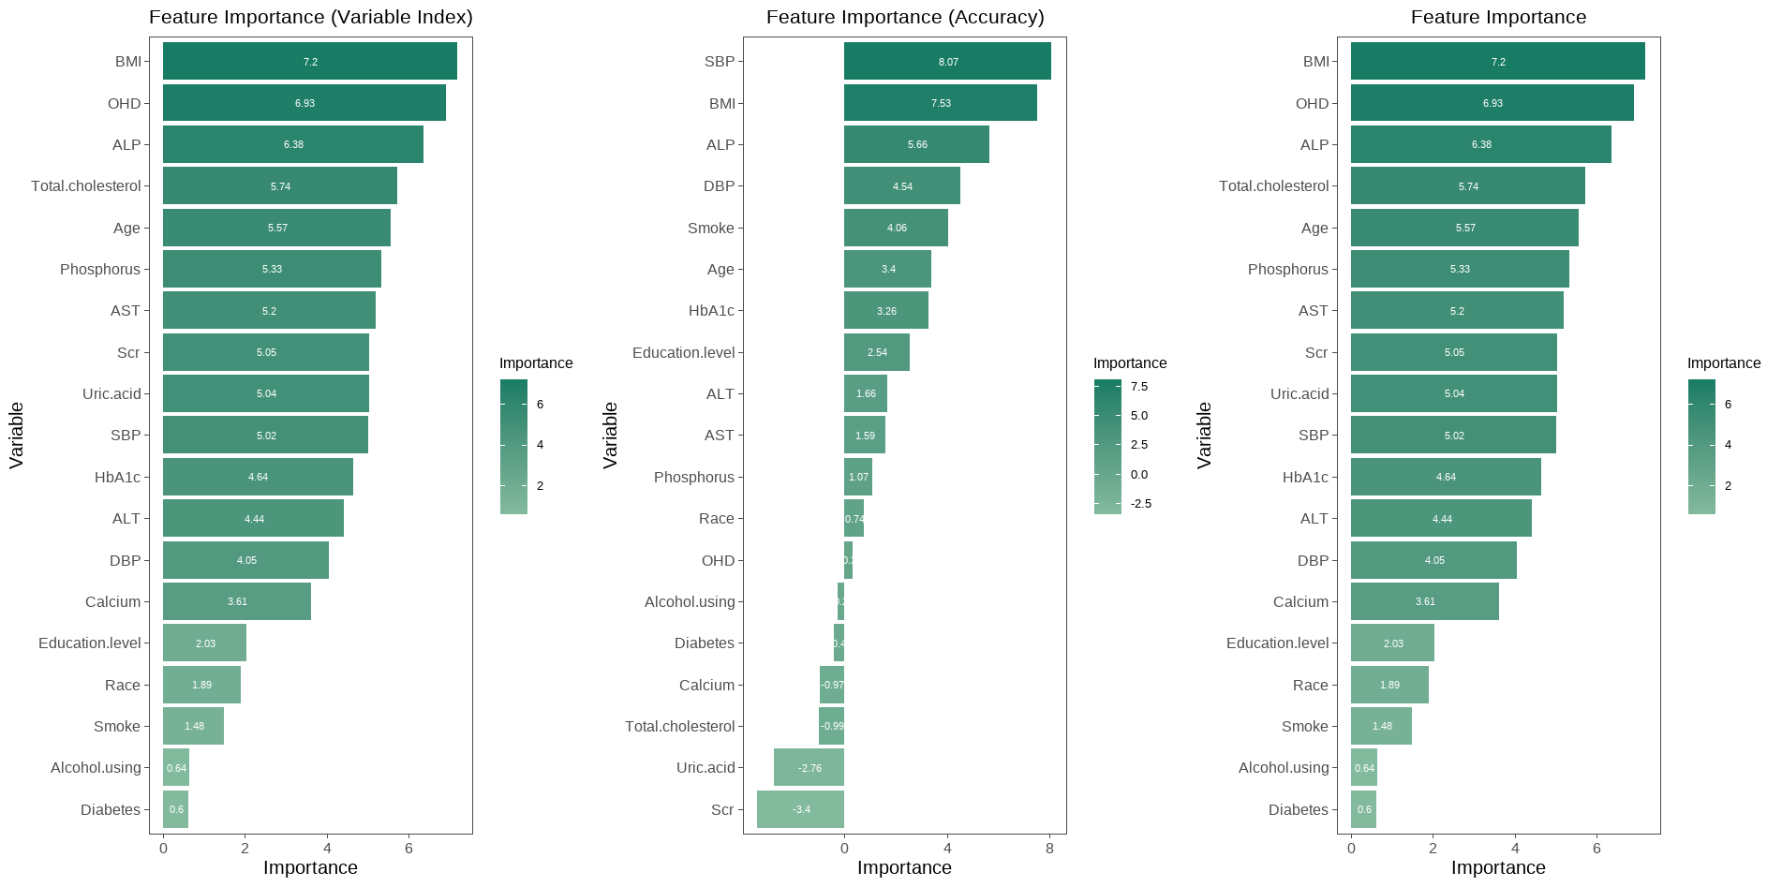
Suppl. Fig 4. The feature importance of random forest by variable index, accuracy and importance among middle-aged females.

Suppl. Fig 5. Multi-way feature importance analysis of the acute rejection combining the mean decrease in Gini, decrease in accuracy, and p values of the features (orange circle; p<0.01) among middle-aged females. (For interpretation of the references to color in this figure legend)

Suppl. Fig 6. Mean minimal depth for the 30 most frequent interactions among middle-aged females. The bar displays the mean conditional minimal depth, whilst the line displays the unconditional mean minimal depth. The horizontal line indicates the minimal value of the statistic in question, calculated across all interactions in which it was determined.
(A)
(B)
Suppl. Fig 7. (A) The prediction of the forest for different values of ALP and BMI among middle-aged females. The effect of interaction: the predicted AAC is highest when BMI is low and ALP is high. (B) The prediction of the forest for different values of ALP and Age among middle-aged females. The effect of interaction: the predicted AAC is highest when Age is high and ALP is high.

A
B
Suppl. Fig 8. Variable selection by the LASSO regression model among middle-aged females. (A) Choice of the optimal parameter (λ) in the LASSO regression model with logλ as the horizontal coordinate and regression coefficients as the vertical coordinate; (B) plot of λ vs. number of variables with logλ as the bottom horizontal coordinate, binomial deviance as the vertical coordinate, and number of variables as the top horizontal coordinate.

Suppl. Fig 9. Force plots visually depicted SHAP values for each feature, determining the final prediction. Yellow and purple bars denoted risk and protective factors, with longer bars indicating greater impact.

