Supplementary information – Methods
DNA Extraction
Leaf tissue was dried in desiccant silica beads and stored at -20 °C. Dried leaf material was ground with a Retsch® MM300 mixer mill (Haan, Germany). We used 25–30 mg of semi-fine powder from each sample with the EZNA Plant DNA kit (Omega-BioTek) or the Fastpure Plant DNA Isolation Mini Kit (Nanjing Vazyme Biotech, China) protocols for dried material, with a final elution volume of 100 μL.
Nextera XT libraries
DNA was quantified using a Qubit fluorometer (Thermo Fisher Scientific) and calculated as the mean of three independent readings for each sample. All samples were either standardised to 2 ng/μL by dilution with nuclease-free water or left undiluted if their concentrations were less than 2 ng/μL (0.4–1.9 ng/μL). Each sample was tagmented with the Illumina Tagment DNA enzyme (TD) and buffer kit (small kit, #20034210). The reagent volumes for the library preparation were 5.5 μL of 5× TD buffer, 0.5 μL of 1× TD enzyme, and 4 μL of DNA (standardised or undiluted), with all reagents kept on ice during preparation. Samples were incubated at 55 °C for 10 minutes and then allowed to cool to room temperature for 5 minutes. Subsequently, 5 μL of each sample was run on an agarose gel to confirm the efficacy of the tagmentation reaction, as evidenced by the presence of visible smears. The tagmented DNA was then amplified using unique dual indexing based on combinations from a total of 24 N7 (47 bases) and 8 S5 (51 bases) adapters (Alpha DNA, Canada). The PCR cocktail included 0.2 µM of each index, 0.5 U of KAPA HiFi HotStart DNA polymerase (Roche), 12.5 μL of 5× KAPA reagent, 5 μL of tagmented DNA, and 6.5 μL of nuclease-free water to a final volume of 25 μL. The PCR cycle consisted of 72 °C (3 minutes), 95 °C (30 seconds), and 14 cycles of 95 °C (10 seconds), 55 °C (30 seconds), and 72 °C (30 seconds). Again, visible smears confirmed amplification success after running 5 μL of the PCR product on an agarose gel; then, 10 μL of each sample was pooled, and the remaining PCR products were stored at -20 °C. The pooled library was purified using a QIAquick PCR purification kit (QIAGEN) according to the manufacturer's protocol, with a final elution in 50 μL of elution buffer. The library was quantified using a D1000 Tapestation assay (Agilent Technologies, USA) and a Qubit fluorometer (Thermo Fisher Scientific).

Supplementary Table S1. Sampling identifiers, geographic coordinates, and species memberships of the samples collected in this study.
Sampling ID | Latitude (approximate) | Longitude (approximate) | Species
BHP1 | 50.79 | -119.21 | T. latifolia
BJL2 | 50.57 | -119.61 | T. latifolia
BJL3_1 | 50.57 | -119.61 | T. latifolia
BRT2B | 44.74 | -63.24 | T. angustifolia
BUN1 | 53.89 | -122.81 | T. latifolia
C05TL | 52.72 | -1.37 | T. latifolia
CA13_TL | 44.85 | 7.71 | T. latifolia
CA3TL | 47.68 | 22.46 | T. latifolia
CC1_TL | 50.77 | 2.31 | T. latifolia
CC2_TL | 50.77 | 2.31 | T. latifolia
CIUU13TA | 43.76 | 24.93 | T. angustifolia
CL10TA | 50.77 | 2.31 | T. angustifolia
COTL6 | 52.72 | -1.37 | T. latifolia
CRR6 | 47.68 | 22.46 | T. angustifolia
CS3_TA | 44.08 | 4.79 | T. laxmannii
CY1ATL | 52.16 | 4.50 | T. latifolia
CY6ATA | 51.43 | -0.11 | T. angustifolia
CY7ATA | 51.43 | -0.11 | T. angustifolia
CY7BTA | 51.43 | -0.11 | T. angustifolia
CYTZ_4ATD | -6.79 | 39.21 | T. domingensis
DAB16TA | 48.20 | 26.59 | T. angustifolia
E74B | 45.03 | -63.50 | T. angustifolia
E91C | 45.03 | -63.50 | T. angustifolia
EDD_44_1 | 47.37 | -68.33 | T. latifolia
EDD_67_1 | 47.37 | -68.33 | T. latifolia
EDW_2_15 | 47.37 | -68.33 | T. latifolia
EDW_3_6 | 47.37 | -68.33 | T. latifolia
EL14_TA | 52.44 | 5.85 | T. latifolia
ELTA_01 | 52.44 | 5.85 | T. angustifolia
ELTA_08 | 52.44 | 5.85 | T. angustifolia
FRD47_2 | 45.96 | -66.64 | T. latifolia
FRTD_1 | 41.64 | 13.34 | T. domingensis
GORE_3 | 43.68 | -70.44 | T. latifolia
G_II3 | 49.11 | 11.93 | T. latifolia
HAD_3_1 | 44.60 | -63.55 | T. angustifolia
HAW_03_12 | 44.60 | -63.55 | T. latifolia
HAW_10_9 | 44.60 | -63.55 | T. latifolia
HM3TL | 47.51 | 19.04 | T. latifolia
HMTM1 | 47.51 | 19.04 | T. laxmannii
HOR_6 | 48.14 | 26.51 | T. latifolia
HUF_13TA | 47.69 | 17.65 | T. angustifolia
HUG_13TA | 47.69 | 17.65 | T. angustifolia
HUS_10TL | 47.51 | 19.04 | T. latifolia
HUS_TA1 | 47.51 | 19.04 | T. angustifolia
HUS_TL1 | 47.51 | 19.04 | T. latifolia
IC17TA | 43.57 | 4.32 | T. angustifolia
ICTD5 | 43.57 | 4.32 | T. angustifolia
IP2 | 44.46 | -64.32 | T. latifolia
IR_25 | 44.97 | -64.06 | T. latifolia
IR_36 | 44.97 | -64.06 | T. latifolia
IR_39 | 44.97 | -64.06 | T. latifolia
IR_41 | 44.97 | -64.06 | T. latifolia
KL14_TL | 46.64 | 14.31 | T. latifolia
KL1TL | 46.64 | 14.31 | T. latifolia
KL28_TL | 46.64 | 14.31 | T. latifolia
KL4_TA | 46.64 | 14.31 | T. laxmannii
KL5_TX | 46.64 | 14.31 | T. laxmannii
KL_TA1 | 46.64 | 14.31 | T. laxmannii
KL_TA3 | 46.64 | 14.31 | T. laxmannii
KL_TH1 | 46.64 | 14.31 | T. latifolia
LIETD_01 | 42.21 | 2.61 | T. domingensis
LIETD_12 | 42.21 | 2.61 | T. domingensis
LiETL_11 | 42.21 | 2.61 | T. latifolia
M23 | 45.08 | -64.49 | T. latifolia
M30 | 45.08 | -64.49 | T. latifolia
M37 | 45.08 | -64.49 | T. latifolia
M53 | 45.08 | -64.49 | T. latifolia
M85 | 45.08 | -64.49 | T. latifolia
MBNK_2_8 | 51.51 | -97.00 | T. latifolia
MOD_01_0 | 46.98 | -70.55 | T. latifolia
MOD_02_1 | 46.98 | -70.55 | T. latifolia
MOD_04_1 | 46.98 | -70.55 | T. latifolia
MOD_05_2 | 46.98 | -70.55 | T. latifolia
MOD_07_0 | 46.98 | -70.55 | T. angustifolia
MOD_08_1 | 46.98 | -70.55 | T. latifolia
MOD_14_0 | 46.98 | -70.55 | T. latifolia
MOD_14_3 | 46.98 | -70.55 | T. angustifolia
MOD_15_1 | 46.98 | -70.55 | T. latifolia
MOD_16_1 | 46.98 | -70.55 | T. latifolia
MOD_17_1 | 46.98 | -70.55 | T. latifolia
MOD_18_0 | 46.98 | -70.55 | T. latifolia
MOD_25_2 | 46.98 | -70.55 | T. latifolia
MOD_26_2 | 46.98 | -70.55 | T. latifolia
MOD_29_1 | 46.98 | -70.55 | T. latifolia
MOD_35_3 | 46.98 | -70.55 | T. latifolia
MOD_45_2 | 46.98 | -70.55 | T. latifolia
MOD_47_1 | 46.98 | -70.55 | T. angustifolia
MOD_54_0 | 46.98 | -70.55 | T. latifolia
MOD_56_1 | 46.98 | -70.55 | T. angustifolia
MOD_57_0 | 46.98 | -70.55 | T. latifolia
NBU_6 | 42.53 | 2.83 | T. domingensis
ORP_TI | 43.28 | -2.13 | T. latifolia
OR_TA4 | 43.28 | -2.13 | T. domingensis
OR_TI2 | 43.28 | -2.13 | T. latifolia
OR_TL5 | 43.28 | -2.13 | T. latifolia
P4 | 45.41 | -64.33 | T. latifolia
P6 | 45.41 | -64.33 | T. latifolia
P9 | 45.41 | -64.33 | T. latifolia
PA2 | 33.19 | -112.15 | T. domingensis
PIW_01_0 | 43.84 | -79.10 | T. angustifolia
PIW_04_6 | 43.84 | -79.10 | T. angustifolia
PIW_06_6 | 43.84 | -79.10 | T. angustifolia
PIW_07_1 | 43.84 | -79.10 | T. angustifolia
PIW_09_1 | 43.84 | -79.10 | T. angustifolia
PIW_10_2 | 43.84 | -79.10 | T. angustifolia
PIW_13_0 | 43.84 | -79.10 | T. angustifolia
PIW_14_3 | 43.84 | -79.10 | T. angustifolia
PIW_15_3 | 43.84 | -79.10 | T. angustifolia
PIW_16_2 | 43.84 | -79.10 | T. angustifolia
PIW_20_6 | 43.84 | -79.10 | T. angustifolia
PIW_21_3 | 43.84 | -79.10 | T. angustifolia
PIW_22_6 | 43.84 | -79.10 | T. angustifolia
PIW_23_3 | 43.84 | -79.10 | T. angustifolia
PIW_24_3 | 43.84 | -79.10 | T. angustifolia
PIW_25_3 | 43.84 | -79.10 | T. angustifolia
PWE19TL | 51.62 | -3.94 | T. latifolia
RGT2 | 45.48 | -74.30 | T. angustifolia
SADT_03 | 45.90 | -64.39 | T. angustifolia
SAD_10_3 | 45.90 | -64.39 | T. latifolia
SAD_17_3 | 45.90 | -64.39 | T. latifolia
SAD_25_0 | 45.90 | -64.39 | T. latifolia
SCH9TA | 47.65 | 26.22 | T. latifolia
SP2_TA | 52.41 | 4.68 | T. angustifolia
TAKT_1 | 45.27 | 37.38 | T. angustifolia
TAKT_2 | 45.27 | 37.38 | T. angustifolia
TALD_1 | 55.73 | 37.61 | T. angustifolia
TAVG_1 | 55.32 | 40.37 | T. angustifolia
TAVG_2 | 55.32 | 40.37 | T. angustifolia
TA_01_F | 26.56 | -81.95 | T. latifolia
TB7 | 44.39 | -64.25 | T. latifolia
TDD_04 | 43.09 | 47.46 | T. domingensis
TDD_08 | 43.09 | 47.46 | T. domingensis
TDD_09 | 43.09 | 47.46 | T. domingensis
TDD_15 | 43.09 | 47.46 | T. domingensis
TDD_16 | 43.09 | 47.46 | T. latifolia
TDD_17 | 43.09 | 47.46 | T. latifolia
TDD_18 | 43.09 | 47.46 | T. domingensis
TDD_22 | 43.09 | 47.46 | T. domingensis
TDD_30 | 43.09 | 47.46 | T. domingensis
TDD_32 | 43.09 | 47.46 | T. domingensis
TDD_33 | 43.09 | 47.46 | T. domingensis
TDD_35 | 43.09 | 47.46 | T. latifolia
TDD_36 | 43.09 | 47.46 | T. latifolia
TDD_37 | 43.09 | 47.46 | T. latifolia
TDD_39 | 43.09 | 47.46 | T. latifolia
TDD_40 | 43.09 | 47.46 | T. domingensis
TDD_41 | 43.09 | 47.46 | T. latifolia
TDD_42 | 43.09 | 47.46 | T. latifolia
TDD_43 | 43.09 | 47.46 | T. angustifolia
TDD_44 | 43.09 | 47.46 | T. domingensis
TDD_46 | 43.09 | 47.46 | T. domingensis
TDD_47 | 43.09 | 47.46 | T. domingensis
TDD_49 | 43.09 | 47.46 | T. angustifolia
TDD_50 | 43.09 | 47.46 | T. domingensis
TDD_51 | 43.09 | 47.46 | T. domingensis
TDD_52 | 43.09 | 47.46 | T. domingensis
TDD_53 | 43.09 | 47.46 | T. domingensis
TDD_54 | 43.09 | 47.46 | T. domingensis
TLAX_1 | 43.35 | 47.24 | T. laxmannii
TLAX_2 | 43.35 | 47.24 | T. laxmannii
TLAX_6 | 41.63 | 48.35 | T. laxmannii
TLAX_7 | 41.63 | 48.35 | T. laxmannii
TLIK_01 | 45.09 | 147.89 | T. latifolia
TLIK_02 | 45.09 | 147.89 | T. latifolia
TLIK_03 | 45.09 | 147.89 | T. latifolia
TLIK_04 | 45.09 | 147.89 | T. latifolia
TLIK_06 | 45.09 | 147.89 | T. latifolia
TLIK_11 | 45.09 | 147.89 | T. latifolia
TLIK_14 | 45.09 | 147.89 | T. latifolia
TLIK_15 | 45.09 | 147.89 | T. latifolia
TLIK_16 | 45.09 | 147.89 | T. latifolia
TLIK_24 | 45.09 | 147.89 | T. latifolia
TLKL_2 | 45.23 | 39.07 | T. laxmannii
TLMK_1 | 45.21 | 38.89 | T. latifolia
TLMK_2 | 45.21 | 38.89 | T. latifolia
TLPK_1 | 45.09 | 147.89 | T. latifolia
TLSK_01 | 47.06 | 142.53 | T. latifolia
TLSK_02 | 47.06 | 142.53 | T. latifolia
TLSK_03 | 47.06 | 142.53 | T. latifolia
TLSK_04 | 47.06 | 142.53 | T. latifolia
TLSK_11 | 47.06 | 142.53 | T. latifolia
TLSK_12 | 47.06 | 142.53 | T. latifolia
TMO2_7 | 46.09 | -64.78 | T. latifolia
TSKL_1 | 43.85 | 39.71 | T. shuttleworthii
TSKL_2 | 43.85 | 39.71 | T. shuttleworthii
TSKL_3 | 43.85 | 39.71 | T. shuttleworthii
TXKT_1 | 45.29 | 37.41 | T. angustifolia
TXKT_2 | 45.29 | 37.41 | T. angustifolia
TXKT_3 | 45.29 | 37.41 | T. angustifolia
TXKT_4 | 45.29 | 37.41 | T. angustifolia
TXKT_6 | 45.29 | 37.41 | T. angustifolia
TXVG_1 | 55.32 | 40.37 | T. angustifolia
TXVG_2 | 55.32 | 40.37 | T. angustifolia
VFW6 | 49.63 | -125.40 | T. latifolia
Vikram_25 | 44.30 | -78.32 | T. angustifolia
Vikram_33 | 44.30 | -78.32 | T. angustifolia
Vikram_73 | 44.30 | -78.32 | T. angustifolia
Vikram_76 | 44.30 | -78.32 | T. latifolia
Vikram_86 | 44.30 | -78.32 | T. latifolia
Vikram_94 | 44.30 | -78.32 | T. angustifolia
Vikram_95 | 44.30 | -78.32 | T. latifolia
WBD20_1 | 44.28 | -84.23 | T. angustifolia
WBD_27_4 | 44.28 | -84.23 | T. angustifolia
WBD_28_3 | 44.28 | -84.23 | T. angustifolia
WBD_32_1 | 44.28 | -84.23 | T. angustifolia
WBD_33_1 | 44.28 | -84.23 | T. angustifolia
WBW5_4 | 44.28 | -84.23 | T. latifolia

Supplementary Table S2. Combinations of ingroup-outgroup (P1) recipient (P2), and donor species (P3) used during the ABBA BABA test to look for introgressive hybridisation between four Typha spp.; T. laxmannii was established as the outgroup species for all comparisons.
P1 | P2 | P3
T. angustifolia | T. domingensis | T. latifolia
T. angustifolia | T. domingensis | T. shuttleworthii
T. domingensis | T. angustifolia | T. latifolia
T. domingensis | T. angustifolia | T. shuttleworthii
T. shuttleworthii | T. latifolia | T. angustifolia
T. shuttleworthii | T. latifolia | T. domingensis

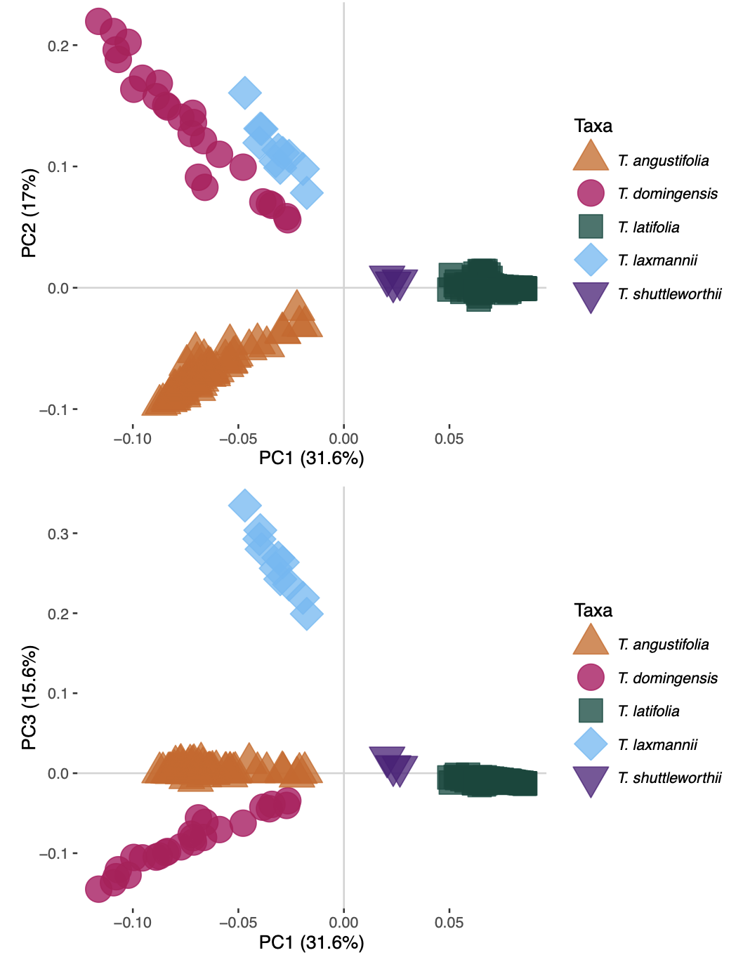
Supplementary Figure S1. Principal component analysis for PC1-PC2 and PC1-PC3. Individual shapes represent individuals, and shape forms and colour codes represent species, as in the box.
Supplementary Figures S3-S12 (Zip file). Genomic landscapes of divergence between five Typha species. Results from Role of selection and introgressive hybridisation on species’ divergence. Islands and valleys of divergence (5 kb) consistent with alternative types of selection are coloured according to the legend.

Supplementary Figures S13-S14 (Zip file). Genomic landscapes of divergence between Typha angustifolia and T. latifolia split by continent (North America and Europe). Islands and valleys of divergence (5 kb) consistent with alternative types of selection are coloured according to the legend.

