Supplementary material

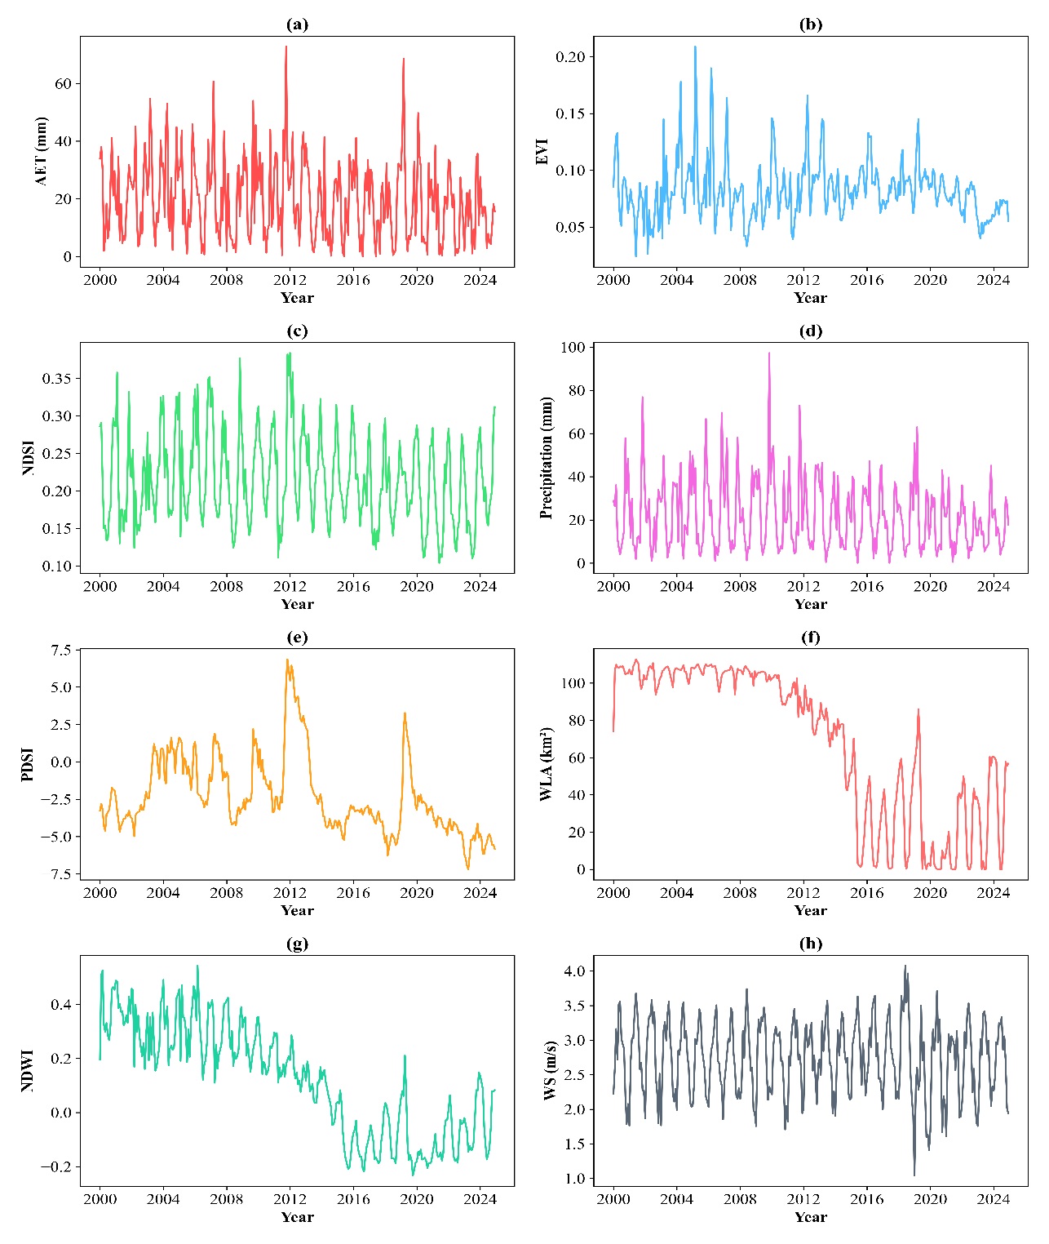
Figure.S1. Monthly changes in AET (actual evapotranspiration), EVI (Enhanced vegetation index), NDSI (Normalized difference salinity index), precipitation (Pre), Palmer drought severity index (PDSI), WLA (wetland lake area), NDWI (Normalized difference water index), WS (wind speed) in Gomishan Wetland, Iran.
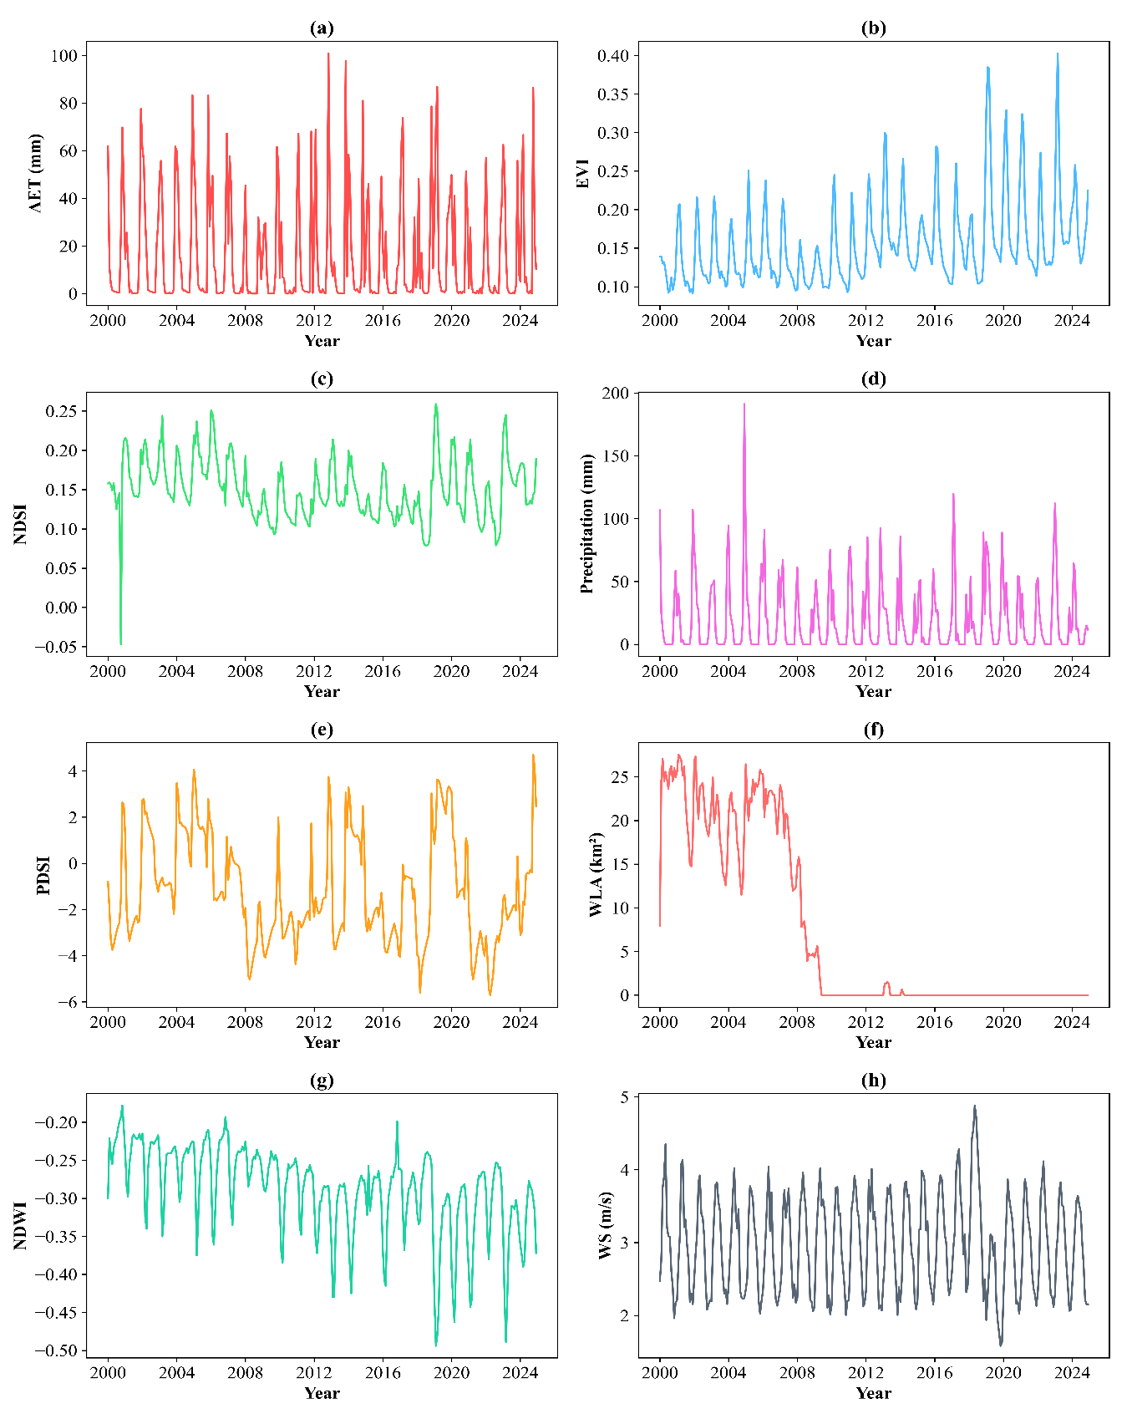
Fig.S2. Monthly changes in AET (actual evapotranspiration), EVI (Enhanced vegetation index), NDSI (Normalized difference salinity index), precipitation (Pre), Palmer drought severity index (PDSI), WLA (wetland lake area), NDWI (Normalized difference water index), WS (wind speed) in Parishan Wetland, Iran.
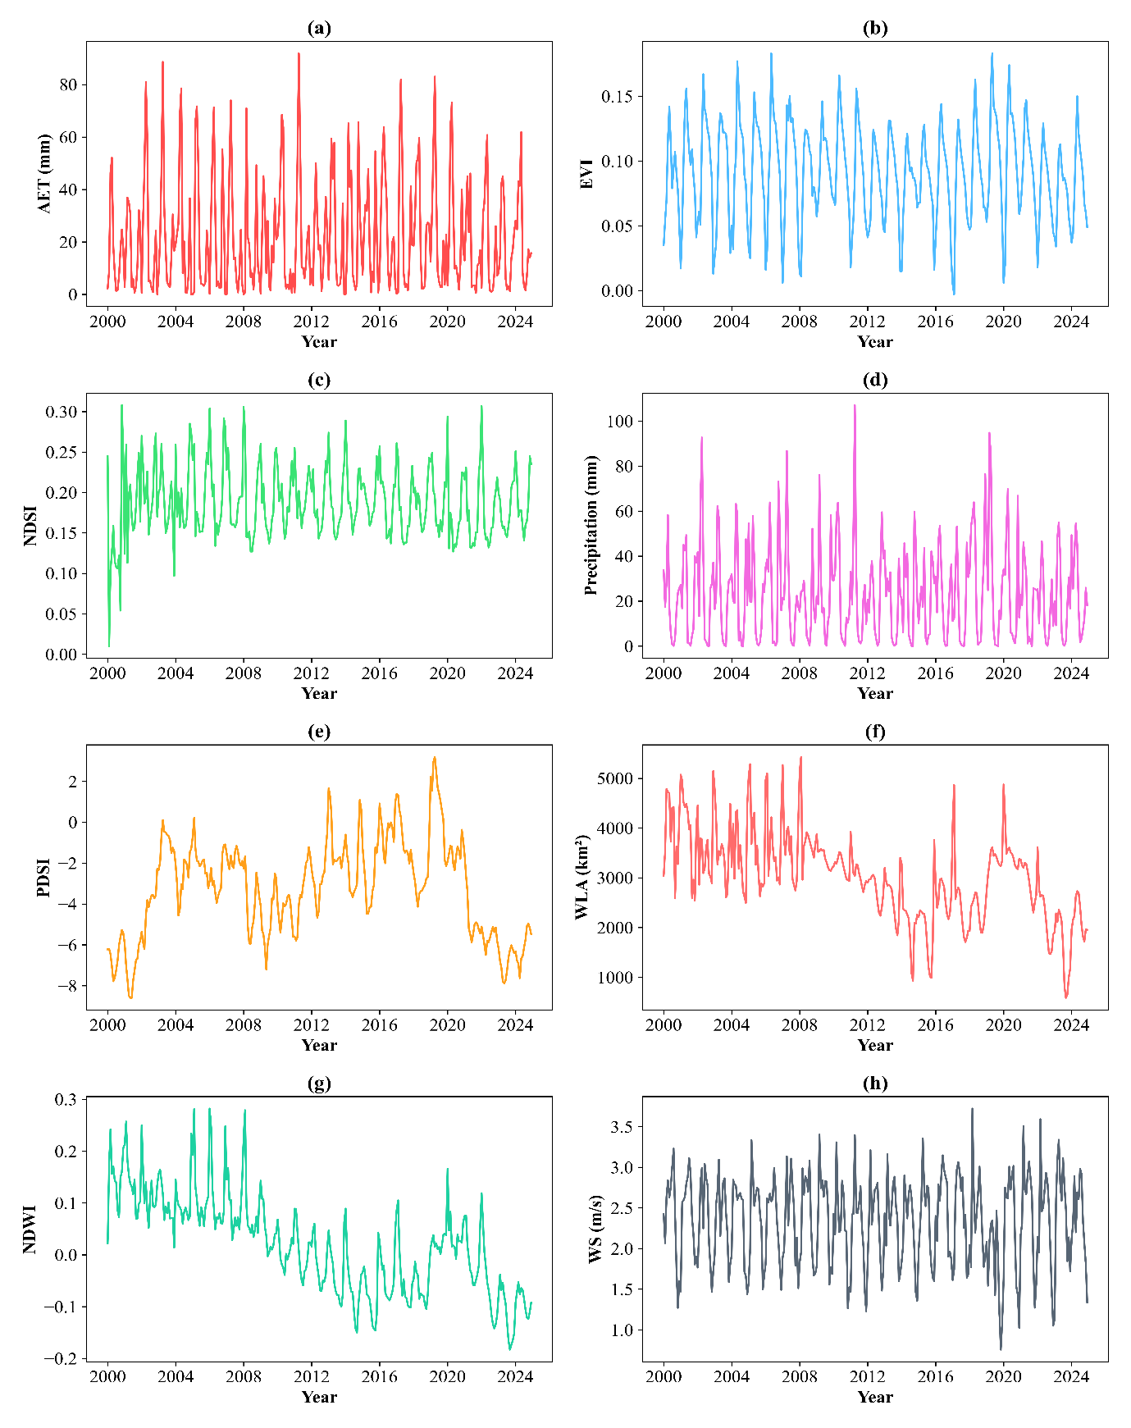
Fig.S3. Monthly changes in AET (actual evapotranspiration), EVI (Enhanced vegetation index), NDSI (Normalized difference salinity index), precipitation (Pre), Palmer drought severity index (PDSI), WLA (wetland lake area), NDWI (Normalized difference water index), WS (wind speed) in Urmia Lake, Iran.
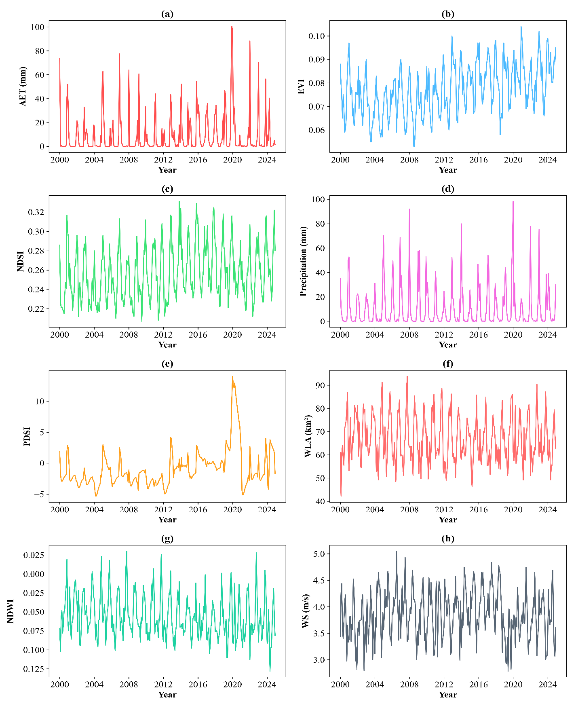
Fig.S4. Monthly changes in AET (actual evapotranspiration), EVI (Enhanced vegetation index), NDSI (Normalized difference salinity index), precipitation (Pre), Palmer drought severity index (PDSI), WLA (wetland lake area), NDWI (Normalized difference water index), WS (wind speed) in Sheedvar wetland, Iran.

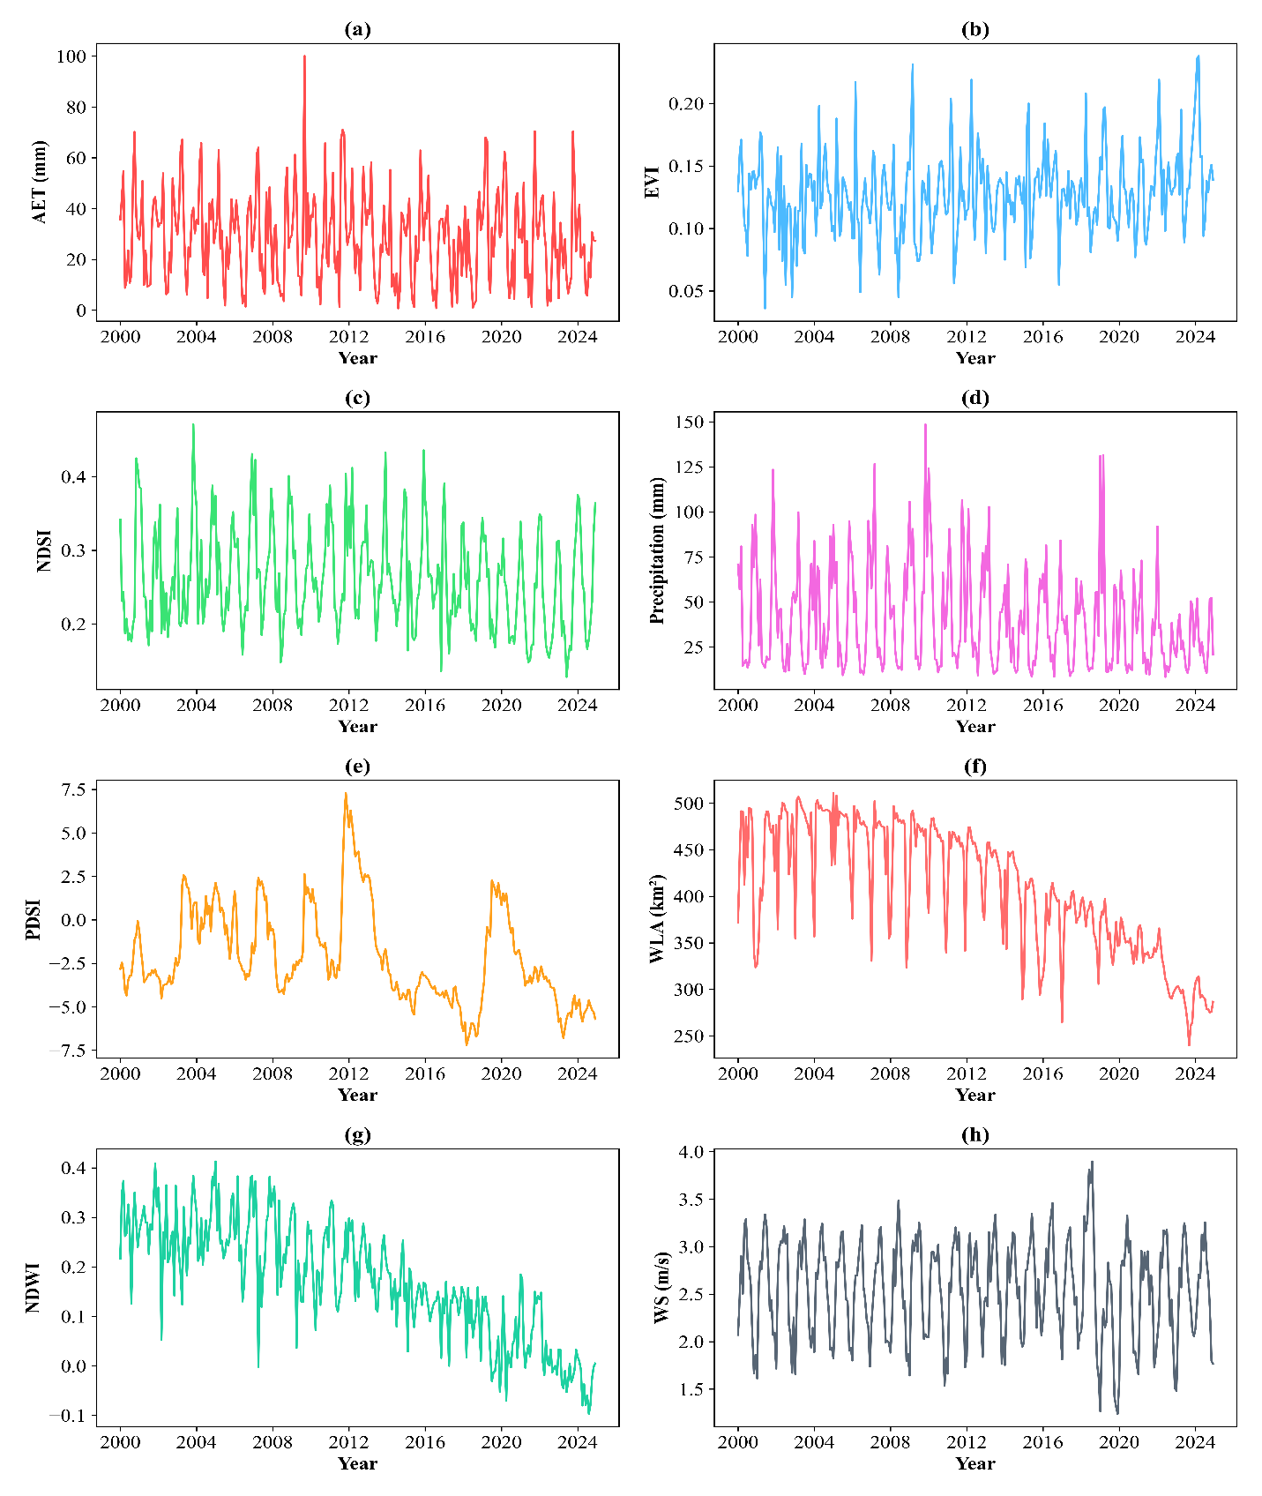
Fig.S5. Monthly changes in AET (actual evapotranspiration), EVI (Enhanced vegetation index), NDSI (Normalized difference salinity index), precipitation (Pre), Palmer drought severity index (PDSI), WLA (wetland lake area), NDWI (Normalized difference water index), WS (wind speed) in Miankaleh wetland, Iran.

