Supplementary Materials for

Global Forest Edge Dynamics in the 21st Century

Authors: Hangkai You¹, Fujiang Ji¹, Taejin Park^{2,3}, Volker C. Radeloff¹, George Hurtt⁴, Minhui Jiang⁵, Min Chen¹*.
Corresponding author: min.chen@wisc.edu.

The PDF file includes:

Figs. S1 to S6
Tab. S1

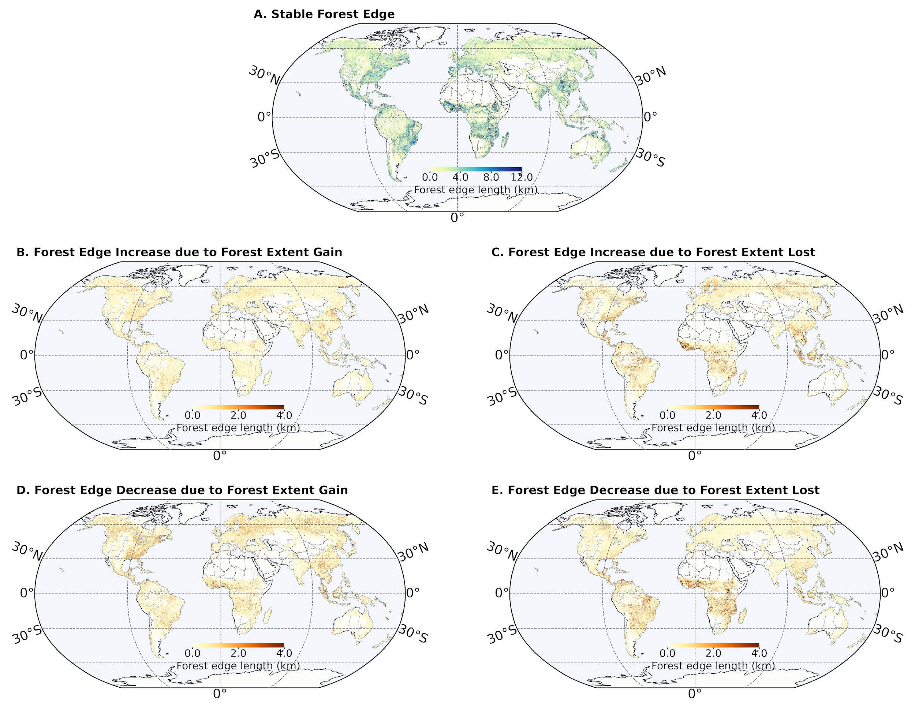
Fig. S1. Global forest edge dynamics by 5 classes between 2000 and 2020.
The edge dynamic is classified into 5 classes based on its forest extent dynamics (see “Materials and Methods” section). A. Stable Forest edge. B. Forest edge increase due to forest area increase. C. Forest edge increase due to forest area decrease. D. Forest edge decrease due to forest area increase. E. Forest edge decrease due to forest area decrease.
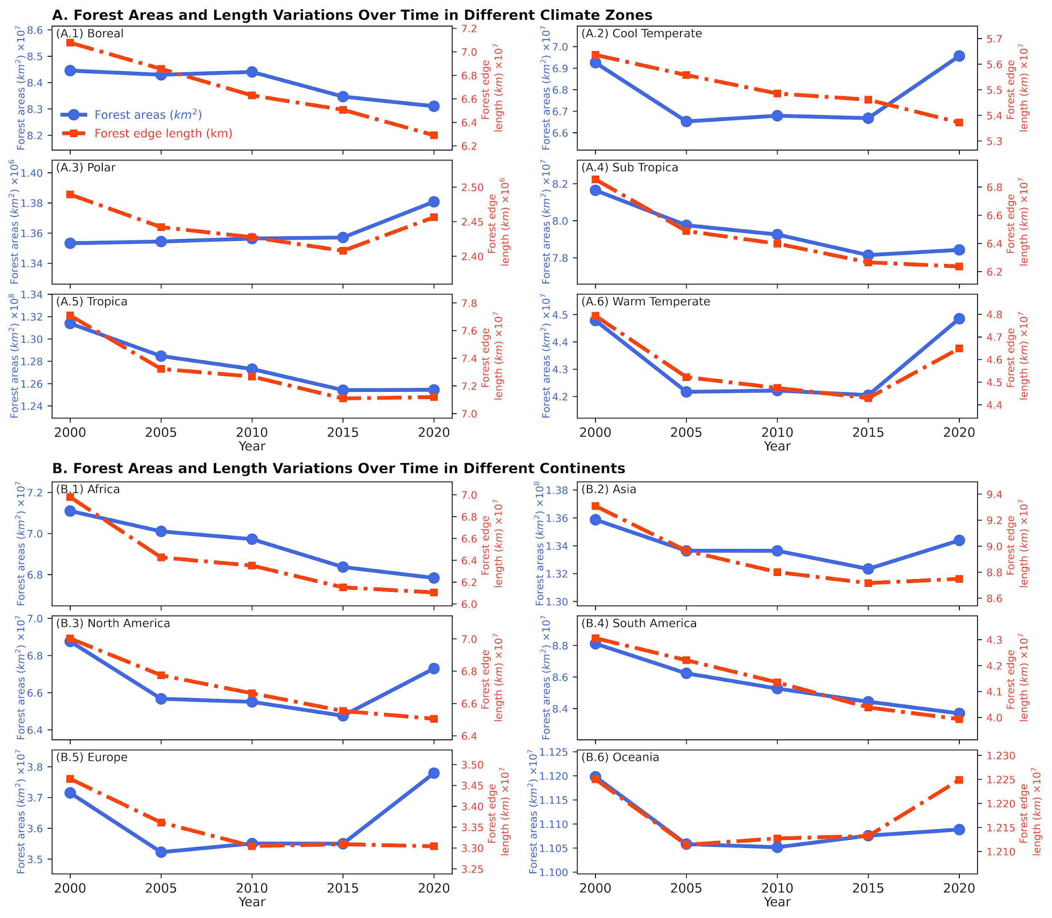
Fig. S2. Forest areas and length variations across climate zones and continents from 2000 to 2020.
A. Forest Areas and Length Variations Over Time in Different Climate Zones: Subpanels A.1 through A.6 show variations for Boreal, Cool Temperate, Polar, Subtropical, Tropics, and Warm Temperate zones, respectively. B. Forest Areas and Length Variations Over Time in Different Continents: Subpanels B.1 through B.6 show variations for Africa, Asia, North America, South America, Europe, and Oceania, respectively.
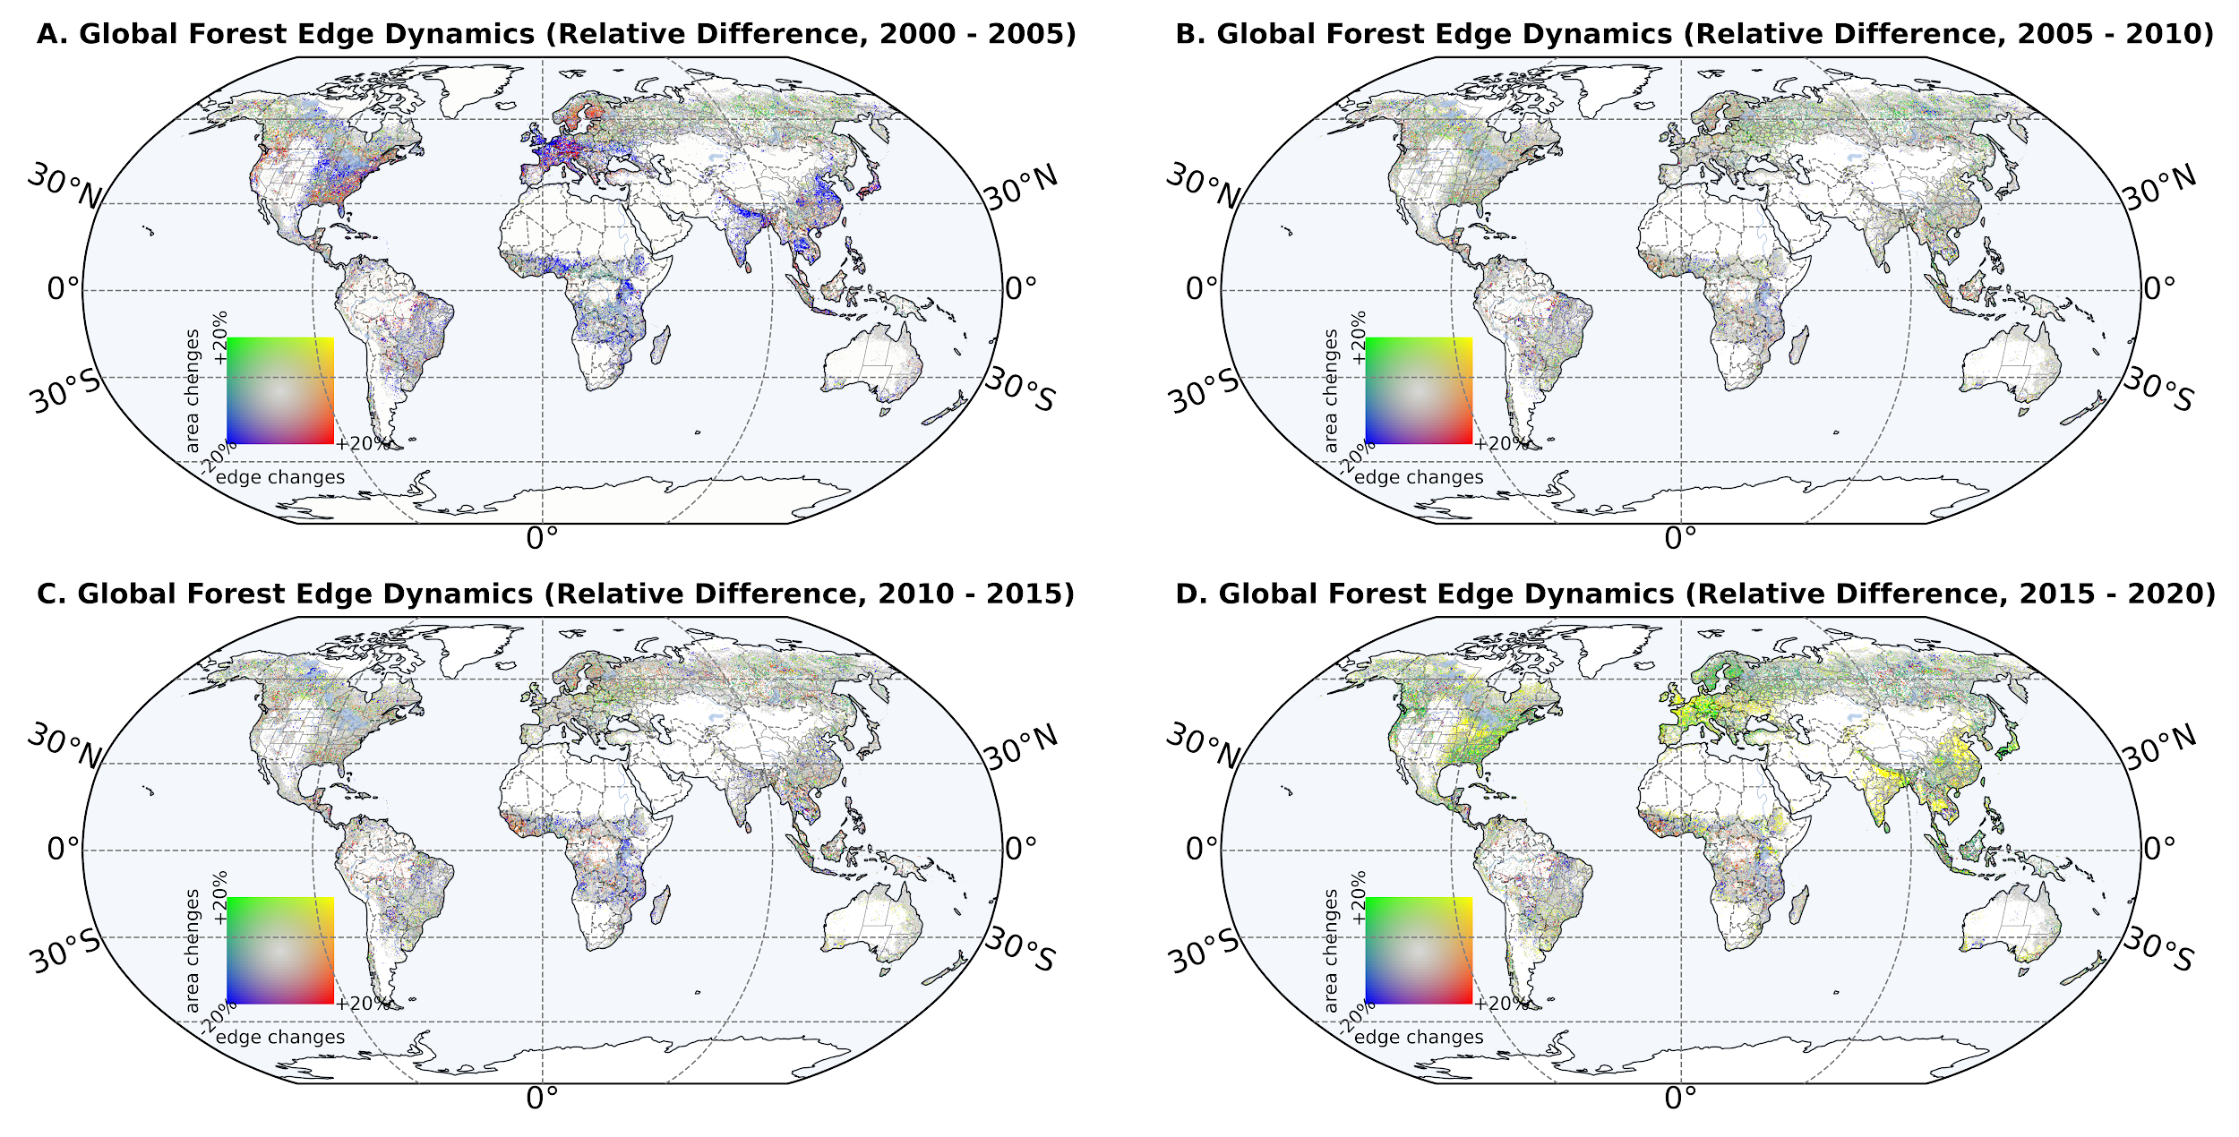
Fig. S3. Global forest edge absolute difference from 2000 to 2020.
Panels A through D provide a global overview of global forest edge dynamics across four periods: 2000–2005, 2005–2010, 2010–2015, and 2015–2020, with color gradients representing the absolute change in forest edges. The scale ranges from forest edges large decrease with areas decrease (in blue) or forest edges large decrease with areas large increase (in green) to forest edges large increase with areas large decrease (in red) or forest edges large increase with areas large increase (in yellow), indicating regions where forest boundaries have contracted or expanded; the edges with mild changes in length are shown in gray.

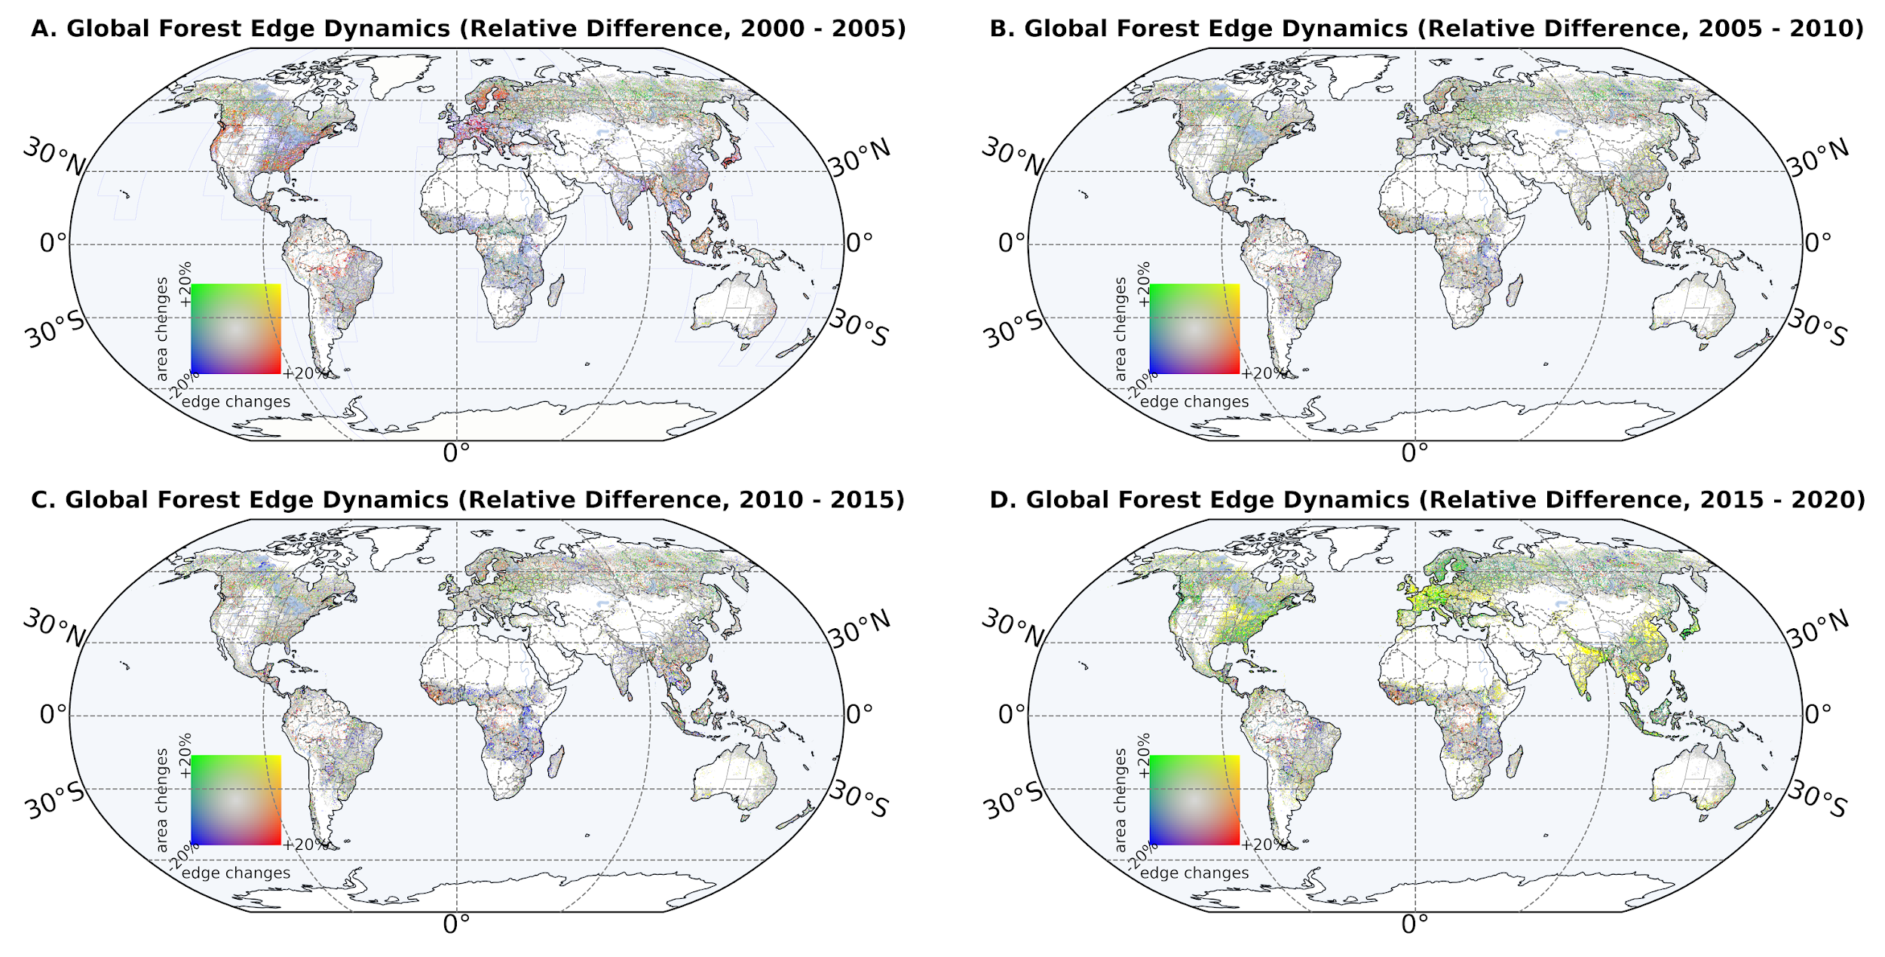
Fig. S4. Global forest edge relative difference from 2000 to 2020.
Panels A through D provide a global overview of global forest edge dynamics across four periods: 2000–2005, 2005–2010, 2010–2015, and 2015–2020, with color gradients representing the relative change in forest edges. The scale ranges from forest edges large decrease with areas decrease (in blue) or forest edges large decrease with areas large increase (in green) to forest edges large increase with areas large decrease (in red) or forest edges large increase with areas large increase (in yellow), indicating regions where forest boundaries have contracted or expanded; the edges with mild changes in length are shown in gray.
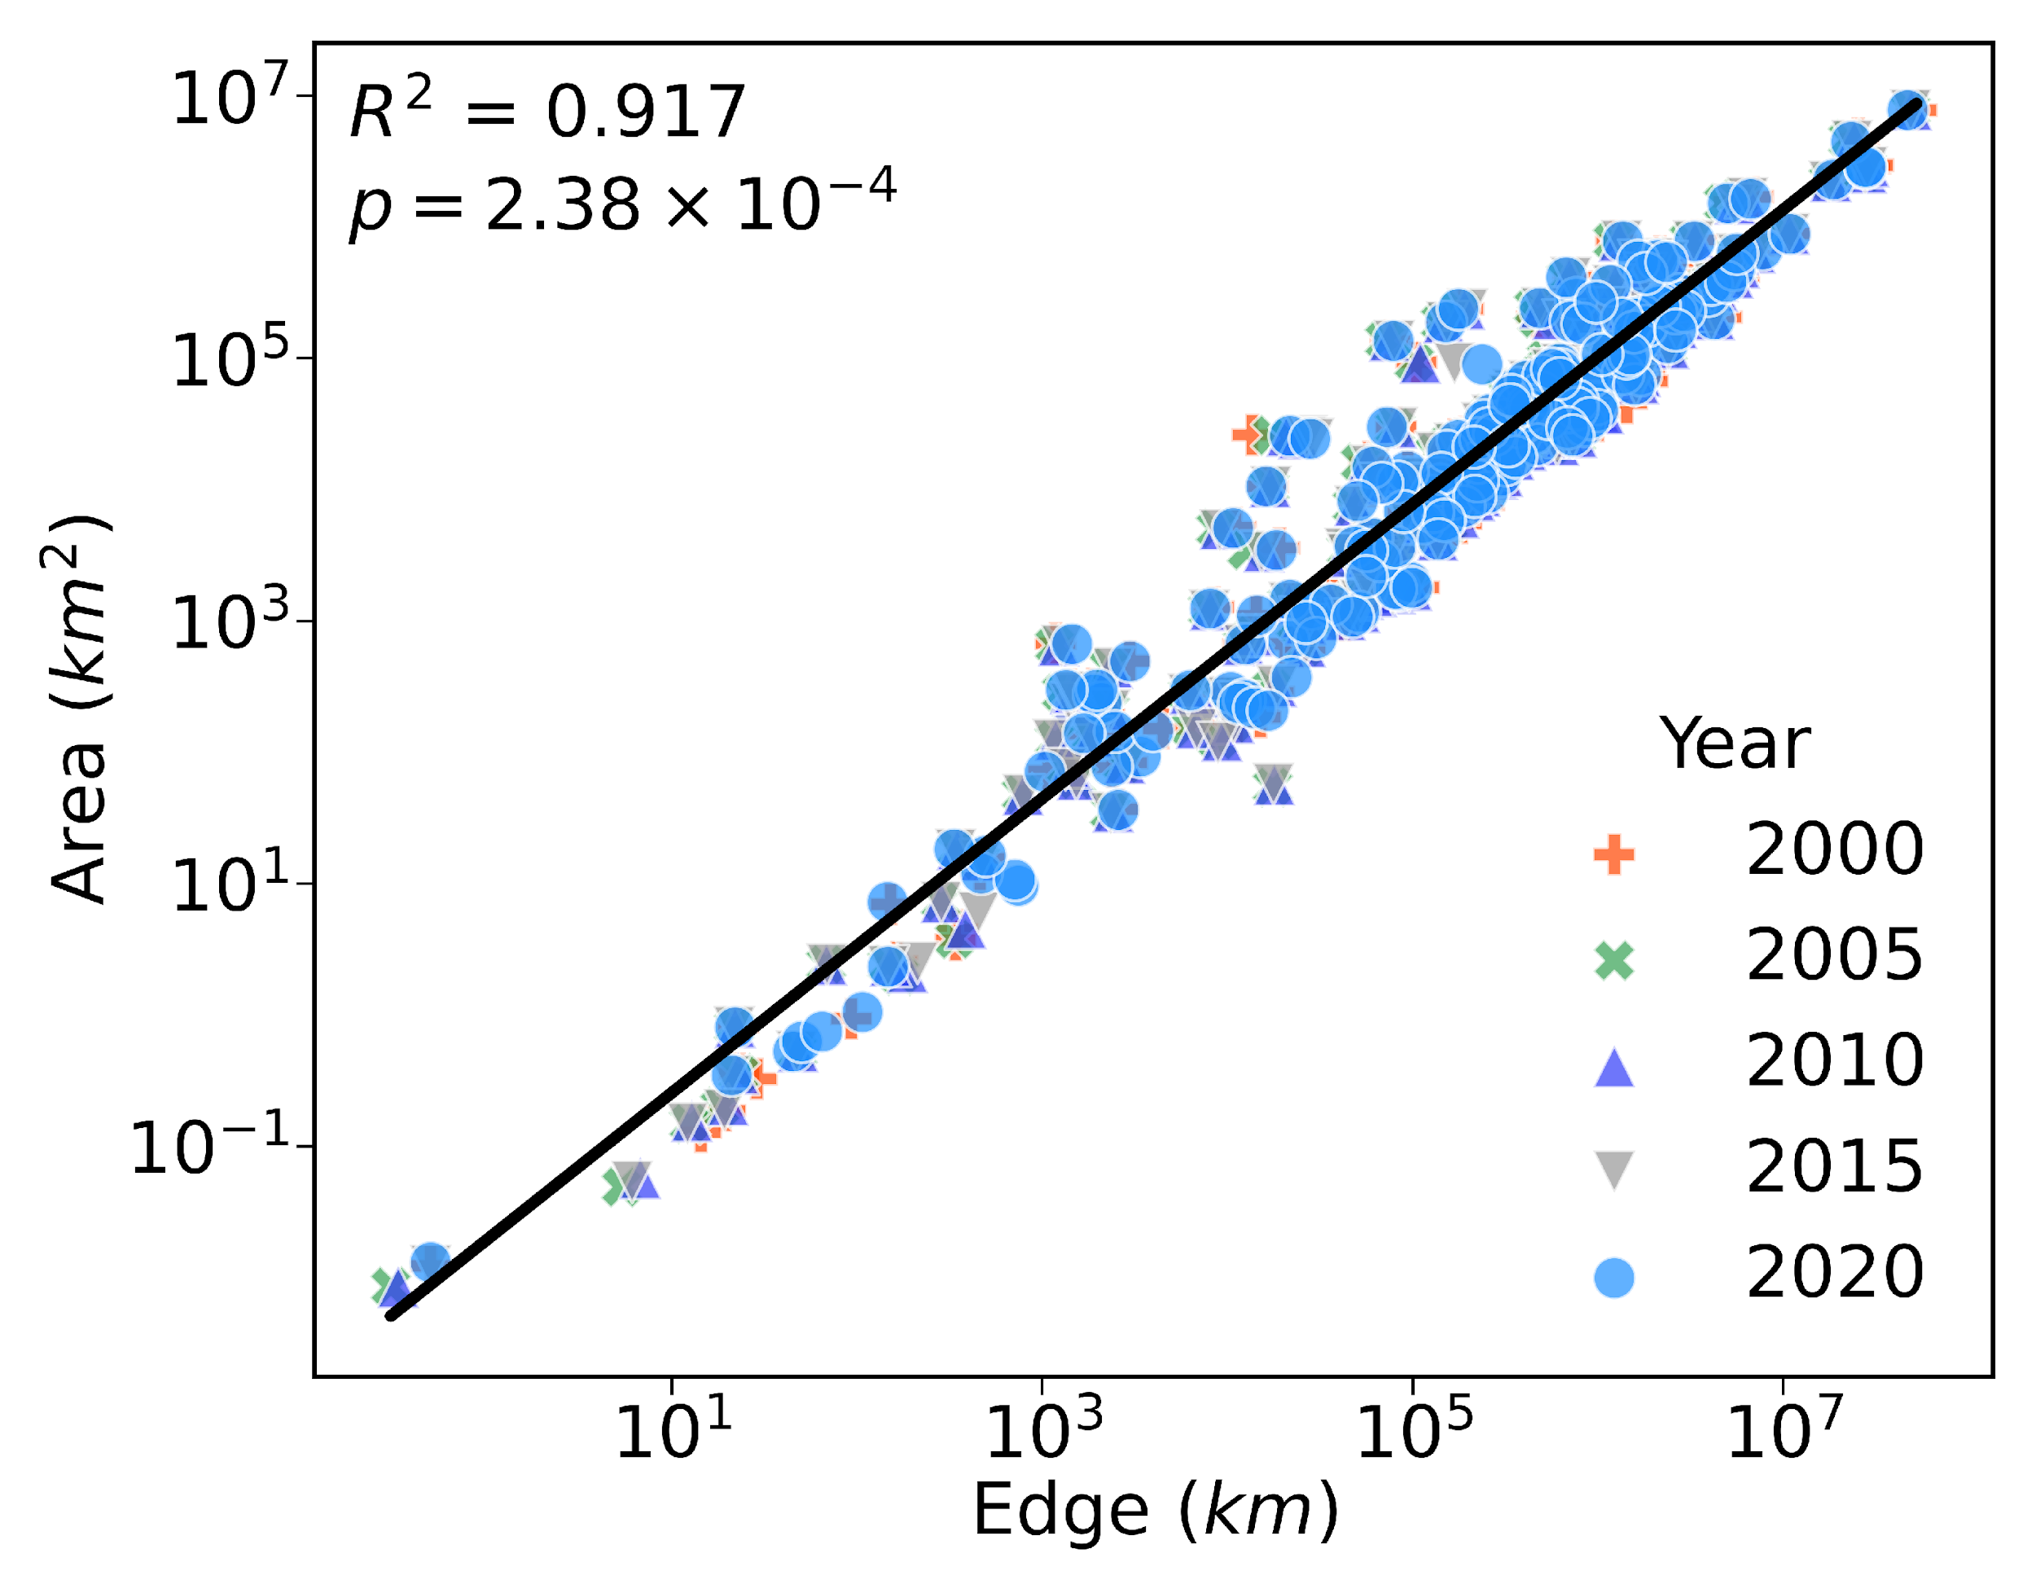
Fig. S5. Forest edge length and area relation at country level.
The scatter plot illustrates the logarithmically transformed relationship between forest edge length and forest area for countries globally. Data for the years 2000 to 2020 are represented by orange, green, purple, gray and blue symbols, respectively. The black line represents the linear regression fit of the data for the year 2000 (log(Area) = 1.12×log(Edge)-3.95), with a coefficient of determination (R²) of 0.917. The statistical significance of this relationship is examined by a p-value of 2.38×10⁻⁴.
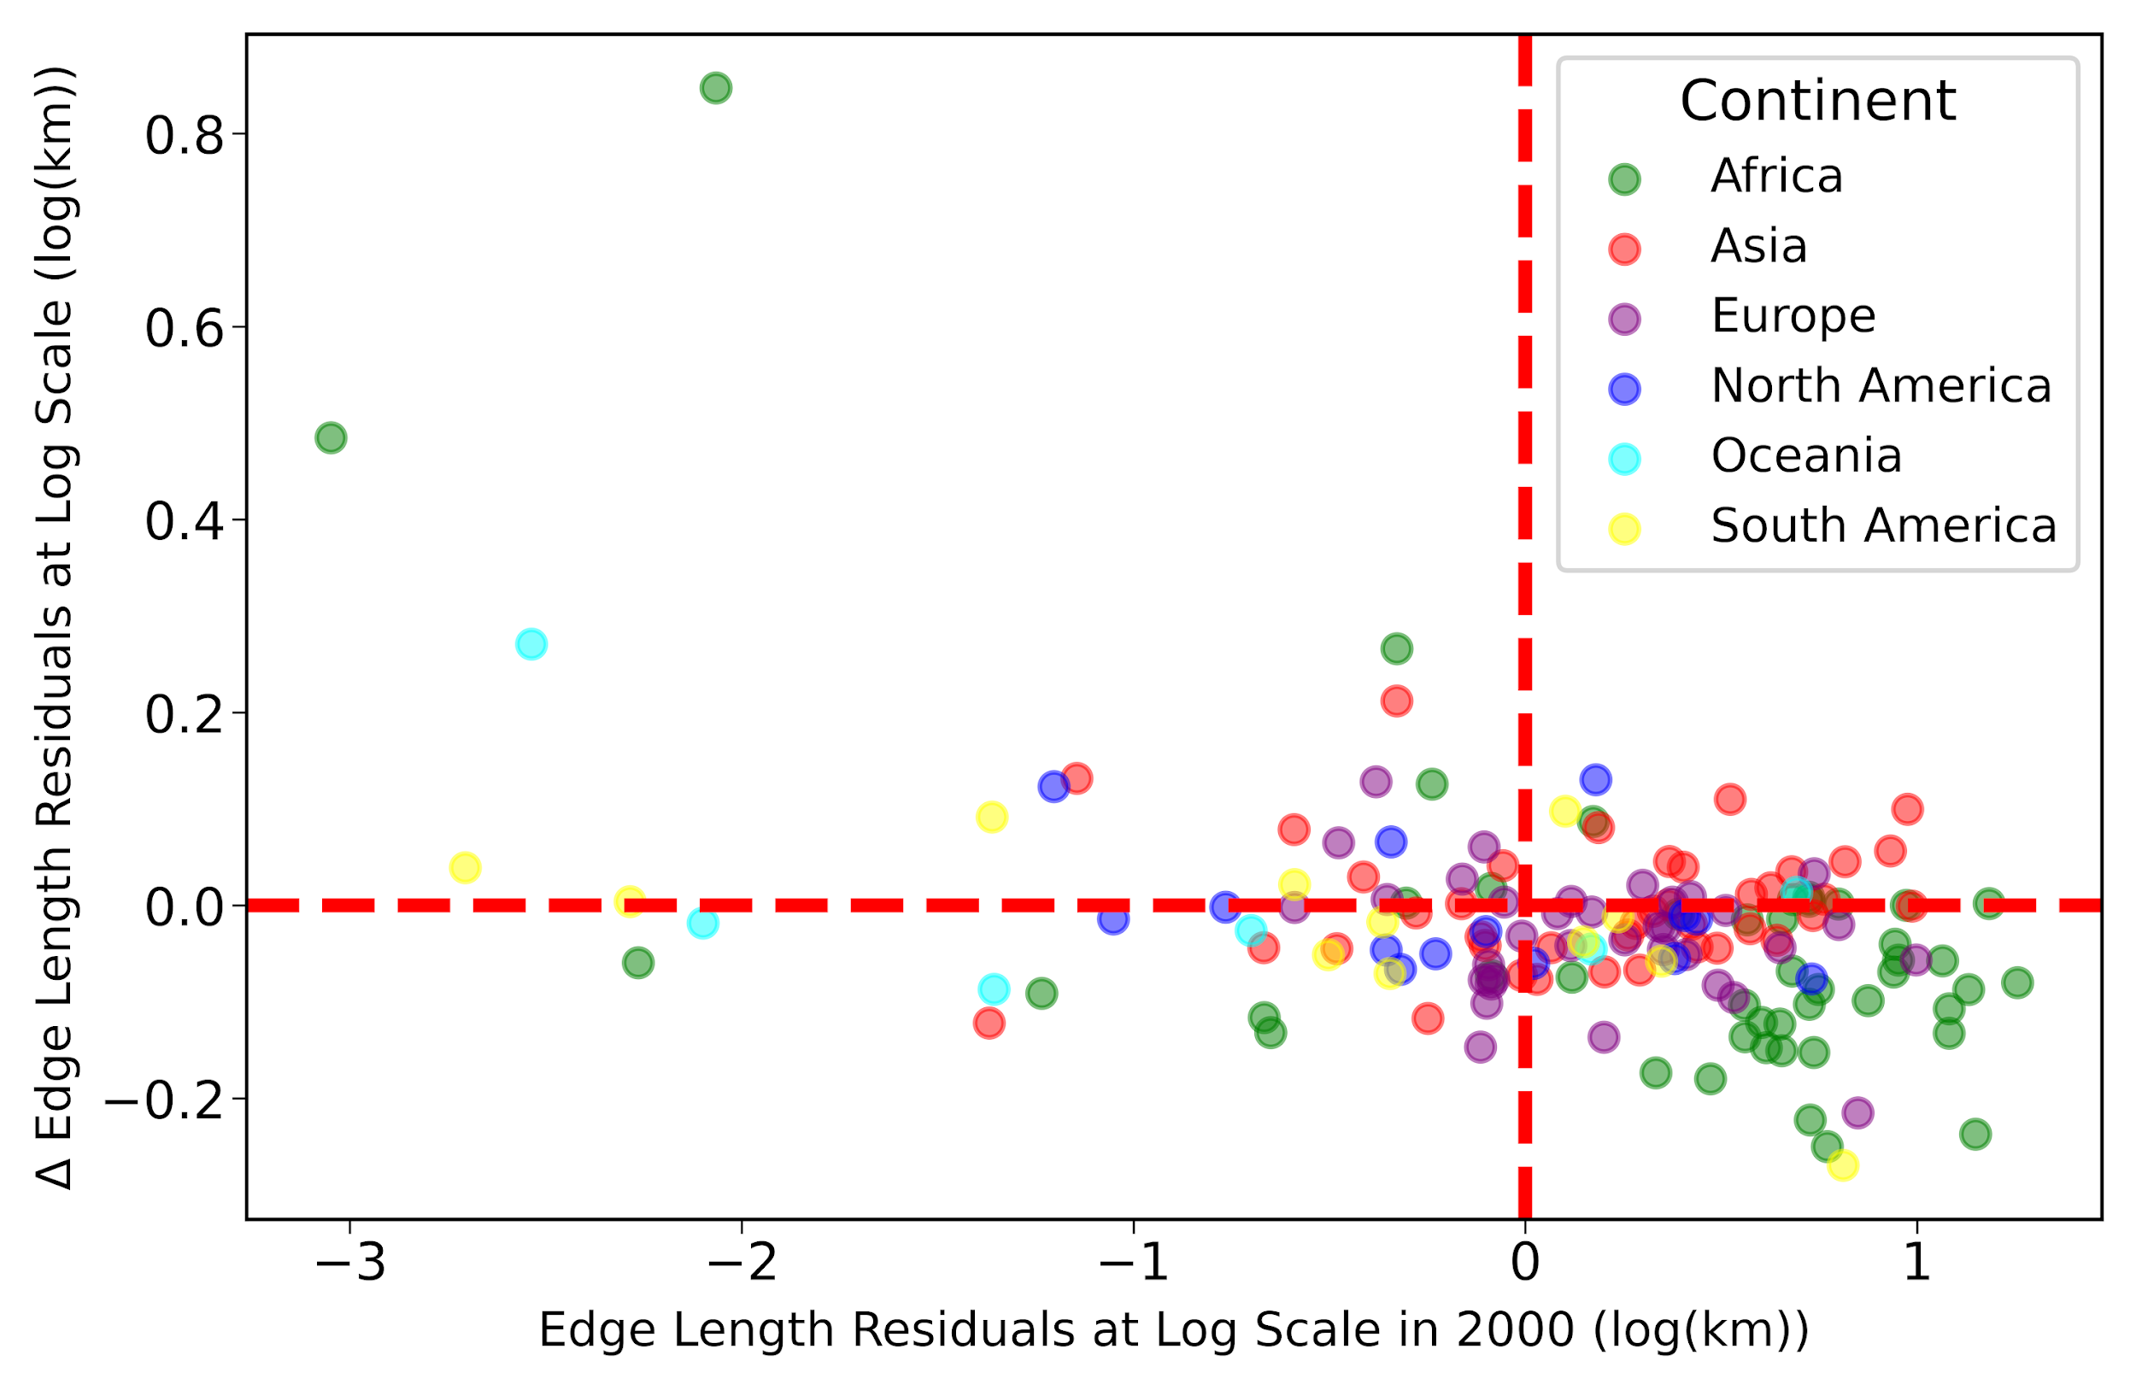
Fig. S6. Unequal development of forest landscape patterns.
The scatter plot illustrates the relationship between the residuals (see “Materials and Methods” section) of each country in 2000 and their changes from 2000 to 2020. Colors indicate the continent to which countries belong, as defined by Natural Earth classifications (https://www.naturalearthdata.com/).

Tab. S1. Forest area and edge dynamics across countries.
The table attached presents data on forest area and forest edge length at the country scale from 2000 to 2020 (with five-year intervals). It includes total forest area (km²), total forest edge length (km), and edge length dynamics (see classification details in “Materials and Methods” section), categorized into stable edges, increase-increase edges, increase-decrease edges, decrease-increase edges, decrease-decrease edges over consecutive time periods.

