Supplementary Material
Table of Contents
Figure S1. Correlation matrix of speech features 2
Table S1. Pairwise Pearson correlation significance (p-values) for speech variables. 3
Figure S2. Differences in speech features between individuals with Major Depressive Disorder (MDD) and non-depressed controls. 4
Table S2. Full ANCOVA results for each speech feature, adjusting for sex, age, total audio duration, education years, and testing location. 5
Table S3. Results from receiver operating characteristic analysis of speech features for detecting depression. 9
10
Figure S3. Associations between speech features and depression severity, as measured by the HAMD-17 scores. 10
Table S4. Full linear model results examining associations between speech features and HAMD-17 depression scores, adjusting for sex, age, total audio duration, education years, and testing location. 12
Figure S4. Associations between speech features and performance on the executive control task, as measured by reaction time (RT). 16
Table S5. Full linear model results examining associations between speech features and anti-saccade RTs, adjusting for sex, age, total audio duration, education years, and testing location. 18
Table S6. Stepwise covariate sensitivity analysis for associations between speech features and anti-saccade reaction times. 22
Table S7. Demographic and Clinical Characteristics by IPAST Completion Status 23

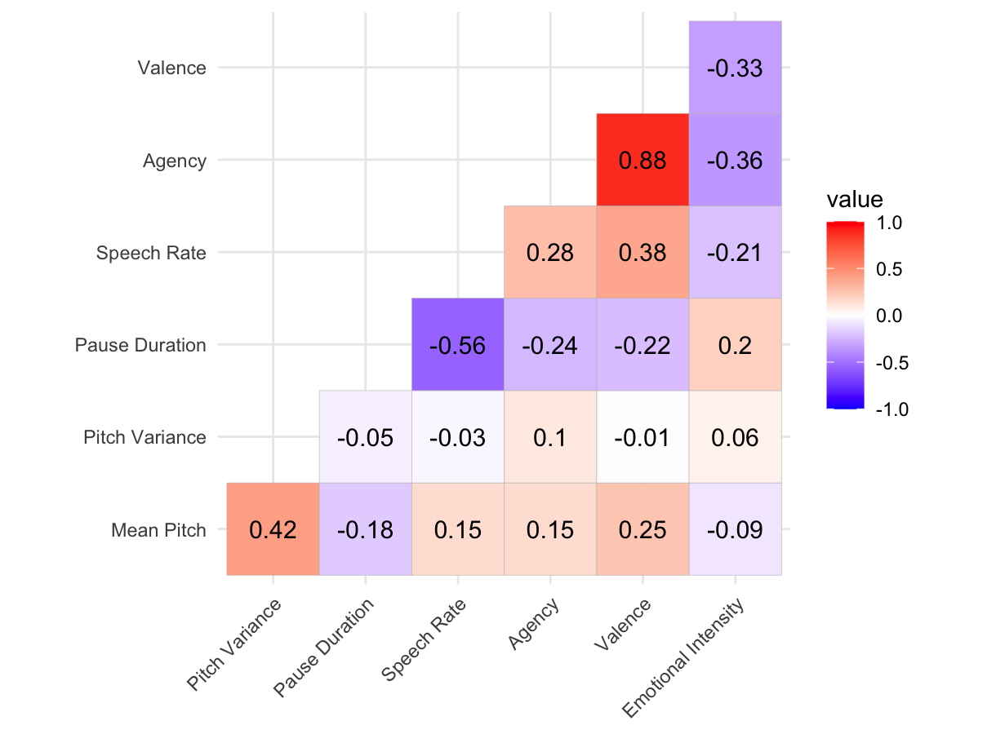
***
***
***
***
***
***
**
**
**
*
*
*
*

Figure S1. Correlation matrix of speech features
Note. All values represent Pearson r coefficients between features. ***, p ≤ .001; ** p ≤ .01; *, p ≤ .05.

Table S1. Pairwise Pearson correlation significance (p-values) for speech variables.
Feature 1 | Feature 2 | p
Valence | Emotional intensity | <0.001
Valence | Agency | <0.001
Valence | Mean pitch | 0.005
Valence | Pitch variance | 0.94
Valence | Pause duration | 0.02
Valence | Speech rate | <0.001
Emotional intensity | Agency | <0.001
Emotional intensity | Mean pitch | 0.31
Emotional intensity | Pitch variance | 0.50
Emotional intensity | Pause duration | 0.03
Emotional intensity | Speech rate | 0.02
Agency | Mean pitch | 0.11
Agency | Pitch variance | 0.28
Agency | Pause duration | 0.008
Agency | Speech rate | 0.002
Mean pitch | Pitch variance | <0.001
Mean pitch | Pause duration | 0.05
Mean pitch | Speech rate | 0.10
Pitch variance | Pause duration | 0.59
Pitch variance | Speech rate | 0.73
Pause duration | Speech rate | <0.001

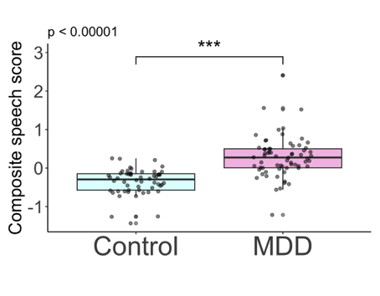
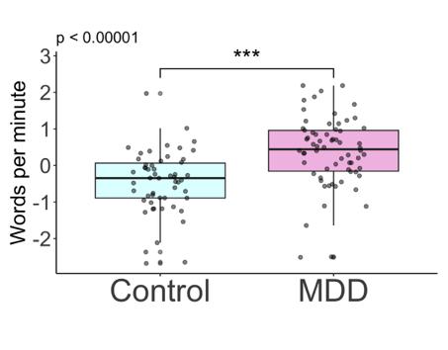
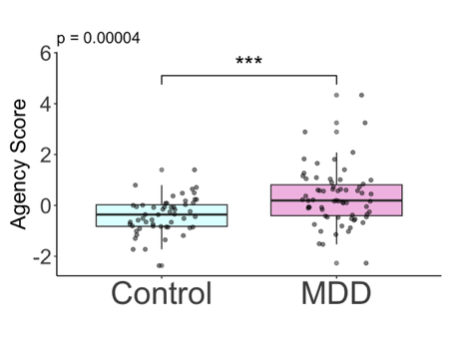
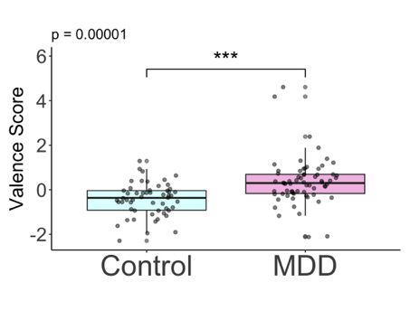
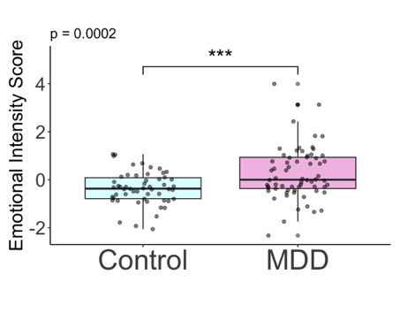
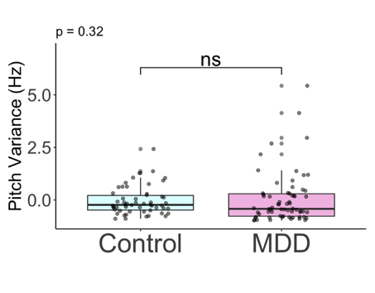
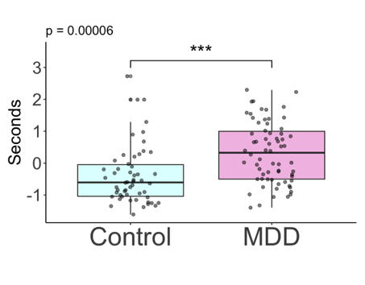
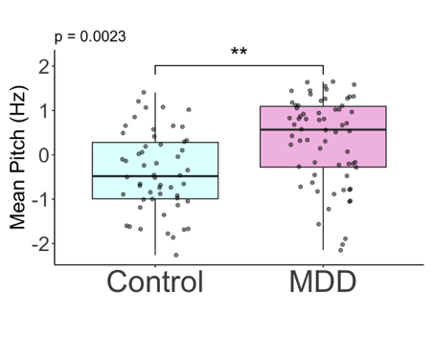
D)
G)
A)
B)
C)
F)
E)
H)
F)
E)

Figure S2. Differences in speech features between individuals with Major Depressive Disorder (MDD) and non-depressed controls.
Relative to controls, individuals with depression A) used significantly more negatively valenced language (F = 21.1, p <0.001, n²=0.16), B) used language that was significantly more emotionally intense (F = 14.9, p <0.001, n²=0.12), C) exhibited significantly lower agency in their language (F = 18.1, p <0.001, n²=0.14), D) spoke with a significantly lower mean pitch (F = 9.7, p = 0.002, n²=0.08), E) did not differ in pitch variance (F = 1.0, p=0.32, n² = 0.008). F) paused significantly more (F = 17.4, p <0.001, n²=0.13), G) spoke significantly slower (F = 26.9, p <0.001, n²=0.19), and H) had significantly higher speech composite scores (F=56.2, p < 0.001, n² = 0.33). Abbreviations. MDD = Major Depressive Disorder, S = seconds, Hz = Hertz, SD = standard deviation.

Table S2. Full ANCOVA results for each speech feature, adjusting for sex, age, total audio duration, education years, and testing location.
 | Speech Feature | Predictor | F-value | p-value | Partial Eta Squared
 | Valence | Group | 14.35 | 0.0002 | 0.038
 |  | Sex | 0.01 | 0.911 | <0.001
 |  | Age | 3.88 | 0.051 | 0.010
 |  | Audio duration (s) | 0.33 | 0.564 | 0.001
 |  | Education, years | 0.87 | 0.354 | 0.002
 |  | Testing location (in-person vs. remote) | 0.71 | 0.401 | 0.002
 |  | Age learned English | 1.14 | 0.289 | 0.009
 | Emotional intensity | Group | 6.19 | 0.014 | 0.013
 |  | Sex | 0.27 | 0.607 | 0.001
 |  | Age | 0.97 | 0.326 | 0.002
 |  | Audio duration (s) | 1.58 | 0.212 | 0.003
 |  | Education, years | 0.00 | 0.950 | <0.001
 |  | Testing location (in-person vs. remote) | 2.65 | 0.107 | 0.006
 |  | Age learned English | 2.76 | 0.100 | 0.023
 | Agency | Group | 9.91 | 0.002 | 0.014
 |  | Sex | 0.52 | 0.471 | 0.001
 |  | Age | 2.27 | 0.134 | 0.003
 |  | Audio duration (s) | 0.09 | 0.759 | <0.001
 |  | Education, years | 0.12 | 0.728 | <0.001
 |  | Testing location (in-person vs. remote) | 1.37 | 0.244 | 0.002
 |  | Age learned English | 0.17 | 0.685 | 0.001
 | Mean pitch | Group | 7.09 | 0.009 | 0.023
 |  | Sex | 89.41 | <0.00001 | 0.287
 |  | Age | 2.26 | 0.136 | 0.007
 |  | Audio duration (s) | 1.43 | 0.234 | 0.005
 |  | Education, years | 0.86 | 0.355 | 0.003
 |  | Testing location (in-person vs. remote) | 0.37 | 0.547 | 0.001
 |  | Age learned English | 0.40 | 0.528 | 0.003
 | Pitch variance | Group | 1.47 | 0.227 | 0.011
 |  | Sex | 3.88 | 0.051 | 0.029
 |  | Age | 2.84 | 0.095 | 0.021
 |  | Audio duration (s) | 0.59 | 0.443 | 0.004
 |  | Education, years | 1.22 | 0.271 | 0.009
 |  | Testing location (in-person vs. remote) | 2.76 | 0.10 | 0.021
 |  | Age learned English | 0.02 | 0.900 | <0.001
 | Pause duration | Group | 5.19 | 0.025 | 0.038
 |  | Sex | 0.04 | 0.838 | 0.000
 |  | Age | 0.13 | 0.720 | 0.001
 |  | Audio duration (s) | 3.81 | 0.053 | 0.028
 |  | Education, years | 0.93 | 0.337 | 0.007
 |  | Testing location (in-person vs. remote) | 4.19 | 0.043 | 0.031
 |  | Age learned English | 0.95 | 0.333 | 0.0008
 | Speech rate | Group | 13.33 | 0.0004 | 0.095
 | Speech rate | Sex | 1.41 | 0.238 | 0.010
 | Speech rate | Age | 0.38 | 0.540 | 0.003
 | Speech rate | Audio durations(s) | 0.22 | 0.639 | 0.002
 | Speech rate | Education, years | 0.01 | 0.925 | <0.001
 | Speech rate | Testing location (in-person vs. remote) | 2.17 | 0.144 | 0.015
 | Speech rate | Age learned English | 0.55 | 0.097 | 0.005
Speech composite score |  | Group | 56.17 | < 0.0001 | 0.328
 |  | Sex | 0.52 | 0.474 | 0.004
 |  | Age | 2.82 | 0.096 | 0.024
 |  | Audio duration (s) | 0.96 | 0.327 | 0.008
 |  | Education, years | 0.001 | 0.975 | <0.001
 |  | Testing location (in-person vs. remote) | 3.37 | 0.069 | 0.015
 |  | Age learned English | 1.40 | 0.233 | 0.014

Table S3. Results from receiver operating characteristic analysis of speech features for detecting depression.
 | Speech Feature | AUC | 95% CI Lower | 95% CI Upper
Valence |  | 0.79 | 0.71 | 0.85 ​
Emotional intensity |  | 0.73 | 0.64 | 0.82
Agency |  | 0.77 | 0.68 | 0.85
 | Mean pitch (Hz) | 0.72​ | 0.63​ | 0.81​
 | Pitch variance (Hz) | 0.61​ | 0.50 | 0.71
 | Pause duration (s) | 0.74 | 0.65 | 0.83
 | Speech rate (words/min) | 0.78 | 0.70 | 0.86
 | Speech Composite | 0.88 | 0.82 | 0.94
Note. AUC = Area under the curve. CI = Confidence interval

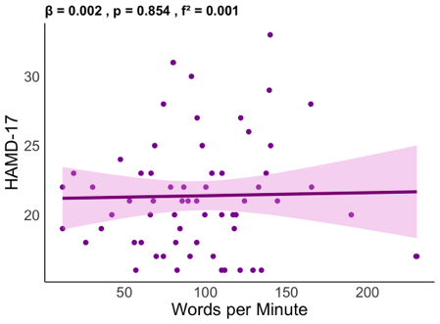
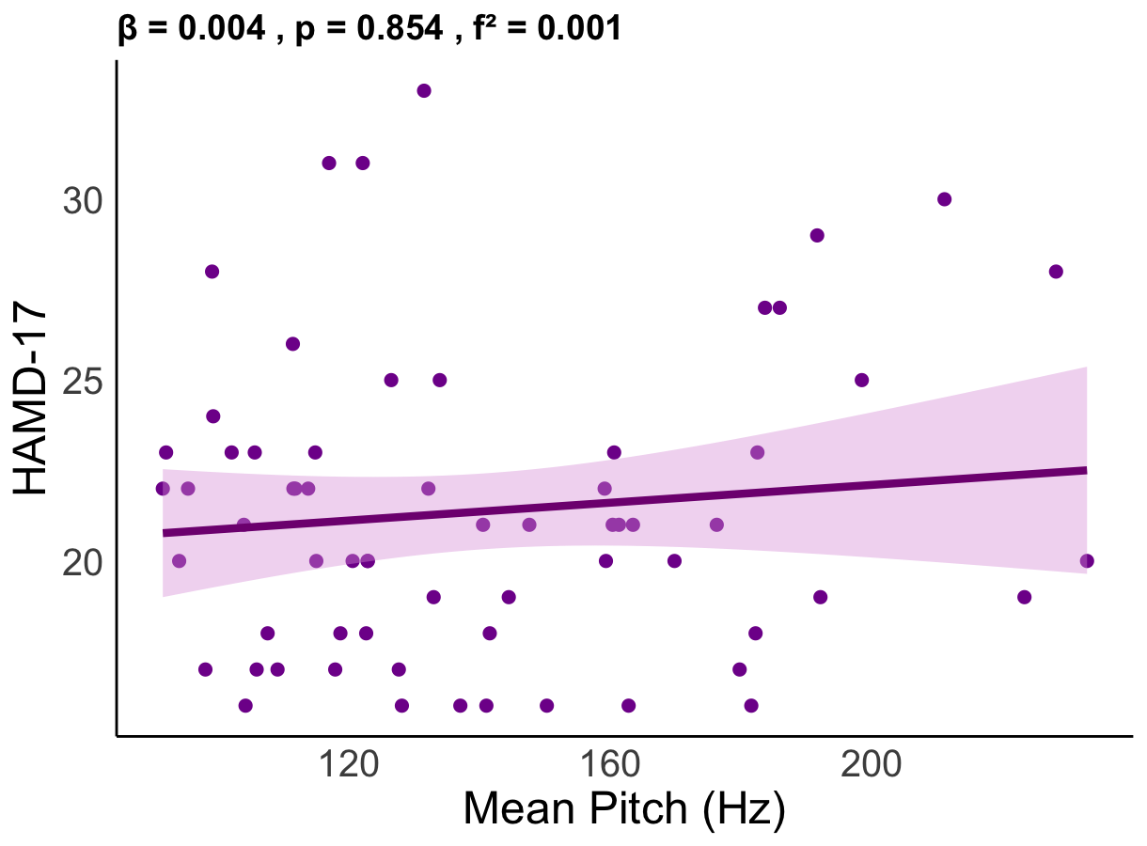
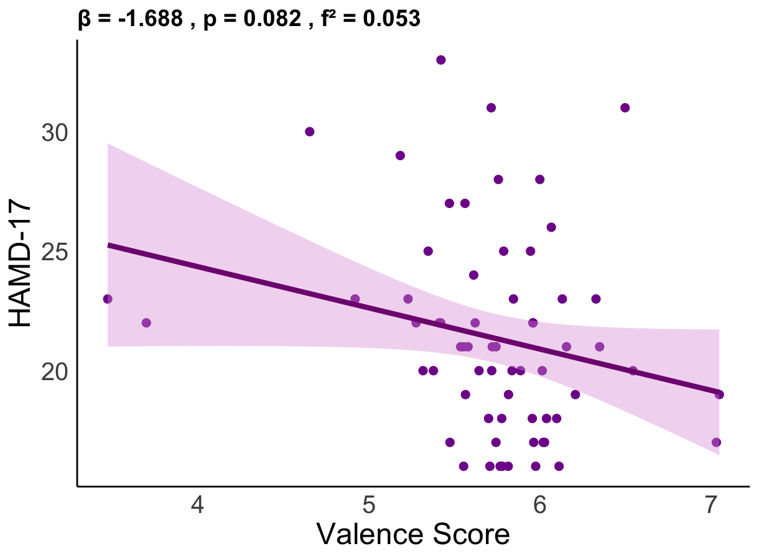
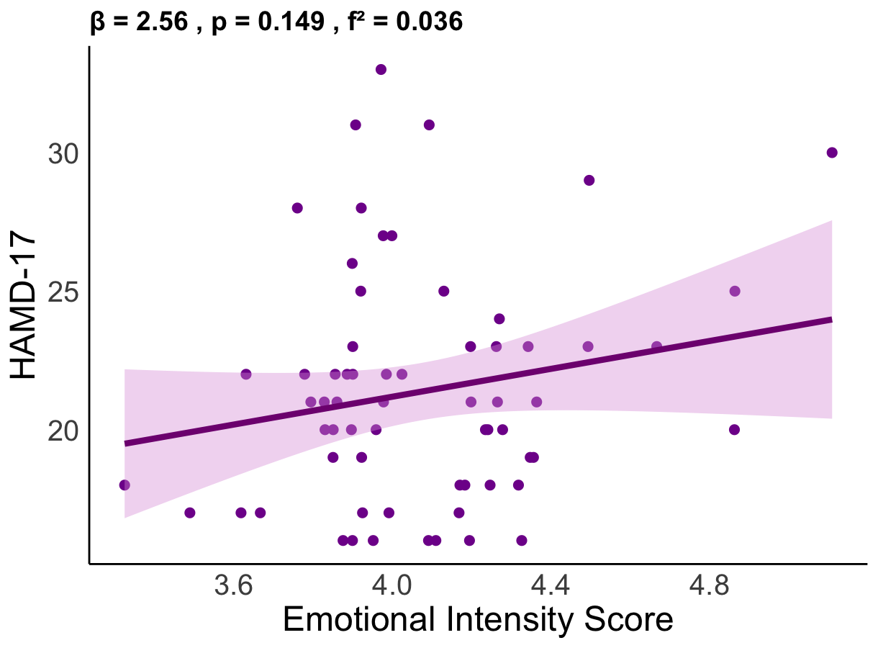
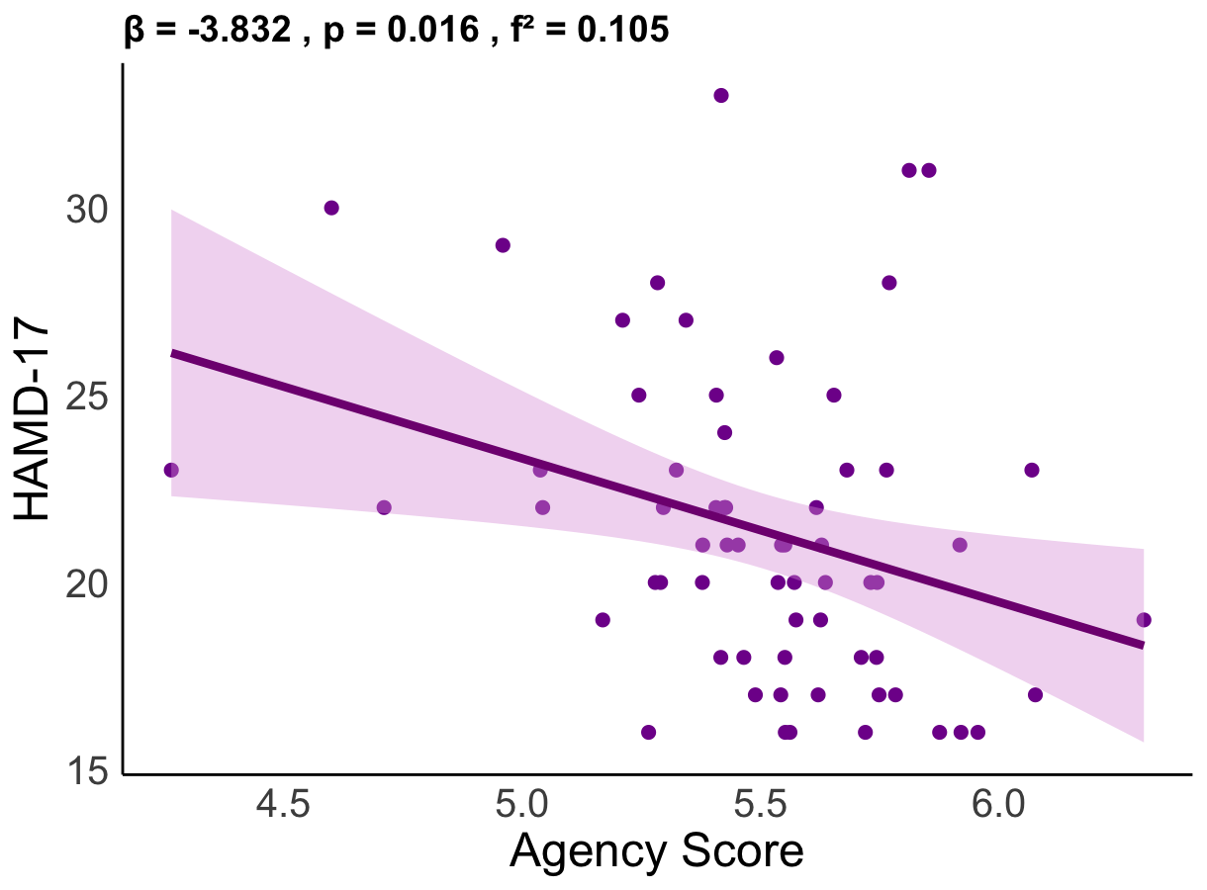
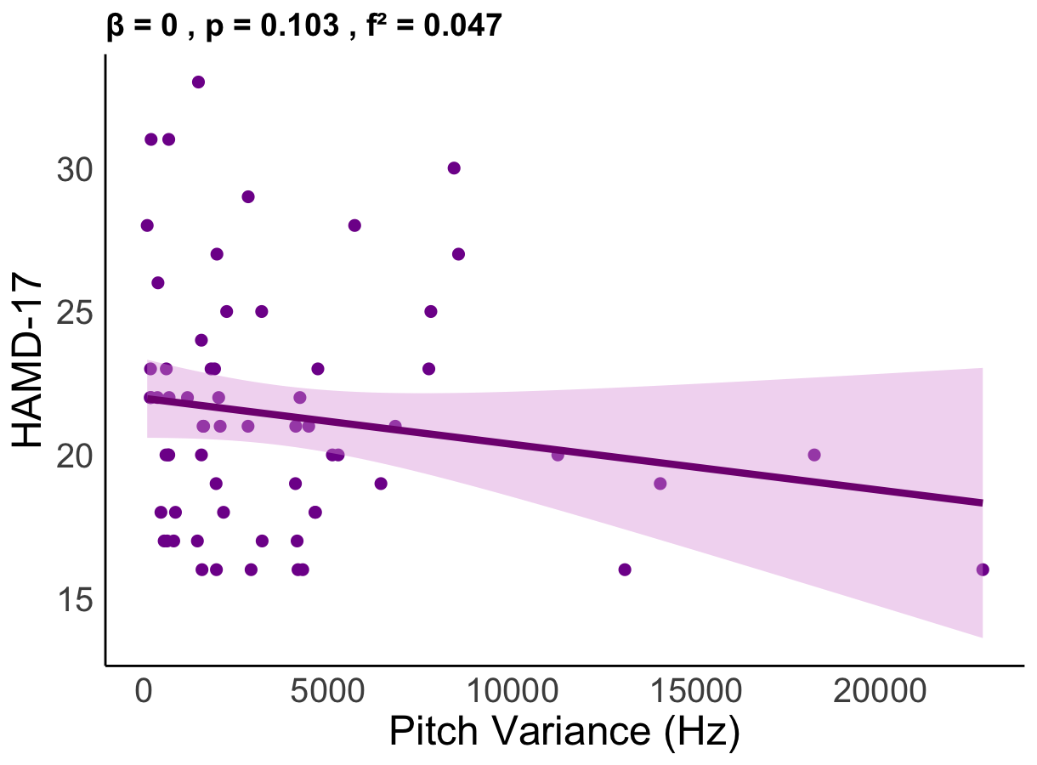
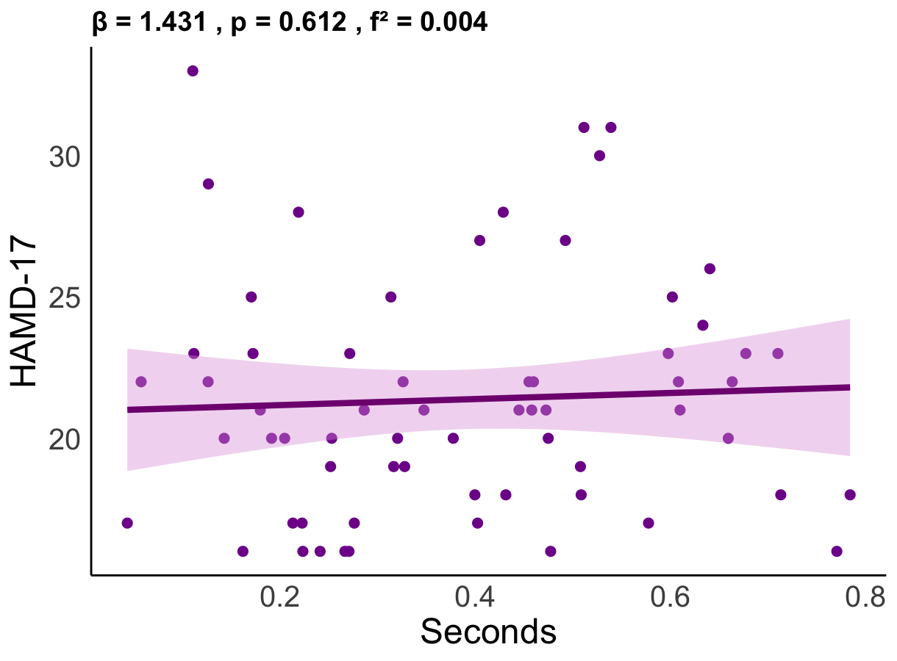
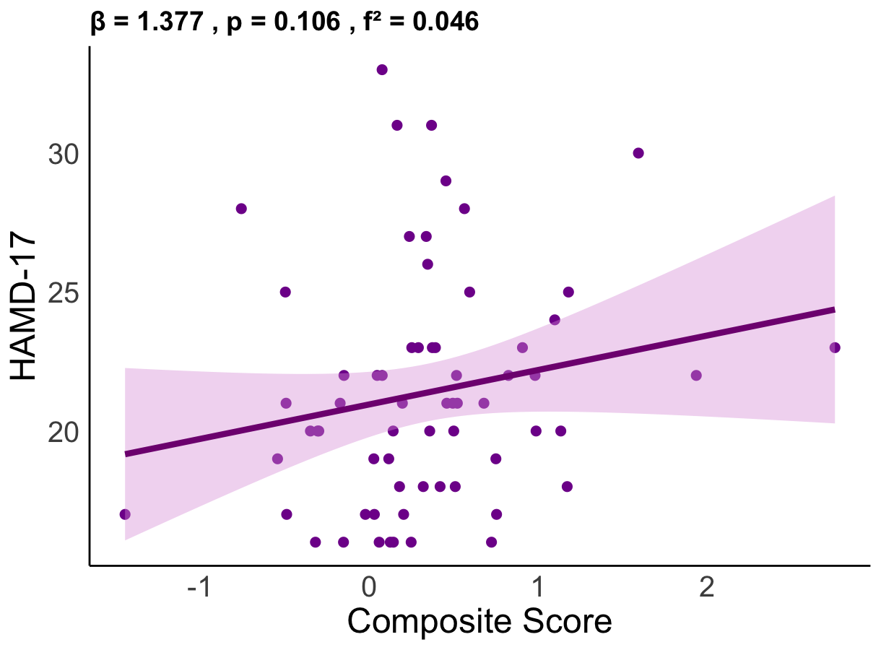
A)
B)
C)
D)
E)
F)
G)
H)

Figure S3. Associations between speech features and depression severity, as measured by the HAMD-17 scores.
A) There was no association between more negatively valenced language and greater depression severity (p=0.08, f² = 0.05). B) There was no association between language that was more emotionally intense and greater depression severity (p = 0.15, f² = 0.04). C) Lower agency in language was significantly related to greater depression severity (p=0.02, f² = 0.10). D) There was no association between mean pitch and depression severity (p = 0.90, f² = 0.001). E) There was no association between pitch variance and depression severity (p = 0.10, f² = 0.05). F) There was no association between pauses and depression severity (p = 0.61, f² = 0.004). G) There was no association between speech rate and depression severity (p = 0.85, f² = 0.001). H) There was no association between the speech composite score and depression severity (p=0.11, f² = 0.05). Abbreviations. HAMD-17 = Hamilton Depression Rating Scale, S = seconds, Hz = Hertz, SD = standard deviation.

Table S4. Full linear model results examining associations between speech features and HAMD-17 depression scores, adjusting for sex, age, total audio duration, education years, and testing location.
 | Speech Feature | Predictor | Estimate (β) | t | p | f²
 | Valence | Valence | -1.78 | -1.87 | 0.067 | 0.06
 | Valence | Sex | -0.76 | -0.70 | 0.489 | 0.01
 | Valence | Age | 0.003 | 0.09 | 0.930 | < 0.001
 | Valence | Audio durations (s) | 0.01 | 0.67 | 0.506 | 0.01
 | Valence | Education, years | -0.05 | -0.20 | 0.843 | 0.001
 | Valence | Testing location (in-person vs. remote) | -1.55 | -1.33 | 0.188 | 0.03
 |  | Age learned English | 0.06 | 0.47 | 0.640 | 0.01
 | Emotional intensity | Emotional intensity | 2.33 | 1.31 | 0.196 | 0.03
 | Emotional intensity | Sex | -0.47 | -0.42 | 0.678 | 0.003
 | Emotional intensity | Age | -0.01 | -0.29 | 0.770 | 0.002
 | Emotional intensity | Audio durations (s) | 0.01 | 0.93 | 0.359 | 0.02
 | Emotional intensity | Education, years | -0.06 | -0.24 | 0.812 | 0.001
 | Emotional intensity | Testing location (in-person vs. remote) | -1.20 | -1.01 | 0.317 | 0.02
 |  | Age learned English | 0.04 | 0.33 | 0.741 | 0.002
 | Agency | Agency | -3.86 | -2.50 | 0.015 | 0.11
 | Agency | Sex | -0.67 | -0.63 | 0.532 | 0.02
 | Agency | Age | 0.004 | 0.12 | 0.904 | < 0.001
 | Agency | Audio durations (s) | 0.01 | 0.83 | 0.410 | 0.01
 | Agency | Education, years | -0.04 | -0.15 | 0.880 | < 0.001
 | Agency | Testing location (in-person vs. remote) | -1.46 | -1.29 | 0.202 | 0.03
 |  | Age learned English | 0.04 | 0.34 | 0.732 | 0.003
 | Mean pitch | Mean pitch | 0.01 | 0.25 | 0.806 | 0.001
 | Mean pitch | Sex | -0.49 | -0.33 | 0.744 | 0.002
 | Mean pitch | Age | -0.01 | -0.36 | 0.722 | 0.002
 | Mean pitch | Audio durations (s) | 0.01 | 0.67 | 0.509 | 0.01
 | Mean pitch | Education, years | -0.02 | -0.09 | 0.930 | < 0.001
 | Mean pitch | Testing location (in-person vs. remote) | -1.47 | -1.22 | 0.226 | 0.03
 |  | Age learned English | 0.03 | 0.21 | 0.833 | 0.001
 | Pitch variance | Pitch variance | <0.001 | -1.49 | 0.143 | 0.04
 | Pitch variance | Sex | -1.18 | -1.04 | 0.304 | 0.02
 | Pitch variance | Age | -0.02 | -0.51 | 0.612 | 0.01
 | Pitch variance | Audio duration (s) | 0.01 | 0.65 | 0.517 | 0.01
 | Pitch variance | Education, years | -0.14 | -0.55 | 0.587 | 0.01
 | Pitch variance | Testing location (in-person vs. remote) | -0.90 | -0.73 | 0.469 | 0.01
 |  | Age learned English | 0.022 | 0.19 | 0.854 | 0.001
 | Pause duration | Pause duration (s) | 0.45 | 0.15 | 0.880 | < 0.001
 | Pause duration | Sex | -0.75 | -0.67 | 0.506 | 0.01
 | Pause duration | Age | -0.01 | -0.35 | 0.725 | 0.002
 | Pause duration | Audio duration (s) | 0.01 | 0.67 | 0.505 | 0.01
 | Pause duration | Education, years | -0.03 | -0.12 | 0.908 | < 0.001
 | Pause duration | Testing location (in-person vs. remote) | -1.39 | -1.13 | 0.263 | 0.02
 |  | Age learned English | 0.03 | 0.23 | 0.823 | 0.001
 | Speech rate | Speech rate (words/min) | 0.01 | 0.49 | 0.623 | 0.004
 | Speech rate | Sex | -0.77 | -0.68 | 0.497 | 0.01
 | Speech rate | Age | -0.01 | -0.32 | 0.754 | 0.002
 | Speech rate | Audio duration (s) | 0.01 | 0.63 | 0.533 | 0.01
 | Speech rate | Education, years | -0.03 | -0.12 | 0.908 | < 0.001
 | Speech rate | Testing location (in-person vs. remote) | -1.57 | -1.29 | 0.203 | 0.03
 |  | Age learned English | 0.03 | 0.21 | 0.838 | 0.001
Composite speech score |  | Score | 0.97 | 0.85 | 0.398 | 0.016
 |  | Sex | -0.969 | -0.74 | 0.465 | 0.014
 |  | Age | <0.001 | 0.01 | 0.994 | < 0.001
 |  | Audio duration (s) | -0.002 | -0.07 | 0.946 | 0.012
 |  | Education, years | -0.004 | -0.01 | 0.989 | < 0.001
 |  | Testing location (in-person vs. remote) | -1.28 | -0.94 | 0.355 | 0.019
 |  | Age learned English | 0.04 | 0.33 | 0.744 | 0.019

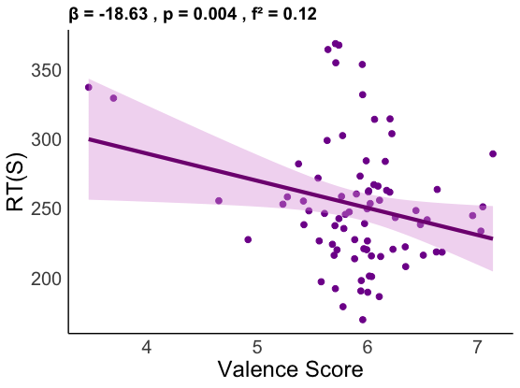
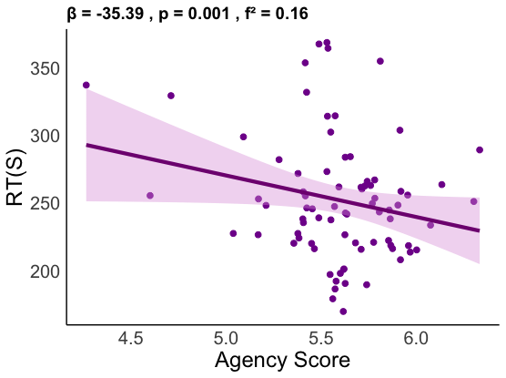
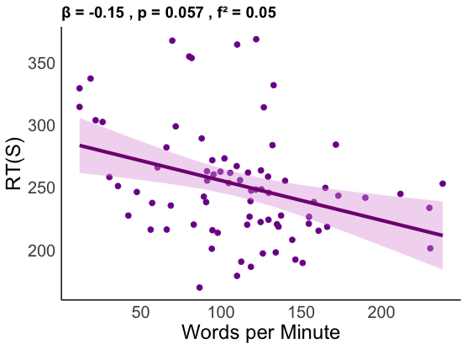
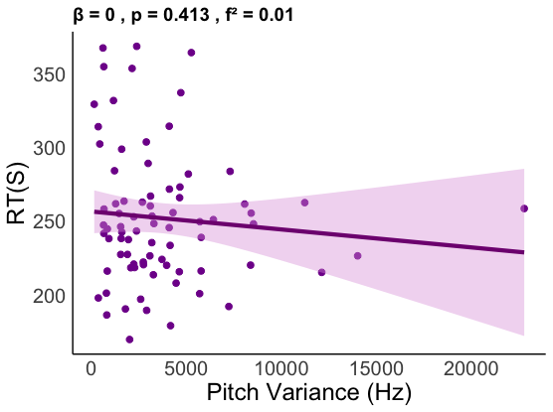
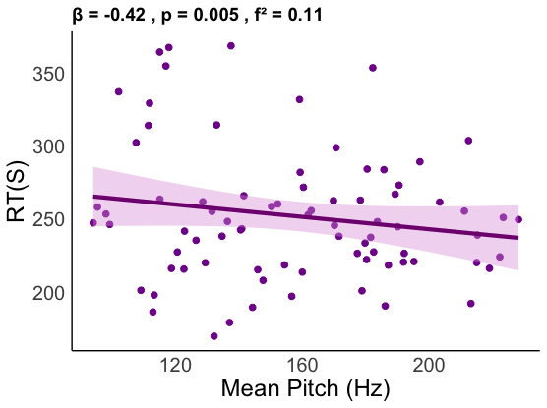
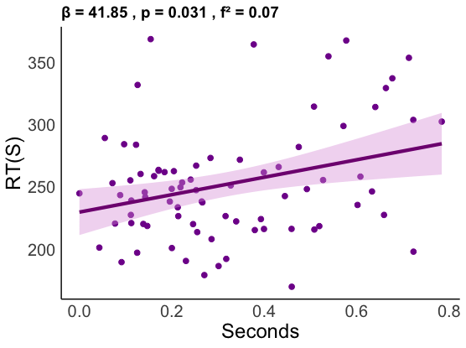
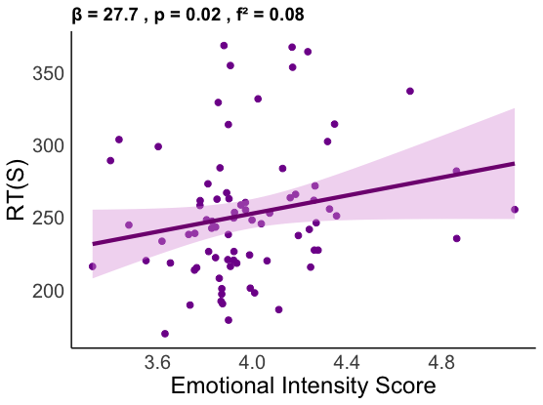
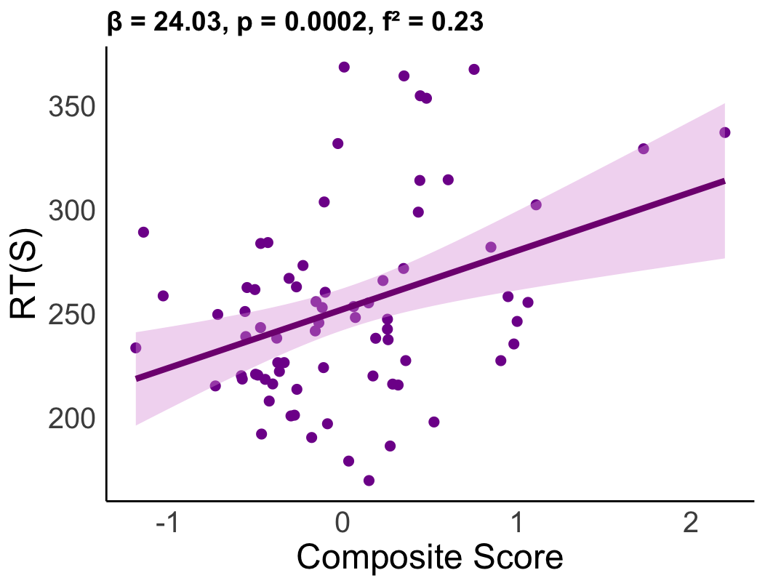
A)
B)
C)
D)
E)
F)
G)
H)

Figure S4. Associations between speech features and performance on the executive control task, as measured by reaction time (RT).
A) More negatively valenced language was associated with worse performance (p=0.004, f² = 0.12). B) More emotionally intense language was associated with worse performance (p=0.02, f² = 0.08). C) Language reflecting less agency was associated with worse performance (p=0.001, f² = 0.16). D) Lower mean pitch was related to worse performance (p=0.005, f² = 0.11). E) There was no association between pitch variance and performance (p=0.41, f² = 0.01). F) Longer pauses was associated with worse performance (p=0.03, f² = 0.07). G) Slower speech rate was associated with worse performance at the trend level (p=0.06, f² = 0.05). H) Greater speech composite scores were associated with worse performance (p <0.001, f²=0.23). RTs = Reaction times (slower reaction time reflects worse performance), s = Seconds, Hz = Hertz, SD = standard deviation.

Table S5. Full linear model results examining associations between speech features and anti-saccade RTs, adjusting for sex, age, total audio duration, education years, and testing location.
 | Speech Feature | Predictor | Estimate (β) | t | p | f²
 | Valence | Valence | -15.54 | -2.42 | 0.018 | 0.083
 | Valence | Sex | 4.89 | 0.65 | 0.516 | 0.006
 | Valence | Age | 0.26 | 1.12 | 0.265 | 0.018
 | Valence | Audio duration (s) | -0.12 | -0.80 | 0.427 | 0.009
 | Valence | Education, years | -1.09 | -0.68 | 0.500 | 0.006
 | Valence | Testing location (in-person vs. remote) | -10.24 | -1.34 | 0.184 | 0.025
 | Valence | Age learned English | 0.34 | 0.52 | 0.602 | 0.004
 | Valence | Pro-saccade RT | 0.76 | 9.30 | <0.0001 | 1.219
 | Emotional intensity | Emotional intensity | 20.74 | 1.68 | 0.097 | 0.040
 | Emotional intensity | Sex | 4.96 | 0.65 | 0.519 | 0.006
 | Emotional intensity | Age | 0.16 | 0.67 | 0.507 | 0.006
 | Emotional intensity | Audio duration (s) | -0.03 | -0.23 | 0.821 | 0.001
 | Emotional intensity | Education, years | -1.33 | -0.81 | 0.422 | 0.009
 | Emotional intensity | Testing location (in-person vs. remote) | -10.39 | -1.30 | 0.197 | 0.024
 | Emotional intensity | Age learned English | 0.32 | 0.47 | 0.636 | 0.003
 | Emotional intensity | Pro-saccade RT | 0.77 | 9.15 | <0.0001 | 1.180
 | Agency | Agency | -29.93 | -2.68 | 0.009 | 0.101
 | Agency | Sex | 6.51 | 0.87 | 0.386 | 0.011
 | Agency | Age | 0.22 | 0.95 | 0.345 | 0.013
 | Agency | Audio duration (s) | -0.09 | -0.62 | 0.539 | 0.005
 | Agency | Education, years | -0.73 | -0.45 | 0.653 | 0.003
 | Agency | Testing location (in-person vs. remote) | -9.28 | -1.22 | 0.228 | 0.021
 | Agency | Age learned English | 0.25 | 0.39 | 0.701 | 0.002
 | Agency | Pro-saccade RT | 0.78 | 9.57 | <0.0001 | 1.290
 | Mean pitch | Mean pitch | -0.36 | -2.36 | 0.021 | 0.078
 | Mean pitch | Sex | -11.68 | -1.14 | 0.257 | 0.018
 | Mean pitch | Age | -0.01 | -0.02 | 0.981 | 0.000
 | Mean pitch | Audio duration (s) | -0.19 | -1.23 | 0.223 | 0.021
 | Mean pitch | Education, years | -1.41 | -0.87 | 0.385 | 0.011
 | Mean pitch | Testing location (in-person vs. remote) | -10.16 | -1.32 | 0.190 | 0.025
 | Mean pitch | Age learned English | 0.411 | 0.62 | 0.536 | 0.006
 | Mean pitch | Pro-saccade RT | 0.79 | 9.63 | <0.0001 | 1.306
 | Pitch variance | Pitch variance | -0.001 | -0.61 | 0.542 | 0.005
 | Pitch variance | Sex | 4.39 | 0.56 | 0.575 | 0.004
 | Pitch variance | Age | 0.17 | 0.70 | 0.486 | 0.007
 | Pitch variance | Audio duration (s) | -0.08 | -0.53 | 0.595 | 0.004
 | Pitch variance | Education, years | -1.61 | -0.96 | 0.341 | 0.013
 | Pitch variance | Testing location (in-person vs. remote) | -13.61 | -1.73 | 0.087 | 0.042
 | Pitch variance | Age learned English | 0.22 | 0.32 | 0.747 | 0.001
 | Pitch variance | Pro-saccade RT | 0.78 | 9.13 | <0.0001 | 1.175
 | Pause duration | Pause duration (s) | 29.03 | 1.43 | 0.156 | 0.029
 | Pause duration | Sex | 2.24 | 0.28 | 0.777 | 0.001
 | Pause duration | Age | 0.19 | 0.80 | 0.428 | 0.009
 | Pause duration | Audio duration (s) | -0.03 | -0.16 | 0.872 | 0.000
 | Pause duration | Education, years | -1.19 | -0.72 | 0.477 | 0.007
 | Pause duration | Testing location (in-person vs. remote) | -11.00 | -1.37 | 0.174 | 0.027
 | Pause duration | Age learned English | 0.27 | 0.41 | 0.685 | 0.002
 | Pause duration | Pro-saccade RT | 0.74 | 8.59 | <0.0001 | 1.040
 | Speech rate | Speech rate (words/min) | -0.10 | -1.28 | 0.205 | 0.023
 | Speech rate | Sex | 5.13 | 0.67 | 0.508 | 0.006
 | Speech rate | Age | 0.20 | 0.83 | 0.407 | 0.010
 | Speech rate | Audio duration (s) | -0.06 | -0.41 | 0.680 | 0.002
 | Speech rate | Education, years | -1.27 | -0.76 | 0.449 | 0.008
 | Speech rate | Testing location (in-person vs. remote) | -11.97 | -1.52 | 0.134 | 0.032
 | Speech rate | Age learned English | 0.18 | 0.27 | 0.792 | 0.001
 | Speech rate | Pro-saccade RT | 0.74 | 8.38 | <0.0001 | 0.990
Composite speech  score |  | Score | 20.65 | 2.94 | 0.005 | 1.017
 |  | Sex | -1.08 | -0.14 | 0.892 | <0.0001
 |  | Age | 0.08 | 0.32 | 0.749 | 0.002
 |  | Audio duration (s) | -0.08 | -0.47 | 0.641 | 0.003
 |  | Education, years | -1.25 | -0.75 | 0.454 | 0.009
 |  | Testing location (in-person vs. remote) | -6.69 | -0.77 | 0.445 | 0.009
 |  | Age learned English | 0.22 | 0.33 | 0.744 | 0.002
 |  | Pro-saccade RT | 0.74 | 8.88 | <0.0001 | 1.212

Table S6. Stepwise covariate sensitivity analysis for associations between speech features and anti-saccade reaction times.
Speech Feature | Base β | Base p | +Edu β | +Edu p | +Loc β | +Loc p | +Eng β | +Eng p | Full β | Full p
Valence | -18.63 | 0.004 | -17.53 | 0.007 | -15.97 | 0.014 | -18.91 | 0.004 | -15.54 | 0.018
Emotional intensity | 27.71 | 0.021 | 25.69 | 0.032 | 21.30 | 0.087 | 28.27 | 0.020 | 20.74 | 0.097
Agency | -35.39 | 0.001 | -33.41 | 0.003 | -30.80 | 0.006 | -35.54 | 0.001 | -29.93 | 0.009
Mean pitch | -0.42 | 0.006 | -0.40 | 0.008 | -0.36 | 0.020 | -0.43 | 0.005 | -0.36 | 0.021
Pitch variance | -0.001 | 0.413 | -0.001 | 0.350 | -0.001 | 0.621 | -0.001 | 0.413 | -0.001 | 0.542
Pause Duration | 41.85 | 0.031 | 37.54 | 0.057 | 30.81 | 0.128 | 42.41 | 0.030 | 29.03 | 0.156
Speech Rate | -0.15 | 0.057 | -0.13 | 0.093 | -0.11 | 0.176 | -0.15 | 0.059 | -0.10 | 0.205
Speech Composite | 28.3 | 0.002 | 22.8 | 0.005 | 20.4 | 0.004 | 20.6 | 0.004 | 20.7 | 0.005
Note: Base models adjusted for sex, age, total audio duration, and prosaccade reaction times. Subsequent models additionally adjusted for education years, and/or testing location, and/or age learned english. Beta coefficients (β), p-values (p), and final significance status are reported.

Table S7. Demographic and Clinical Characteristics by IPAST Completion Status
Variable | Mean  (No IPAST) | Mean  (Yes IPAST) | p | 95% CI | Test
Age | 48.17 | 43.14 | 0.108 | [-1.12, 11.18] | Welch t-test
Education (years) | 15.50 | 16.29 | 0.052 | [-1.60, 0.01] | Welch t-test
Age English Learned | 2.23 | 2.44 | 0.834 | [-2.20, 1.78] | Welch t-test
Sex (Female %) | 57.1% | 67.9% | 0.321 | [OR 0.28–1.53] | Fisher’s exact
HAMD-17¹ | 21.92 | 21.03 | 0.403 | [-1.23, 3.02] | Welch t-test
Note. IPAST, Interleaved Pro and Anti-saccade Task. HAMD-17, Hamilton Depression Rating Scale.
¹ Only participants with depression completed the HAMD-17.

