Supplementary material

Article: Minocycline Ameliorates Cognitive Impairments Without Modulate Microglial Reactivity in Sporadic Hypercholesterolemia: A Sex-Specific Analysis in Mice

Molecular Neurobiology
Matheus Scarpatto Rodrigues*, Natalia Baltazar do Nascimento, Gabriela Joras Baumart, Taina Schons, Alex Paulo Padilha, Mariana Viana Costa, Hemelin Resende Farias, Lilian Costa-Beber, Alessandra Gonçalves Machado, Lucas Santos, Rachel Krolow Bast, Josiane Budni, Daniel Pens Gelain, Jose Claudio Fonseca Moreira, David Engblom, Andreza Fabro de Bem, Jade de Oliveira*.
* Corresponding authors:
Jade de Oliveira, PhD
Programa de Pós-Graduação em Ciências Biológicas: Bioquímica, Departamento de Bioquímica, Instituto de Ciências Básicas da Saúde, Universidade Federal do Rio Grande do Sul (UFRGS), Porto Alegre, Brazil.
E-mail: deoliveirajade10@gmail.com
Matheus Scarpatto Rodrigues, PhD
Department of Psychiatry and Neurology, University of Pittsburgh,
200 Meyran Avenue, Room 507,
Pittsburgh, PA 15213, USA.
Email: matheus_scarodrigues@hotmail.com

Supplementary Figure 1: Effects of diet and pharmacological intervention on mice glucose tolerance stratified by sex.

Supplementary Figure 2: Effects of diet and pharmacological intervention on the immunocontent of claudin-5 and RAGE in the PFC and hippocampus stratified by sex.

Supplementary Figure 3. Full-length Western blot images corresponding to Figure 5.

Supplementary Table 1: T-test coefficients for plasma cholesterol levels and ip-GTT between sexes.

Supplementary Table 2: T-test statistical coefficients for corporal body weight and body weight gain between sexes.

Supplementary Table 3: T-test statistical coefficients for behavioral and memory tasks.

Supplementary Table 4: T-test statistical coefficients for IBA-1 immunoreactivity, microglia branch length, and the number of endpoints in the hippocampal CA3 region.

Supplementary Table 5: T-test statistical coefficients for Claudin-5 and RAGE immunocontent in the prefrontal cortex and hippocampus.

Supplementary Table 6: T-test statistical coefficients for lectin-positive cells and IBA-1 within lectin in the hippocampal CA3 region.

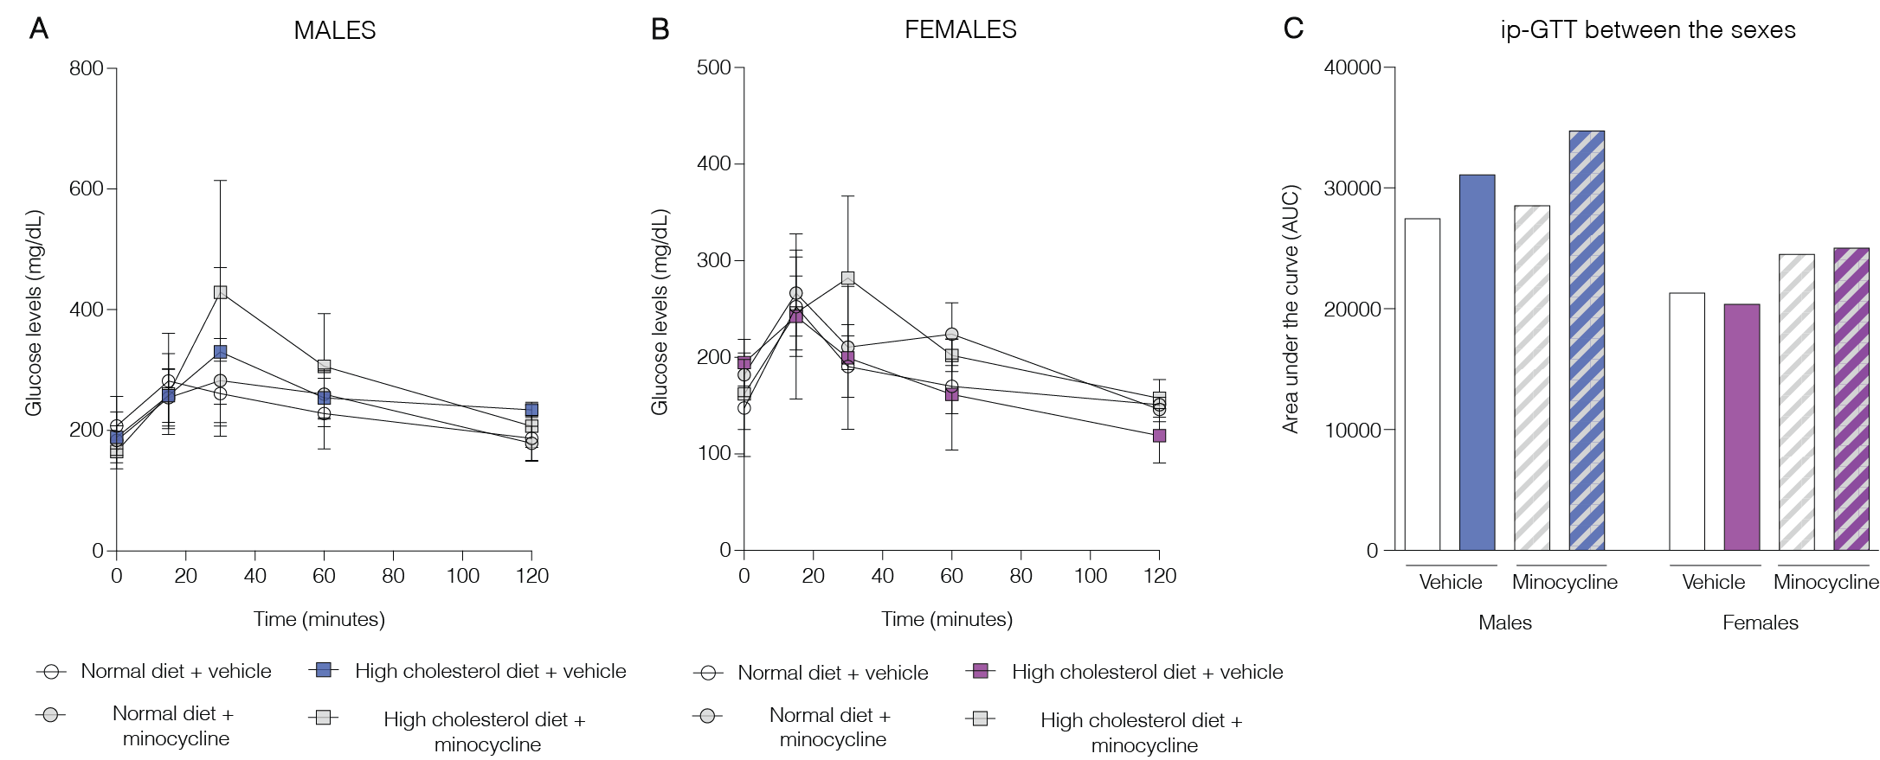

Supplementary Figure 1: Effects of diet and pharmacological intervention on mice glucose tolerance stratified by sex. (A) ip-GTT curve in males (n= 2-4 animals/group). (B) ip-GTT curve in females (n= 2-4 animals/group). (C) ip-GTT test between the sexes (n= 2-4 animals/group). Data are expressed as mean ± SEM. Two-way ANOVA accessed the effects of diet and pharmacological intervention on mice glucose tolerance. T-test accessed possible differences between sexes inside each experimental group.

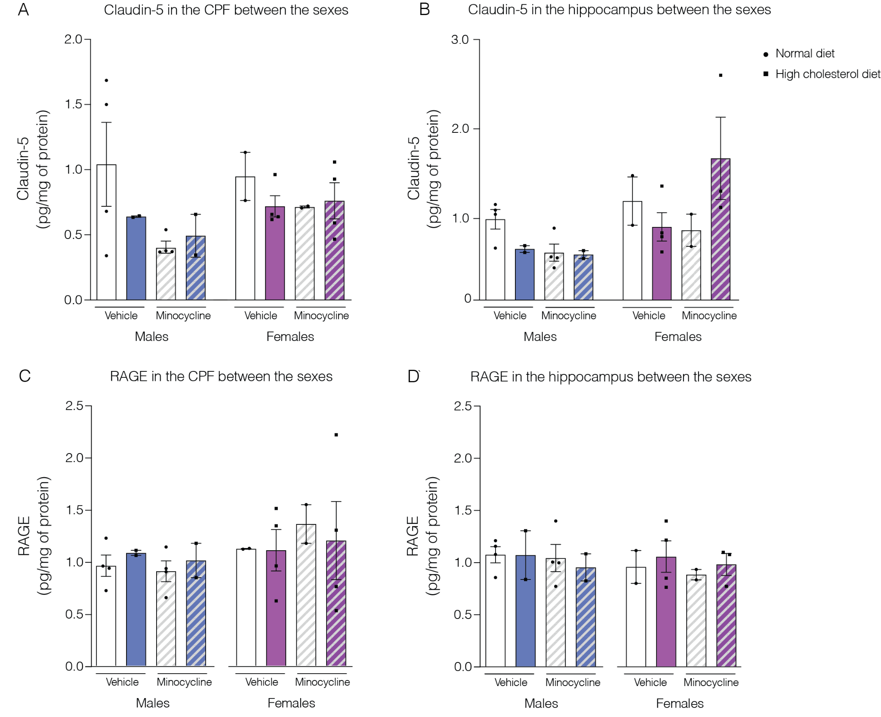
Supplementary Figure 2: Effects of diet and pharmacological intervention on the immunocontent of claudin-5 and RAGE in the PFC and hippocampus stratified by sex. (A) Claudin-5 in the PFC. (B) Claudin-5 in the hippocampus. (C) RAGE in the PFC. (D) RAGE in the hippocampus (n= 2-4 animals/group). Data are expressed as mean ± SEM.
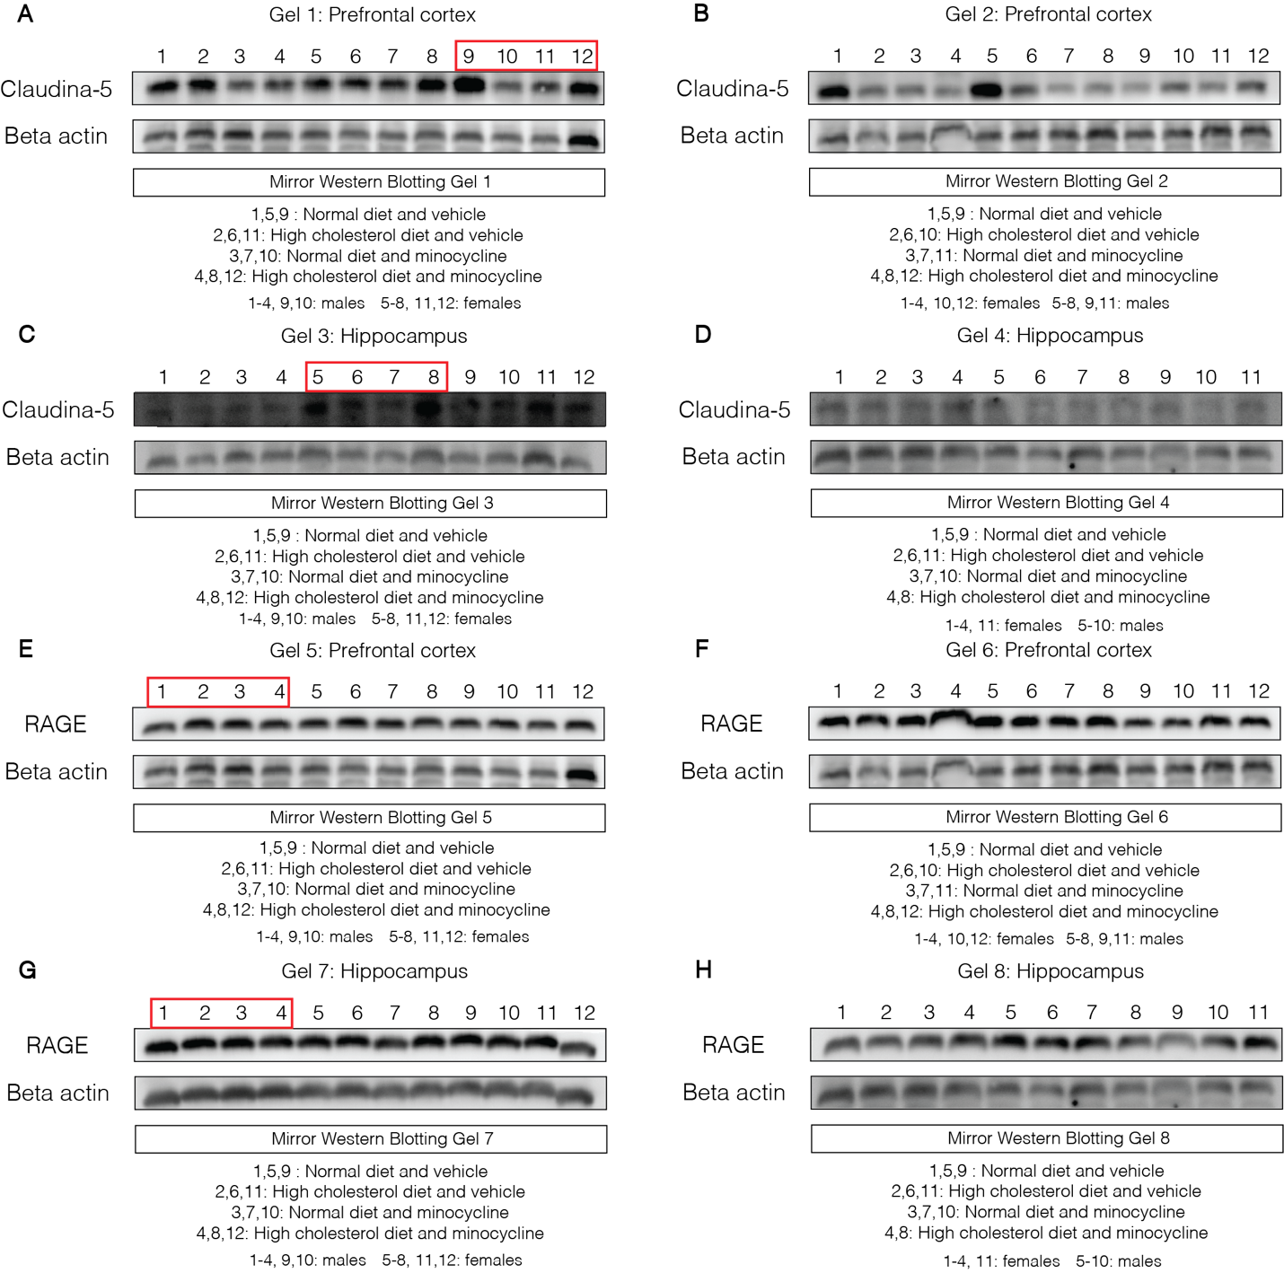
Supplementary Figure 3. Full-length Western blot images corresponding to Figure 5. Uncropped membranes show the complete immunoreactive bands for Claudin-5 in the prefrontal cortex (A, B) and hippocampus (C, D), and for RAGE in the prefrontal cortex (E, F) and hippocampus (G, H). Red boxes indicate the cropped lanes used as representative images in the main Figure 5. Sample loading order, including experimental group and sex, is detailed below each gel image. Mirror blot schematics illustrate the sample distribution across dietary conditions, treatment, and sex.

Supplementary Table 1: T-test coefficients for plasma cholesterol levels and ip-GTT between sexes.
A) T-test coefficients for comparison between sexes - cholesterol levels
Group | df | T-value | P value
ND vehicle male vs  ND vehicle female | 9.423 | -2.168 | 0.056
HCD vehicle male vs HCD vehicle female | 6.786 | -0.745 | 0.480
ND minocycline male vs ND minocycline female | 9.990 | -9.804 | <0.001
HCD minocycline male vs HCD minocycline female | 2.697 | -2.336 | 0.111
B) T-test coefficients for comparison between sexes - ip-GTT
Group | df | T-value | P value
ND vehicle male vs  ND vehicle female | 3.560 | -1.691 | 0.174
HCD vehicle male vs HCD vehicle female | 1.609 | -2.054 | 0.206
ND minocycline male vs ND minocycline female | 2.679 | -2.338 | 0.118
HCD minocycline male vs HCD minocycline female | 1.098 | -1.299 | 0.402

Supplementary Table 2: T-test statistical coefficients for corporal body weight and body weight gain between sexes.
A) T-test coefficients for comparison between sexes - corporal weight
Group | df | T-value | P value
ND vehicle male vs  ND vehicle female | 20.233 | -4.416 | <0.001
HCD vehicle male vs HCD vehicle female | 20.944 | -3.193 | 0.004
ND minocycline male vs ND minocycline female | 17.023 | -1.478 | 0.157
HCD minocycline male vs HCD minocycline female | 19.555 | -4.581 | <0.001
B) T-test coefficients for comparison between sexes - weight gain
Group | df | T-value | P value
ND vehicle male vs  ND vehicle female | 21.869 | -1.327 | 0.198
HCD vehicle male vs HCD vehicle female | 21.999 | 1.031 | 0.313
ND minocycline male vs ND minocycline female | 12.029 | 1.946 | 0.075
HCD minocycline male vs HCD minocycline female | 20.000 | -0.064 | 0.949

Supplementary Table 3: T-test statistical coefficients for behavioral and memory tasks.
A) T-test coefficients for comparison between sexes - total traveled distance
Group | df | T-value | P value
ND vehicle male vs  ND vehicle female | 7.519 | 1.193 | 0.268
HCD vehicle male vs HCD vehicle female | 6.069 | 1.836 | 0.115
ND minocycline male vs ND minocycline female | 9.658 | 2.141 | 0.058
HCD minocycline male vs HCD minocycline female | 9.806 | 3.802 | 0.003
B) T-test coefficients for comparison between sexes - object recognition index
Group | df | T-value | P value
ND vehicle male vs  ND vehicle female | 6.512 | 0.771 | 0.467
HCD vehicle male vs HCD vehicle female | 7.585 | -1.093 | 0.305
ND minocycline male vs ND minocycline female | 6.897 | 1.401 | 0.204
HCD minocycline male vs HCD minocycline female | 5.617 | 0.750 | 0.483
C) T-test coefficients for comparison between sexes object location index
Group | df | T-value | P value
ND vehicle male vs  ND vehicle female | 3.512 | -1.976 | 0.129
HCD vehicle male vs HCD vehicle female | 7.721 | -2.513 | 0.037
ND minocycline male vs ND minocycline female | 5.340 | 0.867 | 0.423
HCD minocycline male vs HCD minocycline female | 5.977 | 1.073 | 0.324

Supplementary Table 4: T-test statistical coefficients for IBA-1 immunoreactivity, microglia branch length, and the number of endpoints in the hippocampal CA3 region.
A) T-test coefficients for comparison between sexes - IBA-1 immunoreactivity
Group | df | T-value | P value
ND vehicle male vs  ND vehicle female | 7.870 | 0.128 | 0.901
HCD vehicle male vs HCD vehicle female | 6.987 | -0.734 | 0.486
ND minocycline male vs ND minocycline female | 4.753 | -0.757 | 0.484
HCD minocycline male vs HCD minocycline female | 5.023 | -0.839 | 0.439
B) T-test coefficients for comparison between sexes - microglia branch length
Group | df | T-value | P value
ND vehicle male vs  ND vehicle female | 7.050 | -2.747 | 0.028
HCD vehicle male vs HCD vehicle female | 5.236 | -1.219 | 0.274
ND minocycline male vs ND minocycline female | 5.810 | -0.729 | 0.494
HCD minocycline male vs HCD minocycline female | 7.103 | -1.752 | 0.122
C) T-test coefficients for comparison between sexes - microglia number of endpoints
Group | df | T-value | P value
ND vehicle male vs  ND vehicle female | 7.043 | -1.500 | 0.176
HCD vehicle male vs HCD vehicle female | 5.994 | -0.687 | 0.517
ND minocycline male vs ND minocycline female | 6.350 | -0.134 | 0.897
HCD minocycline male vs HCD minocycline female | 4.870 | -0.490 | 0.644
D) T-test coefficients for comparison between sexes - cd68 (%IBA-1)
Group | df | T-value | P value
ND vehicle male vs  ND vehicle female | 2.374 | -0.931 | 0.436
HCD vehicle male vs HCD vehicle female | 3.672 | -0.593 | 0.587
ND minocycline male vs ND minocycline female | 2.566 | -1.649 | 0.212
HCD minocycline male vs HCD minocycline female | 3.839 | 0.360 | 0.737

Supplementary Table 5: T-test statistical coefficients for Claudin-5 and RAGE immunocontent in the prefrontal cortex and hippocampus.
A) T-test coefficients for comparison between sexes - Claudin-5 in the prefrontal cortex
Group | df | T-value | P value
ND vehicle male vs  ND vehicle female | 3.999 | -0.249 | 0.815
HCD vehicle male vs HCD vehicle female | 2.594 | 0.702 | 0.540
ND minocycline male vs ND minocycline female | 3.041 | 1.354 | 0.267
HCD minocycline male vs HCD minocycline female | 3.201 | 1.489 | 0.227
B) T-test coefficients for comparison between sexes - Claudin-5 in the hippocampus
Group | df | T-value | P value
ND vehicle male vs  ND vehicle female | 1.344 | 0.695 | 0.587
HCD vehicle male vs HCD vehicle female | 2.442 | 1.885 | 0.176
ND minocycline male vs ND minocycline female | 3.355 | 0.257 | 0.811
HCD minocycline male vs HCD minocycline female | 2.716 | 2.738 | 0.079
C) T-test coefficients for comparison between sexes - RAGE in the prefrontal cortex
Group | df | T-value | P value
ND vehicle male vs  ND vehicle female | 3.007 | 1.584 | 0.211
HCD vehicle male vs HCD vehicle female | 3.985 | 1.515 | 0.204
ND minocycline male vs ND minocycline female | 2.331 | 0.492 | 0.664
HCD minocycline male vs HCD minocycline female | 2.999 | -0.522 | 0.637
D) T-test coefficients for comparison between sexes - RAGE in the hippocampus
Group | df | T-value | P value
ND vehicle male vs  ND vehicle female | 1.518 | -0.668 | 0.590
HCD vehicle male vs HCD vehicle female | 3.813 | -1.069 | 0.347
ND minocycline male vs ND minocycline female | 2.752 | 0.688 | 0.544
HCD minocycline male vs HCD minocycline female | 0.168 | 2.258 | 0.880

Supplementary Table 6: T-test statistical coefficients for lectin-positive cells and IBA-1 within lectin in the hippocampal CA3 region.
A) T-test coefficients for comparison between sexes - lectin-positive cells in the hippocampus
Group | df | T-value | P value
ND vehicle male vs  ND vehicle female | 13.013 | -0.773 | 0.453
HCD vehicle male vs HCD vehicle female | 12.578 | 0.696 | 0.498
ND minocycline male vs ND minocycline female | 13.975 | -1.554 | 0.142
HCD minocycline male vs HCD minocycline female | 13.969 | 0.416 | 0.683
B) T-test coefficients for comparison between sexes - IBA-1 within lectin in the hippocampus
Group | df | T-value | P value
ND vehicle male vs  ND vehicle female | 7.365 | 0.339 | 0.743
HCD vehicle male vs HCD vehicle female | 4.105 | 0.717 | 0.511
ND minocycline male vs ND minocycline female | 7.980 | 0.157 | 0.878
HCD minocycline male vs HCD minocycline female | 6.537 | -0.016 | 0.987

